Email with component order details for Lab #9

Dear ME170 Students;
I have pasted below a picture of the McMasterCarr catalog parts that I showed in class today. These are the parts that you are modeling in lab this week. I have put the physical parts in the EWS lab and the TAs will borrow some calipers from the Innovation Studio for you to use to measure the parts. As I mentioned, the explicit (i.e. strong) dimensions in your CAD models should, by design intent, always show the dimensions that affect functionality. All 3 of these components come in a range of sizes and are selected based on the dimensions shown in the catalog. It is important to at least have all of these as defined explicit, strong dimensions in your model. Other dimensions, and constraints, can be chosen/added as needed and should be both logical and strong. As I think we only have mm calipers, I suggest you model in mms and simply convert the English catalog units to mms. I don’t mind either way if you want to model in inches and convert the other way. For the Ring Terminal part you will need to look up on line and choose appropriate values for the “12-10 Wire Gauge and Number 10 Screw” dimensions.
Happy modeling!
Mike
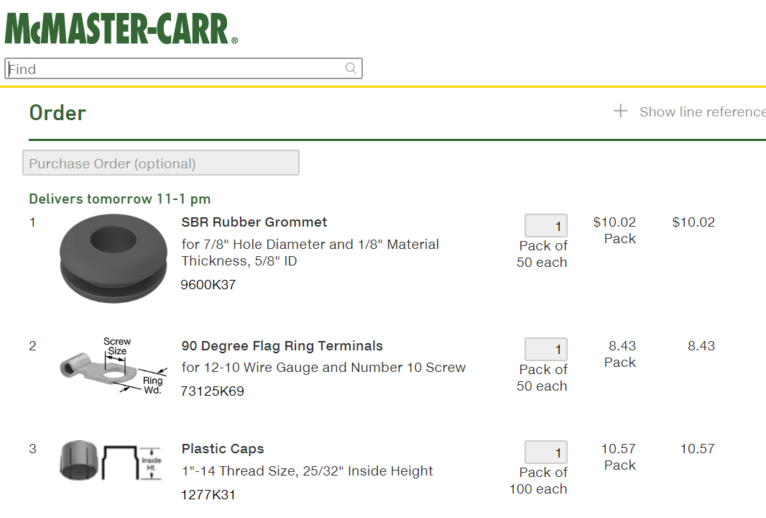

Mike Philpott
Emeritus Associate Professor of Mechanical Science and Engineering, University of Illinois.
Founder, aPriori Technologies, Concord MA
Cell:217-369-8683

