Report By:

Total: ____/20
Lab Partner:
Lab TA:
Section:

Report Guidelines: ___/20
For this report you will need three files:
- LabReport0.m (the main file that runs the other two)
- StepResponseMetrics.m (a file you will edit to show M_{p}, t_{r} and t_{ss})
- controllerlab0.mdl (A Simulink model)
All three files must be saved in the same directory. You only need to edit StepResponseMetrics.m. You can run all three by typing LabReport0 in the Matlab command window because LabReport0.m calls the other two files.

What to hand in:
Use this file as a template (put your name for the Report By line, your partner’s name in the lab partner line, etc.).
You must submit a printout showing M_{p}, t_{r} and t_{ss}, as found in StepResponseMetrics.m. It should look something like the following:
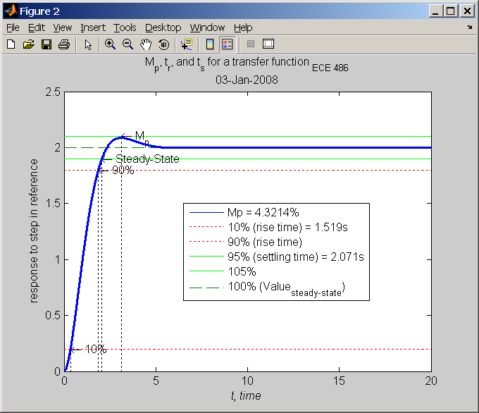
Note: you must show M_{p}, t_{r}, t_{ss} values and must have similar titles and labels.

