Name: _________**Answers**______

ECE 476

Exam #1

Thursday , October 6, 2016

Closed book, closed notes

One note sheet allowed

1. ________ / 20

2. ________ / 24

3. ________ / 24

4. ________ / 32

Total ________ / 100

1. (20 points total)

The circuit shown below is a balanced three phase system with a wye-connected generator producing 1 volt (phase to neutral). Assume that each inductor has an impendance ZL = j5Ω and each capacitor ZC = -j10Ω. Determine Ia, Icap, and the total three phase complex power supplied by the y-connected voltage source.

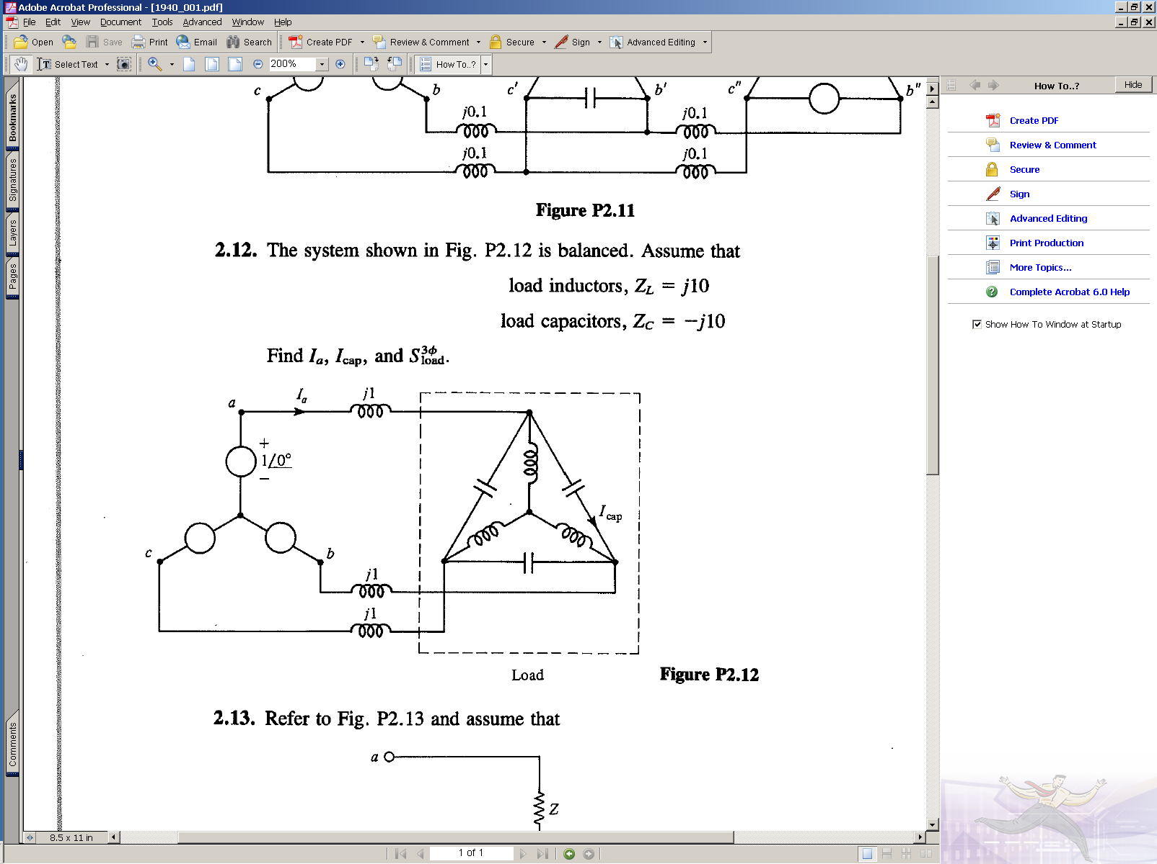



2. (24 points total)

A 3-phase, 60Hz, 80 mile long, completely transposed transmission line is built using Parrot conductor. Parrot conductor has an outside diameter of 1.506 inches; stranding of 54/19 (Al/St), which yields a GMR for the conductor of 0.0507 feet. Resistance at 60-Hz for this conductor is 0.0622 /mile. A horizontal tower configuration is used, with a phase spacing of 30 feet (30 feet between left and center phases, 30 feet between center and right, and hence 60 feet between left and right). Bundling is used, with 3 conductors per phase, spaced 1 foot apart. For reference µ0 = 4π x 10-7 H/m and Ɛ0 = 8.854 x 10-12 F/m.

1. Find the positive sequence inductance in H/m and inductive reactance in Ω/km.
2. Find the capacitance to neutral in F/m and the admittance to neutral in S/km. Neglect the effect of the earth plane.
3. Draw the short line π equivalent circuit (that is, neglecting the shunts), labeling appropriate values.

For reference  = 4 x 10-7 H/m and 0 = 8.854 x 10-12 F/m. There are 1609 meters per mile.



3. (24 points total)

**True/False – Two points each. Circle T if statement is true, F if statement is False.**

**T** F 1. For a large power system model the vast majority of the entries in the Bus Admittance Matrix (**Ybus**) will be zero.

T **F** 2. As demonstrated in class, a network of phasing shifting transformers is used in Indianapolis, IN to control the flow of reactive power through their 345 kV transmission network.

T **F** 3. The magnetic field generated by a transmission line is primarily dependent upon the line's operating voltage and essentially independent of the line current.

**T** F 4. Transformer cores are laminated to reduce eddy current losses.

**T** F 5. In a completely balanced three-phase system the neutral current flow is always zero.

**T** F 6. For live line maintenance, using a helicopter a human could be placed on an energized 345 kV line.

**T** F 7. With balanced three-phase circuits, per-phase analysis is commonly done after converting the Δ -connected loads and generators to equivalent Y-connected loads and generators, thereby solving only one phase of the circuit

T **F** 8. While nonlinear systems may require an iterative solution, a nice characteristics is they are guaranteed to have a single solution.

T **F** 9. The voltage magnitude at any point along the length of any 765 kV transmission line is guaranteed to never exceed that of the sending end.

**T** F 10. On some high voltage transmission lines series compensation (in which capacitors are inserted in series with the line) is used to increase the transmission line’s capacity.

T **F** 11. The ballpark figure given in class for the real power losses on a high voltage transformer (e.g. 500 MVA) was about 8%.

**T** F 12. Sometimes the Bus Admittance Matrix (**Ybus**) can be singular.

4. **Short Answer, eight points each, 32 points total   
(problem continues onto the next page)**

a) A 500-kV, 300-km, 60-Hz, three-phase overhead transmission line, assumed to be lossless, has a series inductance of 1.0 mH/km per phase and a shunt capacitance of 0.01 mF/km per phase. Determine the phase constant  and the surge impedance ZC of the line.



b) A single-phase, 80-kVA, 2400/240-volt, 60 Hz distribution transofmer has a loaded connected on the secondary (240 volt) winding that consumes 50 kVA at a 0.9 power factor of 0.9 lagging; assume the load is operating at 225 V. Assuming an ideal transformer, what is the primary voltage, the load impedance referred to the primary, and the total real and reactive power supplied to the primary winding.   
  


c) Determine the two by two Bus Admittance Matrix (**Ybus**) for this two bus power system.

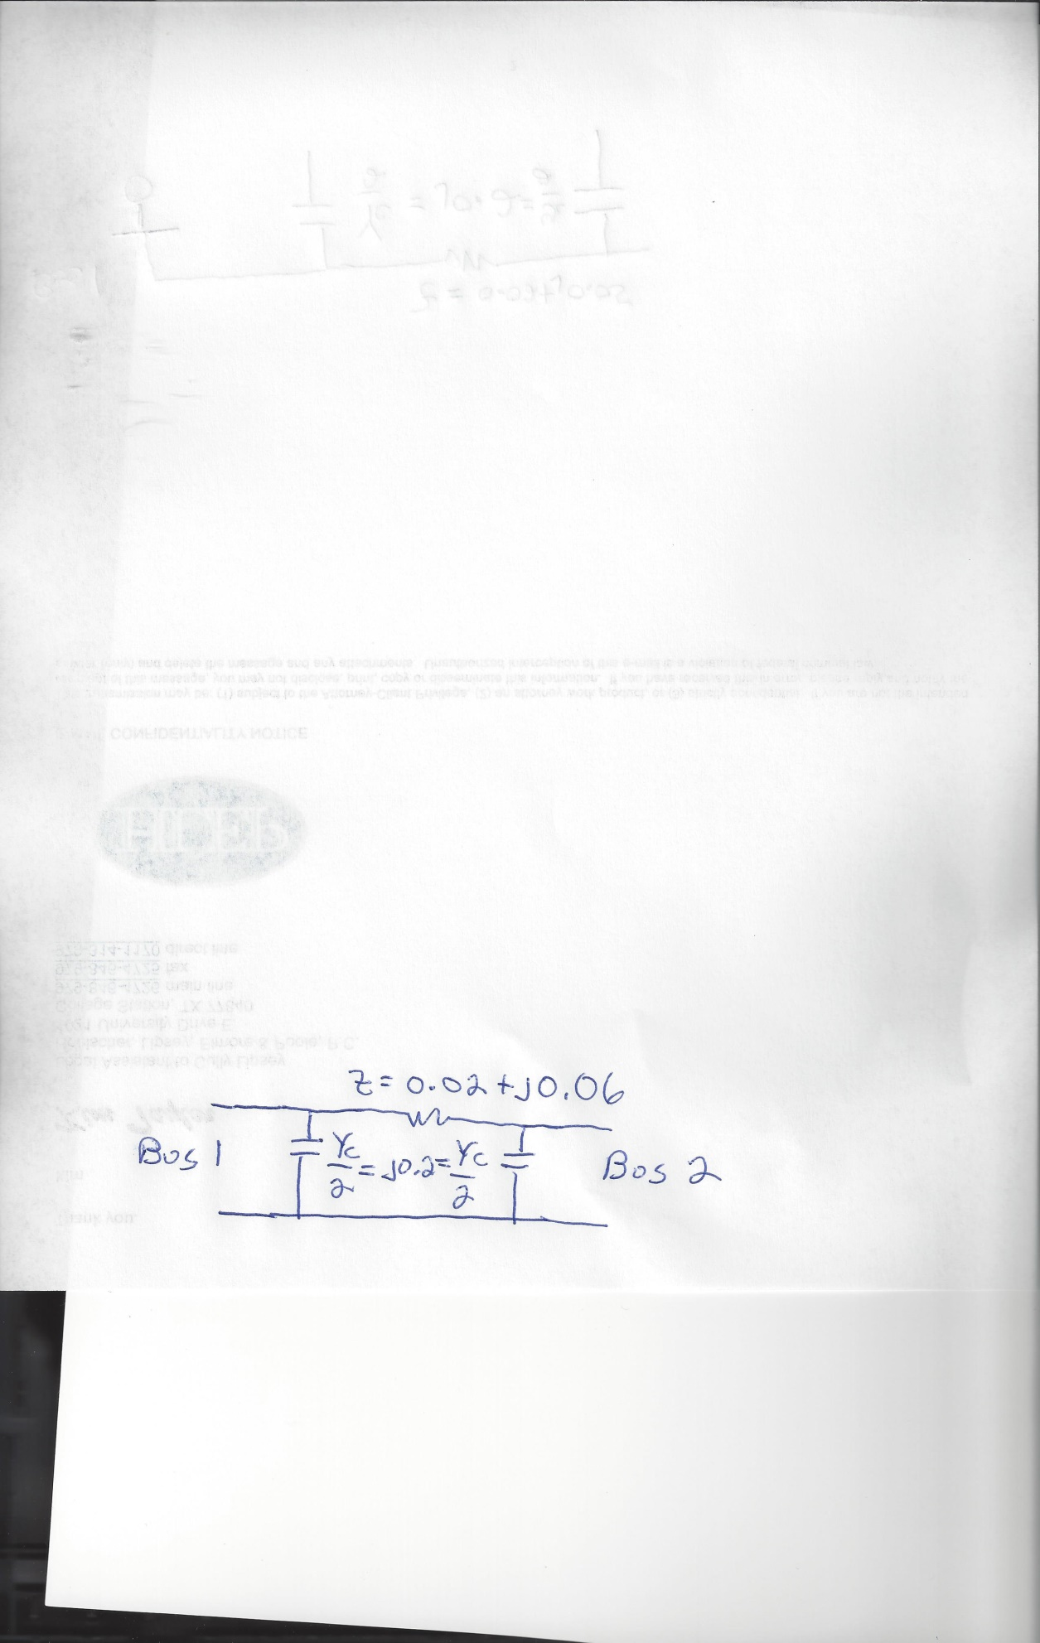



**Problem 4 continues onto the next page**

d) Assume a three-phase, unity power actor load of 100 MVA with VLL of 69 kV is connected to a source through the below network. Convert the two impedances to per unit,and then determine the per unit generator voltage (magnitude and angle). Use a per unit three-phase 100 MVA base, a line-to-line 138 kV voltage base on the left side of the transformer and a line-to-line 69 kV voltage base on the right side.

