#Criterion for Success
-The platform can operate smooth omnidirectional translation and rotation.
-The robotic arm can fetch a 200*200*200mm, 600g-700g EVA cubic (we assume it as dangerous material in laboratory) from a 218*218mm square section tunnel precisely.
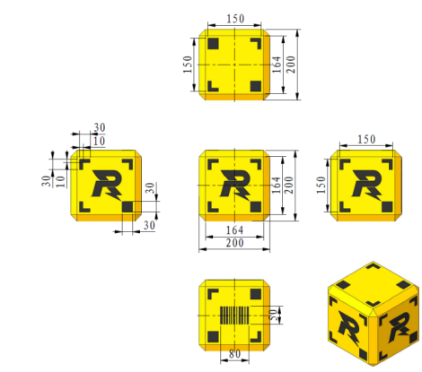
Fig. 1 The cubic use for achievement testing.
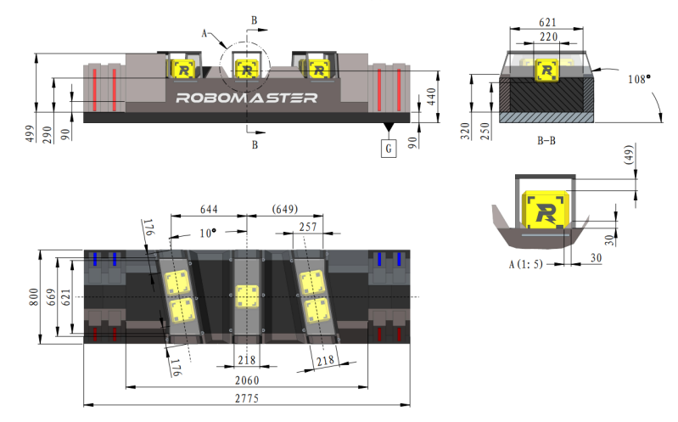
Fig. 2 The tunnel uses for storing cubic.
-The robotic arm can transport the cubic and then placing it into a 240*240*240 mm box whose orientation will varying in 6 axes. The operator can easily control the robotic arm remotely with its hand moving and placing the cubic within 40s.
Fig. 3 The real box for testing.
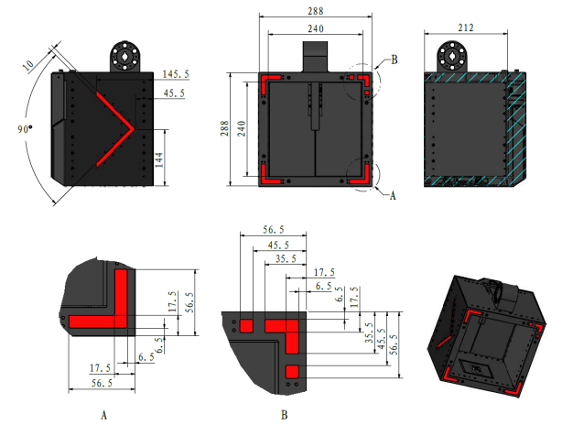
Fig. 4 The dimension of box.

