Project Proposal for ECE 445, Senior Design, Spring 2017
TA: Eric Clark
07 February 2017
Project No. 11
Kristina Chu
Channing Philbrick
Nicholas Ratajczyk

By

project proposal: Power Tool safety zone enforcer
Table of Contents

1. Introduction 1
1.1 Objective 1
1.2 Background 1
1.3 High-Level Requirements List 2
2 Design 3
2.1 Power Module 6
2.1.1 Relay 6
2.1.2 Current Draw Sensor 6
2.1.3 AC Power Input 6
2.1.4 Voltage Regulator Circuit 6
2.2 Control Module 6
2.2.1 Microcontroller 6
2.2.2 Status Lights 7
2.3 Sensor Module 7
2.3.1 Array of PIR Sensors 7
2.3.2 Ultrasonic Range Sensors 7
2.4 Risk Analysis 8
3. Safety and Ethics 9
References 11

Table of Figures

Figure 1: Block Diagram 3
Figure 2: Diagram showing physical layout of system 4
Figure 3: Geometry of PIR Sensor Array 5

1. Introduction

1.1 Objective
When working with heavy machinery in places such as a lab or a machine shop, one of the first concerns is worker safety. Many standards are in place for what is needed to meet the Occupational Safety and Health Administration (OSHA) requirements. Despite these requirements, there are still many safety incidents that result in serious injury. In 2007-2008, the number of injuries treated at emergency rooms from table and bench saws alone was 79,500.¹ Each time a worker is injured, the company has effectively failed at their primary goal of a safe workplace. Furthermore, companies are typically required to perform extensive paperwork and investigation each time any significant work related injury is reported.⁵ Each injury, then, is a failure that results in a loss of efficiency and detracts from the value provided by that workshop. Based on these factors, the objective of our product is to minimize workplace injuries from table-mounted machinery while simultaneously increasing shop productivity and efficiency.

Our solution, therefore, is to design an automated system that will monitor a specified area around the power tool, identify potential hazards within the area, and then react in the safest manner possible. Since our product must be compatible with a variety of tools to properly address the objective, the system will interface solely with the tool’s power source. In this configuration, if an immediate hazard is detected by the system, the tool will not receive power and operation will be inhibited until all hazards have been removed. Once the tool is powered, it will stay powered until the task is complete in order to avoid significant risk of cutting power mid-task if a new hazard is detected. One safety precaution that such a system would successfully enforce is keeping a specified safety zone around a machine clear, protecting the operator from accidental external interference. In precision tasks such as making table saw cuts, any sort of unexpected physical interference can result in the operator contacting the spinning blade, potentially causing amputation or severe muscular or arterial damage. To address this, our system will continuously scan for personnel violating a defined safety zone surrounding the operator and suppress tool operation until the zone is cleared of all but the necessary workers. This implementation will eliminate some of the involved risk in operating power tools and help to automate worker supervision, adding reliability and efficiency to often cumbersome safety procedures.

1.2 Background
Our product seeks to address the elements of human error. Power tools can be made with known failure rates, built-in safety switches, and provide detailed instruction on proper use to help prevent injuries. While these factors address operator error, it is much more difficult to build in additional preventative safety measures for accidental human interference. Human error can come in many shapes and sizes, but the source of the wide majority of human error-related incidents comes from direct, interpersonal physical interference. For direct interference to occur, however, the offending party must first be in proximity to the operator. By establishing that only the required personnel are in proximity to the tool before operation, the potential for direct interference can be significantly reduced.

The reduction of the number of workplace accidents caused by human error has significant implications for machine shop safety. According to an article published by NOPSEMA on human error typology,² “[Human] errors can occur in both the planning and execution stages of a task.” In the context of a machine shop, the planning stage includes the preparation steps leading up to using the machine. Logically, the transition between the planning and execution stage occurs when the device is powered, thus initializing execution of the task. Therefore, performing a check prior to the execution stage to verify a successful planning stage is a necessary and effective safety method. In a report on woodworking hazards,³ OSHA categorized location/distance checks and accidental startup prevention as important safeguarding methods. Our system would address both of these methods, providing redundancy in scope of safety verification methods.

Taking this into account, the effectiveness of our system depends on the physical dimensions of the safety zone. According to a report on recommended safety zones by Podojil Consulting,⁴ for common machine shop equipment, safety zones for the operator to stand in range in dimension from 1x8 feet to 3x6 feet in accordance with ANSI Z535.1-4 standards. The smallest zone that would always provide a standard safety zone for the operator would therefore be 3x8 feet. However, since the eight foot width was an outlier compared to the other safety zone widths in the report, we chose a more average value of six feet. Lastly, in order to increase early detection of potential risks, we extended the length of the zone to four feet. This led us to conclude that a 4’x6’ zone would be the most effective safety zone for the operator. Converting to meters and rounding, our safety zone was defined to be 1.2x1.8 meters.

1.3 High-Level Requirements List
- The system must be able to respond in a consistent manner to an input that designates if the machine is allowed to be powered.
- The system must be able to detect zero, one, or more than one object in the specified 1.2m x 1.8m rectangular area.
- The system must be able to indicate to the user if the machine will not receive power due to insufficient safety conditions being met.

2 Design
The monitoring system requires three main modules to operate fully. The first of these is the power module. This module ensures that the system can receive power from the wall outlet and also is responsible for the control of the power supply given to the tool that we are monitoring. The second module is the sensor module, which collects data about people or items in our 1.2m x 1.8m zone. The third module is the control module. The control module consists of a microcontroller which is responsible for processing all the data collected by the sensor module and making a decision about the number of people in the zone and indicating this to the user. The block diagram of our monitoring system is shown in Figure 1 below.

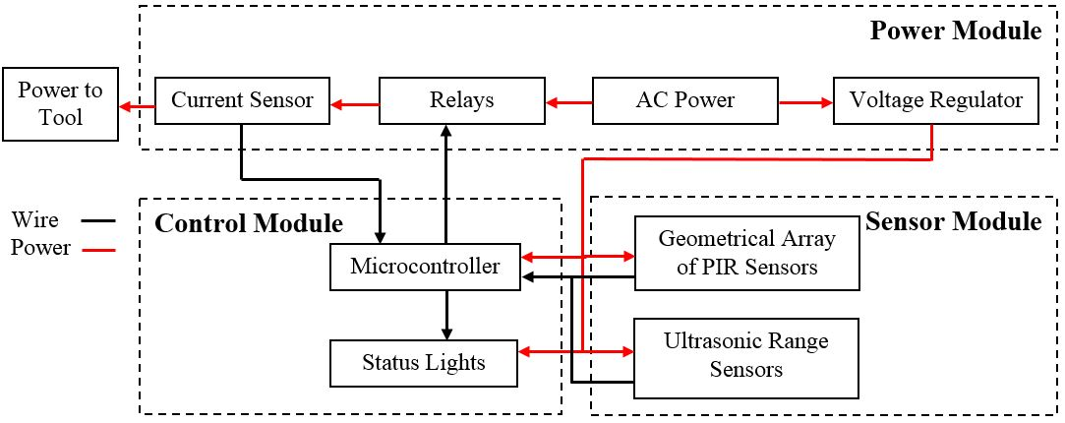
Figure 1: Block Diagram

This system includes a linear array of PIR sensors placed on a variable mounting system that will be placed along the foot of the table that houses the tool. Also on this mounting system will be the ultrasonic range sensor. Since we are monitoring an area that is 1.2m x 1.8m, this sensor array will be placed along the 1.8m side as shown in Figure 2 below.
The processing and control unit will be housed next to the wall outlet for the tool being monitored. The device will plug into the wall outlet and then the power tool’s cord will plug into our device. The geometric layout for the PIR sensors in the zone of safety is shown in Figure 3.

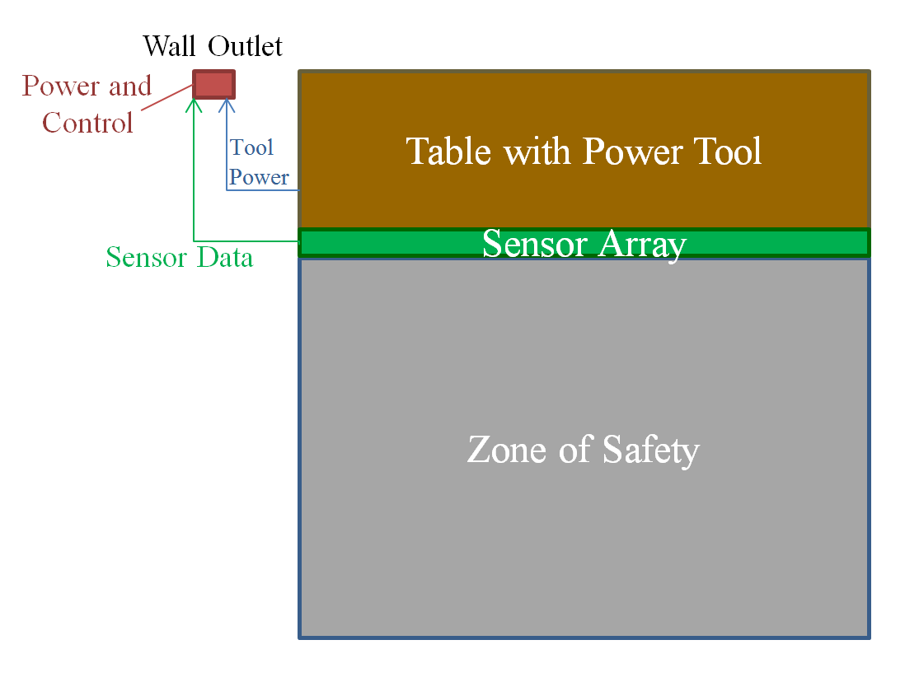
Figure 2: Diagram showing physical layout of system
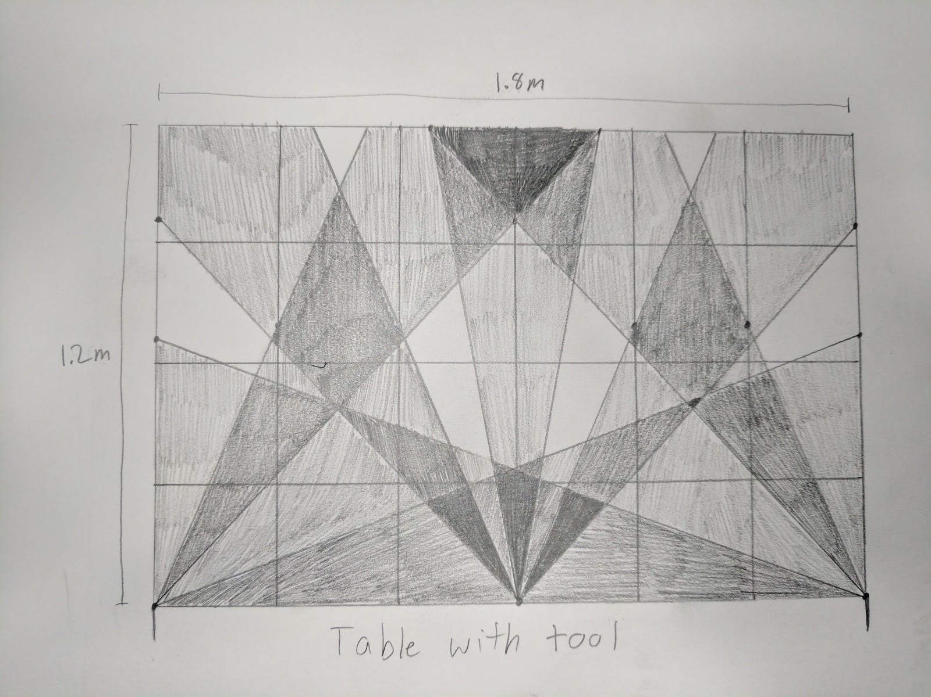
Figure 3: Geometry of PIR Sensor Array

2.1 Power Module
This module contains the power supplies for our system as well as the power connection to the tool itself. We will take the power input from a typical wall outlet that will go along two paths. The first path will go through a relay to tool. The second path will go through a voltage regulator circuit that will transform the power supply into the necessary requirements for the components of our system.

2.1.1 Relay
The relay will mechanically connect or disconnect the AC Power Input to the power cord of the tool based on an input signal supplied by the system.

Requirement: The relay shall take a 4.0 - 5.5 VDC input control signal.
Requirement: The relay shall provide greater than 1M of output isolation for a control input of 0 - 0.5 VDC.
Requirement: The relay shall provide less than 1 of output isolation for a control input of 4.0 - 5.5 VDC.

2.1.2 Current Draw Sensor
This sensor will be used to sense the current being drawn from the tool. This is because we do not want to cut power to the tool while it is being used. The sensor would send a signal to the microcontroller in the control unit so that we would be able to know whether or not the machine is currently running.
Requirement: The current sensor shall sense a minimum of 0.7A
Requirement: The current sensor shall output a voltage level logic 0 (between 0V and 0.5V) when less than 0.7A is sensed and an output voltage level logic 1 (between 4.5V and 5.5V) when more than 0.7A is sensed.

2.1.3 AC Power Input
This is simply a typical wall outlet supply. We will use it to send power to the relay and the voltage regulator circuit.
Requirement: The AC Power Input shall provide 110V and 60Hz to both the voltage regulator circuits and the relay.

2.1.4 Voltage Regulator Circuit
The voltage regulator circuit will be responsible for regulating the microcontroller and sensor power supplies.
Requirement: The voltage regulator circuit shall take a 110VAC, 60Hz input signal
Requirement: The voltage regulator circuit shall output 5VDC with less than 10mV of ripple.

2.2 Control Module
The Control Module will perform all of the logic necessary for our system. It will have a microcontroller and a set of status lights that provide feedback to the user about what the system is doing.

2.2.1 Microcontroller
The microcontroller will take signal inputs from the current draw sensor, array of PIR sensors, and the ultrasonic range sensors. Based on these inputs, it will be able to determine whether or not to open the relay, making it impossible for the tool to be powered. It will also send an output to the status lights which will serve as a visual display for the user to see what the system is doing.
Requirement: The microcontroller shall support up to five analog signal inputs.
Requirement: The microcontroller shall support up to 13 digital signal inputs.
Requirement: The microcontroller shall operate on a supply voltage of 4.5-5.5V.
Requirement: The microcontroller shall respond to the presence of a hazard in less than one second

2.2.2 Status Lights
These status lights will simply be two LEDs, one red and one green. When neither of the lights are on, it means our system (and the tool) is off. When the green light is on, it means our system is on and the zone is safe. When the red light is on, it means that the zone is currently not safe and the tool will not be able to be turned on.
Requirement: The status LEDs must be visible from 1.8 meters away and be provided with 10-15 mA of current.

2.3 Sensor Module
Our sensor unit is the physical layout of sensors we are using to receive information about the safety zone. We will use an array of PIR sensors and several ultrasonic range sensors to accomplish this.

2.3.1 Array of PIR Sensors
The PIR sensor array will be used to sense when there are people near or in the safety zone using an optimal geometry that will be able to give us as much information about where and how many people are in the zone. This “optimal geometry” is still currently undecided upon because a lot of it hinges on the ability of the sensors we will have, but right now we plan to have the sensors angled to cross each other throughout the zone. The angles will serve to pinpoint people because of overlap, but also this will be able to sense a person standing directly behind another person. Since we feel even with a very good geometry, just the PIR sensors will not be able to give a complete picture of how many people are in the zone, we will also have ultrasonic range sensors.
Requirement: Each sensor must be able to determine whether or not a person is in its field of view and output a voltage output logic 0 (0-0.5V) when no person is present and a voltage output logic 1 (4.5-5V) when it detects a person.
Requirement: The array as a whole shall be able to determine whether there are zero, one, or more than one person within the 1.2m x 1.8m safety zone.

2.3.2 Ultrasonic Range Sensors
The ultrasonic sensor array will serve as the range-finding portion of the sensor unit. Each ultrasonic sensor will be interspersed geometrically along the PIR sensor array, returning the distance of the nearest object. This information, synthesized with the PIR sensor array output, will ensure successful identifications of hazards violating safety conditions.
Requirement: Each ultrasonic range sensor shall return an analog signal corresponding to the distance of the nearest object within its field of view.
Requirement: Each ultrasonic range sensor shall be able to determine the distance of an object with an accuracy of +/-10cm.

2.4 Risk Analysis
The sensor unit poses the greatest risk to the successful completion of this project. The ability of this unit to accurately distinguish the number of people in our 1.2m x 1.8m region is crucial to being able to monitor the space as desired. This array of sensors must be able to determine the number of people accurately and consistently in order to have a complete and well-functioning system. These requirements will be difficult to meet because they rely on the accuracy of the sensors and a unique geometrical layout as well as sensor fusion of the PIR and ultrasonic range sensors.

In order to have good visibility over the 1.2m x 1.8m area, the sensors must have the correct geometric layout. If they are not spaced at certain angles that will provide a clear way to identify the number of people in the area then the processing to determine the number of people will become much more difficult. In our ideal layout, we will have enough overlap where two sensors at a time will always be able to sense an object in the zone, but will not have the sensors overlap enough that there are more than three overlapping at once when within the specified zone size of 1.2m x 1.8m. This will ensure redundancy but will minimize the potential risk of false positives and will maintain the simplicity of the processing of sensor data. Once the sensors are obtained, this geometric layout can be modified using trial and error so that we reach maximum coverage of the zone.

The individual sensors will have to be modified so that they will have a narrow field of view. This will ensure that we can meet our goal of having no more than three overlapping sensor fields of view within our 1.2m x 1.8m area. These sensors will be able to be modified using electrical tape. We will experiment to see how much of the existing field of view must be taped off to obtain the optimal narrow field of view.

3. Safety and Ethics
One of the largest concerns for safety with our design is the actual power tool that our system is interfacing with. When working using our system in conjunction with a power tool, users must still be aware that even with the added safety measure we are creating, the tool is still dangerous and must only be used with proper training. Another safety concern is the location of our device. Since it will be a ground mounted sensor system, the possibility of tripping on it is a potential safety hazard. We will attempt to minimize the risk of tripping by placing our sensor array right up against the base of the power tool and trying to minimize the distance that the array protrudes into the work zone.

An additional safety concern occurs in the event that our system suddenly malfunctions while the tool is being operated. This would cut the power to the tool in the middle of use, causing potential damage to the tool. Also, if the system were to briefly cycle power to the device while operating, the worker may assume a malfunction has occurred once the tool shuts off. The worker would not expect the tool to be powered on again and would be in danger of bodily injury.

We also must be aware of the potential hazards of using wall outlets. Wall outlets have the potential to provide AC current levels far above the minimum 10mA lethality level. Power tools are typically higher power devices, so additional care must be given to properly addressing safety concerns with the power bus. All power components of our product will need to be well-insulated, with earth and chassis ground interlocked and the live and neutral lines isolated. The greatest safety concerns regarding the wall outlet are all associated to accidental shorting between any of the three lines present in the power system. Shorting can cause either damage to equipment or accidental electrification of the chassis ground, creating the potential for workers to be electrocuted upon contact with any conductive components of the tool or our product.

Another concern that we must address is the accidental or intentional misuse of our project. As with any project, there will be a way to trick the sensors or to disconnect the power tool from our device. However, it is important to note that this system is there for the user safety and in almost all professional work environments the employees recognize that. If anything, our system is there to remind them of rules more than protect against malicious behavior.

We must also be aware of the IEEE Code of Ethics. In order to follow #1, our product is specifically designed to reduce the risk of danger to workers, satisfying the first clause. The status lights satisfy the second clause by providing immediate feedback to the worker if endangering factors are present. In a worst case scenario where the relay was shorted, the tool would function as if our device was not present, adding no additional safety hazards. If the relay was somehow shorted, the power tool that interfaces with our device will receive no power which will prevent proper functionality of the power tool but will not add any additional safety hazards.

To ensure that we are following IEEE Code of Ethics #3, as part of our sensor characterization procedure, we will ensure that there is no combination of hazards such that a hazard within the detection zone will not be identified. The range of which our product is effective will be explicitly stated and will not deviate from the listed range when physically implemented. Our claims will be reasonable, making the key distinction that our product is able to reduce the number of accidents but is not able to prevent all accidents. Our product only identifies certain types of hazards and cannot protect against circumstances outside of the scope of its functionality.

When creating our system, we will also keep IEEE Code of Ethics #5 in mind by providing documentation and warning labels regarding proper use of wall voltage. Part of ensuring worker safety is addressing all potential dangerous causes such that each worker understands the associated risk and consequences of actions violating proper use of equipment. In addition, our simple user interface will provide immediate feedback to workers regarding power state of the tool and immediate proximity hazards, as previously described.

References

[1] S. R. Chowdhurry. (2009). Survey of Injuries Involving Stationary Saws [online]. Available:
https://www.cpsc.gov/PageFiles/108980/statsaws.pdf
[2] Nopsema.gov. (2017). Human Error [online]. Available:
https://www.nopsema.gov.au/resources/human-factors/human-error/
[3] OSHA.gov. (1999). Guide for Protecting Workers from Woodworking Hazards [online].
Available: https://www.osha.gov/Publications/woodworking_hazards/osha3157.html
[4] Podojil Consulting. Safety Zones Around Machinery [online]. Available:
https://www.podojilconsulting.com/safety-zones-around-machinery.html
[5] OSHA.gov. OSHA Injury and Illness Recordkeeping and Reporting Requirements [online].
Available: https://www.osha.gov/recordkeeping/
[6] Ieee.org. (2017). IEEE Code of Ethics [online]. Available:
http://www.ieee.org/about/corporate/governance/p7-8.html

