Poppins - The Autonomous Weather Balloon

ECE 445 Design Document Fall 2020
Marc Havery (marcdh2), Arturo Cuevas (acueva8), Katie Stapleton (kes8)
Team 15
TA: Yifan Chen

Table of Contents
1 Introduction 2
1.1 Objective 2
1.2 Background 2
1.3 High-Level Requirements 3
2 Design 4
Payload 5
2.1 Heating System 5
2.1.1 Electrical or Non-Electrical Heater 6
2.2 Navigation System 6
2.2.1 PCB Board 6
2.2.2 Microprocessor/Microcontroller 7
2.2.3 GPS Device 7
2.2.4 Wind Sensor 7
2.2.5 Digital Compass 8
2.3 Steering System 8
2.3.1 Motors 9
2.4 Power System 9
2.4.1 Lipo Battery 9
2.4.2 Voltage Regulator 10
Software 10
Ascension System 11
2.5 Reflector Plate 11
2.6 Parachute 12
2.7 Weather Balloon 12
2.8 Tolerance Analysis 13
2.9 Schematic Block Diagrams 13
2.10 Risk Analysis 14
3 FAA Regulations 15
4 Cost and Schedule 17
4.1 Cost Analysis 17
4.1.1 Labor 17
4.1.2 Parts 17
4.1.3 Total 18
4.2 Schedule 18
5 Safety and Ethics 19
6 COVID-19 Contingency Planning: 20
REFERENCES 21

1 Introduction

1.1 Objective
High altitude weather balloons are an essential part of data collecting for many sciences, ranging from weather forecasting to pollution monitoring. Two weather balloons from about 900 sites around the world are launched every day of the year [1]. They consist of a large balloon, usually filled with either helium or hydrogen, and a payload, which often has sensors and computers to obtain data from the heavens. As the balloon and payload float up the air pressure decreases and the diameter of the balloon expands until it pops.
Once it has popped, the payload then deploys a parachute and safely returns to the ground, where the data can be collected. Researchers can predict where the weather balloon will land using calculations, but ultimately, due to outside variables such as jetstreams, they have to rely on GPS to retrieve the payload. Unfortunately, this is an issue when balloons often land in hazardous conditions as it often results in the data collected, as well as the payload, getting destroyed or lost.
Our solution is to give the balloon a way to guide itself; a system that allows the balloon to reposition or apply tension to certain parts of its parachute to land at a designated GPS location. Our custom payload, including power, heating, navigation, and steering, and weather balloon must follow FAA regulations for utilization by other weather balloonists.

1.2 Background
Meteorologists, researchers, and the military deploy these balloons with a diverse and expensive payload of equipment that can exceed thousands of dollars. Besides the financial investment, scientists pour countless hours of work to collect this data that can improve the fields of meteorology, photography and astronomy [2].
The landings of these small unmanned aircraft are also important as they can cause fatal damage. The high frequency of weather balloons and growing urban sprawl are increasing the chance a weather balloon could land in trees, bodies of water, residential areas, or even highways. Due to the nature of the electronic payload, there are cases of crash landings where the payload starts a high blaze [3]. In the wrong situation, these balloons could cause wildfires, destruction of property, or vehicle accidents.
The ability to determine a secure landing location for weather balloon payloads would be an invaluable tool to the scientific community. With just a small amount of overhead, researchers can confidently launch their balloons and ensure it will avoid large catastrophes and loss of their valuable data.

1.3 High-Level Requirements
- Follows all FAA guidelines. Because of our device’s ability to change direction, it is possible it will be labeled a drone by the FAA. We want to avoid this if possible, otherwise we will need to adhere to drone guidelines and the project will be slightly less useful.
- Steers the parachute payload a full 360 degrees. A full range of turning is necessary to direct our payload once the parachute deploys and to autocorrect when it veers off course.
- Lands consistently within a certain threshold distance from our preprogrammed GPS target. If the height of the parachute deployment is 60,000 ft, the payload should be able to land itself within 200 ft of the destination site. This is an acceptable first threshold to achieve because oftentimes weather balloons land 25 or 300 miles away from the launch site [2].

2 Design
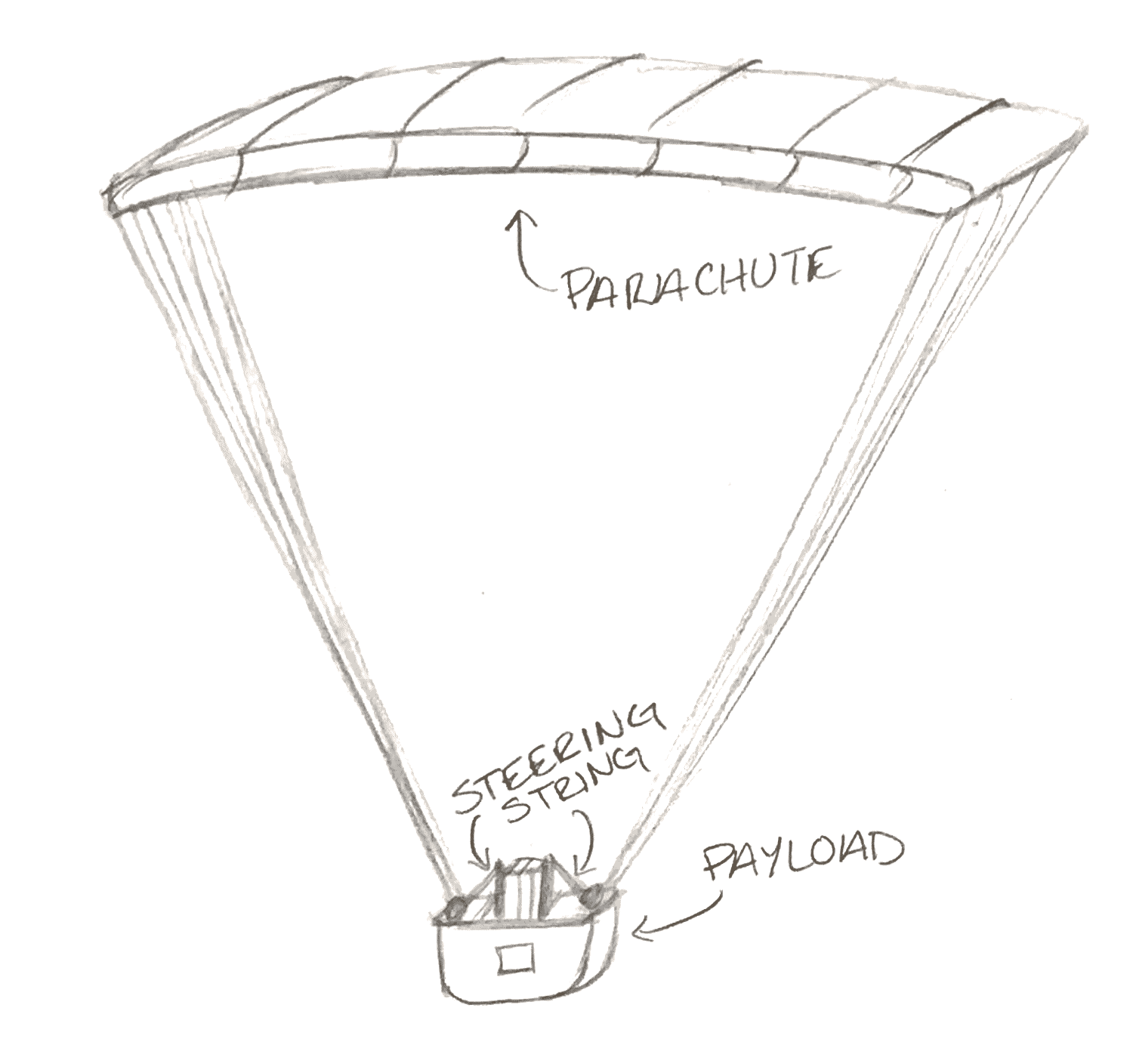
Figure 1. Physical diagram of Poppins parachute and payload systems..
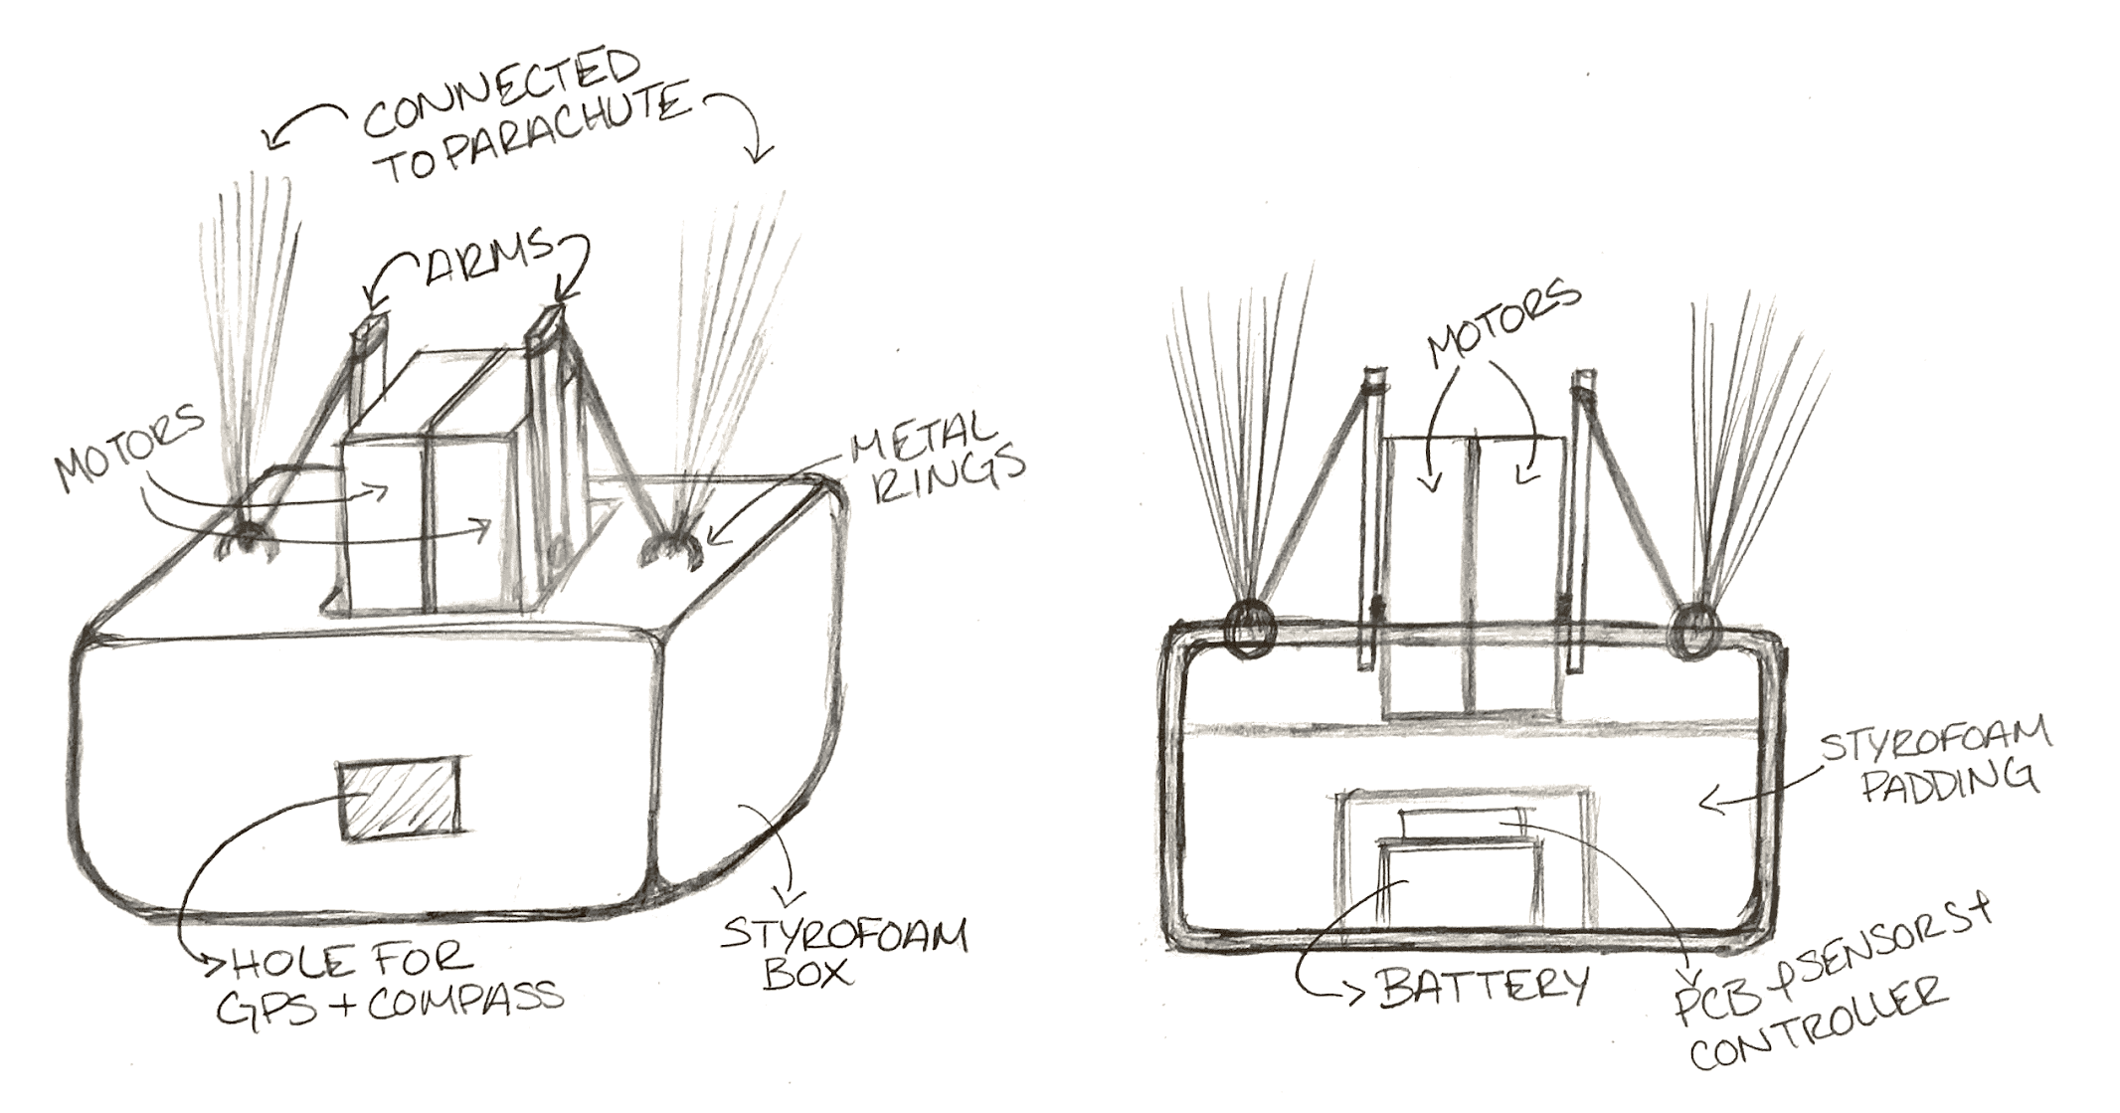
Figure 2. Physical diagram of payload with outer view (left) and inside view (right).

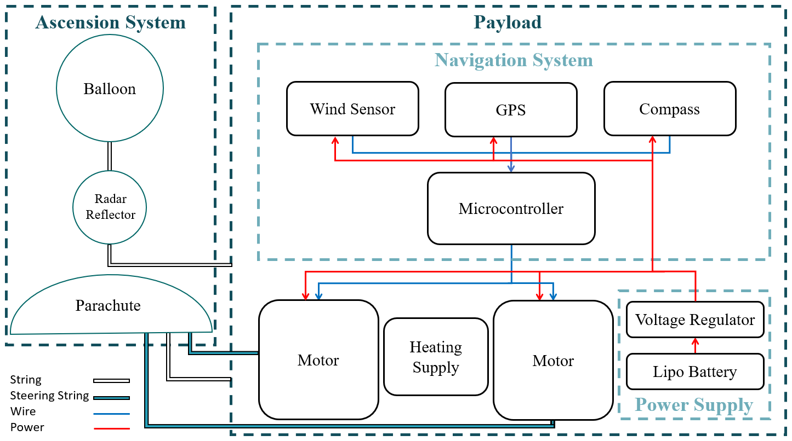
Figure 3. Poppins High Level Block Diagram
Figure 3 shows that our design will be made up of a mostly conventional weather balloon ascension system and a custom payload. We will be able to achieve our requirement to control the movements of the descending payload to a specified location through the navigation system using a microcontroller, sensors, and motors. Within the ascension system, the parachute will be specifically designed to achieve our goal to steer the payload 360 degrees by attaching it to the payload for support and the motors for steering. Each of these block components will be discussed further in the following section.

Payload

2.1 Heating System
The heating system is required because as we approach higher altitudes, the air temperature can reach as low as -69.70℉ at 70,000 ft above sea level [5]. Since most devices, especially the battery, have a minimum operating temperature we need a heating system that can ensure we can still operate our equipment.
This heating system will be in close contact with the other devices and will be connected to the power supply if it is electronic.

2.1.1 Electrical or Non-Electrical Heater
This could either be an electronic heating pad or even something as simple as a hand warmer. The decision to do so will depend on the weight and minimum operating temperatures of our other devices in the payload.
Requirement | Verification
1.) Heats all components to above their minimum operating temperature. The highest of which is 4 ℉. | 1.) Use a thermometer and thermodynamic equations to verify the heating system could heat -69.70℉ up to 4 ℉.

2.2 Navigation System
The main deliverable of this project and what allows us to compute the logic for steering and landing requirements is the navigation system. This system will take in input from the various sensors and use a microcontroller to decide how to power the motors to steer the parachute. This system has its data and power wires connected to our custom PCB board, which is powered by the power supply. The PCB also outputs the power calculated by the microcontroller to the motors in the steering subsystem.

2.2.1 PCB Board
This PCB board will act as the highway for our power and data bus. The board will take in as input power from the power supply, data from all other sensors (GPS, wind, and compass), and the output of the microcontroller logic. As output it will drive all sensor data to the microcontroller and output the final power to the motors in the steering system.

Requirement | Verification
1.) Capable of connecting all sensor data outputs to microcontroller inputs, as well as all microcontroller outputs to motor inputs  2.) Must be able to carry power to all components. | 1 & 2.) Can test each section of the PCB using LEDs to make sure components are properly connected.

2.2.2 Microprocessor/Microcontroller
The navigation system will need a brain to compute how to control the motors based on the data from the sensors. Depending on any issues, the microprocessor required could range from a microcontroller to an Nvidia Jetson, although it will likely require something in between such as an Arduino or Raspberry Pi. It should be able to be done on an Arduino unless it requires unexpectedly high computing power or requires some kind of high-dimensional machine learning.

Requirement | Verification
1.) Capable of executing at least 100 instructions per second.  2.) Enough IO to interact with all sensors. | 1.) Can make a sample program with a similar workload, and see if microcontroller can handle it. Can just use LEDs to verify output of the program.  2.) We can just count the IO on the datasheet, and verify each work by using a test program.

2.2.3 GPS Device
The GPS device will be used so that the payload knows its location. We will have to find a good balance between weight, accuracy, and cost. It needs to be lightweight because it is important for the whole payload to not weigh enough to be considered a drone, and it needs to be accurate so that the navigation system will have good information to make informed decisions [6].

Requirement | Verification
1.) Needs to be able to calculate coordinates with margin of error with less than 50 meters. | 1.) Go to known coordinates and measure the coordinates with the GPS, then compare them to the known.

2.2.4 Wind Sensor
For proper navigation it is essential to measure both wind speed and wind direction. Thus we will need both a wind speed and wind direction sensor, which are sometimes sold as part of the same unit. Alternatively, it might be better for our use case and possibly cheaper to just use four wind speed sensors to determine speed and direction, by having one on each side of the payload.

Requirement | Verification
1.) Needs to be able to detect wind speed to the nearest meter per second.  2.) Needs to be able to detect wind direction to the nearest 11.25 degrees. | 1.) Use a wind generator, which uses a motor and blades to generate air current at a certain speed. Then detect the speed with the sensor and see how close it is.  2.) Use a fan to generate an air current, rotate the position of the fan to different positions, seeing how accurate the direction detection is.

2.2.5 Digital Compass
For the navigation system to know which direction to go, it must first be able to tell which direction it is facing. This can be accomplished with a digital compass.
Requirement | Verification
1.) A digital compass with I2C connections for our microcontroller . | 1.) Connect to microcontroller and verify heading direction accuracy is within 0.5 degrees.

2.3 Steering System
The steering system will be the main mechanism for accomplishing our tasks of steering the balloon in a full 360 degrees and landing our balloon consistently on a designated GPS location. The steering system will consist of two servo motor arms, powered by the microcontroller, that pull on the steering strings of the ram air parachute. By having these two arms we can make the parachute turn left, turn right, and slow down descent velocity. The motors must meet the parachute’s minimum steering pull weight, which in our parachute is 15 kg/cm per string.

2.3.1 Motors
The steering system will consist of two separate servo motors, each connected to a metal arm that is connected to one of the parachute’s brake strings. By activating the motors, we are able to tighten the lift string to turn left and the right string to turn right. By tightening and loosening the strings, the design has the ability to position the parachute in the direction most beneficial toward getting the whole system to move in a wanted direction.
Requirement | Verification
1.) The motors must be able to hold their rotational position against the force of the wind on the parachute. Minimum pull of 15 kg each.  2.) Lighter than 8 ounces each. | 1.) Can verify 1 by attaching a 15 kg weight to a string, and seeing if a motor can pull it.  2.) Use a scale.

2.4 Power System
The power system must be able to power the two stepper motors as well as the whole navigation system. All components of the navigation system can operate at 3.3 volts and the motors can run from 4.8 - 6 volts. The power system will then consist of a 6 volt lipo battery with a minimum 5000 mAh charge and a 3.3 V voltage regulator.

2.4.1 Lipo Battery
The main battery for the power system will be a rechargeable 6 volt lithium polymer battery with around 5000 mAh of charge. The lipo will connect directly to the motors but will pass through a voltage regulator to power the navigation system. The storage amount of 5000 mAh is based on calculations used for a standard 2-4 hour weather balloon flight.

Requirement | Verification
1.) A rechargeable battery that supplies enough current for the circuit (at least 6 volts).  2.) A recharge battery that stores at least 5000 mAh of charge. | 1.) Connect the battery to a sample circuit and verify using a voltmeter.  2.) Leave the battery connected to the sample circuit for 4 hours and observe voltage stays above 6 volts with a voltmeter.

2.4.2 Voltage Regulator
The voltage regulator will be used to step down the main 6 V lipo to the required potential of our navigation system which is 3.3 V.

Requirement | Verification
1.) Supplies 3.3 V +/- 5 % from a 4.8 V to 6 V DC source.  2.) Draws current in a range of 0-275 mA | 1 & 2.) Connect the battery to a sample load circuit and verify with an oscilloscope that the voltage stays within 5% of 3.3 V, while also drawing 275 mA.

Software
The payload will have to make decisions based on the information provided by the sensors, meaning a microcontroller will have to be used. It will be programmed based on the control flow below.

Is CD left of OO by more than 22.5^{O}?

Compass Data (CD)
Get the current direction faced by the payload
In the form a direction out of 360 degrees

GPS Data (GD)
In the form of coordinates

Target Coordinates (TC)
Preprogrammed

Optimal Orientation (OO)
Treats the two coords as an incomplete triangle
Uses a sine calculation to find optimal direction
Yes

Pull right side of parachute by activating right servo
No

Is CD right of OO by more than 22.5^{O}?
Yes
No

Pull left side of parachute by activating left servo

Done. Wait for some amount of time
Loop

Ascension System

2.5 Reflector Plate
The reflector plate is a cardboard sphere that is covered in light reflecting tape so it can be more easily spotted in the sky. This is a mandate from the FAA and will be attached to the same support string of the weather balloon.
Requirement | Verification
1.) A 12 inch by 12 inch sphere with reflective material [6].  2.) Be able to echo radar for a range of 200 MHz to 2700 MHz | 1.) Measure out dimensions with a ruler.  2.) Meet standards by using tested reflective tape.

2.6 Parachute
The parachute will deploy when there is enough air to open it, but in the experiments we will just start manually deployed by holding it above the payload before dropThe parachute we need for our project will have to be highly maneuverable and light weight. A small Ram-Air parachute will serve our requirements of being able to carry the payload and have steering strings that can be fed into our internal steering system [7].
Requirement | Verification
1.) A ram-air parachute capable of holding the full weight of the payload (max 6 pounds).  2.) A left and right brake to toggle the parachute’s yawl. | 1.) We can verify the parachute’s weight and brake yawling through our 120 ft drop tests.  2.) Observing the parachute’s glide ratio stays within the golden mark of 5:1 by comparing the drop height to the distance traveled.

2.7 Weather Balloon
The weather balloon is the main and sole ascension device. The weather balloon will have to be big enough to carry our 12 pound payload and burst at the designated altitude.
Requirement | Verification
1.) A weather balloon capable of holding the full weight of the payload (max 6 pounds)  2.) A weather balloon capable of reaching our target altitude of 60,000 ft. | 1.) Hold up payload by the parachute strings. If it breaks then this isn’t verified.  2.) Back up our results with a weather balloon lift calculator.

2.8 Tolerance Analysis
The most critical component to our design spawns from the navigation system. Without all the devices working at a high precision, our adjustments to the motors could be catastrophic to the flight and result in a mid-air stall. The tolerance we should concentrate our focus on is the degree of accuracy our digital compass is related to the GPS target location. For instance, at deployment our payload could be up to 25 miles away from our GPS target. At this distance a mere 5 degrees off target of the GPS location could direct our payload off course by up to 2.18 miles. That is why it is mission critical we calibrate our system to be accurate to at most half a degree off target.

2.9 Schematic Block Diagrams
The Schematic Diagrams referenced below are from the component data sheets, and will be used when designing our PCB encompassing all the sensors and microcontroller.
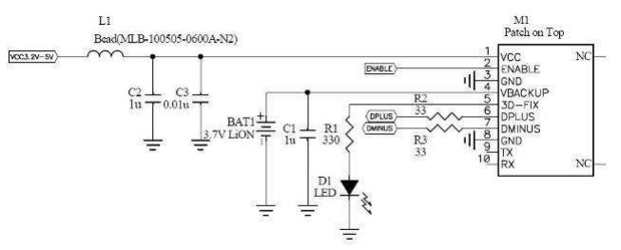
Figure 4. GPS Schematic from Adafruit Ultimate D GPS Breakout data sheet [8]. This diagram is for USB interface. A UART interface is also available.
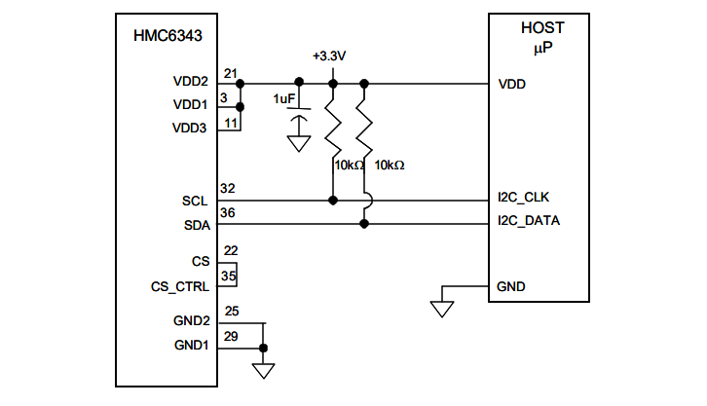
Figure 5. Electric Compass Schematic from HMC6343 Breakout data sheet [9].
Figure 6.

2.10 Risk Analysis
The component that poses the most risk to the project is the navigation system. It is easy to program a microcontroller to spin a few motors to pull string, but it will be extremely difficult to make our navigation system such that it determines what strings to wind and when. Since our design depends on the variable factors of the wind , it will not be as straightforward as it is with drones, where simply making certain rotors spin faster can alter position and direction, because if the wind is not blowing in the direction we need it to, the parachute will have tremendous trouble fighting it.
It will be necessary to program the navigation system to use the wind rather than fight it. It will have to be a system capable of accepting failure and making the best out of worst-case situations, as there will be many cases in which it will be impossible to overcome the circumstances. The system's goal must not be to get within X distance of a target, but just to get as close to X as possible, given wind conditions.
Even when the wind conditions are favorable, the problem of moving in certain directions is still difficult. Sometimes it may be beneficial to tilt the parachute in a non straight direction depending on which way the wind is flowing, and even then the wind direction and speed can change quickly as altitude increases.

3 FAA Regulations
If our design is FAA approved as a weather balloon, our device and team must adhere to these regulations under FAA Part 101 [10]. If a free air balloon meets the exempt requirements, no further contact with FAA or ATC (Air Traffic Control) is mandatory, but still strongly recommended.
Non-exempt balloons are required to meet the listed launch conditions, contact FAA and ATC, and include additional safety equipment. These new safety precautions include a flashing light and two independent cutdown systems that separate the payload from the balloon.

Part 101 - Unmanned Free Balloons

FAA Part 101 Exempt Requirements:
• Payload weighs less than four pounds.
• Or, payload weighs less than six pounds and the smallest surface is more than 36 square inches.
• Or, two payloads that weigh less than 12 pounds together.
• All rope connected to the payload takes less than 50 pounds of force to break it off.

FAA 101 Non-Exempt Requirements:
• No active telephones on the aircraft during takeoff and landing.
• Do not launch in a prohibited or restricted area, or in a place where the balloon is likely to fly into a prohibited or restricted area.
• Do not drop objects if they could be hazardous to people or property below.
• Do not launch where the cloud cover is greater than 50% or if horizontal visibility is less than five miles.
• The first 1000 ft of ascent is not over a congested urban or residential area.
• Do not launch without a prior waiver from the ATC if your balloon will pass through Class B, Class C, Class D, or Class E airspace.
• Two independent cutdown systems that separate the payload from the balloon. Operators must be able to manually activate if cloud cover increases above 50% or if payload malfunctions and might cause a hazard to planes.
• Lights which are visible for at least five miles and flash between 40 Hz to 100 Hz.
• All trailing antenna lines or other suspension devices must be attached to colored pennants or streamers that are alternating bands of highly conspicuous colors, spaced 50 feet apart, and visible for at least a mile.
• A radar reflective plate that can echo a range of 200 MHz to 2700 MHz.

Launch Specification Notification (FAA 101 Non-Exempt):
A formal “launch speciation” containing important launch details must be sent to the regional FAA Flight Standards office at least three days prior to launch. The document should include:
• Location of launch site in degrees, minutes, seconds (latitude/longitude).
• Estimated launch date and time.
• Target burst altitude.
• Estimated ascent rate.
• Estimated flight duration.
• Balloon identification.
• Balloon diameter.
• Rope length.
• Payload weight.
• Trailing antenna length.
• Map of the predicted balloon trajectory.

NOTAM (Notice to Airmen) (FAA 101 Non-Exempt):
Upon FAA command, operators may need to file a NOTAM, a notice to airmen, between three days and 24 hours prior to launch. This notification goes out to all pilots operating around the launch site and must include the following information:
• Location of launch site in degrees, minutes, seconds (latitude/longitude).
• Estimated launch date and time.
• Target burst altitude.
• Estimated ascent rate.
• Estimated flight duration.
• Any additional information requested.

ATC Balloon Position Reports (FAA 101 Non-Exempt):
ATC may mandate that operators record the location of the balloon at least every two hours. If communication with the balloon is lost for more than two hours, the ATC must be given the last recorded position and projected trajectory. One hour before descent, ATC must be notified with:
• Current location.
• Current altitude.
• An estimated time when the balloon will reach 60,000 feet.
• The forecast time and location of landing.

4 Cost and Schedule

4.1 Cost Analysis

4.1.1 Labor
Here are the factors that determine the labor cost:
- $/hour = $50 (around average what a graduate from UIUC engineering makes)
- overhead multiplier = 2.5
- hours to complete = 7 hours/week * 6 weeks = 42
- number of team members = 3

We use the following equation to calculate the labor cost for one person:
- ($/hour) x 2.5 x hours to complete = LABOR COST
- $50 x 2.5 x 42 hours = $5250
- There are 3 team members to the total labor cost is $15750

4.1.2 Parts
Components | Devices | Distributor | Price | Description
Parachute | 4.5 m RC-Flair Wing | https://hackermotorusa.com | $350 | Ram-Air Parachute for gliding
Servo Motors | JX 5521MG | ECE445 Lab | $0 | Servo motors for the arms which steer parachute
Microcontroller | ATmega328P-PU | Amazon | $5.99 | Makes decisions based on sensor data
Lipo Battery |  |  |  | Powers all the devices
GPS Receiver | Adafruit Ultimate D GPS Breakout | ECE445 Lab | $0 | Lets the system know how far away it is from target
Compass | SparkFun HMC6343 Breakout | ECE445 Lab | $0 | Lets the system know its current orientation
Wind Speed Sensor | Vortex Inspeed Wind Speed Sensor | Amazon | $55 | Lets the system know how fast the wind is moving
Wind Direction Sensor | CALT YGC-FX | Amazon | $75 | Lets the system know what direction the wind is going

Total: $485.99

4.1.3 Total
It will require $15750 (Labor) + $485.99 (Parts) = $16235.99 to make this project.

4.2 Schedule

Complete By: | Finished Tasks: | New Tasks:
10/02 | Design Document | Begin purchasing parts
10/05 | All parts purchased | Begin designing PCB based on parts (Katie)
10/10 |  | Begin designing accurate depiction of payload (Marc)
10/15 | All parts acquired except parachute, PCB design finished (Katie), Depiction of payload finished (Marc) | Begin assembling payload (All)
10/25 | Payload assembled (All) | Begin unit testing the completed payload (All)
10/30 | Finish unit testing payload
11/02 | Parachute acquired | Begin drop tests on parachute
11/04 | Drop tests finished | Begin filming demo
11/08 | Demo finished

5 Safety and Ethics
The success of our project can only be measured if we can follow all safety and ethics guidelines. Conveniently, the United States Federal Aviation Administration (FAA) and Air Traffic Control (ATC) have already established requirements for all aircraft. We have contacted the district FAA office in Springfield, IL and the FAA official requested we send the capabilities of our design to determine whether the device is considered a high altitude weather balloon or small unmanned aircraft [11]. If our design is classified as a weather balloon then we only have to contact ATC before flying in an approved air space [12]. If our design is classified as a Small Unmanned Aircraft (similar to a drone) then we are limited to flying under 400 ft in the majority of air spaces. Fortunately, the Springfield official said we could test our “high altitude drone” in their FAA testing field.
Our biggest safety concerns during the construction of our project include working with the high power supply and the motor drive. We need to follow best practices for not blowing out our circuit and ensuring no one is harmed by a motor accidentally turning on.
The accidental issues that can rise during our deployment are the same problems we are trying to solve. These include our device veering off course and causing a crash that would lead to fires, vehicle accidents, or damage to personal property. To limit the probability of these incidents, we have to research the safest launching site for our project.
On the side of ethics, when our device is fully operationally we now face issues with privacy and public safety. Weather balloons are useful tactic devices for military surveillance operations because they do not show up on radar and are silent. Also, the additional capability to land a payload at a GPS location also means this device could be used as a weapon. These concerns will be weighed by both our team and the FAA to ensure we keep the safety of the community and environment in mind [11].

6 COVID-19 Contingency Planning:
Thankfully due to the nature of our project, a switch to online classes will not greatly affect the development of our project. The only equipment we will need from the lab is an oscilloscope for verifying the behavior of our circuit components. Thankfully we can buy a small and affordable oscilloscope to use at home.
As for the construction of the project, all members of our team are able to collaborate on the physical design while still following the appropriate health guidelines. The only issue in debate is whether we will still be able to use the 120 ft utility crane from the University's Facilities and Services department. If we do not have the permission to drop from that height, then we are limited to testing on the ground for our final demo.

REFERENCES

[1] Weather.gov. n.d. Weather Balloons. [online] Available at: <https://www.weather.gov/bmx/kidscorner_weatherballoons#:~:text=Twice%20a%20day%2C%20every%20day,the%20US%20and%20its%20territories> [Accessed 17 September 2020]

[2] Highaltitudescience.com. n.d. Intro To Weather Balloons – High Altitude Science. [online] Available at: <https://www.highaltitudescience.com/pages/intro-to-weather-balloons> [Accessed 17 September 2020].

[3] Hallmark, B., 2019. High Altitude Balloon Crashes In Upshur County. [online] https://www.kltv.com. Available at: <https://www.kltv.com/2019/01/06/high-altitude-balloon-crashes-upshur-county/> [Accessed 17 September 2020]

[4] Engineeringtoolbox.com. n.d. U.S. Standard Atmosphere. [online] Available at: <https://www.engineeringtoolbox.com/standard-atmosphere-d_604.html> [Accessed 18 September 2020].

[5] Elektrimmotors.com. 2020. Elektrim Motors What Does Cold Winter Mean To Outdoor Electric Motor Applications. [online] Available at: <http://www.elektrimmotors.com/blog-electric-motor-winter-weather-conditions#:~:text=Generally%20speaking%2C%20most%20AC%20general,or%20%2D22%C2%B0F).> [Accessed 18 September 2020].

[6] Faa.gov. 2016. Fact Sheet – Small Unmanned Aircraft Regulations (Part 107). [online] Available at: <https://www.faa.gov/news/fact_sheets/news_story.cfm?newsId=20516> [Accessed 18 September 2020].

[7] Globalspec.com. n.d. Parachutes Selection Guide | Engineering360. [online] Available at: <https://www.globalspec.com/learnmore/specialized_industrial_products/transportation_products/parachutes> [Accessed 18 September 2020].

[8] Cdn-shop.adafruit.com. 2020. FGPMMOPA6B GPS Module Data Sheet. [online] Available at: <https://cdn-shop.adafruit.com/datasheets/PA6B-Datasheet-A07.pdf> [Accessed 1 October 2020].

[9] Cdn.sparkfun.com. 2020. Https://Cdn.Sparkfun.Com/Datasheets/Sensors/Magneto/HMC6343.Pdf. [online] Available at: <https://cdn.sparkfun.com/datasheets/Sensors/Magneto/HMC6343.pdf> [Accessed 1 October 2020].

[10] “PART 101—MOORED BALLOONS, KITES, AMATEUR ROCKETS, UNMANNED FREE BALLOONS, AND CERTAIN MODEL AIRCRAFT,” Electronic Code of Federal Regulations (eCFR). [Online]. Available: https://www.ecfr.gov/cgi-bin/text-idx?rgn=div5&node=14:2.0.1.3.15. [Accessed: 29-Sep-2020].

[11] Ieee.org, "IEEE IEEE Code of Ethics", 2016. [Online]. Available: http://www.ieee.org/about/corporate/governance/p7-8.html. [Accessed: 29- Feb- 2016].

[12] Faa.maps.arcgis.com. n.d. Arcgis Web Application. [online] Available at: <https://faa.maps.arcgis.com/apps/webappviewer/index.html?id=9c2e4406710048e19806ebf6a06754ad> [Accessed 18 September 2020].

