Dryer Diagnostic Unit

Supransh Murty (jmurty2)

Xiaobai Li (xiaobai2)

Chenlong Fan (cfan14)

Teaching Assistant: Yifan Chen

Professor: Arne Fliflet

Team 31

Final Report

ECE 445
Senior Design

Fall 2020

Abstract

We designed an external diagnostic unit for dryers. The diagnostic unit informs the user if the dryer is overheating. The unit consists of four modules: a power module, a sensor module, a control module, and a software module. We used a thermocouple to measure temperature from inside the dryer, and we used a microcontroller to convert the analog output from the thermocouple to a digital reading that is stored into the database. The app reads the temperature data from the database, displays the temperature, and sends a warning message to the user if the temperature is above the normal range. Our product provides a low-cost solution that reduces the danger of dryer overheating.

Contents
1. Introduction 1
1.1 Purpose 1
1.2 Background 1
1.3 High-Level Functionality 1
2. Design 2
2.1 Module Overview 2
2.2 Power Module 3
2.3 Sensor Module 4
2.4 Control Module 6
2.5 Software Module 7
3. Function Test 8
3.1 Room Condition 8
3.2 High Temperature Condition 9
4. Cost and Schedule 10
4.1 Cost 10
4.2 Schedule 11
5. Conclusion 12
5.1 Accomplishment 12
5.2 Uncertainty 12
5.3 Future Work 12
5.4 Ethics 13
5.5 Safety 13

1. Introduction

1.1 Purpose

The mechanical status of a clothes dryer is not directly available to its user. Our product is an external diagnostic unit that informs the user if a dryer needs service.

The diagnostic unit consists of a temperature sensor that is temporarily placed inside the dryer and a control box placed outside of the dryer.

The diagnostic unit will transmit temperature readings to a mobile app. Based on the temperature data, the mobile app informs the user about the mechanical conditions of the dryer.

1.2 Background

The temperature inside clothes dryers has an optimal range of between 85 ℃ and 100 ℃. However, mechanical failures inside dryers may cause dryers to overheat and induce safety concerns.

For example, the embedded temperature sensor inside a dryer may have worn-out metal contacts or have metal contacts covered by volatilized fabric softener; this type of failure causes the embedded temperature sensor to output inaccurate temperature readings and undermines the sensor's ability to prevent dryers from overheating. A clogged vent can decrease the dryer's heat dissipation rate; this type of mechanical failure also causes the dryer to overheat.

Typical household consumers are often unaware of the overheating issue and have limited knowledge of when their dryers may need service. Our product aims to provide a low-cost solution to inform users about the mechanical status of their dryers.

1.3 High-Level Functionality

(1) The sensor module measures the temperature inside a dryer with an accuracy of 5 ℃.
(2) The mobile app warns the user when the temperature inside the dryer is above 100 ℃.
(3) The mobile app refreshes temperature readings once per second.

2. Design

2.1 Module Overview

The dryer diagnostic unit has a power module, a sensor module, a control module, and a software module. The power module provides a steady 5 V voltage to the sensor module and a steady 3.3 V voltage to the control module. The sensor module uses a K-type thermocouple to measure the voltage change that corresponds to temperature change inside a dryer. The control module converts the voltage measurements to temperature readings and sends the temperature readings to a database. The software module downloads temperature readings from the database and displays them on an app. The block diagram of the dryer diagnostic unit is shown in Figure 1. The PCB design of the dryer diagnostic unit is shown in Figure 2.

Figure 1: Block Diagram of the Dryer Diagnostic Unit

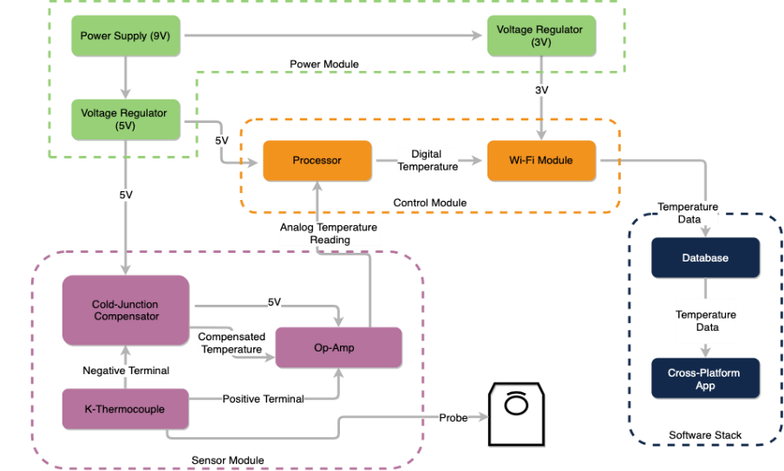

Figure 2: PCB Design of the Dryer Diagnostic Unit

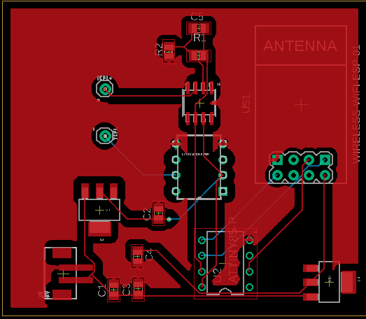
2.2 Power Module

2.2.1 Battery

The battery will provide power to the sensor module and the control module. The battery is a 9 V, PP3-sized battery. Table 1 outlines the requirement and verification of the battery.

Table 1: Requirement and Verification of Battery

Requirement | Verification
(1) The battery outputs a voltage of 9 V ± 5%. | (1a) Connect the positive end of the battery to the red probe of a multimeter; connect the negative end of the battery to the black probe of the same multimeter.  (1b) Set the multimeter to measure the voltage in the 20 V (dc) range.  (1c) Verify that the measured voltage is within the range of 9 V ± 5%.

2.2.2 Voltage Regulator

Two voltage regulators are required. The first voltage regulator will provide a steady 5 V voltage to the cold junction compensator (LT1025). The second voltage regulator will provide a steady 3.3 V voltage to the microcontroller (ATtiny85). The two voltage regulators are low-dropout linear regulators (LM1117). Table 2 outlines the requirements and verification of the voltage regulators.

Table 2: Requirement and Verification of Voltage Regulator

Requirement | Verification
(1) The first voltage regulator outputs a voltage of 5 V ± 5%. | (1a) Connect the positive end of the 9 V battery to the input pin of the voltage regulator; connect the negative end of the battery to the ground pin of the voltage regulator.  (1b) Connect the red probe of a multimeter to the output pin of the voltage regulator; connect the black probe of the multimeter to the ground pin of the voltage regulator.  (1c) Verify that the measured voltage is within the range of 5 V ± 5%.
(2) The second voltage regulator outputs a voltage of 3.3 V ± 5%. | (2a) Repeat (1a) and (1b) using the 9 V battery and the 3.3 V voltage regulator.  (2b) Verify that the measured voltage is within the range of 3.3 V ± 5%.

2.3 Sensor Module

2.3.1 K-Type Thermocouple

The K-type thermocouple is placed inside the dryer near the lint filter, which is the area inside the dryer the has the highest temperature. The K-type thermocouple is selected because of its accurate measurement in the range of temperatures that occur inside a dryer (20 ℃ - 150 ℃). Table 3 outlines the requirement and verification of the K-type thermocouple.

Table 3: Requirement and Verification of K-Type Thermocouple

Requirement | Verification
(1) The thermocouple has a resistance of less than 10 Ω between the positive lead wire and the negative lead wire. | (1a) Connect the two leads of the thermocouple to a lead connector that has a positive lead wire and a negative lead wire.  (1b) Connect the two lead wires of the lead connector to a multimeter using alligator clips.  (1c) Use the multimeter to measure the resistance. The measured resistance is the resistance between the positive lead and the negative lead of the thermocouple.  (1d) A measured resistance of less than 10 Ω indicates that the thermocouple has no internal disconnection.
(2) The thermocouple, when connected to the amplifier, has a 100 mV increase in output voltage when temperature increases by 10 ℃. | (2a) Connect the thermocouple to the lead connector.  (2b) Connect the positive lead wire to the operational amplifier.  (2c) Connect the negative lead wire to the cold junction compensator.  (2d) Increase the temperature of the hot junction of the thermocouple by 10 ℃.  (2e) Observe the measured voltage on the multimeter and verify that the measured voltage increases by 100 mV.
2.3.2 Cold Junction Compensator

The thermocouple measures the temperature difference between its hot junction and cold junction. In practical settings, the cold junction is at room temperature. If we directly measure the temperature difference between the two junctions, the measured difference is the difference between the temperature of the measured object and the room temperature, rather than the actual temperature of the measured object.

The cold junction compensator (LT1025) simulates a 0 ℃ environment at the cold junction of the thermocouple. Using the cold compensator, the measured temperature difference is the actual temperature of the measured object. Table 4 outlines the requirement and verification of the cold junction compensator.

Table 4: Requirement and Verification of Cold Junction Compensator

Requirement | Verification
(1) When the cold junction compensator is connected to the thermocouple and the amplifier, the output voltage at the amplifier is within 5% of the expected voltage. | (1a) Connect the circuit as described in the Requirement and Verification table for the K-type thermocouple.  (1b) Connect the amplifier output to the positive end of the multimeter. Connect the ground to the negative end of the multimeter.  (1c) Read the measured voltage on the multimeter.  (1d) If the amplifier has a gain of 220 V/V, then the amplifier output at 25 ℃ should be 0.22 V.  (1e) Calculate the percent difference between the measured voltage and the theoretical value of 0.22 V.

2.3.3 Operational Amplifier

The operational amplifier (LTC1049) amplifies the output voltage of the thermocouple. The amplifier is necessary because the output voltage of the thermocouple is in the μV range, while the precision of the microcontroller is in the mV range. If the output voltage were directly connected to the microcontroller, then a change in output voltage is undetectable by the microcontroller. Table 5 outlines the requirement and verification of the operational amplifier.

Table 5: Requirement and Verification of Operational Amplifier

Requirement | Verification
(1) The amplifier has a gain of 220 V/V. | (1a) Generate a sinusoidal waveform of 100 Hz and 0.05 V peak-to-peak using a function generator. Connect the sinusoidal waveform to the input of the amplifier.  (1b) Power the amplifier as specified in its datasheet.  (1c) Connect the output of the amplifier to an oscilloscope.  (1d) A measured output voltage of 11.0 V peak-to-peak indicates that the amplifier has a gain of 220 V/V.

2.4 Control Module

2.4.1 Microcontroller

The output of the amplifier is connected to the analog input of the microcontroller. The microcontroller (ATtiny85) reads the changes in the output of the amplifier, and converts such changes into temperature values. Table 6 outlines the requirement and verification of the microcontroller.

Table 6: Requirement and Verification of Microcontroller

Requirement | Verification
(1) The size of the written code does not exceed the available memory of the controller. | (1a) When uploading the written code to the controller, check the notification in the Arduino IDE.  (1b) The IDE will not upload the code to the controller if the code reaches the size limit.

2.4.2 Wireless Transmitter

The wireless transmitter (ESP8266) will transmit data from the microcontroller to the database. Table 7 outlines the requirement and verification of the wireless transmitter.

Table 7: Requirement and Verification of Wireless Transmitter

Requirement | Verification
(1) The wireless module transmits data to a wireless network. | (1a) After the database is set up, program the wireless transmitter to upload a temperature value to the database.  (1b) Check the database and verify that the temperature value is uploaded successfully.

2.5 Software Module

The database stores available temperature data from the sensor module. The app displays the stored data from the database. Table 8 outlines the requirement and verification of the software module.

Table 8: Requirement and Verification of Software Module

Requirement | Verification
(1) The app refreshes temperature display once per second. | (1a) After the database and the app are both set up, send several temperature values to the database.  (1b) Observe the temperature display on the app and verify that the temperature refreshes once per second.
(2) The app sends a warning message to the user when the temperature is higher than 100 ℃. | (2a) Send several temperature values higher than 100 ℃ to the database.  (2b) Observe the app display to verify that a warning message shows on the app.

3. Function Test

3.1 Room Condition

We placed our product next to a commercial thermometer. Our product and the commercial thermometer both used thermocouples to measure temperature. We first measured temperature in room condition; the results are shown in Table 9. Then, we placed the thermocouples in hot water; the results are shown in Table 10.

The temperature measured by our product reflects ten continuous temperature measurements once the temperature was stable. The temperature measured by the commercial thermometer reflects the displayed temperature on the commercial thermometer at the time our product logged temperature data. The temperature difference is the temperature measured by our product subtracted by the temperature measured by the commercial thermometer.

It took only a few seconds for our product to take ten continuous temperature measurements. For a more extended time period of temperature comparison, please refer to Figure 3, which shows a comparison of the temperature measured by our product and the temperature measured by the commercial thermometer over a time period of 100 seconds.

Table 9: Temperature Measurement in Room Condition

Temperature Measured  by Our Product (℃) | Temperature Measured  by a Commercial Thermometer (℃) | Temperature  Difference (℃)
21.3 | 22.4 | -1.1
21.3 | 22.4 | -1.1
21.3 | 22.4 | -1.1
21.3 | 22.4 | -1.1
21.3 | 22.4 | -1.1
20.4 | 22.4 | -2.0
20.4 | 22.4 | -2.0
20.4 | 22.4 | -2.0
20.4 | 22.4 | -2.0
21.3 | 22.4 | -1.1

3.2 High Temperature Condition

Table 10: Temperature Measurement in High Temperature Condition

Temperature Measured  by Our Product (℃) | Temperature Measured  by a Commercial Thermometer (℃) | Temperature  Difference (℃)
62.1 | 59.3 | 2.8
62.1 | 59.3 | 2.8
67.9 | 59.8 | 8.1
61.1 | 59.8 | 1.3
62.1 | 59.8 | 2.3
62.1 | 59.8 | 2.3
62.1 | 59.7 | 2.4
61.1 | 59.6 | 1.5
63.1 | 59.6 | 3.5
61.1 | 59.4 | 1.7

Figure 3: Comparison of Temperature Measured by Our Product and Temperature Measured by the Commercial Thermometer Over 100 Seconds

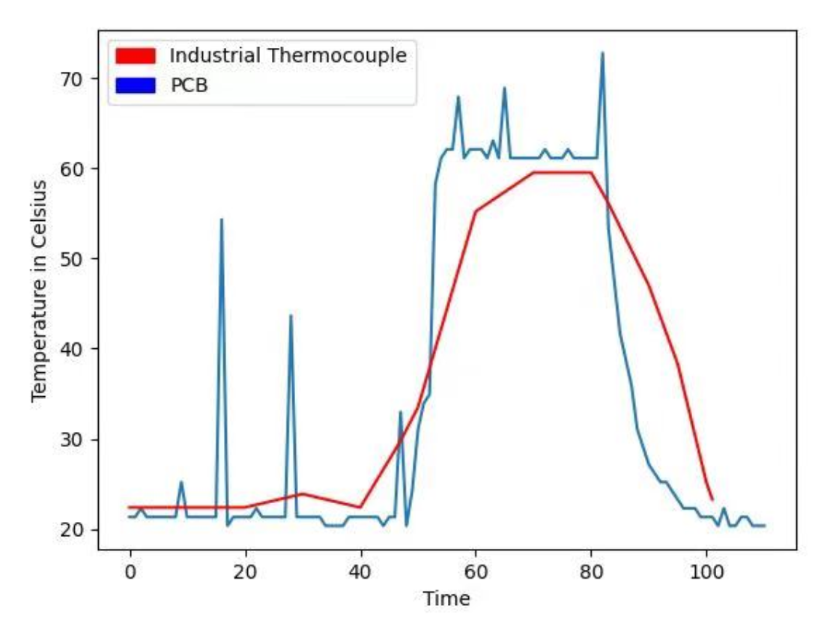
Temperature (℃)
Time (sec)

4. Cost and Schedule

4.1 Cost

Based on our research, a student graduated from the computer engineering program from the Urbana campus has an average starting salary of about 80k - 100k. This roughly translates to $40/hour. The whole project is approximately 10 weeks, with three students working on it for roughly 8 hours per week. Therefore, the total labor cost is:

10 weeks × 3 students × 40 $/hr × 8 hr/week × 2.5 = $24,000

The component cost of the prototype is listed in Table 11. The total cost is $44.90. Cost is an important factor in our project, and the current cost is still higher than what we expect. However, retail prices are usually much higher than bulk purchase prices. If we make bulk purchase in the future, the cost reduction may amount to less than $10.

Table 11: Component and Cost

Component | Cost
9 V Battery x2 (MN1604) | $4.46
Battery Connector Male (PRT-09749) | $0.95
3 V Regulator (LM1117MP-33-NOPB) | $1.11
5 V Regulator (LM1117DTX-5.0/NOPB) | $1.44
K-Type Thermocouple (SEN-13715) | $5.00
Thermocouple Connector Female  (290-1986-ND) | $6.75
Op-Amp (‎LTC1049CN8#PBF-ND‎) | $4.82
Cold Junction Compensator (LT1025CN8#PBF-ND‎) | $5.72
Microcontroller (OLIMEXINO-85-ASM) | $6.91
Wireless Transmitter (1568-1235-ND) | $6.49
Snap Connector (PRT-00091) | $1.25

4.2 Schedule

Table 12: Weekly Schedule of the Team

Week | Xiaobai | Chenlong | Supransh
9/28 | Research and work on the design document | Research and work on the design document | Research and work on the design document
10/5 | Finalize the design and submit the part order to the machine shop | Finalize the design and submit the part order to the machine shop | Finalize the design and submit the part order to the machine shop
10/12 | Order the wireless transmitter | Design the circuit schematics | Design the circuit schematics
10/19 | Learn about Flutter | Finish the circuit schematics; check that all parts are ready | Finish the circuit schematics; check that all parts are ready
10/26 | Have some basic understanding of Flutter; make the first Flutter app | Build the first prototype on breadboard; refine parameters of the components | Build the first prototype on breadboard; refine parameters of the components
11/2 | Finish the app | Test the prototype; modify the prototype if needed | Test the prototype; modify the prototype if needed
11/9 | Test and debug the app | Test the prototype and the app | Test the prototype and the app
11/16 | Finish the first version of our project; prepare for the demo | Finish the first version of our project; prepare for the demo | Finish the first version of our project; prepare for the demo
11/23 | Thanksgiving break | Thanksgiving break | Thanksgiving break
11/30 | Finalize our project; present our project | Finalize our project; present our project | Finalize our project; present our project
12/7 | Finish the final paper | Finish the final paper | Finish the final Paper

5. Conclusion

5.1 Accomplishment

Our project satisfies the high-level requirements. It measures temperature with an accuracy of 5 ℃; the expected temperature ranges from 20 ℃ to 150 ℃. Its thermocouple can be easily placed inside the lint filter to sense the highest temperature inside a dryer. It also transmits temperature data to the Internet and retrieves temperature data using the accompanying app. With the accurate temperature measurement, the user receives timely feedback on the condition of the dryer, reducing the danger of dryer overheating.

5.2 Uncertainty

Our product has a few drawbacks that we would like to mention. It was difficult to find components that had the right size for the PCB. We could not find a battery connector that had the right size; for the testing purpose, we soldered two wires onto the PCB to connect to a battery. In addition, the thermocouple connector did not fit the holes on the PCB, although we designed the PCB to match the size of the thermocouple connector.

It was difficult to debug the voltage regulators. We designed our product to use a 9 V battery as the power source, and we used two voltage regulators to convert the 9 V voltage to 5 V and 3.3 V. However, due to delayed shipping of some components, we were not able to test the voltage regulators before the lab closed for the semester. Without lab access, we were not able to accurately measure the output voltages from the voltage regulators. Based on a rough measurement on the PCB, the 3.3 V voltage regulator was outputting 4.6 V, and the 5 V voltage regulator was outputting 4.3 V. The output voltages did not match the designed voltages. For the microcontroller and the wireless transmitter to work under the safe voltages, we used a 5 V power supply in testing, instead of a 9 V battery.

It might be difficult to expand the database. In the Firebase, we were using single chart with only one channel from the database to the app. We were not sure whether the app would still work properly if multiple data sources from multiple dryers were stored in Firebase, as the storage and computing resources of the database was limited.

5.3 Future Work

We have a few recommendations for future work on this project. We can add a LED indicator, turning red when the dryer is overheating; this feature provides quick feedback to the user even when a smartphone is not around. We can design a box wrapping the PCB, making our product easier to be placed next to a dryer. Next, we recommend debugging and identifying the cause for the mismatched voltages on PCB. We also recommend expanding the database and the app to support multiple inputs from multiple dryers. Lastly, we recommend registering the app on App Store for further use.

5.4 Ethics

In accordance to IEEE ethics code 5 [1], we need to listen to and respect potential criticism of our product, and we must credit others’ work in our project, listing ideas referenced from others, with a special acknowledgement to the team working on a similar project in the Spring 2020 semester.

Some apps have limitations on regions, and to avoid the limitations, we plan to make our app available for free across different platforms, following the IEEE ethics code 7 [1].

5.5 Safety

Safety is of utmost importance. To ensure the safety of our team members, we will follow the safety guide of ECE 445 when working on the project in a lab. We will make sure at least two students work in the lab together, and every student will finish the safety training prior to entering the lab.

Our product may have safety issues. We need to make sure that our product is safe for the user, as mentioned in IEEE ethics code 1 [1]. We will print a warning message on the external package of our product to remind the user that the thermocouple will operate at a high temperature when a dryer is running or just stops running; this warning message helps reducing potential injury from the high temperature inside the dryer or the electronics of the PCB. Also, we need to make sure our app is safe that it does not collect private information from the user.

References

[1] "IEEE Code of Ethics", Ieee.org, 2020. [Online]. Available: https://www.ieee.org/about/corporate/governance/p7-8.html.

