Final Report for ECE 445, Senior Design, Spring 2017
TA: Luke Wendt
03 May 2017
Project No. 67
Yixiong Li
Shan Zhao
Chaoyu Zhou

By
Aliased Water Illusion Screen

Abstract
The device we are implementing is a small gadget that utilizes the stroboscopic effect and creates the illusion of levitating droplets. The device would use a water pump to draw water from a tank into a pipe system. The pipe would then be exposed to vibration created by a set of speakers to create droplets. We provided two sets of strobing lights to project on the water droplets creating the illusion. Droplets would then free fall back into the water tank reservoir. Although we were able to finish the electronic part of the device, due to time constraint and our lack of knowledge in the mechanical aspect of the project, we were not able to create the effect as well as we expected.

Contents

Abstract ii
1. Introduction 1
1.1 Problem Statement 1
2 Design 2
2.1 Physical Design 2
2.1.1 General Appearance 2
2.1.2 Pipe Design 3
2.1.3 Loudspeaker Design 4
2.2 Voltage Supply 4
2.2.1 Voltage Adapter 4
2.2.2 Voltage Regulators 5
2.3 Control Unit 5
2.3.1 Microcontroller 5
2.4 Strobing Light 6
2.4.1 LED Light 6
2.4.2 Light Driver 6
2.5 Loudspeaker: 7
2.5.1 Alternatives 7
2.5.2 Loudspeaker and Driver 7
2.6 Water Pump: 8
2.7 Physical Controller: 9
3 Design Verification 11
3.1 Power Supply System 11
3.1.1 Voltage regulators 11
3.2 Strobing light 11
3.3 Microcontroller 11
3.4 Speaker 11
3.5 Water Pump 11
4 Costs and Schedule 12
4.1 Labor 12
4.2 Parts Cost 12
5 Conclusions 13
5.1 Accomplishments 13
5.2 Uncertainties 13
5.3 Safety 13
5.4 Ethics 13
5.5 Future Work 14
5.5.1 Future Hardware Development 14
5.5.2 Future Software Development 14
6 Reference 15
Appendix A Requirement and Verification Table 16

1. Introduction

1.1 Problem Statement
Aliased water illusion is based on the stroboscopic effect. When a set of droplets are projected with a light source at a set frequency, an observer could potentially perceive successive discrete images and stitch them together with automatic aliases for temporal continuity.^{[1]} We use this effect to create an indoor display that shows various illusions including groups of droplets levitating and moving in different directions. The device could be an interesting interior design to keep in one’s house as a screen, providing privacy between open spaces. The framework of the whole system is shown in figure 1.
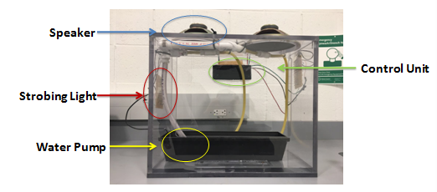
Figure 1 Framework

2 Design
Regarding the electrical design, the device is controlled by a microcontroller unit from the main printed circuit board. The microcontroller (MCU) sends different Pulse Width Modulation (PWM) signals to the corresponding drivers at the operating voltage of the microcontroller. The PWM signal would reach its own driver controlling different individual components including the pump, light set and two different loudspeakers. The drivers function as current amplifiers, amplifying the PWM into operating current that powers the individual components. The whole system is powered by a wall mount DC power supply. A block diagram of the whole system is shown in figure 2.
The electronics are mounted onto a 16’x16’x5’ cabinet, with the main Printed Circuit Board (PCB) stored in the back of the cabinet, loudspeakers on top, two strobing light sets suspended at the side of the cabinet and the water pump fully submerged into the water reservoir installed inside the water tank.
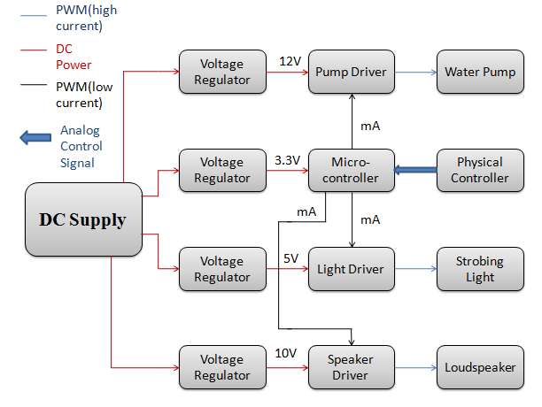
Figure 2 block diagram

2.1 Physical Design

2.1.1 General Appearance
The ECE machine shop assisted us in building a 16’x16’x5’ transparent cabinet. In the cabinet we placed a plastic water reservoir to store water. We intend to fully submerge the water pump in the water reservoir. The power cord of the pump goes through a hole on the side of the cabinet.
We have two separate sets of strobing lights located at the side of the transparent cabinet and two loudspeakers located at the top of the cabinet. All the remaining circuit boards and wires are collected and stored at the back of the cabinet in an enclosure box. The design sketch is shown in figure 3.
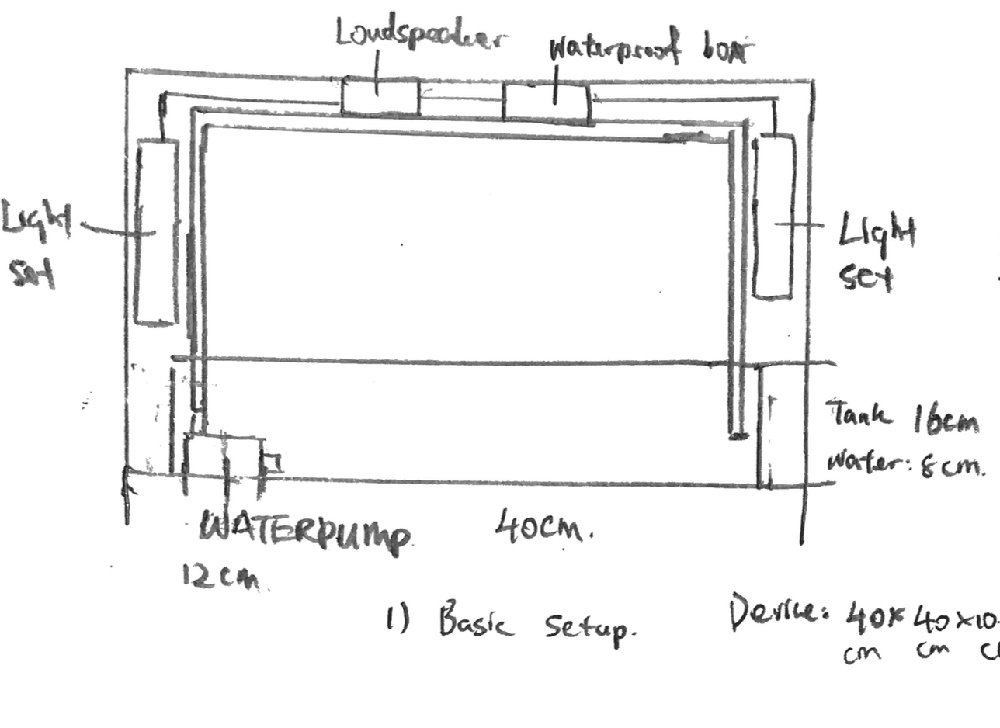
Figure 3 Initial Design Sketch

2.1.2 Pipe Design
Since we want to create the illusion of two lines of droplets going in different directions, we needed to create two lines of droplets each under its own source of vibration. We used zip ties to hold our pipes in place. PVC cement was applied at points of connection to prevent leakage. Our pipe setup is shown in Figure 4.
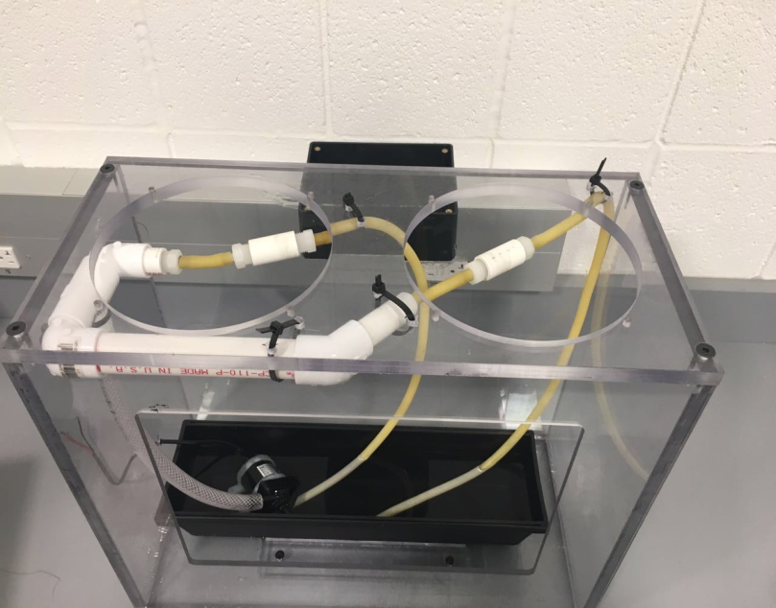
Figure 4 Pipe Design

2.1.3 Loudspeaker Design
We asked the machine shop to remove part of the top cabinet where we would mount our loudspeaker and drilled holes so we could put screws through to securely mount the speaker. The paper cone side of the speaker is exposed to the inside of the cabinet, while the wires and the permanent magnet side of the speaker are facing upwards.
We realized there was a distance between the paper cone of the speaker and where the suspended pipe is. We measured that distance and put a cut-up aluminum can below the paper cone to extend the vibration.

2.2 Voltage Supply

2.2.1 Voltage Adapter
Due to the high power requirement for the speaker, we refrained from using batteries. Instead we chose to use a wall mount AC adapter to provide power for the whole system. The AC adapter converts the input power source ranging from AC 90 V to 264 V into DC 12 V. It also provides a maximum of 4 A of current if necessary. This would satisfy our design requirement. The wall mount AC adapter would connect to the DC power connector power jacks soldered onto our PCB via 5.5mm barrel plug. AC adapter and power jack are shown in figure 5 and 6.Table 1 shows the ratings of different components.
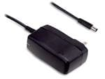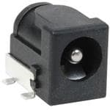
Figure 5 AC Adapter ^{[2]} Figure 6 Power Jack ^{[3]}
Table 1 Ratings of different components
 | Power | Voltage | Current
Loudspeaker | 15W | 10 V | 0.30 A
Strobing light | 1.2 W | 5 V | 0.24 A( One side )
Pumps (600L/H) | 8 W | 12 V | 0.67 A
MCU | / | 5V | /

2.2.2 Voltage Regulators
Different components of the design have different power supply requirements and limitations so we used individual voltage regulators for each component. We need five regulators for our drivers. Our input for all regulators is 12 Volts and we need 10 Volts for loudspeaker, 5 volts for strobing light, 12 volts for water pumps, and 5 volts for MCU.
For regulator, we used devices shown in table 2:
Table 2 Device number of different components
Pumps | MCU | Strobing Light | Loudspeaker
L78S12C | L78S05C | L78S05C | L78S10C

2.3 Control Unit

2.3.1 Microcontroller
We chose Atmega328 ^{[4]} as our microcontroller to operate our drivers for the light set, water pump, and loudspeaker. In order to make mounting the MCU easier, we soldered a 28 pin socket ^{[15]} onto the PCB, and mounted the programmed Atmega328 onto the PCB.
The main goal of our MCU is to provide modulus signals for our drivers. We plan to send a square wave with the proper duty cycle and frequency to each driver, controlling the strobe light and loudspeaker. We would also send a signal to the pump driver to control the voltage input from power source to the pump, in order to control the amount of water it draws into the system per second.
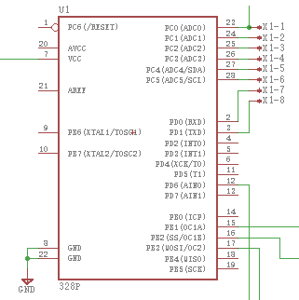
Figure 7 Schematic of MCU
Figure 7 shows how we arrange the pins of our MCU chip. Pin 7 is connected to the voltage regulator which provides 5V DC and we set pin 12, 15, 16, 17 to give out PWM signal to strobing light, water pump, and speaker. The top right four pins functioning as an output port are connected to the physical controller.

2.4 Strobing Light

2.4.1 LED Light
Two strobing light sources are placed on both sides of the cabinet. In order to sample the droplets, duty cycle of PWM is set to be ten percent. Strobing light is driven at a frequency of 50Hz. We used Everlight Elec., 334-15/X1C5-1QSA. Nominal current passing through this kind of LED is 20mA. Maximum forward voltage for LED is 3.6V ^{[5]}. To determine how many LEDs are needed so that the strobing light has a similar luminous intensity as a common light bulb, we used Equation (1) and (2).
$Φv=Iv*Ω$ (1)
$Ω=2π(1-\cos{(\frac{θπ}{360})})$ (2)
$Φv is$ luminous flux, Iv is luminous intensity$and Ω$ is solid angle.LED has a luminous intensity of 3600 mcd, common light bulb has a luminous intensity of 25 lumens. Therefore, we will use twelve LEDs as a group (two groups) to create the brightness of common light bulb ^{[6]}.

2.4.2 Light Driver
To amplify PWM from microcontroller which is only 20mA, we built drivers to provide the strobing light module with signal in higher amperage. At the same time, frequency and duty cycle of driver output has to match the PWM signal provided by the microcontroller. Therefore, we used a NPN transistor as a current amplifier with a voltage gain equal to one.2N2222 is a low-power bipolar transistor with maximum I_{c} equal to 800mA. It is powered by voltage regulator with a voltage of 5V.Input PWM is a square wave with current amplitude of 20mA and voltage amplitude of 3.3V^{[7]}. To make sure LEDs work properly, current was calculated using Equation (3) and (4).

I_{c}=12*20mA=0.24A (3)
I_{c}=I_{e}-I_{b} (4)
C is collector, b is bas and e is emitter. According to Equation (4), we use a resistor of 115Ω at the base of the transistor and twelve resistors of 80Ω to connect with LEDs in series as figure 8 shows:
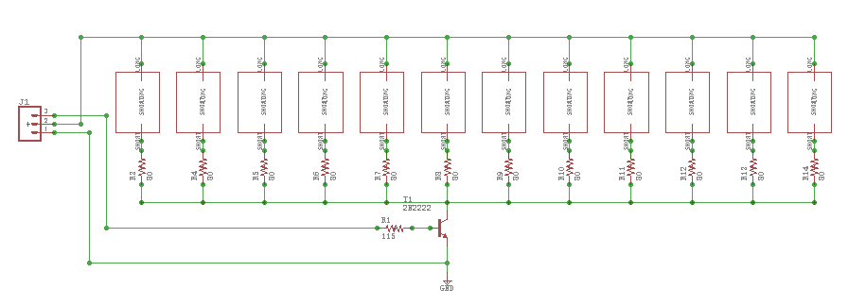
We measured Ic, which should not exceed maximum current 0.24A as shown in figure 9:
Figure 8 Schematic of strobing light
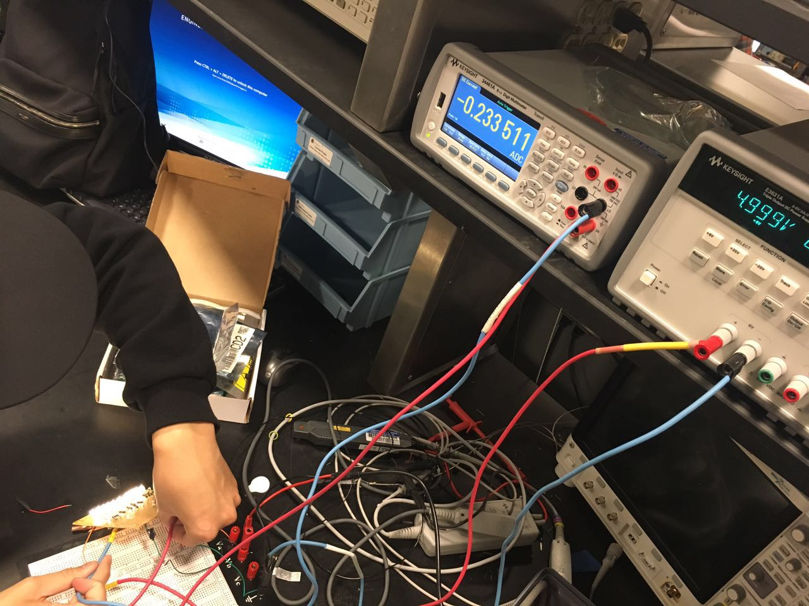
Figure 9 Test of current

2.5 Loudspeaker:

2.5.1 Alternatives
We considered the possibility of using a linear actuator but we could not find a linear actuator that operates at such high frequency. We also considered multiple speakers and we eventually decided on this one.

2.5.2 Loudspeaker and Driver
In our design, we used two 8" Full Range 3oz 15W Paper Cone Speaker ^{[8]}. The loudspeaker is powered by the driver. The MCU provides PWM to the driver and we used a NPN transistor 2N3904 to amplify the current to the speaker to control it.
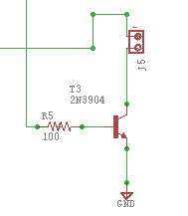
Figure 10 Schematic of loudspeaker driver
Figure 10 is our schematic of the loudspeaker driver. We arrange 100Ω to connect PWM (from MCU) and the base of the transistor. The MCU gives out a 20+ 5%mA current and the transistor amplifies the current to 0.28+ 5%A to manipulate the loudspeaker.
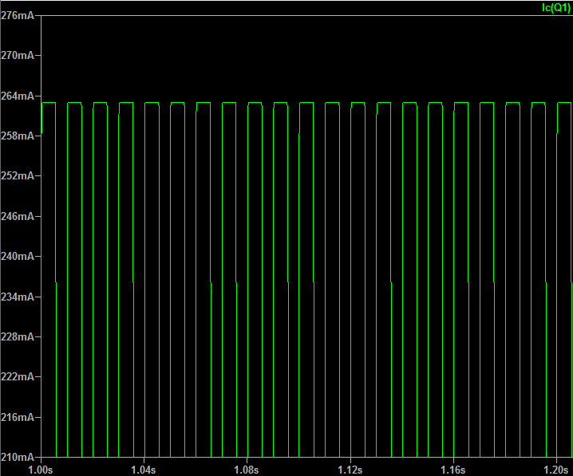
Figure 11 Waveform of current through loudspeaker
Figure 11 shows the current going through the speaker. We can adjust duty cycle to control the amplitude of the vibration. We set the frequency to be 50Hz for the speakers.

2.6 Water Pump:
The pump we use is 10L/min DC 12V Water Pump Submersible oil pump 16ft 8W ^{[9]}. The pump driver is built to control the speed of the water going through the pipes. We figured out that we can simply use a transistor and manipulate the duty cycle of the pump by changing the duty cycle of the input signal. For instance, if we want only 25% water to flow out, we can set duty cycle to be 25%. We use 2N2222 (which has higher current limitation) and set 250 ohms between the base of the transistor and PWM signal.

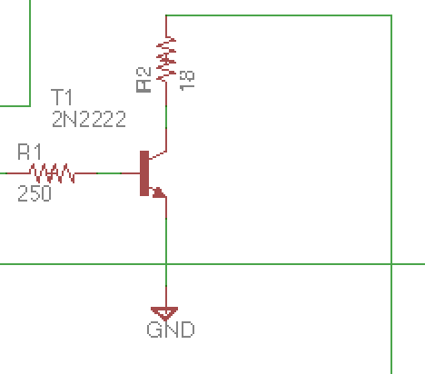
Figure 12 Schematic of water pump driver
Figure 12 is our schematic of the pump driver. The MCU gives out a 20+ 5% mA current and the transistor amplifies the current to 0.64+ 5%A to manipulate the water pump.
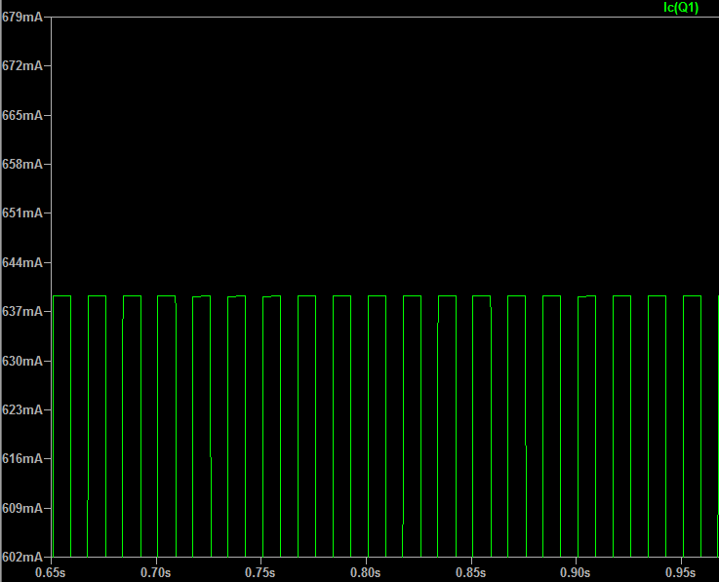
Figure 13 Waveform of current through water pump
Figure 13 shows the current going through the speaker. When we adjust the duty cycle, we can control the speed of the water the pump gives out.

2.7 Physical Controller:
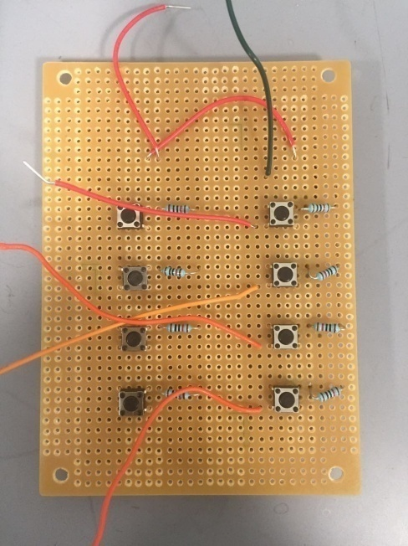
To provide a better user interface for the developer and user to interact with the device, we implemented a physical controller based on a perf-board. The controller provides four buttons, representing the corresponding signal provided by the MCU. When the user pressed a button, the controller would send a digital signal into the MCU. MCU would then alter the corresponding output signal. The PWM dedicated to the water pump would change its duty cycle between 25%, 50%, and 75%. The PWM dedicated to the light set and speakers would change its frequency between 43Hz, 47 Hz, 50Hz, 53Hz, and 57 Hz. Figure 14 shows how our physical controller looks. We also reserved four more buttons for future implementation in case we need more input for the MCU.
Figure 14 Physical Controller

3 Design Verification
By the end of the course, we have finished our design and see the water drops floating in the air caused by the vibration of pipes and the strobing light blinking on both sides. Although our device did not work perfectly, we were able to illustrate how the individual components worked through proper verification details.

3.1 Power Supply System

3.1.1 Voltage regulators
Working AC-DC regulators would convert 120V AC to 5V, 10V, 12V DC. It will have a ripple of up to 0.5 V peak to peak. For details on the specific requirements and testing procedures, please see Appendix A table 4.

3.2 Strobing light
Strobing light has to be bright enough and shine at fixed frequency to make sure audience can see the water droplets clearly. The 2N2222 transistor and LED both have current limits, we conducted two tests using Digit Multimeter to verify if the current running in the circuits reaches maximum current value. Also, we turned off the lights in the lab to see if two groups of LEDs were bright enough and turned on at the same time. For details of requirements and verification, we attached tables in Appendix A table 5.

3.3 Microcontroller
A functioning MCU should be able to take inputs from the physical controller and output PWM to the corresponding pins accurately as the program indicates. We may test its output pin with an oscilloscope. For detail on the specific requirements and testing procedures, please see Appendix A table 6.

3.4 Speaker
The speakers need to function properly to create the vibration to the pipes and allow them to shake so that the water drops can come out in the frequency corresponding to the vibration frequency. The 2N3904 amplifies the current to the speaker and has a current limitation of 800mA. For details of requirements and verification, we attached tables in Appendix A table 7.

3.5 Water Pump
Water pump will draw the water from the reservoir and deliver water up into the system. The transistor 2N2222 amplifies the current to the pump. We set the frequency at 50Hz and we can adjust the duty cycle to control the speed of the pump so that we can control the water speed. The transistor has the current limitation of 0.8A. For details of requirements and verification, please see Appendix A table 8.

4 Costs and Schedule

4.1 Labor
Our fixed labor costs are estimated to be $50/hour, 10 hours/week for three people. We consider our working time to be 50% of this semester (16 weeks), neglecting the breaks, the weekends, central server, we can make a quick calculation for our labor costs:
3 * 55/hour * 10hours * 16weeks * 2.5 = $ 66,000
Machine shop: 20 hours, $50/hour;
The total = 66,000 + 50 *20 = $ 76,000

4.2 Parts Cost
Table 3 illustrates the total cost for our design.

Table 3 Parts Cost
Part | Manufacturer | Retail Cost($) | Actual Cost($)
Regulator | MOUSER | 4.99 | 19.96
PCB | PCBWAY | 23.99 | 65.50
Power Adaptor/Jack | DIGIKEY | 13.99 | 13.99
Strobing Light | DIGIKEY | 0.83 | 20.00
Micro-controller | ATMEL | 22.00 | 44.00
Pipes Set | MENARDS | 14.99 | 55.00
Pump | UNICLIFE | 31.29 | 31.29
Loudspeaker | DYNAVOX | 14.25 | 57.00
Physical controller | ECE STORE | 20.00 | 20.00
Total | ----- | ----- | 326.74

5 Conclusions

5.1 Accomplishments
We successfully assembled the circuitry and tested all the electronic parts, including light sets and drivers, and they worked as desired with the MCU. Unfortunately due to our lack of knowledge in mechanical engineering, even if we were able to have the loudspeaker vibrating at 50Hz per second, the water pipe it vibrates against is creating significantly less droplets than we expected. Due to missing droplets, we weren’t able to observe the illusion.

5.2 Uncertainties
There are several things that we were not certain about. We were not sure the suspension implemented with rubber tubing was a good design. It might have ended up soaking up vibration when not extended. We could potentially achieve a better effect by replacing the whole pipe system with rubber tubes.
One other thing we observed is that water formed droplets and remained on the water pipe due to surface tension. It would not fall until the droplets accumulated and the gravity exceeded the surface tension. We could potentially overcompensate by increasing the frequency of the vibration so that the droplets could form more quickly, resulting in an increasing number of falling droplets per second. However this may not create droplets at a constant rate. Further testing is needed.

5.3 Safety
Due to the nature of this project we applied the following rules in developing, assembling and testing our project.
In order to not have water compromising the circuitry of our project, we set all our circuitry (other than the water pump) outside of the cabinets, physically sealing it off from any water exposure. Also before turning the machine on, we tested enclosure of the pipe by connecting one end of the pipe to the tap water. As we ran water through, we found no leakage in our pipes. We were granted permission to turn the device on by Professor Karl Reinhard and TA Luke Wendt.

5.4 Ethics
As for engineering ethics, we would follow Code of Ethics published by IEEE^{[10]} and ACM^{[11]} and we would read, understand and comment on any sections of the code that bear directly on the project.
We “accept responsibility in making decisions consistent with the safety, health, and welfare of the public, and to disclose promptly factors that might endanger the public or the environment.”
Among our co-workers and lecturers we would “assist colleagues and co-workers in their professional development and to support them in following this code of ethics.”
And in the end we aim to “improve the understanding of technology; its appropriate application, and potential consequences.”

5.5 Future Work

5.5.1 Future Hardware Development
The current loudspeaker does not create enough movement to form visible droplets. We intend to replace it with a model that makes less noise and can generate more vertical displacement from its diaphragm.
We may also re-implement the plumbing system of the device. Replacing the rigid PVC pipe with a softer tubing would potentially solve our droplets situation.

5.5.2 Future Software Development
Our device relied on a perf-board based physical controller to provide user interaction. The perf-board is physically soldered to the PCB and has limited range. Detaching the perf-board or any components from the PCB would potentially compromise the fragile connection of soldered wires. We intend to implement a wireless component to the PCB. Ideally the wireless chip should allow us to upload our program remotely and change parameters of the functions that are currently running on the MCU without having to detach it.

6 Reference
[1] wiseGEEK, “What is Stroboscopic Effect”,2017(online).
Available:http://www.wisegeek.com/what-is-the-stroboscopic-effect.htm
[2] Mouser, “60W AC-DC High Reliability Slim Wall-mounted Adaptor”, 2015(online).
Available:http://www.mouser.com/ds/2/260/SGA60U-spec-642676.pdf
[3] Mouser, “DC Power Jack”, 2015(online).
Available:http://www.mouser.com/ds/2/670/pj-002ah-smt-516100.pdf
[4] Atmel, “ATMEL 8-BIT MICROCONTROLLER WITH 4/8/16/32KBYTES IN-SYSTEM PROGRAMMABLE FLASH DATASHEET”,2015(online).
Available:http://www.atmel.com/images/Atmel-8271-8-bit-AVR-Microcontroller-ATmega48A-48PA-88A-88PA-168A-168PA-328-328P_datasheet_Complete.pdf
[5] Everlight Electronics Co., Ltd ,"334-15/X1C5-1QSA", 2008(online).
Available:http://media.digikey.com/PDF/Data%20Sheets/Everlight%20PDFs/1246342150_6815.pdf
[6] Ohms Law Calculator,"Mcd to Lumens Converter." n.d.(online).
Available: http://www.ohmslawcalculator.com/mcd-to-lumens
[7] Central Semiconductor Corp.," 2N2221", 2013(online).
Available: http://www.mouser.com/ds/2/68/2n2221-28620.pdf
[8] Dynavox, "8" Full Range 3oz 15W Paper Cone Speaker",2017(online).
Available:http://www.dynavox.com/audio-driver-speaker/full-range-paging-address-speaker/8-inch-3-oz-paper-cone-full-range-speaker
[9] Amazon, “Uniclife 10L/min DC 12V Brushless Water Pump Submersible oil pump 16ft 8W”, 2017(online).
Available:https://www.amazon.com/Uniclife-Brushless-Water-Pump-Submersible/dp/B01DWCPFUC
[10] IEEE.org "IEEE Code of Ethics" 2017(online).
Available:http://www.ieee.org/about/corporate/governance/p7-8.html
[11] Association for Computing Machinery, “ACM Code of Ethics and Professional Conduct”2017(online).
Available:https://www.acm.org

Appendix A Requirement and Verification Table

Table 4 Power
Requirement | Verification | Verification status(Y or N)
A. For each voltage regulators, they can provide correct voltages (3.3V, 5V, 10V, 12V).  B. The current through each regulators is below 0.6A and the total current is below 2.5A.  C. The temperature maintains indoor temperature. | A. Use multimeter to measure each voltage across the voltage regulator.  B. Use multimeter to measure currents going through transistors (of strobing light, pump, and loudspeaker drivers) and the current going into MCU Vcc pin.  C. Use thermometer to measure the temperature. | Y  Y  Y

Requirement | Verification | Verification status(Y or N)
A. Forward current for each LED is 20 mA (less than maximum current 30mA)  B. For NPN transistor , I_{c} must be less than 800mA  C. Two strobing light sources turn on at the same time and shine at same frequency | A. Use multimeter to measure current running through each LED when all LEDs are on  B. Use multimeter to measure collector current of transistor when all LEDs(speaker) turn on  C. Observe if two strobing light sources turn on at the same time | Y  Y  Y
Table 5 Strobing light

Table 6 MCU and physical controller
Requirement | Verification | Verification status(Y or N)
- Able to create waveforms at required frequencies  - Buttons works | A. (1) Use Oscilloscope to probe the corresponding pin (12, 15, 16, 17), we are able to show standby frequency 50hz, 10% duty cycle.  (2) With help of physical controller, we are able to switch between modes (50hz, 55hz, 45hz , 52.73hz, 47.62 Hz)  B. (1) The system respond to the buttons  (2) With help of physical controller, we are able to switch between modes (50hz, 55hz, 45hz , 52.73hz, 47.62 Hz) | Y  Y

Table 7 Speaker
Requirement | Verification | Verification status(Y or N)
A. For NPN transistor , I_{c} must be less than 200mA  B. Two speakers turn on at the same time  C. When input with different frequency, the speaker should work on different frequency | A. use multimeter to measure collector current of transistor when speaker turns on  B. (1) Probe the input and output pin of the speaker with oscilloscope  (2) Test two speakers and listen if it they produce the same sound  C. (1) Probe the input and output pin of the speaker with oscilloscope  (2) Test two speakers and listen if it they produce the same sound | Y  Y  Y

Table 8 water pump
Requirement | Verification | Verification status(Y or N)
A. For NPN transistor 2N2222 , I_{c} must be less than 800mA  B. Current going through water pump is less than 0.67A | A. use multimeter to measure collector current of transistor when pump turns on  B. use multimeter to measure collector current of transistor when pump turns on | Y  Y

