The Glove

by

Chenhao Wu

Jiayi Wang

Lei Wang

Final Report for ECE 445, Senior Design, Spring 2016

TA: Luke Wendt

05/01/2016

Project NO. 58

**Abstract**

The Glove provides haptic feedback when users play games in VR world. It is designed to give users a real-world feelings when they are in virtual world. The system can be consolidated into three components: Leap motion create VR environment, circuit proceeds and transmit signals, and servos provide the feedback. All signals transmit through Bluetooth. The system involves the use of both software and hardware. Battery is the only source of power. The Glove enhance the gaming experience in VR world.

**Contents**

Contents

**1.** **Introduction** 4

**1.1** **Statement of Purpose** 4

**1.2** **Objectives** 4

**2.** **Design** 5

**2.1 Block Diagram** 5

**2.1.1 Power supply** 5

**2.1.2 ATmega328P** 6

**2.1.3 Bluetooth module HC-05** 7

**2.1.4 Servo Motor SG-90** 8

**3.** **Verifications** 11

**3.1 Unmet Requirement** 11

**3.1.1 Accuracy & Latency of Leap Motion Controller** 11

**3.1.2 Force Sensor adjustment** 11

**4. Costs** 13

**4.1 Parts** 13

**4.2 Labor** 13

**5. Power Consumption** 15

**6. Conclusion** 16

**6.1 Accomplishments** 16

**6.2 Ethical considerations** 16

**6.3 Future work** 16

**References** 17

**Appendix A** **Requirement and Verification Table** 17

1. **Introduction**
   1. **Statement of Purpose**

Motion tracking technology has been largely used in Virtual Reality Game to offer more engaging gaming experience. Most motion tracking devices enable people to observe the movement of their hands and interact with virtual objects. Based on this, our team think that providing haptic feedback to the contacts with virtual objects makes the experience even better.

So, we plan to mount the servo motors on the glove to control the movement of the fingers/palm. We will incorporate Leap Motion with our glove wirelessly to simulate the signal. Conditions like touching or grabbing the virtual object will output a signal sending to a controller to activate the servo motors and give a haptic feedback to the hand.

* 1. **Objectives**
* Provide force feedback that is similar to real life experience.
* Skeleton will stop fingers from moving into the virtual object.
* Wireless glove with high portability.
* Low power consumption.
* Well incorporated with Leap Motion.

1. **Design**

**2.1 Block Diagram**

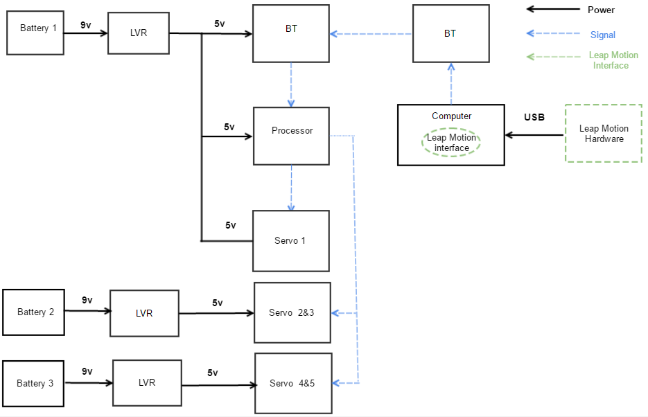

Figure 1

**2.1.1 Power supply**

Three 9v alkaline batteries serve as power supply for the device circuits. Each of the battery is regulated by a linear voltage regulator to output a 5.0 voltage. The first battery is supplying power for micro controller, Bluetooth and the first servo. The other two batteries are supplying power for two servos each in order to prevent possible battery over discharge.

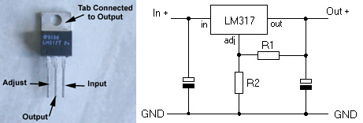

**Figure 2**

For the linear voltage regulator LM317, V out= 1.25(1+ (R2/R1)) where we used R2 for 910 ohms and R1 for 300 ohms. We have:

1.25（1+（300/910)) =5.04V.

The capacitor on the left is usually set to 0.1 μf and the capacitor on the right is usually set to 1 μf. Detailed power consumption will be introduced later in this paper.

**2.1.2 ATmega328P**

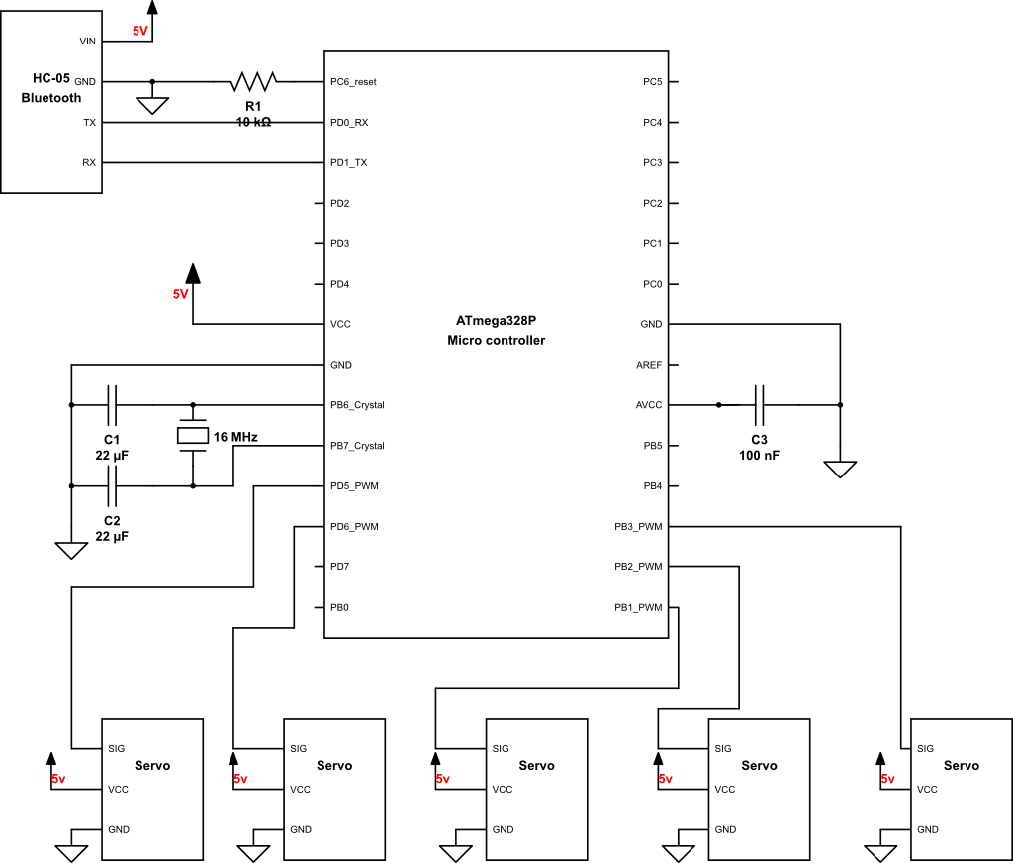

*Figure3*

ATmega328P is the heart of the design which is wired to HC-05 (through RX, TX) and servo motors (through PWM pins). It is clocked by external 16MHZ crystal with two 22  μF capacitor. It reads the serial data received from HC-05 and uses it as the control signal to program servo motors. Meanwhile it also reads in the data from force sensor to constrain servo from moving forward when the force exceeds the threshold (2N).

*Skeleton code coded in Micro-processor:*

*for (tmp0=cur0; tmp0 <=179; tmp0 += 50) {*

*if(force1 >2){   //if force is more than 2 N, the servo will stop turning*

*break;*

*}*

*myservo0.write(tmp0);              // servo  continues to turn and update position*

*delay(10);*

*}*

*cur0 = tmp0;*

*}*

**2.1.3 Bluetooth module HC-05**

Bluetooth module HC-0.5 is a small portable Bluetooth device. It’s powered by 5V from the battery (9v lithium battery with a 9V with linear voltage regulator).

Bluetooth device is connected to the ATmega328P microcontroller. TX port on Bluetooth is connected to RX of ATmega328P and RX is connected to TX of ATmega328P for serial communication. The transmitter module will send the data with baud rate 9600bps to the receiver.

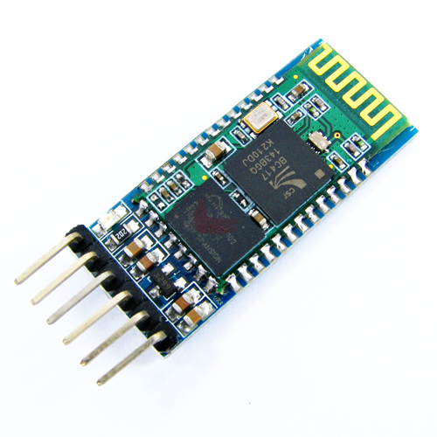

*Figure 4*

**2.1.4 Servo Motor SG-90**

We use 5 servo motors for each finger. For each servo motor, there are three pins. Pin 1 is connected to 5V power supply (9v lithium battery with 9V-5V linear voltage regulator). The voltage supply range is 4.8V to 6V. Pin 2 (middle one) is the signal wire which is connected to microcontroller. Pin 3 is connected to the ground.

SG-90 is comparably cheap and lightweight with only 14.7g each so that we can implement all 5 servos on the armband with a total weight of 73.5g for servo module.

The PWM period for SG-90 is 20ms. Different pulse that received from microcontroller corresponds to different angle that the servo turns to. The pulse width sent to servo ranges as follows: Minimum: 1 millisecond ---> Corresponds to 0 rotation angle. Maximum: 2 millisecond ---> Corresponds to 180 rotation angle. Any length of pulse in between will rotate the servo shaft to its corresponding angle. For example, 1.5 ms pulse corresponds to rotation angle of 90 degree.

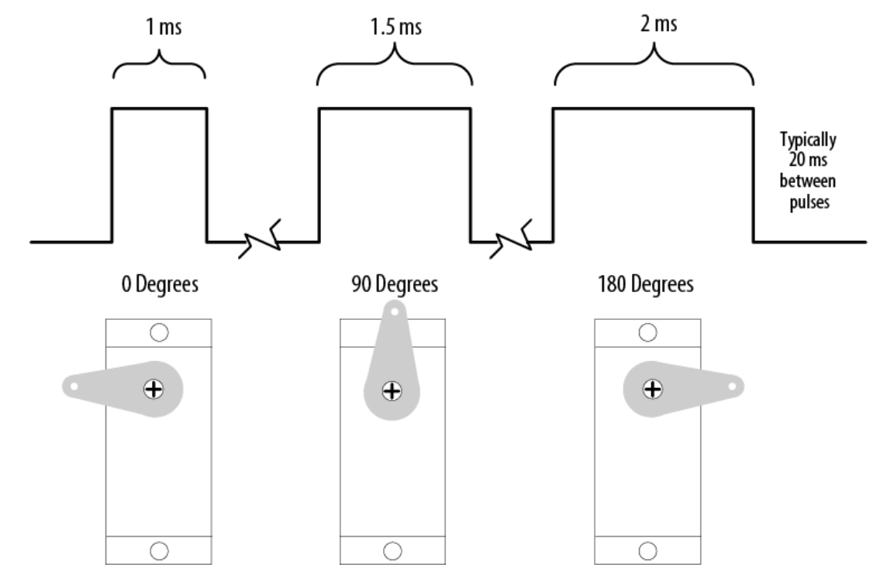

*Figure 5*

SG-90 provides peak stall torque with 1.6 kg-cm, the length of the servo wings is 2.2 cm and the radius is 2.2/2 = 1.1 cm.

Torque = r x F

1.6 kg-cm = 1.1cm * F

=> F = 1.45 kg = 14.25 N

14.25N is the maximal force that the servo can provide without breaking down the servo.

Our survey with 20 students tells us that the comfortable range of force that pull one’s finger is less than 5N. With the inevitable unnecessary power waste (resistors dissipation), the ideal force that applies on our fingertip is 0.1- 5N (measure by electrical scale).

However, with the implementation of the actual glove and the sewing method we use to pull the finger, each finger is not directly pulled by this amount of force. Instead, the string is connected to a wooden stick and the amount of actual force on finger is between 0.1 N - 2.2 N by the test measurements of the scale.

**2.1.5 Bluetooth Transmitter of Computer**

We use the built-in Bluetooth in the computer to connect to the HC-05 in order to transmitting data between our software program and the microcontroller. We wrote code in Java to access the serial port of the Bluetooth in computer.

**2.1.6 Leap Motion Controller & Unity 3D Interface**

ece4452.png

*Figure 6*

**Leap Motion Controller**

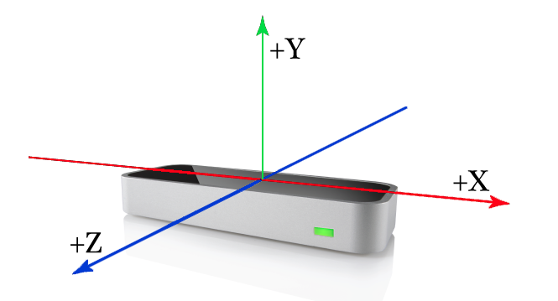

*Figure 7*

The Leap Motion Controller provides coordinates in units of real world millimeters within the Leap Motion frame of reference. That is, if a finger tip’s position is given as (x, y, z) = [100, 100, -100], those numbers are millimeters – or, x = +10cm, y = 10cm, z = -10cm.

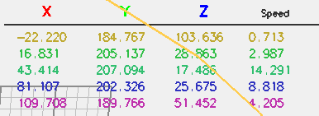

*Figure 8*

Computer will supply 5v to the leap motion controller via USB2.0 cable. On the computer, we built a virtual environment using c# in the Unity 3D Engine.  And we wrote a JAVA program to communicate with the microcontroller and deal with the data from the leap motion in which we can read and store the position data of fingertips and curvature of hand into computer.

**Data Processing**

The leap motion controller will read in the position data of each fingertips. We will first scan each finger in totally 5 loops and in each loop the program will calculate the distance between the corresponding fingertip and the center of the virtual objects. After scanning the 5 fingers of the right hand, it will convert the output into a 5-bit binary number (i.e. 10000 means only thumb is touching the object, and 11111 means all the fingers is touching the object).

1. **Verifications**

**3.1 Unmet Requirement**

**3.1.1 Accuracy & Latency of Leap Motion Controller**

We tested the tracking precision of the leap motion in its x, y, z directions.

group1: fingertip moved in negative y direction with finger straight.

group2: fingertip moved in positive x direction with finger straight.

group3: fingertip moved in positive z direction with finger curves inwards.

|  |  |  |  |  |
| --- | --- | --- | --- | --- |
| test number | Delta Y(IN Leap Motion) | Actual Distance | Difference | Average |
| group1(y axis) | 175-128=47mm | 46mm | 1mm |  |
| group1(y axis) | 175-136=39mm | 46mm | 7mm |  |
| group1(y axis) | 175-132=43mm | 46mm | 3mm | 3.667mm |
| group2(x axis) | 32+47=79mm | 73mm | 6mm |  |
| group2(x axis) | 50+24=74mm | 73mm | 1mm |  |
| group2(x axis) | 55+24=79mm | 73mm | 6mm | 4.333mm |
| group3(z axis) | 61-26=35mm | 35mm | 0mm |  |
| group3(z axis) | 68-24=44mm | 35mm | 9mm |  |
| group3(z axis) | 55-27=28mm | 35mm | 7mm | 5.333mm |

As a result, fingers curving in z axis will cause the most errors with a range of +/- 5.333mm than translations in y(+/-4.333mm) and x (+/-3.667mm)directions.

**3.1.2 Force Sensor adjustment**

To actually test how the force sensor act under real world circumstance, we decided to connect it to the microcontroller and pressure the sensor with various forces and divide the output from minimum to maximum into 3 levels: no force, light force , max force.

Specifically, we put the force sensor on table and put different weights on the sensor to see test its output voltage.

|  |  |  |
| --- | --- | --- |
| Input | Output(V) | Force Level |
| 0.04lb weight 0.2N | 1.30V | No Force |
| 0.22lb weight 1N | 3.10V | Light Force |
| 0.44lb weight2N | 3.23V | Max Force(Threshold) |
| 1.10lb weight 5N | 3.8V | ignore |
| 2.2lb weight 10N | 4.5V | ignore |

**4. Costs**

|  |  |
| --- | --- |
| Parts Total($) | 531.24 |
| Labor Total($) | 16875 |
| Total($) | 17406.24 |

**4.1 Parts**

|  |  |  |
| --- | --- | --- |
| Items | Quantity | Price($) |
| Microcontroller ATmega328P | 1 | 24.95 |
| Panasonic Cr2025 Dl2025 3V Lithium | 1 | 1.24 |
| Parts Express 9V Battery Clip | 3 | 12.06 |
| American Weight Scale H110 | 1 | 7.90 |
| SparkFun 5V Step-Up Breakout - NCP1402 | 1 | 5.95 |
| Leap Motion | 1 | 80.00 |
| Bluetooth Module HC-05 | 1 | 8.99 |
| Servo Motor SG 90 | 5 | 20.00 |
| Linear Voltage Regulator LM317 | 1 | 1.59 |
| Armband I | 1 | 24.99 |
| Force Sensor | 5 | 6.99 |
| Total |  | 531.24 |

**4.2 Labor**

|  |  |  |  |
| --- | --- | --- | --- |
| Name | Hourly Rate($) | Hours Invested(hrs) | Total($) |
| Chenyu Wu | 25 | 225 | 5625 |
| Jiayi Wang | 25 | 225 | 5625 |
| Lei Wang | 25 | 225 | 5625 |
| Total |  | 675 | 16875 |

**5. Power Consumption**

We use 3 9v alkaline battery to power the entire system. For the first two of batteries, each of them powers two servos (parallel connection). And the third one powers one servo and the Bluetooth. Capacity of battery is 750mAh each. Every servo will draw 220+/-20 mA current.

1) Servo 1 & circuit: Circuit draws 100mA current while maximal current that servo draws is 240mA.

Total current = 100 +240 = 340mA

Working hour = 750/340 = 2.2 hrs

2) Servo 2&3; Servo 4&5:

Total current = 240*2 = 480mA

Working hour = 750/480 = 1.56 hrs

In reality, due to some inevitable resistance, the real lifetime is approximately 44 mins for full usage.

**6. Conclusion**

**6.1 Accomplishments**

In summary, the final function of our project is similar to the concept we wanted to prove at the beginning of the class. We had fully working module of the glove and arm armor which successfully provide force feedback to the finger tips while interacting with the virtual objects.

**6.2 Ethical considerations**

We commit ourselves to the highest ethical and professional conduct and agree the following:

1. To accept responsibility in making decisions consistent with the safety, health, and welfare of the public, and to disclose promptly factors that might endanger the public or the environment;

2. To avoid real or perceived conflicts of interest whenever possible, and to disclose them to affected parties when they do exist;

3. To be honest and realistic in stating claims or estimates based on available data;

4. To reject bribery in all its forms;

5. To improve the understanding of technology; its appropriate application, and potential consequences;

6. To maintain and improve our technical competence and to undertake technological tasks for others only if qualified by training or experience, or after full disclosure of pertinent limitations; 7. To seek, accept, and offer honest criticism of technical work, to acknowledge and correct errors, and to credit properly the contributions of others;

8. To treat fairly all persons and to not engage in acts of discrimination based on race, religion, gender, disability, age, national origin, sexual orientation, gender identity, or gender expression; 9. To avoid injuring others, their property, reputation, or employment by false or malicious action;

**6.3 Future work**

First, the whole system is heavy to carry. For the future work, we will use PCB instead of perf board because it’s large and heavy. Also we used a lot of wood on our armband. In the future work, we will redesign the armband to make it lighter.

Second, we will make our glove looks better by using 3D print technology to build some of the components.

Finally, we will choose better servos because there were some latency due to the hardware of servo. The only thing that can eliminate the latency is to replace with better servos.

**References**

1) Arduino UNO data: https://www.arduino.cc/en/Main/ArduinoBoardUno

2)ATmega328P:http://www.atmel.com/images/Atmel-8271-8-bit-AVR-MicrocontrollerATmega48A-48PA-88A-88PA-168A-168PA-328-328P_datasheet_Complete.pdf

3) Leap Motion: Leap

4) Battery: http://www.homedepot.com/p/Energizer-9-Volt-Advanced-Lithium-BatteryLA522SBP/202252832

5) Servo motor: http://www.micropik.com/PDF/SG90Servo.pdf

6) Voltage Regulator: http://www.instructables.com/id/5v-Regulator/

7) HC05 Bluetooth: <http://www.robotshop.com/media/files/pdf/rb-ite-12-bluetooth_hc05.pdf>

8) Servo Motor: http://www.micropik.com/PDF/SG90Servo.pdf

**Appendix A Requirement and Verification Table**

|  |  |  |
| --- | --- | --- |
| **Requirements** | **Verification** | **Pass?** |
| 1. **Power Supply**  9V Energizer Alkaline Battery:             a. Supply +9V±5% power.  Linear Voltage Regulator:             b. Must output +5V±5% at maximum current draw of 480mA.             c. Lifetime of the power system should run for 44 minutes assuming full-time usage(480mA all time) and 90 minutes assuming normal usage.  Current Limiter:            d. Current limiting circuit will prevent battery from burning by a maximum limit draw of 500mA +/-25mA. | 1. **Power Supply**                a. Use digital multimeter to measure the output voltage. It should read 9V +/- 5% steadily.(2)                b. Connect a 10 ohm resistor with battery and linear voltage regulator. Use a digital multimeter to measure the output voltage. It should read 5V+/-5% steadily.(3)                c. Connect a 10 ohm resistor with battery and linear voltage regulator. Use a digital multimeter to measure the current and monitor if it reads 500mA +/-25mA for an hour.(3)                d. Connect a 5 ohm resistor with battery, linear voltage regulator and current limiting circuit. Use a digital multimeter to measure if the output current is 500mA +/- 25mA.(2) | 1. Yes 2. Yes 3. Yes 4. No |
| 4. **Bluetooth Transmission**   1. The built-in bluetooth module on laptop is able to establish stable connection with HC-05. 2. The built-in Bluetooth of laptop is able to transmit effective and accurate data. The microprocessor is able to read the data of a two byte size. 3. The Bluetooth transmitter should be able to transmit data within 1 meters. (The range of Leap motion) | **4. Bluetooth Transmission**   1. Check if the indicating LED on the HC-05 is blinking one time every while for correct connection.(3) 2. Transmit data of a 2 byte size to the microprocessor and transmit back to the computer by programming. Read the data using Tera Term software to check if it aligns with the original one. (5) 3. Take the transmitter 1 meter away and check whether the system is still working.(2) | 1. Yes 2. Yes 3. Yes |

|  |  |  |
| --- | --- | --- |
| 3. **Micro controller**   1. Pin PD5~6, PB1~3 must output PWM signals with the peak-to-peak voltage of 5V +/-0.5V, 50Hz, 2ms pulse width. 2. Micro-controller is able to read correct data package from HC-05 through serial input. 3. Micro-controller is able to decide when and whether the motor starts to turn based on the data received. 4. Micro-controller is able to turn the servo with correct angle within +/- 1 degree. 5. Micro-controller will stop sending signal to corresponding servo if the force sensor data of the finger is higher than 5N. 6. The latency between triggering signal and servo reactance should be within 0.5 second. | 3. **Micro controller**   1. Write test code and use an oscilloscope to check the output of the digital pins to see if it is the corresponding signal. (5) 2. Print the data in serial.read() and check if it align with the data sent from laptop.(5) 3. Test with an external LED that turns on when servo_on is 1 and off when servo_on is 0. First send a data package of servo_on = 0 (LED off) which the servo motors should not move regardless of the value of other variables, which means no matter how your hand is moving the servo will not respond. Then test with LED on to check if servo reacts immediately. Finally while LED is on, put servo_on back to 0 to check if the servo motor will immediately return to the initial position. (5) 4. Computer will send test angles of 30/90/120/150/180 degrees to microprocessor. Put the servo on the angle scale and measure if it is the corresponding angle within the right tolerance.(5) 5. Put an object of 0.6kg on the force sensor ( 0.6kg * 9.8 = 5.88N) and the servo should stop rotating.(5) 6. Use a stopwatch. Measure when the finger touching the object and when servo motor starts to turn. The time elapsed should be no more than 0.5 second. (5) | **a.**Yes    **b.**Yes  **c.**Yes    **d.**Yes    **e.**Yes  **f.**Yes |

|  |  |  |
| --- | --- | --- |
| 4. **Servo Motor**   1. When hand is not touching virtual object, servo motor in initial position should not exert any force to the finger. 2. When hand is pressing virtual object, servo motor should give a force from 1.5N ~ 5N (+/-0.2N) to ensure safety. | 4. **Servo Motor**   1. Set servo_on to 0 and stretch hand with any kinds of gesture and the finger should move freely without any force feedback.(5) 2. Test with a weight scale that’s tied to the string of servos. Interact with the virtual object without wearing the glove and monitor the readings of the weight scale. The reading should be in the range of 1.5N ~5N(+/-0.2N).(5) | **a.**Yes    **b.**Yes |
| **5.Leap motion & Software:**   1. The program is able to show the user interface of the game on the computer correctly. 2. Leap motion is able to send correct data package of whether finger is touching the virtual object.(a virtual ball of r = 75mm above the leap motion device) 3. Leap motion is able to send the current curvature of the right hand in percentage range from 0.00 to 1.00 with open hand as 0 and fisted as 1. 4. Leap motion is able to send the depth that fingers reach into the object range from 0 to r = 75mm. | **5.Leap motion:**   1. After double click to run the program on the computer with the leap motion device plugged in, the program is correctly running and there is a red virtual ball sit in the middle of the screen.(10) 2. Launch the program of the project, place your right hand above the leap motion (palm towards table) with five fingers stretched out. Erect a ruler on the leap motion controller and move your fingers along the ruler downwards. Whenever the fingers is reaching in 15 cm (2*75mm) touching the virtual object, the program should send a signal to the micro controller and turn the servo.(5) 3. Launch the program of the project, place your right hand above the leap motion (palm towards table) with five fingers stretched out. And then slowly clench your fist. The output should range correspondingly from 0 to 1.(5) 4. Launch the program of the project, place your right hand above the leap motion (palm towards table) with five fingers stretched out. Erect a ruler on the leap motion controller and move your fingers along the ruler downwards. Whenever the fingers is reaching in 15 cm (2*75mm) touching the virtual object, the program should output the distance from your fingertips to the point of 7.5cm on the ruler.(5) | **a.** Yes    **b.**Yes    **c.** Yes    **d.** Yes |

|  |  |  |
| --- | --- | --- |
| **6. Force Sensor:**   1. After installed on the glove, force sensor is still able to measure accurate force data on fingertips within +/- 0.1N. 2. Every force sensor(total of 5) will be stably mounted on fingertips with general hand movements. | **6. Force Sensor:**   1. Use digital hanging scale to apply 0.5kg(0.5kg * 9.8 = 4.9N) force on each finger. Read the data from arduino to print the value of force sensor from analog pin. The data should be in the range of 4.8N ~ 5N. 2. Wear the glove and move your fingers with different pose. Force sensors are still able to work properly. | **a.**Yes    **b.**Yes |
| **7. Glove design**  Hand dimension:   1. Glove fits comfortably with the palm size of 9.5-10 inch and finger size of:              Thumb finger: 5.5 +/- 0.2 inch             Index finger: 6  +/- 0.2  inch             Middle finger: 6.5   +/- 0.2  inch             Ring finger: 6    +/- 0.2  inch             Little finger: 5.2    +/- 0.2   inch | **7. Glove design**  Hand dimension:   1. Measure the size of the palm and each finger using a ruler. If it fits the requirement,  wear the glove and the hand should feel comfortable when clenching a fist. Fingers can move freely as well. | **a.**Yes |

|  |  |  |
| --- | --- | --- |
| **8. Forearm armor**   1. Armor fits comfortably with a arm size of 15 - 20 inch(circumference). 2. Armor should stay on the arm stably without sliding when pulled by a 25N force. | **8. Forearm armor**   1. Measure the size of the arm. If fits the requirement, wear the forearm armor and it should fit comfortably. 2. Pull the armor with hanging scale with 2.45kg reading. The armor should be stable on the arm. | **a.Yes**    **b.Yes** |