Final Report for ECE 445, Senior Design, Spring 2017

TA: John Capozzo

23rd May, 2017

Project No. 80

Colin Lu

Jonathan Rakushin-Weinstein

Elizabeth Roels

By

The Battleship project

**Abstract**

At the start of the semester, we set out to create a fun, handheld game to engage audiences both young and old. It was decided to pursue three main categories: a simplistic design, an interactive interface, and maximizing portability. The device ended up being battery powered, with buttons as inputs and lights and sound as outputs. To create two player mode, Bluetooth was included into the design as well. To add to simplicity, the buttons were simple and a microUSB charging port was included to charge the main battery without removing it. By the end we did not fully integrate the project, but most of the parts ended up working as planned on their own.

Contents

1. Introduction 1

2 Design 2

2.1 Power 2

2.1.1 Battery 2

2.1.2 Charging 3

2.1.3 UVLO and 5V boost 3

2.1.4 3.3V Regulator 4

2.2 Sound 5

2.3 Microcontroller 6

2.4 Bluetooth 7

2.5 Button Input 8

2.6 LED Screen 8

3. Design Verification 8

3.1 Power 8

3.1.1 Charging 8

3.1.2 5V and 3.3V Voltage Converters 9

3.2 Sound 11

3.3 Microcontroller 12

3.4 Bluetooth 12

4. Costs 14

4.1 Parts 14

4.2 Labor 15

4.3 Grand Total 15

5. Conclusion 16

5.1 Accomplishments 16

5.2 Errors 16

5.3 Ethical considerations 16

5.4 Future work 16

References 17

Appendix A Requirement and Verification Table 18

# 1. Introduction

This project was designed to create a fun experience for the user. It was a modern take on Battleship that could eventually be slightly modified to add other games as well. When designing the project, it needed power, interactivity, and communication as its main functions. For power, a lithium Ion battery is used for its good voltage range and portability. The interactivity was controlled by a button input array and an LED display, with sounds included for added interactivity. To communicate with the parts, a microcontroller was needed. This would also handle the Bluetooth capability to communicate with another device.

# 2 Design

Below is a block diagram that depicts our proposed design of the project. The inputs module, consisting of the game switch and button array will be fed into the microcontroller, which will then interpret these signals and output the appropriate logic to the LED array. In order to update both the player and opponent boards, a pair of Bluetooth chips will be used to interface data. The entire circuit will be powered by the wireless Li-ion battery circuit.

|  |  |
| --- | --- |
| Block Diagram.png |  |

Figure 1. Block Diagram of Project

## 2.1 Power

The power module would be responsible for supplying power to the rest of the device. With the Lithium Ion battery, a charging module was needed to charge it for simplicity. The chip which does this is the MCP73871. The speaker was at 5V, and UVLO was required to not damage the battery, which was controlled by the TPS61090. Finally, a 3.3V regulator was included for the smaller components. These were all placed onto a single Printable Circuit Board (PCB) along with the sound module and microcontrollers.

### 2.1.1 Battery

The battery used in the project was an 18650 3.7V Lithium Ion battery. A Lithium Polymer battery could have been used as well, but these batteries generally hold less charge, or are more expensive if they hold more charge. Therefore, due to the cheap price and high capacity, we went with an 18650 battery.

### 2.1.2 Charging

For charging an 18650 battery, the best chip on the market was MicroChip’s MCP73871. This chip could easily take a MicroUSB power line, drop it to 3.7V, and charge the battery. One of our requirements was that the battery would charge in less than five hours, which was accomplished well using the ability to charge at one amp. Below is the charging module schematic for one amp operation:

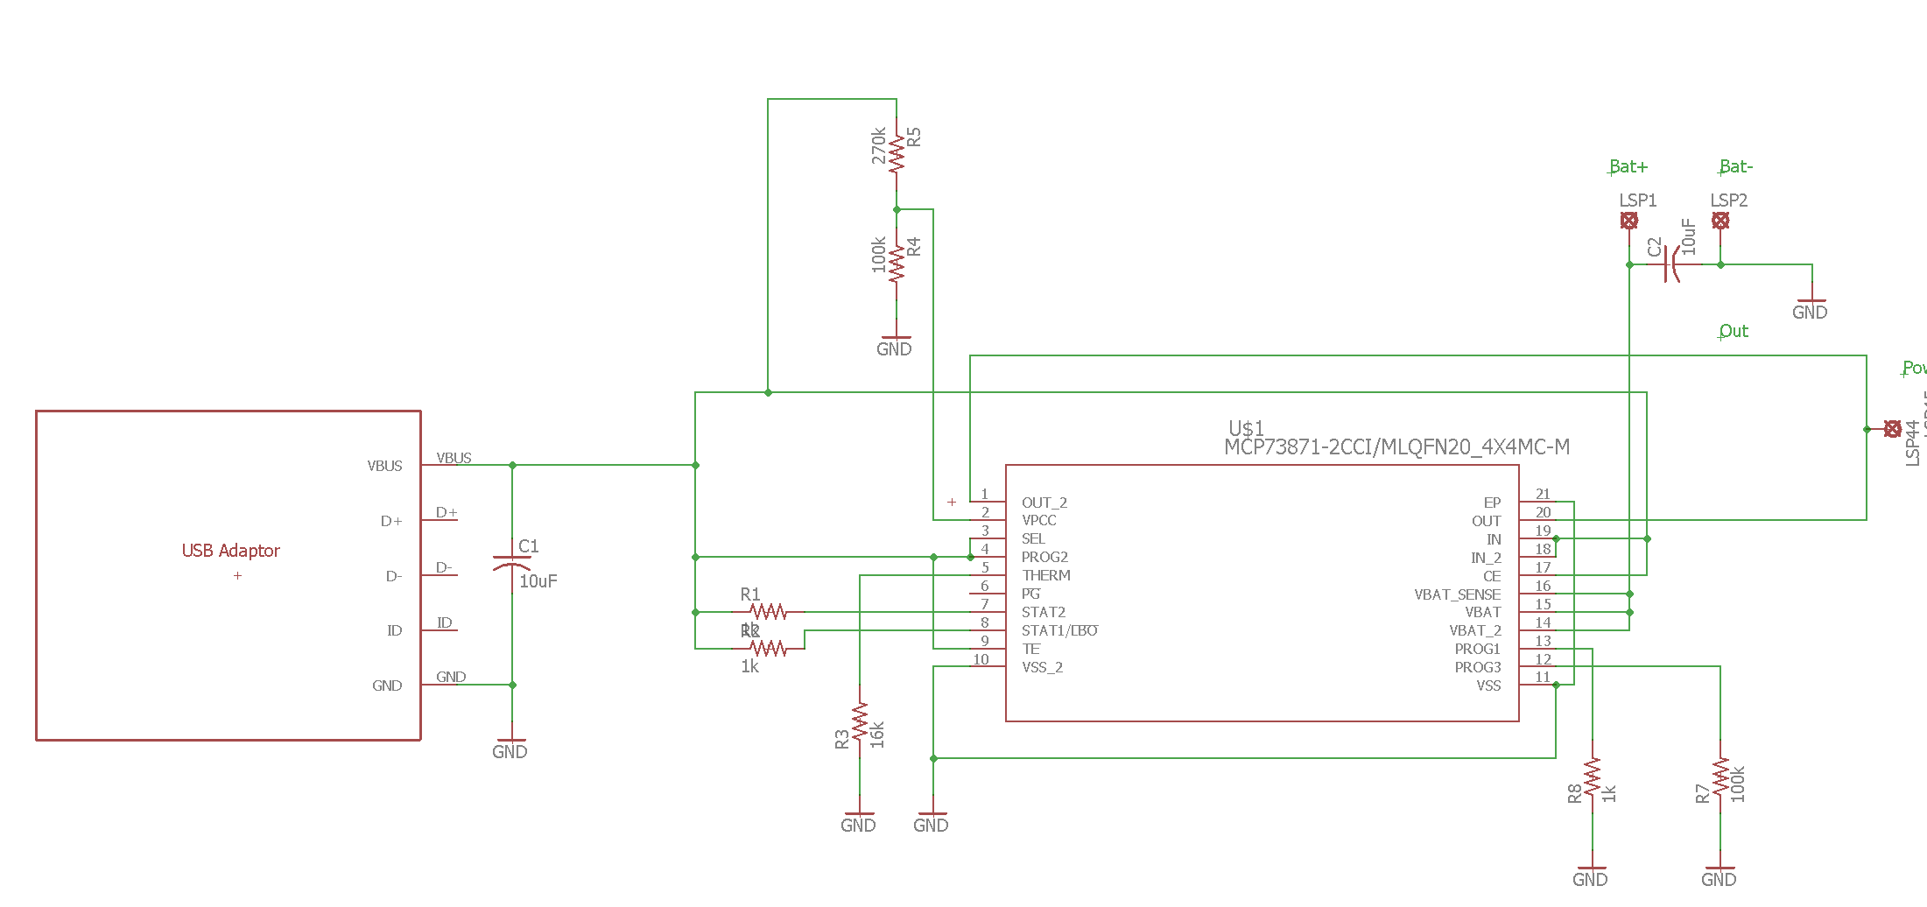

Figure 2. Charging schematic

### 2.1.3 UVLO and 5V boost

The 5V boost and UVLO would be handled by the TPS61090 chip. This chip can take a voltage of 3.7V from the battery and boost it to 5V, with the included Undervoltage Lockout. Undervoltage Lockout is necessary because as the battery drops below its acceptable values, discharging the battery too much can damage the battery. For safety, this was a necessary inclusion. The 5V regulator works by feeding the voltage back to create a 5V feedback loop.

For the undervoltage lockout, according to powerstream.com[x], a Lithium Ion battery has about 5% remaining at 3.6V, meaning this is the ideal lockout for the battery. Using the TPS61090, we can calculate the voltage divider to lockout at this voltage using the equation below:

(Equation 1)[x]

The document recommends a resistance of 390k for R2, and we want the voltage to shut off at 3.6V so we can calculate R1:

For programming the feedback, we calculate the resistance network according to the same document:

(Equation 2)[x]

The document states that a resistance of 200k is best for R4, and to get 5V use a 1.8 resistor for R3. Our implementation of this is seen below:

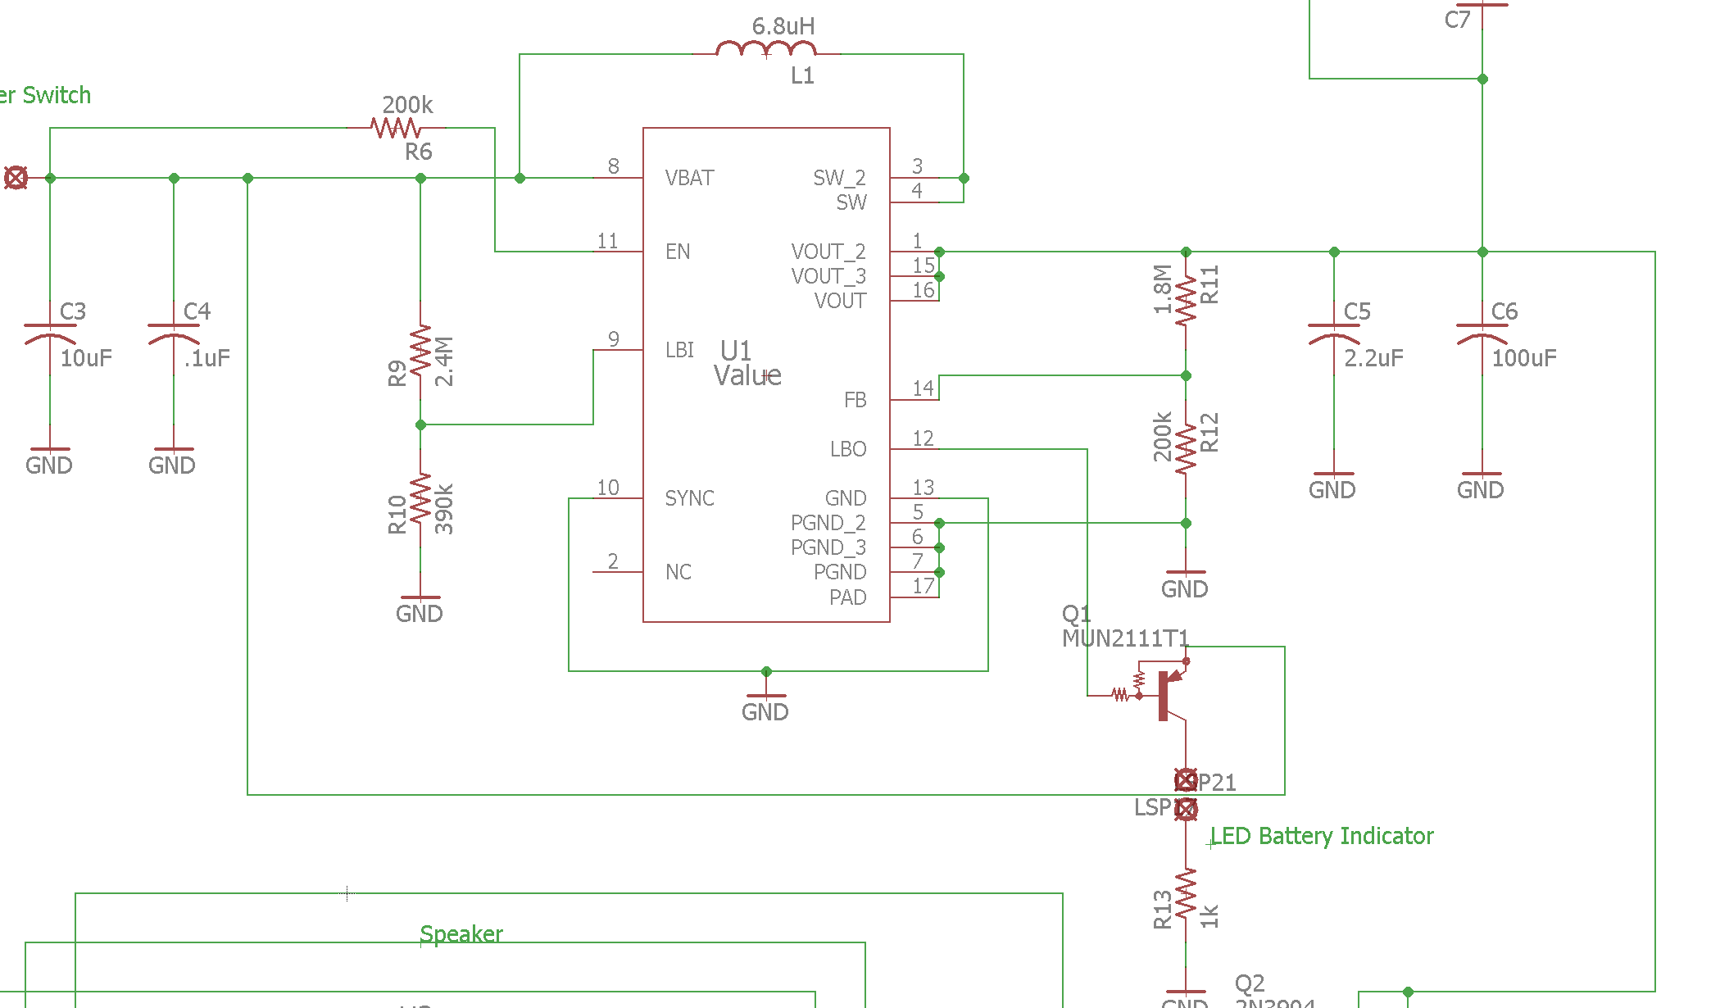

Figure 3. TPS61090 implementation from our schematic

### 2.1.4 3.3V Regulator

To power the microcontroller, Bluetooth and shift registers, a 3.3V regulator was needed. This was attached to the 5V output of the TPS61090 chip. To supply enough power to the LEDs, the regulator used was the LM3940IT-3.3, which can output voltage up to 1A.[x] The chip is also designed to work off of a 5V supply for maximum efficiency, which is what the purpose was. According to the document, the input capacitor is .47F and the output capacitor can be capacitor greater than 33F. Since a 100F would be easier to obtain, that was used in the design.

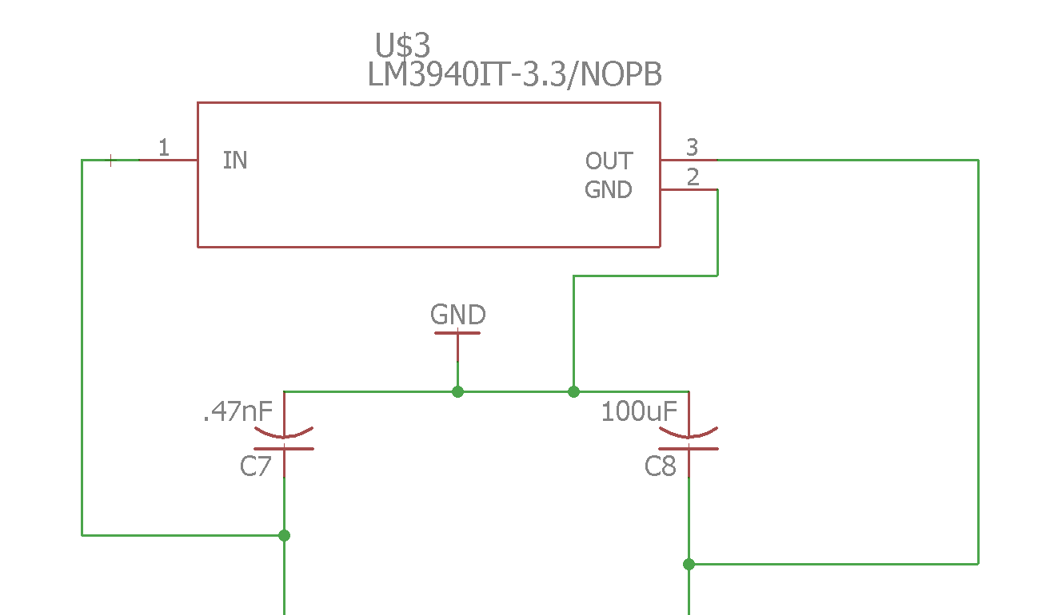

Figure 4. LM3940IT-3.3 implementation from our schematic

## 2.2 Sound

To save costs and decrease design complexity, a pulse width modulation (PWM) implementation of a speaker was used. A PWM signal driven at 100kHz by the microcontroller was to be used, and filtered with a low-pass filter to 20 kHz, which is the range of a human’s hearing (20Hz-20KHz)[x].

For the low-pass filter with a cutoff frequency of 20 kHz, a .1 capacitor was used. To calculate the resistance:

(Equation 3)[x]

Solving for R:

An implementation can be seen below:

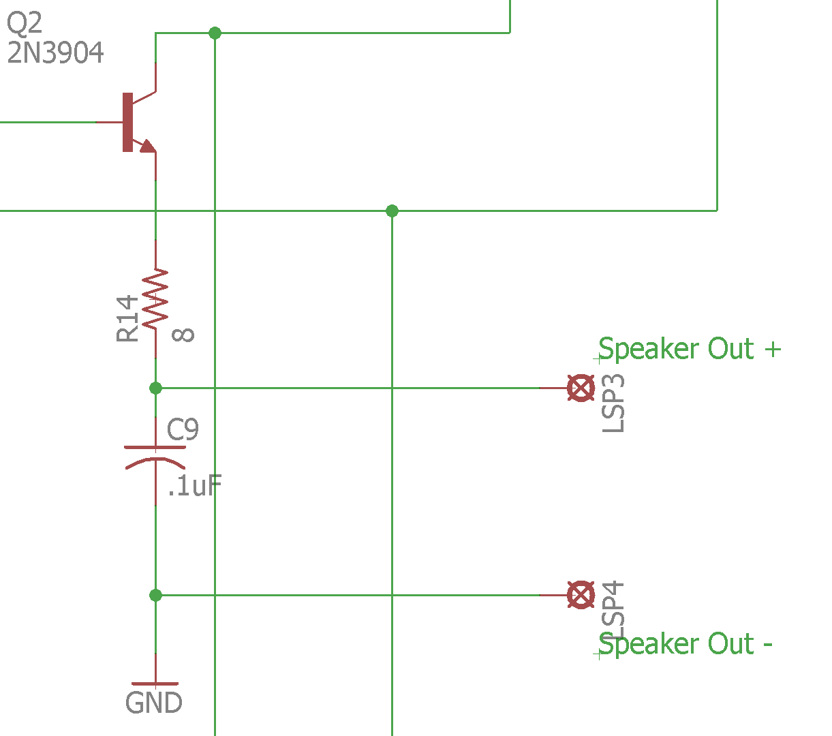

Figure 5. Speaker Modulation with Capacitor

## 2.3 Microcontroller

In order to interface each module with one another, it was necessary to include a microcontroller to act as the “brains” of the project. We went with the Atmel UC3L016, a microcontroller we chose over the other microcontroller of the AT3 series. Its low power requirement, high performance, and support for high code density projects were ideal for the battleship implementation we had in mind.

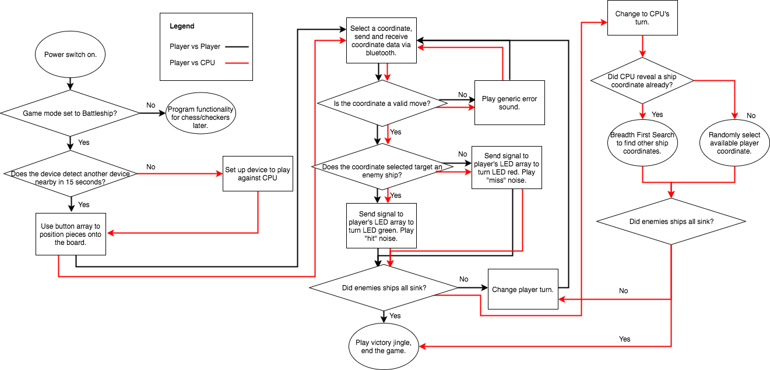

Figure 6. Flowchart of microcontroller logic.

While programming the microcontroller it was important to map the appropriate inputs to the appropriate outputs. Figure 5 shows the flowchart we used to help us accomplish this task. It was important to separate the player vs player logic from the player vs computer logic due to the fact that they required noticeably different functionality. The CPU required automatic button selection, while PVP mode required the user and the opponent to alternate button presses. In order to sync the gameplay properly it was necessary to include Bluetooth chips to detect each players’ selection.

## 2.4 Bluetooth

To implement wireless communication we decided to go with the HC-05 Bluetooth chips. Aside from the ease of programming, the most important feature of the HC-05 chips was the fact that it was possible to set the chip as either master or slave. The programming mode of the chip also required a relatively small voltage input to the KEY pin, 3.3V, which is easily supplied by the battery circuit. Last but not least, the Bluetooth chip supported long distance communication, up to 30 ft.

The primary concern of including the Bluetooth chip is how increasing distance will affect the latency of our device. In order to derive the latency’s dependence on distance, we use the following equation:

(Equation 3)[x]

For the bluetooth chip we are using, the baud rate *r* will be 38400 and the bits transmitted *b* will be 8, according to the datasheet. Because the device is wireless, the propagation speed *s* will be the speed of light, 3 x 108 m/s. With the values we acquire from the datasheet it will later be shown that latency is mainly dependent on the baud rate of the device.

## 2.5 Button Input

For the user interface, we needed to decide how to control our device. Originally we wanted to use a touchscreen interface in order to control the device. Ultimately we decided to go with a button-controlled display due to the fact that it was much easier to program and a lot more cost effective.

The problem we had with going forward with the Button was how to interpret where it was on the board when it is an input since one pin had to constantly be the source and the other pins from the button array was to consider the input. The problem was solved by running a 74hc595 parallel shift mux register at a very quick rate to ‘power’ a potential column for button press which the 74hc165 parallel input mux. Would read the row it was pressed in.

One of the other limitations for the button board was the power limitations. It has been tested to run at 3.3V, but preferable at 5V since the parallel registers become intermittent powered anything below that.

## 2.6 LED Screen

My constraints on power were based on the supply my partner has already designed. I had this in mind when designing my circuits. An array of LED seemed to draw too much power for my partner’s circuit. So I made the following tests before finishing design in Further videos were made of the LED array lighting up at 5V and at 3.3V into shift registers. The reason to test at these values is to assure if the LED display will still light if the microcontroller will read in 3.3V for Vcc or 5V for Vcc from source. A mixture of input voltage settings and power going into shift registers has not yet been tested. These results give me confidence in my design and any limitations on power that we might have. It is worth mentioning the LEDs are very bright in the LED display, so if we were to lower the power to the LED array, I am sure it could still be detected. The LEDs do seem to look brighter looking at the board head on, so I tried soldering so all the LEDs pointed perpendicularly to the board. Further tests will be made as to constraints on signal and timing of information coming into array.

# 3. Design Verification

Below are our verifications after the device was designed.

## 3.1 Power

The desired outcome for power was for the TPS61090 chip output 5V until the battery was less than 3.5V. The original R&V (Appendix A) said 3.0V but this was a mistake, as the battery is fully empty by 3.3V. The rest of the modules were fine.

### 3.1.1 Charging

For charging, the requirements were to stop charging at 4.2 .1V. After the battery was near full, it was left to charge, and then the current going into the battery was zero amps, the battery was at 4.145V, which is within the verification range.

The other requirement was that the battery took less than five hours to charge. Below is a graph showing one hour of charging the battery.

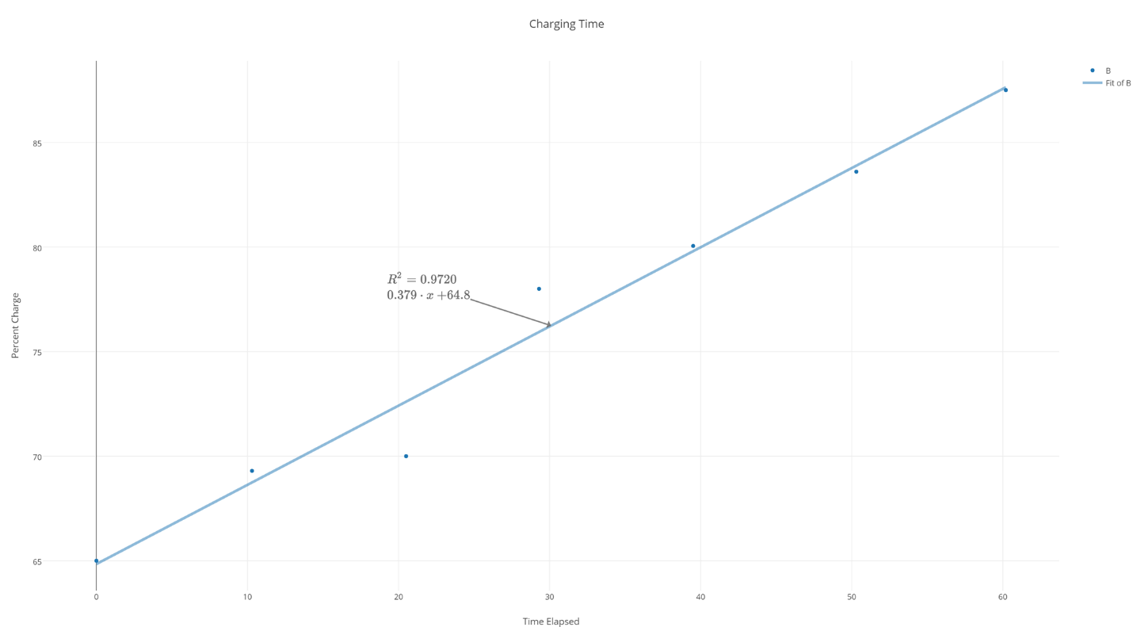

Figure 7. Charging rate of battery

Charging was mostly linear. The rate of charge of the battery was .379% per minute of charging. Since from full to empty is 100% battery charge, we can calculate the length of a full charge:

Therefore, the charging time is within the requirement.

### 3.1.2 5V and 3.3V Voltage Converters

For the main power supply, the outputs were supposed to be 5V for the boost converter and 3.3V for the regulator, when the battery is in operating range. Below is a graph showing input voltage against output voltage of the boost regulator:

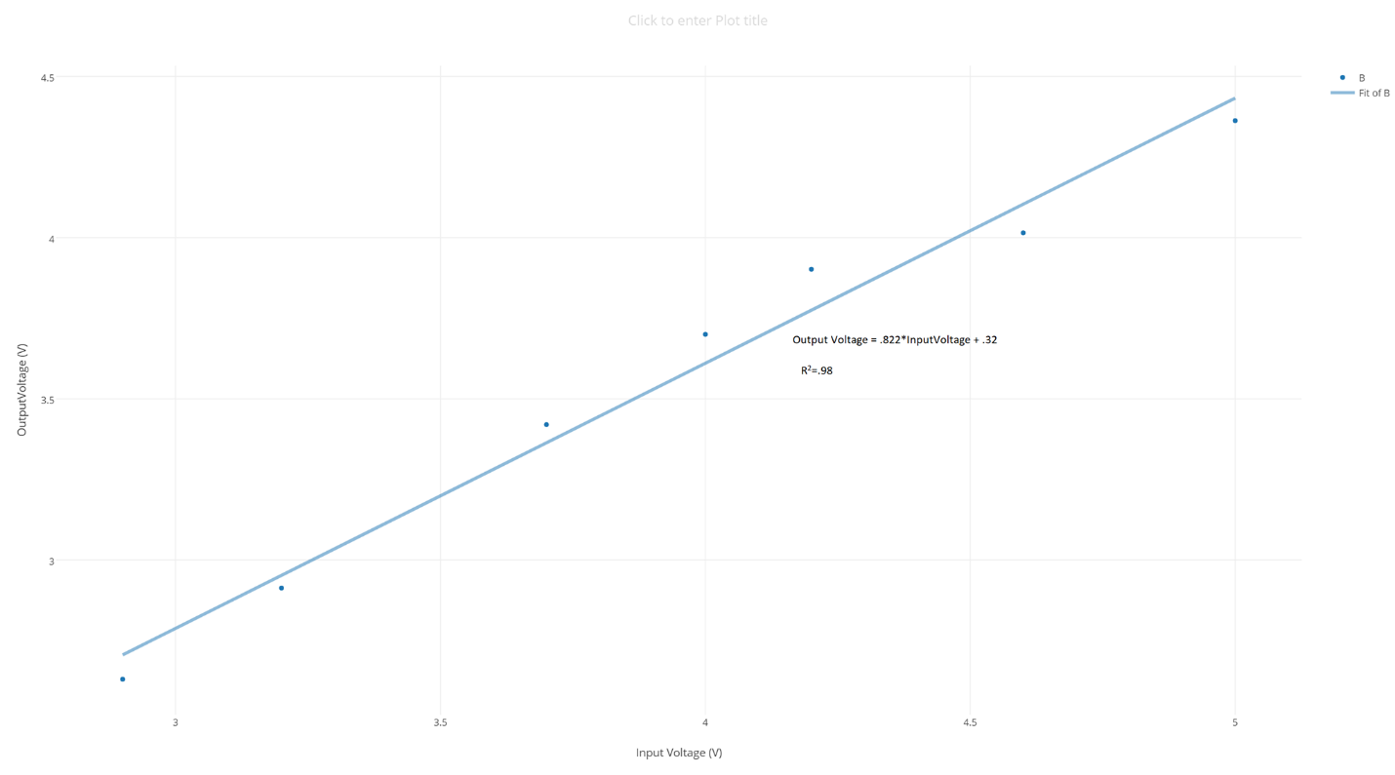

Figure 8. Input vs Output Voltage Through 5V Regulator

As noted in the graph, the output voltage was not with the range of 5V .5V at all ranges, and behaved linearly. This ended up not affecting the project, as the speaker was still functioning normally even at the voltage the boost converter outputted. However, the UVLO never kicked in. After changing many resistor values, nothing seemed to change. Another PCB was soldered as well but it had even more strange results. The reason for this is possibly the pads on the PCB, which were designed for a reflow oven and not meant to be hand soldered. This meant I couldn’t get solder to stick on each pad, meaning some pads may not have connected with the chip.

The 3.3V regulator worked fine until the device got within the UVLO range, outputting near a consistent 3.25V.

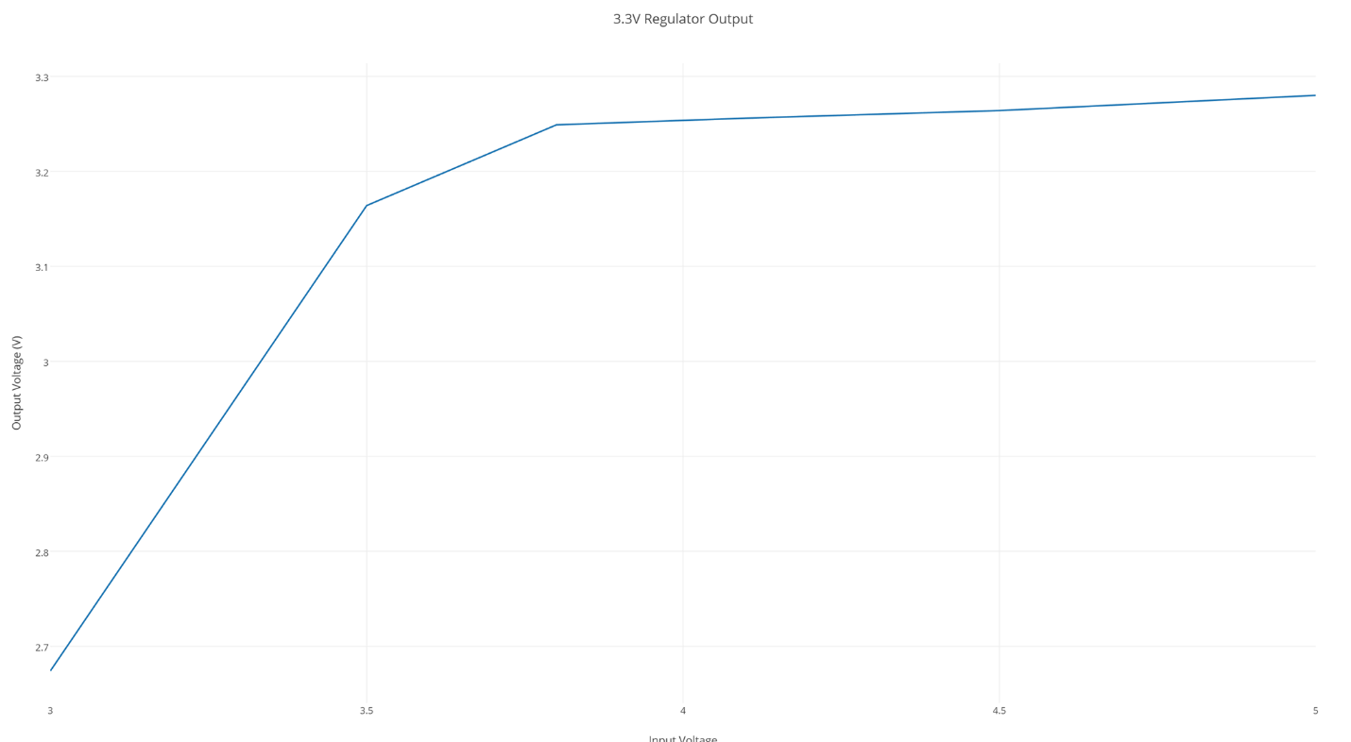

Figure 9. Input vs. Output voltage of the 3.3V voltage regulator

## 3.2 Sound

After testing, the speaker worked quite well. The audio was clear within 5 feet, and the microcontroller was can output a PWM signal. However, since the microcontroller was never implemented, this was not tested, but on the product specifications. Without the microcontroller working, the sound was not tested to be similar to the original sound, however testing several frequencies on a function generator worked. Below is the first order roll off of the RC low-pass filter:

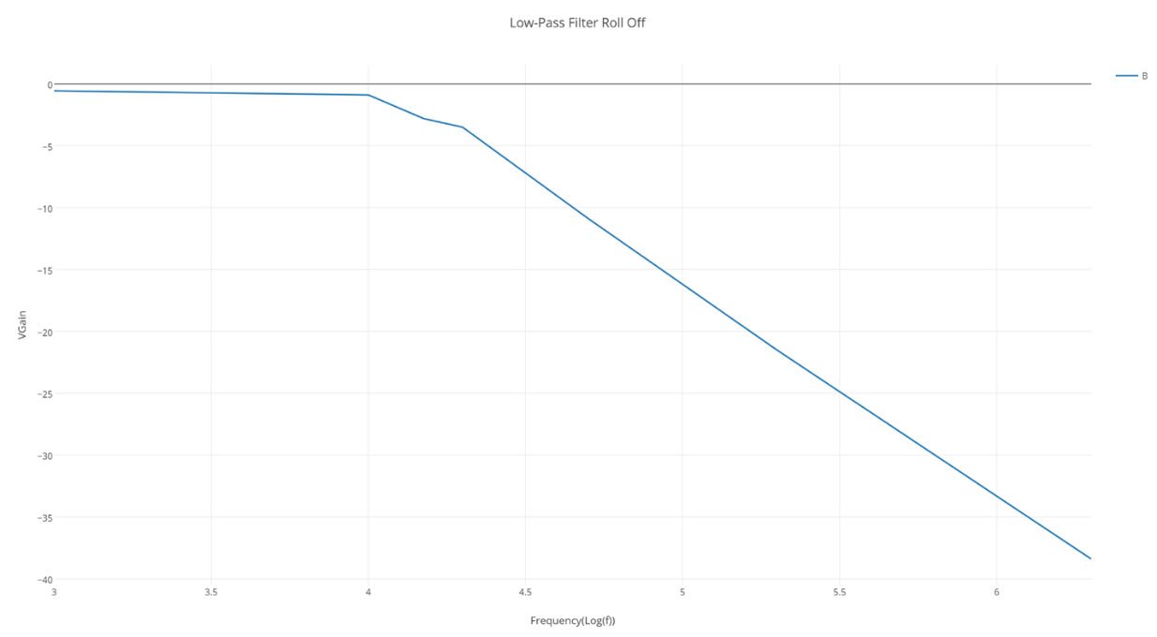

Figure x. Roll Off of Audio Filter

While not exact, the cutoff frequency and slope were pretty similar to the values they should have been.

## 3.3 Microcontroller

For the microcontroller to work within the context of our project we set several goals for it. Firstly, we wanted each battleship turn to be less than 50ms in order to reduce overall latency and gameplay time. In order to test this, we fed a 1 KHz square wave input into through the button shift register and probed the LED of the corresponding button on the LED array. The results are shown below in figure x.

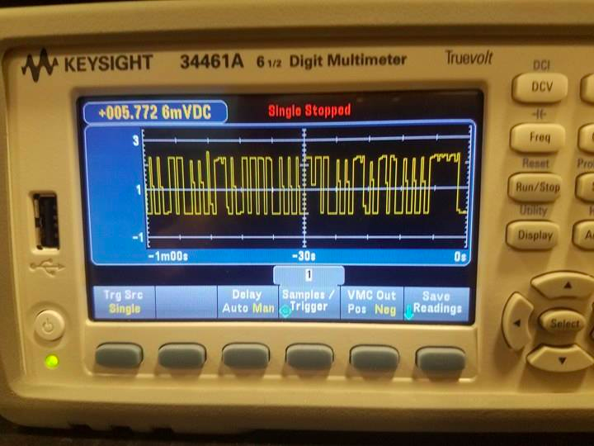

Figure 10. Output voltage from LED

As shown, we were able to achieve a latency of 20 ms, far below our 50 ms target.

The other main requirement we had for our microcontroller was that it was able to interface properly with the Bluetooth chip and light up our entire LED board. While we weren’t able to get the microcontroller to work with the Bluetooth, we did manage to light up the entire LED array with red, green, or blue. We were not able to get a combination of all colors to work on all LEDs, though this does not affect our gameplay functionality. Should we expand our device to support other game, this may prove to be an issue.

## 3.4 Bluetooth

Although we were not able to implement Bluetooth support, we did take a look at the experimental values of the Bluetooth chip and graph the latency dependence on distance.

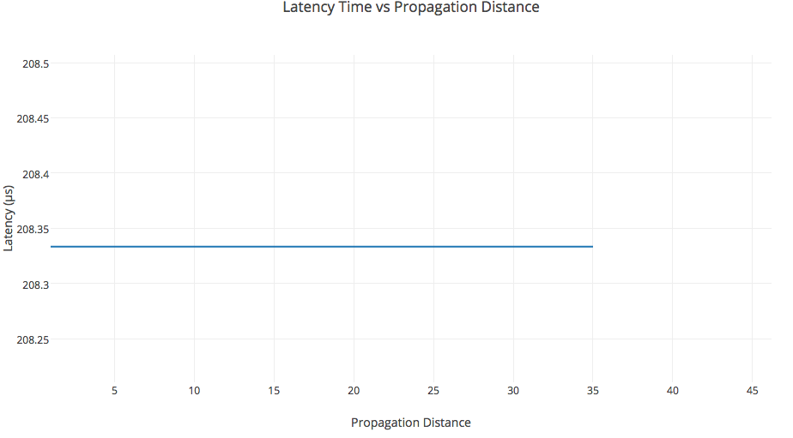

Figure 11. Latency dependence on Bluetooth distance

As shown, the distance between the devices should have a minimal effect on the latency, due to the fact that the transmission delay far outscales the propagation delay. As a result, below the cutoff distance of 35 feet, latency time should be on average 2x10-4 s, far below our requirement of 50 ms. Above the cutoff distance latency is theoretically infinite, as no transmission will occur.

# 4. Costs

## 4.1 Parts

|  |  |  |  |  |  |  |
| --- | --- | --- | --- | --- | --- | --- |
| Description | Manufacturer | Supplier | Part No. | Quantity | Cost | Total |
| Speaker | CUI Inc. | DigiKey | CDMG15008-03A | 1 | $2.58 | $2.58 |
| MicroUSB Connector | Molex | DigiKey | WM9734CT-ND | 1 | $1.06 | $1.06 |
| Microcontroller | Atmel | Microchip Direct | AT32UC3L0256-AUT | 1 | $7.28 | $7.28 |
| Voltage booster | Texas Instruments | Texas Instruments | TPS61090 | 1 | $2.52 | $2.52 |
| Charging Module | Micro Chip | Digikey | MCP73871-2CCI/ML | 1 | $1.84 | $1.84 |
| 3.3V Regulator | Texas Instruments | Mouser | 926-LM3940IT-3.3NOPB | 1 | $1.65 | $1.65 |
| Microcontroller | Atmel | Microchip Direct | AT32UC3L016-AUT | 1 | $3.67 | $3.67 |
| RGB LED | DHgate.com | DHL Free | 386452483 | 146 | $0.04 | $5.84 |
| Push Button | CW industries | digikey | GPTS203211B | 64 | $0.70 | $44.80 |
| 3 Stage Switch | AliExpress | AliExpress | DSC0011 | 10 | $3.42 | $3.42 |
| Bluetooth Chip |  | Newegg | HC-05 | 1 | $5.41 | $5.41 |
| Custom Case |  |  |  | 1 | ~$50 | ~$50 |
| MOSFET | Fairchild | Digikey | 2N3904FS-ND | 1 | $0.18 | $0.18 |
| Battery - 2500 mAH, Li-Ion |  | Gear Best | INR18650 | 2 | $4.73 | $9.46 |
| Battery Connectors |  |  |  | 1 | ~$5 | $5 |
| Pre-Biased Semicunductor | ON Semiconductor | Digikey | MUN2211T1GOSCT-ND | 1 | $0.16 | $0.16 |
| Grand Total: |  |  |  |  |  | $143.65 |

Table 1. Parts List

## 4.2 Labor

|  |  |  |  |  |
| --- | --- | --- | --- | --- |
| Member | Salary | Overhead | Hours | Total |
| Jonathan | $32 | 2.5x | 250 | $20,000 |
| Colin | $32 | 2.5x | 250 | $20,000 |
| Elizabeth | $32 | 2.5x | 250 | $20,000 |
| Grand Total |  |  |  | $60,000 |

Table 2. Labor Costs

## 4.3 Grand Total

Part values were multiplied by two to build two modules to test.

|  |  |
| --- | --- |
| Part | Cost |
| Labor | $60,000 |
| Parts | $287.30 |
| Grand Total | $61012.10 |

Table 3. Grand Total

# 5. Conclusion

## 5.1 Accomplishments

Many of the individual parts worked, however with the microcontrollers unable to be programmed, we could not get the project to integrate all together.

## 5.2 Errors

There is no concrete explanation for why the voltage feedback on the power device did not work. All the resistors were in place; however, the chip did not function correctly. This may be because the pads were not the correct size, or the chip might have been damaged when soldering it to the board. We also could not get the microcontroller to be programmed on time. It would have most likely been better to put the chip on another board for easier programming, as there was no easy way to program it for functionality without soldering. When we would have soldered it to the board, if it didn’t work correctly there would be no way to re-program it.

## 5.3 Ethical considerations

One of our constraints for this project is to make the project portable, so we figured to go forward with the Lithium Ion battery which is large enough in energy for portability. We have been accepted to use Li Ion batteries. For testing, we will use the bench initially if we can avoid the battery, but for testing the power circuit we will test with the battery. When we are done with the batteries, we will place the batteries in the battery bag and ammo box before storing in the yellow locker. We did look at certain safety conditions and procedures in the case of a fire or burning for Li Ion batteries.

When designing the device, we made sure to keep in mind the ethics of using a powerful device according to the IEEE[x] code of ethics. For power concerns, current output was limited to less than 2 amps. Anymore and the device won’t function. There’s also UVLO protection to protect the batteries from harm.

This statement does show our respect and understanding of the IEEE Code of Ethics (3),(5) and (6). The team will be sure to be honest about the safety of the product for public use. When it comes down to the public, we will follow the IEEE Code of Ethics (1),(3),(7) and (8). If the occasion related to the IEEE Code of Ethics (2) and (4,) we will abide the code.

## 5.4 Future work

After receiving the PCB, there were three small design errors. While it worked overall, it would have worked better with several changes, which is why a new PCB would be designed to be exactly correct. We plan to finish implementing the microcontroller functionality, as well as fully integrate our product in a portable device free of external wiring.

# References

[1] <http://www.powerstream.com/lithium-ion-charge-voltage.htm>

[2] <http://www.ti.com/lit/ds/symlink/tps61090.pdf>

[3] <http://www.ti.com/lit/ds/symlink/lm3940.pdf>

[4] <http://www.dspguide.com/ch22/1.htm>

[5] <https://en.wikipedia.org/wiki/Low-pass_filter>

[6] *Motorola Semiconductor Data Manual,* Motorola Semiconductor Products, Inc., Phoenix, AZ, 2007.

[7] *Double Data Rate (DDR) SDRAM,* datasheet, Micron Technology, Inc., 2000. Available at: <http://download.micron.com/pdf/datasheets/dram/ddr/512MBDDRx4x8x16.pdf>

[8] Linx Technologies LT Series, web page. Available at: <http://www.linxtechnologies.com/products/rf-modules/lt-series-transceiver-modules/>. Accessed January 2012.

[9] J. A. Prufrock, *Lasers and Their Applications in Surface Science and Technology,* 2nd ed. New York, NY: McGraw-Hill, 2009.

[10] W. P. Mondragon, “Principles of coherent light sources: Coherent lasers and pulsed lasers,” in *Lasers and Their Applications in Surface Science and Technology,* 2nd ed., J. A. Prufrock, Ed. New York, NY: McGraw-Hill, 2009, pp. 117-132.

[11] G. Liu, “TDM and TWDM de Bruijn nets and shufflenets for optical communications,” *IEEE Transactions on Computers*, vol. 59, no. 1, pp. 695-701, June 2011.

[12] S. Al Kuran, “The prospects for GaAs MESFET technology in dc–ac voltage conversion,” in *Proceedings of the Fourteenth Annual Portable Design Conference*, 2010, pp. 137-142.

[13] K. E. Elliott and C. M. Greene, “A local adaptive protocol,” Argonne National Laboratory, Argonne, IL, Tech. Rep. 916-1010-BB, 2006.

[14] J. Groeppelhaus, “Java 5.7 tutorial: Design of a full adder,” class notes for ECE 290, Department of Electrical and Computer Engineering, University of Illinois at Urbana-Champaign, 2011.

# Appendix A Requirement and Verification Table

I/O

|  |  |
| --- | --- |
| Requirements | Verifications |
| 1. Simple, easy to control user interface.    1. User interface is limited to three controls: on/off switch, button array, and game mode switch.    2. Board offers low latency between commands, <50 ms. 2. Users are able to place pieces on the logical display through button presses. 3. Interface is attractive to the eyes and not harmful by having too high of luminosity 4. Can easily toggle button to be On/Off | 1. Audiences of all ages understand the interface controls.    1. Verify that the interface has 3 controls only.    2. Test latency of the device through a multimeter, confirm the signal delay is <50 ms. 2. Test the touchscreen capabilities, press two coordinates in order to place each piece. 3. The luminosity is 1 which is similar to looking into candle light. 4. Nearly open with 30Ohms when not pressed, and resistive when not pressed with a low resistance, 100mOhm |

Sound

|  |  |
| --- | --- |
| Requirements | Verifications |
| 1. Output is audible from 5ft, with a frequency range of 1-4 kHz. 2. Microcontroller is capable of driving a PWM signal. 3. Sound output is >90% similar to the sound sample. | 1. Verify audio is clear 5 feet away using a sound level meter. 2. Microcontroller uses PWM signal to encode the sound sample. 3. Sample both sounds, verify that the original sound is 90% similar to the speaker sound |

LED Array

|  |  |
| --- | --- |
| Requirements | Verifications |
| 1. Device must be able to communicate and interface with each other as well as each component with <50 ms. 2. Device can interact with a UART Bluetooth chip 3. A single display is able to light all 100 LEDs at once. | 1. Properly interfaces with each module in order to output the correct display info and audio. 2. Verify UART data is received and sent correctly by the MC. 3. Plug in power into the display, press the button array to see if LEDs light up correspondingly on the display board. |

Bluetooth

|  |  |
| --- | --- |
| Requirements | Verifications |
| 1. Able to transmit information between devices at least 304 ft apart. 2. Low latency, data travels between devices quickly (50ms). | 1. Have two devices about 30 ft apart, test to see if devices transfer data properly. 2. Verify there is less than 50 ms between send and receive time for the data transmissions, using a video recorder and checking frames. |

Power

|  |  |
| --- | --- |
| Requirements | Verifications |
| 1. Voltage outputs 55V for the boost regulator and 3.31V for the voltage regulator 2. Shut off the battery when the voltage is less than 3.0V1V | 1. Use a voltmeter to verify both lines, verify that the voltage is in the acceptable range 2. Use a multimeter and verify that current drops |

Charging

|  |  |
| --- | --- |
| Requirements | Verifications |
| 1. Charging takes less than five hours from empty to full. 2. Charging stops at 4.2V1V | 1. Test a full charge cycle with a timer to verify the duration fits the requirement 2. Use a voltmeter to test that the current running into the battery is effectively 0A at 4.2V |