Wireless Sensor Array for Forest Fire Detection

ECE 445 Design Document
Steve Mesi, Travis Sauer and Kenneth Noah Adriatico
Group 2
TA: Anthony Caton
9/25/18

Contents
1 Introduction 3
1.1 Objective 3
1.3 High-­Level Requirements 3
2 Design 5
2.1 Power Circuit 6
2.1.1 Solar Panel 7
2.1.2 Lithium Ion Battery Charger 7
2.1.3 1N4001 Diode 7
2.1.4 Battery Pack 8
2.1.5 Voltage regulator 9
2.2 Microcontroller PCB 10
2.2.1 ATmega 328P 10
2.3 Communication Block 11
2.3.1 XBee Pro 12
2.3.2 GSM Module 14
2.4 Sensor and Button Block 14
2.4.1 Smoke Sensor 14
2.4.2 Flame Sensor 16
2.4.3 Emergency Button 17
2.5 Schematics 18
2.6 Board Layout 20
2.7 Software 21
2.8 Tolerance Analysis 22
3 Costs 23
4 Schedule 24
5 Ethics and Safety 25
References 27

1 Introduction

Objective
Every day we can turn on the news and hear about a forest fire that is out of control, people’s houses at risk of being destroyed, their lives in danger, or firefighters risking their lives. Forest fires have become a huge issue because of their destructive power and their effect on climate. These fires can cause many residual problems to human health as well through their effects on the environment [2]. They contribute to air and water pollution which has harmful effects on both wildlife and humans. Climate change also effects the frequency and severity of these fire because warmer climate leads to dryer conditions which makes fires more prevalent. In turn, the fires release greenhouse gasses into the atmosphere which further contribute to climate change [1].
Our objective is to develop a system that can detect forest fires quickly and notify a user when an incident occurs. The first component of our system is the actual detection mechanism. This will consist of two sensors, a smoke sensor and a flame sensor. We are using two different sensors to account for the different drawbacks in each sensor. The smoke sensor may be more prone to false alarms due to ambient smoke concentrations in the air and the flame sensor will only be able to detect fires within a 60-degree angle [6] in front of the unit. Using these two sensors in conjunction will allow us to have accurate detection while avoiding false alarms. We will also incorporate a button on the sensor unit which will be used to send manual alerts when pressed. The purpose of the manual alerts is to help people who are lost in the wilderness or in any sort of danger. Because this is a remote application it is important that the units require very little maintenance. To accomplish this, each sensor unit will be equipped with two 2.5 watt solar panels which will recharge the 18650 battery cells and allow the system to function indefinitely. We will be implementing a mesh network of sensors using the ZigBee communication protocol. The purpose of the mesh network is to eliminate the possibility of single node system failure. Without a mesh network the entire system could be rendered useless if one of the sensor units is destroyed. With a mesh network, if one sensor unit is destroyed then the signal can be sent to any other node in the network without any issues. Forest fires can travel at up to 6 mph in forests [19] which means that the sensing unit must be able to detect the fire and send an alert within 3.73 seconds assuming a detecting distance of 10 meters.
  - Background
Some of today's forest fire detection methods rely on satellite imaging and optical detection. These methods are unable to detect fires until they are already large and out of control. Current satellite detection methods take images every 15 to 30 minutes and have a detection resolution of up to 1 km [21] for smoke. This means that the fire will have time to grow and spread before the satellite can detect the incident. For this reason, a new method for detection is needed to respond quicker to fires and get them under control. Our system will be able to detect forest fires within 3.73 seconds and will also be able to detect them when they are within 10 meters. This will increase detection accuracy and speed.

1.3 High-­Level Requirements
      - The mesh network must allow the system to function in the event of single node failure
      - The system must be powered by two 2.5W solar panels producing an average output of 519.6mA during the average 10 hours of sunlight per day
      - Sensors must detect fires greater than 10 meters away and alert the user within 3.73 seconds to avoid unit failure

2 Design
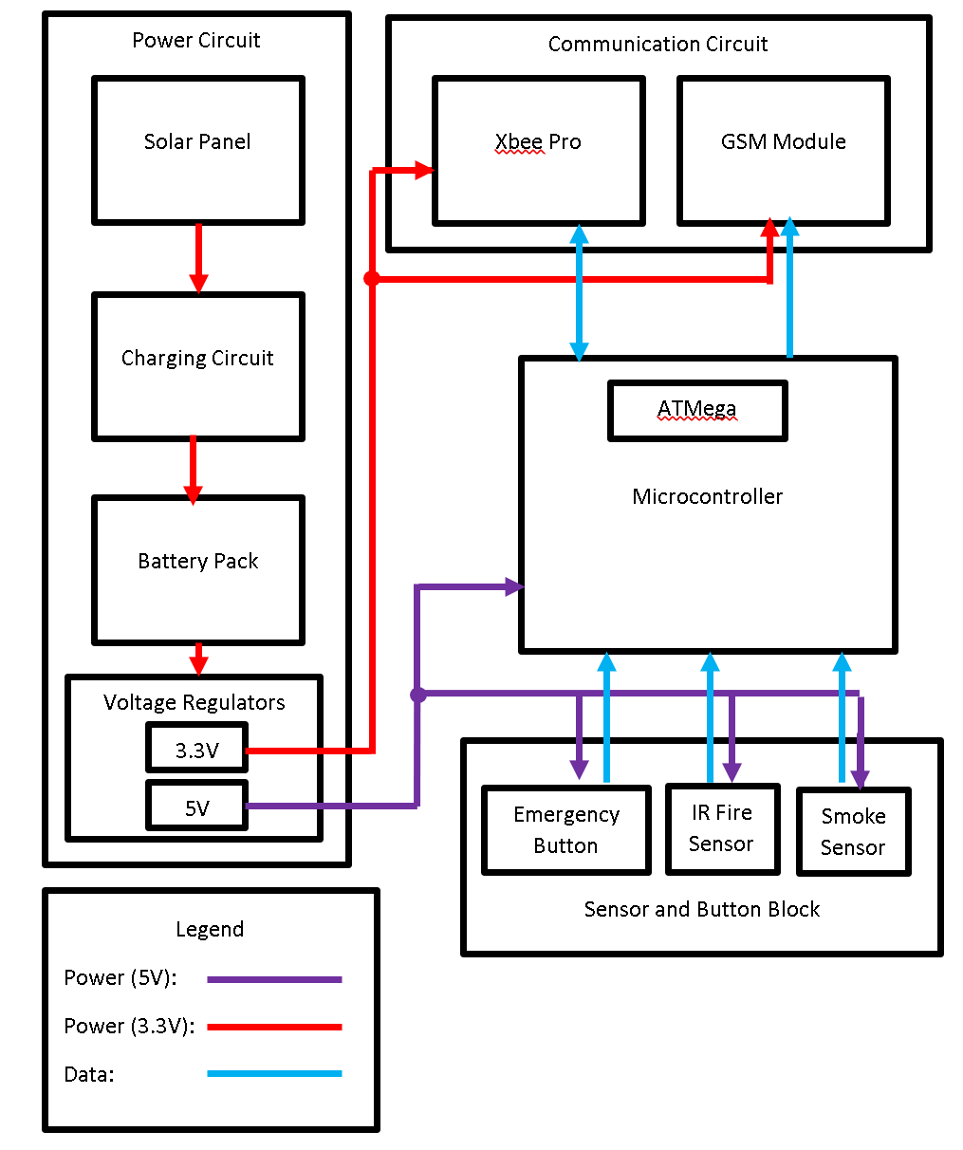
Fig. 1. Block Diagram

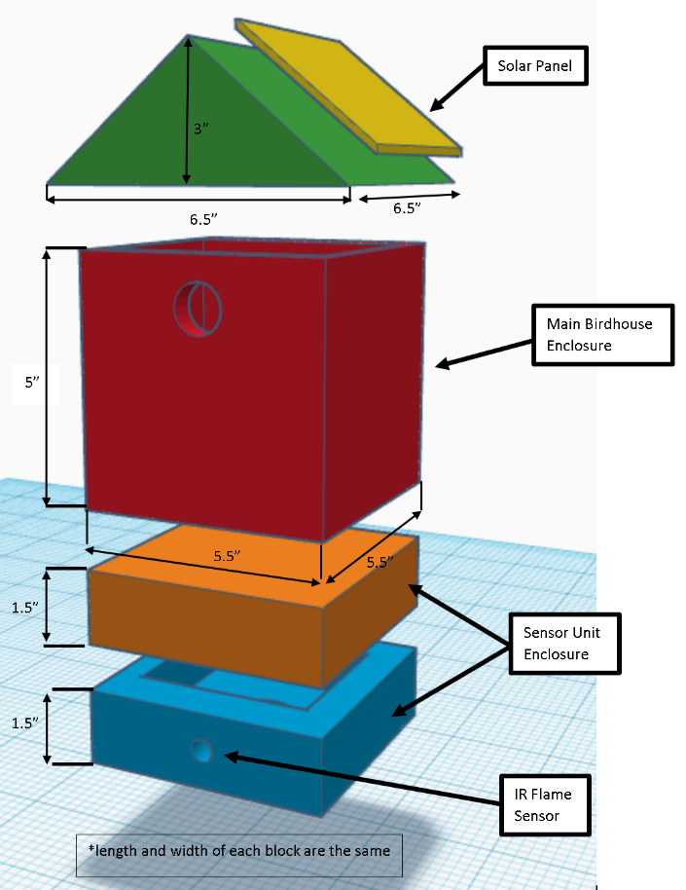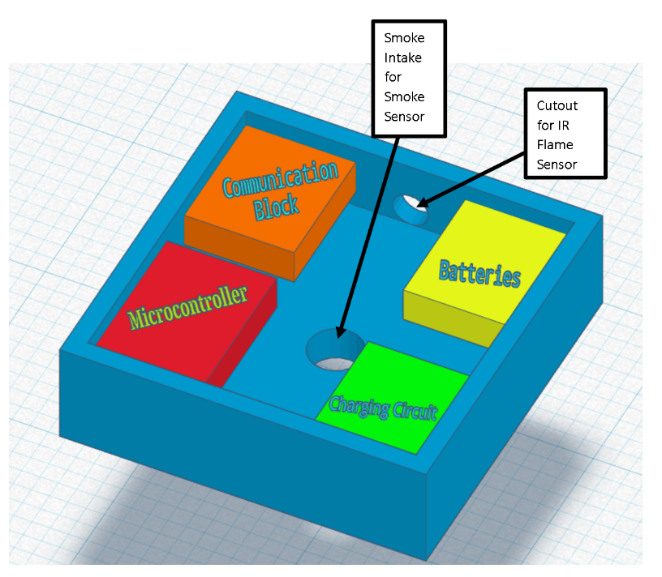
Fig. 2. Physical Design

2.1 Power Circuit
The Power Circuit block is responsible for both the power generation and distribution for the entire sensing unit. This block is essentially focused around the battery pack sub-block; this sub-block is where the power is temporarily stored so it can distribute power to the rest of the system as necessary as the loads will vary; specifically, the battery pack sub-block powers the XBee Pro directly (the communication device that will allow for a Mesh System) and the microcontroller (the programmable ICs that control the entire unit (ATmega328P)). The microcontroller then distributes power to all other components in the unit besides the XBee Pro. Also, inside the Power Circuit block are the Solar Panel and Charging Circuit sub-blocks which allows the unit to self-generate power so that it can continuously recharge the battery pack. In detail, the Solar Panel will generate the power and the charging circuit transfers the power to the Battery Pack in such a way that will not damage the Battery Pack. It also optimizes the power transfer from the Solar Panel to the Battery Pack depending on the Solar Panel’s varying power generation.

2.1.1 Solar Panel
Each unit will be places in a remote location in a forested area. For this reason, they will all be equipped with two solar panels to reduce the maintenance requirements. The two panels with be placed on either side of the birdhouse roof. Wiring them in parallel will double the available current. We chose 5V, 2.5W polycrystalline panels because they are affordable and, when wired in parallel, should produce enough power to charge the batteries. The total average load draws 216.5mA which is 5196mAh per day. With an average of 10 hours of daylight per day, the solar panels need to be able to produce an average of 519.6mA. This current needs to account for the effect of obstructions due to tree cover as well as cloud cover.

Requirements | Verification
Supply an average of 519.6mA at 6±2V to the charging circuit to meet the 5196mAh daily requirement | Place the solar panel in direct sunlight~10,7527 Lux [8].  Use a voltmeter to measure the output voltage of the panel and make sure it is below 8V (the maximum for the charging board) [9].  Use an ammeter to measure the output current and make sure that it is less than 1000mA (the maximum current for the charging board  Repeat the above steps under tree cover and measure the output current to ensure that the average current will be above 519.6mA

2.1.2 Lithium Ion Battery Charger
For charging the batteries, we will be using the TP4056 Linear Li-Ion Battery Charger. This device takes an input voltage from the solar panel and its output terminals are connected to a single battery cell. The input voltage must be 4.2V±1.5% and the current must be below 1A [9].

2.1.3 1N4001 Diode
The diode in that will be used in the charging circuit, as shown in Figure 3, is the 1N4001 diode. The diode was chosen due to its low-cost and high maximum ratings. It has a maximum repetitive reverse voltage rating of 50 volts and a maximum rectified forward current rating of 1 amp. The diode in the charging circuit will be specifically used to prevent batteries attempting to charge other batteries. In result, this ensure the batteries are only charged from the solar panels through the Lithium Ion Battery Charger.
Requirements | Verification
Prevent a reverse current from one battery onto another battery | Connect the batteries as shown in figure 3 and add two 34-ohm resistors in parallel for the load  This will create ~216.5mA draw from the battery pack identical to average expected current draw from the sensing unit  Replace one of the batteries with a 17-ohm resistor  Measure the current across the resistor that replaced the battery  The current measured should be zero

2.1.4 Battery Pack
This is a very crucial component of the design because choosing the correct battery capacity will determine whether the system will function continuously. Our design has an average load of 216.5mA which amounts to 5196mAh per day. We chose to use three 3.7V, 3000mAh 18650 Lithium Ion batteries. We will wire each of the batteries in parallel to achieve a total current of 9000mAh as shown in figure 3. Diodes will be connected at the output of each individual cell to prevent current from the other cells from flowing into it. This is because it can be very dangerous when a battery in parallel with other batteries begins to fail because the other batteries will then dump their current into the failing battery and cause the problem to become worse.

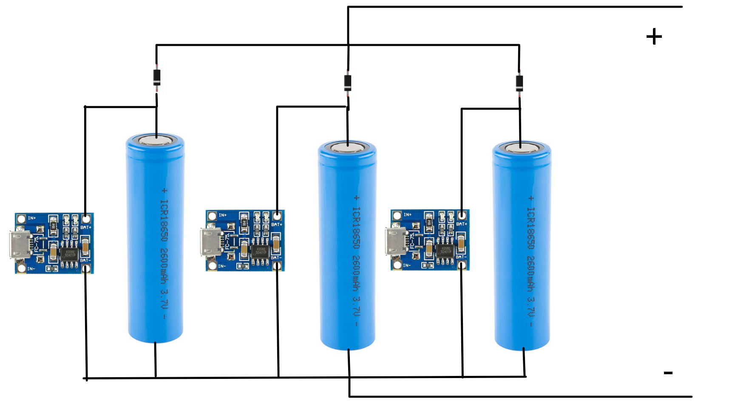
Fig. 3. Battery Connection Diagram
Requirements | Verification
The three-battery system must have a total capacity greater than the basic system requirement of 5196mAh  - The individual batteries must be able to be charged to 3.3V using the output from the solar panel | Construct the circuit shown in figure 3  Connect a load to the positive and negative terminals and hold current constant  Measure the amount of time it takes to discharge the batteries and ensure that it is greater than 5196mAh  Connect the output of the solar panels to each of the charging circuit boards  Use and ammeter to measure the current into each of the individual cells when the charging circuits are on.

2.1.5 Voltage regulator
The power circuit for this project is the most complicated part of the design because there are many different voltage levels that are required and the input voltage to the system is not a constant value because the solar panel output is constantly changing. For this reason, voltage regulators are essential. To achieve a constant voltage of 3.3V we will use the LD1117 voltage regulator. We chose this device because it can convert an input voltage of 5V to a constant 3.3V output, and it also has a maximum output current of 1300mA [12] which is well above what our system requires. No RV table is necessary for this device because there are no requirements that it must meet that are not specified in the datasheet.

2.2 Microcontroller PCB
Microcontroller block will be implemented using the ATmega328P. The ATmega328P will be programmed to handle signals from both Communication Circuit sub-blocks and all the Sensor and Button sub-blocks; it will handle input signals from the XBee Pro, Emergency Button, IR Fire Sensor, and Smoke Sensor sub-blocks. The ATmega328P also needs to be able to transmit signals through the XBee Pro and GSM modules via the serial communication port. The input signals will be processed by the ATmega328P which will determine what output signals need to be sent to the GSM Module or the XBee Pro sub-blocks. In summary, the ATmega328P is the brains of the sensing unit and handles all I/O in the sensing unit and will determine when to send emergency alert signals notifying someone that there is a fire in a specific location.

2.2.1 ATmega 328P
The microcontroller that will process and transmit all data from the various components is the ATmega328P 28 Pin PDIP by ATmel; it is an 8-bit AVR microcontroller in the megaAVR family [5]. This microcontroller was chosen for its cost-effectiveness and dynamic functionality. The chip is USART device making it compatible with a wide range of other devices. Also, the chip has 23 general I/O pins and a max processing speed of 16MHz, which is necessary since the processor will need to do multiple computations simultaneously for extended periods of time. This will also provide flexibility in terms future design upgrades to the units [5]. Most importantly, the ATmega328P has five different power saving modes that can be software enabled; these power saving modes could help drastically reduce power consumption and pro-long the life battery life [5]. The processing power on the chip along with the simplicity of the Arduino based programming language will allow for extremely fast data analysis allowing quick Fire detection.
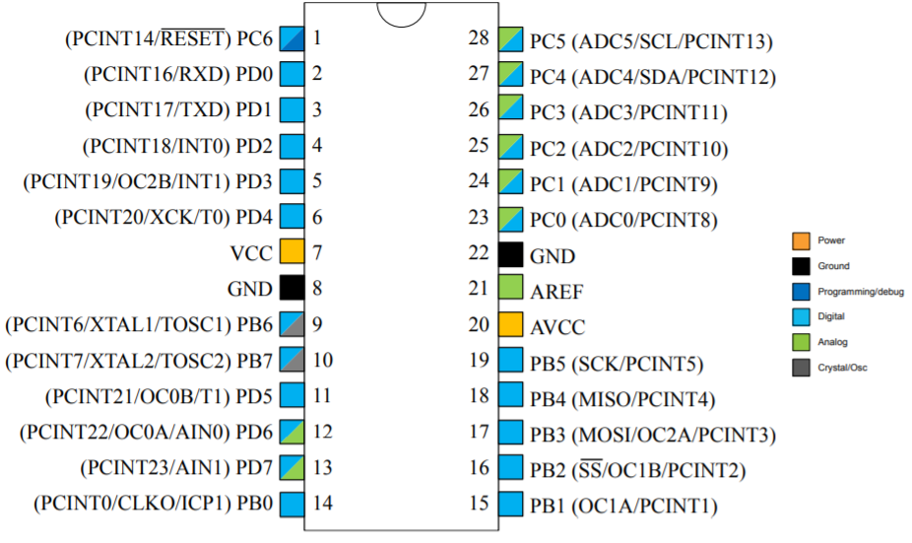
Fig. 4. ATmega328P Pin Layout [5]

Requirements | Verification
Must be able to continuously process data from at least four input pins  - Must have the ability to communicate with both the GSM module and XBee Pro via serial communication port | Connect all four input lines to sensors and XBee Pro to ensure the chip has enough computing power to process all the information  - Transmit data from one XBee Pro to another and check the signal integrity to ensure the serial communication port is compatible with the XBee Pro  - Transmit data from the GSM module to a phone and check the signal integrity to ensure the serial communication port is compatible with the GSM module

2.3 Communication Block
The communication block consists of two sub-blocks, the XBee Pro and the GSM Module. The XBee Pro sub-block transmits and receives signals and is what allows for the Mesh System to be possible as the signals transmitted by the XBee Pro can be sent to multiple units and even relayed through another units’ XBee Pro. For example, if a master unit’s XBee Pro was to fail for whatever reason, the signal would then be sent to an alternate master unit that could interpret the signal, and if necessary, send out a text message alert through the GSM Module sub-block. Also, as mentioned earlier, the XBee Pro is powered directly by the Battery Pack sub-block since it is the one of the larger loads in the unit and would not be able to be powered through the Microcontroller without burning it up. The other sub-block in the Communication Circuit block is the GSM Module; this sub-block can only transmit signals and would only be installed on the master units. The sole purpose of this sub-block is to communicate with the Microcontroller and send out an emergency alert signal via text message if any of the sensing units have detected a fire. In summary, these two communication devices are what allows the Fire Detection System to have such quick and efficient way of transmitting signals so that alerts are received as soon as possible.

2.3.1 XBee Pro
One of the most important aspects of this project is the mesh network functionality. This functionality is implemented using the XBee Pro module. These modules use the Zigbee standard to provide low energy mesh network solutions for communication. They use the IEEE 802.15.4 networking protocol for RF communication. For our project to offer sufficient coverage we require communication distances up to 100 meters in forested areas. For this reason, we have chosen a higher powered XBee module with a transmission power of 60mW. This module has a maximum communication distance of 1-mile LOS [4]. Taking into account trees and other obstructions this module should be able to meet out 100-meter requirements.
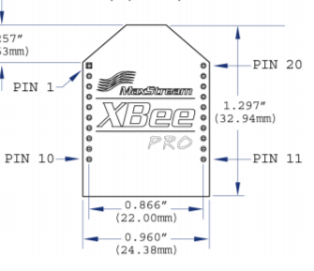
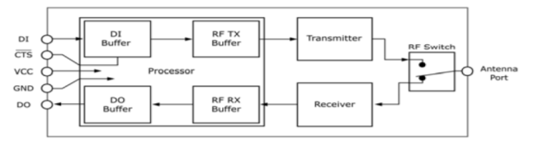
Fig. 5. Xbee Pro Pin Descriptions and Dimensions [4]

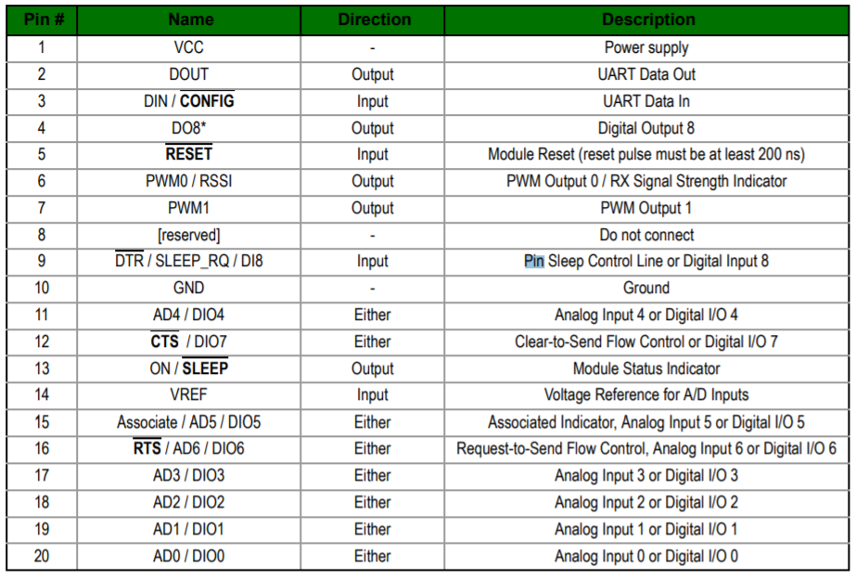
Fig. 6. Xbee Pro Pin Descriptions [4]

Requirements | Verification
Must be able to communicate with other XBee modules at distances up to 100 meters in forested area. | Connect two XBee modules to separate Arduino Unos for testing  Find a forested area such as a park or forest preserve  Measure distances in 10 meter increments between the two XBees and test communication between them  Move further away until the modules can no longer communicate  Record the maximum communication distance and make sure it is greater than 100 meters.

2.3.2 GSM Module
The main advantage that this sensor array has over current forest fire detection systems is its ability to detect fires before they are out of control and alert the user quickly. To send alerts to the user we will be using the GSM network to send text message alerts containing an emergency message with the location of the incident. This will be accomplished using the SIM900 GPRS/GSM board along with a SIM card. This allows the unit to access the 2G GSM network. We chose this board because it is an inexpensive solution that has a very low sleep current draw (1.5mA) [10]. The only time the board will be drawing significant power is when it is transmitting data which will only be when an emergency signal need to be sent. Messages can be sent using AT commands and serial communication.

Requirements | Verification
Must be able to connect to a 2G GSM network when the sensor unit is located in a remote location | Connect the GSM module to the Arduino’s serial pins  Find a forested area such as a park or forest preserve  Use AT commands to send SMS alerts to a phone  Make sure that the GSM signal is strong enough to alert the user

2.4 Sensor and Button Block
The Sensor and Button block consists of three sub-blocks: emergency button, IR Fire Sensor, and the Smoke Sensor. The Emergency Button is the most recent upgrade to the sensing unit; it allows the sensing unit to duel as both a fire detection unit and an emergency alert system for someone who is stranded in the woods. Since these units would theoretically be spread across the wilderness in remote areas, the idea was to have them also function as emergency alert systems. So, if someone was to come across one while lost they could simply press a button, alerting a search and rescue team to be sent. Next, the IR Fire Sensor and Smoke Sensor sub-blocks are what allow the sensing unit to actually detect fires. These sensors will constantly be sending data to the Microcontroller so that once the sensor values hit certain limits the Microcontroller will then determine that there is a fire. Once this happens, the Microcontroller would immediately have either the XBee Pro or GSM Module transmit an emergency signal depending on if it is the master or slave unit.

2.4.1 Smoke Sensor
The smoke sensor module is the first line of defense against forest fires. Smoke will be present before any flames are close enough for the flame sensor to detect. We chose to use the MQ-2 Smoke Detector Board because it is inexpensive and sensitive enough to detect smoke at concentrations of 300 to 10,000 ppm [11]. For our project we do not want the sensitivity to be set at such a low value because this would likely cause many false alarms. One drawback of using this sensor is its large power consumption with a maximum of 181mW [7]. This is an issue for out project because of the power restrictions on the solar panels and battery pack.

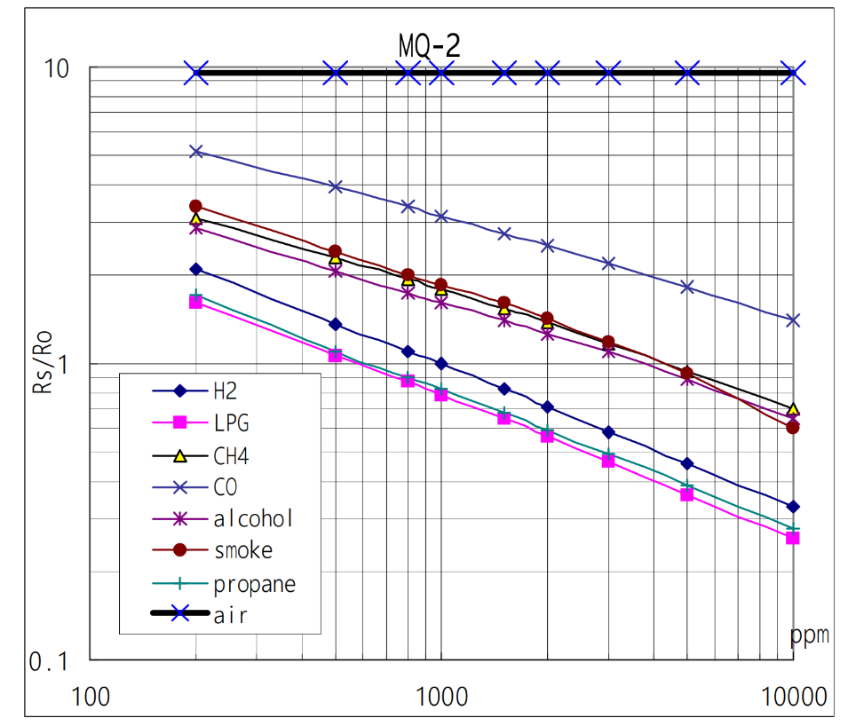
Fig. 7. Smoke Sensor Sensitivity Characteristics [11]

Requirements | Verification
Must be able to accurately detect smoke at concentrations of 0.5±0.25% | Connect the gas sensor to an Arduino for testing  Produce a concentration of smoke between 2500 and 7500 ppm.  Monitor the digital I/O pin on the smoke sensor which will indicate when it detects the smoke  Record the time it takes to detect the smoke
Must be able to distinguish between real forest fires and false alarms such as nearby controlled camp fires | Measure smoke concentrations in air on a burn day  Measure smoke concentrations in smaller confined space with built up smoke  Measure smoke concentrations when having a nearby camp fire  Determine a threshold smoke concentration for consistent general fire detection  Add a constraint that requires the threshold smoke concentration to be present for 5 seconds before triggering  Test these parameters on a variety of fire types and adjusts the parameters as needed

2.4.2 Flame Sensor
Although it is likely that the smoke sensor will detect a forest fire before it is close enough for the flame sensor to detect, the flame sensor is a second line of defense if the smoke sensor fails. We chose the flame sensor because it is a cost-effective option that can detect IR radiation at a distance. The sensor has a detection angle of 60 degrees and detects wavelengths between 760nm and 1100nm [6]. The documentation states that the sensor can detect flame from a lighter at 80cm. We suspect that, with the increased size of the flame source, the sensor should be able to detect the flame at 10-meters.

Requirements | Verification
Must be able to accurately detect a flame at 10-meters | Connect the flame sensor to an Arduino for testing  Create a 1 square meter flame source in a fire pit  Monitor the digital I/O pin on the smoke sensor which will indicate when it detects the smoke  Move further and further away from the fire until the sensor can no longer detect the flame  Record the maximum detection distance and verify that it is greater than 10-meters

2.4.3 Emergency Button
While these units will be very helpful in preventing the spread of forest fires they have all the necessary components for another purpose. We will include an external two pin push button, depicted in figure 7 below, which will allow people who may be lost in the wilderness or in need of help to request assistance. When the button is pressed, the sensor unit sends an emergency alert indicating that the emergency button has been pressed and tells the operator where the alert was sent from. This is an inexpensive addition to the project that is very simple but has the potential to save lives. One terminal of the button will be connected to ground and the other will be connected to a digital I/O pin on the controller, and the internal pull-up resistors will be activated.

2.5 Schematics
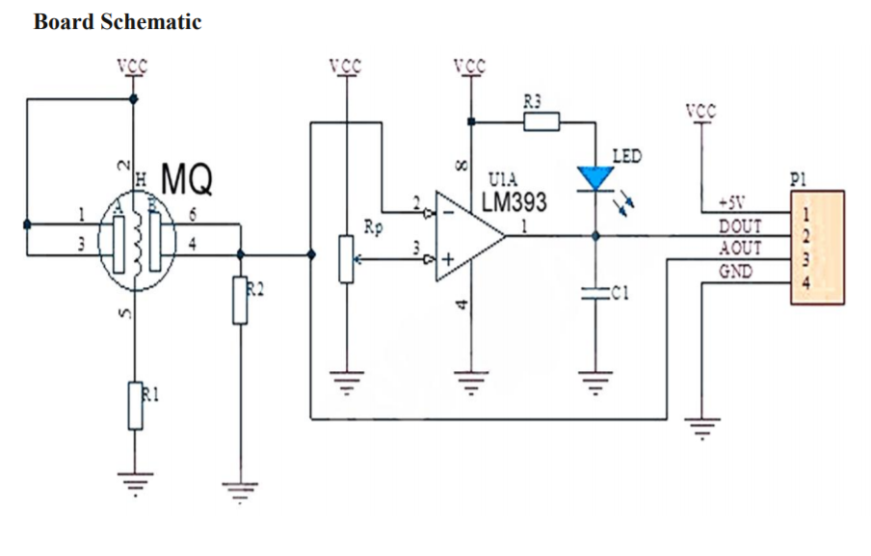
Fig.8. Smoke Sensor Schematic [7]
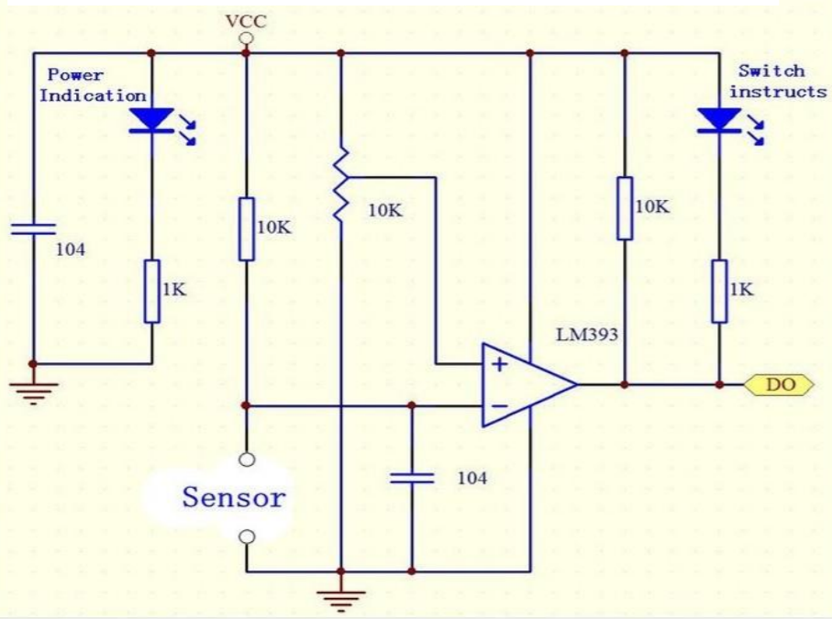
Fig.9. Flame Sensor Schematic [6]

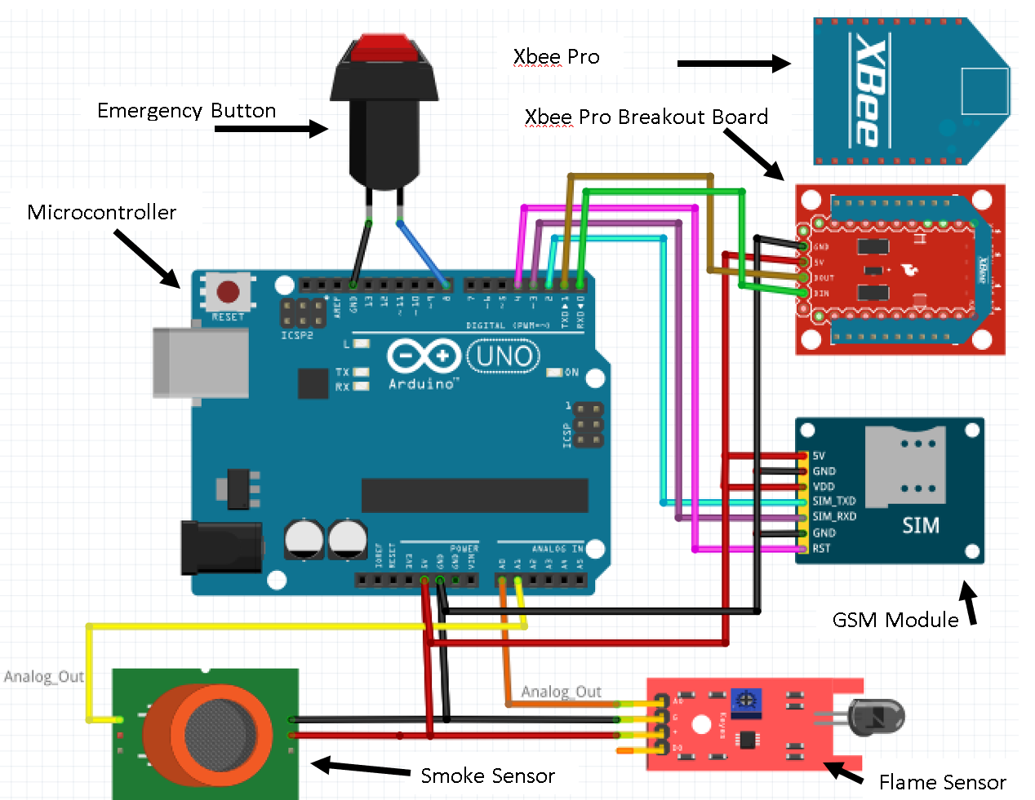
Fig.10. Sensor/Communication Circuit Layout

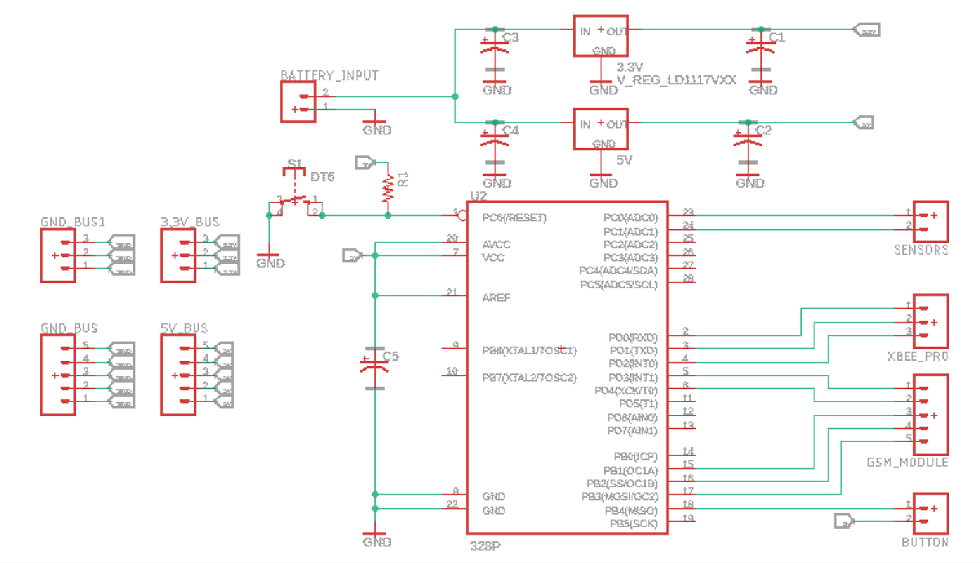
Fig.11. Microcontroller (ATmega328P) Circuit Layout

2.6 Board Layout

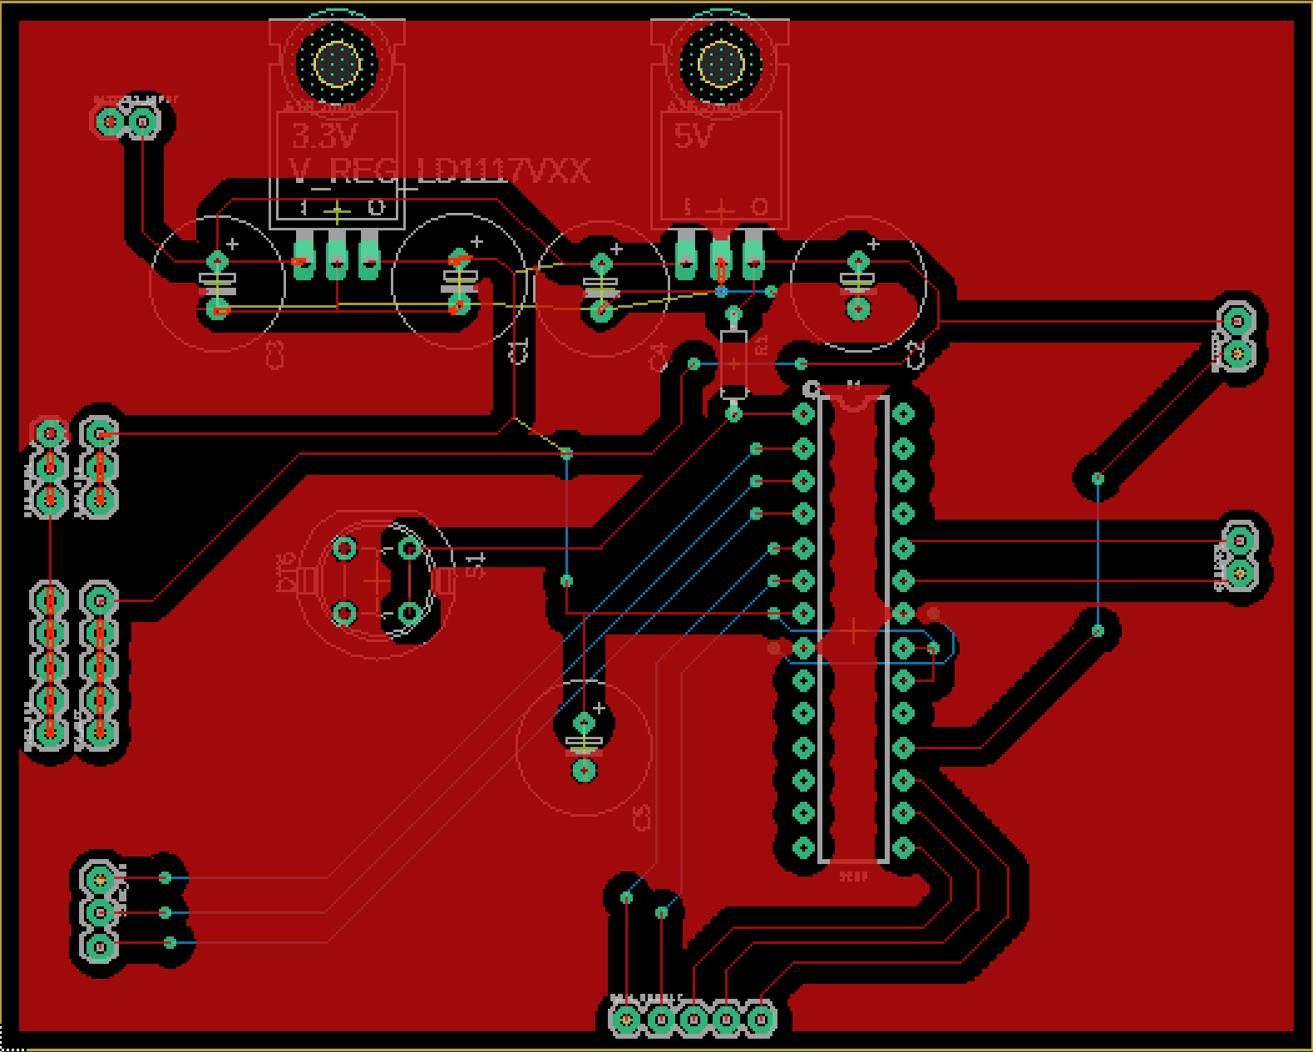
Fig.12. Eagle PCB Layout

2.7 Software
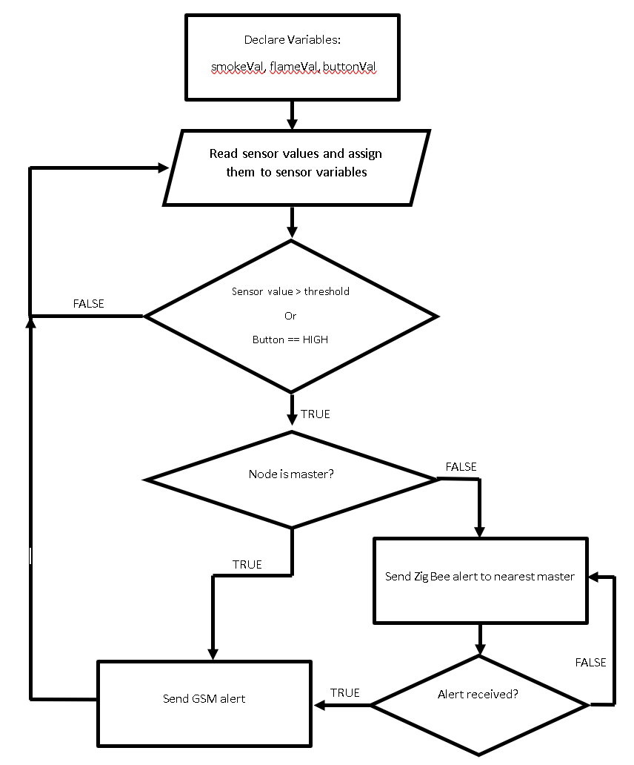
Fig.13. Program Flow Chart

2.8 Tolerance Analysis
For the sensor units to be effective and function properly there are three design elements that need to function properly. The power circuit needs to provide enough power to supply all the circuit elements, the sensors need to be able to detect a fire occurrence, and the XBee modules need to be able to communicate in a wooded area. Of these requirements the most crucial is the power circuit because without power the unit cannot function at all.
One of the most important tolerance that must be meet is the tolerance associated with the XBee Pro. This is because the sensor units must be able to function as a mesh network for there to be meaningful coverage and reliability. The XBee Pro must be able to reliable send and receive information and this is dependent on the input voltage to the unit. If the input voltage varies too much, then data can be lost or misinterpreted.
The XBee Pro can function on an input voltage between 2.8V and 3.4V. This gives us the following tolerance shown in Eq. 1:
$$tolerance=\frac{\frac{V_{max}-V_{min}}{2}}{\frac{V_{max}+V_{min}}{2}}x100\%= \frac{\frac{3.4-2.8}{2}}{\frac{3.4+2.8}{2}}x100\%=9.67\%$$ | Eq. 1
The result from Eq. 1 tells us that the XBee will be able to function properly given the follow input voltage condition:
$$V_{in}=3.1V±9.67\%$$ | Eq. 2
This is a rather large tolerance value for most situations, but it is important for our project because it puts constraints on our power circuit. There are two components in our design that effect the systems capability of meeting this requirement and they are the solar panel and the battery pack. Figure 14 shows the output voltage of an 18650 Lithium Ion battery cell as the battery discharges. As the battery reaches 10% of its total capacity the output voltage drops drastically which would cause the XBee input voltage to fall below the tolerance level.
To ensure that the battery never falls below 10% of its total capacity the solar panels must be able to supply, on average, more power than is being consumed
$I_{avg}=216.5mA$, $V_{avg}=5V→ P_{avg}=1.0825W$ | Eq. 3
$daily energy consumption=P_{avg}*24h=25.98Wh$ | Eq. 4

Using the result shown in Eq. 4 we can see that in order for the sensor units to last indefinitely the solar panels must be able to produce at least 25.98Wh of electricity per day. If this requirement is met, then the XBee Pro input voltage will be within the tolerated range and the system will function properly.
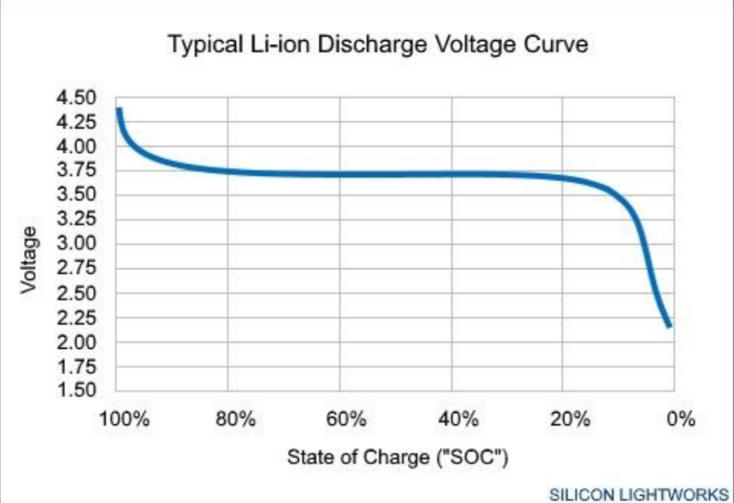
Fig.14. Li-ion Discharge Voltage Curve [17]

3 Costs
Part | Cost
XBee Pro 60mW | $37.95
Smoke Sensor | $3.90
Flame Sensor | $6.99
Button | $2.07
Solar Panel | $15.99
18650 Batteries | $9.99
GSM Module | $32.99
SIM Card | $5.00
ATmega32 | $3.91
3.3V Regulator | $1.95
5V Regulator | $0.95
Charging Circuit | $0.99
Total Cost per Unit | $100.73
Total Cost of Project | $336.94

4 Schedule

Week | Steve | Travis | Kenneth
9/24/18 | - Research equipment and sensors to use | - Research equipment and sensors to use | - Research equipment and sensors to use
10/1/18 | - Create schematics for PCBs and overall design | - Research Solar Panels | - Research Possible Ethics Issues and Lithium Ion Battery in varying temperature
10/8/18 | - Order equipment and sensors. | - Research possible issues with Lithium Ion Battery | - Research possible issues with Lithium Ion Battery
10/15/18 | - Test XBee communication and determine maximum communication distance | - Test IR Flame Sensor and determine maximum detection range | - Test Smoke Sensor detection response time and detection distance
10/22/18 | - Build and test battery pack and charging circuit and  - Test solar panel output power capacity | - Test GSM module communication | - Build birdhouses for each of the sensor units
10/29/18 | - Begin work on program for handling the mesh network capabilities | - Test battery discharge rate | - Research need to implement fan
11/5/18 | - Continue work on program for handling the mesh network capabilities | - Begin assembling full sensor unit | - Begin assembling full sensor unit
11/12/18 | - Final Testing and Fixing Possible Issues | - Final Testing and Fixing Possible Issues | - Final Testing and Fixing Possible Issues
11/19/18 | - Final Testing and Fixing Possible Issues | - Final Testing and Fixing Possible Issues | - Final Testing and Fixing Possible Issues
11/26/18 | - Demo Project | - Demo Project | - Demo Project
12/3/18 | - Prepare Final Presentation | - Prepare final report | - Prepare Final Presentation
12/10/18 | - Prepare final report | - Prepare final report | - Prepare final report

5 Ethics and Safety
Regarding the design of the project, there are a few specific safety concerns that have been taken into consideration for further design improvements of this product. The first safety concern being the use of the Lithium Ion battery which can pose as an issue by violating 1.2 ‘Avoid Harm’ of ACM’s code of ethics and the #1, “endanger the public or environment”, of the IEEE code of ethics [14][15]. The Lithium Ion battery is known to be “substantially more flammable” than other batteries [16]. It is more flammable when the battery is “swollen” which can happen when the battery is over charged, over discharged, short circuited, or exposed to excessive heat [16]. Currently, the charging circuit that is being implemented accounts for over charge and over discharge as charging circuit modules are being used to monitor the battery charge level; furthermore, it disconnects the battery from the charging circuit when it is fully charged and disconnects the battery from the load when it is nearly fully discharge. Having accounted for over charge and over discharge, the other main safety concerns that have not been accounted for in the design are short circuit and excessive heat exposure. Since this Fire Protection System would be implemented where forest fires are prone to occur, the units will most likely be exposed to extreme heat and humidity conditions. One specific concern being that due to the humidity moisture may build up inside the circuitry box and cause a short circuit on the PCB; the other concern is that the Lithium Ion Batteries will be exposed to excessive heat for long periods of time. Taking this into consideration, possible future design upgrades will include implementing a small fan to cool the batteries on hot days and designing a circuitry box that will prevent moisture build up.
Another concern is the possible abuse of the Emergency Alert button; a button implemented to locate people stranded or hurt deep in the middle of the forest. The concern is that people will just press the button when they are not in dangerous situations. A possible solution is to label the emergency button as “For Emergencies Only” and note on the box the possible prosecutions that will take action if the button is abused.

The physical design of the unit is also meant to satisfy IEEE and ACM’s conditions of not harming the environment [14][15]. The unit was designed as a birdhouse to act as a home to birds or other animals that may struggle to build their own nests. But with this design, the circuitry box would be extremely close to living animals; thus, the design of the circuitry box must again be completely secure from the outdoors, so that animals cannot dig into the circuitry box and harm themselves. Finally, the physical design of the birdhouse will be attached to the tree using straps rather than bolts which will allow the tree to continue to grow over time.
Lastly, the statement #7 of the IEEE code of ethics says, “seek, accept, and offer honest criticism of technical work” [14]. This is statement nearly applies to the entirety of the project; as the team is designing or implementing any new hardware or circuitry, it is most important to “seek” advice from peers that have more knowledge and experience in that area [14]. This will ensure that no mistakes are left unnoticed which will ultimately result in an economically safe and reliable product. Having taken all these issues and violations into consideration, the future design improvements for the Fire Protection System should ensure it is completely environmentally friendly.

References
[1] | R. Barbero, J. T. Abatzoglou, N. K. Larkin, C. A. Kolden, and B. Stocks, “Climate change presents increased potential for very large fires in the contiguous United States,” International Journal of Wildland Fire, Jul. 2015.
[2] | C. Fowler, “Human Health Impacts of Forest Fires in the Southern United States: A Literature Review,” Journal of Ecological Anthropology, vol. 7, no. 1, pp. 39–63, 2003.
[3] | “Climate change and forest fires,” NeuroImage, 24-Oct-2000. [Online]. Available: https://www.sciencedirect.com/science/article/pii/S0048969700005246. [Accessed: 04-Oct-2018].
[4] | DIGI, “XBee/XBee-PRO S1 8.15.4 (Legacy),” XBee Pro datasheet, Dec. 2015 [Revised May. 2018].
[5] | Microchip, “AVR® Microcontroller with picoPower® Technology,” ATmega328/P datasheet, Jun. 2016 [Revised Nov. 2016].
[6] | SEEED, “Grove - Fingerprint Sensor,” The Grove - Flame Sensor datasheet, Sep. 2015.
[7] | SEEED, “Grove - Gas Sensor (MQ2) User Manual,” The Grove - Gas Sensor(MQ2) datasheet, Sep. 2015.
[8] | “Illuminance - Recommended Light Level,” Young's Modulus of Elasticity for Metals and Alloys. [Online]. Available: https://www.engineeringtoolbox.com/light-level-rooms-d_708.html. [Accessed: 04-Oct-2018].
[9] | NanJing Top Power ASIC Corp., “TP4056 1A Standalone Linear Li-lon Battery Charger with Thermal Regulation in SOP-8,” TP4056 datasheet.
[10] | SIMCom, “SIM900D_Hardware Design_V2.02,” SIM900D datasheet, May. 2012.
[11] | HANWEI ELETRONICS CO.,LTD, “TECHNICAL DATA MQ-2 GAS SENSOR,” MQ-2 datasheet.
[12] | STMicroelectronics, “LOW DROP FIXED AND ADJUSTABLE POSITIVE VOLTAGE REGULATORS,” LD1117 datasheet, Sep. 2004 [Revised Dec. 2005].
[13] | STMicroelectronics, “POSITIVE VOLTAGE REGULATORS,” LD1117 datasheet, Nov. 2004.
[14] | “IEEE Code of Ethics,” IEEE - Advancing Technology for Humanity. [Online]. Available: https://www.ieee.org/about/corporate/governance/p7-8.html. [Accessed: 04-Oct-2018].
[15] | “ACM Code of Ethics and Professional Conduct,” Association for Computing Machinery. [Online]. Available: https://www.acm.org/code-of-ethics. [Accessed: 04-Oct-2018].
[16] | Salz, “Safe Practice for Lead Acid and Lithium Batteries.” 04-Jul-2016.
[17] | “Silicon Lightworks,” Battery Powered Trade Show Exhibit Lighting. [Online]. Available: https://siliconlightworks.com/li-ion-voltage. [Accessed: 04-Oct-2018].
[18] | On Semiconductor, “Axial-Lead Glass Passivated Standard Recovery Rectifiers” 1N4001 Diode datasheet, Jun. 2018
[19] | E. Siegel, “The Terrifying Physics Of How Wildfires Spread So Fast,” Forbes, 06-Sep-2017. [Online]. Available: https://www.forbes.com/sites/startswithabang/2017/09/06/the-terrifying-physics-of-how-wildfires-spread-so-fast/#478e757e7791. [Accessed: 16-Oct-2018].
[20] | Y. Rauste, E. Herland, H. Frelander, K. Soini, T. Kuoremaki & A. Ruokari (1997) Satellite-based forest fire detection for fire control in boreal forests, International Journal of Remote Sensing, 18:12, 2641-2656, DOI: 10.1080/014311697217512
[21] | “Global Fire Monitoring,” NASA. [Online]. Available: https://earthobservatory.nasa.gov/Features/GlobalFire/fire_5.php. [Accessed: 16-Oct-2018].

