Final Report for ECE 445, Senior Design, Spring 2020
TA: Ruomu Hao
08 May 2020
Project No. 30
Celine Chung
Tingfeng Yan
Zerui An

By

Key master
Abstract
People would usually find it challenging to manage a lot of keys. In spring 2017, team 14 proposed a solution to this problem. They designed a key organizer that uses RFIDs to recognize locks, and then finds the key to the lock inside the organizer. We improved on their design by using QR codes to replace RFIDs, hoping that this change would make it easier for users to add new keys to the system.
Contents

1. Motivation 1
1.1 Problem Statement 1
1.2 Solution Overview 1
1.3 High-Level Requirements 1
1.4 Visual Aids 1
1.5 Block Diagram 3
2 Implementation 4
2.1 Implementation Details and Analysis 4
2.1.1 Voltage Regulator 4
2.1.2 Permanent Memory and Main Control Logic 6
3. Conclusions 8
3.1 Implementation Summary 8
3.2 Unknowns, Uncertainties, Testing Needed 8
3.3 Ethics and Safety 8
3.4 Project Improvements 9
3.4.1 Mobile Phone Scanner 9
3.4.2 Rechargeable Batteries and Battery Management System 9
3.4.3 New Physical Design 10
4. Progress Made on First Project 11
References 13

1. Motivation
In this section we will discuss why a high-quality key organizer is needed. We will also introduce some existing products and explain how our new design improves on the existing ones.

1.1 Problem Statement
How many keys do you usually carry around? Normally, people would have no trouble pairing their keys with the locks, because they only have a few keys to manage. However, there are people who own many lockers or even houses. These people would have a hard time finding the right key to a lock, because there are simply too many key-lock pairs to memorize.
According to several online polls [1][2], over 30% of people would usually carry 6 or more keys with them, so we believe that a good key organizer is needed to help them manage their keys.

1.2 Solution Overview
There are already some companies that have noticed this problem and developed their own solution, like Orbitkey [3]. However, their product only helps the users to keep the keys all in one place, but are unable to match a key to a specific lock.
Our product, on the other hand, would “memorize” all the key-lock pairs for the users, in addition to being a key holder. Once a key-lock pair has been registered, one can look up the correct key simply by scanning a QR code attached to the lock.
This idea is inspired by a similar product developed by team 14 in spring 2017, where they used RFIDs instead of QR codes to identify locks. Compared to the original approach, our new solution makes adding new keys to the system much easier, because QR codes can be easily generated and printed on a piece of paper, whereas RFID tags need to be purchased.

1.3 High-Level Requirements
- The software (including transmission) should spend no more than 200ms looking for the right key
- The product should be able to process 150 find requests without replacing the batteries
- The product has a dimension of less than 20cm*20cm*10cm and weighs less than 300g at empty load.

1.4 Visual Aids
A rough sketch of the physical design is shown in Figure 1. Our product is box-shaped, with a scanner on the top and user interface (including buttons and display) on the front. Keys are kept inside the box, and a number is labeled on each slot. Batteries are installed in the back (not shown in the figure).
Because the user would most likely be carrying the product around a lot, we expect the size to be small enough to fit into an ordinary bag.
The most common use of our product would be finding the right key. To do so, the user would need to press a button on our product to enable the scanner, then scan the QR code attached near the lock. Once the right key is found, its index would be shown on the 7-segment display. This process is illustrated in Figure 2.
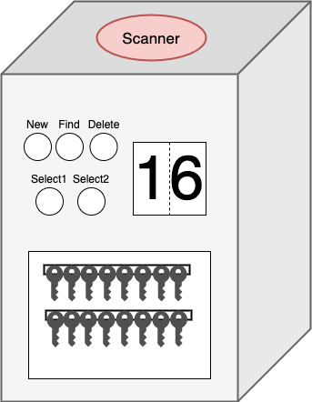
Figure 1. Physical Design
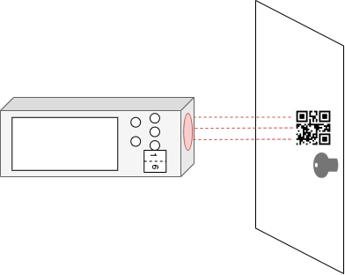
Figure 2. Find Operation

1.5 Block Diagram
As shown in Figure 3, our block diagram, we plan to use alkaline batteries (with regulator) to supply 5V. Signals in between the blocks will be implemented as 5V TTL.
Key storage block is not shown in the figure because it requires no electric signals.
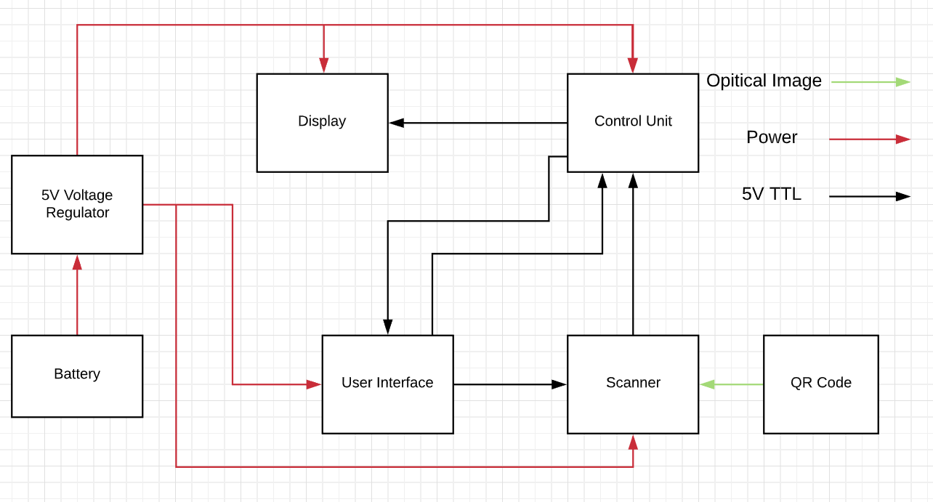
Figure 3. Block Diagram

2 Implementation
In this section we will introduce the components of our product that have been completed. Implementation details and simulation results are also included.

2.1 Implementation Details and Analysis

2.1.1 Voltage Regulator
Figure 4 shows the specific implementation of our 5V voltage regulator, where V1 represents the batteries, and R1 represents the load. V1 = 6V, R1 = 100Ω. The unit of capacitors is F.
Figure 5 shows the relationship between the current through R1 and the input voltage V1. R1 is set to 100Ω. As we can see from the graph, the current increases linearly when V1 is between 2.2V and 5V. When V1 is larger than 5V, the current stays at 50mA, which means the output voltage is 5V.
Figure 6 shows I(R1) = 50mA when V1 = 6V, R1 = 100Ω.
Figure 7 shows I(R1) = 25mA when V1 = 6V, R1 = 200Ω.
By changing the output resistance (R1) multiple times, we can tell that the output voltage is independent of R1 and it remains 5V when the input voltage is 6V.
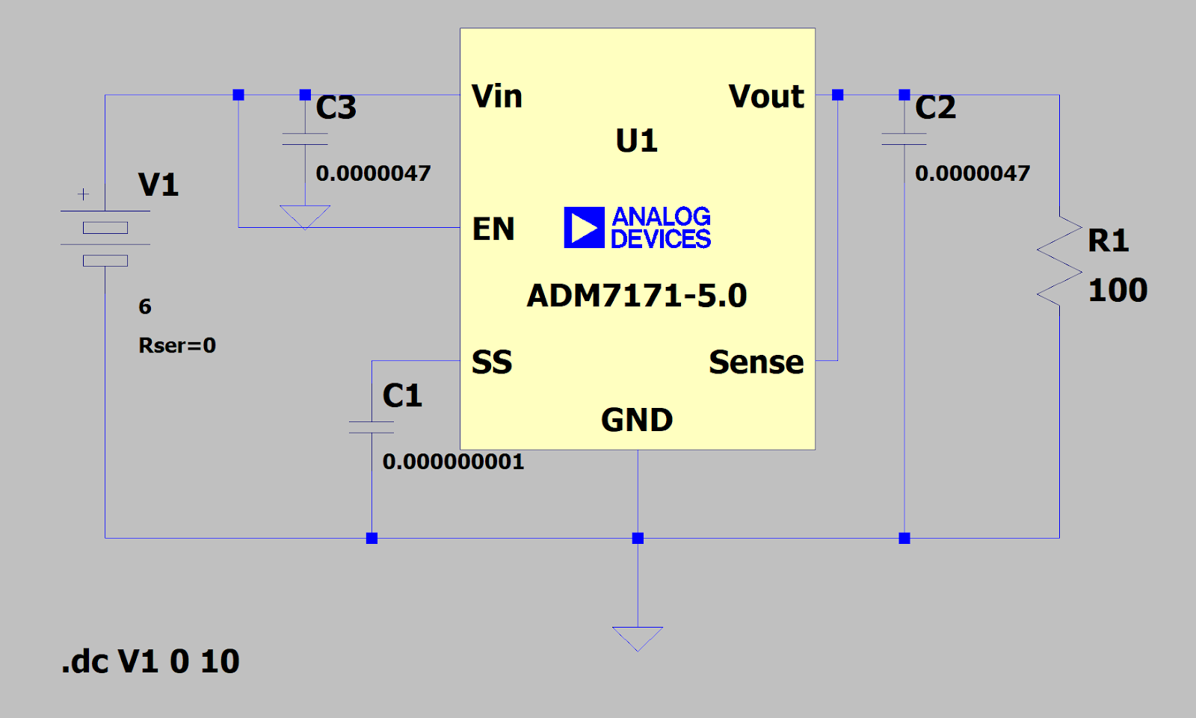
Figure 4. Voltage Regulator
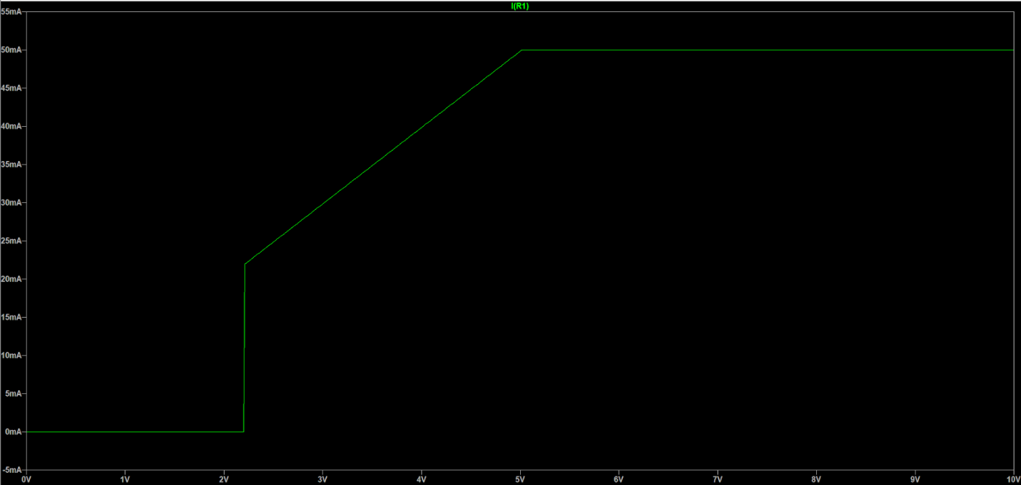
Figure 5. I(R1) vs V1
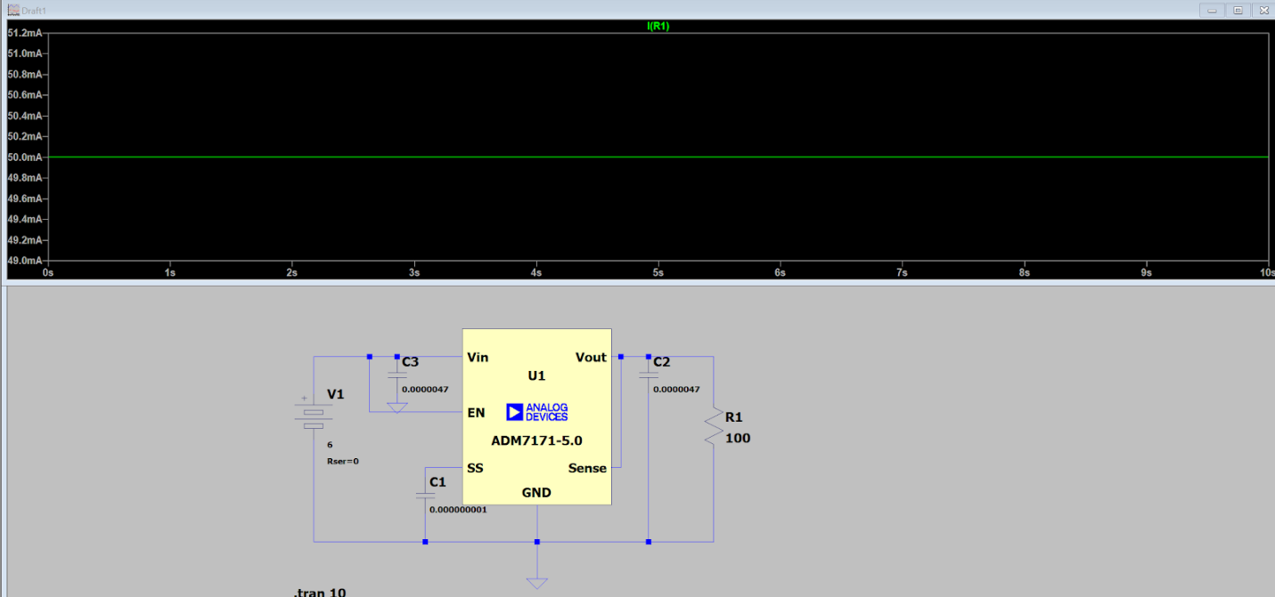
Figure 6. I(R1) @ R1 = 100Ω
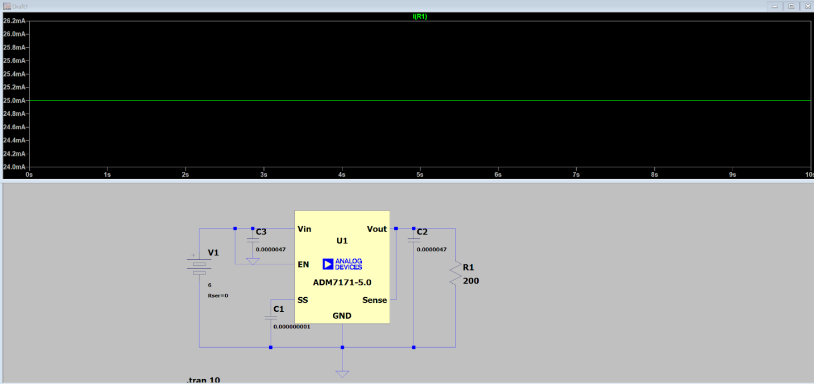
Figure 7. I(R1) @ R1 = 200Ω

2.1.2 Permanent Memory and Main Control Logic
In order to extend the battery life, our system would be powered off most of the time, and the data in main memory would be lost. Therefore, some permanent storage is needed to keep all the QR code data. The EEPROM on an ATMEGA328P microcontroller can store up to 1KB data, which is enough in our case. Each time the system is powered up, the data in the EEPROM is first loaded into main memory (shown in Figure 8), so that future computations can be faster.
The way main control logic interacts with permanent memory is shown in Figure 9. When adding a new key to the system through a valid operation, both the EEPROM and the data in main memory is updated.
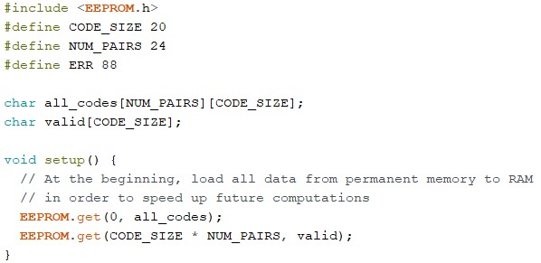
Figure 8. Setup Code
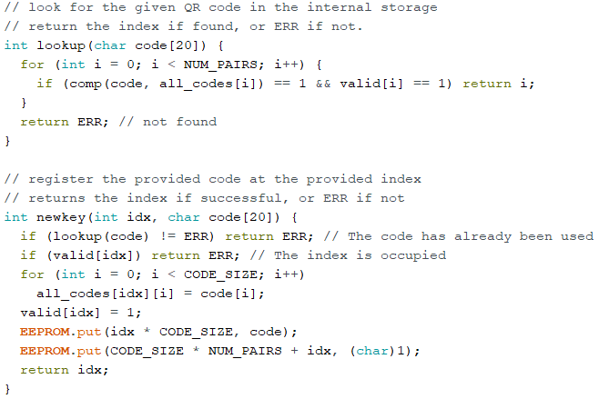
Figure 9. Main Control Logic

3. Conclusions
We implemented some of the core components in our design, including part of control logic and the power supply. However, due to the lack of time and resources, we were unable to test each module, thus their actual performances are still uncertain.

3.1 Implementation Summary
We completely tested the permanent storage (EEPROM) on ATMEGA328p and integrated it into our design. A working permanent storage allows the product to be powered off between uses. This is crucial in ensuring that our system can meet the high-level requirement on battery life, because minimum energy is consumed while the system is not operating.
We wrote some functions for the main control logic. The tasks of the control unit are simple and mostly linear. Based on the operating frequency and average cycles-per-instruction (CPI) of a standard ATMEGA328p chip [4], we conclude that the software would take no more than 100ms to complete a task, which meets the high-level requirement on response time.
We also completed the testing of the voltage regulator. It consistently supplies 5V to the load regardless of the impedance of the load, making sure every unit receives its desired working voltage.

3.2 Unknowns, Uncertainties, Testing Needed
The communication between each module (e.g. control unit and scanner, control unit and user interface) needs to be further tested. Minor adjustments may be needed in circuit and/or software to ensure that the output of each module matches what the receiver expects.
We are uncertain if the product can meet the high-level requirement on size. The dimensions of each individual component can be obtained from datasheets, but it is nearly impossible to estimate the total size after all components are put together. We would be able to estimate the size of our final product much more accurately if we were able to build it physically.

3.3 Ethics and Safety
The general safety of our design can be guaranteed because no hazardous or volatile
material is used in our design. The mechanical design of our product is also user-friendly. The only safety concern might come from the overheating of some electronic components.
But, in the case when users lose their key-master, it would be worse than just losing a simple keychain. So, from the #7 of the IEEE Code of Ethics, “seek, accept, and offer honest criticism of technical work, to acknowledge and correct errors” [5], we will try our best to solve this problem with our teammates. If we can’t solve the problem by ourselves, we will ask for help from the professor and TA.
Our product is box-shaped, with a scanner on the top and user interface (including buttons and display) on the front. We want to make sure its size is small and portable like a wallet to make it a hand-held device. Also, the weight of our product should be less than 1kg when we combine all the components.
We will use a battery for the 5V power supply to power our product when users are using it. We plan to purchase AAA batteries so users can use our product easily just by buying some new batteries. Therefore, we want to make sure that the battery and the supplied voltage to the circuit are within the safe range of 4-5V. To adhere to the IEEE Code of Ethics, #9 “to avoid injuring others, their property”. regarding the safety concern about the power supply, we will be responsible for ensuring the voltage and current fed into all different modules won’t exceed their standard thresholds.
We believe that our design is in compliance with the IEEE Code of Ethics and the ACM
Code of Ethics and Professional Conduct. By following the code #1 from IEEE Code of Ethics, we will make our design process and the final product as safe as we can and try to prevent any possible harm done to the user and society. Additionally, as stated in the ACM Code of Ethics code 2.9, “Design and implement systems that are robustly and usably secure”, our camera will be intuitive and easy to use for users. This will make sure that our key detecting system is made to make the user's life better.

3.4 Project Improvements
We understand that the design of a bulky box may not be very convenient in some cases (e.g. limited bag size). Besides, the 6-7s wait time may not be satisfying for customers who have high requirements. In general, we would aim to decrease the size and weight of the product, as well as increasing the response speed.

3.4.1 Mobile Phone Scanner
Our current design requires that the built-in scanner is used, which is the main cause of the long response time and bulky box design. If we had more time, we could develop a mobile phone app that scans the QR code and sends the data to the microcontroller. With this app and all the necessary communication modules (e.g. Bluetooth), we can make the original scanner removable and allow users to choose which scanner to use, thus decreasing the size of our product. Moreover, thanks to the great computation power that a modern mobile phone has, we can expect the response time to be much shorter.

3.4.2 Rechargeable Batteries and Battery Management System
Four AAA non-rechargeable batteries are used in our design to supply power to all modules. The batteries in our product do not need to be replaced very often, but this also means that users could easily forget when to replace those batteries. To solve this problem, we can instead use some rechargeable batteries and include a battery management system in our design. With this improvement, the product can display its battery status and be recharged regularly like a mobile phone, ensuring that the product can always work when needed.
The size of AAA batteries is another factor (besides scanner) that prevents us from making the product smaller. We could instead use smaller batteries like button or coin batteries. They generally have smaller capacity [6], but that is not a big problem with the use of a recharge system.

3.4.3 New Physical Design
With the improvements discussed above, we should be able to refine the physical design of our product. If we end up keeping the box-shaped design, the size can be shrinked greatly thanks to two of the most space-consuming parts (scanner and batteries) now taking much less space. We could also have a physical design similar to a flip phone, where keys would be stored in the number-pad region, and the user interface would be located at the screen region. Compared to the box-shaped design, this flip-phone design should allow the product to be carried around much more easily. When the product is not in use, none of the user interface components are exposed to the environment, so the users don’t have to worry about breaking anything.

4. Progress Made on First Project
Figure 10 and 11 show our circuit schematic and board design, respectively.
The schematic and board design contain all the modules that need a printed circuit. The Peltier modules are controlled and powered using wires, so only the control signal output (CONTROL_OUT) is shown in the figure.
Figure 12 shows the test code for MLX90614 infrared sensor. It was modified from the library code provided in the hookup guide [7] to meet our needs.
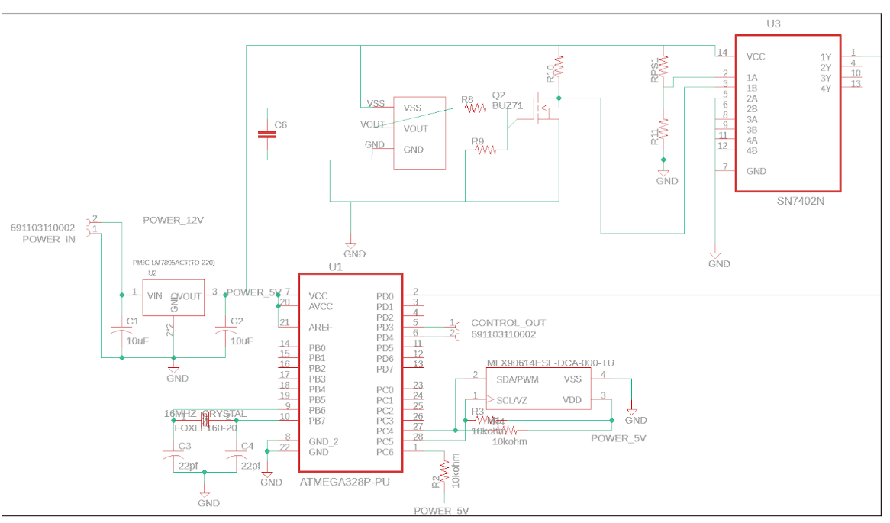
Figure 10. PCB Schematic
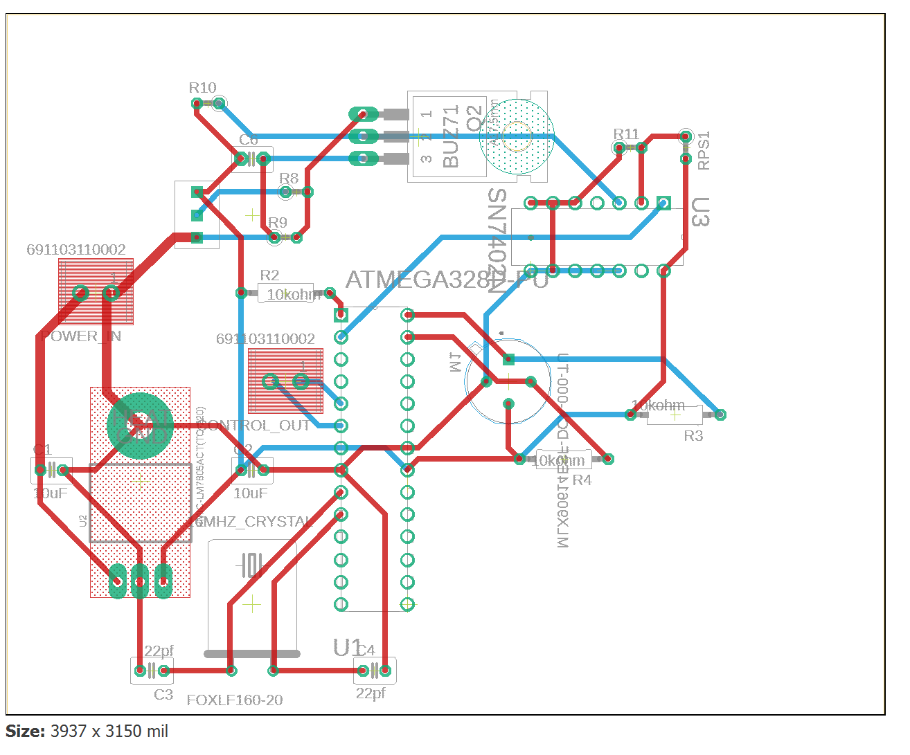
Figure 11. PCB Board Design
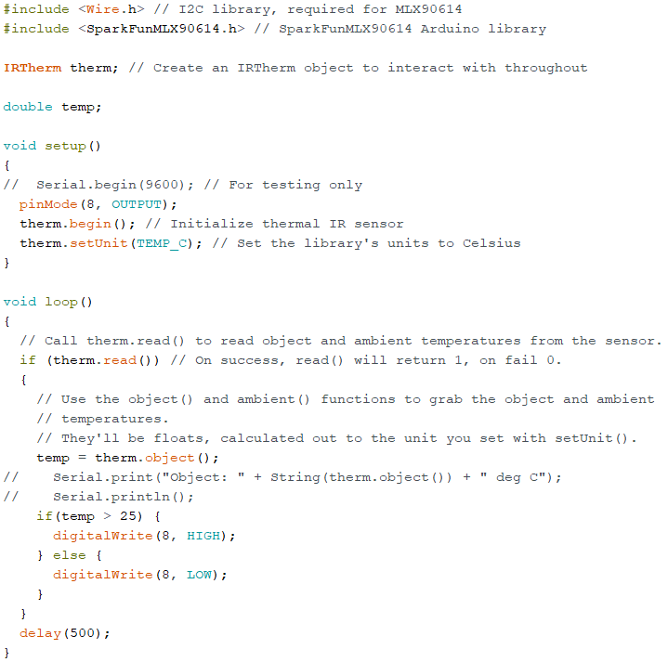
Figure 12. MLX90614 Infrared Sensor Test Code

References
[1] Kenny, “How many keys do you carry?”, Pricescope, 08-Oct-2012. [Online]. Available: https://www.pricescope.com/community/threads/how-many-keys-do-you-carry.180672/ [Accessed: 01-Apr-2020]
[2] Mediocrebot, “How many keys are you usually carrying?”, Meh, 07-Dec-2018. [Online]. Available: https://meh.com/forum/topics/how-many-keys-are-you-usually-carrying?sort=most-likes [Accessed: 01-Apr-2020]
[3] “Orbitkey - Our Story”, Orbitkey. [Online]. Available: https://www.orbitkey.com/pages/about [Accessed: 01-Apr-2020]
[4] Cybergibbons, “Arduino misconceptions 2: Arduino is “slow””, Cybergibbons, 01-Feb-2013. [Online]. Available: https://cybergibbons.com/uncategorized/arduino-misconceptions-2-arduino-is-slow/ [Accessed: 16-Apr-2020]
[5] “IEEE Code of Ethics”, IEEE. [Online]. Available: https://www.ieee.org/about/corporate/governance/p7-8.html [Accessed: 02-Apr-2020]
[6] “Coin Size Battery Chart”, Batteries and Butter, 2020. [Online] Available: https://www.batteriesandbutter.com/coin_batttery_chart.html [Accessed: 08-May-2020]
[7] JIMBLOM, “MLX90614 IR Thermometer Hookup Guide”, sparkfun, 29-Oct-2015. [Online]. Available: https://learn.sparkfun.com/tutorials/mlx90614-ir-thermometer-hookup-guide/all [Accessed: 08-May-2020]

