By
Kevin Dahm
Justin Lindstrom
Brendan Weibel

Project proposal for ECE 445, Senior Design, Fall 2017
TA: Channing Philbrick
September 2017
Project No. 2
APP CONTROLLED SOLAR POWERED STREET LAMP

Introduction

1.1 Objective
There are many reasons for needing an area far from your home to be lit. Unfortunately, solutions today have drawbacks. A hardwired switch provides control, but not portability. A battery powered lamp provides portability, but not longevity or control. Our goal is to design a remote-controlled solar powered lamp. Our lamp would be portable, offer control, and provide longevity. This will be done using solar power to charge the battery for longevity, Wi-Fi to transmit data to the user for control, and being disconnected to any wires for portability.

1.2 Background
There is much research on the use of lighting to prevent crime. The theory is that those who want to burglarize also want to keep their anonymity and will shy away from areas that are well lit. City Lab published an article stating that “crime rates increase as much as 134 percent when street lights were out”[4] showing a need for lighting. But lighting is not always wanted. According to an article published in the US National Library of Medicine, increased lighting during hours of darkness can tamper with humans circadian clock and result in bad sleep quality [6]. This is why our solar powered street lamp will only produce 3000 lumens and be placed far enough away from one’s home to not cause any issues.
There are many other solar powered street lights that are currently on the market, however none of them allow the user to remotely monitor the state of charge on the battery or are too expensive for residential use. If a single-family home wants to light a long driveway they would have to spent roughly $1100 per light for a high quality solar powered street lamp. This seems unreasonable to us, so we will make sure our product remains under $200 while maintaining the same quality of more expensive lights.
The unique features of our product will allow the end user mobility to light any area of their home or business without the daunting task of running and burying power cables to the lamp. Not only will our lamp be able to be placed in any location, the user will be able to remotely view the state of charge of the battery, as well as be able to toggle the light on or off. The added security and peace of mind knowing the state of charge of the battery is unparalleled within the consumer market.

1.3 High-Level Requirements
- The lamp must be able to light a wide radius and therefore will provide at least 3000 lumens
- The battery charge must be remotely checked from a cell phone by using WiFI connection and an independently designed application
- Due to long night conditions the lamp must be able to function for a minimum of 15 hours without sunlight

2 Design

2.1 Block Diagram

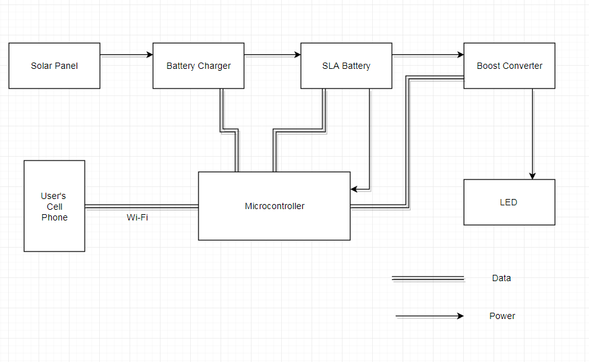
Figure 1: Block Diagram

2.2 Physical Design
The physical design will resemble that of a traditional street light or residential yard light. The base will be large enough to contain the 12v lead-acid battery, control circuitry and add stability to the unit. the base will also need to be weatherproof so that any electronics remain dry. The pole of the product will be made of PVC piping and will be approximately 8 feet tall. The solar panel will be mounted part-way up the pole and will face south. The light housing structure will be mounted on the top of the pole and will consist of a light receptacle, aluminum sides, plastic windows, and a top cone. The light housing structure will be weatherproofed to protect the LED.
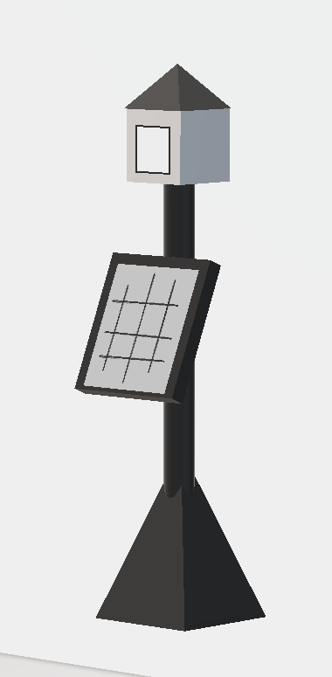
Figure 2: Product sketch

2.3 Solar Panel
A solar panel will provide the power for our system. It will route all of its generated power through our battery charger. The size of the solar panel will be 75w
Requirement: Provide 517.5 watt-hours to the battery in one day; Output 17v +/- 10%

2.4 Battery Charger
The battery charger will regulate the power coming in from the solar panel to provide the necessary voltage that our battery will accept. It will also prevent overcharging of the battery by being fed information on the current charge of the battery through the microcontroller. This will be implemented using a switched-mode power supply converter called a buck or step-down converter. The main driver of this converter will be a power MOSFET capable of handling the power required and will be controlled by the microcontroller. The voltage from the solar panels will be approximately 17.5v and will need to be stepped down to 14.6v. In case of short circuits, this component will have a fuse to prevent any currents over 3A.
Requirement: Must provide about 14.6v to the terminals of the SLA Battery when it is need of charge and the panels are generating power. Input 17.5 +/- 10%; Output 14.6v +/- 10%; Safety 3A fuse

2.5 SLA Battery
The sealed lead acid battery must hold enough charge to power the entire system for 15 hours with no energy generation from the solar panels. To meet the above requirements the battery will be 12v with 50ah capacity.
Requirement: Must be able to store enough charge to power the 34.5 watt system for 15 hours (minimum of 43 amp hours at 12 volts)

2.6 Boost Converter
The boost converter will boost the 12v from our battery up to the 110v need for our LED light. This will be a switched-mode power supply converter called a boost converter and will be driven by a power MOSFET. The MOSFET will be controlled by the microcontroller.
Requirement: input 12v +/- 10%; output 110v +/- 5%, 0.273A, 30w minimum

2.7 Microcontroller
The ESP32 microcontroller will serve four main purposes in our design. It will convey to the battery charger when to stop charging the battery. It will measure the state of charge of the battery, to both tell the charger when to stop charging and to display the batteries state to the user. It will control the boost controller MOSFET to supply enough voltage for the LED. Lastly, it will allow for Wi-Fi communication between the system and the user’s phone.
Requirement: Must be able to communicate with a cell phone over Wi-Fi with transmit power of 19.5 dBm

2.8 LED
The LED is the main feature and will be required to emit at a minimum of 3000 lumens. This will have a regular house socket interface and is compact enough to maintain a low profile. The LED light will require 110v and 30w of power to operate. In case of short circuits, this component will have a fuse to prevent any currents over 1A.
Requirement: Must provide 3000 lumens while consuming 30w from the boost converter. Input 110v +/- 10%; Safety 1A fuse

2.9 App
The mobile application will be the feature that allows for a user to track and change the state of the street lamp from a distance. We will have one GUI that tracks the state of the battery (in terms of its charge), and it will allow for the light to be turned on and off. The application will require an internet connection. We will be building this application using Java for the Android platform.
Requirement: Must be able to view the battery charge and turn off/on the light from a mobile application

2.10 Risk Analysis
The component that poses the greatest is the battery. This has the highest risk potential due to the nature of energy storage devices. If our charge controller outputs too much current then the battery has a potential to leak or even cause a thermal event. Because of this, our charge controller will be crucial for successful implementation of our design. This is also why the microcontroller will monitor the voltage level of the battery and control the MOSFET driver circuit and a safety fuse of 3A will be placed in series with the battery.

3. Ethics and Safety
We, the members of ECE445’s group 2, realize the impact that our product can have on the quality of living around the globe, and in taking full responsibility of our profession and to the consumers that we do business with, we do hereby commit ourselves to the best professional and ethical standards and agree will all ten of the IEEE Codes of Ethics. More specifically:
Codes #1 and #2 due to the potential that our product can cause bodily harm or death. To ensure no harm befalls our end user, strict protocol will be used to ensure that the mounting pole is stable and will not fail unless unforeseeable “acts of god” occur. Furthermore, all electrical components will have insulating material to prevent any potential shock hazards.
Codes #2, #4, #8, and #10 due to the proximity that we will be working with our peers and the bonds that we share with them. We hold ourselves with high moral standards and integrity, because of this we understand that our peer’s work is theirs and theirs alone, and by no means shall we demean ourselves by passing their work as are own.
Codes #3, #6 and #7 due to the vast amount of data readily available, we ensure all credible sources are known and nothing that we publish is false. The result of making false claims would not only cause harm to ourselves, but could bring both mental and physical harm to the end users. A system of checks will be enacted to ensure each member of our group remains honest and open for the entirety of this project.

For our project, safety concerns that we will be responsible for include: LED light housing and support pole falling and causing injury or death. This will be addressed by ensuring that all components are fastened together tightly and the support pole will be placed far enough into the ground to prevent it falling during extreme weather events. Next is the battery and circuitry shock hazard causing injury or death. This will be addressed by isolating the high voltage side of our circuit and enclosing it with an intrinsically safe material. The last safety concern is the light increasing in brightness to point of causing temporary or permanent blinding. This issue can be controlled by using LEDs that can only produce a certain amount of lumens.

References
[1] Ieee.org. (2017). IEEE IEEE Code of Ethics. [online] Available at: http://www.ieee.org/about/corporate/governance/p7-8.html [Accessed 21 Sep. 2017].

[2] Basic Electronics Tutorials. (2017). MOSFET as a Switch - Using Power MOSFET Switching. [online] Available at: http://www.electronics-tutorials.ws/transistor/tran_7.html [Accessed 21 Sep. 2017].

[3] Batteryuniversity.com. (2017). Charging Information For Lead Acid Batteries – Battery University. [online] Available at: http://batteryuniversity.com/learn/article/charging_the_lead_acid_battery [Accessed 21 Sep. 2017].

[4] CityLab. (2017). Street Lights and Crime: A Seemingly Endless Debate. [online] Available at: https://www.citylab.com/equity/2014/02/street-lights-and-crime-seemingly-endless-debate/8359/ [Accessed 21 Sep. 2017].

[5] Schneier.com. (2017). Light and Crime - Schneier on Security. [online] Available at: https://www.schneier.com/blog/archives/2007/09/light_and_crime.html [Accessed 21 Sep. 2017].

[6] Chepesiuk, R. (2017). Missing the Dark: Health Effects of Light Pollution. [online] PubMed Central (PMC). Available at: https://www.ncbi.nlm.nih.gov/pmc/articles/PMC2627884/ [Accessed 21 Sep. 2017].

[7] Outdoor Solar Store. (2017). Solar Street Lights. [online] Available at: https://www.outdoorsolarstore.com/collections/solar-street-lights?gclid=CjwKEAjwxo3OBRDp3Pvxhd7s_D8SJABLtfrZgUWElr-Yg3DvfMk3tVTXfPnEBltnmVP2D_M1TwHeHhoCSnzw_wcB [Accessed 22 Sep. 2017].

