Final Report for ECE 445, Senior Design, Spring 2020
TA: Ruhao Xia
08 May 2020
Project No. 45
Didrick Manahan
Michael Chang
Syed Ali
Ying Ming Lee
By

Pet guardian
Abstract
The focus of the Pet Guardian is to detect threats household pets/animals may face when let unattended (e.g. outside, backyard, car, etc.). The original project solution, Pet Pest Protector, focuses on detecting threats from other living animals and creatures, and provides a safety system through flashing lights on the collar, as well as an alert to the owner via Bluetooth. Our project solution, Pet Guardian, focuses on detecting threats from weather conditions/ambient temperature, and alerts the pet owner via Bluetooth if an unsafe condition is detected. The difference is the detection of environmental conditions, which can pose a bigger threat to animals, rather than the detection of other creatures.

Contents

1. Motivation 1
1.1 Problem Statement 1
1.2 Solution 1
1.3 High-Level Requirements 2
1.4 Visual Aid 2
1.5 Block Diagram 3
2. Implementation 4
2.1 Design Description & Component Justification 4
2.2 Supporting Material 8
2.3 Tolerance Analysis 11
Software Implementation 12
3. Conclusion 13
3.1 Summary of Implementations 13
One accomplishment we were able to achieve was the software implementation of our 2nd order Low Pass Filter. The significance of this filter is to ensure that the data received from the respiratory sensor is only through the contracting of the lungs, and not through other movement, such as the wagging of the tail. The low pass filter is equipped with the right cutoff frequency such that only the low frequency rhythm of the expansion of the breathing chest is passed through, and the higher frequency movements are not. Initially, we planned on creating the filter through hardware components. However, during the design review, we were suggested to create a software implementation such that we would not have to lose vital data with frequencies greater than our cutoff. Rather, we can obtain all the data input into the sensor and filter out the data after on the software side. This prevents loss of physical data. 13
Didrick implemented our 2nd order LPF in python with our specific design specifications. This was one suggestion we were given from the design review. This design choice was suggested to us, rather than creating the filter using hardware. The benefit of a software implementation over a hardware implementation is that you can choose to ignore certain data during the software implementation without actually losing the data. However, if we created the filter in hardware, we would quite literally ‘lose’ all the other data we are physically filtering out. It is better design practice to obtain all data inputted into the sensor, and then filter/fine tune that data using software, rather than trying to filter out data right from the hardware/sensor itself, which could cause loss of crucial data. 13
3.2 Unknowns and Uncertainties 13
3.3 Ethical Considerations 14
3.4 Future Work & Improvements 16
The first improvement would be the electrostatic discharge prevention techniques we talked about in the safety and ethics. The reason this is the first improvement we would make is that for our project specifically, electrostatic discharge poses as one of the biggest risks since animal fur will be involved/one of the materials our product and electronic components will be constantly exposed to. This is of huge importance because our components could be easily destroyed if we do not have electrostatic discharge prevention measures. The faulty behavior of these components due to electrostatic discharge could lead to an inaccuracy of our product, which can result in a sick or injured pet because of the inability of our product to send an alert when needed. 16
The second improvement we would make would be how we choose to obtain the heart rate of the pet. Currently, we make use of a PPG, which uses light-based technology to examine the rate of blood flow caused by the heart’s pumping action. We chose this over the ECG (which is more accurate), because of the safety concerns that arise (e.g. electrocution from accidental current being passed through the pet through skin-electrode contact points). However, the downside of the PPG is that accurate measurements might only be obtained if the PPG sensor is attached to the ear using a clip-on mechanic. This clip-on mechanic could prove to be very uncomfortable to the animal, which would defeat the purpose of our Pet Guardian harness feeling like any other normal harness to the pet (without weighing the pet down or providing any discomfort). 16
The third improvement we would make would be to waterproof our harness and have it detected humidity. The reason this improvement makes it on the top three list is that our product is meant to detect extreme environmental conditions. Even though our initial focus is to detect extreme hot and cold temperatures which could result in either hypothermia or heat stroke, our end goal would be to detect all weather conditions that could affect an animal’s well-being. As we know, temperature is not the only deciding factor on pet well-being, as rain, snow, and humidity can also play a role. A combination of rain/snow in addition to extreme heat/cold could bring up other dangerous risks, such as frostbite. Furthermore, there is a difference between the ‘real temperature’ and the ‘temperature it feels like’. Perhaps, the ‘temperature it feels like’ could be more valuable in knowing what an animal might feel, but in order to obtain this we would need to detect the amount of humidity in the ambient air. Therefore, being able to detect humidity and having a harness that can operate in rain/different humidity’s would be our third overall improvement. 16
4. 1st Project 17
References 18

1. Motivation

1.1 Problem Statement
There are many scenarios in which pet owners (especially owners of larger pets/dogs) let their pets outside for long periods of time, or even have their pet reside outside, if the conditions are suitable. However, knowing whether these conditions are suitable or not can be tricky for the owner to identify, and long enough exposure of that pet in the wrong conditions could leave the pet in a life-threatening situation [1]. The original project, Pet Pest Protector, helps with encounters with other living animals which could be a risk to pets outside. Although encounters with other creatures do pose a threat to pets, environmental conditions can also pose as one of the biggest threats to pets (sometimes bigger than other animals) [2].

1.2 Solution
In order to ensure that an individual’s pet is never left outside in the wrong conditions, we are creating a Pet Guardian harness that can detect if a pet (testing on a dog) is being adversely affected by its surrounding environmental condition/temperature, and send that information to the owner via a mobile application. Our outfitted harness would be able to obtain information about the surrounding environment temperature, the pet’s respiratory activities, and the pet’s heart rate, all of which are factors that can be used to tell whether a pet is at risk of a heatstroke, hypothermia, or any other life-threatening condition.

The biggest difference between our project (Pet Guardian) and the original project (Pet Pest Protector) will be the sensing of environmental factors on the dog's well-being, rather than other animals. As stated before, for certain communities and other groups of people (based on location, living conditions, etc.), environmental factors could prove as a greater threat to dogs than other wild animals. “There is no notion of the best solution, because best is relative depending on the community and group of people that are using the product” - Professor Jing Jiang. In other words, different solutions can be bad or good based on the consumers buying them. For example, because the Pet Guardian harness will detect environmental changes that pose as a threat, this product will appeal to a more niche market/community in which pets are often left outside for longer periods of time (e.g. Large Dog Owners who have their dogs reside outside because of size constraints/regulations/preferences). While the Pet Pest Protector excels in locations with consistently-moderate temperatures safe for animals (like in North California), the Pet Guardian excels in locations which experience varying weather conditions harmful for pets (rain, snow, extreme heat & cold) that can prove more hazardous than wild animals.

High-Level Requirements

- All electrical components must be operable well within temperature ranges safe for dogs (about 15-100° F), and must be operable for 12 hours (assuming fully charged).

- Our design must fit on a size “Large” harness for dogs (50-80 lbs.), and weigh less than 5 pounds (weight limit to ensure the dog is not weighed down too much).

- Microcontroller must be able to send a custom message to the Android App within less than 30 seconds of detection of unsafe conditions for the dog, with a maximum range of 45 meters.

Visual Aid
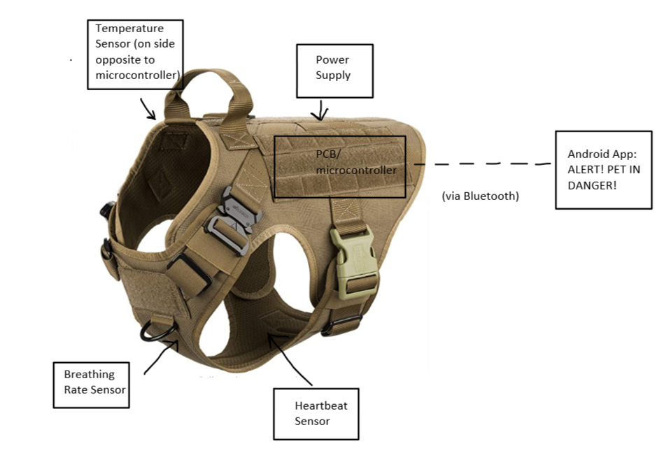

Block Diagram
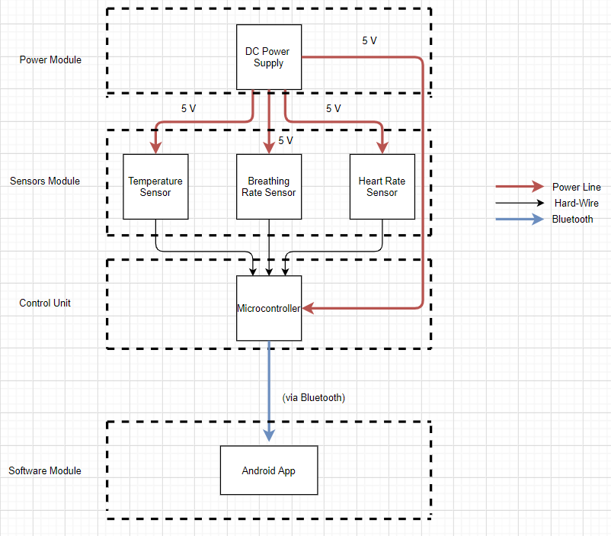

2. Implementation

2.1 Design Description & Component Justification

Sensors Module/Subsystem
This subsystem is responsible for collecting all the vital information needed in order to analyze the level of risk the pet is experiencing. This includes ambient temperature, heart beat rate, and breathe rate. Since the information we collect will be in a range of conditions/temperatures, we have to ensure that all sensors within this module can operate within these conditions/temperatures so that no vital information is missed or no circuit failure happens. This will guarantee overall success at a high level. All this vital information will be passed to the processor module, which will analyze this information and decide the risk intensity level. This module (sensors) also communicates with the power module, as it will be receiving power via hardwire.

Temperature Sensor
A temperature sensor can be used to detect if environmental temperature conditions are too extreme/outside the bounds of safe pet conditions (for dogs its 32° F - 85° F; dogs can experience hypothermia/frostbite in temperatures lower than 32° F and heatstroke in temperatures higher than 85° F). We need to be sure that this temperature sensor can operate in the temperature ranges that we will be exposing the electronics to. This sensor will be great for detecting unsafe weather conditions that are not reflected through the dog’s heart or breathing rate (e.g. dog getting frost bite on foot but breathing does not change much). However, since temperature is not the only factor in determining the pet’s health, we will need more data from other sensors.

The sensor we chose is the MCP9808. For its relatively low cost, it has operating temperatures well beyond the bounds of those we need to detect, and also includes 8 addressable pins and a low operating current, which makes it easily compatible with the ATMega328P. The main requirement is that it’s operating temperature is wide enough with an accuracy of one degree, and the -40°C to 125°C range accurate to 0.5°C encompasses that.

Respiratory/Breathing Sensor
The goal of this sensor is to obtain the breathing rate of the dog. A piezoelectric sensor measures changes in mechanical stress, like pressure, and converts it into an electrical charge. We can make use of this to reliably monitor the respiratory activities of the pet, which changes based on prolonged exposure to unsafe weather conditions. Obtaining a functional sensor which monitors respiratory activity can prove challenging because breathing sensors are relatively new and could not be found on the market a few years back. Current respiratory sensors today go for around $300 [3]. We will most likely make our own circuit for much cheaper by making use of a piezoelectric transducer. This will help turn the movement of the dog’s chest into a voltage signal. We will most likely also have to create a filter for ensuring the movement is due to breathing, and not due to ambient movement (tail wagging or dog walking).

The piezo transducer we chose is the 7BB-20-6L0. This piezo bender fit our requirements, as it has an operating temperature of -20℃ to 70℃. This was the only requirement needed, as this component does not need any complex functionality aside from being able to convert a mechanical pressure into an electrical signal, because the complex filtering and processing of this information will be through our low pass filter.

Heartbeat Sensor
This sensor will be used for detecting the heart rate, which is the most notable change in a dog when at risk of experiencing heat stroke or hypothermia. A photoplethysmogram (PPG) circuit achieves similar information as the ECG, but instead uses changes in light to sense the rate of blood flow controlled by the pumping heart. This would need to be attached to the pet’s ear, which could prove uncomfortable for the pet. There is a spot on the underside of a dog which has no fur. This spot might prove to be suitable for placement and could prove to be more comfortable. However, for accurate measurements, placement in the ear will be the base case.

Our proposed PPG (SEN-11574) is made using ABS plastic, which has a melting point of about 220+° F. Based on the technical details of the product description, our PPG should have no problem operating within our testing temperature ranges, as we will also take measures to verify the operating temperature ranges.

Processor Module/Subsystem (Control Unit):
This module is essentially the brains in deciding the conditions and thresholds for what it means to be in either ‘Critical Danger!’, ‘High Risk’, or ‘Moderate Risk’. The information that will be analyzed will be collected and passed in through the sensor’s module. This module also communicates with the software module via Bluetooth, as a message will be sent to the software module if unsafe conditions are detected. We need to make sure the message is rapidly sent so that we satisfy our third high level requirement, and to ensure the safety of the pet. This module will also be receiving power via hardwire from our power module.

Microcontroller
We will be making use of a microcontroller in order to analyze the data received from the sensors. The inputs to the microcontroller will be the output of the sensors, and the output of the microcontroller will be an alert message. Rather than having just one ‘alert’ message, we plan on having three different alert messages (ranked High, Medium, and Low) so that the owner can be aware of the intensity of the situation their pet is in. For example, the ‘High Risk’ would be sent if the safe temperature conditions are well out of bounds, and a ‘Medium Risk’ would be sent if the temperature is within the bounds, but the heart rate is starting to increase more than usual.

The microcontroller we chose to use is the ATMega328P. The main reason for the design choice was to satisfy the high-level requirement which states that the harness should not weigh down the pet. Even though we have our limit set to 5 lbs., we would ideally like to make the harness as light as possible (the closer to the exact weight of the original stock harness, the better). ATMega328P was the smallest, lightest, and most cost-efficient microprocessor we had available to us. For its super cheap cost, it has an operating temperature of -40°C to +125°C, low power consumption, and a very small weight and volume of 37.4 x 6.76 x 3.28 mm. The ATMega328P satisfies our high-level requirements to a greater extent than the one we previously planned on using, the Raspberry Pi.

Power Module/Subsystem
This module is responsible for providing the necessary power to all the other modules (sensors and processor module) except the software module. All our components, including the sensors and microcontroller, will most likely be running on 3-5 Volts. We need to ensure these components obtain the power they need for at least a 6-hour time period, which will fulfil our high-level requirement. We also want this subsystem to be as modular and convenient as possible, either through a rechargeable or easily replaceable power supply.

Power Supply
The power supply will be used for making sure all components on the dog harness have power, including the sensors and microcontroller we will be using for analyzing the input data so that we can send a signal to the owner’s mobile app if need be. As of right now, this power supply needs to provide constant power to the microcontroller and sensors for a prolonged period of time. Ideally, we would want the power supply to provide power for as long as possible to account for dogs that reside outside for long periods of time. We would like this harness to operate for weeks/months on end to provide ease of use for the owner, such that he/she will not have to replace the power supply every day. We also want recharging to be easy, such that all the owner has to do is remove the power supply and recharge is separately. A power bank proved ideal, since we are only powering sensors and a microcontroller and nothing that requires a great deal of power consumption.

The power bank we chose (PB-N54) is specific for our application. Most power banks do not feature a low current mode, and if the current draw is not high enough, it will shut off and not output anything. Our specific power bank that we chose includes a special low current mode, which optimizes charge to low-current devices, which is exactly the type of power bank we need. The battery capacity is 5000mAh, so assuming we draw 100 mA of power (max power draw), our harness will be able to operate for 50 hours before the next recharge, which is longer than our proposed 12 hours in our first high level requirement. It also weighs just 4.8 ounces, much lighter than most other power banks, which helps bring down the overall weight of the harness.

Software Module/Subsystem
This module will only be communicating with the processor module. In fact, the processor module only sends information and the software module only receives information via Bluetooth. However, the software module should only receive any alert from the processor module if the dog is in an unsafe condition, and not otherwise. We do not want to constantly spam the user app with the condition the dog is in, rather only alert the user app when certain thresholds are passed (e.g. too fast heart rate or too high temperature).

Bluetooth Module/Android App
This subsystem will be used for allowing the Pet Guardian harness to send a message to the pet owner about the condition of his/her pet. Once the microcontroller detects a possible risk to the dog’s health (hypothermia, heat stroke) will send a warning message to the user on the Android App wirelessly through Bluetooth, since Wi-Fi range would be limited dependent on the availability of a nearby Wi-Fi source. The transfer of data will be through the UART protocol (Universal Asynchronous Receiver/Transmitter) in order to communicate with our microprocessor (AT Mega). Our android app will feature two modes, indoor mode (temperature sensor turned off since no environmental factors to detect underlying conditions like heart disease) and outdoor mode (with temperature sensor on and warnings sent if temp + heart rate or temp + breath rate pass safety thresholds), the flowchart can be found below.

The Bluetooth module we used is the HC-08. We chose this module because of its compatibility with ATMega328P, but more importantly its range/reference distance. Initially, we planned on using the HC-05. However, with more research we found that its maximum range is 10 meters, much shorter than our proposed range of 45 meters (average distance from location inside house to backyard, or from car to supermarket). The HC-08 has a range of up to 80 meters, which is almost twice our proposed distance in our third high level requirement.

2.2 Supporting Material

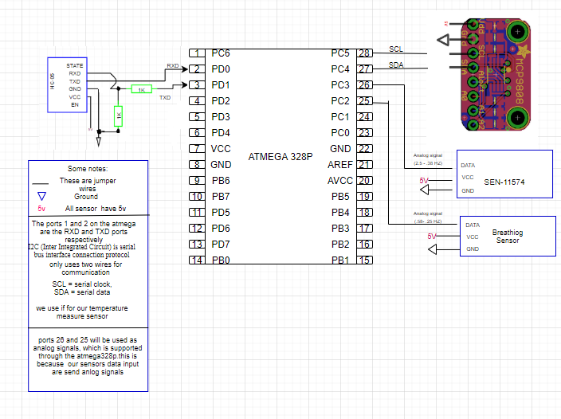
*Hardware Connection of Sensors and Microprocessor

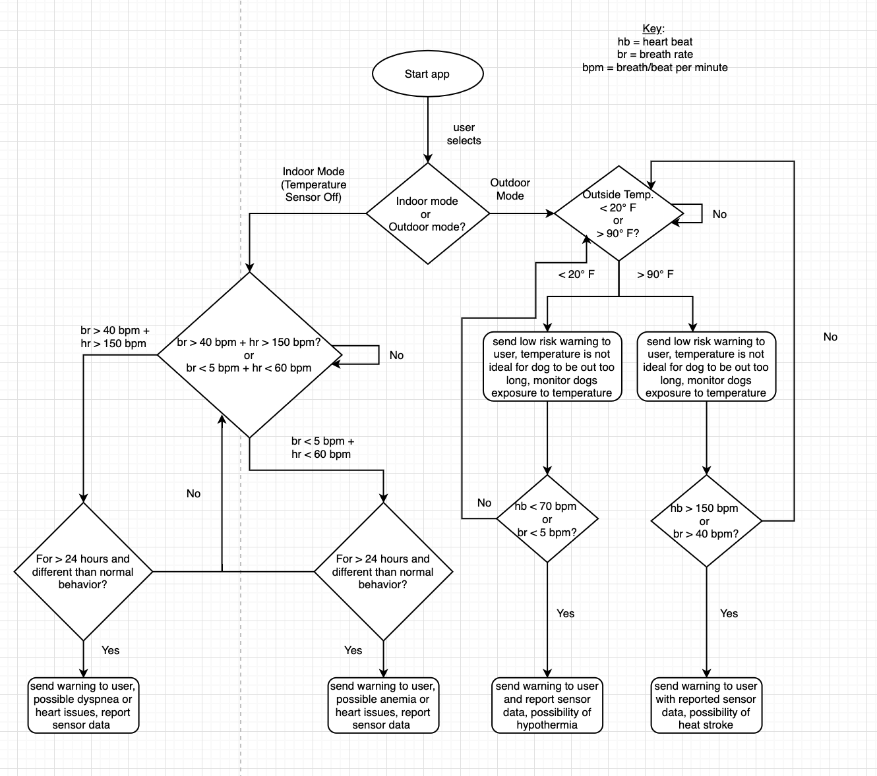
*Logic Flow Chart for Android App

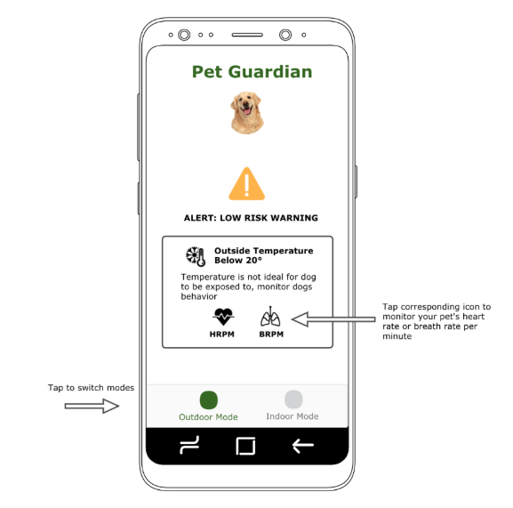
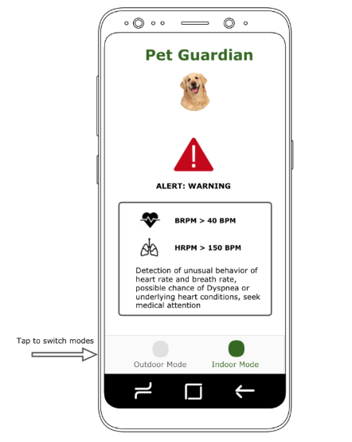

*Android App User Interface Design

2.3 Tolerance Analysis
Our most critical subsystem that poses the greatest risk to the completion of this project is the sensor module, in particular the respiratory/breathing sensor. The completion and accurate functionality of this sensor is crucial, as it will be one of the main data collected for analysis in order to decide whether a dog is in a healthy condition or not. If this sensor is faulty or inaccurate, this could completely throw off the signals being sent to the user’s phone app, or even worse, not send a signal to the android app when a dog is detected in a critical condition. The challenging part for the breathing sensor is making a much cheaper alternative to the existing $300 respiration sensor in the market today, while still achieving similar accuracy. The hardest part in making this custom sensor for dogs will be making sure that we detect only changes in pressure due to breathing, and not due to other movement (e.g. Tail wagging or scratching ear). In order to ensure we detect only pressure from the chest/breathing movement, we are planning to create a second order low pass filter in order to detect just the chest movement from breathing. The filter we are choosing to construct is based on the Sallen-Key filter [5]. Through additional research, we found out we can easily create an active second order filter for increased accuracy by cascading two first order low pass filters together, or adding an additional R-C network within the feedback path. Our filter will be active rather than passive as we are using a gain of 3 to increase the output into a voltage that our microprocessor can analyze/work with while maintaining stability, since the output of the piezoelectric transducer by itself is too low [6]. As for the cut off threshold, the value we choose to use is 35 breaths per minute, which correlates to a frequency of 0.58 Hz.
Gain (Av) = 1 + (Ra/Rb)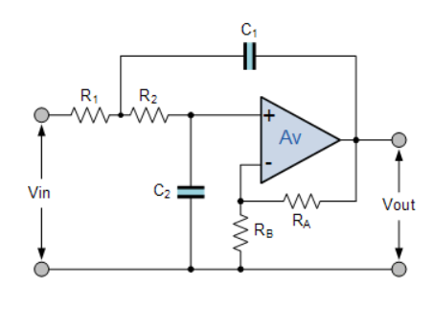

Fc (cutoff frequency) = 1/(2π√R1R2C1C2)

*We can use that same resistor and capacitor values (R1=R2 and C1=C2) to further simplify our frequency cutoff equation to → Fc (cutoff frequency) = 1/(2πRC) where C = C1 = C2 and R = R1 = R2

Calculations for 2nd order active LPF:
*One design consideration is finding reasonable values of R and C such that we still obtain our desired RC time constant. In general, it will be much cheaper to make use of large resistance values and smaller capacitance values, rather than trying to find capacitors with large C values. Therefore, taking into account our allocated budget, we set our capacitance C at 100 nano-farads and find our resistance accordingly.

Gain = 3 → 2 = Ra/Rb → Ra = 20 𝑘Ω, Rb = 10 𝑘Ω

0.58 Hz = 1/(2πRC) [C = 100 nF] → R = 1/(1e-7*2π*0.58) → R = 2744.05 𝑘Ω

Final 2nd order active LPF values:
Av = 3, Ra = 20 𝑘Ω, Rb = 10 𝑘Ω, R1 = R2 = 2744.05 𝑘Ω, C1 = C2 = 100 nano-farads = 0.1 microfarads

Software Implementation

1) Filter requirements
T = 5.0 # Sample Period
fs = 30.0 Hz # Sampling Rate
cutoff = 0.58 Hz
nyq = 0.5 * fs # Nyquist Frequency
order = 2
n = int(T * fs) # total number of samples

2) Sample Data and Noise
sig = np.sin(1.2*2*np.pi*t)
noise = 1.5*np.cos(9*2*np.pi*t) + 0.5*np.sin(12.0*2*np.pi*t)
data = sig + noise

3) Implementation using SciPy
def sallenkey_lowpass_filter(data, cutoff, fs, order):
normal_cutoff = cutoff / nyq
b, a = sallenkey (order, normal_cutoff, btype='low', analog=False)
y = filtfilt(b, a, data)
return y
4) Plot and Filter Data
y = butter_lowpass_filter(data, cutoff, fs, order)
fig = go.Figure()fig.add_trace(go.Scatter(
y = data,
line = dict(shape = 'spline' ),
name = 'signal with noise'
))
fig.add_trace(go.Scatter(
y = y,
line = dict(shape = 'spline' ),
name = 'filtered signal'
))
fig.show()

3. Conclusion

3.1 Summary of Implementations

One accomplishment we were able to achieve was the software implementation of our 2nd order Low Pass Filter. The significance of this filter is to ensure that the data received from the respiratory sensor is only through the contracting of the lungs, and not through other movement, such as the wagging of the tail. The low pass filter is equipped with the right cutoff frequency such that only the low frequency rhythm of the expansion of the breathing chest is passed through, and the higher frequency movements are not. Initially, we planned on creating the filter through hardware components. However, during the design review, we were suggested to create a software implementation such that we would not have to lose vital data with frequencies greater than our cutoff. Rather, we can obtain all the data input into the sensor and filter out the data after on the software side. This prevents loss of physical data.

Didrick implemented our 2nd order LPF in python with our specific design specifications. This was one suggestion we were given from the design review. This design choice was suggested to us, rather than creating the filter using hardware. The benefit of a software implementation over a hardware implementation is that you can choose to ignore certain data during the software implementation without actually losing the data. However, if we created the filter in hardware, we would quite literally ‘lose’ all the other data we are physically filtering out. It is better design practice to obtain all data inputted into the sensor, and then filter/fine tune that data using software, rather than trying to filter out data right from the hardware/sensor itself, which could cause loss of crucial data.

3.2 Unknowns and Uncertainties
There were many parts of the project that we were unfortunately unable to complete due to physical restrictions caused by the shift to online classes this semester. The reason for this is that our project is not software focused. Even though we do have software code/implementation for some parts of our project, the successful completion of the project depends mostly on physical measurements, such as temperature, physical heartbeat, and respiratory breath rate. We also did not have lab access to test physical components. The parts of the project we were unable to complete due to online/physical complications are the verifications of the hardware components, as well as the connection of the sensors to the microprocessor. However, in the case that we did have our physical components and sensors but still NO access to the labs, we would be able to find a way to complete the verifications for all our sensors. For the temperature sensor, we would need to make use of a digital thermometer to verify. For the heart rate and breathing rate, the verification is through physical comparison of the amount of heart beats we feel and the amount of times we see the chest contract and expand respectively. However, we would still be unable to verify our power supply, since doing so requires the use of a digital multimeter/oscilloscope.

3.3 Ethical Considerations
Addressing ethical and safety issues is extremely important to us, especially considering that our final product is meant to be worn by a living household pet (in our case for testing purposes, a large adult dog), rather than an inanimate object. Therefore, because the health of a living animal can be at risk, I believe it is necessary to address liability issues that may inevitably occur.

To start, our product does NOT serve as a replacement to existing professional practices used to evaluate general pet health/well-being. As such, the owner of the pet using this product should still follow proper dog care techniques, such as twice-yearly veterinarian check-ups [9]. This product is initially intended for “Large” adult dogs (American Labrador Retriever will be breed used to set threshold limits), and though it can be used on other animals/dogs, Pet Guardian’s primary use will be on Large American Labs (50-80 lbs. in weight); use on other animals and dog breeds might not guarantee same behavior/accuracy. It should also be noted that proper use of this product will require the awareness of the owner (owner must be aware and ready to act as soon as there is an alert message that his/her dog is in danger). To ensure safety of the dog used for testing, we have to be sure to test our product design in a safe environment and stable conditions when tested on the dog. Although we may test our components/circuit separately in other conditions, we must ensure safe conditions when testing with the dog. To prevent any discomfort for the dog, we will make sure to not alter the fitting or design of the harness. By doing this, we can ensure the dog’s safety (does not choke on harness or incur rashes) and also ensure safety of everyone during testing, as testing with an aggravated dog poses a risk to the dog, people around the dog, as well as the state of the overall product.

Moving forward, other safety and ethics issues arise when creating our design. In regards to the IEEE Code of Ethics first point [10], it is crucial that we make sure the materials we use for this harness are non-toxic to plants, people, and especially animals. The fact that this product will be used on a living animal makes this safety and ethics issue of very relevant and of utmost importance to us. This should not be taken lightly by any means, as we can be held accountable to liability issues that occur due to poisoning of a person or animal due to toxic materials. We have to also be sure to take into account the possibility that a certain component or material can become toxic when exposed to certain conditions (either too hot, too cold, rain, etc.), and be aware of what conditions create toxic effects, if any. Environmental conditions that can bring out any toxic hazards within the product components must be avoided.

One potential safety hazard that should also be addressed is hazards regarding the power supply. If using a simple Li-ion battery, we face the possibility of explosion of the battery due to thermal runaway [11]. This again is of huge concern to us, because the battery will be on the harness, which is connected to the dog. Any explosion or failure in the battery will result in damage to the dog, which is completely unacceptable. In order to ensure this does not occur, we need to utilize a protection circuit/mechanism. One way could be to use a thermistor, which changes its resistance based on temperature. Utilizing this can disconnect the battery from the entire circuit if high enough temperatures are detected. Another viable solution would be to make use of a power bank, which excels in drawing low current for long periods of time, perfect for our application. One benefit is that a power bank comes equipped with a protection circuit to limit current drawn.
For risk mitigation techniques and for future development, it is worth talking about the possibility of electrostatic discharge and measures of prevention we can take. The issue of electrostatic discharge was previously unknown to us, as other harnesses equipped with electronics did not seem to regard this as an issue (e.g. Pet Pest Protector). However, this possible issue was brought to our attention from our TA, and upon further research, we found that electrostatic discharge could possibly be an issue in our specific application [12]. The causes of electrostatic discharge can be either through electrostatic induction, or through the triboelectric effect (tribocharging). In our case, our source of concern is through tribocharging (e.g. when you rub a balloon on your head and there is a difference in charge between your hair and the surface of the balloon). The reason tribocharging can be an issue is that if the pet were to come into contact with another surface which causes the fur to become charged, electrostatic discharge could occur between the fur and the electronic components. However, analyzing whether or not electrostatic discharge prevention measures need to be taken is tricky because the amount of discharge harmful for devices depends on the type of material the device is made out of, as well as the sensitivity classification of the device. On top of that, we would also need to know the maximum amount of charge fur can hold, which would differ greatly depending on pet/breed. Nonetheless, we do have some possible electrostatic discharge protection strategies within the budget if we find out later on that this is a major issue (depending on what protection measures are taken, it can become very costly) [13]. The idea behind any basic electrostatic discharge protection strategy is to ground the items that are possible sources of electrostatic discharge. This common ground ensures that there is no potential difference between the two sources, and therefore no possibility of electrostatic discharge. One simple and cheap solution would be to make use of an anti-static ESD wrist strap. This wrist strap would be attached to one of the dogs front upper legs, as their upper legs are around the size of human’s wrists. It also comes with a jumper coiled cord that connects to ground. The only issue with this design choice would be the loose hanging cord. A more advanced design which solves the hanging cord issue while making use of the ESD wrist strap would be to attach/sew the wrist strap to the vest, and run the cord along the inside of the harness. A more expensive and complex design would be to make use of an anti-static mat, and customize the mat to make it fit and attach to the inside of the harness. However, this would be more costly and harder to design, as we would have to figure out how to attach the anti-static mat to the harness without the pet losing comfort.

3.4 Future Work & Improvements

The first improvement would be the electrostatic discharge prevention techniques we talked about in the safety and ethics. The reason this is the first improvement we would make is that for our project specifically, electrostatic discharge poses as one of the biggest risks since animal fur will be involved/one of the materials our product and electronic components will be constantly exposed to. This is of huge importance because our components could be easily destroyed if we do not have electrostatic discharge prevention measures. The faulty behavior of these components due to electrostatic discharge could lead to an inaccuracy of our product, which can result in a sick or injured pet because of the inability of our product to send an alert when needed.

The second improvement we would make would be how we choose to obtain the heart rate of the pet. Currently, we make use of a PPG, which uses light-based technology to examine the rate of blood flow caused by the heart’s pumping action. We chose this over the ECG (which is more accurate), because of the safety concerns that arise (e.g. electrocution from accidental current being passed through the pet through skin-electrode contact points). However, the downside of the PPG is that accurate measurements might only be obtained if the PPG sensor is attached to the ear using a clip-on mechanic. This clip-on mechanic could prove to be very uncomfortable to the animal, which would defeat the purpose of our Pet Guardian harness feeling like any other normal harness to the pet (without weighing the pet down or providing any discomfort).

The third improvement we would make would be to waterproof our harness and have it detected humidity. The reason this improvement makes it on the top three list is that our product is meant to detect extreme environmental conditions. Even though our initial focus is to detect extreme hot and cold temperatures which could result in either hypothermia or heat stroke, our end goal would be to detect all weather conditions that could affect an animal’s well-being. As we know, temperature is not the only deciding factor on pet well-being, as rain, snow, and humidity can also play a role. A combination of rain/snow in addition to extreme heat/cold could bring up other dangerous risks, such as frostbite. Furthermore, there is a difference between the ‘real temperature’ and the ‘temperature it feels like’. Perhaps, the ‘temperature it feels like’ could be more valuable in knowing what an animal might feel, but in order to obtain this we would need to detect the amount of humidity in the ambient air. Therefore, being able to detect humidity and having a harness that can operate in rain/different humidity’s would be our third overall improvement.

4. 1st Project
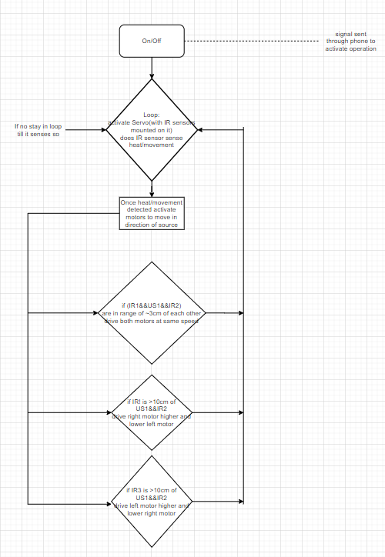
We were given feedback to drastically change our design because of the complications due to smart trash can navigation through BLE sensors. We changed our design to a bin can that follows your hand instead, and can follow you wherever you go, such that you do not have to worry about picking up a super heavy load (whether it be trash or other items). In doing so, we updated the block diagram, physical design, flowchart, and tolerance analysis to talk about hand following techniques and field of view complications.
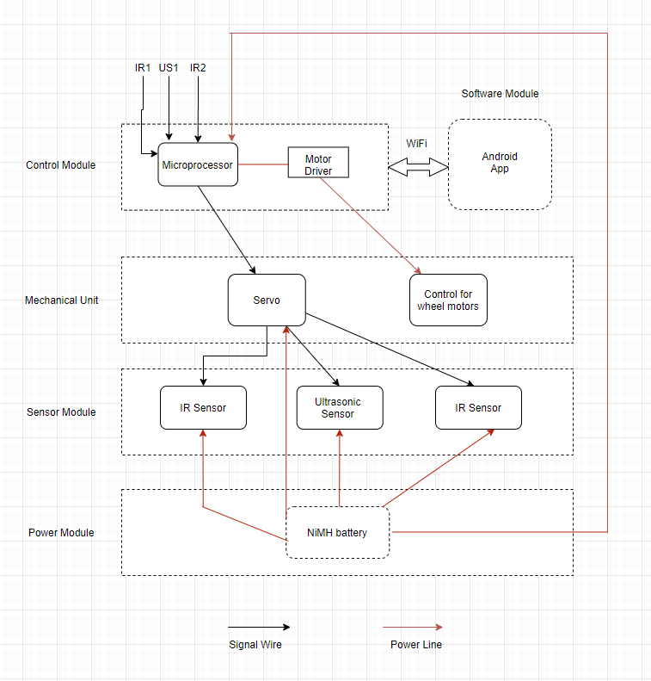
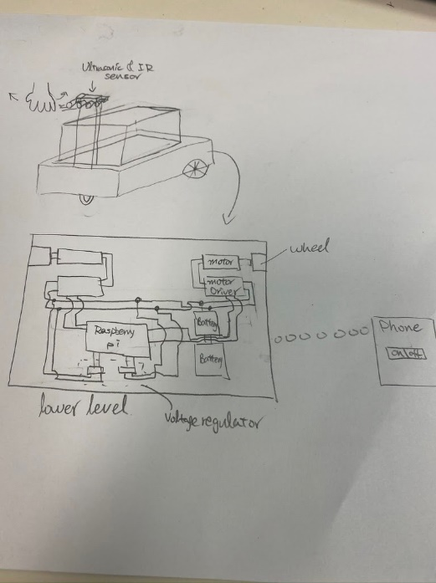

FOV (full cone): horizontal ~21º, vertical ~4º
Spatial resolution (full cone): ~0.6-1.4º
Range: tested from 5 to 200 cm
Accuracy: absolute error ~0.035 cm/cm
Precision: standard deviation ~0.1-0.5 cm
tan⁻¹(3/6) = 26°= max horizontal FOV for whole hand
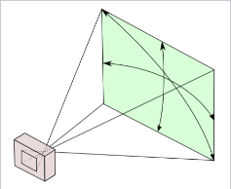
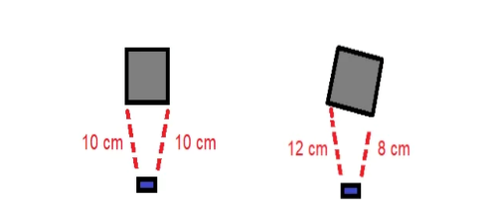

References

[1] peta.org, “Animal Companions.” Heat-Related Deaths Since 2018. [Online] Available: https://www.peta.org/features/dogs-and-other-companion-animals-suffer-heat-related-deaths/. [Accessed: 2-April-2020]

[2] hillspet.com, “Important Tips.” Leaving Your Dog Outside. [Online]. Available: https://www.hillspet.com/dog-care/routine-care/keeping-your-dog-safe-outside. [Accessed: 2-April-2020]

[3] thoughttechnology.com, “Thought Technology Ltd.” Respiration Sensor - SA9311M. [Online]. Available: http://thoughttechnology.com/index.php/respiration-sensor.html. [Accessed: 2-April-2020]

[4] NeuroSky.com. ECG vs PPG for Heart Rate Monitoring. [Online]. Available: http://neurosky.com/2015/01/ecg-vs-ppg-for-heart-rate-monitoring-which-is-best/. [Accessed: 2-April-2020]

[5] electronic-tutorials.ws, “ElectronicsTutorials”. Second Order Filters. [Online]. Available: https://www.electronics-tutorials.ws/filter/second-order-filters.html. [Accessed: 15-April-2020]

[6] americanpiezo.com, “APC International, Ltd.”. What is a Piezo Transducer? [Online]. Available: https://www.americanpiezo.com/piezo-theory/whats-a-transducer.html. [Accessed: 15-April-2020]

[7] peta.org, “Animal Companions”. Animal Companions Are Dying in Cold Weather—These Are the Reported Cases. [Online]. Available: https://www.peta.org/features/animal-companions-winter-freeze-death/. [Accessed: 16-April-2020]

[8] ecs.engineering.illinois.edu, “Engineering Career Services”. Student Success - Undergraduate Success. [Online]. Available: https://ecs.engineering.illinois.edu/outcomes/. [Accessed: 16-April-2020]

[9] WebMD.com, “FETCH by WebMD”. How Often Should Your Pet See A Veterinarian. [Online]. Available: https://pets.webmd.com/features/your-pet-veterinarian#1. [Accessed: 2-April-2020]

[10] ieee.org, “IEEE Code of Ethics”, 2020. [Online]. Available: https://www.ieee.org/about/corporate/governance/p7-8.html. [Accessed: 3-April-2020]

[11] BatteryUniversity.com. Lithium ion safety concerns. [Online]. Available: https://batteryuniversity.com/learn/archive/lithium_ion_safety_concerns. [Accessed: 3-April-2020]

[12] electronics-notes.com, “ElectronicsNotes Incorporating Radio-Electronics”. What is Electrostatic Discharge: ESD basics. [Online]. Available: https://www.electronics-notes.com/articles/constructional_techniques/electrostatic-discharge/esd-basics.php. [Accessed: 16-April-2020]

[13] electronics-notes.com, “ElectronicsNotes Incorporating Radio-Electronics”. ESD Protection. [Online]. Available: https://www.electronics-notes.com/articles/constructional_techniques/electrostatic-discharge/esd-protection.php. [Accessed: 16-April-2020]

[14] vetstreet.com, “Dr. Marty Becker”. Normal Dog Temperature, Heart Rate and Respiration. [Online] Available: http://www.vetstreet.com/dr-marty-becker/what-is-normal-dog-temperature-heart-rate-and-respiration. [Accessed: 15-April-2020]

[15] usarveterinarygroup.org,” Lori E. Gordon, DVM MA TF-1 US&R”. Hypothermia and Frostbite in the Canine. [Online]. Available: http://www.usarveterinarygroup.org/docs/HypothermiaAndFrostbiteInTheCanine.pdf. [Accessed: 16-April-2020]

