Speaker Shower Head
ECE 445 Project Proposal

Team 19
Abhijun Gupta (abhijun2)
Bhavana Ambatipudi (bhavana4)
Manav Modi (manavm2)

TA:
Akshat Sanghvi

Senior Design Spring 2023
February 24, 2023

Table of Contents
1 Introduction
1.1 Problem
1.2 Solution
1.3 Visual Aid
1.4 High Level Requirements
2 Design
2.1 Block Diagram
2.2 Subsystem Overview
2.2.1 Showerhead Subsystems
2.2.2 Remote Subsystems
2.3 Tolerance Analysis
3 Ethical and Safety Concerns

1 Introduction
1.1 Problem

Showering can become a monotonous chore with nothing to do but be left with their thoughts. Some people prefer to use their phone to play music while showering to have some to listen to or sing along to. The music is often blocked by the shower curtain and drowned out by the water leading to a lackluster listening experience. Additionally, in the shower you cannot control the song that is playing as the phone would get wet if used inside the shower. Another common problem in the shower is initially setting the proper temperature of the shower. Most people utilize the guess and check method to get the correct temperature for the shower. Although this method can work it leads to users standing outside for longer than necessary and sometimes having the temperature be just a bit off. Some people in the shower often lose track of time in the shower and use a lot more water than they need to. Having a timer in the shower to notify users of the duration of the shower will motivate people to waste less water and take shorter showers. Our goal is to enhance the shower experience by allowing users to control their music, monitor shower duration, as well as see the current temperature of the water to ensure that the temperature is just right every time.

1.2 Solution

Our objective is to address some of the challenges associated with showers including displaying the current water temperature, shower duration, and playing music. Our showerhead design will incorporate a temperature sensor to allow users to view the current water temperature so they can set the dials right to get the temperature exactly right before even stepping into the shower. The showerhead will also keep track of average shower duration by using a moisture sensor to motivate users to utilize less water. Additionally we will add a bluetooth speaker to the showerhead to allow control of music and better audio quality than a phone outside of the shower. All in all, the showerhead will incorporate sensors for detecting water temperature and if the shower is currently running, a bluetooth speaker to play music, a display for displaying sensor information, buttons to control the music being played by the shower, and a sturdy physical structure suitable for most shower setups to improve shower quality.

1.3 Visual Aid

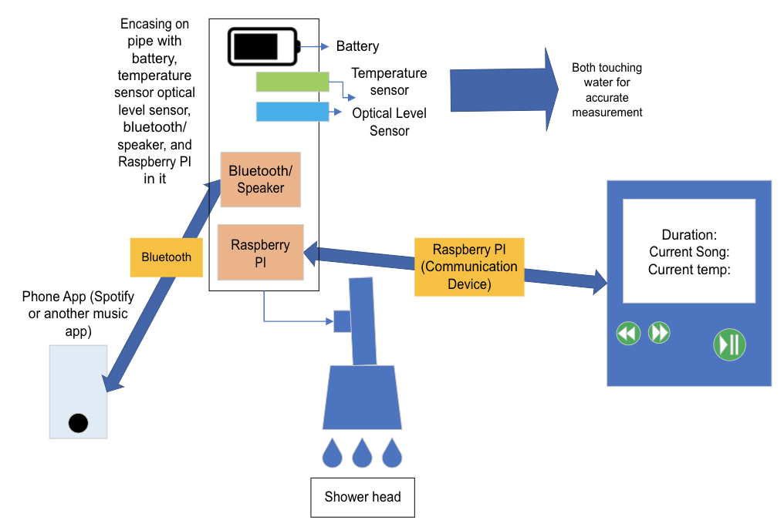

1.4 High-level requirements

Temperature Sensing
- Correctly displaying temperature of the water: one of the core requirements of our design is accurately measuring how hot or cold the water is for the user.
Shower Duration
- Correctly detecting if the shower is on: the display should accurately show the current shower duration as well as the average shower duration.
Speaker/Button Functionality
- Have the ability to connect a phone to the speaker through bluetooth and play music through a speaker which can be controlled by the buttons on the shower remote.

2 Design
2.1 Block Diagram

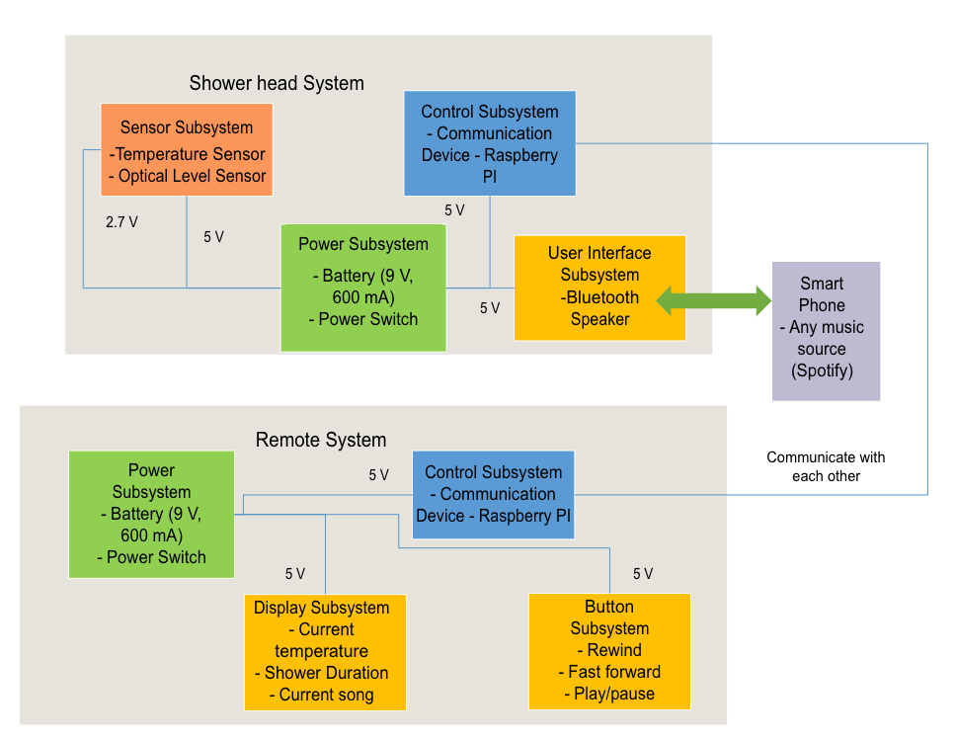
2.2 Subsystem Overview and Requirements
2.2.1 Showerhead Subsystems
- Showerhead Sensor Subsystem
  - The sensor subsystem is important in order to detect the temperature of the water and display it on the remote. This will enhance the user’s shower experience by allowing them to choose a temperature before even getting into the shower. A temperature sensor requires around 2.7-5.5 Volts in order to properly work and an optical liquid level requires around 2.7 V to properly work. In this case we would err on the side of caution and require 5 V for each device to work the way we intend.
  - Requirements:
    - Sensing accurate temperature of the shower water
    - Sensing when the shower is on and off
    - When the shower is detected to be off, the optical liquid level sensor will detect the water as not running
- Showerhead Control Subsystem
  - The showerhead control system is used as a communication device to connect to the remote. In this case there will be a PCB using a bluetooth connection that will connect to the remote and send information gathered from the sensor subsystem and bluetooth speaker.
  - Requirements:
    - Connect to the remotes’ Raspberry PI and get I/O information
    - Send sensor subsystem information to the remote
    - Take button input information and control the speaker
- Showerhead Speaker Subsystem
  - The showerhead speaker subsystem will consist of a 5 volt bluetooth speaker that will be able to connect to the user’s phone and be able to play music depending on the user’s choosing. The speaker will connect to the communication device in the shower head and be able to be controlled by the button subsystem in the remote subsystem.
  - Requirements:
    - Connect to phones with bluetooth capabilities
    - Be able to change/pause/play songs using the button subsystem (controlled by the showerhead control subsystem)
- Showerhead Power Subsystem
  - The Showerhead will all be powered by the power subsystem that will provide consistent amperage to all the components at 5 volts. We are planning on using a 9 volt battery to connect to the components in the shower head (communication device, bluetooth speaker, and the sensors). The power subsystem will have to be carefully placed to ensure no water can get to the battery since the battery cannot be waterproof and would be very close to the showerhead itself.
  - Requirements:
    - Stable voltage and amperage throughout the showerhead and its subsystems.

2.2.2 Remote Subsystems
- Remote Control Subsystem
  - The Raspberry PI in the remote subsystem will control the display, the buttons, and power distribution. It will take inputs from the PCB communication device in the shower head and from the buttons and display information based on its inputs as well as output button presses to the showerhead control subsystem. Our Raspberry PI will require 5 volts to work.
  - Requirements:
    - Communicate with showerhead control subsystem
    - Control display
    - Take inputs from buttons
- Remote Power Subsystem
  - Our power subsystem in the remote will send a consistent voltage and amperage through all of the other subsystems. It will consist of a 9-volt battery which will be cased thoroughly to ensure no water can seep in and deteriorate the battery.
  - Requirements:
    - Stable voltage and amperage throughout the remote and its subsystems.
    - Double encasing surrounding the battery
- Remote Display Subsystem
  - The display subsystem will output information based on the data collected by the Raspberry PI as well as current information given from the sensor subsystem. The display subsystem will be a small 5-10 inch waterproof display with an input voltage of 5 volts to keep a common necessary voltage throughout the remote.
  - Requirements:
    - Displays information based on the Raspberry PIs inputs
- Remote Button Subsystem
  - The button subsystem will take user input to the Raspberry PI and connect to the speaker to pause, skip, or play the previous song. The button subsystem does not need a set voltage so it will have 5 volts running through it when the button is pressed and send it to the Raspberry PI to let it know it has been activated.
  - Requirements:
    - Button inputs are read by the Raspberry PI
    - Buttons are able to control the bluetooth speaker inside the shower head

2.3 Tolerance Analysis
2.3.1 Battery Power Analysis
One risk of the feasibility of our project is the usage of 9-volt batteries to power our components in the remote including a display, raspberry pi, and buttons. Our initial idea was to use our 9 volt battery with a voltage regulator to power our 3 components at 5 volts, but after doing the tolerance analysis on this aspect of our power distribution we found that a typical 9 volt alkaline battery is rated for 550 mAh while the raspberry pi model 3B which we were considering using due to its bluetooth functionality uses 260 mA while idle giving us less than 2 hours of use time for our remote without including the power loss due to the voltage regulator. After considering this problem and weighing our options we decided a more powerful battery may be the best solution. After some searching we found a rechargeable 3.7 volt lithium ion battery rated for 2000 mAh. A DC-to-DC step up converter circuit also known as a boost converter would need to be added to this battery to output a consistent 5 volts which has a typical power efficiency of 85% giving us,
$2000mAh*0.85=1700mAh$
Adding other real world inefficiencies such as heat, battery voltage variation, and raspberry pi amperage pull variation our efficiency would reach closer to approximately 70% on top of the boost converter,
$1700 mAh * 0.70 = 1190 mAh$
1190 mAh running at 5 volts will be able to power our raspberry pi for,
$1190 mAh/260 mA =4.58 hours$
4.58 hours can be better represented as,
$(4.58 hours*60 min/hr)/20 min/shower =13.73 showers$
Assuming an average of 20 minutes per shower and that the user turns off the remote while it is not being used. Approximately 14 showers is quite a high duration especially since the remote can be charged right after each shower and ensure that the battery is at a high level before using it inside the shower. This is a much better alternative to having a plug into the remote while being used inside the shower and can allow the user to use the remote without fear of electrocution from a power wire connecting to the remote.

2.3.2 Waterproofing Analysis

Waterproofing would be the greatest risk to the feasibility of this project since the entire project is planned to be in the shower where water can get anywhere and mixing water with electronics can cause many issues with safety. Our project is still feasible because all of our components can be completely encased in housing that will not allow any water inside. The only things that would not be completely encased would be the sensors but we will use waterproof sensors that will mitigate the risk due to waterproofing.
The IP waterproof standard is useful to understand the waterproofing necessary for us and gives us a way to test if our device will withstand shower conditions. Our housing will be tested with standard IP testing to ensure that over time water does not leak into our electronics. IP x5 is our goal which gives protection against low pressure jetting water. This requires our housing to withstand a light spray of about 4psi from any angle. Our housing should also be IP x6 for the angle at which the water will flow through the pipe. IP x6 require the housing to withstand high pressure jetting water which can be tested with 15 psi of water. There are many housings that can withstand these conditions and many examples that we can use. The IP waterproof rating gives a great standard of protection that we will qualitatively follow for our testing to ensure that our showerhead will mitigate risk as much as possible.

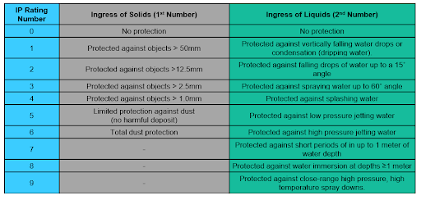
IP Rating Standard

3 Ethics and Safety

The main IEEE ethical dilemma we are facing is the safety aspect of water with all of our equipment. Most of the safety features regarding our project involve water. As we are creating a showerhead that will interact directly with the water, we need to make sure that most of our equipment we are using is waterproof. We also need to consider the power source of our project being affected by water. We cannot have a battery inside of the shower reacting with the water as that will be dangerous. Another option we had was to keep the power source outside of the shower; however, we would need to have wires connecting to our device which would also pose a threat. We have decided to encase the power source and its connecting wires inside of a box in order to ensure no water can disrupt the system.
It is crucial to put safety first and take all required safeguards to protect both the user and the equipment when building electrical gadgets that interact with water. This entails giving considerable thought to the device's design, the materials it is made of, and its intended purpose.
The construction of a watertight box to contain the battery and sensor is a crucial step in ensuring safety. This will aid in preventing water damage, which can malfunction, short circuit, or even start fires, in the electronics. The box should be built to be totally impermeable to water and strong enough to sustain any pressure or impact during usage (Brown).
Also, it's critical to include detailed instructions on how to operate the gadget safely, highlighting the need of keeping it dry and preventing any contact with water. This might contain instructions on how to operate the gadget, how to use it safely, and what to do if it becomes accidentally submerged in water.
The IEEE's Code of Ethics, which describes the duties of engineers in their profession, should be borne in mind when creating such a device. In accordance with this code, it is crucial to put the public's safety and welfare first, be truthful and objective in your job, and abstain from any conflicts of interest or other unethical actions (IEEE Xplore).

5 References
“Optical Level Sensors: Research and Buy Optical Liquid Level Sensors.” SMD Fluid Controls, 6 Oct. 2021, https://www.fluidswitch.com/2015/10/16/how-do-optical-level-sensors-work/
“How to Configure WIFI on Raspberry Pi 4.” BINARYUPDATES.COM, 4 Aug. 2021, https://binaryupdates.com/how-to-configure-wifi-on-raspberry-pi-4/#:~:text=The%20first%20step%20is%20to,networks%20with%20all%20necessary%20information
Brown, Christian. “Nothing Gets in: Waterproof Enclosure Design 101 (and IP68).” Fictiv, https://www.fictiv.com/articles/nothing-gets-in-waterproof-enclosure-design-101-and-ip68
IEEE Xplore. https://ieeexplore.ieee.org/Xplore/home.jsp
Martin, Taylor. “How to Setup Bluetooth on a Raspberry Pi 3.” CNET, CNET, 20 May 2016, https://www.cnet.com/tech/computing/how-to-setup-bluetooth-on-a-raspberry-pi-3/

