Coil Gun Control System and User Interface
Design Review

TA: Luke Wendt

Group: 52
Bryan Mbanefo (mbanefo2)
Adwaita Dani (aadani2)
Felipe Fregoso (fregoso2)

February 19, 2017

Table of Contents
1 Introduction 3
1.1 Multi-stage Coilgun System Overview 3
1.2 Objectives 3
1.3 Benefits and Features of the coil gun 3
2 Design 4
2.1 Block Diagram 4
2.2 Physical design 4
2.2.1 MCU 4
2.2.2 Power Supply 6
2.2.3 Sensors 6
2.2.4 UI 9
2.2.5 Control Algorithm 9
2.3 Physical Dimensions 11
2.4 Tolerance Analysis 11
3 ETHICS AND SAFETY 13
3.1 Ethics 13
3.2 Safety 13
4 Cost and Schedule 14
4.1 Cost Analysis 14
4.1.1 Labor 14
4.1.2 Parts 14
4.1.3 Total Cost 15
4.2 Schedule 15
5 References 18

1 Introduction

1.1 Multi-stage Coilgun System Overview

The multi-stage coilgun is a device that fires a small projectile at high speeds using an electromagnetic force. It works by generating a large current in a coil that winds around a projectile with a conduction path in the same direction as the winding. As mentioned in Ampere’s law, a magnetic field is generated in the projectile’s conducting path and by Faraday’s law, the induced current in the projectile will create a magnetic field opposing that of the core. The projectile is then accelerated by a force proportional to the gradient of mutual inductance between the coils, coil and projectile currents.

The purpose of this project is to shed light on the many applications of electromagnetics. We chose this project because of the technical challenges it presents and because it aligns with the skills and academic focus of our group.

1.2 Objectives

The goal of this project is to design and build a control circuit and a user interface for the coil gun. The function of the control circuit is to accurately determine when to trigger the coils to increase the velocity of the projectile as it passes through. The goal is for the final speed of the projectile to be between 15-17 m/s. The launch speed and estimated distance travelled will be displayed on the user interface. We also need to ensure that our project is safe and adheres to the rules and regulations of IEEE and the University.

1.3 Benefits and Features of the coil gun

Benefits:
- Entertainment.
- Can be used as a teaching aid to display the effects of electromagnetism.
- Portable and easy to set up.
- Good application of power electronics and control systems.

Features:
- User Interface
- High mobility and easy set up
- Launching a projectile at speeds of 15m/s and above.

2 Design

2.1 Block Diagram
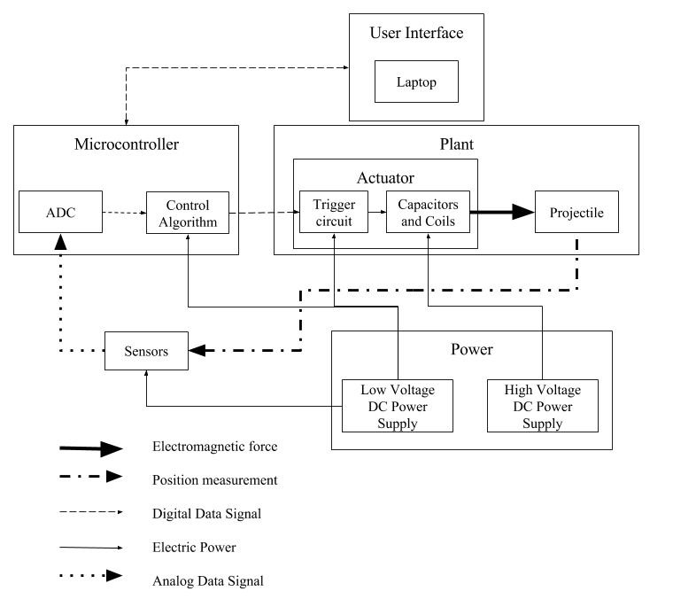
Figure 1: Block diagram for control system of the coil gun

2.2 Physical design
2.2.1 MCU
The microcontroller that we are using is the Arduino Mega that uses the ATMEGA2560. The microcontroller will read in the data from the position sensors and use it as an input to the control algorithm. We calculate the sampling frequency needed for the ADC in the microcontroller using equation 1. $∆d$ is the resolution desired and $v$ is the speed of the projectile.
$∆t=\frac{∆d}{v}$ (1)
The data can then be used to send a trigger signal to the trigger circuit when the projectile is in the optimum position within the coils. The user interface will also send the microcontroller directions on when to start the sequence. The microcontroller in return will send back the calculated velocity so that it can be displayed in the user interface.
The MCU will be on a custom designed PCB that will isolate the digital signals for communication from the analog signals from sensors using a ground plane. It will also have a USB port to connect to the UI and a JTAG port for flashing new firmware and debugging existing code.
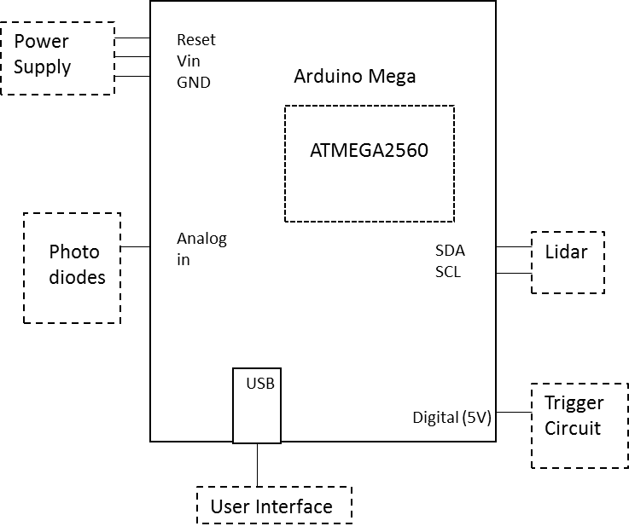
Figure 2: Interface between MCU and other devices

2.2.2 Power Supply
Sorensen SLC 48-4.1b
The power supply to be used is the Sorensen SLC 48-4.1b. Our power supply consists of 6 of these Sorensen’s. Each Sorensen supplies 50V, so we connect 4 of them in series to get an output voltage of 200V DC. The Sorensen’s will supply power to our three capacitor banks as shown in the figure below:
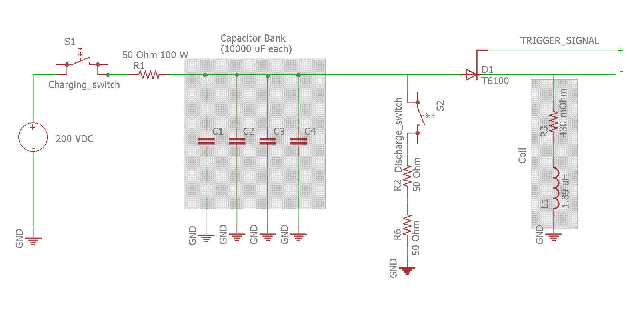
Figure 3: power circuit to charge-discharge capacitors and energize coils

A discharge circuit is also included to enable us to discharge the capacitor banks if we choose not to fire the bullet after we have charged the capacitors. This helps to ensure safety especially when stowing away for a long time.

5V power supply
The 5V volt power supply is the one provided by the ECE department in our tool boxes.

2.2.3 Sensors
This is the most important part of the project because to achieve a speed of 15m/s, we need to accurately know the location of the bullet in the barrel at each point in time. The calculations for this are shown below:
Assuming we take a sample every 4mm and we are moving at a speed of 15m/s (the bullet does not move at this speed all through but Ideally this will be the max speed)

Then the time it takes the bullet to move through 4mm is:
$t= \frac{4 *{10}^{-3} m}{15m/s}={266.67*10}^{-6}s$ (2)
Then the sampling frequency can be calculated as such:
$f= \frac{1}{t}=\frac{1}{266.67* {10}^{-6}}=3750Hz$ (3)
Due to the timing complexity of this project, we have two options for the sensing of the projectile. We might use both the options in conjunction to increase the accuracy of our position measurement.

Option 1
Photodiode: A photodiode is a device that converts light to current. To view the position of the bullet within the coil, the photodiode and receiver will be placed at angles so that when the bullet is in the position, the return signal is reflected to the receiver. The bullet itself will have to be painted with black and white stripes. This will vary the intensity of the reflected light and give us a square wave that tells us how many strips have been passed and how far into the barrel has the bullet moved.
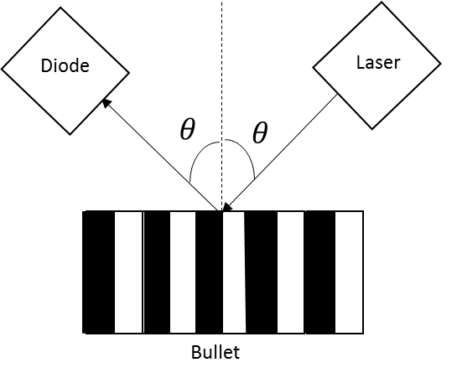
Figure 4: Block diagram showing the placement of photodiodes
Now we need to calculate the parameters for the bullet:
The length of the bullet:
$l = 2.5cm$ (4)
Length of each strip will be:
$l_{s} = 0.25cm$ (5)
Assume that the speed of the bullet is 15m/s (this is the max speed; the speed of the bullet is different for every coil but if we use the max speed to approximate the extra resolution will help the timing. The laser will be focused on one point inside the coil so we need to know the amount of time it takes for the bullet to pass that point and that will be t_{b}:

t_{b}$= \frac{l}{speed of bullet}= \frac{2.5* {10}^{-2}m}{15m/s}=1.67ms$ (6)

We want to have 10 samples within this period. This means we will see white and black strips 5 times each. Therefore, the time the laser will spend on each strip t_{l,} will be:

t_{l} = $\frac{1.67}{10}=0.167ms$ (7)

We would like to see a specific color for 10 cycles in time t_{l,} therefore, we will hold the specific color value for 0.0167ms, and this will be our rise time. The photodiode used is the BPW34 which has a rise time of 100ns, this is within our constraints.

Option 2:
LIDAR (light detection and ranging): This is a remote sensing method that uses light in the form of a pulsed laser to measure ranges. A good LIDAR could accurately tell us the position of the bullet as it moves through the barrel in real time, the more powerful the LIDAR, the higher accuracy. Unlike option 1, this component will be bought and not built due to the complexity of building one. The component that we buy will have to meet the above timing requirements with at most a 5% error.

The wires for the sensors will be shielded using a Faraday cage. This is to remove the EMI (electromagnetic interference) due to the magnetic fields of the coils. If this is not done, the sensor data may get altered and have some false positives.
2.2.4 UI
The user interface will consist of a windows desktop computer that will stay on the table with the coil gun. The computer will communicate with the MCU for when the user wants to fire. The MCU will also send back the velocity at which the projectile is travelling. The MCU and the computer will communicate with each other though USB.

2.2.5 Control Algorithm
The control algorithm that runs on the microcontroller will use a switching state-space feedback control system to determine appropriate triggering times for the three stages of the coil gun. A mathematical model of the force applied to the bullet is calculated using equation x.
${ f}_{e}=i_{coil}i_{bullet}\frac{∂M}{∂z}$ (8)
Mutual inductance between the coil and bullet is analytically calculated using elliptical integrals. The current in the bullet is calculated by diving induced voltage by path impedance in the bullet. The path impedance of the bullet is estimated by measuring the DC path resistance and path inductance using the model below:
Aluminum Bullet Ring
Plastic Bullet Core
Probe contacts
Figure 5: Measurement of coil impedance
If we accurately position the two probes on two sides of the bullet, the measured resistance can be considered a parallel combination of two resistors representing each half of the cylindrical bullet. So, the DC path resistance can be calculated using the following relations:
$R_{measured}=R∥R=\frac{R}{2}⟹R_{path}≈4R_{measured}$ (9)
This would be the lower bound of out path resistance in the bullet since skin effect will cause a higher resistance. Path inductance can be calculated from an analysis like the resistance analysis above. Current going into the coils can be measured using a current transformer, but such a sensing block is out of the scope of our section of the project. The position of the bullet will be an input from the sensing block and it will be used to determine the mutual inductance, estimated force applied in case the coil is to be energized and the stage of the gun that is to be controlled at that specific point. Since elliptical integrals will be computationally expensive, it might be faster to generate a lookup table for the mutual inductance values at different distances.

2.3 Requirements and Verification

Requirements | Verifications
Processing (5 points)  - The microcontroller must sample the analog data input at 3.7kHz minimum. | Processing  - Connect function generator to an input digital pin. Read when the signal goes high and then send out an output signal. Get the time it took between receiving the signal and sending it out. Calculate the velocity by dividing that time over the distance between the sensors. Check that the velocity is within the range at which the projectile will be moving.
DC Power supply (5 points)  - Supply +195V - +200V power to two banks with three capacitors of 10000uF each and one bank of four capacitors of 10000uF each.  5V DC Power supply (5 points)  - Supply +4.5V - 5V to the sensors, microcontroller and PCB. | DC Power supply  - Use a multimeter to check if the voltage output is within the specified range. Use an oscilloscope to check if the voltage signal is steady.  5V DC Power supply  - Use a multimeter to check if voltage output is within the specified range.
Sensors (10 points)  - The resolution of the sensors should be 4mm $±$1mm.  - The photodiode must have a rise time less than 0.0167ms (16700ns) | - To verify this, measure the exit speed of the bullet and using the sampling frequency from equation (3), we can calculate the resolution similarly to equations (6) and (7) above.  - We can verify the rise time by plugging a current probe and viewing the results on an oscilloscope and checking the rise time there.
User Interface (5 points)  - Computer needs to communicate with the microcontroller through USB | - Check the display of the computer and see if expected outputs of the microcontroller are shown.
Trigger time accuracy (10 points)  - Error in trigger signal output time ≤0.167ms. | Trigger time accuracy  - Input and output signals to the algorithm will be analyzed using a Digital Signal Analyzer.

2.3 Physical Dimensions
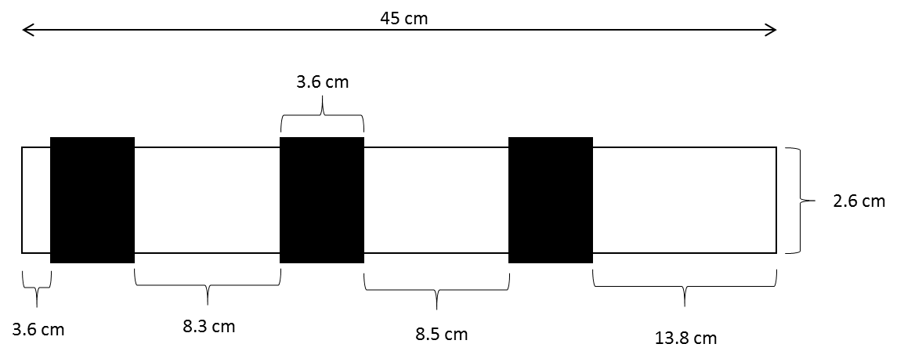

Figure 6: Coil gun tube and coil
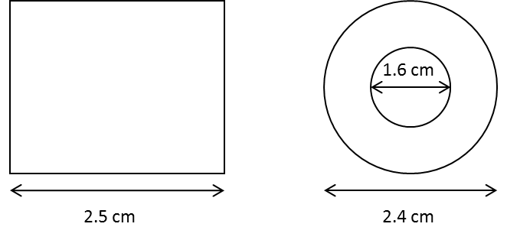
Figure 7: Projectile dimensions

2.4 Tolerance Analysis
The most important part of this project will be the sensors, more specifically their timing. Looking at figure 8 The optimal window for triggering the coil is between 0.02m and 0.04m of the center point of the coil.
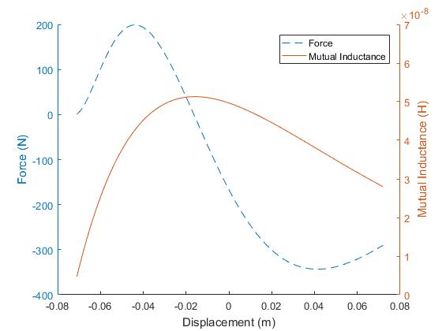

Figure 8: Electromagnetic force (N) and mutual inductance (H) vs bullet displacement from coil midpoint (m)

The coil can be fired a little after 0.04m (to about 0.06m) and we will still get forward motion, but the difference is that the force will be much lower which reduces the acceleration of the bullet. However, if we fired before the 0.02m mark, we will risk applying a negative force on the bullet which will slow it down, and possibly even reverse the direction of its motion. This can be extremely dangerous.
Ideally, our control algorithm energizes the coil when the center of the bullet lines up with the +0.035m mark on the coil. We calculate the error tolerance in this position measurement below:
The length of the bullet is 0.025m. When the bullet’s center is at the +0.035m mark, the body bullet extends from +0.0225m to +0.0475m. We subtract the minimum extent of the bullet, i.e. +0.0225m with the minimum value of the optimal firing window, i.e. 0.02m. This leaves a 0.0025m room for error:
$percentage error= \frac{0.0025}{0.035}*100=7.14\%$ (10)

3 ETHICS AND SAFETY
3.1 Ethics
We understand that this project has many applications including military purposes, however we would like to reiterate that we are doing this purely out of interest and for the purpose engineering. We do not have any ambitions to cause harm or danger of any kind and we will uphold both the university and IEEE code of ethics
The most important code in the IEEE code of ethics for our project is #1. “to accept responsibility in making decisions consistent with the safety, health, and welfare of the public, and to disclose promptly factors that might endanger the public or the environment” [2]. This project involves making a weapon that could hurt people. It is important that guidelines are laid out for everyone to stay safe. Another important rule is #9, “to avoid injuring others, their property, reputation, or employment by false or malicious action” [2]. This project is meant to teach people about electromagnetics and it should not be used for malicious actions.

3.2 Safety
The lasers currently used in the project have a power of 5 mW. This means that the lasers fall into Class 3a of lasers. These lasers pose no threat for short periods of view with the eye, but are dangerous if viewed through an optical instrument [4]. Proper warning will be given to people to not use binoculars or other optical devices. People will also be advised to not stare at the laser.
Operating a gun is always dangerous, even more so when it involves the use of high voltage, current and fast moving projectiles. Appropriate safety precautions will be put in place to prevent undesirable and unforeseen circumstances. Some of these safety features include:
- A protective cover for the capacitor box.
- A discharge circuit for discharging charged capacitors.
- Three pole switch to prevent capacitor charge from flowing back into the source.
Some safety rules to follow:
- Never point the coil gun at something you do not want to shoot.
- Making sure the power is off before changing any of the circuit connections.
- Check and test for faulty equipment before use.
- Always assume that the capacitors are charged.
- Always discharge capacitors if stowing away for a long time.
- Always keep the gun pointed in a safe direction.
- Do not place your finger on the trigger button unless sure that you are ready to fire.
- Make sure everyone around you is following the safety rules.
- Do not directly touch the capacitors.
- The coil gun should never be operated by persons under the influence of alcohol or drugs.
- Children must never be left alone with the coil gun.
4 Cost and Schedule
4.1 Cost Analysis
4.1.1 Labor
Name | Hourly Rate ($) | Hours = 12 weeks $×$ 12 hours per week | Total $×$ 2.5 ($)
Adwaita Dani | 33 | 144 | 11,880
Bryan Mbanefo | 33 | 144 | 11,880
Felipe Fregoso | 33 | 144 | 11,880
Total | 99 | 432 | 35,640

4.1.2 Parts
Parts | Part # | Quantity | Unit Cost ($) | Cost ($)
Op-amp | MC34072AP | 2 | 0.10 | 0.20
Capacitor | DCMC103P450DG2BS | 10 | 70.00 | 700.00
Photodiode | BPW34 | 15 | 1.00 | 15.00
Silicon Controlled Rectifier (175A,600V) | T610061804BT | 7 | 40.53 | 283.71
LIDAR |  | 1 | 300.00 | 300.00
Capacitor Frame | - | 3 | 10.00 | 30.00
Capacitor Cover | - | 3 | 6.00 | 18.00
Capacitor Cover Latches | - | 6 | 1.33 | 7.98
Copper Bar | - | 6 | 54.00 | 324.00
Winding | - | 6 | 1.00 | 6.00
Projectile | - | 1 | 2.00 | 2.00
PCB | - | 1 | 0.00 | 0.00
Fiberglass Bar | - | 6 | 2.50 | 15.00
Screws, bolts, other mechanical items | - | - | 5.00 | 5.00
 |  |  | Total Parts  Costs ($) | 1706.00

4.1.3 Total Cost

Labor | $35,640
Parts | $1,706
Grand Total | $37,346.89
4.2 Schedule

Week | Task | Responsibility
2/5 | - Test existing sensors on the coil gun  - Test power supply and capacitor banks  - Research and test microcontroller to be used | Bryan  Dani  Felipe
2/12 | - Research new sensors and alternate methods of measuring time, speed and distance  - Perform calculations for the sampling rate and time of flight with respect to tube length.  - Run simulations for the circuit, Force and mutual Inductance of the coil. | Bryan  Dani  Felipe
2/19 | - Order all sensors to be used for the project  - Design Circuit and PCB to be used with the microcontroller  - Write code for the microcontroller to meet all timing requirements | Bryan  Dani  Felipe
2/26 | - Build and test all sensor circuits  - Test PCB design  - Design and build discharge circuit for the capacitors | Bryan  Dani  Felipe
3/5 | - Assemble all circuit components, first full test of the coil gun with the capacitors charged to halfway (~100V) | Bryan  Dani  Felipe
3/12 | - Second full coil gun test at ~150V | Bryan  Dani  Felipe
3/19 | - Get and test display screen for the user interface  - Test USB connection for user interface and  microcontroller connection  - Programming of the user interface | Bryan  Dani  Felipe
3/26 | - Third full coil gun test at ~200V with user interface connected and outputs displayed | Bryan  Dani  Felipe
4/2 | - Simulate the results shown on the user interface and ensure that they match up with predictions. | Bryan  Dani  Felipe
4/9 | - Fix any errors that may have occurred | Bryan  Dani  Felipe
4/16 | - Final Tests for the whole system (coil gun and user interface) | Bryan  Dani  Felipe
4/23 | - Prepare final presentation | Bryan  Dani  Felipe

5 References

[1] Reinhard, K., “A Methodology for Selecting an Electromagnetic Magnetic Gun,” M.S. thesis, Dept. Elect. Eng., Univ. of Texas, Austin, TX, 1992.

[2] IEEE, “IEEE IEEE Code of Ethics”, 2017. [Online]. Available:
http://www.ieee.org/about/corporate/governance/p7-8.html. [Accessed: 8-Feb-2017].

[3] Dagdagan, J., Ko, Y., Nanavati, S., “Multistage Coil Gun”, 2013. [Online]. Available: https://courses.engr.illinois.edu/ece445/projects.asp. [Accessed: 1-Feb-2017].

[4] "Laser Classification | Environmental Health and Safety", Ehs.research.uiowa.edu, 2017. [Online]. Available: https://ehs.research.uiowa.edu/laser-classification. [Accessed: 25-Feb- 2017].

[5] V. profile, "AIXIZ 650nm 5mw 12x30mm laser module 3.2VDC", Darutid.blogspot.com, 2017. [Online]. Available: http://darutid.blogspot.com/2013/03/aixiz-650nm-5mw-12x30mm-laser-module.html. [Accessed: 25- Feb- 2017].

[6] S. I. Babic and C. Akyel, "Magnetic Force Calculation Between Thin Coaxial Circular Coils in Air," in IEEE Transactions on Magnetics, vol. 44, no. 4, pp. 445-452, April 2008.

