Wireless Sensor Array for Forest Fire Detection
Steve Mesi, Travis Sauers, Kenneth Noah Adriatico

- Introduction
  - Objective:
Forest fires are a major problem today for many reasons. They cause deforestation which hurts the environment; they destroy property which costs billions of dollars, and most importantly, they are responsible for thousands of deaths. With a forest fire detection system, that can all be avoided. The system includes a set of several sensing units equipped with flame and smoke sensors which will be scattered throughout the forest to efficiently detect forest fires. Each sensing unit can communicate with one another and thus send out alerts as soon as a fire has been detected. The major design aspect on this system is focused around the mesh network that the system is built upon. This gives the system great stability allowing for certain sensing units to fail and still have a functioning system. The need for a mesh system is needed so sub nodes can rely on more than a single master node to send information.
  - Background:
Some of today's forest fire detection methods rely on satellite imaging and optical detection. These methods are unable to detect fires until they are already large and out of control. For this reason, a new method for detection is needed to respond quicker to fires and get them under control faster. Forest fires are predominant around the west coast of North America. According to current information from Sept. 19, 2018 on https://fsapps.nwcg.gov/ on National Fire Activity, there are currently 19 uncontained large fires. The need for a better design for wildfire detection is apparent.
  - High-level requirements list.
      - The mesh network must allow for efficient communication between nodes and the user
      - The system must be completely powered by a solar panel to reduce maintenance
      - The sensors must be able to quickly detect fires and alert the user

- Design
The block high-level block diagram shown below in figure 1 shows four main modules that are necessary for a functioning project that can meet all of the design requirements. The microcontroller controls how all the other modules function and respond to certain events. The power circuit module is responsible for supplying power to the entire system and maintaining this power over an extended period. The communication module allows for communication between other devices as well as the user. The sensors in the sensor/button module allow for detection of a forest fire while the button is used to manually send an emergency signal by pressing it. All these modules together allow the system to function properly.
The block diagram below shown by Figure 1 is a good overall representation of how each individual sensing unit will be set up. Specifically, it briefly summarizes functionality of the hardware in the sensing unit which consists of four main blocks: Power Circuit block, Communication Circuit block, Sensor and Button block, and Microcontroller block. Each block has sub-blocks that describe how the blocks operate in a little more detail which will be discussed in detail.
The first and arguably the most important block that will be discussed is the Power Circuit block. This block is responsible for both the power generation and distribution for the entire sensing unit. This block is essentially focused around the battery pack sub-block; this sub-block is where the power is temporarily stored so it can distribute power to the rest of the system as necessary as the loads will vary; specifically, the battery pack sub-block powers the XBee Pro directly (the communication device that will allow for a Mesh System) and the microcontroller (the programmable ICs that control the entire unit (ATmega)). The microcontroller then distributes power to all other components in the unit besides the XBee Pro. Also, inside the Power Circuit block are the Solar Panel and Charging Circuit sub-blocks which allow the unit to self-generate power so that it can recharge the battery pack whenever there is enough sunlight. In detail, the Solar Panel will generate the power and the charging circuit transfers the power to the Battery Pack in such a way that will not damage the Battery Pack. It also optimizes the power transfer from the Solar Panel to the Battery Pack depending on the Solar Panel’s varying power generation. With this design, the only way that the system will lose power is if the average load is larger than the average produced power from the solar panel. Thus, with this design implemented, the only way that the unit will lose power is if the average load is greater than the average power produced by the solar panel over a long period of time.
The next and most complex block of the sensing unit is the Microcontroller. The Microcontroller block will be implemented using the ATmega which are essentially programmable ICs. The ATmega will be programmed to handle signals from both Communication Circuit sub-blocks and all the Sensor and Button sub-blocks; it will handle input signals from the XBee Pro, Emergency Button, IR Fire Sensor, and Smoke Sensor sub-blocks. These signals will be interpreted by the ATmega which will determine what output signals may be sent to the GSM Module or the Xbee Pro sub-blocks. In summary, the microcontroller handles all I/O in the sensing unit and will determine when to send emergency alert signals notifying someone that there is a fire in a specific location. Also, as briefly discussed earlier the ATmega will distribute power to the GSM Module, Emergency Button, IR Fire Sensor, and Smoke Sensor sub-blocks. This can be done if the load of those sub-blocks is under the maximum threshold for the ATmega.
Now for the most crucial and innovative block on the sensing unit is the Communication Circuit block. The communication block consists of two sub-blocks, the XBee Pro and the GSM Module. The XBee Pro sub-block transmits and receives signals and is what allows for the mesh network to be possible as the signals transmitted by the XBee Pro can be sent to multiple units and even relayed through other units’ XBee Pros. For example, if one unit’s XBee Pro was to fail for whatever reason, the signal would then be sent to the next nearest master unit that could interpret the signal, and if necessary, send out a text message alert through the GSM Module sub-block. Also, as mentioned earlier, the XBee Pro is powered directly by the Battery Pack sub-block since it is the largest load in the unit and would not be able to be powered through the Microcontroller without burning it up. The other sub-block in the Communication Circuit block is the GSM Module; this sub-block will only transmit signals and would only be installed on the master units. The sole purpose of this sub-block is to communicate with the Microcontroller and send out an emergency alert signal via text message if any of the sensing units have detected a fire. In summary, these two communication devices are what allows the Fire Detection System to have such a quick and efficient way of transmitting signals so that alerts are received as soon as possible.
Finally, the last block in the sensing unit is the Sensor and Button block. This block consists of three sub-blocks: emergency button, IR Fire Sensor, and the Smoke Sensor. The Emergency Button is the most recent upgrade to the sensing unit; it allows the sensing unit to double as both a fire detection unit and an emergency alert system for someone who is stranded in the woods. Since these units would theoretically be spread across the wilderness in remote areas, the idea was to have them also function as emergency alert systems. So, if someone was to come across one while lost they could simply press a button, alerting a search and rescue team to be sent. Next, the IR Fire Sensor and Smoke Sensor sub-blocks are what allow the sensing unit to detect fires. These sensors will constantly be sending data to the Microcontroller so that once the sensor values hit certain limits the Microcontroller will then determine that there is a fire. Once this happens, the Microcontroller would immediately have either the XBee Pro or GSM Module transmit an emergency signal depending on if it is the master or slave unit.
Block Requirements
- Microcontroller Block
- Must be able to supply 3.0 to 3.6 volts to power sensors
- Must be able to operate on an input voltage between 4.8V and 6.0V
- Must have enough I/O ports to accommodate both communication modules, the smoke sensor, fire sensor and the emergency button.
- Power Circuit Block
- Must have enough battery capacity to supply power to the system for multiple days without charging. This will help ensure that the system does not go offline too quickly when the batteries are not being charged. To accomplish this, it will be equipped with between 4000 and 6000 mAh of battery power.
- The charging circuit must be able to charge the battery pack using a variable input voltage and current from the solar panel. This is because the output of the solar panel will vary depending on the access to sunlight.
- The power circuit will also need to be able to output different voltage levels. One voltage level between 3 and 3.6 V and another voltage level between 4.8 and 6V.
- Communication Circuit Block
- Xbee modules must be able to communicate with each other in a forested area up to a range of 100 meters.
- Must be able to route signals from one sensor unit to another in order to increase coverage and reliability
- Sensor and Button Block
- Must be able to detect fires from 0 to 10 meters away
- Must be able to detect button press in a variety of weather conditions
Risk Analysis:
The block that poses the greatest risk to the success of this project is also the block that plays the most crucial role to the functionality of the sensing unit itself, and that is the Microcontroller. Without the Microcontroller properly working, the sensing unit would have absolutely no functionality. The Microcontroller is what holds the entire unit together; it is how unit is able to interpret data sent from the sensors and XBee Pro, and it is how the unit knows when to send out signals to the XBee Pro and GSM Modules. Other than the absolute need to have a properly functioning Microcontroller, the Microcontroller will also be the hardest piece of hardware to implement in the unit. It will take a lot of trial and error in terms of designing the I/O layout on the Microcontroller itself as well as the programming for handling information from both the XBee Pro and the Sensors. This will be especially difficult since no one on the team has this type of experience.
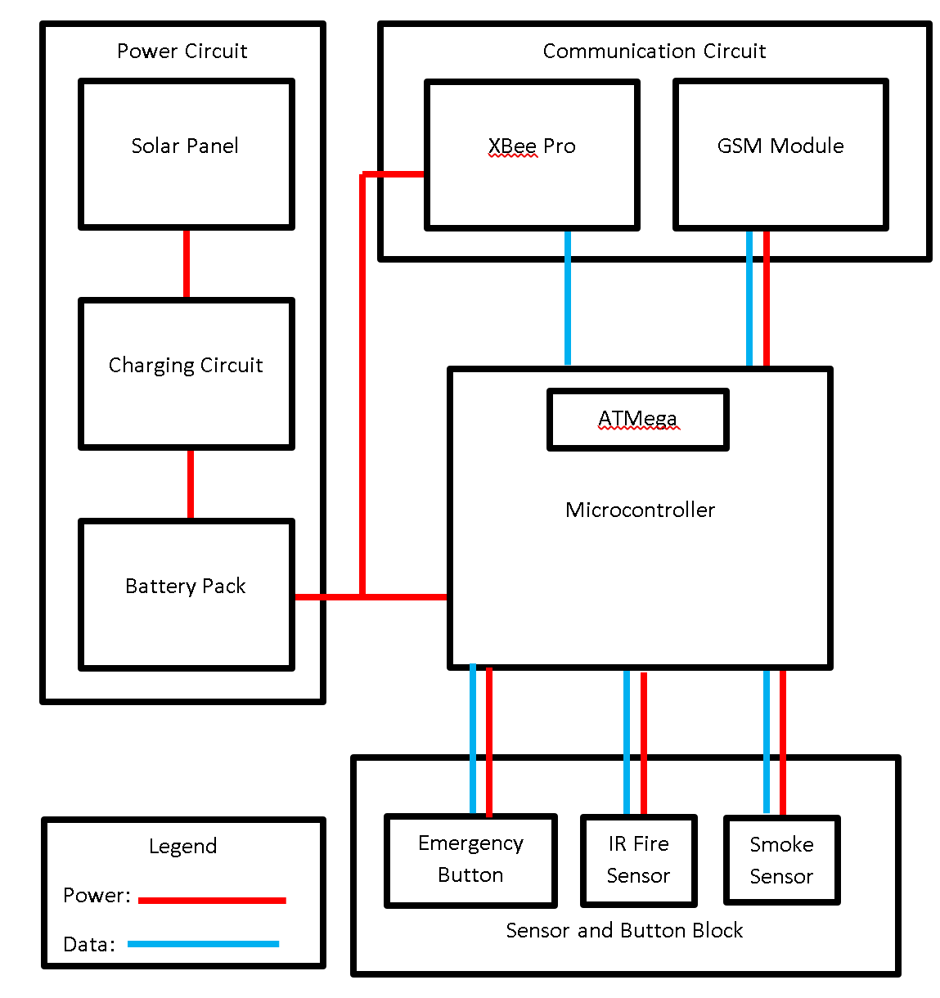
Figure 1: High-Level Block Diagram

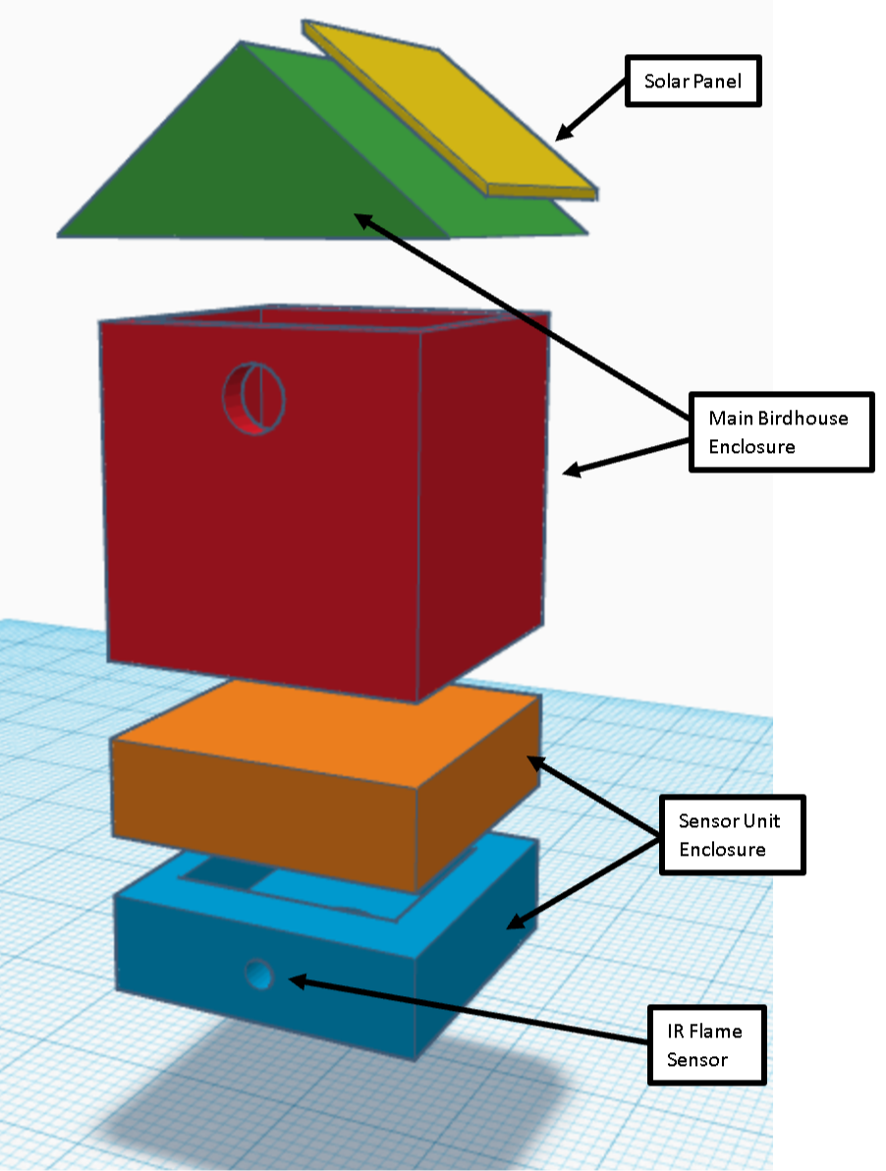
Figure 2: High-Level Physical Design

- Ethics and Safety
Currently, there are no safety issues that can occur from using the wildfire detector. However, there is a possibility of its misuse since it has a button which can manually warn about wildfires. This can mislead workers of wildfire extinguishing and waste money. This issue can be reduced by raising the birdhouse design of the wildfire detector upon trees away from the reach of people.

