Sola gratia farm
Proposal for Senior Design Project
Cesar Martín Cachero (cesarm4)
José Antonio Leiva Orcoyen (jal9)
Objective:
Sola Gratia Farm wants to add a third cooler in his facilities because they need to store more products. The problem is that currently, Sola Gratia Farm pulls power from the church located to the south of it. Because of this, the entire farm is powered off a breaker that is connected to the church. Sola gratia wants to add a third cooler, but it will overload the amperage of the Ameren line that connects from the grid to the church. Adding another line will put them on the grid as their service line, but they don’t prefer it as they would have to pay for their electricity (instead of the church), and it could be potentially expensive. It’s our task to help create a plan once they get more money that will allow them to add the third cooler without overloading their line. We planned to add a solar array which function will be to feed the coolers and at the same time if the power exceeds we will store it in some batteries which we will connect to an electronic device that we will design which is going to limit the current coming from the line of Ameren avoiding to have a peak of current on the line because this peak of current will be provided from the batteries.
Background:
Sola Gratia Farm is a community-based farm dedicated to producing locally-grown, high-quality, natural produce. Responding to the Gospel, the farm is committed to helping those who lack adequate food resources by donating a minimum of ten percent of its produce to support regional hunger programs. They want to develop their facilities but as they are a charity organization, they plan to reduce costs as much as possible.

Physical design:
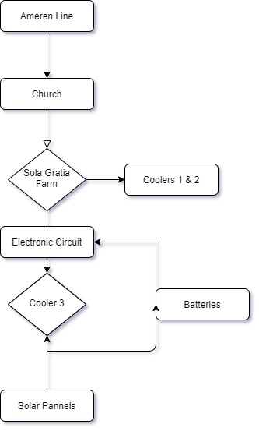
Figure 1:Physical design

High-level requirements list:
- A complete design of the installation that they will have to implement with a list of all the components and how they should be connected
- A demo of our electronic device which meets all the requirements of avoiding the peak current
- A financial analysis of all the components and how long it will take to amortize the installation

Block Diagram:
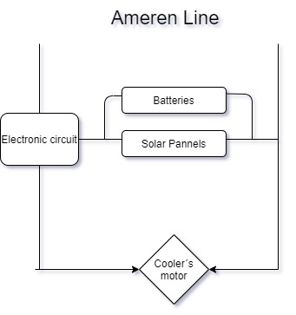
Control Unit
Power Supply
Figure 2:Block Diagram

We plan to connect the electronic circuit just before the third cooler to control the flow of power through it and avoiding exceed the maximum amperage. Batteries and solar panels will be located in parallel and connected to the electronic circuit to supply the extra energy. The third cooler will be directly connected to the electronic circuit which will provide the power from the Ameren line and at the same time from the solar panels/batteries.
Functional overview:
- Solar panels: will produce energy and will be directly conducted to the electronic circuit which will handle it to the cooler when turning in on all devices.
- Batteries: will store extra energy from the solar panels and at the same time provide energy to the cooler when solar panels can’t.
- Electronic circuit: its goal is to manage the energy that receives from the Ameren line, solar panels and batteries to meet the line maximum requirement and at the same time provide all the demanded power from the third cooler.
Block Requirements:
- Solar Panels: we plan to introduce the solar panels to feed the third cooler with extra power. When we turn on all the devices the farm plans to have, it is estimated that the line will carry between 75 and 80 amps. Ameren's line has been designed to withstand a maximum of 70 amps, for that reason including the new cooler will lead to overloading the line. The solar panels are going to produce the extra power demanded from all devices. We need this because with our electronic circuit we are going to control the maximum power flowing through the line.
- Batteries: the batteries will have a double feature. On one hand, when the solar panels produce more energy than the demand from the devices, the batteries will store this energy for future needs of the line. Moreover, in those cases when the extra power is so high, we can think to sell it and make a profit of it. On the other hand, we are going to use the batteries to provide the extra power needed in case the solar panels are unable to feed it. By this, we are thinking of those periods in which the sun’s light is insufficient to fully charge the solar panels and give enough power.
- Electronic circuit: this device is going to be the heart of our project. We plan to use a microcontroller and an electronic circuit which will take control of all the measures in the Ameren line. When turning on all the devices the microcontroller will measure that the devices are demanding more than the maximum of the line. At this point, it will steady the power conducted from the line to the third cooler at the line’s maximum and open the circuit where we have the batteries and the solar panels. The microcontroller will decide to take the extra energy needed to feed the third cooler from the solar panels or from both the panels and the batteries depending on the capacity of the solar panels at that moment.
Risk Analysis:
We believe that the microcontroller and the electronic circuit that make it works is the hardest part of the project as we have to figure out how to manage the received power from the Ameren line and the batteries and solar panels. Getting the power from the solar panel or storing it on the batteries it will be difficult but feasible as it has a lot of power electronics terms. However, in the electronic circuit, we are handling with a microcontroller that we have to program at the same time that it measures the amperage on the line and the amperage from the solar panels and batteries. Making the microcontroller work properly will be the challenge of this project.
Furthermore, we have to take into account that the amperage that flows through the Ameren line is unpredictable and it can’t be estimated as a fixed value over the time as we don’t even depend only from the devices of the farm but the rest of places that are connected to this line. For that reason, the microcontroller has to be as accurate as we can to avoid overloading the line and cause major damage.
Moreover, we can not predict how much sun it will be during the year, especially during winter periods when we have sun’s light for less than 10 hours.
Ethics and Safety:
A potential unethical issue could be the misuse of the extra power supplied by either the batteries or the solar panels. The objective of these devices is to supply power to the third cooler and not to make a profit of it making at the same time an overload of the line. Since we have said before we can sell the extra power that solar panels produce but only in the case there is enough to feed the cooler.
Another threat could be selling the project to a third person/company and again make a profit of it. Or even take advantage of this project by realizing the profitable issue of the project, stopping using all of this to charity and profiting themselves.
The main risk of the project could have failures during the implementation and development of the design that could make the near areas to the cooler a dangerous place. We have to control every detail to avoid this to happen.
Apart from the implementation, there are other external risks that we can not handle but we can control as the batteries behavior, which can have unforeseen failures.
Codes to follow:
- ASABE – American Society of Agricultural and Biological Engineers – standards for engineering applicable to agriculture, food, and other biological systems
- OSHA Electrical Standards - Occupational Safety and Health Act – standards for worker safety and protection
- 2014 National Electrical Code
- IEC International Electrotechnical Commission – standards for electrical, electronic, and related technologies
- ACM Code of Ethics

