AUTONOMOUS INDOOR FOOD DELIVERY AGENT
Team Members: Nishqa Sharma, Ignacio Ampuero González, Belén Castellote López
TA: Weihang Liang
1. INTRODUCTION
1.1 Problem and solution overview
The ECE Building at UIUC is home to one of the strongest ECE Departments in the United States. The students, faculty and staff at UIUC are extremely busy, working on research, teaching, or studying. However, everyone needs food, getting which can often be a time-consuming source of disturbance or a break of concentration. Placing orders on apps such as DoorDash and Grubhub can be expensive, especially for the students, since these apps charge about $4-$8 [1] per order on an average. Moreover, tracking or waiting for an order from an external restaurant can also be a source of disturbance. Hence, our goal is to build an autonomous food delivery agent, which can take customer orders, accept payment, and deliver food within the ECE Building, allowing for substantially cheaper, quick and hassle-free delivery from The Daily Byte Café, located in the ECE Building.
Our solution is to build an autonomous food delivery agent with a metal body, with separate compartments for hot and cold food, which can accept orders from customers using a drop down of the daily byte menu (with updated item availability) using a virtual, remote user interface application, accept payments to pass on to the Daily Byte, pick up the food to the Daily Byte, and deliver the food to a room number in the ECE Building specified by the user whilst placing the order, which will be delivered for a very minimal delivery fee.
1.2 Visual Aid

1.3 High Level Requirements
Our agent will be judged by the following criteria:
- It must be able to update availability correctly, based on the updates performed by the Daily Byte Staff, as well as process payments and take orders correctly. Errors will be tolerated in case of returned or enqueued items, or slow updates due to slow internet speeds, etc.
- It must be able to navigate back and forth between the “home base” (the robot’s resting place in the ECE Building Lobby, the Daily Byte Café, and the rooms of the ECE Building, )
- It must be able to detect every obstacle in its path and take an alternative path to avoid it.

2. DESIGN
2.1 Block Diagram
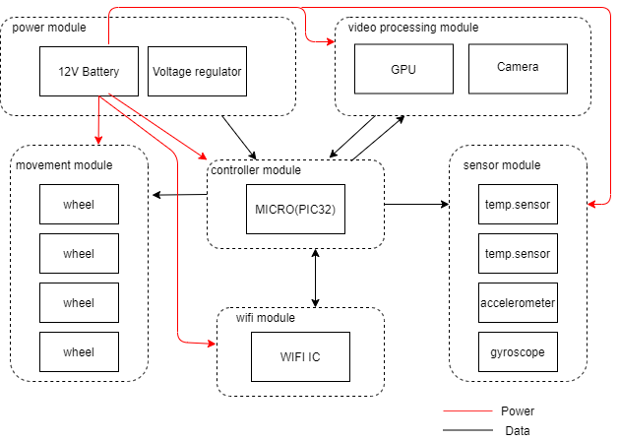
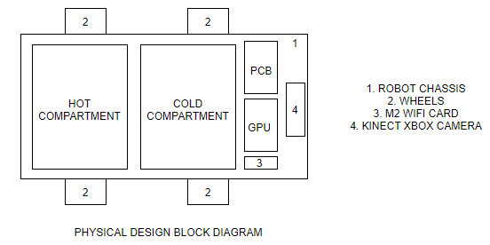
2.2 Physical Design

We plan to have a robot body of a 1’ x 1’ base, and 0.5’ in height, made of Aluminium, and lined with double reflective insulation material (used commonly by almost all restaurants in the USA to maintain food temperature). Also, Aluminium is a bad conductor of heat, and will help preserve the food temperature as a result. Each compartment will have a separate hinged lid. There will be 4 wheels, which will be used to drive the vehicle using differential drive. The PCB will consist of the electronic circuit, the power systems (Li 12-V batteries), and the motors (370 brushless motors, which will be connected to the wheels, but controlled by the electronic circuit on the PCB). ‘4’ in the diagram above represents the Kinect Xbox Video Camera, which will generate a video stream data, which will be transmitted to the laptop via the Jetson Nano Single Board Computer, indicated by “GPU” in the above figure, using ‘3’, the M2 wifi card.

2.3 Controller Module
This module will be the responsible for controlling everything. It will control the wheels , process the information that receives from the cideo processing module , communicate via WIFI to update its availability and position and receive all the information from the sensors and process it.
2.5 Sensor Module
2.6 Power Module
2.7 Movement Module
2.8 Wifi Module
The controller module will communicate with this module via UART or SPI. This module wil be the responsible of keeping us updated via server.
This primary software module that the robot chassis will connect to will have two components, namely the front end and the back end. The backed of this module will be updated by the Daily Byte staff to record item availability, as well as to collect payment and orders. The front end of this interface will be used by the user to place the order, the room number and make the payment via PayPal/credit card. Once the order has been placed, this module will activate the camera sensor on the chassis, which will start collecting the data and transmitting the video data stream to the two aforementioned software modules, namely “April Tag Module” and “Visual SLAM Module”.
2.9 Video Processing Module
The robot will make use of a Kinect Xbox video camera to implement Visual SLAM and April Tag recognition, which will be used to localize the robot and map the surroundings. To implement these, we will be making use of the following ROS libraries:
- “Slam toolbox” for performing Visual SLAM
- “Apriltags_ros” to perform bundle calibration and video stream tag detection
Once our localization and mapping are done, we will use our maps to implement the Obstacle Avoidance and Path Planning Module via the following libraries:
- "global_planner" for global path planning
- "teb_local_planner" for optimizing the robot's trajectory with respect to trajectory execution time, separation from obstacles and compliance with kinodynamic constraints at runtime
- “locomotor”, which will “provide a mechanism to for controlling what happens when the global and local planners succeed and fail."
This module will also use the data sent from the Kinect Xbox camera to form a map of the ECE Building. This will be done using the “Slam tool box” ROS library, which will create a 3D map of the ECE Building, which will then be used to plan the path and avoid obstacles in the planned path, as detailed in 2.3 (d), which will further help the robot navigate in real time.

Risk Analysis
The weakest link in this design is the Obstacle Avoidance and Path Planning Module. This is because it is not self-dependent in operation; it requires data from the visual SLAM Module and the April Tags Module. Moreover, it needs to process the constant data that it will get from the GPU. In addition to that, it also needs to plan the path both locally and globally, specify what to do in case one fails, which can be a tough decision to make, and avoid dynamic obstacles on the fly. Hence, it is central to the project, heavy in computation and dependent on other modules for functioning. Hence, it is the biggest risk to the success of the project.
2. 10 Tolerance Analysis
3. Cost and Schedule
3.1 Cost Analysis
- Labor: our goal is that we all work the same number of hours and optimizing the time in the best possible way. For this, it will be necessary a previous distribution of tasks that make our work a place for a complete project and in which the high-level requirements are met. As we are assuming that for the project we are working as engineers without experience, a reasonable salary should be 13$/hour. Ahora que ya sabemos lo que cobraríamos (más o menos), nosh ace fata hacer una estimación de las horas empleadas en el Proyecto, que yo diria que serían unas 10 horas semanales, por parte de cada uno, por tanto, el dinero que ganaríamos finalmente sería:
$$13\frac{\$}{h}*2.5*70 hours to complete=2275 \$ as TOTAL$$
- Parts: Table# bellow include all the parts that needs to be buy to build the robot.

Description | Manufacturer | Part # | Quantity | Cost
Camera | Kinect | 1 | 1
Wheel |  | 2 | 4
Motor |  | 3 | 4
Battery |  | 4 | 1
Wi-Fi chip |  | 5 | 1
GPU |  | 6 | 1
Microcontroller |  | 7 | 1
Temperature sensor |  | 8 | 2
Gyroscope |  | 9 | 4
Accelerometer |  | 10 | 4
Voltage regulator |  | 11 | 1
TOTAL FOR THE PARTS |  |  |  | ???

- Sum of cost:
3.2 Schedule
Build the robot
Start programming the micro.
Learn both AprilTags and Visual Slam.

3. DISCUSSION OF ETHICS AND SAFETY
Since our agent is going to be carrying items from the Daily Byte, it will most likely carry liquid beverages. We will have to make sure that those do not come in contact, with the electrical components, which could cause short circuits, which would not be significant enough to hurt anyone, but would cause the robot to malfunction, or potentially stop working completely until the circuit were repaired. To prevent this, we will add an extra layer of casing around the electronic components present on the chassis, compliant with the IP67 regulatory standard.
We will also have to make sure that the navigation is accurate, so that no people or property present in the ECE Building are hurt by the body of the navigating robot. This is in alignment with section 1.2 of the ACM Code of Ethics [7]. We intend to do this by adding temporary stops and emergency stops, so that if the robot is unable to assess where to turn in a situation, it will come to a halt rather than collide with a person or property.
Although we will take full care to only use the video stream data for the purposes of navigation, it is possible that this data could be intercepted and used maliciously over the Wi-Fi for gathering private data from the ECE Building. This would go against sections 1.1, 1.2 and 1.6 of the ACM Code of Ethics [7], because it would violate the privacy and safety of individuals in the surroundings of the product. To avoid this, we will encrypt the transmitted video data so that it cannot be used maliciously.

5. CITATIONS
[1] Helling., Brett, et al. “DoorDash - Everything You Need To Know About This Delivery Service.” Ridester, 2 Feb. 2020, www.ridester.com/doordash-on-demand-food-delivery-service/.
[2] “Bear Robotics, Inc.: Future of Restaurants.” Bear Robotics, www.bearrobotics.ai/products/.
[3] “Savioke.” Savioke, www.savioke.com/.
[4] vestacookingrobot001, and vestacookingrobot001. “China's 1st Cooking Robot: Robot Waiter: Dishwasher Supplier - VestaCookingRobot.” Vesta Cooking Robot Co., Limited, 13 Jan. 2020, www.vestacookingrobot.com/.
[5] mpetrova92. “These Butler Bots Are Building Resumes at Companies like FedEx and Residence Inn.” CNBC, CNBC, 25 Aug. 2017, www.cnbc.com/2017/08/24/fedex-and-hotels-and-hire-autonomous-delivery-robots.html.
[6] https://www.mdpi.com/1424-8220/19/24/5480/pdf
[7] “The Code Affirms an Obligation of Computing Professionals to Use Their Skills for the Benefit of Society.” Code of Ethics, www.acm.org/code-of-ethics.

