Posture Sensing Smart Chair
Brian Hill, Geonil Kim, Steven Zhou
ECE 445 Project Proposal - Spring 2020
TA: Jonathan Hoff

Introduction
1.1 Objective
Back problems due to slouching have reached record levels as people spend more and more time sitting in cubicles, hunched over a computer for hours upon hours every single day. In fact, according to a University of Washington study, Forty-five percent of Americans ​between the ages of 35 and 55 suffer acute back pain each ​year. Moreover, other studies carried out by the Social Security Administration identified back pain as the top cause of disability under the age of 45 in the United States [1]. Not only is poor posture unsightly, but it also introduces stress on the neck and spine, causing further muscular tension as the body attempts to compensate for the lack of support.

While maintaining proper posture is something that needs to be taken seriously 24/7, we have decided to combat this problem by focusing on time spent sitting in front of a computer, like in a traditional office environment, for example. After all, many adults spend a significant portion of their lives in this position! In response to this, we have set out to create a chair that automatically senses a person’s posture throughout the day, alerting users when they begin to slouch and tracking their positions over time. From our own experiences with posture-related back problems, we know the hardest part about changing our habits is accountability. While strengthening postural muscles is important in correcting kyphotic posture, it is useless if you are unable to remember to put those muscles to use. By using our product, we hope to make people more aware of the way they are sitting and allow them to monitor their progress as they try to break the habit!

1.2 Background
Because poor posture is such a widespread problem there currently exist many solutions on the market. A large portion of these solutions fall under the umbrella of electronic wearables. While we did initially play with the idea of designing our own wearable, we ultimately decided against it because we suspect that many people would not like the idea of wires running through their clothing. Other solutions involve harnesses that physically pull the shoulder blades back. The problem with these lies in the fact that they don’t support the development of stronger postural muscles and therefore won’t actually fix the problem. The last major class of solutions to poor posture in the workplace are ergonomic workstations and include things like standing desks and using an inflatable ball instead of a chair. While these solutions have the right idea in mind, the average person does not want to stand or roll around on a ball for eight hours a day; it’s exhausting and unsustainable for many! We believe a posture sensing chair would have many advantages over the existing products on the market.

1.3 High-level requirements list
- Ultrasonic range sensors and pressure sensors must be able to accurately collect and send data for the computer to determine whether an individual’s posture is considered acceptable.
- The computer must be able to collectively analyze the data provided from the two subsystems (back and seat) and send feedback back to the chair’s LEDs and vibrating system to notify the user’s current posture.
- The data analyzed must be shown visually through some sort of graph display indicating gradual progression and other logistics.

Design
Block Diagram
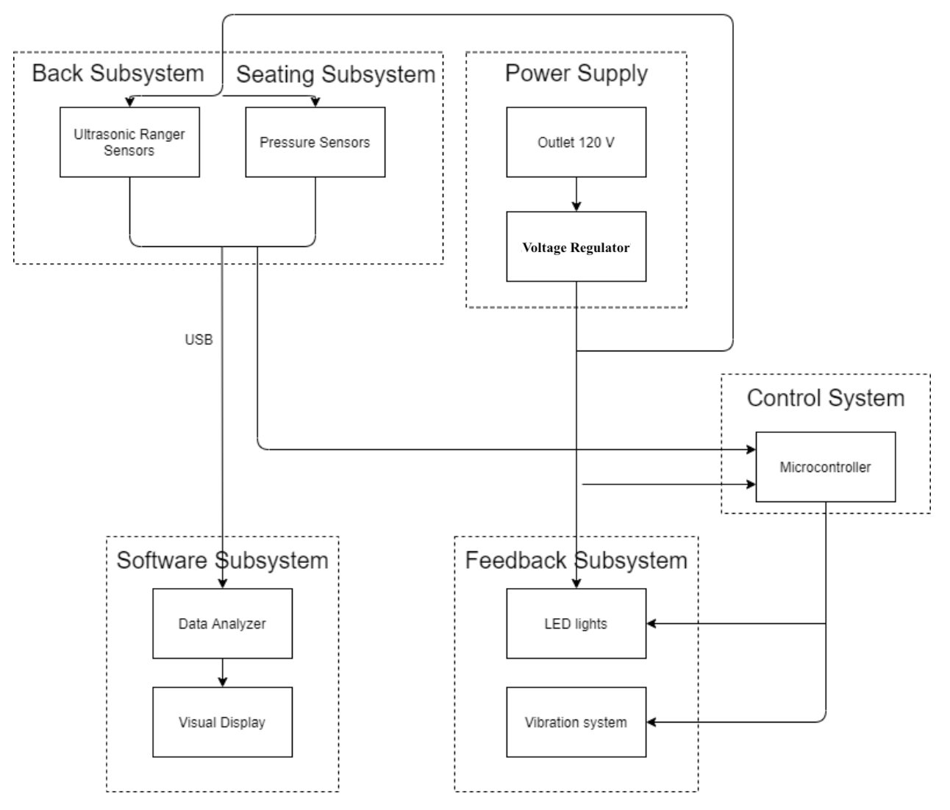
2.1 Power Supply
2.1.1 Outlet 120 V
Outlet of 120 V will be used to power the sensors, microcontroller, and the feedback subsystem (LEDs and vibration system).

2.1.2 Voltage Regulator
Power from outlet converted to appropriate voltages for use in other modules
Requirement: This module must convert standard 120V AC to input requirements of other modules. For example, the microcontroller will likely require 3-5V DC (depending on the exact model chosen). The vibration system on the other hand might require some other voltage level. The voltage regulator should accommodate both of these.

2.2 Control System
2.2.1 Microcontroller
We will use the stm-32 as our microcontroller in order to process data collection from the back and seat subsystems to the computer software for analysis. It will also send signals to the LED lights and vibration system to determine if any areas are causing a bad posture.

Requirement: This module must be able to efficiently collect and encode data at every 1 minute interval then sent to the computer for data analysis. Upon reading the analyzed data, the module must be able to send signals to notify the user.

2.3 Sensors
2.3.1 Ultrasonic Range Sensors
We will use 5-6 ultrasonic range sensors to measure distances from the back of the chair to various points on the spine.

Requirement: This module must be able to distinguish between natural (good) and excessive (bad) curvature of the spine with 70% accuracy. Measurements must be accurate to +/- 1 in.

2.3.2 Pressure Sensors
We will use an array (10x10) of pressure sensors on the bottom of the chair to track positioning

Requirement 1: Must be able to withstand weights up to 400 lbs and be comfortable enough to sit on all day long
Requirement 2: Must be able to track weight distribution well enough to determine if the user is properly balanced between left and right sides as well as not too far forward.

2.4 Software Subsystem
2.4.1 Data Analyzer / Visual Display
The data analyzer will receive data from the sensors and interpret the data. It will determine how often the user had a poor posture throughout the day. This data will be sent to the visual display so that the user can understand the current state of his or her posture.

2.5 Feedback Subsystem
2.5.1 LED Lights
LED lights will be used to indicate how good the user’s posture is. After the microcontrollers receive data from the sensors and analyze the data, the microcontroller will tell the LEDs to be lit in green or red depending on the user’s current posture.

Requirement: LEDs turn red when posture is poor, and green when posture is good.

2.5.2 Vibration Subsystem
The vibration system will also be used to notify the user when they begin to slouch. We include this because the user won’t be able to constantly look at the LEDs and be aware of his or her posture. The vibration system will vibrate when the posture of the user is in a poor form.

Requirement: vibration must be strong enough to be felt, but not so strong that it is annoying or disruptive.

2.6 Risk Analysis
The sensors pose the greatest risk to the success of our project. The sensors collect and send data to our other subsystems, but if the data is not accurate, they may lead to wrong results. Therefore, they need to be positioned accurately so that the sensor readings can be used in our software analysis of the user’s sitting position. Another problem is the discomfort the sensors can bring to the user. Since the sensors are electrical hardware system, they need cushions or a protective layer so that the user is comfortable while sitting on the chair.

Ethics and Safety
Our project has several potential safety issues. Like addressed in 2.6 Risk Analysis, our electrical/mechanical components will be attached to where someone will sit on daily. The electrical circuits need to be safely placed in order to prevent potential dangers to the users. In order to prevent this, we need a protective and insulating material that can be put between the sensors and the user. At the same time, we need a material that is comfortable enough that a user can sit on the chair for multiple hours.

We believe that our design is in compliance with the IEEE Code of Ethics. For example, we will make our chair design safe and ethical as stated in code 1. We believe that our design also follows the ACM Code of Ethics. Like ACM 1.1 states, our design will contribute to human well-being as the main purpose of this chair is to correct people’s poor posture.

References
[1] Wang, C. (2020). Good Posture and its Wealth of Benefits to the Workplace. [online] Pdfs.semanticscholar.org. Available at: https://pdfs.semanticscholar.org/7755/d5c48864b44937a639fc3c72f4dd3d4d63df.pdf [Accessed 13 Feb. 2020].

[2] Acatoday.org. (2020). Posture. [online] Available at: https://acatoday.org/content/posture-power-how-to-correct-your-body-alignment [Accessed 13 Feb. 2020].

