Off-grid Photovoltaic Generator

Team 36 - Robert Parkinson, Jack Shea, Ruben Chairez
ECE 445 - Project Proposal - Fall 2018
TA: Zhen Qin

1 Introduction
1.1 Objective
With today's increase in technological dependence, humans require power for more purposes than ever before. Some of these purposes include home projects such as smart gardens, heated/cooled dog houses, etc. which are typically on homeowner’s property but away from the electrical grid. Current solutions such as fossil fuel generators, or extension cords have certain drawbacks including carbon footprint, control, & safety. In addition, many people are drifting away from the use of fossil fuels and are pursuing a greener solution. Figure_1 [1] shows how the use of renewable resources has grown over the years, which suggests that there are more potential users for our product as years pass.

Our project offers the ideal solution to these semi-remote home projects by delivering off-grid solar energy within 20 feet of a weatherproof location with wi-fi connection. It supplies enough energy to feed low power projects such as those mentioned previously & many more. It also gives customers the option to remotely monitor the capability & reliability of the solar system by offering real time information available on the web. This web interface also allows the user to switch loads on & off and to add preference on load priority in order that the system can optimize the power distribution.

1.2 Background
Generators have existed for a long time and are used for all sorts of purposes. Some of which include backup power for home use, Trailer/RV setups for camping/traveling, & remote power for temporary events such as festivals. However, typical generators take fossil fuels to operate and therefore require physical interaction and have a large carbon footprint. Smaller home projects such as smart gardens, dog houses and outdoor lighting usually don’t require quite as much energy as some of the previously mentioned examples and therefore it is rather unreasonable to use a typical generator for these situations. The homeowner then is faced with the decision of whether they should run electricity out to the project, or run an extension cord and hope that nothing goes wrong. Our product provides a user friendly & semi-portable solution that allows for remote monitoring/control which can be very useful for many purposes.

Aside from this, the number of homes installing larger solar systems (such as rooftop) has steadily been rising in the past decade [3]. One of the major factors holding back that increase in homes is the significant financial investment required. In order to aid that increase, our solar generator offers the perfect low-cost stepping stone for wary homeowners who are considering upgrading to a full home solar system. It offers them an opportunity to go partially green and to see the capability and reliability of a PV system by watching it operate in real time via wifi access to the real time data.

1.3 High-Level Requirements
- The unit must provide 250Wh on average per day and last 2 days without any sun.
- The unit must transmit data depicting the performance of the solar panels, charge of the battery & draw from the loads 20ft over bluetooth to a web server where it will then be available to the user via wi-fi.
- The user must be able to control the power being supplied to the outlets & add load preferences in order to optimize the power being delivered.

2 Design
2.1 Block Diagram
As shown in Figure 2.1, this system consists of six main sections. The Solar System/Battery section will consist of the photovoltaic array connected to battery through a charge controller. The power will be fed out of the battery through a DC to AC Inverter to the Relays/Outlets section. The Relay/Outlets section will consist of two solid state relays controlling two outlets based on output from the microprocessor to implement the control & power optimization. The Monitoring Circuit section will contain all necessary circuits for monitoring the current battery charge, solar panel output, and the power drawn from each load. It will then step down the readings to low enough levels for the microprocessor to handle. The Microprocessor will perform all the necessary calculations to make the readings real values then use the bluetooth module to send the data to a raspberry pi which will host the web server. User input data from the web server will then be sent back to the microprocessor where it will be used to control the loads and optimize the power output. The Raspberry Pi and Web/UI sections will work together to act as a server storing and then displaying the measured values and take in the user input then transmit that to the microprocessor.
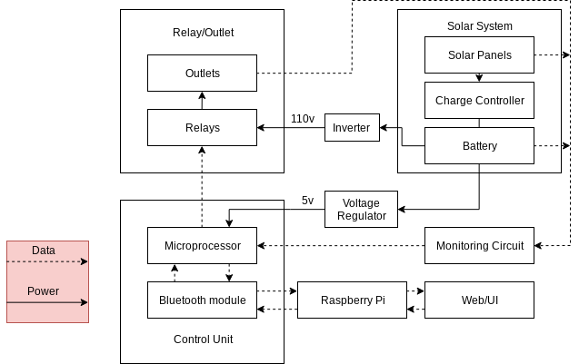

Figure 2.1: Block Diagram

2.2 Physical Design
The panels will have adjustable fold out legs to hold them up while still allowing for relocation and some portability. The main components will be housed in a weatherproof container to protect against rain and snow. Inside the container we will mount the battery, charge controller, and inverter. We will also build a housing for our circuit board that will be mounted to the side of the container to keep it safe from accidental movement. A rough sketch of the project can be seen in figure 2.2.

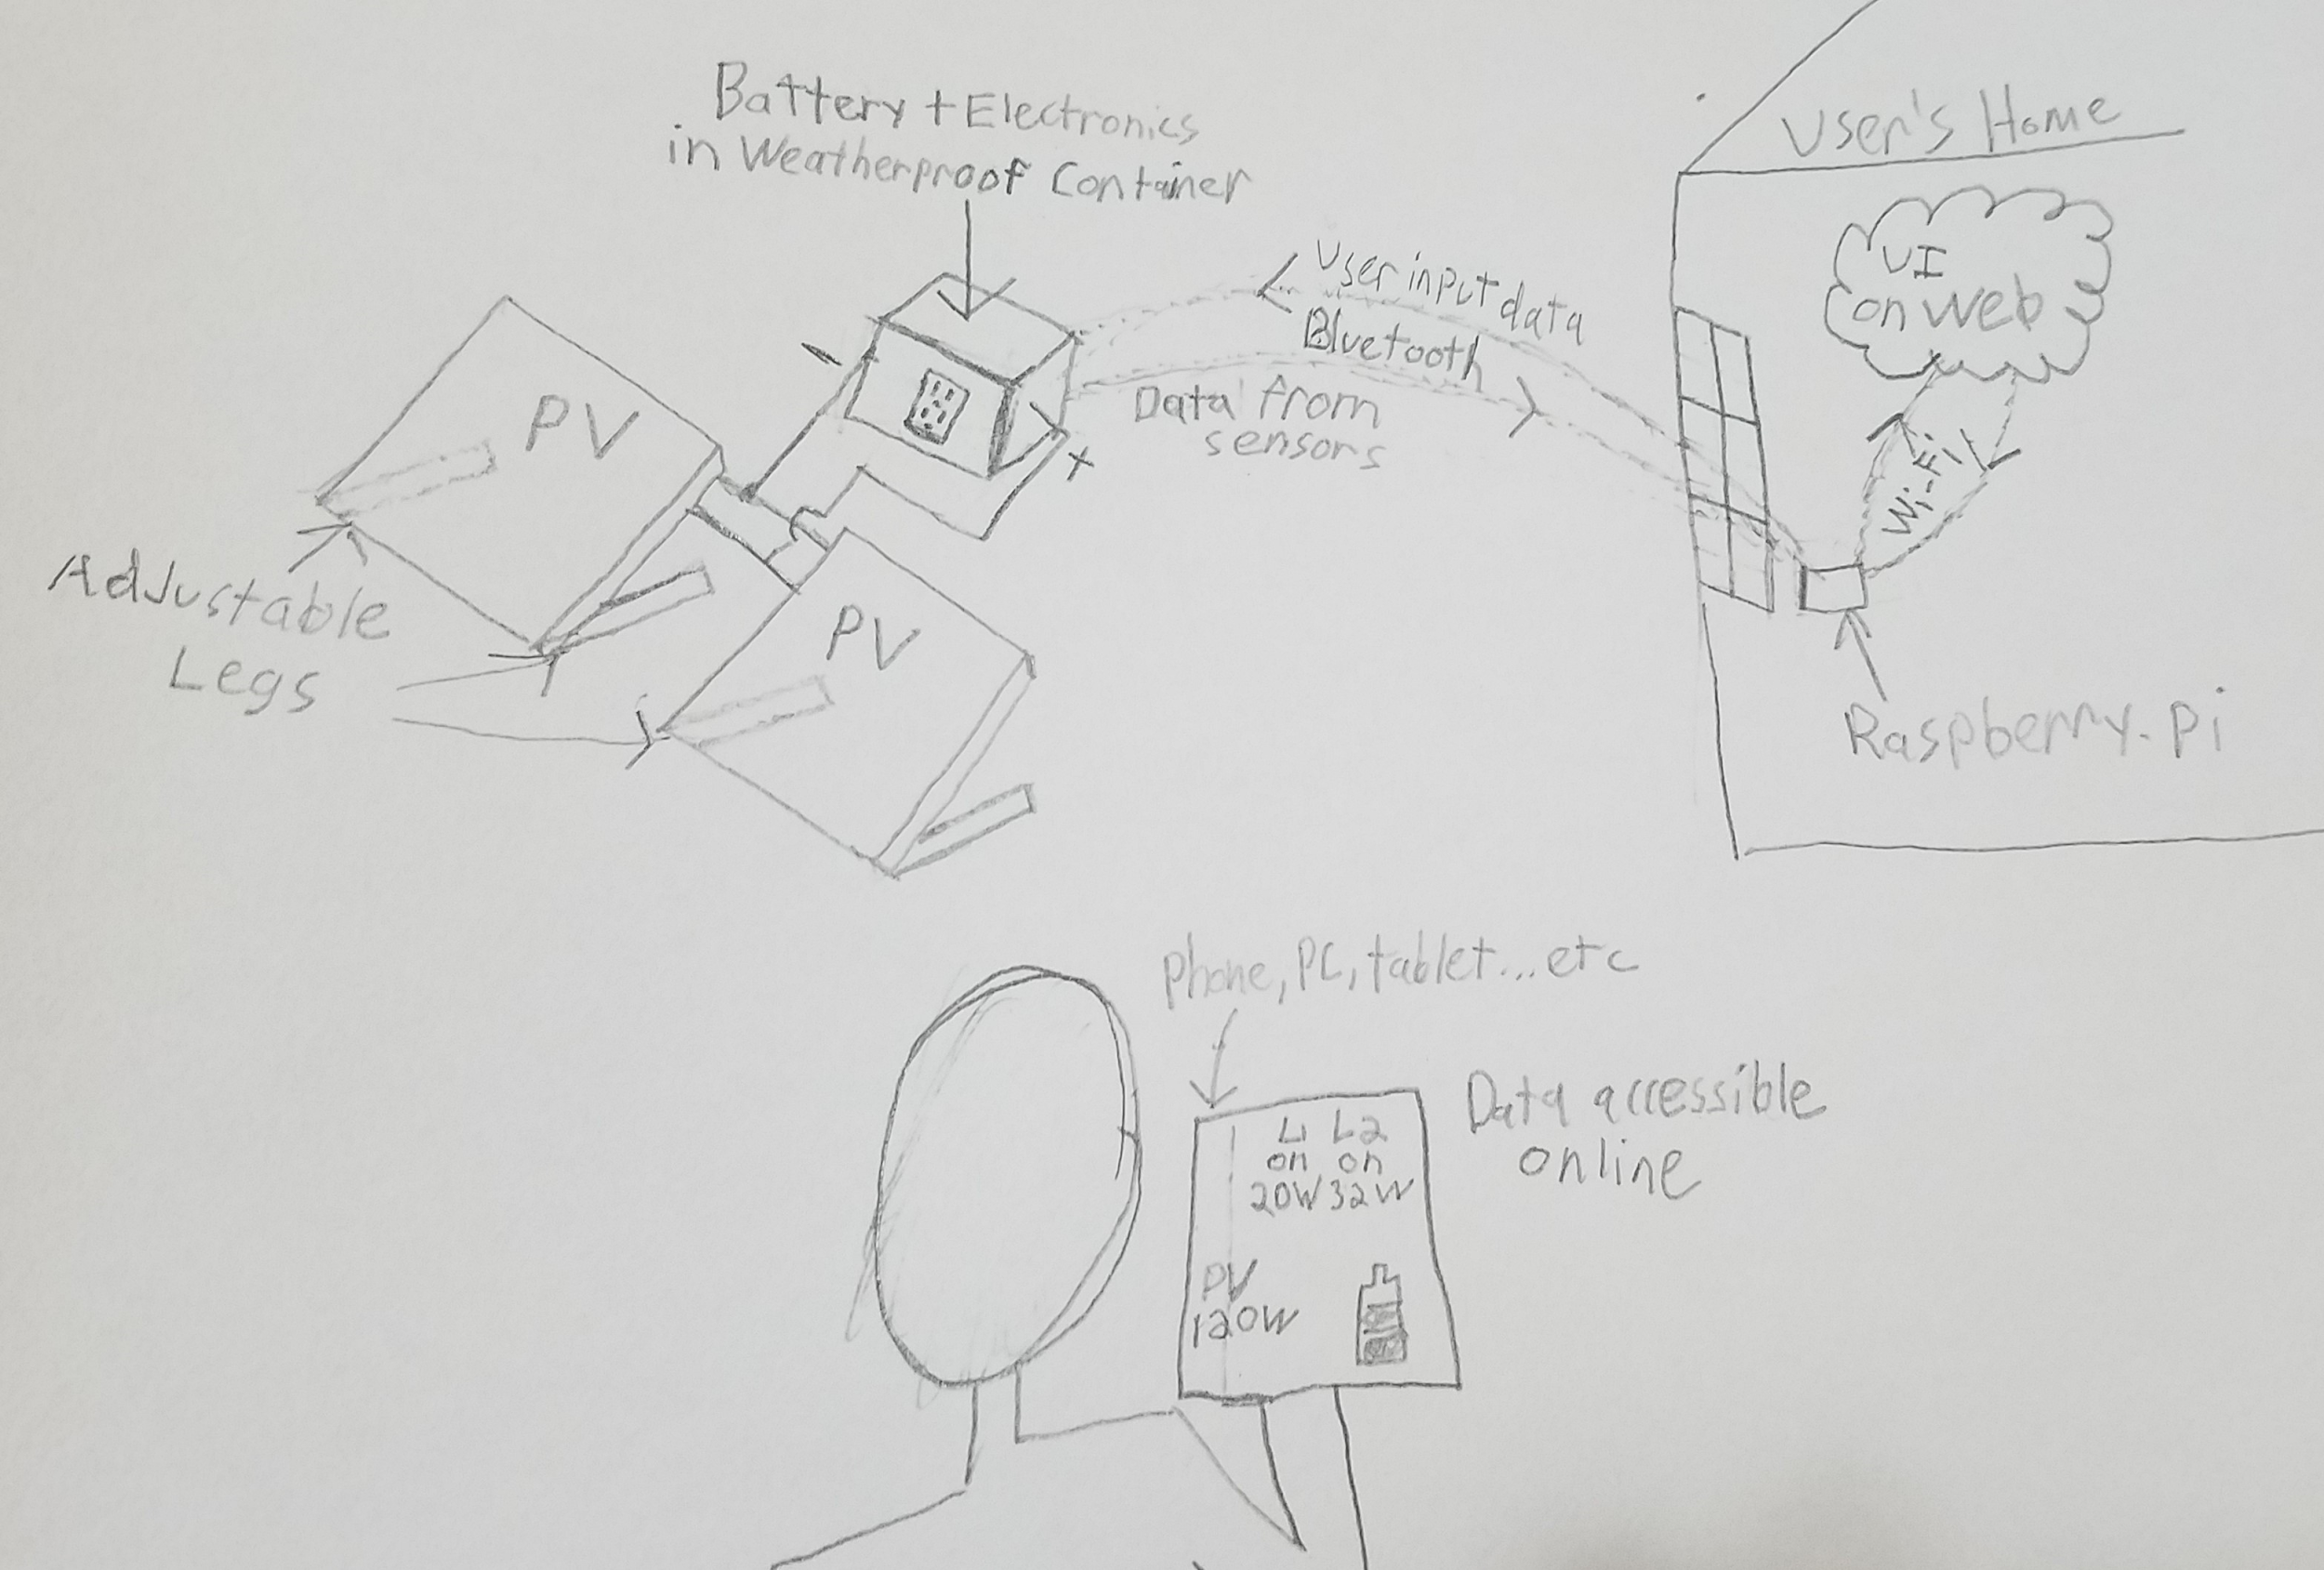
Figure 2.2: Physical & Practical Use Sketch

2.3 Block Design: Functional Overview, Requirements, Supporting Material
2.3.1 Microprocessor/Bluetooth

This block will be entirely implemented on a group designed PCB which with house an ATmega328 microprocessor and a bluetooth module to communicate with other blocks. It will also contain the power circuit needed to take the 12v output from the battery to the 5.5v input needed to run the microprocessor and other components.

Requirements | Verification
- Verify that the data packets sent are correct after transmission  - Data is sent over bluetooth at the correct baud rate  - Verify the bluetooth module can transmit data up to 20 feet (+/- 1 foot) | 1.  - Connect bluetooth module to microcontroller  - Start program on the microcontroller that make predefined packets and sends them over bluetooth  - Check data received by the Raspberry Pi and compare with the predefined values for correctness  - Start program on the Raspberry Pi that makes predefined packets and sends them over bluetooth to the microcontroller. Check data received by the microcontroller and compare with the predefined values for correctness  2.  - Start program on microcontroller to send data at different predefined baud rates  - Use the Raspberry Pi to verify that data is received at different baud rates  - Verify the data is the correct predefined value that was sent  3.  - Run the code to start the bluetooth module and have it start transmitting data.  - Use a bluetooth signal meter app to test the signal strength of the bluetooth module at different distances and record data.  - Verify that the module can send data without loss of data at 20 feet

2.3.2 Battery

The battery required for this project will be a 100Ah 12V lead-acid deep-cycle battery.

When sizing our battery we took the following into consideration:

- Actual Lead Acid Battery Capacity = 50% * rating
- Inverter Efficiency = 85%
- Required Capacity = 250Wh/day * 2 days = 500Wh

500Wh = Nameplate Capacity * .5 * .85

Nameplate Capacity = 1180Wh or 98 Ah at 12VDC

Requirements | Verification
- Must supply 10.5V +- .5V when discharged & 15V +- .5V fully charged.  - Must supply 250Wh on average per day for 2 days | - Leave battery charging until max capacity  - Measure Voltage across positive and negative terminals using multimeter  - Drain battery entirely by running a 200W load  - Measure voltage across positive and negative terminals using multimeter  - Leave battery charging until max capacity  - Wire 200W load and see that it lasts for 2.5 hours +- .5 hours

2.3.3 Solar Panels

The solar array will consist of 2 100W monocrystalline panels.

In order to size the solar array for our project, we took the following into consideration:

- The average hours of direct sunlight in Illinois is 3.14hrs [7].
- The charge controller efficiency is 80%
- The panels on average should supply twice the daily load (2 * 250Wh = 500Wh)

500Wh = 3.14h * Power Rating * .8
Power Rating = 199W

Requirements | Verification
- Must supply 13 - 20V and between 4.5 & 5.75A in direct sunlight.  - Must be self standing & adjustable between 30 - 80 degrees from the ground | - Set panel up facing south at optimal angle on sunny day  - Measure voltage across positive and negative terminals with multimeter  - Change multimeter to current setting & wire it in series with the panel to measure current.  2.  - Set panel up at lowest possible angle  - Measure angle using protractor and verify it is less than or equal to 30 degrees  - Set panel up at largest possible angle  - Measure angle using protractor and verify that it is greater than or equal to 80 degrees

2.3.4 Charge Controller

The charge controller for our project is a 20A PWM charge controller

When choosing a charge controller, we took the following into consideration:

- Solar panel short circuit current = 5.75A * 2 = 11.5A
- LED Display for displaying voltage/current (Useful for checking our monitoring circuit)
- 5V USB output in order to avoid needing a regulator for the microprocessor & other 5V electronics
- PWM charging technology is efficient & affordable
- Provides open circuit, over current, over charge, over discharge, reverse current, & short-circuit protection to ensure that the battery charges safely in all situations

Requirements | Verification
- Must take 13 - 20V input & convert to PWM signal with amplitude ranging from 12V to 16V. | - Hook DC source up to positive and negative PV terminals on charge controller  - Hook oscilloscope up to positive and negative battery terminals on charge controller  - Adjust DC source voltage to 19 V & 5amps & verify PWM output amplitude of 15V +- 1V.

2.3.5 Inverter

For this project, we decided to use a 500W 12VDC to 110VAC Sine Wave Inverter.
This inverter includes overload. Short circuit, low voltage, & high temperature protection. It also includes replaceable external fuses.

Requirements | Verification
- Must provide 110VAC (+-10V) sine wave output with inputs ranging from 10 - 16VDC | - Hook DC source up to positive and negative DC terminals of the Inverter  - Hook oscilloscope up to positive and negative terminals of the inverter AC output  - Change DC source output from 10-16V and verify the waveform is 60Hz sinusoid at 110V+-10V RMS.

2.3.6 Relays/Outlets

We will have 2 outlets that will be controlled through solid state relays mounted on our group designed PCB. These relays will be controlled by the microprocessor to allow the user to control what load is currently operational & to add load preference in order to optimize power output.

Requirements | Verification
- The relay must be able to handle up to 110v (+/- 10v) and up to 5A without failure  - Relays must be independently controlled | 1.  - Hook up a known AC source to the input of the relay  - Set relay control pin for the selected outlet to high on the microcontroller  - Using a voltage meter measure the given voltage across the terminals of the chosen outlet and check the voltage with your known value  - Repeat steps a through c for all outlets  2.  - Set the relay pin to high for one outlet and the others to low on the microcontroller  - Using a voltage meter to measure the voltage across all outlets  - Make sure one outlet is at high while the others are low  - Repeat steps a through c for all relays

2.3.7 Monitoring Circuit

The monitoring circuit will require 3 30 amp (AC/DC) current sensors. It also will require resistors, and capacitors for the current sensing circuits as well as a voltage divider circuits for safely monitoring the charge of the battery. The current sensors & their required circuitry will have direct connections or adapters on our PCB.

Requirements: | Verifications:
- Voltage Monitoring Circuit: Readings are within 0.5v of the actual value and are stepped down to within 0-5v so that the microprocessor can read the values.  - AC Current Sensors: Readings are within .2A of actual value.  - DC Current Sensors: Readings are within .5A of actual value | To test if the readings meet designated range:  - Use a multimeter to test the voltage and current of the different measurement locations and check the values with the computed values from the monitoring circuit.

For the voltage monitoring circuits, we need to “step-down” the voltage from the solar panels & battery to 0-5V in order to protect the microprocessor. We used a simple voltage divider circuit with high value resistors to reduce power waste & a small capacitor to keep the readings steady. The circuit can be seen in figure 2.4.2. The max battery voltage is 17V which calls for R1/R2 = 12/5 and the max PV voltage is 23V which calls for R1/R2 = 18/5.

2.3.8 Raspberry Pi and Web/UI

These blocks will work together to collect the monitoring data output by the processor and display it. It will use bluetooth to interface with the microprocessor and collect the monitoring data then store it to be displayed in human readable format such as graphs. There will also be a user input feature that allows users to control the loads and prioritize them implemented in these blocks.

Requirements: | Verification:
- Must be able to receive and display the data from the microcontroller in real time at least once every 6 seconds (+/- 1 second) without loss of data or precision.  - User can turn on and off the different outlets independently and remotely. | 1.  - Send known data from the microcontroller over bluetooth.  - Check the validity of the received data against known values to check if transmission is working properly.  - Check transmission speed and verify data is received at least every 6 seconds.  2.  - Use voltage meter to verify the voltage across the chosen outlet is low.  - Send activation command from the raspberry pi to turn on the chosen outlet.  - Use voltage meter to verify voltage across the chosen outlet increases to desired level.  - Repeat steps a through c for each outlet.

2.4 Schematics
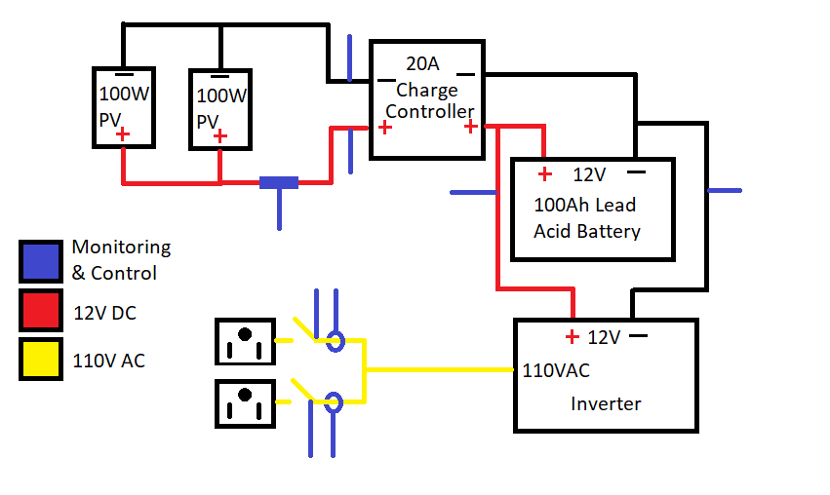
Figure 2.4.1: Solar Circuit Diagram

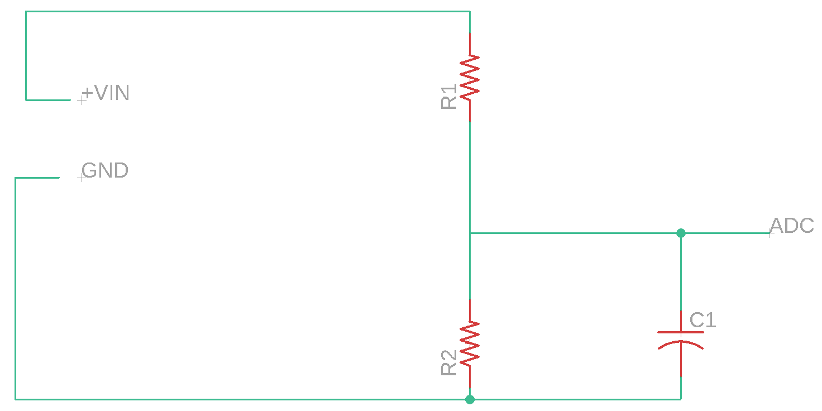
Figure 2.4.2: Voltage Monitoring Circuit

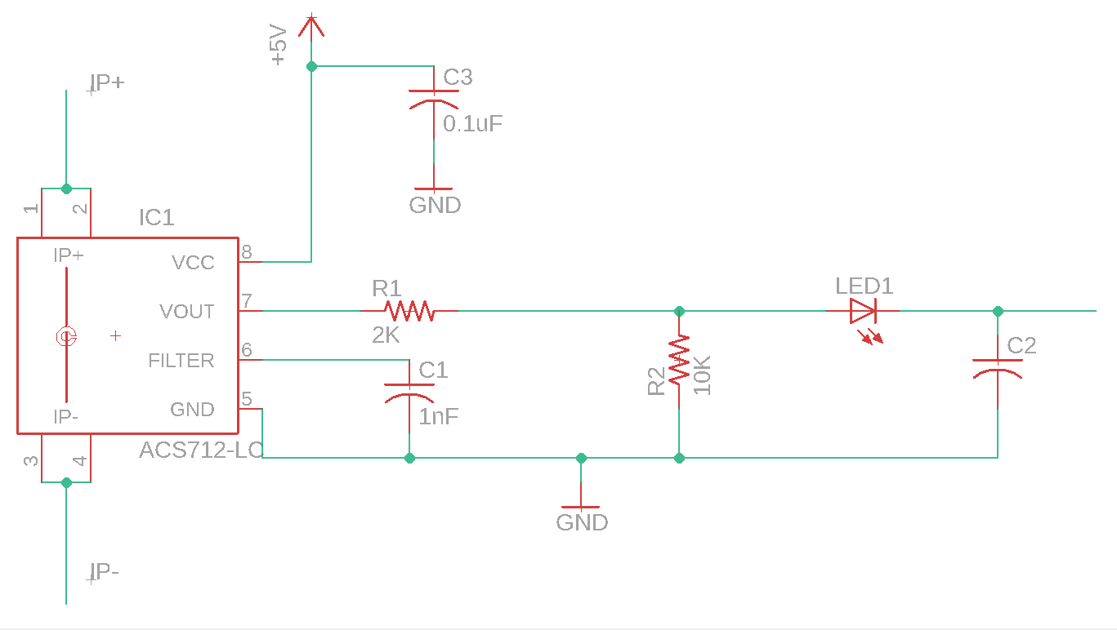
Figure 2.4.3: Current Sensor Circuit
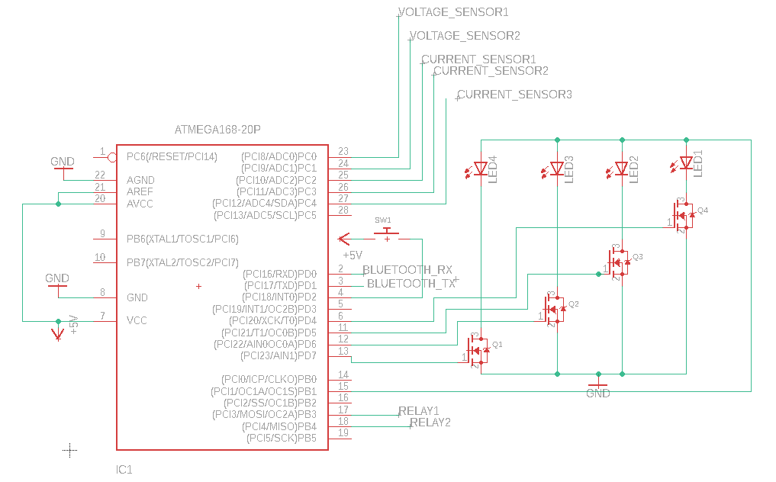
Figure 2.4.4: Microprocessor Circuit

2.5 Software
The software can be broken into three major parts, the control loop algorithm (figure 2.5.1), the Bluetooth packet received algorithm (figure 2.5.2), and the hub control code. The control loop algorithm runs constantly and handles the power optimization, led power level display and checking if the Bluetooth module has received a packet from the hub. When the processor receives a Bluetooth packet it moves over to the Bluetooth packet received algorithm that handles performing all measurement and sending of data back to the hub after it is requested. The hub control software will be responsible for collecting the data from the microprocessor and displaying it to the user as well as collecting user input and relaying it to the microprocessor.

2.5.1 Control Loop Algorithm

This algorithm will run on every clock cycle and will perform most of the control operations. First it will communicate with the bluetooth module and check if a packet was received. If it has been received it will move into the Bluetooth packet received algorithm. If no packet was received then it will move on and take a reading of the current battery level and save it to be used in the rest of the steps. It will then check if the button has been pushed indicating that the user would like to see the current battery level. If the button has been pushed the microcontroller will turn on the LED’s corresponding with the current level of the battery for a few clock cycles so the user can see the current charge level of the battery. After that the algorithm will go into the power optimization steps used to determine if there is enough power left to run both loads or if it should only power the primary load. It will first check the level of the battery against the chosen default switching level if it is higher than it does nothing and goes back to the start. If the battery level is lower than the switching level then the program will turn off the relay for the secondary load, effectively turning the load off until the battery recharges to the desired switching level.

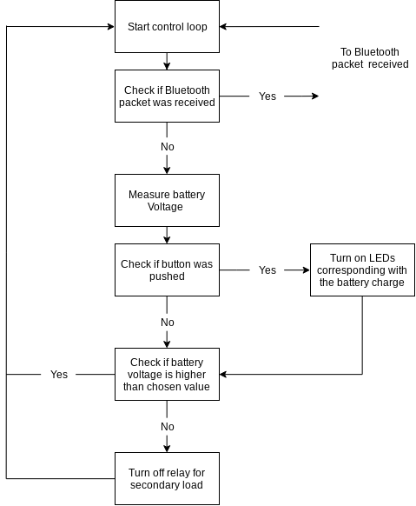
Figure 2.5.1: Control loop
2.5.2 Bluetooth Packet Received Algorithm
This algorithm will only run after a Bluetooth packet has been received and will handle all measurements as well as setting user controlled settings. The first thing the algorithm will do is decode the packet and determine what kind of packet it is, either a command packet or a data request packet. If the packet is a data request then the microprocessor will decode the rest of the packet to determine what data the hub is requesting. Depending on what data the packet is asking for the microprocessor will perform a reading from the control circuit to retrieve the information. It will then make a new data packet containing the data from the measurement and send it back to the hub and move back into the control loop algorithm. If the data packet was a command packet then the microprocessor will decode the packet to determine what command it is issuing. The packet can be either, to toggle on or off a given outlet or to change the current primary load for the power optimization. If the command is to toggle on or off a given outlet then it will toggle on or off the relay for that outlet effectively turning on or off the chosen outlet. Or if the command was to change the current primary load then the algorithm will change the variables needed to control the primary load. After either command it will then make a new action completed command packet and send it back to the hub then move back to the control loop algorithm.

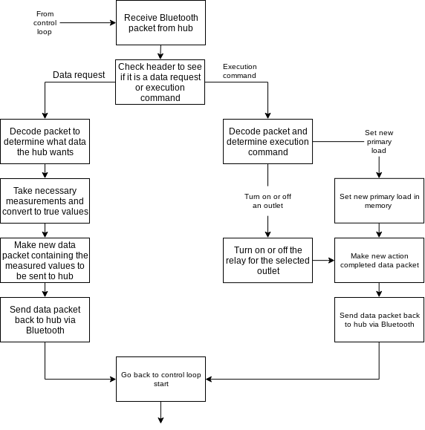
Figure 2.5.2: Bluetooth packet received

2.5.3 Hub Control Code
This code will run on the Raspberry Pi and will perform the necessary steps to collect the data and display it to the user as well as relay user commands to the microprocessor via bluetooth. The main function of this code will be the collection of data and displaying it in human readable formats such as graphs or tables. The hub will start by sending a bluetooth packet to the microcontroller asking for data from the monitoring circuit then wait for the response. When it receives a response it will then decode the data and save it into memory to be used later then it will ask the microprocessor for new data. While it is doing this another program will take the saved data and make human readable graphs or tables out of the saved data and present it to the user in the form of a webpage. The other function of the hub code is to take in user input and relay it to the microprocessor via bluetooth so the user can control the power optimization functionality and toggle the loads on and off.

2.6 Tolerance Analysis
Microprocessor. A crucial component of our design is the monitoring system. We will be using a simple voltage divider, R2/(R1+R2) , in order to step down to an appropriate voltage for the ADC. This voltage will later be multiplied in our software by the same voltage division from the hardware (R1+R2)/R2. Typical resistors have a tolerance of 5% or 1%. Since we want to offer the most accurate data to our user we will be using the 1% resistors. Since we are adding two resistor values we will have a total tolerance of 2%.
Our current sensing circuit will be using an ACS712 chip capable of obtaining currents up to 30 amps and providing an output to the ADC with a 1.5% error at 25°C.
Our ATMega328 microprocessor has an ADC we will be utilizing. These ADC ports have a plus minus 2-bit accuracy with a 10-bit resolution. In other words, we will have a 0.4% error.

3 Cost and Schedule

3.1.1 Labor
$3 people x \frac{\$33}{hour}x\frac{10 hours}{week}x\frac{14 weeks}{semester}x2.5=\$34,650$

3.1.2 Parts

 | Part Title | Vendor | Quantity | Cost | Total Cost
PV System Electrical Parts | Panels | Amazon | 2 | $115 | $230
 | Battery | Walmart | 1 | $100 | $100
 | Charge Controller | Amazon | 1 | $80 | $80
 | Inverter | Amazon | 1 | $50 | $50
Monitoring & Control Electronics | AC current sensor | Amazon | 2 | $15 | $30
 | 3.5mm female adapters | Amazon | 2 | $7 | $14
 | DC current sensor | Amazon | 1 | $15 | $15
 | Resistors | DigiKey | x | $0.10 | $0.1*X
 | Capacitors | DigiKey | y | $0.10 | $0.1*y
 | Relays | Amazon | 2 or 3 | $5 | $5
Data Electronics | ATMEGA328P | MICROChip | 1 | $2 | $2
 | Bluetooth module | Cypress | 1 | $25 | $25
 | Raspberry Pi | Adafruit | 1 | $35 | $35
 | Current Sensor chip | Digikey | 3 | $5 | $5
 |  |  |  | Total: | $586.00

3.1.3 Grand Total
$586.00 + $34,650 = $35,236
3.2 Schedule
Week |  | Objectives
10/8 | Robert | Have all power circuit parts ordered and delivered
 | Jack | Have microprocessor ordered and delivered
 | Ruben | Have bluetooth module ordered and delivered
10/15 | Robert | Have voltage sensing schematic complete
 | Jack | Have adc ports set up on microsessor with accurate readings
 | Ruben | Have current sensing schematic complete
10/22 | Robert | Confirm setup location
 | Jack | Have solar panel and charge controller connected to battery with full functionality
 | Ruben | Have PCB gerbers ready for order
10/29 | Robert | Find and buy battery
 | Jack | Have solar panel legs built
 | Ruben | Find interior insulation for battery and electronic circuitry
11/5 | Robert | Find and order weatherproof container
 | Jack | Mount all accessory components to fixture
 | Ruben | Solder PCB board
11/12 | Robert | Have user interface functional
 | Jack | Have web interface functional
 | Ruben | Have bluetooth communication between module and Raspberry pi
11/19 | Robert | Finish debugging and troubleshooting power analysis
 | Jack | Finish debugging user/web interface
 | Ruben | Finish building container with holes for outlets and have circuitry all installed

4 Ethics and Safety

Because we are using a deep cycle lead-acid battery in our project, we will refer to IEEE 931-2007 “IEEE Recommended Practice for Installation and Maintenance of Lead-Acid Batteries for Photovoltaic (PV) Systems” [4] when installing & working with the battery. In addition, we will include standard operating procedures for the battery in our final report. We will also add a fuse and insulated disconnect switch to the battery for safety.

The project is intended to be used outdoors so we will need to take special care to make sure the housing is element proof and can protect the internal components. We will accomplish this by making sure our housing is waterproof up to IPX2. [6]

The overall project will follow the following IEEE Code of Ethics [2].

All of our electrical components, minus the solar panels, will will be stored in a weather proof container that will have all the dangers of high power batteries insulated. We provide quantitative claims with ranges due to the variability of our idea, but plan on building and testing all of our components before finalizing product claims. The project is not sponsored so we will not be accepting any bribery. The reason for pursuing our idea is for society to have the knowledge and access to renewable energy. Every member of our group has successfully completed the lab safety module and all offer experience in fields required to successfully implement this idea. Our team consists of diverse members with different backgrounds and experience who offer a unique point of view for all aspects of our project. The safety of everyone is always a concern for our group and we plan on creating our idea properly and following all suggested guidelines. Our team is motivated to achieve our goals and understand that knowledge share and skills development is required by all of us to successfully build our idea.

References
[1] “Home.” CRYPTO News, www.stupen.com/markets-news/the-world-set-a-new-record-for-renewable-power-in-2017-but-emissions-are-still-rising/.

[2] “IEEE Code of Ethics”, ieee.org, 2017. [Online]. Available: http://www.ieee.org/about/corporate/governance/p7-8.html

[3] Solar Energy Industries Association, “Solar Industry Research Data.” (n.d.). [Online]. Available: from https://www.seia.org/solar-industry-research-data

[4] Standards.ieee.org. (2018). IEEE 937-2007 - IEEE Recommended Practice for Installation and Maintenance of Lead-Acid Batteries for Photovoltaic (PV) Systems. [online] Available at: https://standards.ieee.org/standard/937-2007.html [Accessed 2 Oct. 2018].

[5] Sparkfun.com. (2007). Fully Integrated, Hall Effect-Based Linear Current Sensor with 2.1 kVRMS Voltage Isolation and a Low-Resistance Current Conductor. [online] Available at: https://www.sparkfun.com/datasheets/BreakoutBoards/0712.pdf [Accessed 4 Oct. 2018].

[6] Sp.se. (2018). IP-classification. [online] Available at: https://www.sp.se/en/index/services/ip/Sidor/default.aspx [Accessed 4 Oct. 2018].

[7] Peak Sun Hours for Solar Panels in Illinois. (2018). Retrieved from https://www.turbinegenerator.org/solar/illinois/

Figures
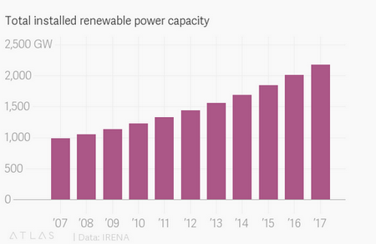
Figure_1: Growth of Renewable Power Capacity

