Contact Probe Aligner
for Semiconductor Measurement
Team 6 Stanford Zhou, Zehua Chen, Zihao Xie
ECE445 Project Proposal Fall 2017
TA: Rebecca Chen

1 Introduction
1.1 Objective
As the semiconductor technology improves, the size of each device in the wafer is decreasing exponentially[1]. Even though in industry the measurements of semiconductor devices in the micro and nano level are handled electronically, students and researchers in campus still use lab equipments mainly controlled manually by hand. One of the more challenging measuring instruments to handle is the probe station, which is used in the IC fabrication lab class here. Usually, the devices are on the scale of micrometers, and thus navigating the probes by hand requires the user to have advanced experience and precision. In addition, noticing the probe is in contact with the wafer with bare eyes, even with the help of a microscope, can be difficult. A mistake in either way can scratch the device and even damage the probes, disabling the probe station.
To solve these problems, we introduce this project that will control the movement of the probes electronically with motors and a computer interface, sense the distance between the probes and the device so the probes won’t bend, differentiate metal from non-metal so the probes will be placed at the right place, and unallow all movement in the horizontal plane so the wafer won’t be scratched. The user will use the computer as the interface to control the motors on the high level. With our features and electronic control, we can alleviate a lot of risk involved in the measurement of semiconductor devices using the probe station.

1.2 Background
The core of the original instrument is the four probes, which serves to connect the metal contacts of the source, drain, body, and gate of an MOS device[2]. The probe station can also measure other integrated circuit devices such as capacitors. Since the probes are measuring integrated circuits in the micron scale, they are very slim and fragile. And once they are bent or blunt, the measurement results will be affected drastically. In last semester’s IC fabrication lab, two of the three probe stations used to measure the wafers, our semester-long work, were disabled because during earlier sections, some students bent the probes while trying to get measurements. As a result, most of the students taking the class that semester didn’t get the right data.
Furthermore, the sharp probes can easily damage the devices on the wafer if not handled carefully. When we make the semiconductors, each deposition level is on the scale of nanometers, and the metal contacts are micrometers in thickness. Fortunately, we’ve made a lot of devices on our 4 inch silicon wafer, and scratching a few of them off isn’t costly. But if people don’t have an abundant amount devices on their wafer, this can potentially be a serious problem as well.

1.3 High level requirements
- Allow the probe to be moved by motors with precision in 3 dimensions(horizontal plane, up and down in vertical plane).
- Prevent the user from performing operations that potentially damages the probes or the wafer.
- Alert the user when the probes is linked on a region where there’s no possible connection.
- Allow the user to have full control over the choice of moving a certain probe on a certain axis.
- The user should be able to see the image of the wafer under microscopic lens through the computer screen, where he/she will be controlling the probes.

2 Design
Block diagram
The block diagram for our design is shown in Figure 1. Implementation contains Sensor unit, Control unit, Motor unit, Computer, User interface unit and Power supply. Motor unit enables the movements of probe in three dimensions. Sensor unit is mainly responsible for measuring whether the probe has contact with the wafer and recording the images in the microscope. The measurement may help user prevent damages to both probe and wafer. User interface unit gives user a vision of where the probe and metal region of wafer are so that user knows where the probe should be moved. The input of user interface which is Keyboard is used for user to control the probe in three dimensions. Computer is used here to perform image processing and send signal to control unit. It can also alert user when the point of probe is going to is nonmetal region. Power supply provide power to different components of design.
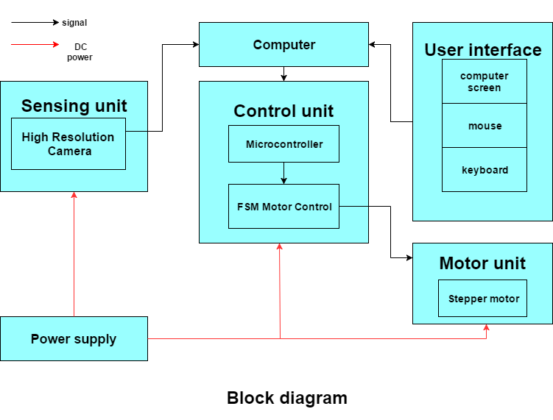
Figure 1. Block Diagram

Functional Overview
2.1 Motor unit
There are three knobs to control a probe in three dimensions. Therefore, motor unit contains three stepper motors. Each motor controls the movement of probe only in one dimension. These three motors are connected with three knobs on the probe station separately with gear boxes. This unit replace the manual control before completely with accurate position control motor: stepper motor. These three motors are controlled by the motor drive. Motor drive not only supplies input power to run these three motors but also have control mechanism to run motor accurately.
There are seven states for motor driver to control these motors. Three of states are to move the probe fastly in each dimension when the probe is relatively far away from the destination. Another three of states are to move the probe slowly in each dimension when the probe is close to destination. The last state is a stop state and movement of probe is not allowed in all three dimension. Pulse width modulation is used to set two different speeds for stepper motors. [3] Motor driver receives signals from the control unit. According to different signals, motor driver then adjust duty ratio to set desired speed and select correct motor to move.

Requirement 1: With certain amount of loading torque, three motors are still able to move in desired speed
Requirement 2: The time it takes to stop motors should be within 0.5 seconds

2.2 Sensor unit
2.2.1 High Resolution Camera
The High Resolution Camera will be attached to the microscope to receive image data. The data will be transferred to computer by USB port. The area allowed for probe operation can be seen by the user. Since this is an off the shelf product.The power requirement is given by the datasheet.

Requirement: camera can recognize metal and nonmetal color.

2.3 Control unit
The control unit receives signals from the user interface and instructs the motor units to move in accordingly.
2.3.1 Micro-controller
We will use an arduino board to control the motor drives.[4]

2.3.2 FSM for contact sensing
we will implement an FSM where the position/movement of the probe(captured by the computer) is the input, the expected velocity is the condition, and the output is the signal to allow/disable the probe to move further downwards.[5]

Requirement: the FSM must be accurate and precise enough so the probe tip and wafer is not damaged

2.4 User Interface
The user will control the components mentioned below, which will trigger signals that will be sent to the control unit and motor unit via an arduino. The user will first select a region with the mouse to place the wafer on the computer screen, choose which probe will be moved, and then move them with the keyboard.
2.4.1 Computer screen
The computer screen will show the user the snapshot of the image captured under the lens by the camera. This image will be processed by a computer program to determine which regions the probes are allowed to touch. And show a drop-down menu to select which probe to move.

2.4.2 Mouse
The mouse will be used to select from the drop down menu, and select a region on the snapshot on the computer screen to see if the region is metal contact or not. The user can also select from two speeds to operate using the mouse; a faster speed when the probe is far from the region of contact, and a slower one for more precision. [6]

Requirement: In the case that the user selects a region that is non-metal to contact the probe, a warning window should pop up alerting the user and make him/her reselect.

2.4.3 Keyboard
The keys W,S,A,D will control the movements of the up, down, left, right respectively on the horizontal plane. The UP and DOWN keys will control the vertical plane up and down movements. [6]

Requirement: Only one key can be pressed at a time effectively. If two keys are pressed, the one pressed later will be neglected.

2.5 Power supply
2.5.1 Battery
The power source for the design consists of three batteries. Battery 1 will be used for powering the microcontroller. Battery 2 will be used to power the motor driver.

Requirement 1: all of batteries should supply power for sufficient amount of time.

2.6 Risk Analysis
One of the more challenging aspects of our project is to find the right motors that will guarantee enough precision in the micro-level scope. Since the probe knobs themselves have a decent built-in angular motion to actual probe movement ratio, our motors will be gears to help the knobs move. This will involve very precise calculation about the angular velocity of the gears driven by the motors, the radius of the gears we choose, and the supply voltage. The supply voltage have to be large enough to guarantee the torque of the gears so that they can drive the knobs consistently without slipping.
The other risky part about our scheme is the FSM control unit that determines whether the probe is already touching the contact and prevents the probe from moving down further. The frequency of the clock cycle of this FSM will have to be large, and any hint of a disturbance from the feedback have to be noticed right away. The probe shouldn’t penetrate deeper than a few nanometers of the device or the device may be terminated. Therefore, the velocity of the probe when approaching the wafer should be monitored very closely. This ties back to the precise control of speed and the probes. The torque applied to the knobs have to be strong enough to move the knobs effectively, but also weak enough to be impeded once

3 Ethics and Safety
Our project will not harm people according to code 1. Our decision is made to improve the learning experience of ECE 444 students. The power source for our main circuit design is considered as low voltage. It will not cause a significant safety issue. However, the battery will potentially pollutes the environment if handled not correctly. We will take care of all the waste materials and dispose them with caution. The off-shelf components may use a regular 110v wall outlet. For the safety issue for those components, please review the safety documents in the user manual.
We commit to the IEEE code of ethics[7]. The access of the document is in the reference section of this proposal. Since plagiarism is prohibited, we will not use an existing auto-probe station as a reference. Instead we will improve the old manual model of the probe station of our school. Our design will be original and approach the problem in a different way. We abide to code 9 and 10; we will study and reference, but not copy or steal any existing ideas related to our project without giving them their due, and make sure each member of the group understand the consequences of such actions.
In this proposal, we believe, as of right now, all the design features are achievable and are within the scope of our abilities. As code 3 states, this proposal is an honest, realistic projection of our potential. We will also divide the credentials of this project as it’s due, according to code 7 and 10. Every member will be given credit solely based on their contributions toward the project.

References
[1] The scaling of MOSFETs, Moore’s Law, and ITRS. Available online http://userweb.eng.gla.ac.uk/fikru.adamu-lema/Chapter_02.pdf

[2] Probe Tips and Probe Holder Reference manual, Micromanipulator Inc, 2013.

[3] Msraynsford, Arduino Hardware PWM for Stepper Motor Drives. Available: http://www.instructables.com/id/Arduino-Hardware-PWM-for-stepper-motor-drives/

[4] W. Durfee, University of Minnesota, Arduino Microcontroller Guide ver. oct-2011
Available on-line at www.me.umn.edu/courses/me2011/arduino/

[5] M. A. Laughton，D.F. Warne Electrical Engineer's Reference Book Available online at
https://books.google.com/books?id=5jOblzV5eZ8C&pg=SA15-PA6&lpg=SA15-PA6&dq=general+FSM+design+reference&source=bl&ots=tZjN3DRgTQ&sig=QLu6JYU2viU65dtCtsy5haetlK4&hl=zh-CN&sa=X&ved=0ahUKEwiI3_OVobfWAhVi6IMKHXrxD8YQ6AEITDAE#v=onepage&q=FSM&f=false

[6] Mouse and Keyboard libraries, Arduino website
Available online at https://www.arduino.cc/en/Reference/MouseKeyboard

[7] Ieee.org, "IEEE IEEE Code of Ethics", 2016. [Online]. Available: http://www.ieee.org/about/corporate/governance/p7-8.html. [Accessed: 21-SEP- 2017]

