Final Report for ECE 445, Senior Design, Spring 2018
TA: Mickey Zhang
02 May 2018
Project No. 16
Anika Manzo
Brianna Szczesuil
Gregg Cruz Lugo

By

The Lug-N-Go
Abstract
This report discusses the design and verification process of creating The Lug-N-Go, an autonomous suitcase capable of charging a phone, avoiding obstacles, and following a specific user. This system utilizes a TSA friendly and easily removable Lithium-Ion Polymer battery as the main power source. Infrared proximity sensors are analyzed with various objects and distances to determine its suitability for obstacle detection. Received Signal Strength Indication (RSSI) provided by Bluetooth modules is successfully used to estimate a distance between the user and the luggage. By integrating these features with a motor control system, the final prototype was able to achieve most objectives set at the beginning of the semester.
Contents

1. Introduction 1
1.1 Objective 1
1.2 Project Goals 2
2 Design 2
2.1 Power Supply 2
2.1.1 Lithium Ion Polymer Battery 3
2.1.2 Buck Converter #1 3
2.1.3 Buck Converter #2 4
4
2.1.4 Buck Converter #3 4
2.2 Control Unit 4
2.2.1 Microcontroller 4
2.2.2 Obstacle Sensors 5
2.2.3 Bluetooth Modules 5
2.3 Motor Control 7
2.3.1 Motors 7
2.3.2 Motor Drive 7
2.4 USB Charging Dock 8
2.5 Software 8
2.5.1 Obstacle Avoidance 8
2.5.2 User Following 8
3.1 Power Supply 9
3.1.1 Lithium Ion Polymer Battery 9
3.1.2 Buck Converter #1 9
10
3.1.3 Buck Converter #2 10
3.1.4 Buck Converter #3 10
3.2 Control Unit 11
3.2.1 Microcontroller 11
3.2.2 Obstacle Sensors 11
3.2.3 Bluetooth Modules 12
13
3.3 Motor Control 13
3.4 USB Charging Dock 14
3.5 Motors 14
4 Costs 14
4.1 Parts 14
4.2 Labor 15
4.3 Total Costs 15
5 Conclusions 16
5.1 Accomplishments 16
5.2 Uncertainties 16
5.3 Ethical Considerations 16
5.4 Future Work 16
6 References 18
Appendix A Requirement and Verification Table 19
Appendix B Current Readings for each Component 25

1. Introduction

1.1 Objective
Traveling is an adventure that everyone loves embarking upon. However, walking through an airport with duffle bags on your shoulder or dragging a carry-on bag behind you, all while walking from line to line is something that no one wants to do. For years, we have been using the same method for luggage: stick some wheels on it and awkwardly drag it around. We aim to rid people of this burden with the Lug-n-Go.
The Lug-n-Go’s goal is to modernize the carry-on luggage to conform to today’s technologically advanced world. This luggage will be automated to follow the owner and avoid obstacles so that he or she does not have to lug around a fully packed bag that can weigh up to 40 pounds [1]. We also want to add a USB charging port because finding an open outlet or charging station is nearly impossible at an airport. Our design will incorporate these features into a reliable and affordable package that abides by TSA regulations on size, weight, and battery type.
Our design consists of four main modules, each playing an important role in our overall design. The first module is the power supply unit. This unit is responsible for safely and efficiently supplying power to the other modules in our design. This module includes a Lithium Ion battery that follows all TSA rules and regulations and three buck converters to efficiently step down the voltage from the battery to other necessary levels.
The second module is the control unit. This module consists of the microcontroller, two obstacle sensors, and two Bluetooth modules. It is responsible for requesting and processing data from the obstacle sensors and Bluetooth modules. After processing all data, this unit is responsible for sending signals to the motor control module to properly avoid obstacles or follow the user.
The third unit is the motor control module. This module consists of our motor drive and two DC motors. This module is responsible for taking signals from the control unit and properly adjusting the speed of the correct motor. The fourth, and last, unit is the USB charging dock. This module is responsible for charging a phone or iPod using the 5 V output from our buck converter.
Figure 1 shows how each module is integrated together to create our final design. Each module in our design was fully functional and met the requirements set at the beginning of the semester. Figure 2 shows the initial design that was developed in Cadence and used as a reference when building the final design which is shown in Figure 3. This report discusses the design and verification process for each module. It also includes a cost analysis including each component used in our design. Lastly, overall accomplishments, uncertainties, and ethical considerations are described in detail.

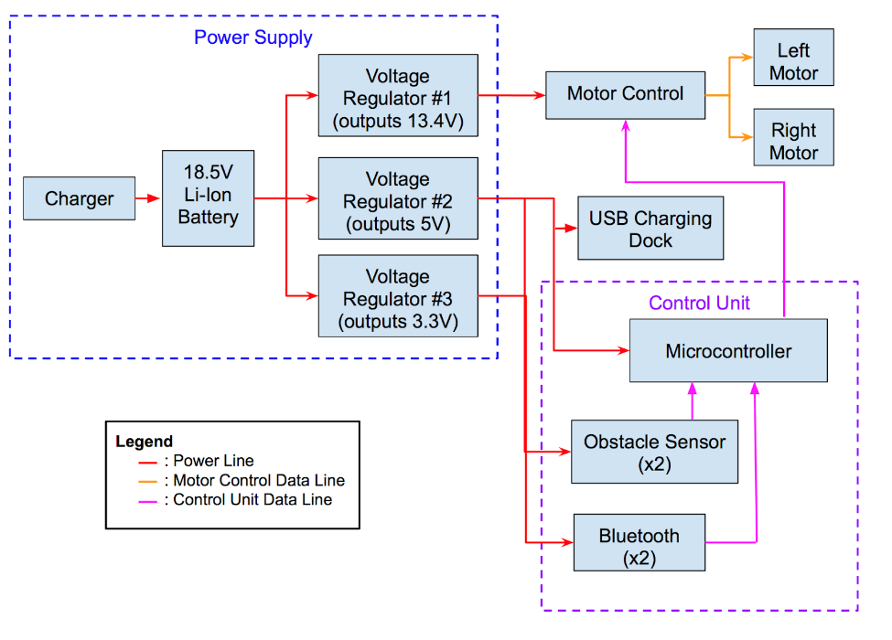

Figure 1: High Level Block Diagram
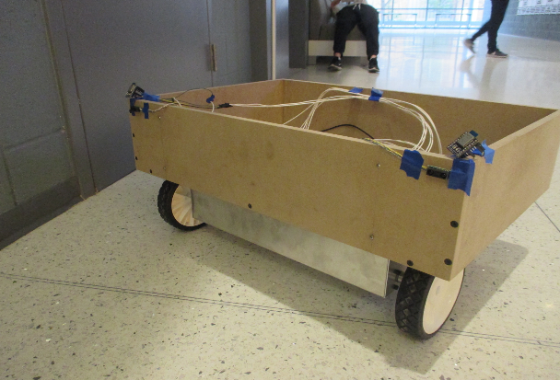
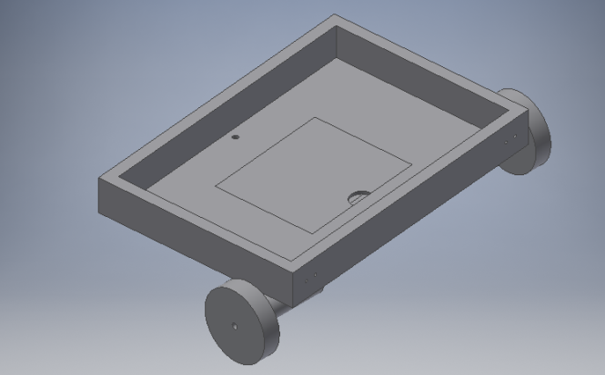
Figure 3: Final Product

Figure 2: Initial Physical Diagram Designed in Cadence

1.2 Project Goals
Our project consists of several subsets as described above. To provide direction for each subset and for our overall project, several goals were set by our team.
- Luggage must avoid obstacles within 2 feet of its direct path and follow at least 3 feet behind the user while traveling at a maximum speed of 6 MPH and supporting a maximum weight of 40 pounds.
- Luggage has a USB charging dock capable of charging a cellphone by providing 5 V and 1 A for at least an hour when the battery is fully charged.
- Luggage must be as low cost as possible and follow all TSA rules and regulations.

2 Design

2.1 Power Supply
A reliable power supply was required for most components in our design. This module consists of a lithium ion polymer battery acting as the main source of power and three buck converters designed to step the voltage down to the appropriate amount based on component requirements. Many safety considerations were made when designing and building this module due to the risk of potential hazards when working with batteries.

2.1.1 Lithium Ion Polymer Battery
An 18.5 V, 3300 mAh Lithium Ion Polymer battery will be used as the main power source in our design. The battery placement will be designed such that it can be easily removed by the user. This battery is within the maximum voltage and power ratings of the Transportation Security Administration (TSA) [4]. With these ratings, the theoretical time that the lithium ion battery will last before it needs to be recharged can be calculated. If both of the motors are running but the user is not using the charging dock, the total current will be 1.89 A, allowing the battery to last up to 1.75 hours. This total current is found by summing the currents from each module used. This data can be found in the appendix under Table 4: Module Maximum Currents. This was calculated as shown in Equation 1. If the user only needs to charge his or her phone, the Lug-N-Go draws 1.152 A, which means that the battery power up the system for up to 2.87 hours, as shown in Equation 2.
$Time= \frac{3.3Ah}{1.89A}=1.746 hours$ (1)
$Time= \frac{3.3Ah}{1.152A}=2.865 hours$ (2)

2.1.2 Buck Converter #1
The first buck converter steps the 18.5 V power source down to 13.4 V to power the L298N Motor Controller Board. This buck converter was assembled using the LM2576-ADJ Simple Switcher which provides efficient active functions in the buck converter along with feedback to ensure a stable output [3]. The LM2576-ADJ was used for this buck converter because it provides an output that can be adjusted to 13.4 V as required for our motor control module. Even though the motors used in the Lug-N-Go are rated at 12 V, the diodes in the H-Bridge must be accounted for; so, 0.7 V per diode was added to the target voltage. Figure 4 shows the circuit schematic for this buck converter. The output of the LM2576 was adjusted by calculating resistance values that would produce the desired output. The
resistances were calculated using Equation (3) where the reference voltage is given in the datasheet as 1.23 V and the desired output voltage is 13.4 V. Solving Equation (3) led to Equation (4). Based on Equation (4), R1was chosen to be 9.89 kΩ and R2was chosen to be 1 kΩ.
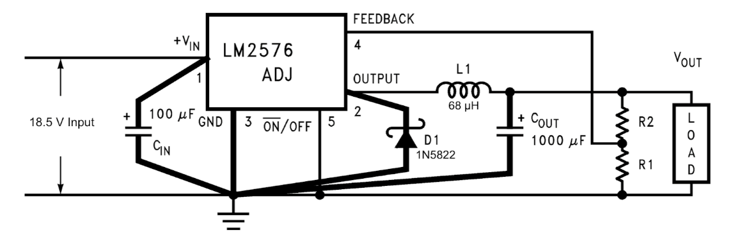

Figure 4: 18.5 V to 13.4 V Buck Converter circuit schematic

$R_{2}=R_{1}(\frac{V_{out}}{V_{ref}}-1)$ (3)
$R_{2}=9.89 × R_{1}$ (4)

2.1.3 Buck Converter #2
The second buck converter steps the 18.5 V power source down to 5 V to power the ATmega328P and the USB charging dock. This buck converter was assembled using the LM2576-5G Simple Switcher which provides efficient active functions in the buck converter along with feedback to ensure a stable output. Figure 5 shows the circuit schematic for this buck converter.
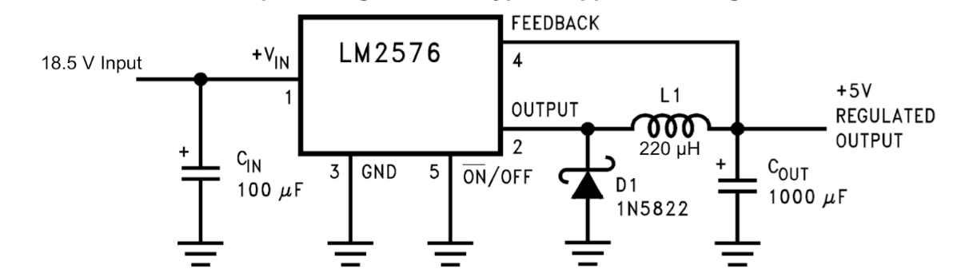

Figure 5: 18.5 V to 5 V Buck Converter Circuit Schematic

2.1.4 Buck Converter #3
The third buck converter steps the 18.5 V power source down to 3.3 V to power the Pololu SDS02A proximity sensors and the RN4020 Bluetooth modules. This buck converter was assembled using the LM2576-3.3G Simple Switcher which provides efficient active functions in the buck converter along with feedback to ensure a stable output. Figure 6 shows the circuit schematic for this buck converter.
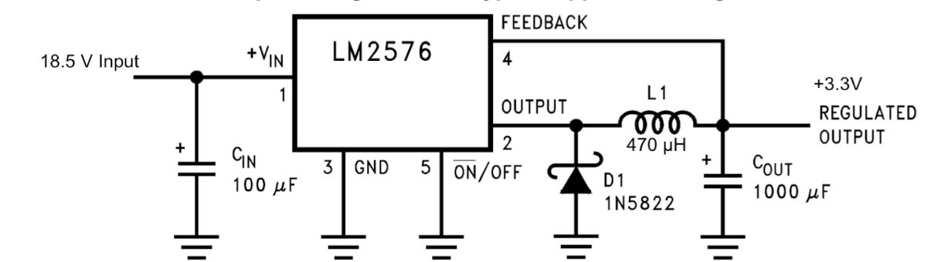

Figure 6: 18.5 V to 3.3 V Buck Converter Circuit Schematic

2.2 Control Unit
The control unit consists of the microcontroller, obstacle sensors, compass, and Bluetooth modules. Each of these modules plays an important role in the functionality of our design. The Control Unit as a whole is responsible for determining the luggage’s travel path and sending proper signals to the motor control to ensure it avoids obstacles and follows the user.

2.2.1 Microcontroller
The microcontroller used in our design is the ATmega328P. It is responsible for controlling each sensor, reading the data from the sensor, and sending signals to the motor drive unit based on the data. This microcontroller was chosen for our design due to its compatibility with the Arduino Uno, its built-in Pulse Width Modulation pins capable of providing control for our motors, and the built-in TX and RX pins allowing serial communication between the Bluetooth module and the microcontroller. The circuit schematic shown in Figure 7 is required to operate the ATmega328p in standalone mode. Before connecting the microcontroller to the circuit schematic shown in Figure 7, the software program must first be uploaded to the microcontroller using an Arduino Uno board.
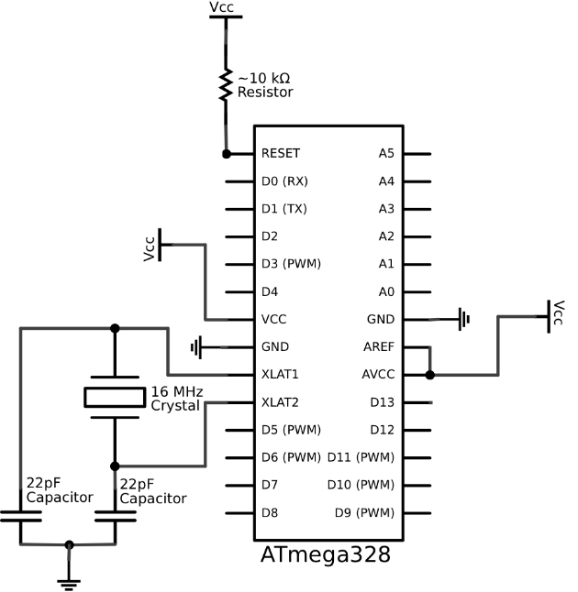

Figure 7: ATmega328p Standalone Circuit Schematic

2.2.2 Obstacle Sensors
Long range infrared proximity sensors (Pololu SDS02A) are used to detect any upcoming obstacles in the luggage’s path. Two sensors are used in our design, one in front of each motor. The infrared sensors output an analog voltage response, dependent on the angle read by the sensor when sending and receiving an infrared signal. Figure 8 was obtained from the datasheet [4] and it shows that the analog voltage has a non-linear relationship with distance. We linearized this indirect relationship, making it easier to calculate a PWM voltage signal to send to the respective motors and control their speeds, which allows the system to veer left, veer right, continue the path of the user, or come to a complete stop.
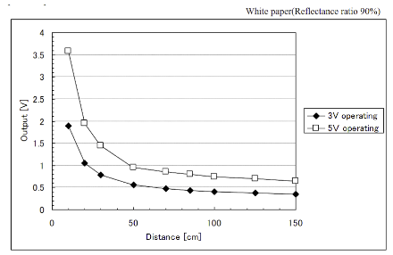

Figure 8: Relationship between Analog Voltage Output and Distance

2.2.3 Bluetooth Modules
The Bluetooth module chosen for our design is the RN-4020 Bluetooth module. The RN-4020 module was chosen because of its low power modes and compatibility with Bluetooth 4.0 [5]. Picking a Bluetooth module compatible with Bluetooth 4.0 was essential in our design because Bluetooth 4.0 allows multiple Bluetooth devices to connect to the same phone. Because our design required two Bluetooth modules connected to one phone, Bluetooth 4.0 compatibility was crucial.
Two RN-4020 Bluetooth modules are placed on the two front corners of the luggage and used to connect to the user’s cellphone. The RN-4020 Bluetooth modules are used to return a Received Signal Strength Indication (RSSI) that is proportional to the distance by the Inverse Square Law [6]. As shown in Figure 9, as the distance between the phone and the Bluetooth module increases, the RSSI value decreases. This relationship can be used to estimate a distance between the user and the luggage.
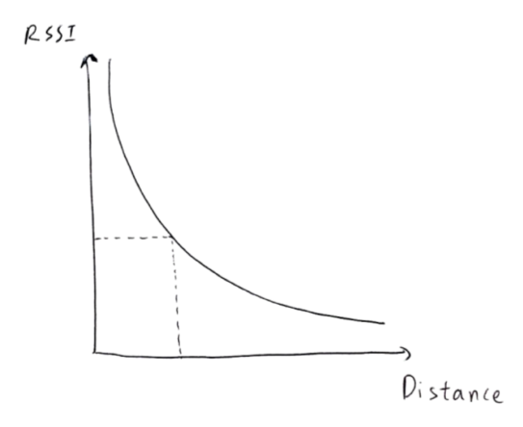

Figure 9: Relationship between Received Signal Strength Indication (RSSI) and Distance

The distance can be calculated as shown in Equation 5 where RSSI_{,1m} is the RSSI value seen by the receiver when 1 meter from the transceiver, PathLoss is an environment factor ranging from 2-4, and RSSI_{,measured} is the measured RSSI. When using the modules indoors, the environment factor is typically 2 or 3 [7]. With a Bluetooth module placed in front of each motor as shown in Figure 10, two distances can be separately calculated and used to adjust each motor individually to follow the user.

$d=10\frac{{RSSI,}_{1m}-{RSSI,}_{measured}}{10xPathLoss}$ (5)
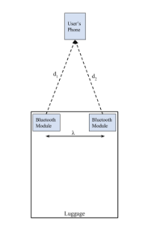

Figure 10: Bluetooth Module Placement on the Luggage

2.3 Motor Control

2.3.1 Motors
We originally wanted the motors to run at a speed of 6 MPH and had decided on motors with a rating of 550 RPM and 0.03 Nm; however, this was much faster than what would be necessary for a walk and also the torque was too small to support the 40 lb load. The ideal motors that we wanted to use have a speed of 168 RPM and a torque of 0.68 Nm. The calculations for the speed can be found in Equation 6. The torque was found using Northeast Power Inc. [8] and can be found in Equation 7 and Equation 8, where $w$ is the weight, $dN$ is the input change in speed required, $t$is the acceleration time, $v$is the linear input velocity, and $N_{m}$ is the input speed of the driving motor. Based on these values and budget restrictions, the motors used are Uxcell Double Shaft Worm Gear Motor DC Speed Reduction Motors. These have the following ratings: 12 V, 220 RPM, 0.49 Nm, and 870 mA. The characterization for the two motors can be found in Table 1. Because the left motor has a higher turn on voltage, it tended to move faster than the right motor. The right motor had a higher stall voltage, making it most likely the motor to stall during testing. The PWM signals that were sent to the motor drive were different for each motor due to the fact that they had different characterizations.
$Desired RPM= \frac{3 mile}{1 hour}×\frac{63,360 feet}{1 mile}×\frac{1 rev}{6π inches}×\frac{1 hour}{60 minutes}=168 RPM$ (6)
$Desire Torque= \frac{WK^{2} × dN}{308 × t}= \frac{WK^{2} × 168}{308 × 2}=0.68 Nm$ (7)
$WK^{2}=\frac{w x v^{2}}{39.5 × {(N_{m})}^{2}}= \frac{40 x 3^{2}}{39.5 × {168}^{2}}$ (8)

2.3.2 Motor Drive
The L298 motor bridge is used to drive two motors. This module receives PWM inputs as well as digital inputs from the microcontroller to control the speed and direction of rotation of the motors. By controlling the speed of each motor, the luggage is able to adjust its direction to avoid obstacles and continue following the user. The L298 module has built in current sensors that work by generating a voltage across the sensing resistors because they are in series with the load [8]. The relationship between the current and resistor tells you what voltage you see for what current. This acts as a safety feature to limit the current that goes to each motor.
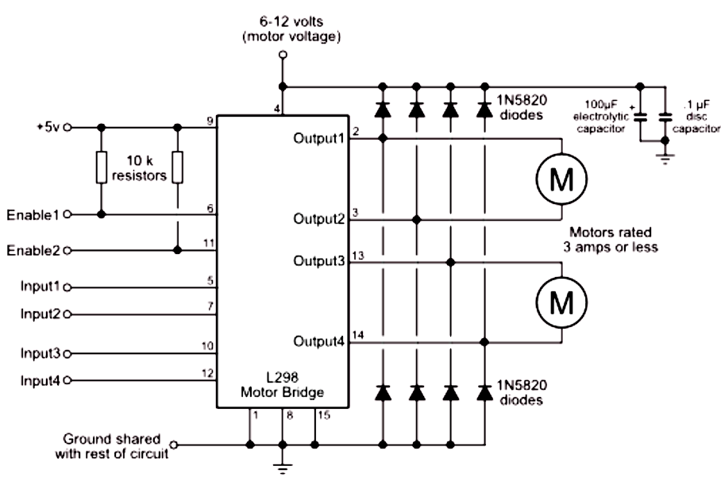
Figure 11: Motor Drive Circuit Schematic using the L298 Motor Bridge

2.4 USB Charging Dock
The USB charging dock is responsible for charging a phone or iPod for up to an hour when the Lithium Ion battery is fully charged as shown in Equation 2. This module was designed by properly connecting the four wires within a USB cord. A USB cord consists of a 5 V, input data, output data, and ground wire. Because our design did not require data transfer, the input data and output data wires were connected to ground along with the ground wires. Lastly, the 5 V wire was connected to the output of the Buck Converter #2 which provides a stable 5 V output.

2.5 Software

2.5.1 Obstacle Avoidance
Figure 12 shows the software flowchart used for avoiding obstacles. The first conditional statement checks to see whether or not both of the Bluetooth modules are connected. If they are, there are a series of cascading conditional statements that determine the behavior of the output PWM voltage, and ultimately, the behavior of the motors. If both sensors detect an object within 25 centimeters, then the motors would yield to a stop by having an input PWM signal of 0. If only the right sensor detects an object within 25 centimeters, then the left motor would slow down, but not to a complete stop, as to avoid stalling, and the right motor would increase in speed according to a calculated linear equation, such that the entire luggage will maneuver leftward. Similarly, if only the left sensor detects an object within 25 centimeters, then the right motor would slow down and the left motor would speed up to maneuver rightward. If neither sensor detects an object within 25 centimeters, then the PWM signals to the motors are dependent on the distances calculated from the Bluetooth modules to follow the user.

Figure 12: Obstacle Avoidance Software Flowchart

2.5.2 User Following
Figure 13 shows the flowchart used to implement the user following feature in software. The first step consists of advertising the Bluetooth module allowing the user to select the two modules on the user’s phone. The luggage does not begin to move until the user connected to both Bluetooth devices. Once both devices are connected, the next step consists of retrieving two RSSI values from the Bluetooth modules and calculating two distances. To improve the accuracy and reduce the fluctuations of the calculated distances, a running average of five values is used. The calculated distances are stored in their own running average. The running average returns an averaged distance which is then sent to the motor control to appropriately adjust the motors based on the averaged distances. The last step consists of incrementing the counter for the running average and checking if the counter has reached 5 samples. If the counter has reached 5 samples, the running average is cleared. The entire process is then repeated until the user disconnects from the Bluetooth modules.
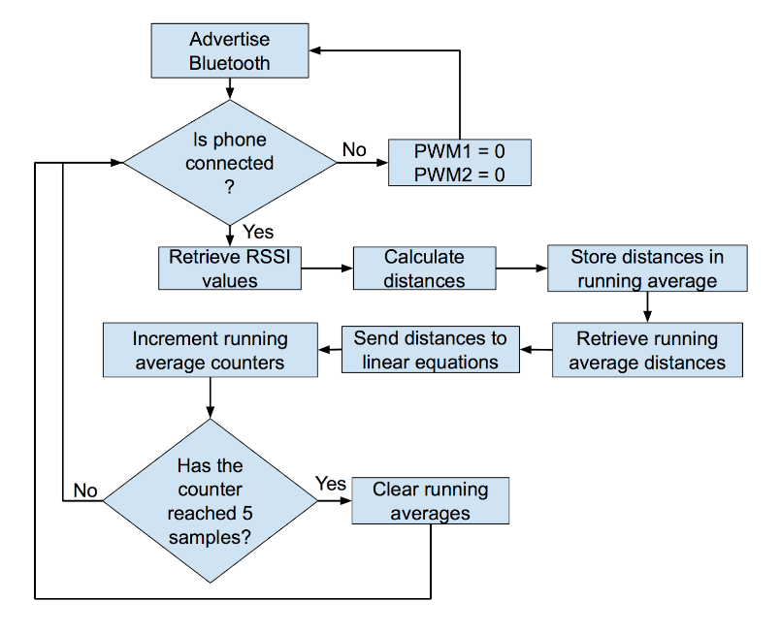

Figure 13: User-Following Software Flowchart

3 Verification
Before integrating each module of our design together, each component was built and tested to verify its individual functionality. Once each component functioned individually, the modules were then integrated together and tested to ensure proper functionality as a complete design.

3.1 Power Supply

3.1.1 Lithium Ion Polymer Battery
To verify that the battery was fully functional, a voltage probe was placed across the battery to ensure that it was capable of supplying 18.5 V. Additionally, the battery was used in our final design and all components were successfully powered up for the calculated amount of time, meaning the battery had the correct voltage output and capacity.

3.1.2 Buck Converter #1
The first buck converter is supposed to output 13.4V in order to supply the motor drive. We first tested the circuit on a breadboard before moving the components to the PCB. Once it was confirmed that the buck converter successfully outputted 13.4V, the components were soldered onto the PCB. We then again used a multimeter to measure the voltage that the buck converter outputted. In order to test that output ripple was less than 5%, a voltage probe was connected to the output voltage and an oscilloscope. After zooming in on the ripple voltage, the peak-to-peak voltage was measured to be 203mV which was well within 5% of the desired ripple voltage.

$Ideal Ripple≤ .05 × 13.4=670 mV$ (9)
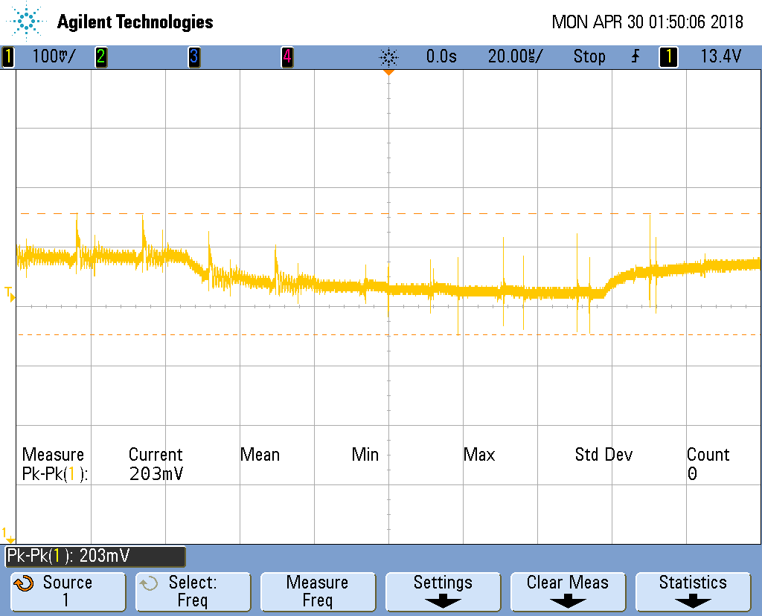

Figure 14: Ripple Voltage of Buck Converter #1

3.1.3 Buck Converter #2
The second buck converter was tested in a similar way to the first buck converter. The output of this converter should be 5V in order to supply the microcontroller and the USB charging station. The circuit was first built on a breadboard and then a multimeter was used to measure the output voltage. Once it was verified that this outputted the correct 5V, the circuit was then built onto the PCB. We then used a multimeter to again confirm that the output voltage was 5V. A probe was then used to view the output voltage waveform on the oscilloscope. The peak-to-peak ripple voltage of this buck converter was found to be 125mV. This is also well within the desired 5% maximum ripple voltage.
$Ideal Ripple≤ .05 × 5=250 mV$ (10)
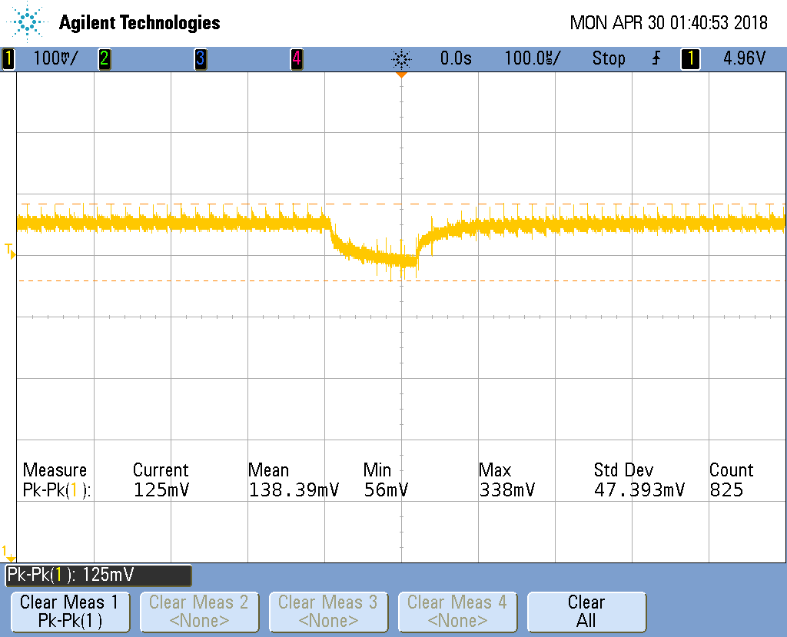

Figure 15: Ripple Voltage of Buck Converter #2

3.1.4 Buck Converter #3
The third buck converter has a desired output voltage of 3.3V in order to power the infrared proximity sensors and the Bluetooth modules. The circuit was first built on a breadboard to ensure that the output of this buck converter was 3.3V. This was confirmed so we then proceeded to build the circuit on the PCB. Once the voltage was again confirmed to be the correct output, the ripple voltage was viewed on the oscilloscope. This was found to be 165mV which again was within our 5% limit on the allowed ripple voltage.

$Ideal Ripple≤ .05 × 3.3=165 mV$ (11)
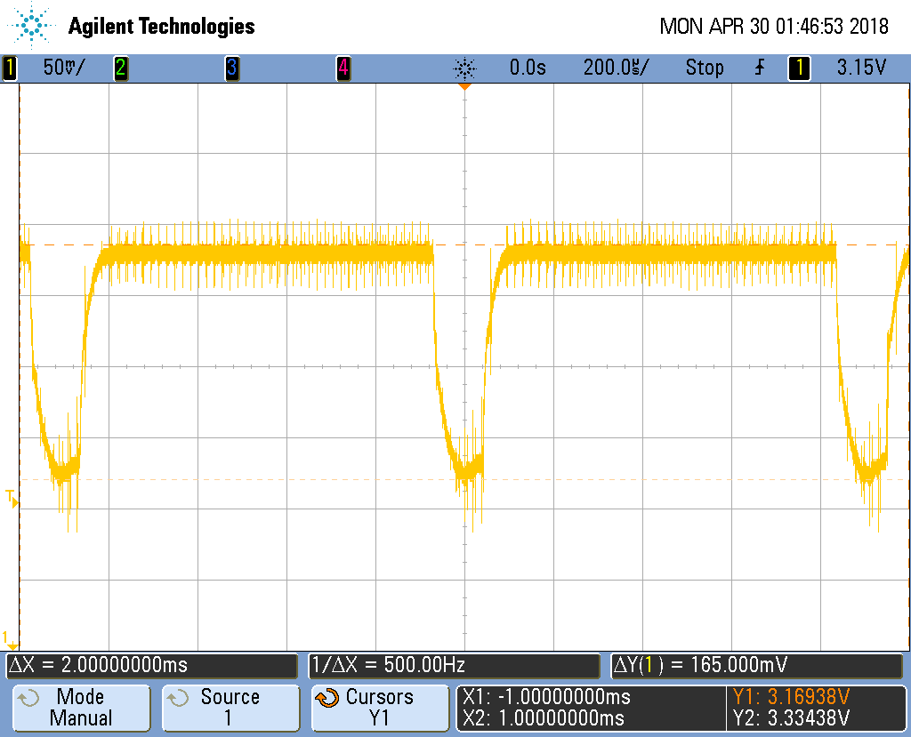

Figure 16: Ripple Voltage of Buck Converter #3

3.2 Control Unit

3.2.1 Microcontroller
The verification of the ATmega328p consisted of uploading the code and inserting the microcontroller in the standalone circuit shown in Figure 7. The circuit shown in Figure 7 was integrated into our final PCB and used to process data and send signals to the motor drive. This was verified by integrating the code and all modules into one system and testing the complete design. The luggage was capable of detecting obstacles and following the user proving that the microcontroller was properly processing data and sending motor control signals.

3.2.2 Obstacle Sensors
To verify that the infrared distance sensors are working as they should, we first had to calibrate the sensors to linearize the analog output voltages to a distance scale. After doing so, we placed a notebook in front of the sensor at varying distances to compare the software’s mapped distance, which is the distance calculated through the software calibration and code, versus the actual measured distance. The results are shown in Figure 17. Ideally, this graph would have been perfectly linear with a slope of 1 to indicate that the mapped distance is equal to the measured distance. Although there are some discrepancies in the comparisons between the mapped and measured distances, the graph still demonstrates a fairly linear relationship between the two, which is proof that the software’s mapping capabilities are quite accurate within the range of testing.
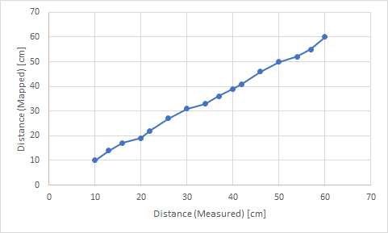
The sensors were also tested amongst a variety of objects and surfaces. Figure 18 shows the results from those tests. Though all of the objects were placed 30 centimeters away from the sensor, there were still fluctuations in the sensor readings. We discovered that the color, or more accurately, the reflectivity of the surface, is what caused the variances in sensor readings. This poses a potentially major issue because the sensors would not even detect an object if its surface very reflective, such as the shiny black card or the blank phone screen, which means that the distance calculated is inaccurate, the PWM voltage is miscalculated, and the motors ultimately misbehave.
Figure 17: Accuracy of estimated distance when using infrared sensors

Figure 18: Accuracy of estimated distance when using infrared sensors

3.2.3 Bluetooth Modules
To verify that the Bluetooth modules were fully functional, the first step was to establish a connection between the RN-4020 and a cellphone. This was done using RN4020 Commands found in the datasheet. The ‘A’ command is used to begin advertising the Bluetooth module. Once advertising, the Bluetooth modules will appear on the cellphone and can be connected to. The ‘Q’ command was used to retrieve a connection status and double-check that the phone was properly connected.
The second step consisted of retrieving RSSI values and determining the RSSI_{,1m} value necessary for calculating a distance in Equation 5. This was done by placing the phone one meter away from the Bluetooth module and using the ‘M’ command to retrieve RSSI values. This process was done in an apartment building and in the ECE building as shown in Figure 19a and 19b respectively. In an apartment building, the average was -61.5 dB whereas in the ECE building, the average -72.4 dB. The results from these plots show that the RSSI_{,1m} value varies based on location. Because most of the testing was done in the ECE building, the RSSI_{,1m} value of -72.4 dB was used.
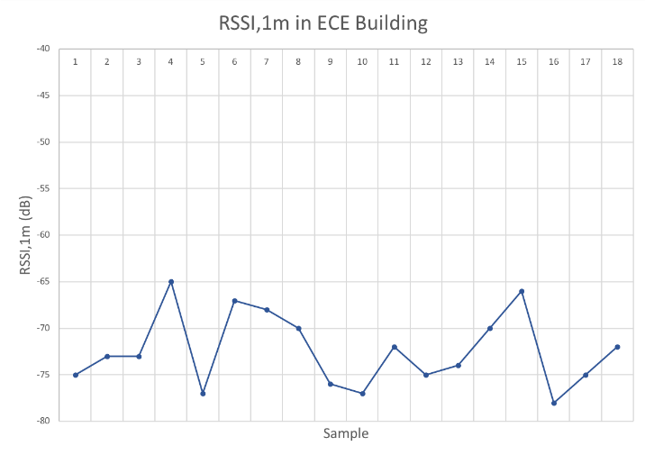
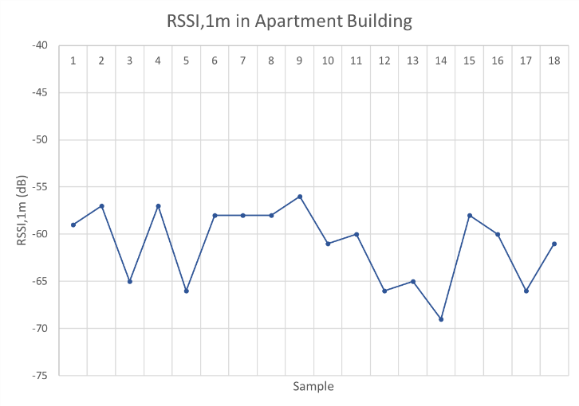

Figure 19a: RSSI_{,1m} Calibrations in Apartment Building
Figure 19b: RSSI_{,1m} Calibrations in ECE Building

The third step in ensuring the Bluetooth modules met requirements and were suitable for this application consisted of determining its accuracy when estimating a distance using RSSI. This test was done by placing the phone at different distances from the Bluetooth module, calculating five distances, and taking an average of the five. Figure 20 shows the results of this test for distances between one to ten feet. The estimated distances begin to become inaccurate around 8 feet and above. For example, at a distance of 10 feet, the estimated distance was 8 feet. However, because our application did not require distances larger than 4 feet, the results were suitable for our design.
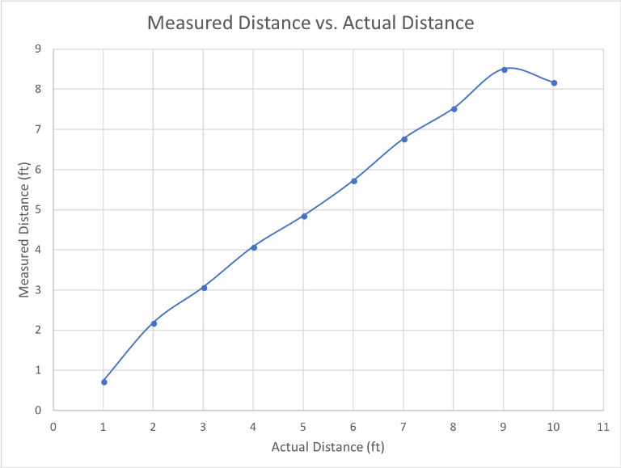

Figure 20: Accuracy of estimated Distance when using RSSI

3.3 Motor Control
In order to test that the L298N motor control was working, it was connected to buck converter #3, the microcontroller and the motors on a breadboard. We then applied an 18.5 V source to the buck converter to ensure that the motors would begin to run. After seeing that this was successful, the L298N was then soldered onto the bread board and a similar test was done to ensure that the motors would run when connected to the motor drive. We also measured the voltage across the motors to confirm that they were receiving 12 V and there was no risk of damaging them.

3.4 USB Charging Dock
In order to test the USB charging dock, the voltage across the VCC and GND was measured using a multimeter to ensure that it was outputting the necessary 5 V. To test that there was no voltage being applied to the USB data pins, we also measured the voltage across those to ensure that there was 0 V applied. We then used an ammeter to detect the current across VCC and GND to ensure that it was outputting 1 A. After all these measurements were confirmed, a phone was plugged in to ensure that the device would charge. This test was successful as we were able to charge the phone.

3.5 Motors
To characterize the motors, we needed to determine the turn on and also the stall voltage for each of the motors. The turn on voltage was found by incrementing the voltage supplied to the motors until they began to turn on. The stall voltage was found by decrementing the voltage starting from 12 V until the motors no longer were able to turn. The results for this can be found below in Table 1: Characterizing the Motors.

Table 1: Characterization of the Motors
Motor | Turn-On Voltage [V] | Stall-Voltage [V]
Right | 1.20 | 0.70
Left | 0.90 | 0.60

4 Costs

4.1 Parts

Table 2: Estimated Parts Cost
Part | Manufacturer | Retail Cost ($) | Bulk Purchase Cost ($) | Actual Cost ($)
Motors (x2) | Uxcell | 32.99 | N/A | 65.98
BT Modules (x2) | Hadley Research | 25.00 | N/A | 50.00
IR Sensors (x2) | Pololu | 11.95 | 10.95 | 23.90
5V Regulator | ON Semiconductor | 2.05 | 1.39 | 2.05
3.3V Regulator | ON Semiconductor | 2.28 | 1.55 | 2.28
Adj. Regulator | ON Semiconductor | 2.24 | 1.52 | 2.24
L298 Motor Bridge | St Micro | 12.15 | N/A | 12.15
Wheels (x2) | Partner | 4.98 | N/A | 9.96
Battery | ZEEE | 29.99 | N/A | 29.99
Battery Charger | HOBBYMATE | 33.92 | N/A | 33.92
470 uH Inductor | Bourns | 1.10 | 0.74 | 1.10
68 uH Inductor | Bourns | 1.92 | 1.24 | 1.92
220 uH Inductor | ABRACON | 1.23 | 0.89 | 1.23
16 MHz Crystal | IQD Frequency Products | 0.27 | 0.22 | 0.27
ATmega328p | Microchip Technology/Atmel | 2.28 | 1.68 | 2.28

4.2 Labor

Table 3: Estimated Labor Cost
Team Member | Hourly Rate ($) | Total Hours | Total Cost (Rate*Hours*2.5)
Anika Manzo | 30 | 160 | 12,000
Gregg Lugo | 30 | 160 | 12,000
Brianna Szczesuil | 30 | 160 | 12,000
Team Total | 90 | 480 | 36,000

4.3 Total Costs

Table 4: Total Costs
Parts | Labor | Total
239.18 | 36,000 | 36,239.18

5 Conclusions

5.1 Accomplishments
For the prototype of this product, the power supply and control unit were a success. We were able to successfully supply the correct amount of power to each of the modules and also use a battery that was TSA friendly. The control unit was able to complete the task of avoiding obstacles and following the user. The physical design for this product also allowed for the option of hiding the electronics, making it overall more marketable.

5.2 Uncertainties
The largest challenge that came with the Lug-n-Go was the motors that were used. Due to the torque being less than what was desired, the motors would occasionally stall which would affect the overall operation of the luggage. While the control logic was working perfectly, when a motor stalled, the product would spin in directions that were not a part of the original path until the motor began to run again. The reason that these motors were used was due to budget restrictions; our goal was to create the most affordable version of this autonomous luggage. However, in order to get this project working as well as it should, new motors with higher torque ratings would be necessary. Another solution would be to use lighter weight material as to lower the weight of the load that is applied to both the motors.

5.3 Ethical Considerations
There are various potential safety hazards in the design of this project that were carefully addressed to ensure complete safety when designing this product. Firstly, our design uses a Lithium-Ion Polymer battery which is capable of causing a fire or exploding when used improperly [10]. To avoid potential safety hazards, all modules of this design were tested individually with a DC power supply to ensure proper functionality before using the lithium ion battery as the main source of power.
Suitcases are used in various environments and weather conditions. Rain and snow can cause damage to the internal electronics and wiring of our design. All wiring and circuitry in our design was safely covered using a false bottom to keep the design dry and safe in various weather conditions.
Along with following IEEE standards, we must ensure that our design follows TSA rules and regulations. According to Business Insider, starting in 2018, smart luggage will only be allowed on flights if the battery is removed [11]. To abide by this new rule, our design allows the battery to be easily and safely removed by the user. We also ensured that our lithium ion battery is within the 100Wh TSA limit for a carry-on bag.
Overall, our design follows the IEEE Code of Ethics, #1, “To hold paramount the safety, health, and welfare of the public” [12]. Our goal throughout the semester was to provide an innovative product without compromising the safety, health, and welfare of the public.

5.4 Future Work
To make this product more marketable, multiple improvements will need to be made to the overall design. First, we would use lighter weight material and a smaller framed luggage to make the control easier and ensure less strain on the motors. The second change would be to use motors with a higher torque rating that are as affordable as possible and can handle the overall weight of the luggage. Some extra useful features that could be added to this product would be password secured Bluetooth access when connecting to the phone; including a calibration system in the code to determine if the user is inside or outside to allow for more accurate RSSI readings and user following. Lastly, we would use ultrasonic sensors because, unlike the infrared sensors, their output does not depend on the reflectivity of an object. With the changes made to this design, the Lug-n-Go could become a marketable product that would overall improve the convenience of travelers.

6 References

[1] Consador, K. (2015). Rules for Carry-On Luggage Size. [online]. USA Today. Available at: http://traveltips.usatoday.com/rules-carry-on-luggage-size-21688.html. [Accessed 21 Feb. 2018].

[2] Transportation Security Administration. (2013). Travel Tips Tuesday: Safely Packing Batteries for Your Trip. [online]. Available at: https://www.tsa.gov/blog/2013/06/11/travel-tips-tuesday-safely-packing-batteries-your-trip. [Accessed 20 Feb. 2018].

[3] Texas Instruments. (May 2016). LM2576xx Series SIMPLE SWITCHER® 3-A Step-Down Voltage Regulator. [online]. Available at: http://www.ti.com/lit/ds/symlink/lm2576.pdf.

[4] SHARP. (2001). Pololu SDS02a Distance Sensor: GP2Y0A60SZ Datasheet. [online]. Available at: https://www.pololu.com/file/0J812/gp2y0a60szxf_e.pdf.

[5] Microchip Technology. (2015). RN4020- Bluetooth Low Energy Module Datasheet. [online]. Available at: http://ww1.microchip.com/downloads/en/DeviceDoc/50002279B.pdf.

[6] Hassanieh, H. (2016). Lecture 11: Wireless Localization. [online]. Avaliable at: https://courses.engr.illinois.edu/ece598hh/fa2016/Lec/Lec11b.pdf. [Accessed 15 Feb. 2018].

[7] Bulten, W. (2015). Kalman Filters Explained: Removing Noise from RSSI Signals. [online]. Available at: https://www.wouterbulten.nl/blog/tech/kalman-filters-explained-removing-noise-from-rssi-signals/. [Accessed 10 Mar. 2018].

[8] Sparkfun Electronics. (2000). L298 Dual Full-Bridge Driver. [online]. Available at: https://www.sparkfun.com/datasheets/Robotics/L298_H_Bridge.pdf.

[9] Microchip Technology. (2014). RN4020- Bluetooth Low Energy Module User’s Guide. [online]. Available at: http://ww1.microchip.com/downloads/en/DeviceDoc/70005191B.pdf.

[10] Batteryuniversity.com. (2018). Safety Concerns with Li-ion Batteries. [online]. Available at: http://batteryuniversity.com/learn/article/safety_concerns_with_li_ion. [Accessed 8 Feb. 2018].

[11] Matousek, M. (2017). Airlines will begin banning smart luggage in 2018. [online]. Available at: http://www.businessinsider.com/airlines-announce-smart-luggage-bans-2017-12. [Accessed 8 Feb. 2018].

[12] Ieee.org. (2018). IEEE Code of Ethics. [online]. Available at: https://www.ieee.org/about/corporate/governance/p7-8.html. [Accessed 8 Feb. 2018].

Appendix A Requirement and Verification Table
Table 5: Battery Requirements and Verifications
Requirement | Verification | Verification Status (Y or N)
1. Battery must provide 18.5V. | 1. A digital multimeter will be used to measure the voltage across the battery by placing the black probe on the negative terminal of the battery and the red probe on the positive terminal. | Y
2. Battery stores 3.3 AH of charge. | 2A. Fully charge the battery using the battery charger. | Y
 | 2B. Connect the battery to the 13.4V Voltage Regulator.
 | 2C. Connect the 13.4V Voltage Regulator to the Motor Driver Unit.
 | 2D. Connect two motors to the Motor Drive Unit such that they are constantly on. Measure the time it takes for the motors to stop turning.
 | 2E. Repeat Steps 2A-2D 5 times to calculate the average AH of charge the battery has by multiplying the measured time with the current drawn by the load.

Table 6: Buck Converter #1 Requirements and Verifications
Requirement | Verification | Verification Status (Y or N)
1. Must provide 13.4V +/- 2.5% from an 18.5V source. | 1A. Connect a power supply, set to produce 18.5V, as the voltage source shown in Figure 4. | Y
 | 1B. Use a voltage probe, connected to an oscilloscope, to measure the voltage across the resistive load by placing the terminals across the load.
 | 1C. Zoom in on the oscilloscope to observe the ripple voltage and ensure it is within +/- 2.5% of 13.4V.
2. Must provide 0.12A, the rated current to each motor | 2A. Connect a power supply, set to produce 18.5V, as the voltage source shown in Figure 4. | Y
 | 2B. Use a current probe or fluke meter, connected to an oscilloscope, to measure the current going through each element and ensure it is providing enough current.

Table 7: Buck Converter #2 Requirements and Verifications
Requirements | Verification | Verification Status (Y or N)
1. Must provide 5V +/- 5% from an 18.5V source. | 1A. Connect a power supply, set to produce 18.5V, as the voltage source shown in Figure 5. | Y
 | 1B. Use a voltage probe, connected to an oscilloscope, to measure the voltage across the resistive load by placing the terminals across the load.
 | 1C. Zoom in on the oscilloscope to observe the ripple voltage and ensure it is within +/- 5% of 5V.
2. Must provide a specific maximum current across each load (microcontroller: 40mA, Charging Station: 1A, Obstacle Sensor: 33mA) | 2A. Connect a power supply, set to produce 18.5V, as the voltage source shown in Figure 5. | Y
 | 2B. Use a current probe or fluke meter, connected to an oscilloscope, to measure the current going through each element and ensure it is providing enough current.
3. Must be able to charge a cell phone for up to 1 hour. | 3A. Connect a power supply, set to produce 18.5V, as the voltage source shown in Figure 5. | Y
 | 3B. Use a current probe or fluke meter, connected to an oscilloscope, to measure the current going through the phone for one hour and ensure that it charges.

Table 8: Buck Converter #3 Requirements and Verifications
Requirement | Verification | Verification Status (Y or N)
1. Must provide 3.3V +/- 5% from an 18.5V source. | 1A. Connect a power supply, set to produce 18.5V, as the voltage source shown in Figure 6. | Y
 | 1B. Use a voltage probe, connected to an oscilloscope, to measure the voltage across the resistive load by placing the terminals across the load.
 | 1C. Zoom in on the oscilloscope to observe the ripple voltage and ensure it is within +/- 5% of 3.3V.
2. Must deliver a maximum current of 60 mA to each bluetooth module and .64 mA to the compass. | 2A. Connect a power supply, set to produce 18.5V, as the voltage source shown in Figure 6. | Y
 | 2B. Use a current probe or fluke meter, connected to an oscilloscope, to measure the current going through each load.

Table 9: Microcontroller Requirements and Verifications
Requirement | Verification | Verification Status (Y or N)
1. ATmega328P must be integrated into the final PCB design | 1A. Include a 28-pin DIP socket on the PCB design to hold the ATmega328P. | Y
2. ATmega328P must request and process the output from the obstacle sensors (two voltage values) every two seconds with a maximum delay of two seconds. | 2A. A test code will be written based off the flowchart in Figure 12 to read data from the Pololu sds02a, calculate the distance, and print the distance on the computer monitor for a 30 second time interval. | Y
 | 2B. Count the number of measurements printed on the display within the 30 second time interval. There must be 15 measurements.
3. ATmega328P must request data from the Bluetooth module (two RSSI values) and process the data by calculating the corresponding distances every two seconds with a maximum delay of two seconds. | 3A. A test program will be written based off the flowchart in Figure 13 to read data from the Bluetooth modules and compass. It will calculate the theoretical distance using the RSSI value and print the distance on the computer monitor as well as the direction the luggage was facing for a 30 second time interval. | Y
 | 3B. Count the number of measurements printed on the display within the 30 second time interval. There must be 15 measurements.
4. ATmega328P must send signals to the motor drive based on the sensor information. | 4A. Write a test code based off the flowchart in Figure 12 to calculate the obstacle distances based on the data read from the obstacle sensors. | Y
 | 4B. Adjust the appropriate PWM based on the calculated distances.
 | 4C. Measure the PWM waveform on an oscilloscope to ensure the PWM is adjusting properly by observing the on and off durations. If the PWM is off for a longer period of time, this means the motor will slow down.

Table 10: Infrared Sensors Requirements and Verifications
Requirement | Verification | Verification Status (Y or N)
1. Must accurately detect obstacles, with a minimum height of 2 feet and width of 1 foot, within 2 feet of its direct path. | 1A. Connect the obstacle sensor as shown in the datasheet. | Y
 | 2A. A test code will be written based off the flowchart in Figure 12 to read data from the Pololu sds02a, calculate the distance, and print the distance on the computer's monitor.
 | 3A. Place an object of minimum size in front of the sensor at various distances and personally measure the distance. Compare the measured distance to the distance calculated in the test program.
2. For obstacles below the minimum size requirement, the obstacle must be detected within 1 foot. | 2A. Repeat steps 1A-3A for the appropriate obstacle size. | Y

Table 11: Bluetooth Modules Requirements and Verifications
Requirement | Verification | Verification Status (Y or N)
1. Must maintain a connection to the user’s phone within a 5ft radius. | 1A. Connect one of the Bluetooth modules to a cell phone and move the phone 5 ft away from the luggage to determine if the module will stay connected. | Y
2. RSSI must be used to calculate the distance from the Bluetooth module to the user with an error no larger than 1 meter. | 2A. Write a test code based off the flowchart in Figure 13 to calculate the theoretical distance using the RSSI value and compare the calculated distance to the measured distance. | Y

Table 12: Motor Drive Requirements and Verifications
Requirement | Verification | Verification Status (Y or N)
1. The Motor Drive and Control Unit must provide a maximum of 12 V each to the motor. | 1A. Connect the motor drive and control unit to the microcontroller. Connect the motors go the L298n Motor Drive Module. | Y
 | 1B. Use a voltage probe, connected to an oscilloscope, to measure the voltage across each motor. At full-speed, there should be 12V on each motor.
2. The Motor Drive and Control Unit must include safety features such as a current limiter to prevent damage from large current spikes if either of the motors stall. | 2A. Use a current probe or fluke meter, connected to an oscilloscope, to measure the current going through from the Motor Drive and Control Unit to the motors. Ensure that there are no large current spikes and that the maximum current limit on the motors is not reached. | Y
Table 13: Motors Requirements and Verifications
Requirements | Verifications | Verification Status (Y or N)
1. The motors must be capable at moving the luggage at a maximum speed of 3 mph. | 1A. To test that the motors can reach a speed of 3 MPH, tie a piece of tape to the rotor and then use a strobe light tachometer to determine the speed of the rotor at different drives. | N

Table 14: USB Charging Port Requirements and Verifications
Requirement | Verification | Verification Status (Y or N)
1 . The USB Charging dock must provide 5V +/- 5% and 1.0A from an 18.5V source for up to one hour when the battery is fully charged or after driving the luggage for a maximum of 2.5 hours. | 1A. Connect a power supply, set to produce 18.5V to simulate a fully charged battery. | Y
 | 1B. Use a voltage probe, connected to an oscilloscope, to measure the voltage across the resistive load by placing the terminals across the load.
 | 1C. Zoom in on the oscilloscope to observe the ripple voltage and ensure it is within +/- 5% of 5V. Use a current probe or fluke meter, connected to an oscilloscope, to measure the current going through each element and ensure it is providing enough current.
 | 1D. Observe the current and voltage over a period of time on the oscilloscope to ensure that it produces enough voltage and current for an hour of charge.
 | 1E. Repeat steps 1B-1D using the 18.5V battery after first driving the motor for two hours.

Appendix B Current Readings for each Component

Module | Max Current | Quantity | Total Max Current
Bluetooth | 12 mA | 2 | 24 mA
USB Charger | 1 A | 1 | 1 A
Microcontroller | 40 mA | 1 | 40 mA
Obstacle Sensor | 33 mA | 2 | 66 mA
Motor Drive | 22 mA | 1 | 22 mA
Motor | 870 mA | 2 | 1.74 A

