Appendix for ECE 445, Senior Design, Spring 2018
TA: Nicholas Ratajczyk
Bjorn Oberg
Rahul Sachdeva

By
02 May 2018
Project No. 40

Remote Area Clearence Device
Contents

1 PCB Layout 1
2 Full Circuit Schematic 2
3 Microcontroller Code 2
4 Metal Detection Code 4
5 Physical Design 7
6 Tolerance Analysis 8

1 PCB Layout

2 Full Circuit Schematic

3 Microcontroller Code
#include <SoftwareSerial.h>
#include <Servo.h>

SoftwareSerial mySerial(0, 1); // RX, TX
//byte read
int character='0';
//Motor 1
int dir1PinA = 8;
int dir2PinA = 9;
int i=0;
// Motor 2
int dir1PinB = 10;
int dir2PinB = 11;
//Brush
int brush = 7;

//brush state
int state = 0;

Servo servo;
int pos = 0;

void setup() {
// put your setup code here, to run once:
mySerial.begin(9600);
//Define L298N Dual H-Bridge Motor Controller Pins

pinMode(dir1PinA,OUTPUT);
pinMode(dir2PinA,OUTPUT);
pinMode(dir1PinB,OUTPUT);
pinMode(dir2PinB,OUTPUT);
pinMode(brush, OUTPUT);
servo.attach(12);
servo.write(0);
character='0';
state=0;
}

void loop() {
// put your main code here, to run repeatedly:
if(mySerial.available()) {
character = mySerial.read();
}

switch(character){
//Front
case '1':
digitalWrite(dir1PinA, HIGH);
digitalWrite(dir2PinA, LOW);
digitalWrite(dir1PinB, LOW);
digitalWrite(dir2PinB, HIGH);
break;
//Back
case '2':
digitalWrite(dir1PinA, LOW);
digitalWrite(dir2PinA, HIGH);
digitalWrite(dir1PinB, HIGH);
digitalWrite(dir2PinB, LOW);
break;
//Left
case '4':
digitalWrite(dir1PinA, HIGH);
digitalWrite(dir2PinA, LOW);
digitalWrite(dir1PinB, HIGH);
digitalWrite(dir2PinB, LOW);
break;
//right
case '3':
digitalWrite(dir1PinA, LOW);
digitalWrite(dir2PinA, HIGH);
digitalWrite(dir1PinB, LOW);
digitalWrite(dir2PinB, HIGH);
break;

//stop rotating
case '5':
digitalWrite(dir1PinA, LOW);
digitalWrite(dir2PinA, LOW);
digitalWrite(dir1PinB, LOW);
digitalWrite(dir2PinB, LOW);
break;

//lift up
case '8':

pos -= 1;

servo.write(pos);
delay(50);
break;

//lift down
case '7':

pos += 1;

servo.write(pos);
delay(50);
break;

//start and stop brush

case '9':
state=state+1;
character = '0';
delay(50);
break;

default:
digitalWrite(dir1PinA, LOW);
digitalWrite(dir1PinB, LOW);
digitalWrite(dir2PinA, LOW);
digitalWrite(dir2PinB, LOW);
if(state%2==0){
digitalWrite(brush, LOW);
}
else{
digitalWrite(brush, HIGH);
}
break;
}

}

4 Metal Detection Code

// Number of cycles from external counter needed to generate a signal event
#define CYCLES_PER_SIGNAL 8000

unsigned long lastSignalTime = 0;
unsigned long signalTimeDelta = 0;

boolean firstSignal = true;
unsigned long storedTimeDelta = 0;

// This signal is called whenever OCR1A reaches 0
// (Note: OCR1A is decremented on every external clock cycle)
SIGNAL(TIMER1_COMPA_vect)
{
unsigned long currentTime = micros();
signalTimeDelta = currentTime - lastSignalTime;
lastSignalTime = currentTime;

if (firstSignal)
{
firstSignal = false;
}
else if (storedTimeDelta == 0)
{
storedTimeDelta = signalTimeDelta;
}

// Reset OCR1A
OCR1A += CYCLES_PER_SIGNAL;
}

void setup()
{
Serial.begin(9600);
// Set WGM(Waveform Generation Mode) to 0 (Normal)
TCCR1A = 0b00000000;
// Set CSS(Clock Speed Selection) to 0b111 (External clock source on T0 pin
// (ie, pin 5 on UNO). Clock on rising edge.)
TCCR1B = 0b00000111;

// Enable timer compare interrupt A (ie, SIGNAL(TIMER1_COMPA_VECT))
TIMSK1 |= (1 << OCIE1A);

// Set OCR1A (timer A counter) to 1 to trigger interrupt on next cycle
OCR1A = 1;
}

void loop()
{

float storedTimeDeltaDifference = (storedTimeDelta - signalTimeDelta);
Serial.print(signalTimeDelta);

Serial.print("\n");

}

5 Physical Design
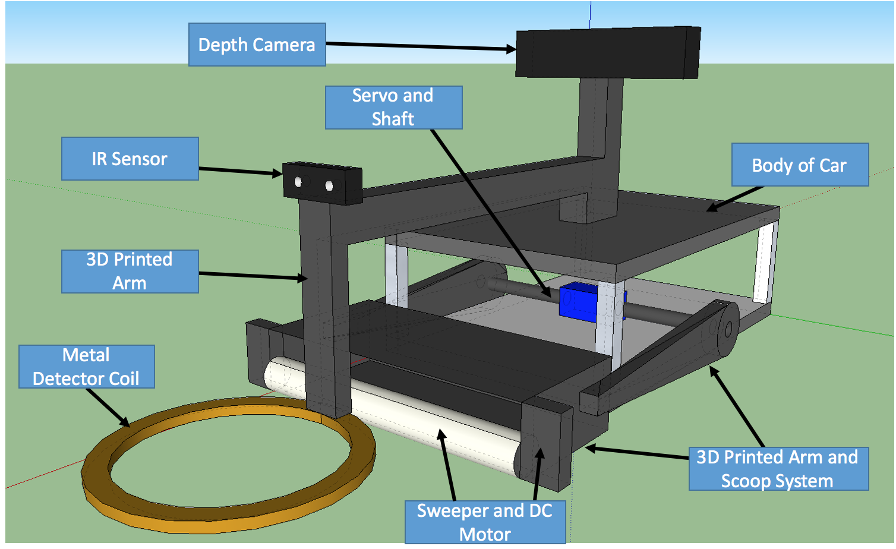

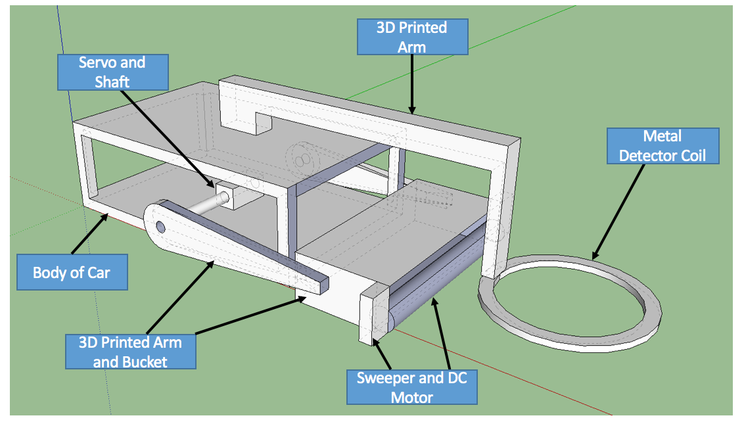

6 Tolerance Analysis
One of the most critical components of our project is the metal detector circuit. This circuit consists of two parts; a detector coil and a Colpitts oscillator circuit.
The two capacitors in the tank circuit act as a voltage divider, and their junction is connected to the emitter terminal of the transistor [6]. When power is applied, the two capacitors charge up and discharge through the inductor.
The frequency of the oscillations can be calculated as:
$$F=\frac{1}{2×π×\sqrt{L×C_{T}}}$$
where $C_{T}$ is the total capacitance of the two capacitors connected in series on the tank circuit. This is given as:
$$C_{T}=\frac{C_{1}×C_{2}}{C_{1}+C_{2}}$$
The inductance of a coil is calculated as [8]:
$$L=\frac{N^{2}μ_{o}A}{l}$$
where, $N=Number of turns in coil,$
$$A=Area of coil, and r=radius of the coil$$
$$l=length of coil,$$
$$μ_{o}=permeability of free space=1.26×{10}^{-6} T-m/At$$
We will aim to set the resonant frequency of the tank circuit to 100kHz. This is because the higher frequency is best to induce Eddy currents, which are induced in non-ferrous objects and decrease the inductance of the coil [4]. Second, a higher frequency increases the resolution for the integration time during counting [4].
Further, we want to control the amount of feedback voltage returned to the circuit. A large amount of feedback will cause the sine wave to become distorted, whereas a small amount will prevent the oscillation to begin I the first place [6]. The feedback fraction is given by:
$$\frac{C_{1}}{C_{2}}\%.$$
A metal object, when brought near the inductor, will change its inductance. Since we are aiming to detect small metal objects, the capacitances need to be stable with an error margin lower than the change in the inductance due to the magnetic field. We want to be able to detect the change in frequency of at least 10kHz.
$$F (10kHz)∝\frac{1}{\sqrt{C_{T}}}$$
As seen the calculations, we have set $C_{T}=5 nF$. To be able to detect a change in frequency of as little as 10kHz due to the inductor, the effect of $C_{T}$ on frequency needs to be less than 5kHz. Thus, $C_{T}$ needs to be within the following range:
$$5nF ±0.4$$
This implies that the tolerance for each individual capacitor is
$$C_{1}=C_{2}=10nf±0.8$$
This is an 8% tolerance level for the capacitors. This tolerance level will limit the effect of capacitance on the frequency to 5kHz. Thus, we will be able to detect a change in frequency as little as 10kHz caused due to the inductor.

