Final Report for ECE 445, Senior Design, Spring 2018
TA: Bryce Smith
3 May 2018
Project No. 54
Meghan LeMay
Michael Rupp

By

LED Rubik’s Cube
Abstract
The LED Rubik’s Cube is an alternative implementation of the classic Rubik’s Cube puzzle. The LED Rubik’s Cube’s novelty features allow the user to reset the cube while still being able to manually rotate each face of the cube. The mechanical aspects the puzzle were the main factors taken into consideration for the physical implementation of the prototype. As a result, each of the 26 blocks comprising the larger cube is self-contained and contains three different electrical component modules: the control unit, display unit, and power unit. The control unit is responsible for ensuring proper operation of cube after power-up. The display unit is responsible for maintaining the proper colors of the RGB LEDs for the user. Finally, the power unit is responsible for supplying power to the electrical components of this design. Overall, this project has produced a successful proof of concept for the design of the prototype.

Contents

1. Introduction 1
1.1 Objective 1
1.2 Background 1
1.3 High-Level Requirements 1
2 Design 2
2.1 Physical Implementation 4
2.2 Control Unit 4
2.2.1 Microcontroller 5
2.2.2 Microphone 5
2.2.3 Photodiode 5
2.3 Display Unit 7
2.3.1 RGB LEDs 7
2.3.2 Status LEDs - Infrared LEDs 8
2.4 Power Unit 9
2.4.1 Voltage Regulator 9
2.4.2​ 9 Volt Battery 9
2.5 Schematics and PCB Layouts 9
3. Design Verification 10
3.1. Photodiode 10
3.2. IR LED 10
4. Costs 12
4.1 Parts 12
4.2 Labor 12
4.2.1 Partner Labor 12
4.2.2 Machine Shop Labor 12
5. Conclusion 13
5.1 Accomplishments 13
5.2 Ethical Considerations 13
5.3 Safety 14
5.4 Future Work 15
References 16
Appendix A Physical Implementation 17
Appendix B Schematics and PCB Layouts 20
Appendix C Requirement and Verification Table 23
Appendix D Costs 26
Appendix E Additional Figures 28

1. Introduction

1.1 Objective
The Rubik’s Cube is the most popular puzzle in the world with 350 million cubes sold since its inception [1]. Each year, numerous national and international competitions are held where cube enthusiasts compete to see who can solve the 3x3x3 puzzle the fastest [2]. Solving a Rubik’s Cube can be a daunting task to those that are not familiar with the puzzle. With over 4.3 x 10¹⁹ possible permutations of the cube, neither a user nor a computer can determine a solution using a brute force method in a reasonable amount of time. Solving this puzzle take practice, and the LED Rubik’s Cube can aid in this task.
One of the main drawbacks of learning how to solve the 3x3x3 puzzle is that there is no reasonable way to reset the puzzle to its initial state if the user cannot solve it. Yes, the user can peel the stickers of the cube and rearrange them to the initial state, but that is a painstaking process a discouraged user may never want to repeat. The purpose of the LED Rubik’s Cube is to provide beginning Rubik’s cube enthusiasts with an easily resettable puzzle to prevent frustration to the user and any ensuing destruction of the cube. Further, when the user begins to master solving this puzzle, the cube will have the potential to be able to supply “random” puzzles for the user to solve.

1.2 Background
The Futuro Cube and Magic Cube are two examples of LED Rubik’s cubes that are on the market. The Futuro Cube is a cube backlit by 54 color changing LEDs that senses rotation, orientation, and tapping. The user taps the side to rotate clockwise, taps the bottom to rotate counterclockwise, and shakes the cube to scramble the puzzle. The cube has other games that use these features as well [3]. The Magic Cube is a cube also backlit by 54 color changing LEDs, but in order to complete a move in a Rubik’s cube puzzle, the user pushes a button corresponding to the move they want to make. In addition, the cube has other games that the user can play [4].
What neither of these designs has is the ability for the user to manually rotate each face of the cube like the original Rubik’s cube puzzle. The LED Rubik’s Cube is a teaching tool for individuals new to solving the puzzles and individuals who want to master the game. The cube, therefore, must be able to physically rotate to allow the user to practice moves the same way he or she would normally implement them on a standard Rubik’s cube. The ability to manually rotate each face along with the ability to implement a reset are the main features that drive the implementation component of the design.

1.3 High-Level Requirements
- The cube must be able to physically rotate with the implementation of color changing LEDS.
- The cube must allow the user to reset each face to the solved state of the Rubik’s cube.
- Each block must have low power consumption to allow extended play time for the user.

2 Design
The Rubik’s cube is a large cube comprised of 26 smaller cubes. Each smaller cube is either a center smaller cube in the middle of each face, a corner smaller cube which is a corner of the large cube, or a side smaller cube which lies along the edges of the large cube between the corner cubes. For the purposes of reducing confusion and succinctly expressing ideas, the following nomenclature will be used. The entire “large” Rubik’s cube will be referred to as the “cube.” The 26 smaller cubes that comprise the cube will be referred to as “blocks.” Further, the center smaller blocks will be called the “center blocks,” the corner smaller blocks will be called the “corner blocks”, and the side smaller blocks will be called the “side blocks.”
Several factors needed to be considered due to the mechanical aspects of this design. Since each face of the cube can rotate and each corner and side block can change position due to this rotation, any wires linking blocks will get tangled after several rotations. Therefore, the implementation of the cube will be comprised of self-contained blocks with the necessary circuitry needed to execute all functions each block must perform within the block. Since each block is self-contained, all blocks must be able to update at nearly the same time for a reset or any user specified state, and this update needs happen as quick as possible.
There are three modules within the overall circuit design of the LED Rubik’s Cube whose implementation is heavily influenced by the considerations outlined above. The modules are the control unit, the display unit, and the power unit. The control unit is responsible for determining the color each LED should be lit to and implementing resets. The display unit is responsible for lighting up the face of each block to a specific color and communicating color information between the center, side, and corner blocks. The power unit is responsible for maintaining power into the microcontroller of each self-contained block. Together these three modules working symbiotically ensure that the LED Rubik’s Cube performs as expected.
The entire cube is comprised of three different types of blocks: center blocks, corner blocks, and side blocks. There are six center blocks, twelve side blocks, and eight corner blocks in total, and the block diagrams for each type of block are shown below in Figure 1, Figure 2, and Figure 3, respectively. The relationships between the different types of blocks are extremely important when the LEDs need to be updated which happens right after power-on or a reset.
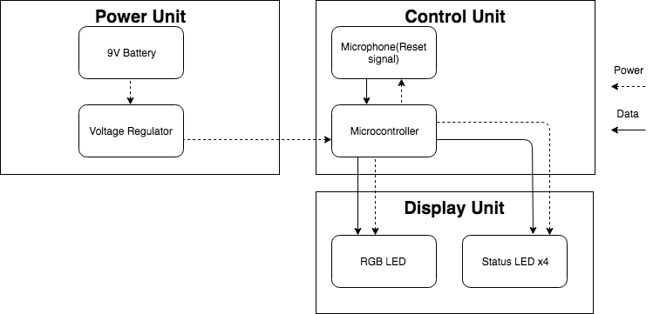Figure 1: Block Diagram of Center Block

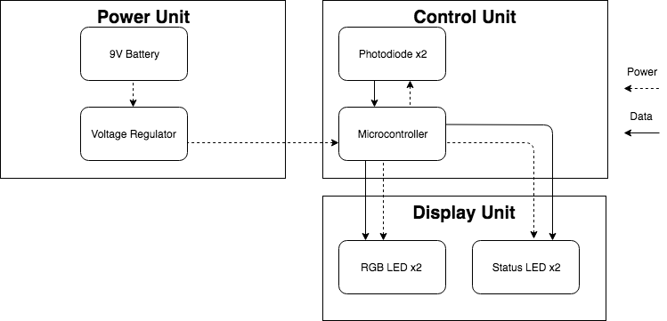
Figure 2: Block Diagram of Side Block

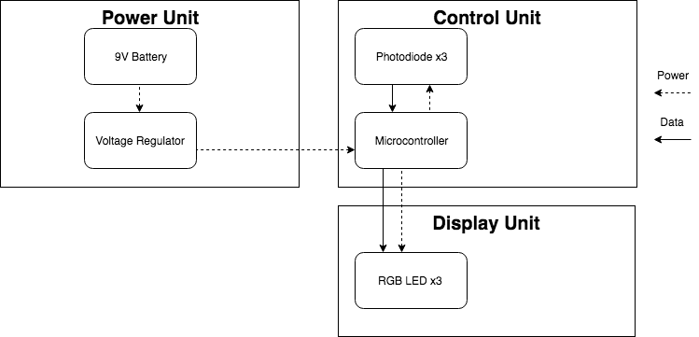
Figure 3: Block Diagram of Corner Block

2.1 Physical Implementation
The physical implementation of the cube is the key factor driving circuit design for the individual blocks. A Rubik’s cube is a 3 x 3 x 3 puzzle comprised of six colors. The cube purchased to be the base of the prototype with modification is shown in Figure 10 in Appendix A with dimensions of 18 cm x 18 cm x 18 cm. A large implementation of the cube was decided upon to make the implementation of each self-contained block easier. The shell of the device is a large size Rubik’s cube made of 26 smaller blocks. The color of each visible face of the 26 blocks is the original state of one of the faces of the cube. There are eight corner blocks that have three faces exposed, twelve side blocks that have two faces exposed, and six center blocks that have one face exposed. The layout of each of the 26 smaller blocks is shown in Figure 11 in Appendix A. Each face of the cube can rotate about its center block by the mechanism shown in Figure 12 in Appendix A which allows the design to meet the high-level requirement of being able to physically rotate. The color of each of the visible faces of the blocks will be shown using an RGB LED. Depending on the block type, either one, two, or three RGB LEDs will be housed inside each block to signify what color that each exposed face of the block should be. Holes will be cut into each of the visible faces as shown in Figure 13 in Appendix A, and each LED will be housed inside the smaller cubes according to Figure 14 and Figure 15 in Appendix A. The necessary circuitry will then be placed in the remaining room of each of the smaller cubes, and additional holes will then be cut to allow communication between the infrared LEDs and the appropriate photodiodes.

2.2 Control Unit
The control unit is responsible for ensuring proper operation of the LED Rubik’s Cube during power-up, reset, and any user specified mode to help satisfy the high-level requirements of having a reset and having low power consumption. The control unit for each of the block types is comprised of a microcontroller and either a microphone or multiple photodiodes. Power is provided to the control unit by the power unit. For the center blocks, the control unit takes inputs from the user with a microphone. For the corner and side blocks, it takes inputs from the status LEDs of adjacent blocks using photodiodes. For all implementations of the control unit, the control unit outputs color data to the display unit. For both the center and the side block implementations, it outputs status data to the status LEDs in the display unit.

2.2.1 Microcontroller
The ATmega328P microcontroller will be used for all implementations of the control unit. This controller was chosen because of its low cost, since 26 are needed, and its small size. since each one needs to fit in a 6 cm x 6 cm x 6cm block. The microcontroller is powered by a 9 V alkaline battery whose voltage is regulated to 5 V using a voltage regulator that can supply a 6.75 mA current. Supplying 5 V to the microcontroller allows the microcontroller to run at speeds of up to 20 MHz [5]. The microcontroller is responsible for powering, grounding, and receiving inputs from the microphone in the center implementation and the photodiodes in the side and corner implementations. It is also responsible for powering and grounding all elements in the display unit (i.e. RGB LEDs and status LEDs). For the center block implementation, inputs from the microphone will be used to determine what mode the cube is in and then output that data to the status LEDs in the display unit. For the side block implementation, inputs from the photodiodes will be used to determine the mode the cube is in and then output color and status data to the display unit. For the corner block implementation, inputs from the photodiodes will be used to determine the mode the cube is in and then output color data to the display unit.

2.2.2 Microphone
The microphone is responsible for initiating the reset sequence. If the microphone in the center block detects a certain frequency signal, it will become active and send a signal to the microcontroller. When the microcontroller receives this signal, it will initiate the reset sequence that will propagate throughout the face of the cube. In total, there will be six microphones each outputting a signal to its respective microcontroller in each center block when the user initiates a reset. Once the microphone is active, the microcontroller can then illuminate an infrared LED used to propagate the reset signal to an adjacent cube. By using the microcontroller to read the output of the microphone, multiple types of sounds can be picked up to display different orientations of the cube. This microphone outputs a signal with amplitude of a few millivolts. Thus, the output must be amplified to properly identify a signal and distinguish it from noise.

2.2.3 Photodiode
The photodiodes are responsible for receiving the reset signal from the infrared status LEDs. Photodiodes will send information about receiving infrared pulses to the microcontroller. The enumeration of infrared sequences is mapped to different color resets as shown in Figure 4. Each color signals starts with an initial pulse to let the receiving microcontroller know that it is going to receive an enumerated color signal. The next three bits are used to determine the color of the signal sent. Three bits are needed to uniquely identify up to eight colors. The microcontroller will determine the color the corresponding RGB LED needs to be based on the output of the photodiode according to the diagram in Figure 4. If this is a side block, the microcontroller will output data to the corresponding status LED in the display unit so that it repeats the pattern the photodiode received, and the corresponding photodiode in the corner block can receive the pulses.
The Fairchild QSE773 Photodiode was chosen for its capability to convert infrared light pulses into voltage signals and for its peak spectral sensitivity. As shown in Figure 5, the photodiode has a peak spectral sensitivity at approximately 940 nm which is the same wavelength as the infrared LEDs chosen [6].
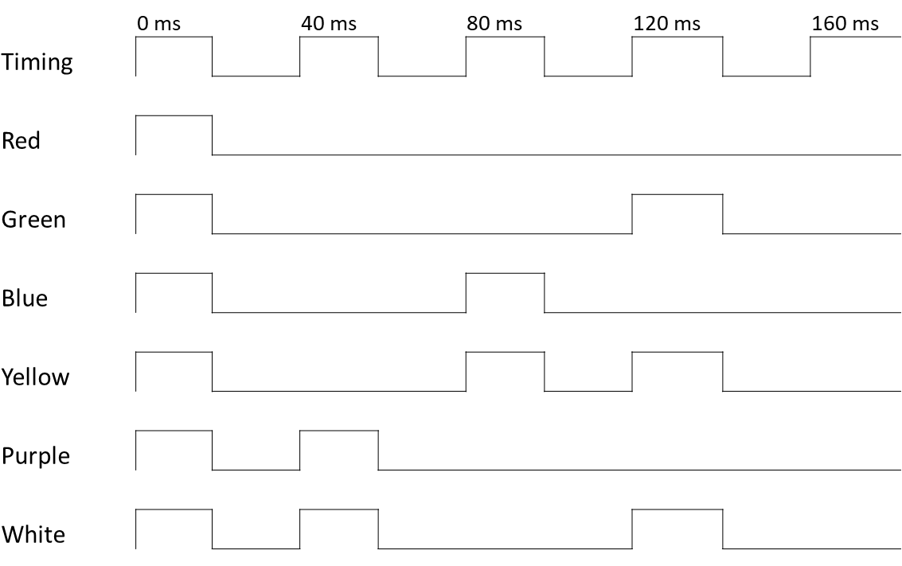
Figure 4: Color Information Timing Diagram
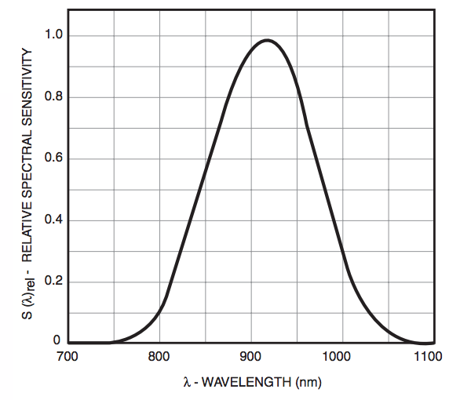
Figure 5: Relative Spectral Sensitivity vs. Wavelength of Photodiode [6]

2.3 Display Unit
The display unit is the circuitry necessary to individually light each block with a color changing RGB LED. This module is comprised of RGB LEDs and status LEDs. There are four status LEDs and one RGB LED in the center block implementation, two status LEDs and two RGB LEDs in the side block implementation, and three RGB LEDs in the corner block implementation. The microcontroller in the control unit is responsible for powering, grounding, and sending the appropriate data to the RGB LEDs and status LEDs. The RGB LEDs will update during a reset and a user specified mode. The status LEDs will be initiated to propagate a reset or a user specified mode from the center cube to the corner cubes of on its face. This is necessary to complete both the reset and any future user specified “random” functions.

2.3.1 RGB LEDs
Fifty-four RGB LEDs will display the proper color of the of each face of each block based on the voltage across them. There are four terminals on each RGB LED, one connected to ground and three controlling the amount of light emitted from their respective color LED, red, green, or blue. The red, green, and blue terminals are connected to resistors as shown by the schematic in Figure 6 obtained from wiring.org [7]. The voltages across the terminals and the ground for the RGB LED is provided by the microcontroller in the control unit. There are six colors representing the initial state of each of the six faces of the cube. The colors chosen are red, green, blue, yellow, purple, and white. These colors were chosen because they are formed by turning on combinations of the red, green, and blue LEDs inside the RGB LED with the same intensity making it easy to switch between colors simply by turning on or off different LEDs within the RGB LED. To emit red, green, or blue light, only one of the three LEDs need to be turned on either the red, green, or blue LED, respectively. Additionally, each red, green, and blue LED consumes 20 mA of current. To emit yellow light, the red and the green LEDs are turned on giving a total current consumption of 40 mA. To emit purple light, the red and the blue LEDs are turned on giving a total current consumption of 40 mA. To emit white light, the red, green, and blue LEDs are turned on giving total current consumption of 60 mA. The current specifications for each color are additionally referenced in Table 1.
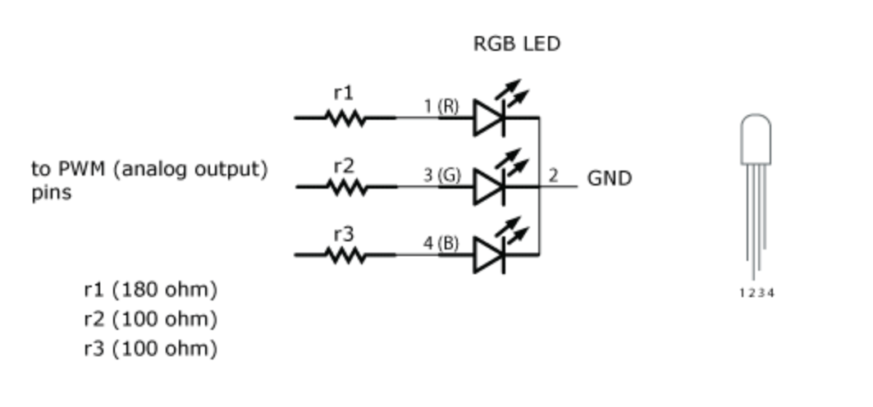
Figure 6: Schematic for RGB LED [7]
Table 1: Current Usage of RGB LEDs per Color
LED Color | Current Usage  (mA)
Red | 20
Green | 20
Blue | 20
Yellow | 40
Purple | 40
White | 60

2.3.2 Status LEDs - Infrared LEDs
The infrared LEDs are responsible for sending signals in between each block. The ECE Machine Shop has drilled holes in between the blocks so that the infrared beam can be picked up by a photodiode located in the receiving block. The main purpose of the infrared LEDs is to propagate a reset signal initiated by the microphone in the center block. Infrared LEDs were chosen to transmit data because wires entering and exiting the cubes would tangle when the user rotates each face of the puzzle.
The infrared LEDs chosen are GaAlAs semiconductors that emit light at a wavelength of 940 nm. As seen in Figure 7, the diode emits the highest intensity of light at wavelengths near 940 nm [8]. The infrared LEDs are responsible for sending sequences of pulses to the photodiodes. Each sequence of pulses represents one of the six colors of the RGB LEDs according to diagram shown in Figure 4.
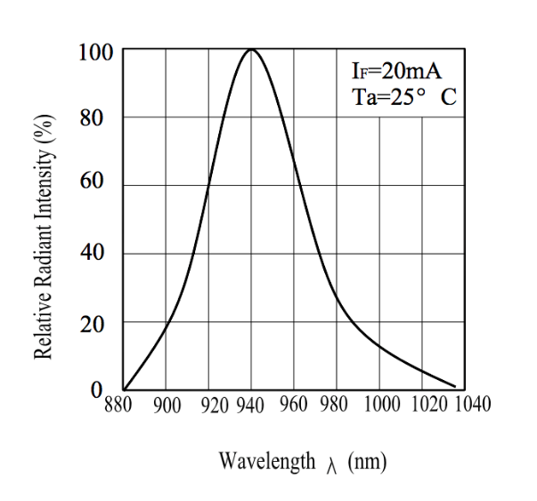
Figure 7: Spectral Distribution of Radiant Intensity [8]

2.4 Power Unit
The power unit is responsible for maintaining a constant 5 V to the microcontroller. Without power to the microcontroller, the high-level requirement of implementing a reset and any future additional user-specified modes of operation could not be possible.

2.4.1 Voltage Regulator
The voltage regulator is used to maintain a 5 V input to the microcontroller from the 9 V battery. The regulator must bring this voltage down to 5 V and be able to supply a current of 6.75 mA to power the microcontroller. The maximum allowed input voltage to the ATmega328P microcontroller is 5.5 V, so the input voltage to the microcontroller must be well below 5.5 V to make ensure that no ripple or noise voltages damage the device. In addition, the voltage regulator prevents large amounts of current from flowing into the microcontroller. The voltage regulator requires an input voltage at least 2 V higher than the output voltage to be supplied which is 5 V in this case. Therefore, a 9 V battery was chosen because it is well above the 7 V minimum.

2.4.2​ 9 Volt Battery
A standard 9 V battery is used to power the microcontroller in the display. This was chosen because it would have a longer lifetime than a smaller battery, and it was the largest battery that could fit inside each block. Since there are a total of 26 different 9 V batteries between all the blocks, it makes sense to not have to charge 26 different batteries for this implementation.

2.5 Schematics and PCB Layouts
The schematics and PCB layouts for each of the three block types are shown in Appendix B. The schematic for the center block is shown in Figure 16. A few considerations were taken into account for the layout of the center block PCB as shown in Figure 17. The microphone was placed as far away from other components as possible to minimize microphone distortion. Additionally, each of the four IR LEDS was placed close to its corresponding edge of the center block to make the physical implementation into the block easier. The schematic for the side block is shown in Figure 18. For the side block PCB design shown in Figure 19, each of the two RGB LEDs was placed on opposite edges of the block along with its corresponding IR LED. The schematic for the corner block is shown in Figure 20. For the corner block PCB design shown in Figure 21, each of the three RGB LEDS was placed on a different edge of the block. Additionally, on all PCBs ground VIAs were added so that additional components could be added to the PCBs later and to make testing easier.

3. Design Verification
There were many requirements the components in the prototype needed to adhere to. The requirements and their respective verification procedures are shown in Table 2 in Appendix C. To avoid redundancy in description since each design requirement was verified, only a select set of requirements will be described in this chapter.

3.1. Photodiode
The photodiode is responsible for reading signals from the IR LED. In order to have a properly functioning reset sequence, the photodiode is required to sense infrared wavelengths between 900 nm and 1000 nm. Using an analog input pin of an Arduino Uno connected to the output of the photodiode and the Arduino serial monitor, an IR LED verified to emit light at a wavelength between 900 nm and 1000 nm was shown onto the photodiode. The IR LED emitted light in pulses, and the resulting Arduino serial monitor display is shown in Figure 8. The y-axis represents a voltage from 0 V to 5.0 V scaled from 0 to 1023 meaning each unit represents 4.9 mV. The x-axis corresponds to the data bit number since the analog input data was read at a rate of 9600 bits per second. The serial data shows that for each of the IR LED pulses, the output of the photodiode significantly decreases to approximately 0 V. This confirms that the photodiode is sensing infrared light at a wavelength between 900 nm and 1000 nm.
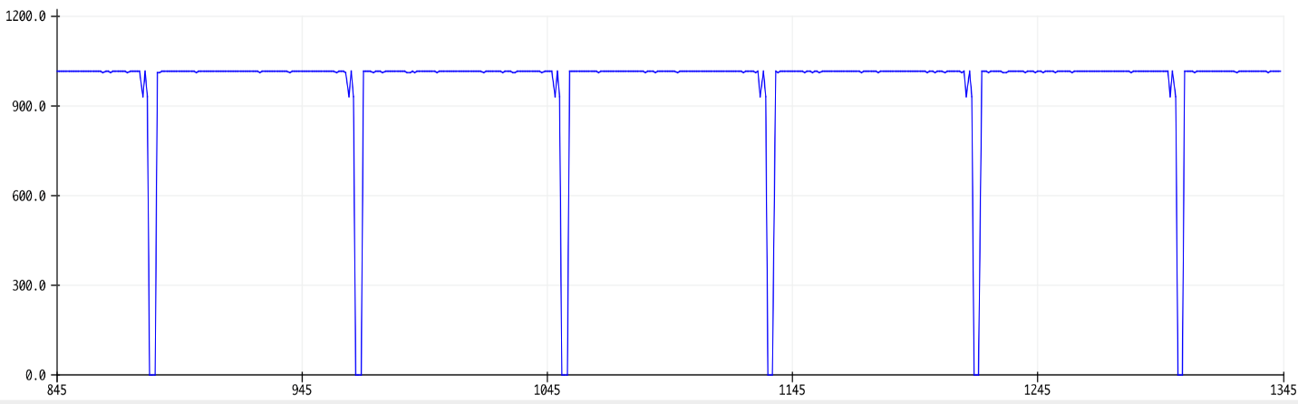
Figure 8: Photodiode Output - Voltage vs Time

3.2. IR LED
To verify that the IR LEDs emit a wavelength of light between 900 nm and 1000 nm, an optical spectrum analyzer provided by Professor Xiaogang Chen was used to determine the intensity of light emitted by the IR LED for an optical spectrum of 790 nm to 1090 nm wavelengths. The intensity graph of this optical spectrum for the IR LED is shown in Figure 9. The two red markers on the graph show the points at which the wavelength is 900 nm and 1000 nm. Using these plot markers, it can be determined that the peak intensity seen by the optical spectrum analyzer for the IR LED is at a wavelength between the specified range of 900 nm to 1000 nm.

Figure 9: Intensity vs Wavelength of IR LED

4. Costs
To estimate the total costs of this prototype, the total estimated parts and labor costs were calculated in the following sections.

4.1 Parts
On the component side of this prototype, Table 3 in Appendix D lists both the bulk cost and the actual cost of each component used in the prototype. The total actual cost of the components of this project is $320.94. For future reference, the cost of all the parts needed to build one LED Rubik’s Cube with components bought in bulk would be $255.58.

4.2 Labor

4.2.1 Partner Labor
This group had two partners. Each partner spent on average 10 hours per week on this project. According to the ECE Illinois website, an average Electrical Engineering Graduate makes a $67,000 starting salary. Assuming a 2000-hour work year, this is a rate of $33.50 per hour [10]. The partner labor cost was calculated to be $26,800 using Equation 1.
(1)

4.2.2 Machine Shop Labor
The manufacturing shop estimated that they will put 70 hours of work into the project. The hourly rate of machine shop labor as quoted by the machine shop is $55 per hour. The machine shop labor cost was calculated to be $3,850 using Equation 2.
(2)

5. Conclusion
This project demonstrated a successful proof of concept since it is currently possible to initiate and propagate a reset signal between microcontrollers. However, when attempting to assemble the prototype with the electronics that were developed throughout the course of the project, many difficulties manifested themselves making it impossible to integrate the electrical and mechanical components together.
The biggest challenge was that many of the soldered wires that were used to connect the RGB LEDs, IR LEDs, and photodiodes to the PCBs repeatedly sliced off as they were placed in their corresponding blocks. Additionally, each center block did not have enough space to fit the 9 Volt battery needed to power its electrical components. A quick fix for this was implemented by stringing the battery leads out of the blocks between the shell of the block and the white plastic covering for the RGB LED. Further, there were difficulties in configuring the infrared transmitter and receiver network to realign with each other after rotation of the cube making the implementation of the reset impossible. In the future, a careful mechanical design will be built to complement the intricate electronic sensor system developed. The mechanical design would incorporate solutions to each of these problems and allow extra room in each block to add additional components.

5.1 Accomplishments
The biggest accomplishment of this project was completing each of the different circuit subsections. The first major milestone was achieving communication between two separate microcontrollers using only IR LEDs and photodiodes. This was the most critical milestone because this provided a successful proof of concept for the communication aspect of prototype. To provide a full proof of concept much more circuit testing would be required for a fully developed circuit, but this subsection was crucial in accomplishing a full reset of the Cube.
One of the most difficult parts of the project was implementing the microphone circuit. With the microphone being so sensitive, rotations of the Rubik’s Cube could cause the circuit to trigger false positives. This required the circuit to be able to filter out this noise. To accomplish this, code was added to the microcontroller to provide the ability to detect the frequency of an incoming sound signal. Successful implementation of the frequency reading of a 1 kHz signal initiating the start of the reset change was accomplished, and a total proof of concept can be confirmed. In addition, these signals could then be mapped to different reset infrared signal sequences, which in turn would generate new reset combinations for future implementations.

5.2 Ethical Considerations
Research was done on similar products to the LED Rubik’s Cube to ensure that this product is different from other Rubik’s Cubes using LEDs on the market. The LED Rubik’s Cube is unique because it features the ability to allow the user to manually rotate each of its faces while still being backlit by LEDs. One example of a similar product is the Rubik’s Futuro Cube [3]. This product features an LED Cube that is interfaced with a touch screen. There are different games that can be played on this 3 x 3 x 3 LED puzzle. The touch screen can sense if the user has made a swiping or a tapping motion and will adjust the LEDs according to each move. However, there is no physical rotation of the Futuro Cube. All moves are done using the touch screen. Our project features a cube that can physically rotate about each face. This team has acted in accordance with the IEEE Code of Ethics #9 to make every effort to avoid infringing on the intellectual property of the Futuro Cube and other similar products [11].
Many projects utilize assistance from outside sources at different points of the project. To properly follow the IEEE Code of Ethics #7 by crediting the contributions of others to this project [11], the team would like to give credit to those who helped with this project. This project received assistance from the ECE Machine Shop. After first ordering the novelty-size Rubik’s Cube, there was no way to access the inside of each block to place the LEDs, PCBs, and other components inside easily. had no way to get inside of the Cube to place LEDs and other components easily. David Switzer and Scott McDonald from the ECE Machine Shop created latches on each of the blocks that can easily be opened and closed so components can be placed inside without difficulty. Additionally, David Switzer created the housings for the RGB LEDs to ensure that they were properly placed within each block and did not interfere with each other. Further, he was responsible for cutting the holes in the sides of the blocks to allow communication between blocks using the pattern the team provided to him. The pattern for reference is shown in Figure 22 in Appendix E.
Skot Wiedmann from the Electronics Services shop provided valuable advice at crucial stages of the project. He helped formulate the concepts for each of the blocks and provided guidance about which components to use and how to fix many of the problems that arose. Professor Xiaogang Chen can be credited with the idea to use light at different wavelengths to communicate information from the center blocks to the corresponding side and corner blocks about the color of the RGB LEDs for a reset or any other state. Finally, the project TA, Bryce Smith, provided much guidance about the layout and creation of PCBs along with advice about how to power the microchip and reduce the microphone noise.

5.3 Safety
This project did not have any outstanding safety concerns related to the implementation of this prototype. One should always exert proper precaution and respect for all electrical devices even if their operation may seem harmless. The most dangerous part of this project is the 9 Volt batteries used as the power supply. Batteries, although many may encounter and interact with them on a daily basis, must be handled with proper precaution to prevent human harm. The battery safety manual whose procedures the team members adhered to has been provided to the reader [12]. An important battery safety precaution extremely relevant to this project is that the battery leads should never touch loose metal. This may cause the battery to discharge and heat up the metal which has the potential to cause a fire. This could be a potential problem for this project if the cube is being rotated and the batteries are not secured properly. To prevent this from happening proper leads that snapped onto the battery were soldered directly to each PCB.
Another potentially dangerous component of this project is use of IR LEDs to communicate between blocks. For normal cube operation, the IR LEDs will be completely covered, and the light will not escape the cube. However, in the process of developing the cube, the infrared light may be exposed. It is known that infrared light has the potential to cause damage to the corneas of one’s eye. One should never intentionally bring infrared light close to the eye or direct the light into the eye. Some safety precautions regarding infrared LEDs can be found in reference [12]. In this design, casings have been included around the LEDs to direct the beam into the photodiode. This will also serve as an extra layer of protection so that the beam does not accidentally harm anyone.

5.4 Future Work
Future additions to the LED Rubik’s Cube include allowing the user to reset the cube to more complex states. By mapping a variety of sound signal inputs to infrared signals, it is possible to achieve setting the cube to any color scheme. This can be used to practice solving the Rubik’s Cube from predetermined states. With further programming of the Atmel microcontroller, it is additionally possible to achieve pseudorandom puzzle states.
With further circuit and sensor development, extra features can be implemented into the circuitry. It is possible to implement a solving algorithm in the microcontroller code. By appending and characterizing an Internal Measurement Unit to each PCB, the position of each cube relative to each other can be determined. Given the position of each cube, a solving algorithm can determine a sequence of moves to make that will terminate with the Rubik’s Cube being solved.

References

[1] “Cube Facts.” Rubiks, www.rubiks.com/about/cube-facts. [Accessed: February 2, 2018].
[2] “Competitions.” World Cube Association, World Cube Association, www.worldcubeassociation.org/competitions [Accessed: February 18, 2018].
[3] Ing. Jan Krejsa, Ing. Jaroslav Altmann, Ing. Vladimir Vejvoda, “Rubik’s Futuro Cube” PCT CZ2013/000013 November 2nd, 2013 [Accessed: February 4, 2018].
[4] Kit Eaton, “LED Rubiks Cube is Unnecessary Digitization of a Classic”, Gizmodo, October 21, 2008. [Online] Available: https://gizmodo.com/5066330/led-rubiks-cube-is-unnecessary-digitization-of-a-classic [Accessed: February 16, 2018].
[5] Everlight, “Technical Datasheet 5mm Infrared LED”, IR333-A, July 2005 [Accessed: February 20, 2018].
[6] Fairchild, “Sidelooker Pin Photodiode”, QSE773, August 2013.
[7] Hernando Barragán, “RGB LED”, wiring.org. [Online] Available: http://wiring.org.co/learning/basics/rgbled.html [Accessed February 2, 2018].
[8] Everlight, “Technical Datasheet 5mm Infrared LED”, IR333-A, July 2005 [Accessed: February 20, 2018].
[9] Texas Instruments, “A7800Series Positive-Voltage Regulators”, May 1976 [Accessed: February 22]
[10] “Salary Averages, ” ECE Illinois, University of Illinois at Urbana-Champaign, [Online] Available: ece.illinois.edu/admissions/why-ece/salary-averages.asp [Accessed: February 20, 2018]
[11] Ieee.org, "IEEE IEEE Code of Ethics", 2016. [Online]. Available: http://www.ieee.org/about/corporate/governance/p7-8.html. [Accessed: February 18, 2018].
[12] Energizer, “Alkaline Battery Product Safety Data Sheet”, 2017 [Online] Available: data.energizer.com/pdfs/alkalinecylindrical_psds.pdf [Accessed: February 12, 2018].

Appendix A Physical Implementation

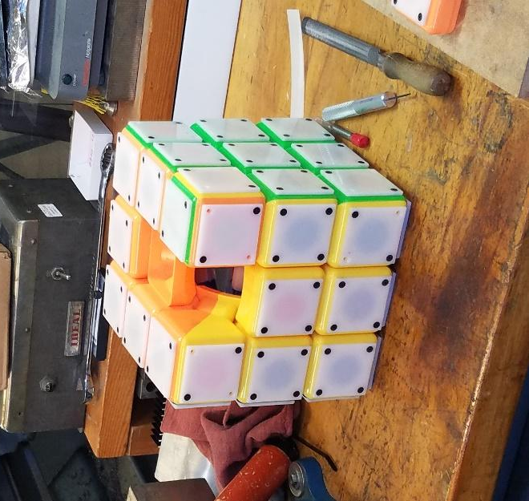
Figure 10: LED Rubik’s Cube Base of Physical Implementation

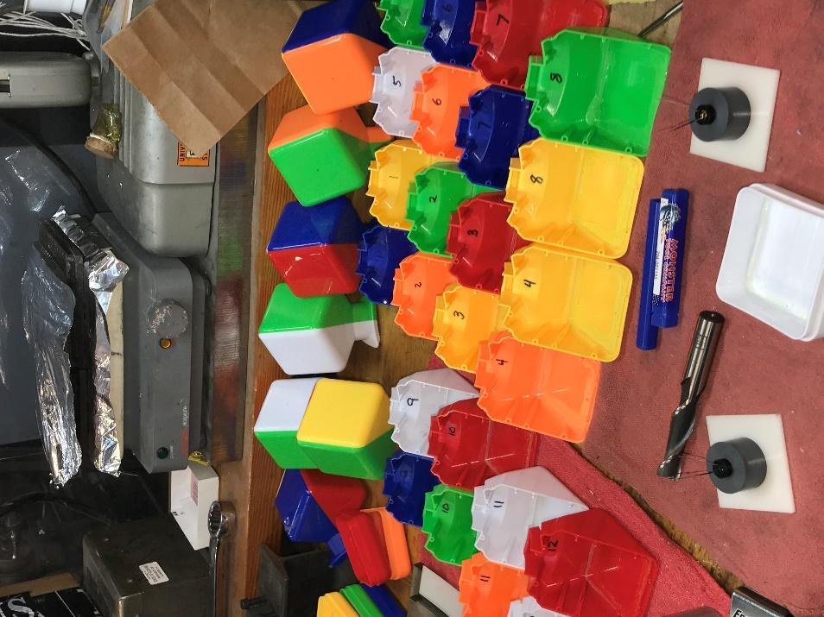
Figure 11: Twenty-six Blocks Comprising Large Rubik’s Cube

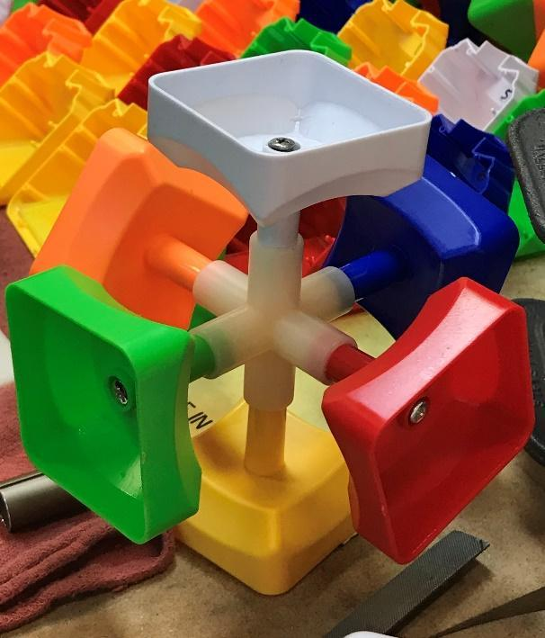
Figure 12: Rotation Mechanism

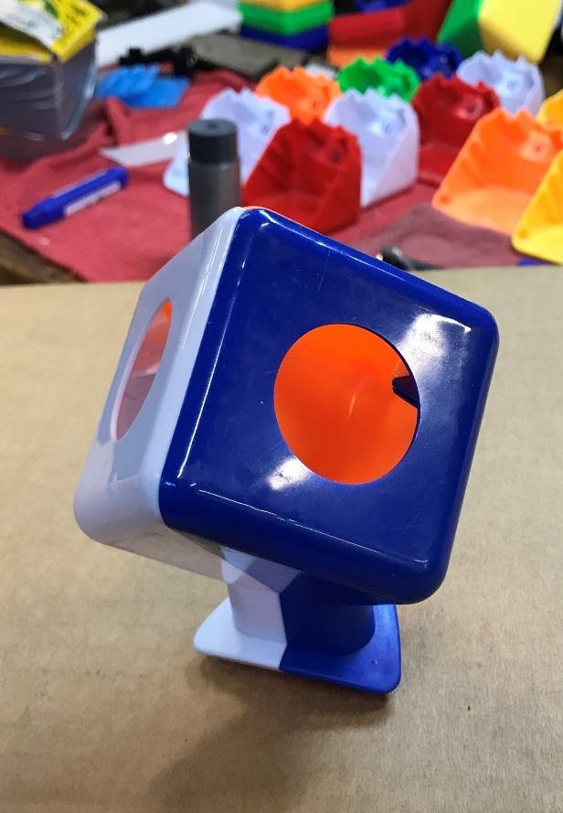
Figure 13: Cutouts Made for Each Block

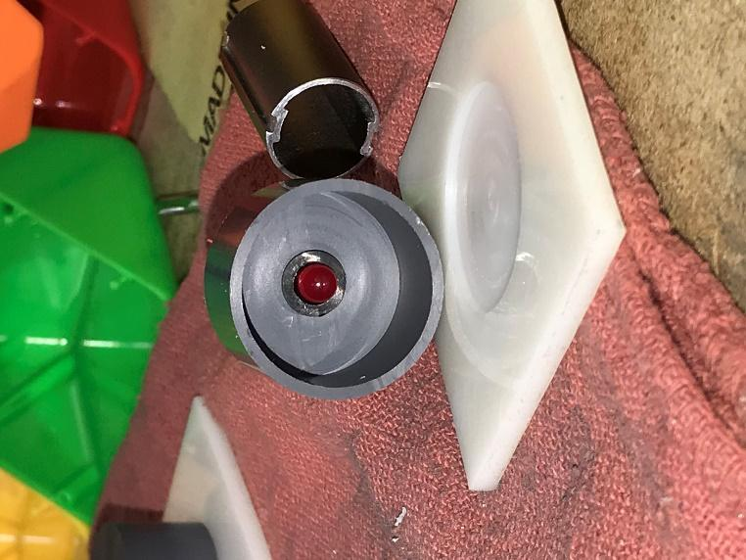
Figure 14: Top View of RGB LED Housing

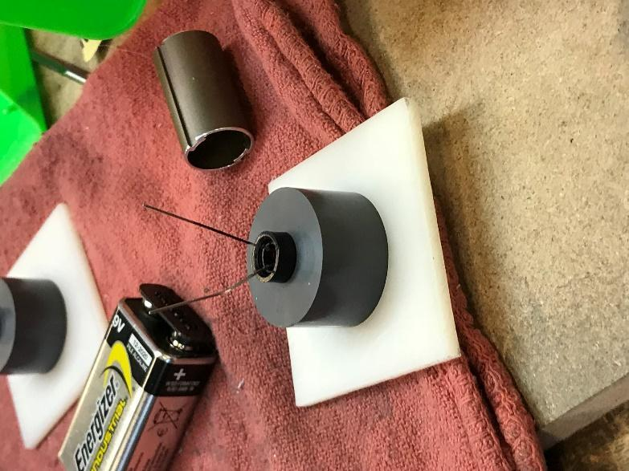
Figure 15: Bottom View of RGB LED Housing

Appendix B Schematics and PCB Layouts
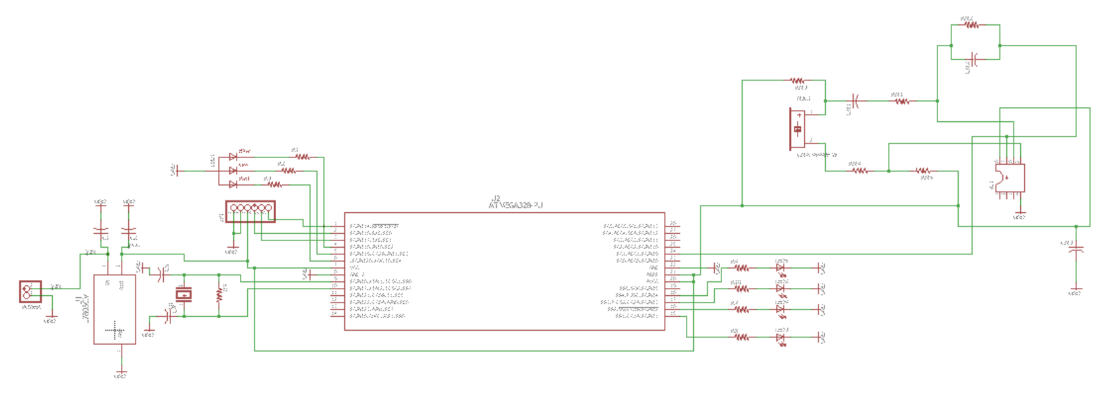
Figure 16: Center Block Schematic

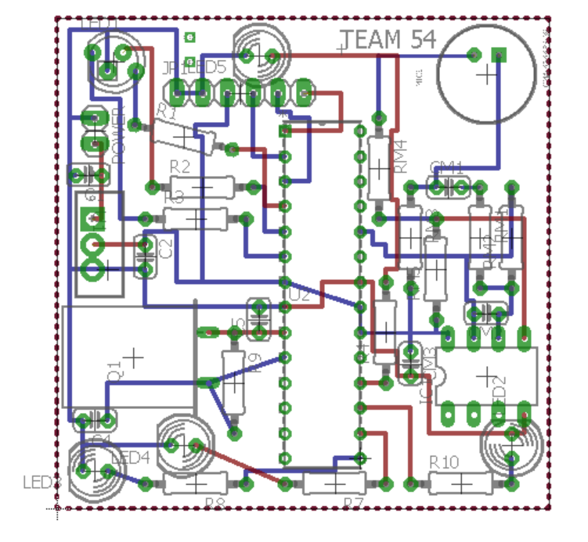
Figure 17: Center Block PCB

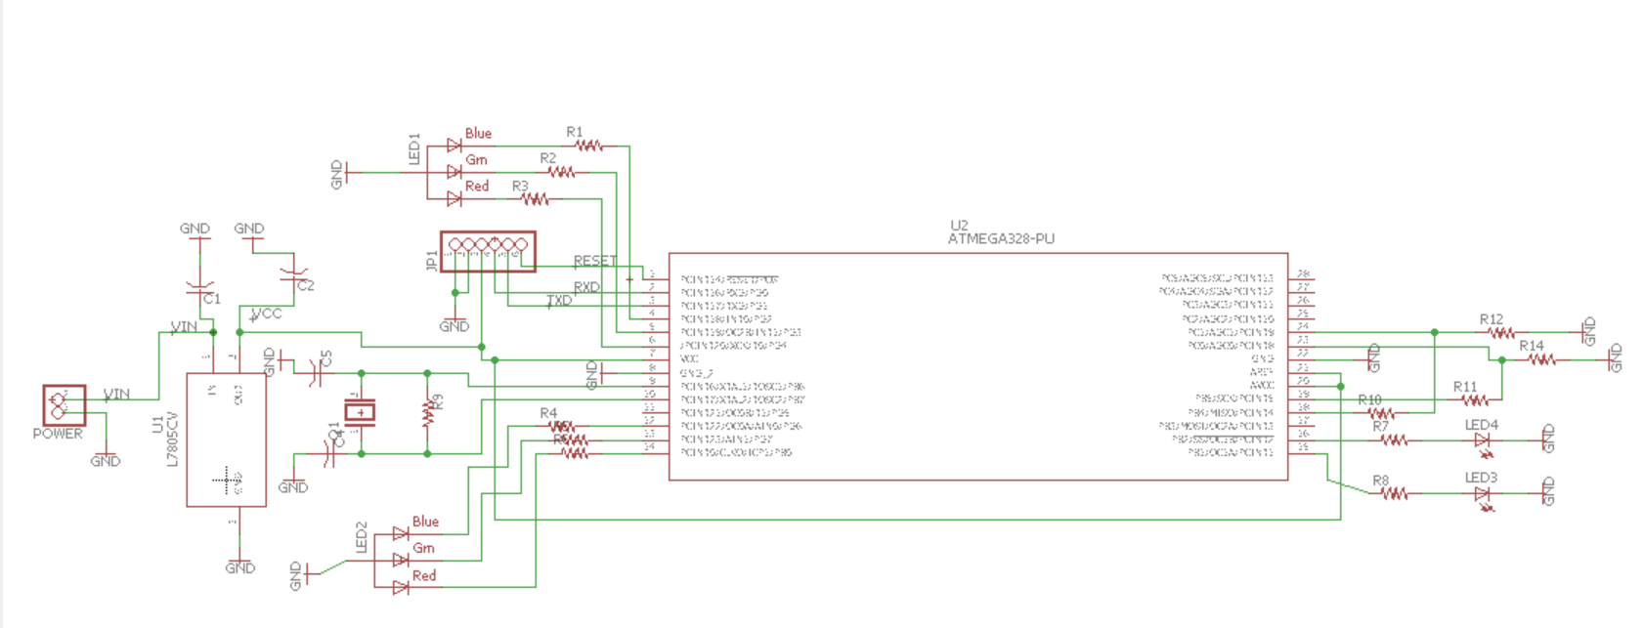
Figure 18: Side Block Schematic

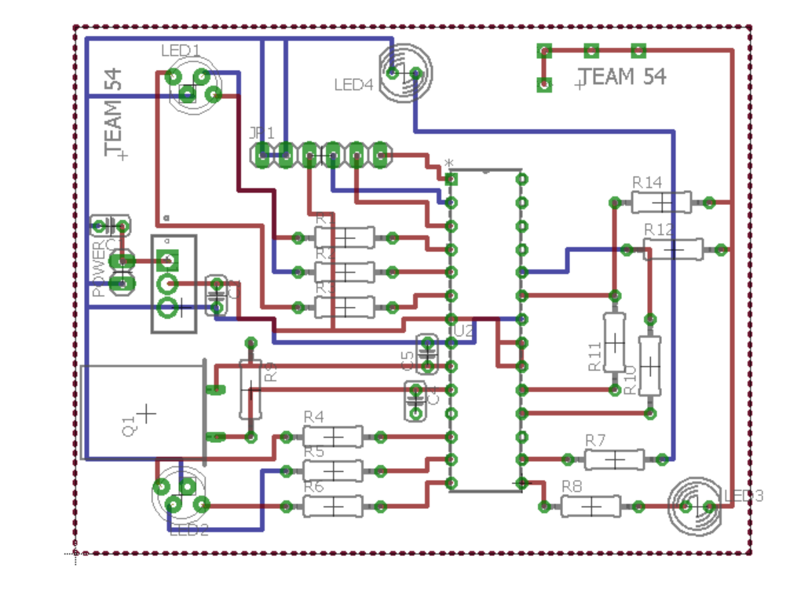
Figure 19: Side Block PCB

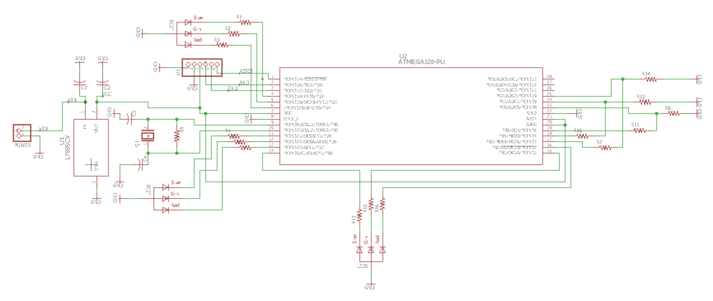
Figure 20: Corner Block Schematic

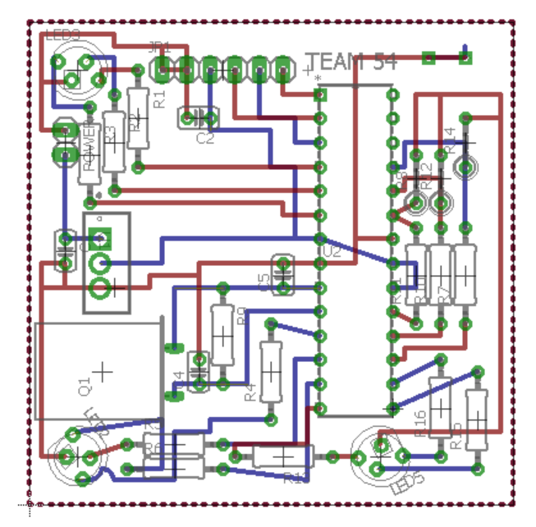
Figure 21: Corner Block PCB

Appendix C Requirement and Verification Table

Table 2: System Requirements and Verifications
Requirement | Verification | Verification status  (Yes or No)
Microcontroller
The microcontroller should read a reset signal from the microphone and propagate this signal to the IR status LED. | - Connect microcontroller to computer.  - Send a reset signal to the microcontroller and read output from photodiode showing that the reset signal was propagated through the IR status LED. | Yes
The microcontroller must output at least 4V to each digital output pin in use to drive each LED color | - Connect one lead of voltmeter to the supplied ground pin of the microcontroller, then connect the other lead to each digital output pin and measure each potential difference. | Yes
Microphone
Microphone signal must be amplified to at least 30 dB gain. | - Provide a small signal sine wave from a function generator with amplitude of 1 mV.  - Connect small signal to input of the microphone’s amplifier.  - Read output of amplifier with oscilloscope.  - Determine if gain is greater than 30 dB using Equation 3. | Yes
Microphone must be able to identify the reset signals 9 out of 10 times. | - Trigger reset signal 30 times. Verify that Cube resets at least 27 times. | Yes
Must not respond to false positive reset signals 9 out of 10 times. | - Rotate segments of Cube 30 times. Verify that this does not trigger a reset of Cube more than 3 times. | Yes
Photodiode
Must be able to sense infrared wavelengths between 900 nm and 1000 nm | - Connect microcontroller to computer and set up to read photodiode output.  - Shine IR LED verified to emit a wavelength between 900 nm to 1000 nm into the photodiode sensor.  - Determine if output of photodiode is different when shining infrared LED vs. ambient light. | Yes
Display Unit
Must consume less than 225 mA of current for 2 hours of play time on a 450 mAh battery. | - Turn on all components in display unit connected to microcontroller.  - Measure the total current output running through each component.  - Verify that sum of total current does not exceed 225 mA of current. This will ensure that the battery can last for at least 2 hours of play time. | Yes
Must be self-contained | - No wires leaving any of the blocks. | Yes
RGB LED
Must be easily visible to user from two feet away. | - Measure two feet with a ruler.  - Inspect RGB LED to see if its color can be easily determined. | Yes
Must be oriented in each block such that multiple LEDs in a single cube do not interfere with each other. | - Check colors of all LEDs to make sure that the only colors displayed are red, green, blue, yellow, purple and white. | Yes
IR LED
Must be able to send six unique signals to the photodiode | - Write a test Arduino program that creates six different pulse sequences to excite the infrared LED.  - Verify that this program can produce six different RGB color outputs. | Yes
Must emit a wavelength of light  between 900 nm to 1000 nm | - Use spectrometer to measure intensity vs wavelength of IR LED.  - Determine whether peak intensity reading of IR LED is between 900 nm to 1000 nm. | Yes
Voltage Regulator
Provides 5 V from a 9 V source within a 5% error. | - Connect voltmeter to output of voltage regulator.  - Check if voltage is between 4.75 V to 5.25 V. | Yes
Supplies current at 6.75 mA. | - Connect a test load to the output of the regulator with a resistance of 740 Ω or less.  - Connect an ammeter in series with the resistor.  - Measure the current reading of ammeter. | Yes

(3)

Appendix D Costs

Table 3: Parts Costs
Part | Part Number | MFR | Distributer | Cost  ($) | Bulk Cost ($) | Qty | Total ($) | Bulk Total ($)
Micro-controller | ATMEGA328-PU | Atmel | Mouser | 1.85 | 1.68 | 26 | 48.10 | 43.68
5mm Common Cathode RGB LED | 100F5T-YT-RGB-CC | Chanzon | Amazon | 0.09 | 0.09 | 54 | 4.84 | 4.84
Photo-diode | QSE773 | Fairchild | Mouser | 0.63 | 0.25 | 48 | 30.24 | 12.19
940 nm IR LED (5mm) | 15400394A3590 | Wurth Electronics | Mouser | 0.35 | 0.20 | 48 | 16.75 | 9.74
9 Volt Alkaline Battery | B00MH4QM1S | Amazon  Basics | Amazon | 1.25 | 1.19 | 26 | 32.47 | 30.84
Voltage Regulator | L7805CV | STMicro-electronics | Digi-Key | 0.43 | 0.19 | 26 | 11.08 | 5.03
Electret Micro-phone | MO093803-1 | DB Unlimited | Mouser | 0.57 | 0.28 | 6 | 3.42 | 1.67
16.000 MHz Dip Quartz Crystal | AT49S | Uxcell | Amazon | 0.16 | 0.16 | 26 | 4.23 | 4.23
28 Pin DIP IC Socket | a11090300-ux0241 | Uxcell | Amazon | 0.28 | 0.28 | 26 | 7.38 | 7.38
22 pF Capacitor | K220K15C0-GH53L2 | Vishay | Mouser | 0.20 | 0.06 | 52 | 10.40 | 3.12
10 pF Capacitor | FG18C0G1H100-DNT00 | TDK | Mouser | 0.16 | 0.05 | 6 | 0.96 | 0.32
0.33 μF Capacitor | FG18X7R1H334-KRT00 | TDK | Mouser | 0.20 | 0.09 | 26 | 5.10 | 2.29
0.1 μF Capacitor | C322-C104-K5-R5TA | Kemet | Digi-Key | 0.15 | 0.05 | 32 | 4.80 | 1.48
9 Volt Battery Clip | B078K9H56V | XiangLv | Amazon | 0.22 | 0.22 | 26 | 5.67 | 5.67
1 µF Capacitor | C330-C105-K5-R5TA | Kemet | Digi-Key | 0.47 | 0.12 | 6 | 2.82 | 0.74
330 Ohm Resistor | CFR-25JB-52-330R | Yageo | Digi-Key | 0.02 | 0.01 | 162 | 3.92 | 1.26
3.3 kOhm Resistor | CFR-50JB-52-3K3 | Yageo | Digi-Key | 0.04 | 0.01 | 54 | 2.42 | 0.59
100 Ohm Resistor | CFR-25JB-52-100R | Yageo | Digi-Key | 0.04 | 0.01 | 48 | 2.07 | 0.37
1 MOhm Resistor | CFR-25JB-52-1M | Yageo | Digi-Key | 0.10 | 0.01 | 6 | 0.60 | 0.05
27 kOhm Resistor | CFR-25JB-52-27K | Yageo | Digi-Key | 0.10 | 0.01 | 6 | 0.60 | 0.05
10 kOhm Resistor | CFR-25JB-52-10K | Yageo | Digi-Key | 0.10 | 0.01 | 6 | 0.60 | 0.05
22 kOhm Resistor | CFR-25JB-52-22K | Yageo | Digi-Key | 0.10 | 0.01 | 6 | 0.60 | 0.05
IC OPAMP Dip | LM358N | ON Semi-conductor | Digi-Key | 0.52 | 0.20 | 6 | 3.12 | 1.20
Corner Block PCB |  | PCBway | PCBway | 3.00 | 3.00 | 8 | 24.00 | 24.00
Side Block PCB |  | PCBway | PCBway | 3.00 | 3.00 | 12 | 36.00 | 36.00
Center Block PCB |  | PCBway | PCBway | 3.00 | 3.00 | 6 | 18.00 | 18.00
Female to Female Jumper Wires |  | HIGHROCK | Amazon | 0.20 | 0.20 | 204 | 40.75 | 40.75
Total: |  |  |  |  |  |  | 320.94 | 255.58

Appendix E Additional Figures

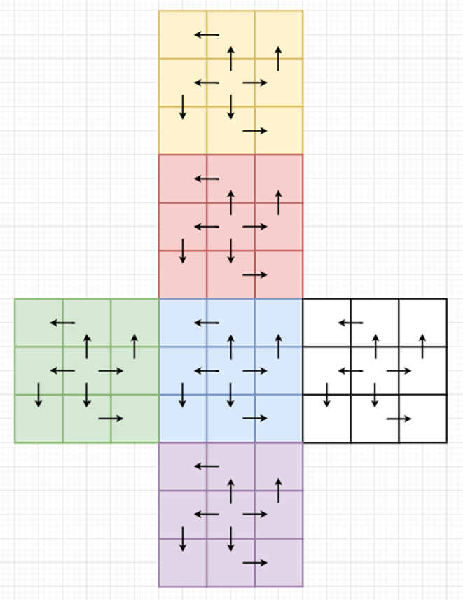
Figure 22: Pattern for Reset Propagation with Photodiodes and IR LEDs

