ECE 445 Project Proposal
Megan Heinhold, Evan Lindquist, Carl Wolff
1. Introduction
1.1 Problem
Many people suffer from conditions that affect their ability to operate in certain environments such as ADD, epilepsy, and sensory processing disorder[1],[2]. Those affected by these conditions deserve the right to be aware of certain triggers such as loud noises, flashing lights, or crowded areas before they enter an establishment. Beyond common sense predictions, there isn’t a reliable way of gauging how many of these triggers will be present at a bar or restaurant.
Along with the previously mentioned issues, many people want to gauge the activity of a public place before making the trek out to said establishment, whether it's for a lively night out, or a quiet sitdown get-together. With the rapidly advancing technology of the modern era, a useful solution will be able to be implemented fairly easily and efficiently.
1.2 Solution
In this project, we propose the use of a static measurement device which will measure various factors in a social area in order to provide a live report of the activities going on within. Data taken from the scene will be uploaded to a server, interpreted, and subsequently sent out to users on the app. This would allow people to gauge the various noise, light, and capacity levels before making a commitment to going out, for whatever their individual needs may be.

1.3 Visual Aid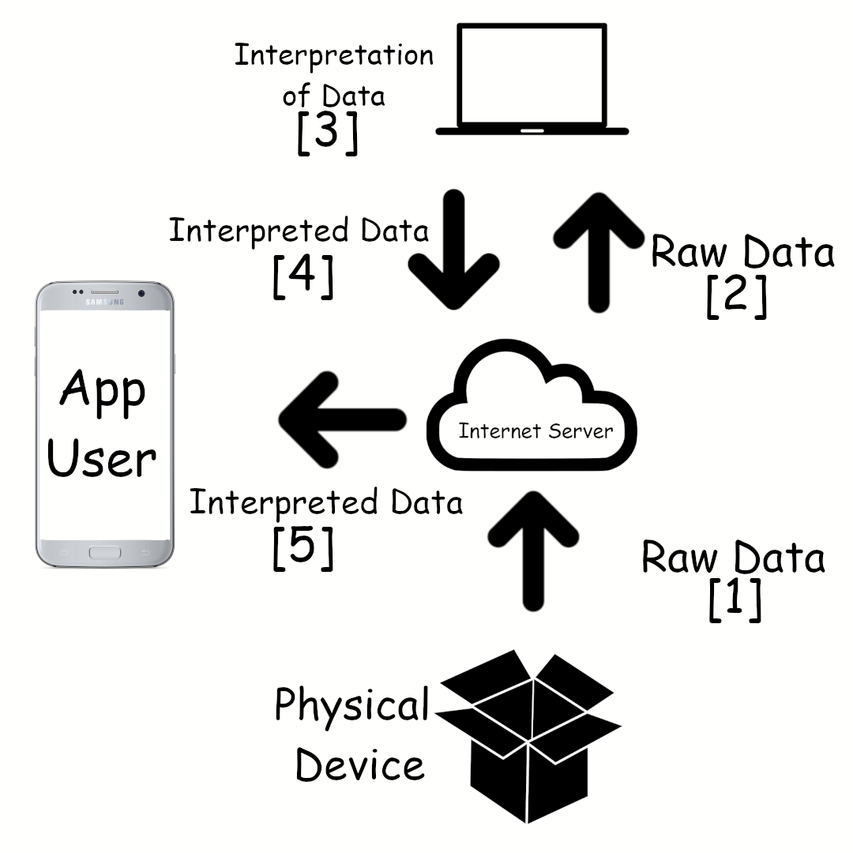
1.4 High-Level Requirements List
1.4.1 The device must be able to be plugged into a 110 V wall outlet and remain mostly out of the way of guests of an establishment, but still be able to gather accurate information through its various sensor systems.
1.4.2 The device must accurately gather and transfer data to the web server. The data must be adequately interpreted so that it can be transmitted to and interpreted by the user in a useful way.
1.4.3 The transmission of data to the user must be “real-time”, so collection, transmission, and interpretation of data can not take more than 10 minutes.
2. Design
2.1 Block Diagram
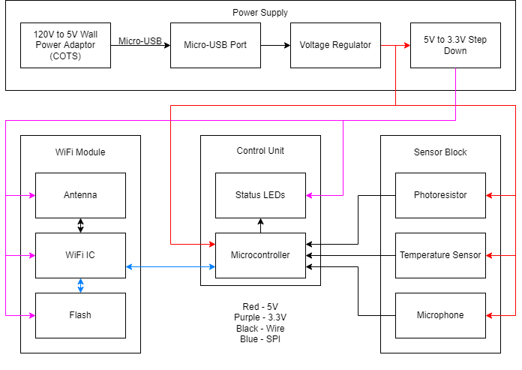
2.2 Subsystem Overview
2.2.1 Power Supply
The power supply is responsible for being a stable voltage source for all other subsystems and components within the device.
2.2.1.1 Wall Power Adaptor
The wall power adaptor is responsible for being plugged into an outlet and stepping that voltage down to 5V. It will deliver power to the circuit board via a USB cable.
Requirement 1: The adaptor must be able to supply a semi-stable stream of 5V.
2.2.1.2 Micro-USB Port
The micro-USB port will be used to connect the USB cable supplying the five volts to the circuit board.
Requirement 1: USB port must be able to securely connect the cable to the board.
Requirement 2: USB port must have accessible ground and power pads.
2.2.1.3 Voltage Regulator
The voltage regulator is responsible for ensuring that the supply voltage is a constant 5V to avoid any damage to or underperformance from any system component.
Requirement 1: The voltage regulator must take in ~5V and output a constant 5V.
2.2.1.4 5V to 3.3V Step Down
The step down is used for converting the 5V line to a 3.3V volt line because some of the components on the board use 3.3V as opposed to the 5V.
Requirement 1: The step down must be able to supply 3.3V+/-0.2% with a max current of 1.5A.
2.2.2 Control Unit
2.2.2.1 Microcontroller
The microcontroller is responsible for initiating the internet connection via the WiFi module, maintaining the internet connection LED, sampling data from the sensors at appropriate frequencies, checking for any safety concerns (strobe lights or excessive noise levels), sending alerts to the app if there are any safety concerns, and regularly reporting other readings to the app at ten minute intervals.
Requirement 1: The microcontroller needs to have three A2D converters (or three analog pins) for the three sensors, each of which will output an analog value.
Requirement 2: The microcontroller needs to have one digital I/O pin available exclusively for maintaining the network LED.
Requirement 3: The microcontroller needs to have SPI support so that it can interface with the WiFi Module.
Based on these three requirements and the materials provided by the course staff, we intend to use an ATMEGA328p chip.
2.2.2.2 Status LEDs
There are two status LEDs on the device: one indicating it is powered on and another indicating it is connected to the network. The on/off LED is driven directly from the power and should come on as soon as the device is plugged in. The network LED stays unlit until the MCU receives the “connection made” message from the WiFi module, at which point the network LED will turn on.
Requirement 1: One LED is driven directly from the power supply and is on any time the device is powered.
Requirement 2: The other LED is turned on by the MCU when a valid internet connection exists and off when one does not.
2.2.3 Sensor Block
The sensor block is responsible for acquiring data on the environment. The data we plan to acquire is split into two types: urgent and non-urgent data. Urgent data pertains to safety hazards and includes sensing for flashing lights and excessively loud noise. Non-urgent data is reported less frequently and includes information on ambient light levels, noise levels, and temperature. All of this data is tracked using the control unit.
2.2.3.1 Photoresistor
The photoresistor is responsible for gaining information on the lighting within the environment. The readings from the photoresistor are used by the MCU to determine if there are any strobe lights present (checks for rapid fluctuations between brightness and darkness) as well as an ambient light level reading. We plan to use a 5506 photoresistor (light resistance: 2-6k, dark resistance 150k). It is used in a resistor divider with a 100k ohm resistor.
Requirement 1: The photoresistor must be able to output to the MCU a value between ~2.5V and ~0V based on the level of light.
Requirement 2: The photoresistor must be able to take accurate readings at frequencies of at least 10 Hz (frequency of commercial strobe lights).
2.2.3.2 Temperature Sensor
The temperature sensor is used to report the room temperature to the MCU. We plan to use a TMP36 temperature sensor which has a high resolution and range that covers all feasible temperatures (-40 to 302 degrees fahrenheit) while being easy to use and cheap.
Requirement 1: The temperature sensor must be able to output to the MCU a value between 2V and 0.1V based on the temperature.
2.2.3.3 Microphone
The microphone is responsible for gathering information on the noise level of the environment. The microphone outputs its reading to the MCU. We plan to use a KY-038 microphone with breakout board for simplicity. The breakout board should have ample amplification for use within this project, but if – after we characterize the sensor ourselves – we determine that the amplification was not sufficient (i.e. our MCU is not able to read anything of note), then we will use a basic electret microphone and create our own amplification scheme to achieve the desired results.
Requirement 1: The microphone sensor must be able to output a valid value between 5V and ~0V to the MCU based on the sound level of the environment.
2.2.4 WiFi Module
The WiFi module is responsible for uploading data to the app so it can be processed and displayed to users. The WiFi module receives data from the control unit using SPI (Serial Peripheral Interface); it receives power from the power supply.
2.2.4.1 Integrated WiFi Chip
The device makes use of an integrated WiFi transceiver to carry out this connection. The integrated chip has a WiFi IC, antenna, and flash all on board. Using an integrated chip is preferable to three independent components because it is cheaper, easier to use, and takes up less space on the PCB. The part we plan to use is the ESP8266 which connects to the main microcontroller using SPI.
Requirement 1: The WiFi chip must be able to connect to a WiFi network and regularly output data packets sent from the MCU to that network.
2.3 Tolerance Analysis
The system block that is most difficult to implement into the project is the WiFi module. The hardware to implement this device is pretty simple: power, ground, and SPI connections. But the software associated with it is unfamiliar to all of us in the group. Our plan to work around any complications with the ESP8266 part is to purchase one early and connect it to an Arduino to try to get it up and running. This will also allow us to get working on the app sooner as we should be able to send a packet of dummy data to the app as soon we have the ESP8266 connected to the Arduino.
3. Ethics and Safety
3.1 Development
Regarding the development of our project, we plan to do everything in our power to respect both IEEE and ACM Codes of Ethics. Since the underlying purpose of our project seeks to improve accessibility of social gatherings in restaurants and bars, we will also ensure that the development of our project respects all persons, and does not discriminate against anyone especially against those with disabilities that our project may be useful for as outlined in [3, Principle 1.4] and [4, Sec. II]. Use of our device by establishments will be completely optional, and furthermore continued use of our device and corresponding app will be optional as well. At any time, users of our device and app can discontinue use, as well as delete any data uploaded through their profile to the app, especially if undue harm to their customers or business occurs from the use of our project [3, Principle 1.2]. To respect privacy and honor confidentiality, we will avoid storing confidential user information beyond what is required for our application. It shall not be used for any purpose other than our project’s implementation and only with user consent [3, Principle 1.6]. As a part of the course for which this project will be carried out, we will seek out and listen to review from peers and advisors regarding technical aspects, social context, and any ethical concerns of our project [4, Sec. I.5],[ 3, Principle 2.4].
3.2 Misuse
Improper use of our product may result in violation of both IEEE and ACM Codes of Ethics. Because our device is intended to be installed on a ceiling or above a room, improper mounting can result in physical injury as well as general malfunction of the device. In addition, since there is a software component of our project that involves both individuals and establishments interacting with the system, there is a possible opportunity for misuse by either party. It is possible that establishments may try to falsify readings or data shown on the app to appeal to their target audience, which could cause safety concerns or severe discomfort for a user who makes a decision to enter a business based on this data.
3.3 General Safety Concerns
As mentioned above regarding misuse of this device, a physical object that is mounted high in the air could pose potential safety hazards. To mitigate this, we will research required mechanisms to prevent accidental falls due to accidental breakage of our product. In addition, since our product is intended to identify safety concerns regarding sensory input, misclassification of these inputs by our device could lead to safety concerns or severe discomfort of a user who is expecting there to be none. Because of this, our app will specifically need to inform users of the risks associated with relying only on information displayed in our app coming from our devices.

References
[1] “Epilepsy Data and Statistics”. Centers for Disease Control and Prevention. https://www.cdc.gov/epilepsy/data/index.html (accessed February 8, 2022).
[2] “Data and Statistics About ADHD”. Centers for Disease Control and Prevention. https://www.cdc.gov/ncbddd/adhd/data.html (accessed February 8, 2022).
[3] “ACM Code of Ethics and Professional Conduct”. Association for Computing Machinery. https://www.acm.org/code-of-ethics (accessed February 7, 2022).
[4] “IEEE Code of Ethics”. IEEE. https://www.ieee.org/about/corporate/governance/p7-8.html (accessed February 7, 2022)

