Design Document for ECE 445, Senior Design, Fall 2018
TA: Evan Widloski
October 4, 2018
Project No. 4
James Wyeth
Karl Mulnik

By

Integrated Lithium-Ion Battery Sensors
Contents

1 Introduction 1
1.1 Objective 1
1.2 Background 1
1.3 High-Level Requirements 1
2 Design 2
2.1 Block Diagram 2
2.2 Mechanical Design 4
2.3 Functional Overview 4
2.3.1 Voltage Sensing 4
2.3.2 Temperature Sensing 5
2.3.3 Brain 5
2.3.4 Isolation 5
2.3.5 Power 5
2.3.6 Battery 5
2.3.7 Communications 5
2.3.8 Measurement 6
2.4 Requirements and Verification 6
2.5 Initial Schematic 10
2.6 Tolerance Analysis 10
3 Cost and Schedule 12
3.2 Cost Analysis 12
4 Ethics and Safety 14
References: 15

1 Introduction

1.1 Objective
This project is a redesign of some of the sensing devices in an electric vehicle battery pack. The goal is to design modular sensing circuitry to send data to a central Battery Management System (BMS). For each module, six temperatures and two voltages are to be measured. The system needs to use minimal wiring.

To do this we will create a printed circuit board (PCB) with voltage sensing and temperature sensing modules with a microcontroller for processing and communication. The data will be sent using single-wire serial down a daisy chain to minimize wiring.

1.2 Background
Cars use large packs of Li-ion batteries. Because of the sensitive nature of these batteries, systems need to be put in place to protect them from exceeding their parameters. They can go into thermal runaway and ignite if they are operated outside of their voltage or temperature boundaries. The voltage, current, and temperature need to be monitored and the batteries disconnected if there are issues with any of them. A registered student organization (RSO) at the University of Illinois in Urbana-Champaign, Illini Solar Car, has a battery pack that contains 420 individual 18650 cells. If this pack were to undergo thermal runaway, the results would be catastrophic.

The batteries are mechanically constrained using PCBs, forming a module of two cells in series and 15 in parallel. By creating a sensing board for each battery module we can power the sensors board with the cells in that module. This way, if installed incorrectly, only one of the sensor boards needs to be replaced. It also makes assembly more clear as it involves focusing on one module at a time. The goal of this project is to mitigate the issues we have had with these systems in the past, with the addition of modularizing the system so in the event of an issue, it can be solved quickly.

1.3 High-Level Requirements
- Sensors must measure temperatures from -20 C to 60 C and cell voltages from 2.5 V to 4.2 V with an accuracy of 10 mV, communicating them with the next module.

- Device must use less than 10 mW average, and use minimal wiring.

- All communication must be electrically isolated between modules.

2 Design
Each module needs the voltage of each cell to be measured as well as six thermistors to get temperatures from multiple places on the module. A large number of thermistors is used because modules are physically large, and if thermal runaway starts early detection is critical. These measurements will be taken with a microcontroller on the module itself. The data will then be sent down the line of modules and eventually to the BMS, a board that is already designed and is outside the scope of this project. In order to keep working voltages to a minimum, the devices on each module will be referenced to the lower cell and communication between modules will be isolated.

Over the course of a race, packs cannot be modified and automatic balancing is not guaranteed. As such, power consumption needs to be minimal and fairly consistent across all modules.

2.1 Block Diagram
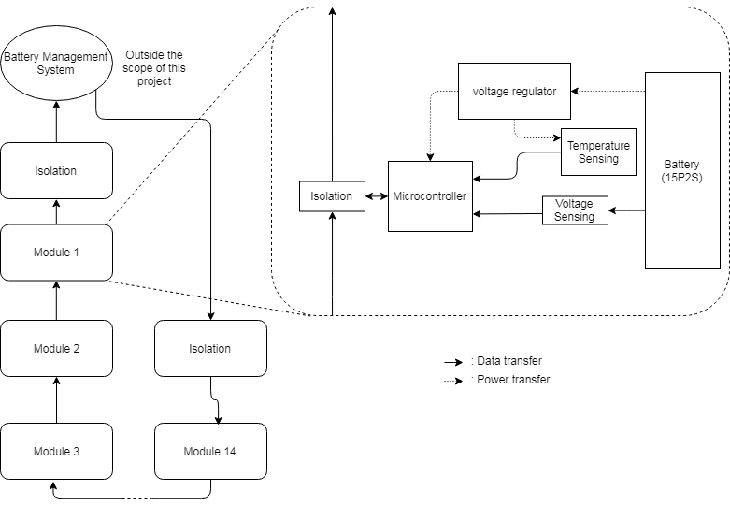
Figure 1 Block Diagram.

Communication Algorithm
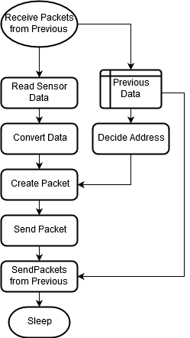
Figure 2 Code flow chart.

2.2 Mechanical Design
This design needs to fit in a compact space. It must be no wider than the assembled battery module, which is approximately 40 mm wide. Because of the limited amount of space between the edge of the battery module and the edge of the battery box, which the batteries are inside, the PCB will be mounted parallel to the batteries. It cannot be any taller than the batteries, so it will need to be less than 65 mm long. To make mounting easier, the PCB will fill the space, allowing attachment directly to the modules and directly to each other. The mounting mechanism will be part of the design of the sensor PCB and the battery modules will be designed with this in mind.
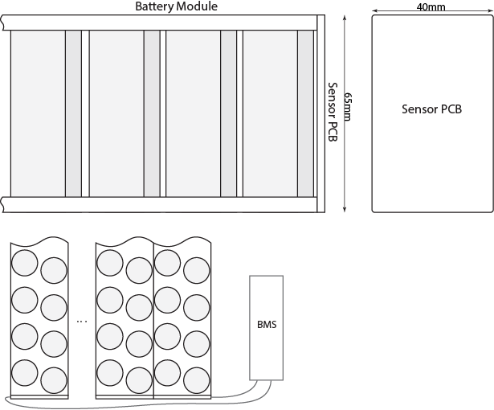
Figure 3 Physical diagram.

2.3 Functional Overview

2.3.1 Voltage Sensing
This will involve an analogue to digital converter (ADC) on the microcontroller and a voltage divider to step down the battery voltage and keep the voltage within the measurement range of the chip. The resistances will be as large as possible to minimize leakage current. ADC will need at least 10 bits for the required accuracy. As each battery module has two cells in series, there will need to be two voltage sensors for each module.

2.3.2 Temperature Sensing
This circuit measures the temperature of the batteries and will be powered by the voltage reference. This will be done with a negative temperature coefficient (NTC) thermistor in a voltage divider. This will in turn go into an ADC, which also needs to be 10 bits to satisfy accuracy requirements. As with the voltage sensing, the resistances will be as high as possible without inhibiting measurement. There will need to be six temperature sensors per module. This gives more accurate temperature readings as different parts of the battery module may be at different temperatures.

2.3.3 Brain
This will take the measurements from the measurement modules and translate them into data that can be sent to the next module. It will need UART for communication, eight 10-bit ADCs for voltage measurements, and low power consumption.

2.3.4 Isolation
Between modules, this will isolate communications so different ground references can be used. These need isolation of 10 V. Between the BMS and the modules, this will also isolate communications, but will need to have higher isolation capabilities. At the top of the stack, it will need isolation of 130 V, while the bottom needs isolation of 0 V, just decoupling the references. This high isolation level can be achieved with a fiber optic connection.

2.3.5 Power
This will be powered by the battery and will supply power to the rest of the microcontroller at the required voltage. It will also provide a stable voltage reference to the ADC. The voltage reference should be turned off when not in use to conserve power.

2.3.6 Battery
The batteries in the solar car will provide power for the circuitry. This will be emulated using a power supply to eliminate the need for Li-ion batteries in the lab.

2.3.7 Communications
Data packets will include an address, all measurements, a checksum, and all messages from above the current module. The messages will be sent newest first, letting the next microcontroller estimate the length of the message. The first module will receive a message from the BMS, approximately every 200ms under normal operation.

The packet will consist of the following: five address bits, eight high cell voltage bits, eight low cell voltage bits, and 10 bits for each of six temperatures. After assembling the packet, it will be sent eight bits at a time, with a ninth odd parity bit.

2.3.8 Measurement
The software will need to take the measurements from the ADC and convert them into a usable form. Simple calculations will be performed to convert the values from the ADC to a voltage or temperature. The voltage readings will be stored in units of 10 mV and the temperatures in units of 0.1C, with offsets of 2.5V and -20C respectively. This will allow exclusive use of unsigned integer storage, ensuring the memory usage is as low as possible. These calculations can be performed while communication is being received to save time. In addition, to make measurements more accurate, a calibration procedure will be implemented.

2.4 Requirements and Verification

Table 1 Voltage Sensing
Requirements | Verification | Pass Condition
Leakage current less than 1 mA per measurement. | Measure current supplied to board with only voltage measurement module populated in off-state using digital multi-meter (DMM). | Total current < 2 mA
Voltage sensing from 2.5 V to 4.2 V with 5mV accuracy. | Power both cell inputs with 10 voltages spanning the range. Record cell voltage with DMM and software. | DMM-Software < 5 mV

Table 2 Temperature Sensing
Requirements | Verification | Pass Condition
Leakage current less than 1 mA per measurement. | Measure current supplied to board with only temperature measurement module populated in off-state using DMM. | Total current < 6 mA
Temperature sensing with 0.1 degree accuracy at 40 C and 60 C. | Apply heat to thermistors using heat pad. Record measurements at 5 temperatures spanning 30 C and 40 C as well as spanning 50 C and 60 C from firmware and using a thermocouple module. | DMM-Software < 0.1 C
Temperature sensing from -20 to 60 degrees C. | Use thermal chamber to bring ambient to -20 C and 60 C. Record temperature measured with firmware. | Any temperature is sensed at extreme ambient

Table 3 Brain
Requirements | Verification | Pass Condition
Communicates at 115200 kbaud. | Send data to the module input and read the data at the output using a USB serial converter set to 115200kbaud | Data in is the same as data out
ADCs accurate to one count. | Supply 10 voltages spanning 0 to 1.024V. Measure with DMM and record ADC value. | Measured voltage is within 1 of ¼ * ADC counts

Table 4 Isolation
Requirements | Verification | Pass Condition
10 V isolation between each module. | Set up at least two modules to communicate with the BMS. Operate the two boards with up to 10 V difference between their ground references. Apply test voltages to voltage sensors. Read data received by the BMS. Measure voltage between Isolated boards and survey isolation components | The applied voltage was received by the BMS with no errors. The components showed no signs of damage from overvoltage
130 V Isolation between the top module and the BMS. | Supply 130 V to the top module connected to the BMS. Measure the voltage on the off BMS | BMS input voltage less than 0.1 V

Table 5 Power
Requirements | Verification | Pass Condition
Average power usage within 1 mW across all modules. | Assemble a 5-module system and measure average power over 10 seconds to each module while operating normally. | The range of average powers is less than 1 mW
Can provide 100 mA between 1.71 V and 1.85 V from 5 V-8.5 V source. | Supply 5 V to system and use a digital load to draw 100mA. Supply 8.5 V with no load. | Output voltage stays between 1.71 V and 1.85 V
Can provide 5 mA at 1.024 V ±1 mV from regulated voltage. | Supply 1.71 V to reference and use digital load to draw 5 mA. Supply 1.85 V with no load. | Output voltage stays between 1023 mV and 1025 mV

Table 6 Communications
Requirements | Verification | Pass Condition
No more than 1% of measurements corrupted | Run system under normal operation for one minute | Maximum of 150 measurements fail checksum
100 ms delay between request and receipt of message | Send a measurement request on BMS and time response 100 times | No delay exceeds 100 ms

Table 7 Measurement
Requirements | Verification | Pass Condition
Memory usage does not exceed on board storage | Set up the system to communicate with the BMS. Apply test measurements for about one hour. | All data is measured and is sent to the BMS.

2.5 Initial Schematic
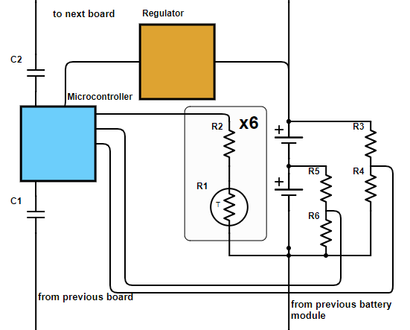
Figure 4 Schematic.

2.6 Tolerance Analysis
The accuracy of the measurements is very important. It determines whether the battery pack will be operated safely. Inaccurate measurements could result in battery overvoltage or overtemp. Using equation 1, where X is the number of bits, we can find the least number of bits required for 10mV accuracy. Here, that is 10 bits. To meet this requirement, we will be using a 12-bit ADC as it is the next step up. Unfortunately the values of the components used can vary. Even taking into account the tolerance of the resistors and voltage supply, the measured values should be within 10mv. A critical part of this sensing is the voltage divider for the voltage sensing. If the resistors are out of range the voltage could exceed safe levels. To analyze the worst-case scenarios, equation 1 was plotted in Octave. To meet the 10mV requirement we can allow up to a 0.48% change from the expected value

$$2^{x}=\frac{8.5}{0.01}$$ | (1)

$$\frac{V_{meas}}{V_{exp}}=\frac{\left(R_{1}±tol(\%)\right)V_{bat}}{\left(R_{1}±tol(\%)\right)+\left(R_{2}∓tol(\%)\right)}$$ | (2)

After simulating the various tolerances of the components, it seems that only a resistor with an exceptionally low tolerance level will work. Therefore, we will be unable to meet the requirement. The solution is to calibrate the values of the voltage divider for each device such that the tolerances are taken into account by the microcontroller’s calculations.

3 Cost and Schedule

Table 7 Timeline
Week | Task | Person | Hours
10/8/2018 | Schematic | Karl | 5
10/8/2018 | Communication Software | James | 5
10/15/2018 | Physical Design | James | 2
10/15/2018 | Layout | Karl | 8
10/15/2018 | Communication Software | James | 5
10/22/2018 | Layout | Karl | 8
10/22/2018 | Measurement Software | James | 5
10/29/2018 | Measurement Software | James | 5
11/5/2018 | Power Saving | James | 7
11/12/2018 | Hardware Test | Karl | 5
11/12/2018 | Software Integration | James | 7
11/26/2018 | Integration Test | James and Karl | 8
Total Hours |  |  | 70

3.2 Cost Analysis
This system will require significant engineering cost, but parts cost will
be low. Assuming a yearly salary of around $65k, labor would be around $30/hr; including other business expenses would bring this up to $75/hr, which we will use as the hourly cost of this project. The timeline shows that it will take approximately 70 hours. Part costs are approximate, and are bulk costs of 1000. A company will typically not invest this much development cost into a project without planning to assemble several thousand units.

Table 8 Cost

Item | Cost @ 1000 | Quantity | Module cost
Processor | $0.90 | 1 | $0.90
VRef | $0.70 | 1 | $0.70
VReg | $0.30 | 1 | $0.30
RSense | $0.05 | 10 | $0.50
RTemp0 | $0.05 | 6 | $0.30
Other passives | $0.01 | 10 | $0.10
PCB | $0.50 | 1 | $0.50
Total per Module |  |  | $3.30

The total labor cost for this project is $5250. For the parts cost to outweigh the labor cost, 1600 units need to be assembled. At this point, and with a small profit margin, these modules could be sold for $7 each.

4 Ethics and Safety

As our project involves lithium batteries, there are safety concerns. This means the first in the list of IEEE Code of Ethics must be adhered to: “to hold paramount the safety, health, and welfare of the public, to strive to comply with ethical design and sustainable development practices, and to disclose promptly factors that might endanger the public or the environment” [1]. Our finished project acts to increase safety as it is an essential element to prevent battery failures.

Proper battery safety is a concern. The sensing circuitry must closely monitor the battery voltage to ensure safety against overcharging (above 4.2V). This can lead to the breakdown of the cathode. The temperature sensing circuitry must closely monitor the temperature so that the BMS can keep the battery temperature below 45 degrees C. Otherwise thermal runaway will occur. Failures to meet these requirements could cause fire and/or the explosion of the battery [2]. To ensure this, all circuitry will be thoroughly tested to ensure proper measurements and data transfer. The communication portion of the module must transmit data reliably so that the BMS can accurately monitor the battery. The amount of wires and connections is kept at a minimum in the design to prevent misuse, while still providing reliable data transfer.

References:
[1]"IEEE Code of Ethics", Ieee.org, 2018. [Online]. Available: https://www.ieee.org/about/corporate/governance/p7-8.html. [Accessed: 17- Sep- 2018]

[2]K. Liu, Y. Liu, D. Lin, A. Pei and Y. Cui, "Materials for lithium-ion battery safety", Science Advances, 2018. [Online]. Available: http://advances.sciencemag.org/content/4/6/eaas9820. [Accessed: 17- Sep- 2018]

