ECE 445 - Wind Turbine Phone Charger - Project Proposal

Introduction

Objective

Phones have become essential in modern society but their great potential is often limited by battery life. There are portable, external batteries but these too run out. There are even such innovations as a solar charger but the pitfalls come when it is cloudy or after the sun sets. An excellent source of energy that has been utilized for over 100 years is wind energy. In fact, as of June 2017, world wind energy generation reached 511 GW[1]. Yet, most of the turbines that provide this power are massive, towering 212 feet tall not counting the blade height [2]. These towers are complicated electromechanical systems with sensors and motors that constantly make adjustments to best utilize the wind. However, the concept is simple and can easily be imitated. Wind hits a blade, which turns a turbine connected to a generator, that converts this motion into electrical energy. This concept can be scaled to any size we require as long as a generator can be physically built. Typical wind turbines generate in the order of megawatts which can power small communities. This potential could be scaled down to power small devices. Wind blows nearly everywhere and in some places, all the time. For instance, the average wind speed in Champaign was 9 mph but typical Illinois winters are quite cloudy. These are weather conditions that are poor for solar power but great for wind.

The biggest problem facing a technologically dependent society is powering the numerous devices that have become bare necessities. Wearable technology has made large strides, electronic watches are becoming the norm and despite the advancements in battery science, phones are unable to last indefinitely. A 30W power bank/battery is able to power so many electronics, including but not limited by mobile phones, portable stereos, GPS systems and handheld tablets/gaming devices. The ability to connect a limited resource such as a battery to an essentially unlimited resource such as a wind turbine supports the many different devices in need of a power source.

The aforementioned devices have become the norm due to their portability and convenience. It is not feasible to carry a very large device that will have a long battery life. The same logic dictates that the associated power source must be equally portable. The convenience, affordability, portability and durability of a miniature wind turbine will favor the needs of the end user. It will solve a much needed problem while providing a very clean and environmentally conscious solution.

Background

Historically, harnessing the power of the wind as an energy source has liberated man from manual labor for centuries. Windmills were first used to mill grain by turning stones, and then later as an efficient means of pumping water into storage for later use on demand. Efforts have been made to harness wind energy large scale like General Electric, Tata, Nordex through hovering 212ft turbines that can generate more than 6 million KWh in a year, which is enough to supply 1,500 households. As of today, wind power provides 1.9 percent of all the energy consumed in the United States. Commercial wind energy generation has been relatively non-existent. The managing and extraction of fossil fuels and natural resources and the effective use of revenues is a challenge for many countries, especially in the developing world and for high value resources such as hydrocarbons. Partly due t

Our turbines must be as affordable as possible, to ensure that they can be reasonably purchased with the disposable income of a rural villager. For example, a farmer in India could have a disposable income of about $10 a year, some of which has to go to electricity for his family. Another viable use case is for recreational purposes. Touring cyclists commonly use their phone to collect ride data which is taxing for a phone since it uses location data. These bicycles usually have a flat stand in the back which would be excellent for our small scale turbine. Additionally, those who enjoy sailing, especially trips that last through multiple nights would benefit greatly from a phone charger since they may need to use a satellite phone in case of emergencies. Another basic use is simply placing it outside a tent, after a long day of hiking and an extremely depleted phone battery.

High-Level Requirements list
- The turbine must be able to generate at least 2.5 Watt-hours of charge over 1 hour which can be stored in the internal battery and supplied to USB devices.
- The turbine must operate indefinitely on wind energy.
- The turbine must be low-cost, ideally under $50.
- The turbine must be portable and easy to mount.

Design

Block diagram
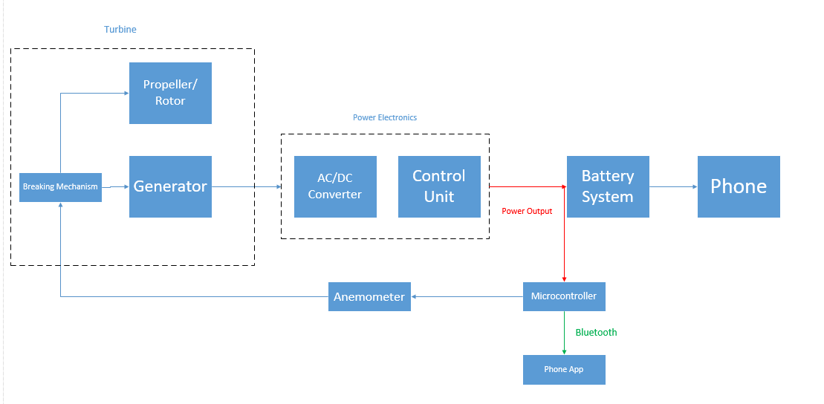

Physical Design

The physical design should look similar to a normal vertical axis wind turbine. There will be three elongated airfoils that extend by three 20 cm arms from the rotating base. The arms and rotating base should be 30 cm tall with a static 15 cm base that will house the circuitry. Using a vertical axis wind turbine does not require positioning to utilize the direction with highest wind speeds. Also, they operate at higher efficiency at lower speeds than horizontal since they can be moved by winds from various directions at the same time [4]. The static base at the bottom would be 20 cm wide and square shaped to be easily attached to most surfaces. The base would have a strap attachment that would make it simple to affix it to many things. Also, there could be holes at the bottom of the base for nails or screws to secure it more firmly.

Functional Overview

- Turbine: As illustrated in the block diagram, the turbine has several subcomponents.

- Propeller/Rotor: This is the main exterior component that will provide the torque necessary to power our generator. They will most likely be some sort of plastic blades that will be aerodynamically feasible as well as portable.
  - Requirement: Able to rotate at low wind speeds and up to 15 m/s
(b) Generator: Taking its input from the propeller, the generator will provide the
conversion of the mechanical motion of the blades to electrical power. This may be created by converting an existing motor to a generator.
(i) Requirement: When rotated produce AC power
(c) Braking Mechanism: The braking mechanism will ensure that the turbine is not damaged at very high speeds. It will stop the turbine operation if the anemometer readings state an undesired wind speed.
(i) Requirement: Upon receiving a signal from the microcontroller the mechanism must be able to stop the turbine and release when the wind speed decreases

2) Power Electronics:

- AC/DC Converter: The generator will output unregulated AC, which must then be converted through the use of an AC/DC converter into regulated DC. The unregulated AC will pass through an input filter first. Then, the filtered AC will pass through a full-bridge rectifier circuit that will convert it to DC. Then there will be power correction and an output filter.
Requirement: Able to convert AC power to DC
Requirement: Above 90% efficiency
-Control Unit: The main function of the control unit will be to certify that our power output will not exceed what the battery is rated for. It’s a fundamental feature that will safeguard a sensitive component, the battery. The control scheme will likely be PID and will lower or raise the duty ratio to appropriately
Requirement: Upon seeing a current or voltage greater than what the battery can handle the control will change the switching pattern to reduce the voltage and current

3) Battery System: This will be an off the shelf purchase. It will be rated for approximately 30W. This will allow us to charge our device. It will be powered through the output of our AC/DC converter. This will power the phone and microcontroller

4) Phone: The battery system will feed the user phone with electricity to charge and/or power their device. The user will connect their device through a USB into the battery system.

5) Anemometer: The anemometer is one of the most critical components for this design, in addition to playing a large role in risk analysis, it allows us to safely operate our wind turbine. It measures the speeds recorded by the turbine, and may provide the information that will cause the system to brake.

6) Microcontroller: This will be a custom built microcontroller that will mimic/clone a basic arduino. The main function will be to take the input from the anemometer and measure the output of the power electrons as well as communicate with the phone app and the braking mechanism.
Requirement: Take in input from the anemometer and send a signal to the brake and info to the phone app.
Requirement: Successfully read the voltage and current output and send the info to the phone app

7) Phone App: A phone app may provide essential information output by the turbine. It could for example provide the power output by the generator. Communicates via bluetooth since many use cases will be away from WiFi signals.

Risk Analysis
The wind turbine is highly dependent on the availability of wind. It will be unable to provide the required power at low speeds, and at high speeds it may become unsafe to operate due to the electrical and mechanical constraints of the components that we use. The minimum generation must be 2.5 Watt-hour in order to operate a typical mobile phone.

A corollary to the fact above, the power electronics must be able to provide a constant output. Even though there may be a threshold through the use of an anemometer and a brake, it is extremely important that the power provided to the battery and microcontroller is stable and within the electrical limitations of the devices.

Ethics and Safety

The user of our Wind Turbine will be directly involved with the operation of the device; thus, it is important that we ensure a safe and reliable product. There must be safeguards in place to protect both the product and the user.

There are several components in our product that may be potential safety hazards for the user if mishandled or incorrectly designed. The main components to consider is the battery, the rotor blades and the electrical circuitry.

Batteries always pose a risk since they can leak or explode. Proper handling will minimize the risks associated from damaging the battery due to impact. In order to prevent an explosion, it’s important to monitor the temperature of the device, as well as the power input into the battery. Since the input of the battery is through the output of the power electronics, there is always an underlying risk of unstable power being fed. The monitor of the output through the phone app, as well as a meticulous power electronics design will lessen the risks related to the battery.

Another component to consider are the blades that will be spinning when the wind turbine is in motion. The responsibility is on the user side mostly, users should always approach these machines with the knowledge that they will have moving parts which should be handled with care. The blades will be made from a plastic-like material which at high speeds may be dangerous if direct contact is made. As the designer, there is a responsibility to make these blades safe to operate and through the use of tools such as brakes have the required automated oversight.

The wind turbine is expected to portable and may be chosen to be brought along on hiking trips or other strenuous outdoor activities. Such activities may lead to occasional impacts, however, it is not the normal mode of operation and therefore it should ideally be handled with care. There are many electrical elements within the structure, and a strong exterior will provide the necessary protection for the fragile interior. Different weather conditions in which the turbine will operate must also be considered when designing the exterior and choosing the materials.
In addition to the portability and the conditions in which the turbine will be carried through, we must also consider the operating conditions. At high speeds there may be vibration and temperature variations that we have to account for. Ideally, the material and structure of our turbine should withstand these effects. The consideration of a secure mount also holds paramount importance in this aspect, as it may help to minimize these factors.

Most products assume that the user will behave such that they do not put themselves or others at risk. This wind turbine is no exception and it assumes that the user will act responsibly. We as the designers must ensure that all the necessary steps are taken in order to mitigate the risks.

In compliance with the IEEE Code of Ethics[5], we must consider that our product will be available to everyone, and that “to treat fairly all persons and to not engage in acts of discrimination based on race, religion, gender, disability, age, national origin, sexual orientation, gender identity, or gender expression”, thus adhering to #8 of the IEEE Code of Ethics. Additionally, we must follow the guidelines underlined in #1, “to hold paramount the safety, health, and welfare of the public…” and in #3, “to be honest and realistic in stating claims…” We must make sure that our wind turbine operates in a way that is safe for the environment and surroundings. The output data that we provide in our phone application must reflect what is measured in our devices.

References

[1] “Half-Year Statistics 2017” http://www.wwindea.org/information-2/information/ [Accessed Feb 6. 2018]
[2] “FAQ - size” https://www.wind-watch.org/faq-size.php [Accessed Feb 6. 2018]
[3] Dr. Jim Angel “Average Wind Speed in Illinois” http://www.isws.illinois.edu/atmos/statecli/wind/winter-windspeed.png [Accessed Feb 6. 2018]
[4] “Vertical Axis Wind Turbines vs Horizontal Axis Wind Turbines” https://www.windpowerengineering.com/construction/vertical-axis-wind-turbines-vs-horizontal-axis-wind-turbines/ [Accessed Feb 6. 2018]
[5] “IEEE Code of Ethics.” Institute of Electrical and Electronics Engineers. 2016. https://www.ieee.org/about/corporate/governance/p7-8.html [Accessed Feb 6. 2018]

