Synthetic Optical Holography Stage Implementation

ECE 445 Design Review

TA: Luke Wendt

Team #52
Sung Hun Kim Ye Hyun Kim Hyunjae Cho

October 14, 2016

Table of contents
- Introduction…….……………………………………………………………………………………………………………3
  - Statement of Purpose………………………………………………………………………………………. 3
  - Objectives …………………………………………………………………………………………………………3
- Design……………..……………………………………………………………………………………………………………4
  - Block Diagram and Flow Chart.…………………………………………………………………….……. 4
  - Block Description ………………………………………………………………………………………..……. 5
  - Schematic and Simulation …………………………………………………………………………………7
  - Calculations ……………………………………………………………………………………………………... 8
- Requirements and Verification……………………………………………………………………………………. 9
  - Tolerance Analysis ………………………………………………………………………………………….…9
- Cost & Schedule…………………………………………………………………………………………………………10
  - Cost Analysis.……………………………………………………………………………………………………. 10
    - Labor………………………………………………………………………………………………………. 10
    - Parts……………………………………………………………………………………………………….. 10
    - Grand Total………………………………………………………………………………………….…. 11
  - Schedule …..……………………………………………………………………………………………….…. 12
- Safety & Ethics……………………………………………………………………………………………………………12
    - Safety ….…………………………………………………………………………………………………13
    - Ethics ..……………………………………………………………………………………………………. 13
- Reference………………………………………………………………………………………………………………….. 14
1.0 Introduction

1.1. Statement of Purpose
Confocal Microscopy is an optical imaging technique for obtaining high resolution image mostly used in biological science. Confocal microscope uses point illumination method and discards any other stray light. Conventionally, Synthetic Optical Holography (SOH) is used for quantitative phase mapping of confocal microscopy by adding a linearly moving reference mirror.Using this method, the reference mirror needs long travel range for creating a linear-phase synthetic reference wave. Two methods are available to improve this drawback. One method is to oscillate the reference mirror sinusoidally, and the other method is to tilt and change the height of the glass slide where sample is located. Our design uses the method of changing the height and tilt the glass slide by using four piezo-electric controllers, which reduces the travel range compared to the conventional method.

1.2 Objectives
1.2.1 Goals and Benefits
- Implement SOH on a confocal microscope
- Control piezo individually and together
- Improve control accuracy
- Improve repeatability of four piezos
- Reduce the travel range of piezo controllers
1.2.2 Functions and Features
- Measure individual height of piezos
- Measure height of the sample
- Ability to tilt the glass top
- Control piezo by using computer user input
- Control piezo in nanoscale precision

2.0 Design
2.1 Block Diagrams and Flow Chart

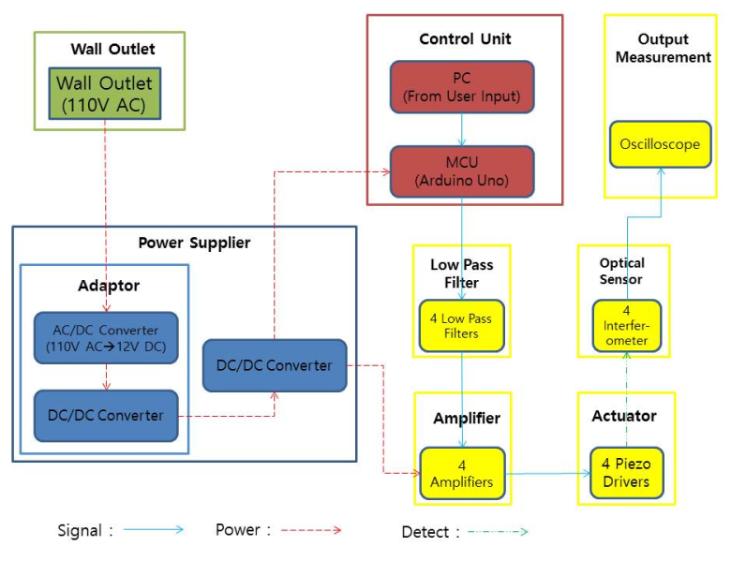
Figure 1. Block Diagram.

Figure 2. Software Flow Chart
2.2 Block Descriptions
2.2.1 PC
The PC is to send the height input, which can be obtained from the user and the PC sends signal to the MCU. Within this MCU, we use an Arduino Uno, which will get the power from the DC to DC converter.

2.2.2 MCU
The Microcontroller Unit will receive the input signals from the PC, which is 7-12V, and outputs 0.55-2.75V using digital to analog converter, which is embedded in the MCU. For the programming part, we can use the Arduino Software (IDE), and can write a simple code to control the output voltage. Afterwards this output signal will be going into the low pass filter.

2.2.3 Low Pass Filter
The Low pass filter (LPF) will receive the input signal from the output of the MCU. Since we are dealing with nanometer scale, we need precise signals and reduce noise as much as possible.

2.2.3 Amplifier
Amplifies voltage received from voltage regulator to send the amplified voltage to piezo actuators. The output voltage range is from 1.25 – 37V. Also, the output current should be greater than 1.5A.

2.2.4 Piezo Driver
There are 4 Piezo drivers that move in z-axis in nanoscale precision with maximum displacement of 2.2 micrometers. Piezo drivers change height according to the voltage applied.

2.2.5 Interferometer
Interferometers are used to obtain height information of each piezo drivers in nanoscale to send the information about calibration to PC. The interferometer used will be HeNe laser source with 633nm. We can measure the phase shift of the reflected wave from the glass slide, and can calculate the height difference as mentioned below

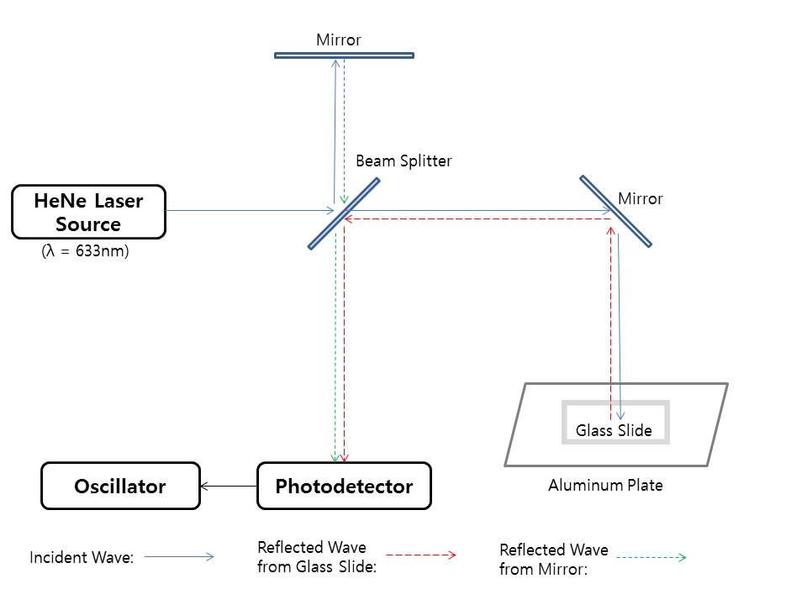
Figure 3. Block Diagram of Interferometer
2.2.5.1 Interferometer Description
When the light source, ‘HeNe Laser Source’, goes through the beam splitter, the light divides into two sections: One that goes through the mirror on the top of the block diagram, and the other that goes to the glass slide. When there is a height difference in the glass slide, there will be a phase shift on the reflected light. The height difference can be calculated as follow:
Height difference = $\frac{∆φ}{4π}λ$
We will be measuring the phase shift, $∆φ$, by using the photodetector, and can plug in $λ=633nm$ for the HeNe Laser Source. Afterwards, we can use the oscilloscope to measure the voltage difference.

2.3 Schematics and Simulations
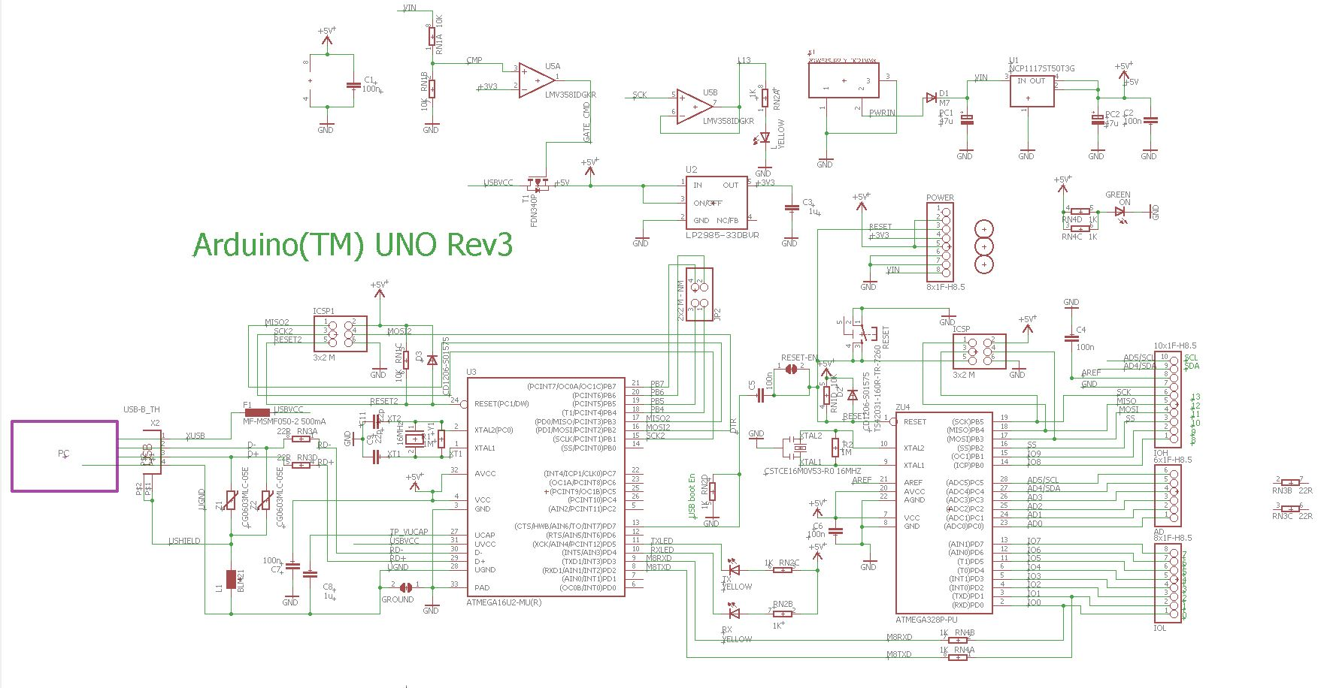
Figure 4. Schematic for control unit

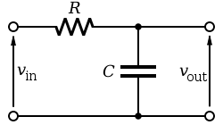
Figure 5. Schematic for low pass filter

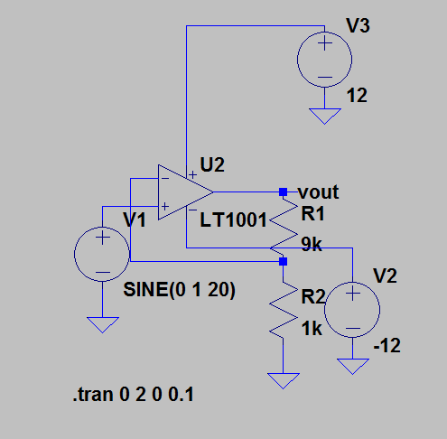
Figure 6.Gain of 10 Amplifier Circuit.

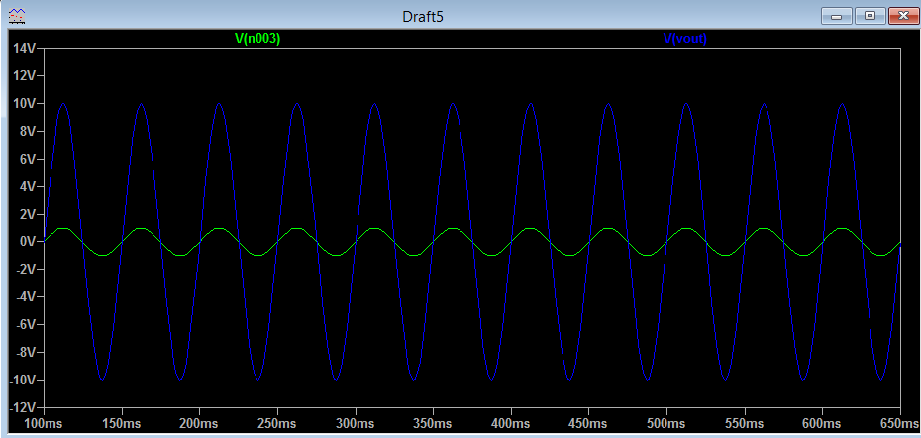
Figure 7. Gain of 10 Amplifier Simulation.

2.4 Mechanical design

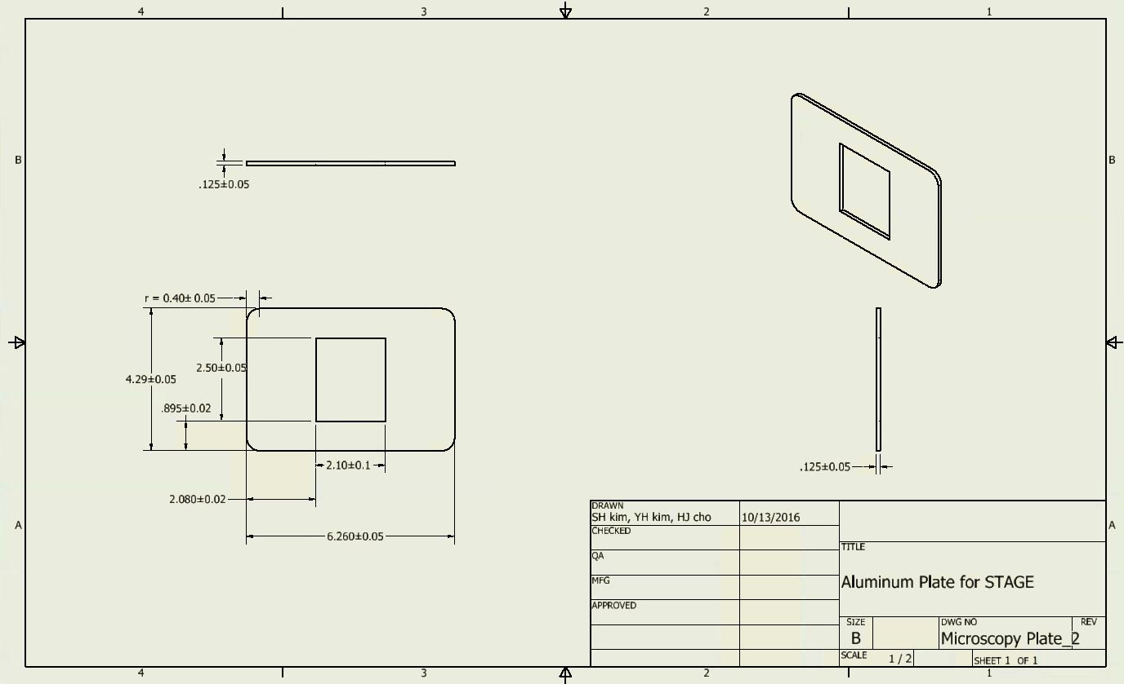
Figure 8. Drawing for Stage of microscope

The stage of microscope should be designed to fit into the ‘Leica SP8’ microscope. The four piezo drivers sit on the stage and there should be enough spaces to put (3x1 inch) glass plate on the piezos.

2.5 Calculations
2.5.1 Amplifier Calculation
To achieve voltage from 0V to 120V to send it to piezo drivers, the voltage received from programmable voltage regulator are amplified with the gain of 10. Because negative pin of amplifier has high impedance, current through the negative pin is negligible. Using voltage divider rule and kirchoff’s current law, following equation can be used.
$V_{out}=\frac{R_{1}+R_{2}}{R_{2}}V_{in}$ (1)
With the input voltage of V_{in}=1V, R₁=9kΩ, R₂=1kΩ, V_{out} is calculated as equation 2.
$V_{out}=\frac{9k+1k}{1k}*1=10V$ (2)

3.0 Requirements and Verification
Requirement | Verification | Points
1. Piezo Drivers  Piezo drivers must be able to have minimum displacement of 0.5 micrometers | 1. Piezo Drivers  Measure difference in height of the piezo drivers using interferometer | 20
2. Piezo Drivers  Must be able to precisely move the piezo drivers within 3 nanometers | 2. Piezo Drivers  Measure the variation in displacement with interferometer | 10
3. Metal Plate  Weigh less than 800g and dimensions of 160mm*110mm +/- 5% with square shape | 3. Metal Plate  Measure the dimensions of the plate caliper and measure the weight | 10
4. Metal Plate  Must have a hole smaller than the glass top of 3inch*1inch for imaging and have thickness less than 7mm to suite microscope working distance | 4. Metal Plate  Check whether the plate fits in the microscope and verify microscope is functioning | 15
5. Piezo Drivers  Must be able to withstand 500g weight when objects are placed on top of four piezo drivers | 5. Piezo Drivers  Operate Piezo Drivers with 500g object placed on top of the glass and check if the drivers are operating | 10  5
6. Amplifier  Must be able to output up to 20V +/-5% with 50mA +/-5% | 6. Amplifier  Check the output of the amplifier with multimeter | 15
7. Frequency should not change more than 0.1% of the original frequency for all components | 7. Measure the frequency for each components and check the change in frequency | 10
8. Piezo drivers joint  When piezo drivers are lifted, glass top should have x-y displacement tolerance of less than 1um. | 8. Piezo drivers joint  Measure the x-y displacement of the glass top with interferometer | 5

Table 1. R&V Table

3.1 Tolerance Analysis
It is the most critical part of our project that piezo drivers are actuated in precision of +/- 5% of input height. To satisfy this requirement, the input voltage of piezo driver has to be precise. Moreover,piezo driver has to keep the stability no longer than 5 nanometers when it is actuated for an hour. As voltage is applied for an hour, the registers in amplifier are heated and it causes to increases resistances of resistors. Because the piezo driver has to be able to be lifted more than 800 nanometers. Because 5 nanometer is 0.625% of 800 nanometer, second requirement is more difficult to achieve.
In assumption that one of registers in amplifier is not heated up, the maximum tolerance of resistance that satisfy requirement can be calculated. When ‘A’ is the offset of R1 in Figure (3) and ‘B’ is the offset of R2in Figure (3), following equations can be obtained.
$R_{1}=9kΩ*\left(1+A\right)=(9000+9000A)Ω$ (3)
$R_{2}=1kΩ*\left(1+B\right)=(1000+1000B)Ω$ (4)
By rearranging equation (1), following equation can be obtained.
$\frac{V_{out}}{V_{in}}=\frac{R_{1}+R_{2}}{R_{2}}$ (5)
To satisfy the requirement above, output voltage of amplifier has to be within 0.625% of ideal value. By using equation (5), the ratio input voltage of piezo can be calculated as following because input voltage is not changed when resistances in amplifier are changed..
$\frac{V_{out,ideal}-V_{out,tolerated}}{V_{out.ideal}}={({\left(\frac{V_{out}}{V_{in}}\right)}_{ideal}-{\left(\frac{V_{out}}{V_{in}}\right)}_{tolerated})}/{{\left(\frac{V_{out}}{V_{in}}\right)}_{ideal}}$ (6)
Therefore,
${({\left(\frac{V_{out}}{V_{in}}\right)}_{ideal}-{\left(\frac{V_{out}}{V_{in}}\right)}_{tolerated})}/{{\left(\frac{V_{out}}{V_{in}}\right)}_{ideal}}={(\frac{R_{1}+R_{2}}{R_{2}}-\frac{R_{1}'+R_{2}'}{R_{2}'})}/{\frac{R_{1}+R_{2}}{R_{2}}}$ (7)
In assumption that only R1 is heated up, the maximum offset of R1(A) can be obtained from equation (7).
0.00625>$\left|{(\frac{R_{1}+R_{2}}{R_{2}}-\frac{R_{1}'+R_{2}}{R_{2}})}/{\frac{R_{1}+R_{2}}{R_{2}}}\right|=\left|{(\frac{9000+1000}{1000}-\frac{9000+A+1000}{1000})}/{\frac{9000+1000}{1000}}\right|=\left|{-\frac{A}{1000}}/{10}\right|$(8)
By calculation, maximum A = 62.5Ω, which is about 0.694% tolerance of 9kΩ. In assumption that only R2 is heated up, maximum offset or R2 (B) can be obtained from equation (7) as following.
0.00625>$\left|{(\frac{R_{1}+R_{2}}{R_{2}}-\frac{R_{1}+R_{2}'}{R_{2}'})}/{\frac{R_{1}+R_{2}}{R_{2}}}\right|=\left|{(\frac{9000+1000}{1000}-\frac{9000+1000+B}{1000+B})}/{\frac{9000+1000}{1000}}\right|=\left|{(\frac{-B}{1000+B})}/{10}\right|$(9)
By calculation, maximum A = 66.67Ω, which is about 6.67% tolerance of 1kΩ. Even though the maximum tolerances of registers to satisfy requirements are low, this can be improved by feedback loop in controller. Even though there is more tolerance than 7%, our design can meet the requirement by applying more input voltage through controller.

4.0 Cost and Schedule
4.1 Cost analysis
4.1.1 Labor
Student | Hourly Rate | Total Hours Invested | Total*2.5
Hyunjae Cho | $30 | 250 | $18750
Sung Hun Kim | $30 | 250 | $18750
Ye Hyun Kim | $30 | 250 | $18750
Total |  | 750 | $56250

4.1.2 Parts
For | Item | Quantity | Cost
Regulator | LTC3886 | 2 | $18.14
Regulator | USB-PMBus | 2 | $100
AC/DC Converter | Adaptor | 1 | $20
Piezo drivers | PL022 | 4 | $200
Piezo drivers | Sphere end caps | 25(sold in packs) | $31
Interferometer | Interferometer | Provided | $0
Amplifier | LTC1052CN#PBF | 4 | $25
ALL | Various Resistors, Inductors, Capacitors, FETs, Transformers, etc. | Varies | $100
Total |  |  | $494.14
Table 2. BOM Table
4.1.3 Grand Total
Section | Total
Labor | $56250
Parts | $494.14
Grand Total | $56744.14
Table 3. Cost Grand Total Table
4.2 Schedule
Week | Task | Responsibility
9/12/2016  (Week 1) | Prepare Project Proposal | Ye Hyun Kim
 | Consult with Experts | Sung Hun Kim
 | Prepare Mock Design Review | Hyunjae Cho
9/19/2016  (Week 2) | Contact Seller & Order parts | Ye Hyun Kim
 | Finalize Mock Design Review | Sung Hun Kim
 | Build precise logic diagram | Hyunjae Cho
9/26/2016  (Week 3) | Practice on Microcontroller | Ye Hyun Kim
 | Test Hardware parts (Piezos) | Sung Hun Kim
 | Design Control Logic | Hyunjae Cho
10/3/2016  (Week 4) | Program Code for embedded system | Ye Hyun Kim
 | Run requirements of Piezos | Sung Hun Kim
 | Test Microcontroller &Piezos | Hyunjae Cho
10/10/2016  (Week 5) | Review coding for Microcontroller | Ye Hyun Kim
 | Verification test on individual Piezos | Sung Hun Kim
 | Combine Microcontroller &Piezos | Hyunjae Cho
10/17/2016  (Week 6) | Debug Code | Ye Hyun Kim
 | Combine 4 Piezos& verification test | Sung Hun Kim
 | Assemble external power source for MCU | Hyunjae Cho
10/24/2016  (Week 7) | Finalize Code | Ye Hyun Kim
 | Finish assembling all components | Sung Hun Kim
 | Run tests on both hardware & software | Hyunjae Cho
10/31/2016  (Week 8) | Begin working on Presentation | Ye Hyun Kim
 | Prepare for Mock Demo | Sung Hun Kim
 | Ensure functionality | Hyunjae Cho
11/7/2016  (Week 9) | Check Stability of the Piezo | Ye Hyun Kim
 | Finalize Mock Demo | Sung Hun Kim
 | Test/Debug Whole system | Hyunjae Cho
11/14/2016  (Week 10) | Prepare Presentation | Ye Hyun Kim
 | Prepare Final paper | Sung Hun Kim
 | Prepare Demonstration | Hyunjae Cho
11/21/2016  (Week 11) | Celebrate Thanks Giving Day | Everyone
11/28/2016  (Week 12) | Final Presentation/Demos | Ye Hyun Kim
 | Final Presentation/Demos | Sung Hun Kim
 | Final Presentation/Paper | Hyunjae Cho
12/5/2016  (Week 13) | Final Presentation/Demos | Ye Hyun Kim
 | Final Presentation/Demos | Sung Hun Kim
 | Final Presentation/Paper | Hyunjae Cho
Table 4. Schedule Table
5.0 Safety and Ethics
5.1 Safety
5.1.1 Electrical Concerns
In our design, the first step is by converting the signal from the power outlet of 110V AC signal to 12V DC signal. This process is powered by the outlet through a power cord which is protected by a plastic around the wire inside. Whenever the power cord is torn or uncovered, users should immediately stop all processes and turn off the power. Afterwards, the users should purchase another power cord, or protect the uncovered cord by a friction tape. Be aware that any of the circuits should not be placed in extreme environments. Above 70°C temperature is hazardous to the modules and the power system.
5.1.2 Optical Concerns
Although we are indirectly using lasers for confocal microscope, users should avoid staring lasers directly. In order to image live cells, the power of the laser should be 0.2% of the 10mW source. This optical power may be trivial, but when exposed for long period of time, the eyes will likely to get unexpected harm.

5.2 Ethics
Our project is based on IEEE Code of Ethics, and was used as a guideline for ethical considerations
- To accept responsibility in making decisions consistent with the safety, health, and welfare of the public, and to disclose promptly factors that might endanger the public or the environment;

In order to implement a safe performance, we must use the confocal microscope only in the allowed lab. In addition, as mentioned in the ‘Safety’ part, users should not be handling any device or circuits in extreme environments.

- To avoid real or perceived conflicts of interest whenever possible, and to disclose them to affected parties when they do exist;

This project will be performed along with Professor Paul Scott Carney. All intellectual property rights and patents will belong to Professor Carney.

- To be honest and realistic in stating claims or estimates based on available data;

All data we report on lab report or graphs will be based on the real experiment, instead of making it up. We will perform our experiment with total honesty.

- To reject bribery in all its forms;

- To improve the understanding of technology; its appropriate application, and potential consequences;

Conventionally, Synthetic Optical Holography (SOH) is used for quantitative phase mapping of confocal microscopy by adding a linearly moving reference mirror. Using this method, the reference mirror needs long travel range for creating a linear-phase synthetic reference wave. Consequently, in order to improve this drawback, our design uses the method of changing the height and tilts the glass slide by using four piezo- electric controllers, which reduces the travel range compared to the conventional method.

- To maintain and improve our technical competence and to undertake technological tasks for others only if qualified by training or experience, or after full disclosure of pertinent limitations;

In order to improve our technical competence, we will ask helps from professors and TAs. With help from their knowledge, we can get advice and consult about limitations and restrictions of the project.

- To seek, accept, and offer honest criticism of technical work, to acknowledge and correct errors, and to credit properly the contributions of others;

In order to complete our project with precise measurements, we need to read many related papers for calculations. When any of their intellectual properties are used, we need to properly credit the contributions.

- To treat fairly all persons and to not engage in acts of discrimination based on race, religion, gender, disability, age, national origin, sexual orientation, gender identity, or gender expression;

- To avoid injuring others, their property, reputation, or employment by false or malicious action;

- To assist colleagues and co-workers in their professional development and to support them in following this code of ethics.

6.0 References

[1] Linear Technology ‘LTC3886 - 60V Dual Output Step-Down Controller with Digital Power System Management’, (n.d). [Online].
Available: http://www.linear.com/product/LTC3886 [Accessed: 3-Oct-2016]
[2] Linear Technology ‘LTC1052 - Zero-Drift Operational Amplifier’. (n.d). [Online]
Available: http://www.linear.com/product/LTC1052 [Accessed: 3-Oct-2016]
[3] B. Deutsch, M. S, R. H, P. C, “Synthetic optical holography with nonlinear-phase reference”, Optical Society of America, Vol 22, No. 22| DOI:10.1364/OE.22.022621
[4] “IEEE Code of Ethics,” (n.d). Retrieved October 3, 2016
Available: http://www.ieee.org/about/corporate/governance/p7-8.html

