Noninvasive PoC Anemia Detection Device
Team 11 - Project Proposal
ECE 445 Spring 2018
Jeremy Dejournett
Mythri Anumula
TA: Yamuna Phal

Table of Contents

Introduction 3
Objective: 3
Background: 3
High-level Requirements 3
Design 4
Block Diagram 4
Power System 5
Processing System 6
Communications System (COM) 6
Spectroscopy Subsystem (SPS) 7
Client System (CLS) 10
Image Processing Subsystem (IPS) 10
Diagnosis Indication System (DIS) 11
Risk Analysis 11
Ethics and Safety 11
References 12

Introduction

Objective:
The purpose of this project is to design and prototype a non-invasive point of care device for the detection of anemia. The minimum viable product will deliver two complete detection systems for data capture, a processing system for data analysis and detection, a power system for delivering the required capacity and charging needs, and a diagnosis indicator to relay the results to the testing administrator.

Background:
Anemia is a condition that affects nearly 2 billion people, according to the WHO. Anemia is an entirely preventable disease, and once detected, the patient can take corrective action to restore their iron levels to a healthy state. According to Miller et al, the probability that you are affected by anemia increases five-fold in underdeveloped geographies [1]. Current non-invasive POC detection methods can be relatively expensive, and are difficult to move from place to place which makes them all the more inaccessible to the geographies that need it most. We propose to build a more portable and cost effective non-invasive anemia detection method by combining image and spectroscopy based detection methods in a wearable device that can be taken to regions without adequate medical facilities and used to help diagnose this preventable disease.

High-level Requirements

- The device we build will be required to provide accurate binary diagnosis of anemia at least 9 times out of 10.
- The device should be able to provide diagnosis based on data from both the oxygen level from a fingertip pulse oximeter [2], and the hemoglobin level based on RGB heuristics given by the pallor of the conjunctiva [3].
- The device will deliver all 10 diagnoses on a single charge, and be able to deliver diagnoses even while charging.

Design

Block Diagram

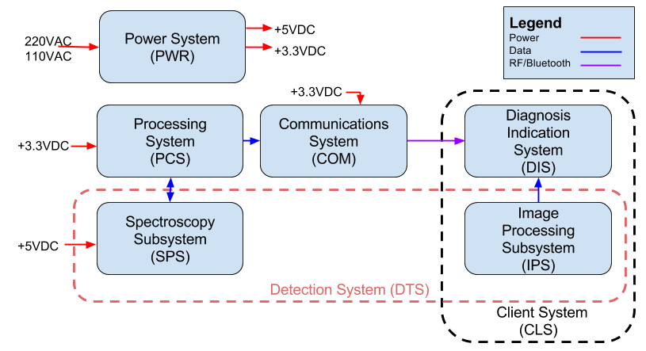
Figure 1: High level block diagram

The high level design shown consists of the core modules required to power our detection, processing, and communications systems, as well as the core detection and processing systems required to implement our detection algorithm. The Client System is described later in this document as being a system implemented entirely in software, and run on an Android smartphone. The Processing System will consist of an undecided embedded processor and some simple DSP required to implement the SpO2 detection algorithm required for the Pulse Oximetry data.

Power System
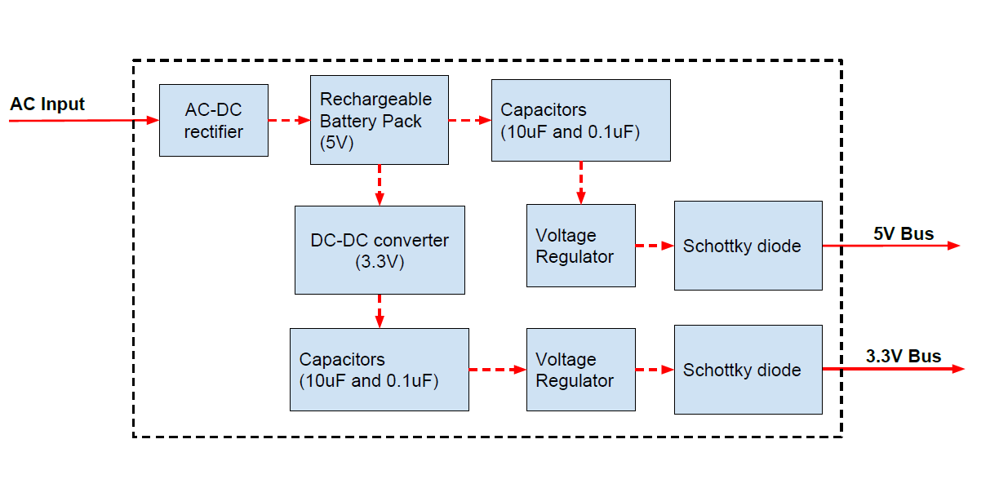
Figure 2: Block diagram of the power system

The power system will be used to first convert and then deliver power to all other subsystems, with the exception of the CLS. It will first convert 120V AC power to 5V DC. This low voltage line will then be used to deliver charge to the local battery. From 5V given by the rechargeable battery, two individual low voltage DC lines will feed the rest of the circuit. The first line will remain at 5V and the second will be stepped down to 3.3V using a DC-DC converter. Both lines will go through a bypass capacitor, decoupling capacitor, and voltage regulator to smooth out signal and manage the power needs of downstream instruments. Lastly, for protection and isolation, the 5V and 3.3V lines will go through a schottky diode before providing power to other subsystems. It is our intention to use an off the shelf system that contains a rechargeable battery and AC-DC conversion. From there, the rest of the power system can be custom designed.

Current Consumption
We assume the following current consumption from each component:

Component | Quantity | Current/Component | Notes
MSP430 | 1 | 5mA | N/A
555 Timer | 2 | 250uA | CMOS version
LED | 2 | 20mA | N/A
BJT Transistors | 4 | 5mA | Assuming max Ic
Passive Components | 20 | 1mA | Estimate
PAN1470 Bluetooth | 1 | 30mA TX, 1uA passive | Assume 30mA
TOTAL | x | 115.5mA

Total power consumption:
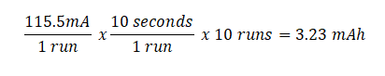

Requirements for the Power System are as follows:
- Rechargeable battery pack must have minimum capacity of 20mAh of charge.
- 5V and 3.3V outputs must be within a +/-1% tolerance after filtering and isolation.
- Power system should be able to supply current of 150mA sustained and 200mA peak.

Processing System
The Processing System (abbreviated PCS) consists of the embedded processor, and the spectroscopy processing algorithm which will calculate the SpO2 from the spectroscopy data provided by the spectroscopy subsystem, as described more fully in [2].
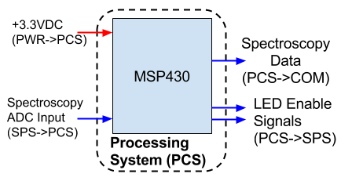
Figure 3: Block diagram of the processing system
The processing system has the following requirements:
- The embedded processor must have an ADC that operates from 0 to 3.3VDC, +/-1%
- The embedded processor must be able to drive an LED by pulsing a DAC.
- The embedded processor must be able to run on 3.3VDC, +/-1%.
- The embedded processor must have a UART to send spectroscopy data to the communications system.

Communications System (COM)
The communications system (abbreviated COM) will facilitate the transmission of pulse oximetry data obtained by the Spectroscopy Subsystem to the Client System, so it can be processed and shown by the Diagnosis Indication System.
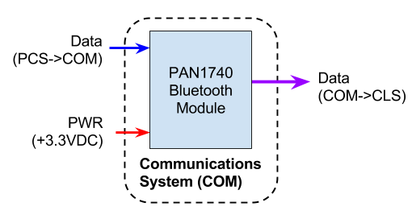
Figure 4: Block diagram of the communications system
The communications system has the following requirements:
- The communications system must be capable of running on one of the analog voltages provided by the power system, 3.3V, to a tolerance of +/- 1%.
- The communications system must be capable of transmitting at a rate of at least 9600 bits/sec, and support up to 115200 bits/sec.
- The communications system must consume no more than 40mA during transmission, and no more than 200uA during idle mode.
- The communications system must interface with the processing system over UART.

Spectroscopy Subsystem (SPS)
The Spectroscopy Subsystem (abbreviated SPS) is one of two subsystems that comprise our Detection System, the other being the Imaging System within the Client System. It will excite the finger of the patient with red (660nm) and infrared (940nm) light on a 50% duty cycle, which will then be captured by a photodiode and filtered before being sent to the processing system for further refinement. The design of our pulse oximetry system is heavily influenced by a reference design given in [6].
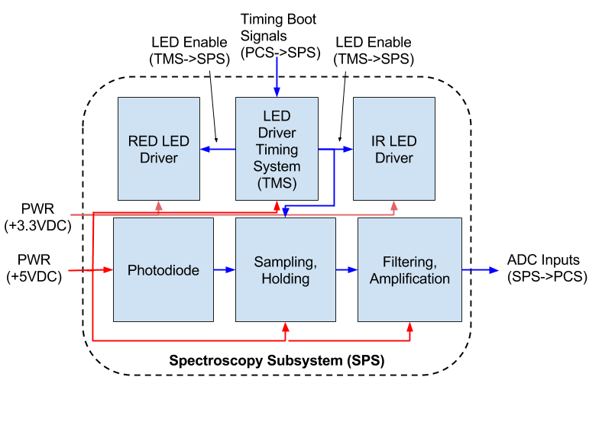Figure 5: Block diagram of the spectroscopy subsystem

The spectroscopy subsystem has the following requirements:
- The photodiode must be capable of detecting both the red and infrared outputs of the two LEDs.
- The final output sent to the processing system must be between 0 and 3.3V, +/- 1%.
- The spectroscopy subsystem must run on 5VDC and 3.3VDC.

We choose to add a series of hardware timers (based on the 555 design) to more tightly control the sequencing and timing of the pulses. We also introduce an analog sampler that is tied to this timing circuit in order to ensure that there are no timing issues in processing the ADC input. Using an analog sampler, we can ensure that what the ADC samples are the data we want, and not the data from a different channel.
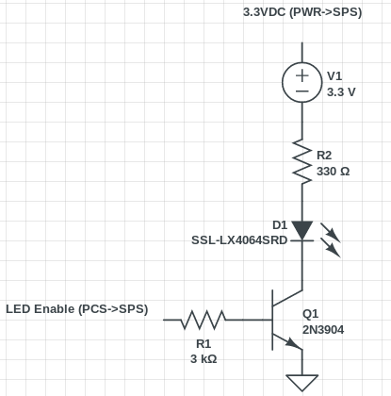
Figure 6: Simple LED Driver (660nm LED pictured). The Enable signal comes from the TMS, not the PCS
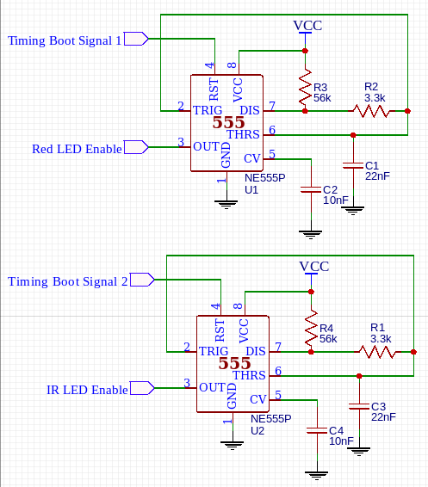
Figure 7: LED Timing Circuit (50us pulse, 1ms period)
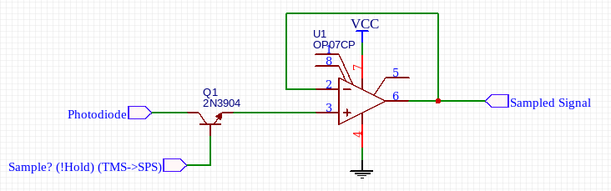
Figure 8: Sample/Hold Circuit. Enabled using the LED Enable. Two used in practice.
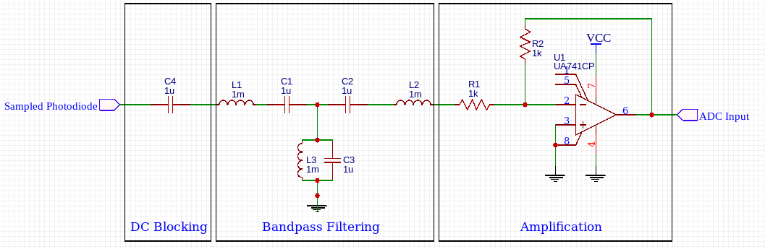
Figure 9: DC Blocking, Bandpass Filtering, and Amplification. Circuit parameters undecided.

Client System (CLS)
The client system (abbreviated CLS) consists of the image capture, image processing, and diagnosis indication systems. It combines these systems through use of complex software systems that are exposed to the user via a smartphone application. The block diagram shown in the High Level Block Diagram is sufficient to show the function of this system.

The client system has the following requirements:
- The client must support data transfer from the communications system
- The client must be capable of displaying the final diagnosis.
- The client must be capable of running the image processing subsystem.

Image Processing Subsystem (IPS)
The Imaging Processing Subsystem (abbreviated IPS) consists of the smartphone camera of the client system, and an image processing algorithm that will identify the redness of the conjunctiva to arrive at a partial diagnosis. As this system contains no hardware, it does not have a block diagram.

The Image Processing Subsystem has the following requirements:
- The image processing algorithm must give a binary diagnosis (anemia/no anemia) in no more than 1000ms.
- The image processing algorithm must run on an Android device.
- The image processing algorithm must use less than 250MB of RAM on the client.
- The image processing algorithm must feature some type of feature detection to identify different sections of the image.

Diagnosis Indication System (DIS)
The Diagnosis Indication System is where the user will read out their final diagnosis. This diagnosis will be implemented in software and shown through an Android application. As this system contains no hardware, it does not have a block diagram.

The Diagnosis Indication System has the following requirements:
- The diagnosis indication system must show a final diagnosis to the user in the form of a likelihood for anemia
- The diagnosis indication system must show a confidence value for its given diagnosis
External to these requirements, we may extend the Diagnosis Indication System to do the following:
- Show measured SpO2 from the SPS
- Show EI value from the conjunctiva image

Risk Analysis
The block that poses the greatest risk to the completion of our project is the Client System. The client system contains an as-yet unspecified image processing algorithm that will need to provide feature detection, classification, and diagnosis capabilities. To mitigate this risk, we will be scoping the features of the image processing algorithm such that the identification of the features of the image is part of the image capture itself, so as to decrease the complexity in the most complicated portion of the algorithm. One potential manifestation of this is using an image template that all images must conform to, such that features exist in a known location of the image.

Ethics and Safety
Both ethics and safety are of great importance to us while pursuing this project.

Because we will be working with a 120V AC line and stepping it down to a lower DC voltages, we will be sure to abide by the following safety precautions when working in lab. First and foremost, we will always be aware of any damaged or frayed equipment, and work without bringing food or water into a lab setting. When testing, we can take precaution by placing one hand on our back or in our pocket to prevent a closed loop current passing through the body. Additionally, using proper grounding methods, working with a partner, and wearing PPE will ensure that any safety risk regarding electrical shock is minimized.

In addition to safety, our group will also hold ethics in high regard as this project may require us to work with medical/patient data. When working with others, our group will stand by the IEEE code of ethics, and follow the appropriate methods set out by the IRB if working directly with patient data.

Lastly, we promise to attribute any research or information taken from a source to the source itself, and never pass off the work as our own.

References
[1] https://www.ncbi.nlm.nih.gov/pmc/articles/PMC3685880/
[2] https://www.nxp.com/docs/en/application-note/AN4327.pdf
[3] https://www.ncbi.nlm.nih.gov/pmc/articles/PMC1497067/
[4] http://ieeexplore.ieee.org/document/8249080/
[5] http://epomedicine.com/clinical-medicine/clinical-examination-pallor/
[6] https://www.robots.ox.ac.uk/~neil/teaching/lectures/med_elec/notes6.pdf

