Portable Sport Boundary Sensors
Team 62 – Neil Bhide, Andreya Dart and Modhura Kar
ECE 445 Final Paper – Spring 2017
TA: Jose Sanchez Vicarte

Abstract

The Portable Sport Boundary Sensors serves to improve the tennis playing experience for players by correctly calling shots that are close to boundary lines thus allowing players to focus more on their gameplay. Our design consists of eight paired receivers and emitters placed on boundary lines throughout the court and one central receiver by the net that wirelessly connects to the other receivers. This allows both players to see the central receiver light up at the same time. While this project was designed for tennis, it can be expanded for other sports with slight modifications.

Table of Contents

1 Introduction ................................................................................................................................4
2 Design Verification.......................................................................................................................4
3 Block Description ........................................................................................................................7
3.1 Power Module..............................................................................................................7
3.1.1 Battery Charger..............................................................................................7
3.1.2 DC Converter (12 V to 5 V) ............................................................................8
3.1.3 DC Converter (12 V to 3.3 V) .........................................................................9
3.2 Detection Module.......................................................................................................10
3.2.1 Hit Detection Circuit.....................................................................................10
3.2.2 Ball/Leg Detection Circuit............................................................................11
3.3 Display Module .........................................................................................................,14
3.3.1 Battery Level Indication...............................................................................14
3.3.2 Wireless Indication......................................................................................14
3.3.3 Detection Indication....................................................................................15
3.3.4 Physical Connection Indication....................................................................16
4 Cost Analysis..............................................................................................................................16
4.1 Parts............................................................................................................................17
4.2 Costs...........................................................................................................................17
4.3 Total Costs..................................................................................................................17
5 Conclusion.................................................................................................................................18
5.1 Accomplishments.......................................................................................................18
5.2 Uncertainties..............................................................................................................18
5.3 Future Work...............................................................................................................19
5.4 Ethical Considerations................................................................................................19
6 References.................................................................................................................................21
Appendix A - Requirements and Verification Table.....................................................................22

1 Introduction

Imagine yourself playing tennis and the game is starting to get very close. You’re getting paranoid that your opponent is starting to call a few of your shots incorrectly which causes arguments in the match. As you get increasingly mad, your play starts suffering and you end up losing this match. Unfortunately, this is something that happens a lot in tennis. Being tennis players ourselves, we wanted to work on a project that could help players focus on the physical aspects of tennis gameplay instead of the mental aspect.

In professional tennis, there exists Hawkeye Systems that tracks if the ball is in or out. Hawk-Eye started being used professionally at the 2006 US Open¹. Its estimated cost for one court is approximately $65,000². However, in recreational play, there is no system that can be used for determining if a ball is in or out. In the past, systems have used pressure sensors, video cameras, and magnetized tennis balls to detect currents. These systems lack portability and affordability. Using a system of advance cameras (similar to Hawkeye) requires six cameras to be placed aerially around the court. The images from all six cameras are used to determine if a ball is in or out. Looking at the price of the cheapest camera that could work for this arrangement, this system would run at about $2000, and that’s just for the cameras.

We wanted to created a cheaper system for tennis players that could be used recreationally and for high school tennis teams. The system consisted of IR Emitter and Receiver sensors. The sensors detected balls that land close to the line and determined if any part of the ball had touched the line or not. The sensor system would be easy to install, portable, able to withstand wind and water. The sensors are able to be pulled off the main playing area on a court in order to be out of the way of players. All blocks are battery powered with LEDs notifying users of battery-life.

We focused on designing this project around tennis but we would like to expand this project to other sports. By modifying certain aspects of the system, the ball/leg detection and distance the sensors are placed off the line, it should be able to adequately call shots for other sports.

2 Design Verification

Our system can be broken down into three blocks as you can see in Figure 1; emitter, receiver, and central receiver. In each block, there are three modules; power, detection, and display. The complete Requirements and Verification Table can be found in Appendix A.

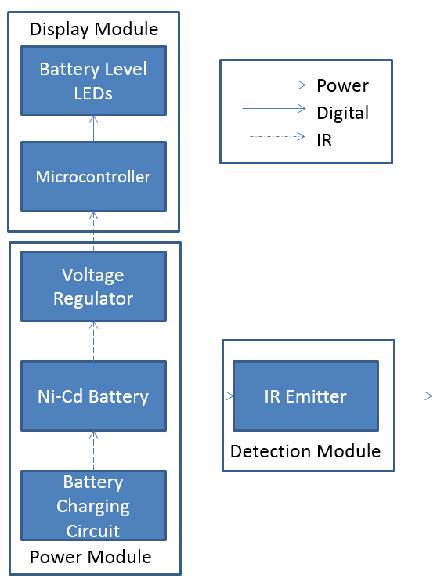

Figure 1: Emitter Block Diagram

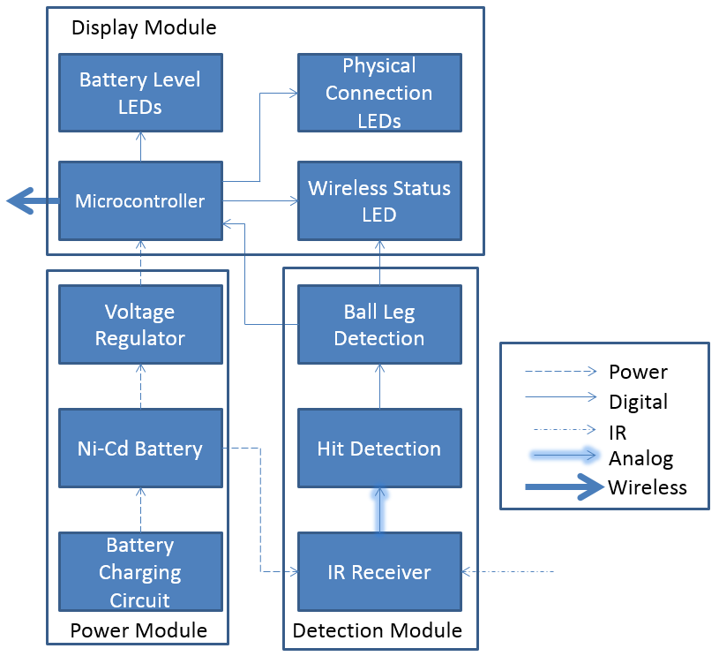
Figure 2: Receiver Block Diagram

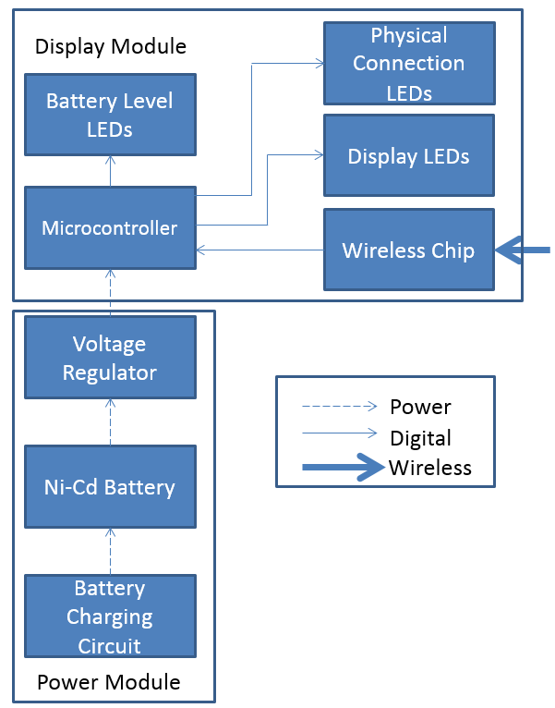

Figure 3: Central Receiver Block Diagram

3 Block Descriptions

3.1 Power Module
The power module was an essential part to all three blocks of our project. The battery used was a 12 V rechargeable Ni-Cd battery that powered the sensors. DC-DC Converters were used to step-down the battery voltage to 5 V and 3.3 V to power the microcontroller and wireless chips.

3.1.1 Battery Charger
The battery charger charged the 12 V Ni-Cd battery to full capacity. The design for the battery charger changed during the building stages of our project. Most parts needed for the first design were on backorder, which resulted in a new design with parts that were readily available. Yellow and Green LEDs were added to the design to alert users of whether the battery was charging or done charging. The final schematic and final product can be seen in Figures 4 and 5.
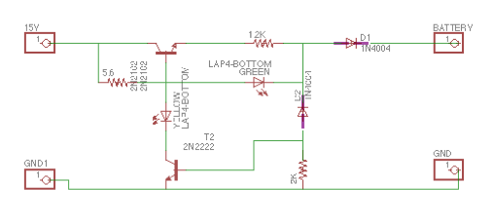
Figure 4: Battery Charging Circuit Schematic

The battery charger successfully charged the battery to full voltage before shutting off. The charger was pretty fast until it hit 9 V where it slowed down. The green LED would turn on at 11.5 V to signify the battery was fully charged because one of the transistor, T2 would turn on at 11.5 V allowing the green LED to turn on prematurely.

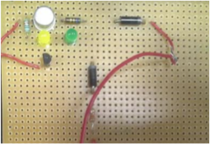
Figure 5: Battery Charging Circuit built

3.1.2 DC Converter (12 V to +/-5 V)
The DC/DC Converter stepped down the input voltage, battery voltage, to a steady output of 5 V. This was used to power the microcontrollers. When simulated, the originally designed circuit outputted a steady 5 V, but once built, the circuit outputted 9.34 V. So a voltage divider circuit was used to output a 4.78 V output. The 4.78 V was deemed acceptable, as it was adequate enough to power the microcontroller.

In order to power the op-amps, an output of -5 V was needed. Originally a Cuk converter was designed, but because of a lack of time and supplies, a -5 V output was achieved by simply switching the polarities of the 12 V to 5 V converter.

When the converters were placed on the perfboard (Figure 6), a wire was soldered incorrectly, which shorted the load of the circuit, causing the input capacitance to blow up and fry the voltage regulator. This incidence happened multiple times to the point where there was only one voltage regulator left that was left on the board beard. This prevented the power module from being able to properly interface with the other modules in our project.

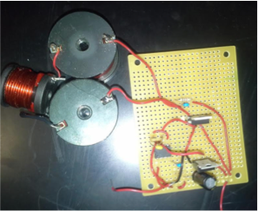
Figure 6: DC/DC Converter with no load

3.1.3 DC Converter (12 V to 3.3 V)
The DC/DC Converter stepped down the input voltage, battery voltage, to a steady output of 3.3 V. This was used to power the wireless chips. The circuit built was very different from the original design. In order to be more efficient, the 3.3 V output was established by using the same core circuit from the 12 V to 5 V converter and adding another voltage divider to output 3.3 V as can be seen in Figure 7. The output of the built circuit came out to be 3.3 V with a 6 mV voltage ripple.
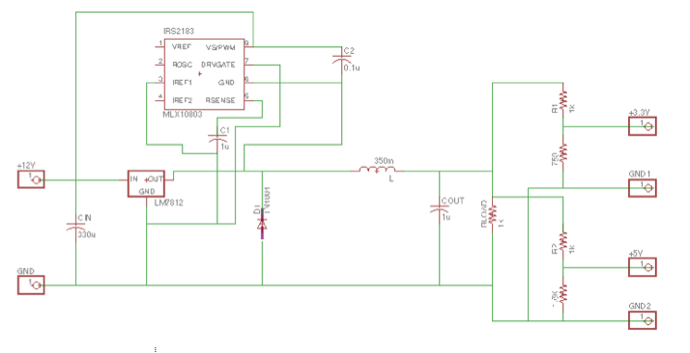
Figure 7: DC/DC Converters schematic

As mentioned in the section above, the converters were stuck on a breadboard because there was a shortage of supplies that didn’t allow for the power module to interface with other components of our project.

3.2 Detection Module
The detection module was a large part of the emitter and receiver blocks. This module acted as the intelligence of the circuit, determining whether or not a ball was in or out. It consisted of two infrared sensors, an IR emitter and receiver, a hit detection circuit, and a ball/leg detection circuit. The sensors sent an infrared beam from emitter to receiver, and would output current if the beam was broken. From there, the hit detection circuit and the ball leg detection circuit would interpret the output to determine if the break in the beam was due to a ball or an outside source.

3.2.1 Hit Detection Circuit
The hit detection circuit originally designed was a trans-impedance amplifier. It was built to amplify the current from the sensors into a large enough voltage that the ball leg detection circuit could integrate over. From the data sheet, we expected no current flow for the off state, and a 130mA flow from the on state of the sensors. That would correspond to an output voltage of 0 V for our off state and 4 V for our on state from the amplifier. Though after receiving the sensors, we found that the output current was approximately 100mA for the off state. Our circuit was not robust enough to handle the nonzero current, and amplified both states to approximately 4V.
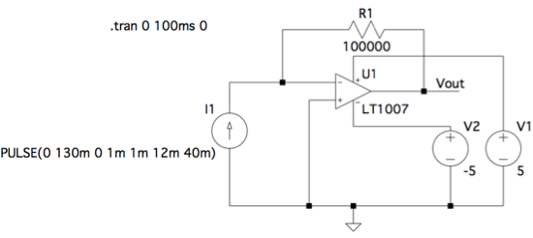
Figure 8: Trans-impedance Amplifier Design for Hit Detection Circuit

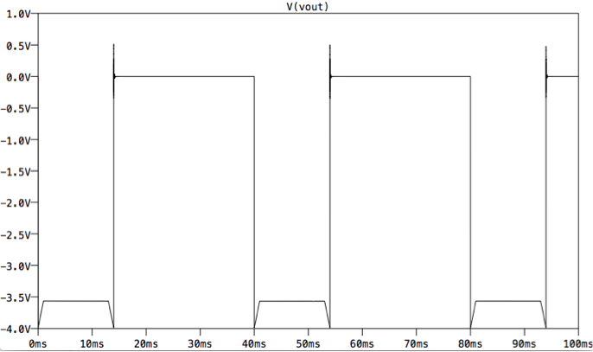
Figure 9: Trans-impedance Amplifier Simulation with Ideal Sensor Load

The design had to be changed to obtain the correct output. We were not able to redesign and reorder parts for the circuit, due to a lack of time, so we chose to redesign the circuit using the microcontroller. After measuring the output of the sensors, we found that an on state output measured 36 mV and an off state output measured 6 mV. We attached the output of the sensors as an input to the microcontroller. Using simple code, the microcontroller would output a digital high (5V) if it read a value greater than or equal to 36 mV, and a digital low (0V) if it read a value less than 36 mV. This output was then sent to the ball leg detection circuit. The pseudo code can be seen in Figure 15.

3.2.2 Ball/Leg Detection Circuit
The ball/leg detection circuit designed was an analog integrator. The goal was to be able to integrate the output of the sensors and output different voltages for specific on-state times from the sensors. This was used to determine whether or not a ball or a leg was breaking the beam.

We calculated the slowest time for a ball to break the beam and the fasted time for a leg to break the beam using data from a professor at the University of California-Davis⁴, and the world record values for a male sprinter and average shoe sizes. We determined that the slowest time for a ball to break the beam to be 12ms, and the fastest time for a leg to break the beam to be 17ms.
$y=V_{y}*\sin\left(Θ\right)$
$$28 mph=12.21\frac{m}{s}$$
$$16 mph=7.51\frac{m}{s}$$
$$12.21*\sin\left({25}^{o}\right)= 5.19\frac{m}{s}$$
$$7.51*\sin\left({40}^{o}\right)= 4.76\frac{m}{s}$$
$$t_{before}=\frac{3 cm}{5.19\frac{m}{s}}=0.0058 s$$
$$t_{after}=\frac{3 cm}{4.76\frac{m}{s}}=0.0063 s$$
$$t_{before}+t_{after}=0.0121 s$$

The original design simulations produced a -2.8 V output for 12ms, and a -3 V output for 17 ms. Though after building the circuit with the original design values, we were unable to get a large enough difference in the two output voltages, so many of the resistor values had to be changed. Also, to stabilize the output and invert the signal from negative to positive, we added another amplifier with a large resistor network. After changing the circuit, we were able to obtain a 2.9 V output for a 12ms break and a 2.95 V output for a 17ms break, which was significant enough for the microcontroller to distinguish between.

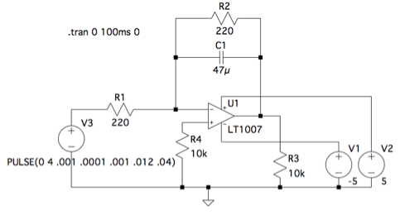
Figure 10: Ideal Analog Integrator Circuit Design for Ball Leg Detection Circuit

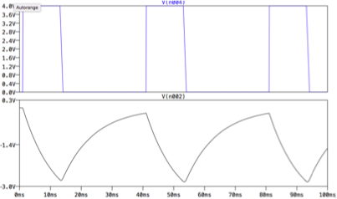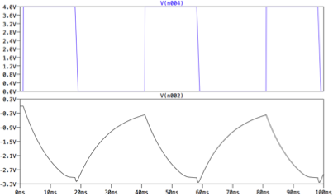
Figure 11: Simulation of Ball Leg Detection Circuit from Figure 11 for 12ms (Left) and 17ms (Right)

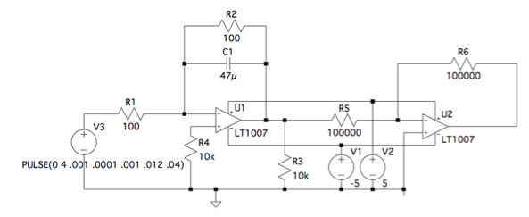
Figure 12: Actual Built Analog Integrator Circuit Design for Ball Leg Detection Circuit

3.3 Display Module
The display module of our project notified the user of the voltage remaining in the battery, the active wireless connection between the receivers and central receiver, and if the ball that broke the IR beam was in or out. This was primarily done with an ATMEGA328P-PU microcontroller, nRF24L01 wireless chip, and a resistor network to step down the voltage to a safe limit for the inputs to the microcontroller and wireless chip.

3.3.1 Battery Level Indication
The battery level indication alerted the user about how much charge was left in the 12V Ni-Cd battery. The table below shows the operating voltages for when each LED would turn on. The yellow LED indicated to the user that there was 30 minutes of charge left while the red LED indicated to the user that there was 5 minutes of charge left.

LED Color | Operating Voltage
Green | 12 V – 11.52 V
Yellow | 11.51 V – 11.08 V
Red | 11.07 V – 10.66 V
Table 1: Battery Level Indication Operating Voltages

A resistor network was used to step down the voltage. Below is the schematic used to step down the 5 V to a safe threshold for the microcontroller to read and analyze.
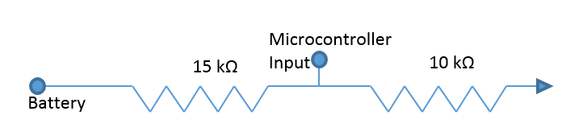
Figure 13: Resistor Network for Battery Level LED

3.3.2 Wireless Indication
The wireless indication LED is used to alert the user when the receiver block (transmitter) is connected to the central receiver block (receiver). This was established at the beginning and is checked every 5 seconds. The transmitter sends a data string with the first data of the string high to the receiver. The receiver then will turn on the LED when it receives this and the first string is in fact high. The check of 5 seconds was used because the receiver gets data from eight different wireless chips, so therefore data from multiple transmitters would not be sent to the same receiver at the same time. Below is the flowchart used to send data.
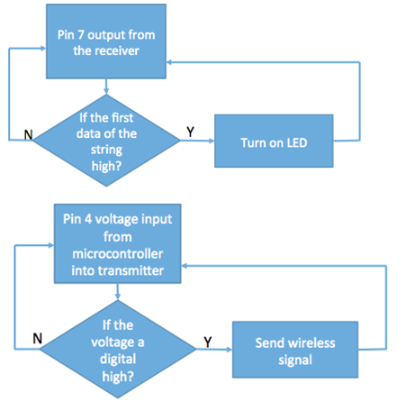
Figure 14: Flowchart for Wireless Indication

3.3.3 Detection Indication
The Detection Indication LED display alerts the user when a ball has broken the beam through an LED display on the central receiver. The LED display is made up of multiple LEDs so that players can both see the display from the back of their respective sides. The LED display has to be lit for at least 5 seconds so players are able to see the call. The microcontroller took two inputs from the hit detection circuit and ball leg circuit. Because of the lack of difference between the broken and the unbroken beam voltage, the microcontroller was used instead of the circuit. An input from the sensor of less than 36 mV meant that the beam was not broken and an input of greater than 36 mV meant that the beam was broken. Furthermore, an input less than 2.9 V from the Ball Leg Circuit meant a ball broke the beam and an input greater than 2.95 V from the Ball Leg Circuit meant that something slower than a ball broke the beam. If both conditions were met (the sensor outputting a value higher than 36 mV and the Ball Leg Circuit outputting a value less than 2.9V), the receiver block (transmitter) would output a digital high and send a signal to the central receiver to light up the LED. Below are the two flowcharts used to determine if a ball has broken a beam.

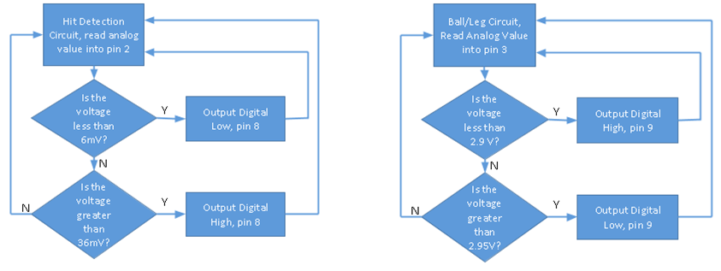
Figure 15: Flowcharts for Detection Indication

3.3.4 Physical Connection Indication
The design for this was for an LED to be placed on the receiver when the receiver and emitter are lined up. The microcontroller code was written so that when there was a small current present because they were connected, an LED would light up. However, when we received the sensors, there was already a connection LED that was placed on the emitter so we didn’t have to design this component.

4 Cost Analysis

4.1 Parts
Part | Part Type | Manufacturer | Retail Cost | Quantity | Actual Cost
ATMEGA328P-PU | Microcontroller | Atmel | $2.08 | 3 | $6.24
nRF24L01 | Wireless Chip | Nordic Semiconductor | $7.99 | 3 | $23.79
LM7812 | Voltage Regulator | Fairchild | $0.64 | 3 | $1.92
FES16DT | Fast Rectifying Diode | Fairchild | $1.12 | 3 | $3.36
2N2222 | Transistor | Central Semiconductor | $2.03 | 3 | $6.09
2N2102 | Transistor | Central Semiconductor | $1.92 | 3 | $5.76
IRS2183 | Half-Bridge Gate Driver | Infineon | $1.68 | 3 | $5.04
MLSI-18 | MINI-EYE Emitter - 18mm, LED, Thru-Beam, Infrared, Cabled Sensor | Tri-Tonics | $39.00 | 1 | $39.00
MR-18 | MINI-EYE Receiver - 18mm, NPN Infrared, Cabled Sensor | Tri-Tonics | $29.00 | 1 | $29.00
LT1007 | OP AMP | Linear Technologies | $4.15 | 2 | $8.30
Total |  |  |  |  | $136.36

4.2 Costs
Name | Hourly Rate | Hours Invested | Multiplier | Total ($)
Neil Bhide | $30.00 | 175 | 2.5 | $13,125.00
Andreya Dart | $30.00 | 175 | 2.5 | $13,125.00
Modhura Kar | $30.00 | 175 | 2.5 | $13,125.00
Total |  |  |  | $39,375.00

4.3 Total Costs
Type | Costs
Labor | $39,375.00
Parts | $136.36.00
Total | $39,511.36

5 Conclusion

5.1 Accomplishments
At the end of this semester, we were able to get most of our requirements because most parts worked modularly. However, we weren’t able to integrate our design. Regardless, we all learned a lot from this experience. We learned that we could output different voltages from our converters simultaneously with voltage dividers. We had limited experience with microcontroller programming and wireless communication but after working with them these past couple months as well as the other parts of our project, we gained more insight into the multiple stages of integration needed to produce a working project.

5.2 Uncertainties
We were left with many questions after demoing our project. This was due to not being able to integrate our design. The battery was connected to a lot of components on our circuit, either directly or indirectly. Because our power module was on the breadboard and due to a shortage of parts, we weren’t able to connect all of our components together which meant we couldn’t test if our system could actually last a full 3 hours.

Parts of the design simply stopped working. After testing the perf-boarded ball leg detection circuit multiple times a week before demo, the circuit appeared to be working perfectly. Though, the night before demo, the circuit abruptly stopped working without changing anything. Due to this, we could not integrate this circuit with the rest of our design, and were confused to what had happened.

Lining up the receiver and emitter proved to be a difficult challenge in the lab. Getting it to 20 feet took approximately 15 minutes. Instead, mounting the sensor on a physical device could help placement be easier, however for this product and design to be successful we need the user to be able to easily and efficiently align the sensors.

An uncertainty that we came across with the wireless chips was the receiver processing data when the transmitter was not sending any data. This was fixed when both devices were isolated and proper data was being sent. Because of this, multiple transmitters connecting to one receiver was tested only a couple times and therefore it was inconclusive if the chip used would be feasible to be used in our application.

5.3 Future Work
In the future, this project could be expanded to support other sports. By modifying parts of the system, it should successfully be able to adjust to basketball, volleyball, badminton, etc. Sensor placement, time to break the beam, and court locations would have to change from sport to sport. For example, in basketball, if the ball or the player's foot touches the line, the ball is considered out. So, the placement of the sensors would need to be on the line instead of just off the line. Also, because both a foot and a ball touching the line means that the ball is out, the ball/leg circuit would not be used. However, in other sports like badminton and volleyball, the time it breaks the beam is different. Applying it to different sports allows the system to be versatile and could be used in other applications like in Elementary, Middle, and High School Physical Education classes as well as at different afterschool programs like the Boys and Girls Clubs.

5.4 Ethical Considerations
IEEE Code of Ethics
[1] to accept responsibility in making decisions consistent with the safety, health, and welfare of the public, and to disclose promptly factors that might endanger the public or the environment;³
It was very important that we thought about player’s safety when designing our project. These sensors will be physically placed on the court and could serve as a tripping hazard. We designed our sensors so that they could be pulled off the boundary lines and therefore be out of the way of the main playing area.

[5] to improve the understanding of technology; its appropriate application, and potential consequences;³
If you google “sensors to call tennis shots”, you get many results that discuss the use of pressure sensors placed under the court to determine if shots are in/out.^{5,6} Besides last year’s similar project, there aren’t many projects out there that use IR sensors for this cause. By working on our design, we hope that more people take on this project and improve it because as tennis players, we believe this is very marketable if done correctly.

[6] to maintain and improve our technical competence and to undertake technological tasks for others only if qualified by training or experience, or after full disclosure of pertinent limitations;³
We were able to divide our project by strengths. Each of us worked on modules that we had experienced knowledge in. At the same time, none of us had experience with microcontrollers and wireless chips. We had to do a lot of research and use outside help to understand how they worked before we could start working on the design of the detection module.

[7] to seek, accept, and offer honest criticism of technical work, to acknowledge and correct errors, and to credit properly the contributions of others;³
It was very important to us that we got criticism and help from peers when designing our project. We wanted to not only create a working project, but an efficient project. We made sure to seek help from peers that were more experienced and could provide feedback on our designs.

6 References

[1] Pi in the Sky. “The History of Hawkeye”, 2015. [Online]. Available: http://www.stpetersbray.ie/piinthesky/the-history-of-hawkeye/. [Accessed 10-Feb-2017].

[2] GameSetMap. “Unlocking Hawk-Eye data: What it means for tennis, the ATP, WTA and ITF”, 2013. [Online]. Available: http://gamesetmap.com/?p=74. [Accessed: 10-Feb-2017].

[3] IEEE. “7.8 IEEE Code of Ethics”, 2017. [Online]. Available: http://www.ieee.org/about/corporate/governance/p7-8.html. [Accessed 10-Feb-2017].

[4] Pallis, Jani Macri. The Tennis Server. “Follow the Bouncing Ball - Ball/Court Interaction - Part III”, 2016. [Online]. Available: http://www.tennisserver.com/set/set_02_11.html. [Accessed 19-Feb-2017].

[5] Bradley, Logan. SportTechie. “In/Out Portable Device For Tennis Provides Affordable Solution For Line Calling, Stats Analysis”, 2017. [Online]. Available: http://www.sporttechie.com/2017/03/16/othersports/tennis/inout-portable-device-for-tennis-provides-affordable-solution-for-line-calling-stats-analysis/. [Accessed 1-May-2017]

[6] Bane, Michael. University, Victoria. Gizmodo. “Beyond The Line Call: How Technology Is Changing Tennis”, 2017. [Online]. Available: https://www.gizmodo.com.au/2015/01/how-line-call-technology-is-changing-tennis/. [Accessed 1-May-2017]

[7] Chen, David. Joe, David. “Tennis Boundary Ball Detection”, 2016. [Online]. Available: https://courses.engr.illinois.edu/ece445/getfile.asp?id=8687. [Accessed 13-Feb-2017]

Appendix A - Requirements and Verification Table

Block | Requirement | Verification | Status (Y/N)  (Quantitative Results Shown in Block Descriptions)
Battery Charging Circuit | The battery charging circuit will stop charging the circuit if the temperature of the battery is over 45 degrees Celsius. .  The circuit will stop charging the battery when it is at 12 +/- 2% | Use an infrared thermometer to check the temperature of the Ni-Cd battery  Use a Digital Multimeter to check the value of the battery while the battery charging circuit is charging the battery | N  Y
12/5 V DC-DC Converter | Accept an input of 2-12 V and deliver a steady output of 5 V. | Vary the input voltage by 0.1 V between 2 V and 12 V with a DC power supply while measuring the output voltage with multimeter. | Y
12/3 V DC-DC Converter | Accept an input of 2-12 V and deliver a steady output of 3.3 V. | Vary the input voltage by 0.1 V between 2 V and 12 V with a DC power supply while measuring the output voltage with multimeter. | Y
Hit Detection Circuit | Must be able to detect a boundary hit given different current magnitudes flowing from the receiver. It must recognize 0-75mA +/- 5mA as a cleared hit and 75mA-130mA +/- 5mA as a boundary hit. | Use a waveform generator to input different current magnitudes into the hit detection module: 0mA, 20mA, 40mA, 60mA, 80mA, 100mA, 120mA, and 130mA. Use an oscilloscope to measure the output voltage and check for the accurate response (output high for boundary hit & output low for cleared hit). | N
Ball/Leg Detection | Must recognize a “ball hit” as a beam break less than .012s +/- 2.5% and a “leg hit” as a beam break greater than .012s +/- 2.5%.  Circuit must reset (output voltage returns to zero) after .012s +/- 5%. | Use a waveform generator to input a square wave with different T_{on} durations into the ball leg detection module: .0025s, .005s, .0075s, .01s, .0125s, .015s, .0175s, .02s, .0225s, and .025s. Use an oscilloscope to measure the output voltage sent to the Display LEDs and check for the accurate response (output high for “ball hit” & output low for “leg hit”).  For each test above, using an oscilloscope, measure the time it takes for the output of the analog integrator voltage to return to zero. | Y
Battery Level Indication | Battery level lights must turn on and off according to the battery voltage. The green LED must turn on if the voltage is between 12V and 11.52V, the yellow LED must turn on if the voltage is 11.51V and 11.08V and the red LED must turn on if the voltage is less than 11.07V and 10.66V. | Use a digital multimeter to check that the correct LED is lit when a certain voltage is applied to the logic. | Y
Wireless Indication | Central receiver must create wireless network available to all receivers within 70 ft.  Multiple receivers must be able to pair with that network and detect connection loss.  LEDs must light up corresponding to correct wireless connection. | Test that the receiver accepts and processes a signals from the transmitter from a distance of 70 feet away.  Test that the receiver can accept a range of frequencies from the transmitter based on the data from the microcontroller  Test that the LED shuts off when the connection is interrupted by the transmitter to the receiver  Test three different types of signals: constant connection, pairing connection, and no connection and verify that the LED status is correct | N  Y  N
Detection Indication | The display LEDs must light up within 5s of a detected boundary hit.  The display LEDs must remain on for 5s +- 1s so that the players have time to process the boundary ruling.  Each display LED must emit 5 lumens $±$ 5% so it can be seen at a distance of 50 ft (the furthest you are from the net of the tennis court while playing). | Use an oscilloscope to measure the duration between when the boundary hit signal is transmitted from the microcontroller and when the LEDs light up.  Use an oscilloscope to measure the duration the LEDs are on after initially lighting up.  Use an oscilloscope to read the voltage and current to calculate power. From there, use the watts to lumens formula and the luminous efficacy of 62 lm/W to ensure that the brightness is sufficient. | N  Y  Y

