ECE 445 – Senior Design Laboratory
Design Document

Smart AC Unit Device

Team 56
Vineeth Kalister
Xavier Oliva
Kevin Zhang

TA: Douglas Yu

February 19, 2024

Contents
1 Introduction 2
1.1 Problem 2
1.2 Solution 2
1.3 Visual Aid 3
1.4 High-Level Requirements 4
2 Design 5
2.1 Block Diagram 5
2.2 Subsystem Overview 6
2.2.1 Air Conditioner System (Smart AC device) 7
2.2.2 Mobile Device System (User Application) 7
2.3 Subsystem Requirements 8
3 Ethics and Safety 9

1 Introduction

1.1 Problem
In the United States, 90% of homes and apartments built have an air-conditioning unit installed. However, about a third of homes lack a central air conditioning system. While some homes are in climates where they do not need a robust air conditioning solution, homes that don’t have central air conditioning typically use a window unit for climate control. This is especially true in communities with older homes, such as New York City and Boston. Many of these older homes use “dumb” wall-mounted AC units that are inefficient and manually set, thus contributing to the national energy burden. Furthermore, there is the risk of over-cooling the living space, decreasing overall comfort for those who have a window unit. Therefore, there is a gap in the market for a more affordable and effective AC unit. As such, we want to target these homes and make them more efficient through “smart” AC control units.
“Smart” AC control units that make up most of the market are exclusively to be used with central air conditioning systems, many of which allow you to integrate voice assistants and other AI services. Although there exist “smart” wall-mounted units, these are often equipped with proprietary solutions that exclusively work with certain brands of expensive window units or are, themselves, expensive devices that simply modulate the voltage going inside the AC unit without changing the physical settings of the unit. With our Smart AC Unit system, we believe that we can accomplish a more efficient and equitable experience for those with window unit ACs and ensure optimal ease of access as well as a lower power bill. As the central air conditioning market advances in the technology available to make the air conditioning experience easier, such advances and improvements are lacking in homes that do not have central air conditioning.

1.2 Solution
Our proposal is a multipart system combining temperature and humidity sensors, servo motors, and central control units to allow for window-mounted ACs to be automatically controlled through an application on one’s smart device. Our “smart” AC device will be able to latch on top of the knobs of a window unit AC, regardless of the brand, and, with the help of the User Application available on their mobile device, be able to accurately adjust the knobs remotely to the settings of the user’s choosing. The main system relies on sensor units, control units, and mobile devices. The prototype device will be tested on a 5000 BTU Arctic King window air conditioner. Overall, our unit will offer significant energy and cost-saving capabilities as well as a user-friendly experience and convenience with its mobile device connectivity.

1.3 Visual Aid
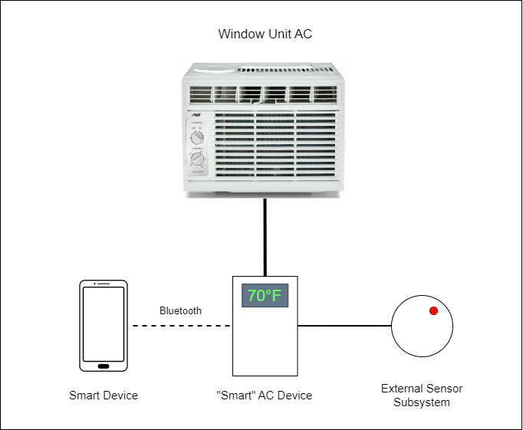
Our smart device has several modules that interface with each other. Typical window-AC smart control units require significant modifications ont the original design
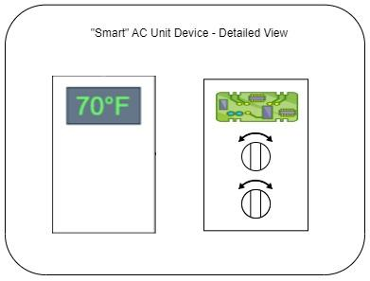

1.4 High-Level Requirements
- Temperature Sensor Integration:
  - The Smart AC Unit can be controlled and changed following signals from the temperature sensors. If the temperature sensed is lower than the desired temperature, the actuators turn the AC unit off, and if the temperature is too high, the actuators turn the AC Unit back on.
- Accuracy and Precision of Temperature:
  - Our system will accurately read and compute the current room’s heat index with an accuracy of +-0.5 Celsius. This information will be displayed on the display to the nearest degree fahrenheit.
- Bluetooth Connectivity:
  - Mobile Devices can communicate via Bluetooth with the Smart AC Device as well as relay instructions that will manipulate the Window Unit AC, whether that’s knob adjustment, temperature adjustment, etc. Changes can be made through the user-friendly mobile application.
- Manually Set Automation:
  - Be able to manually automate instructions such that the Window Unit AC will increase efficiency when the user is not in the room and save energy and money. Also be able to set “plans” in the UI system so that the AC unit can be turned off at certain intervals to save power.

2 Design

2.1 Block Diagram
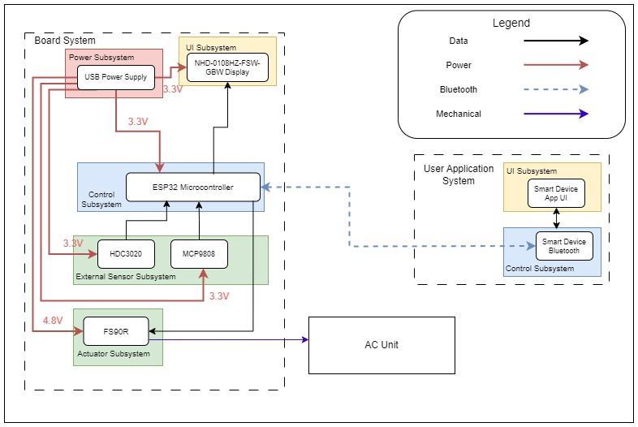

2.2 Subsystem Overview

2.2.1 Air Conditioner System (Smart AC device)
Power Unit
The Smart AC itself will need to be powered with enough voltage to be able to power the two motors responsible for turning the knobs on a 5,000 BTU Arctic King window air conditioner as well as the temperature and air quality sensors.
The goal is to have the entire control and sensor units powered by USB power through a wall outlet. This necessitates a voltage regulator to ensure the correct voltage to the microcontroller and the Servomotors, which will both operate at 4.8-5V. We will use USB-based power. To ensure correct operation, we will use a USB-PD two-wire communication system between a charger and our device.
Sensor Unit
The Smart AC device will be equipped with a temperature sensor to read the temperature of the room, and thus, regulate the temperature to the temperature selected by the User Application. The Smart AC device will also be equipped with an air quality sensor which enables the air quality of the room to be read and communicated to the user through the User Application.
For a more accurate sensor reading of the current temperature, we will use the MCP9808 sensor with a +-.25C temperature accuracy. Our humidity detector will use an HDC3020 IC made by Texas Instruments, which will have a +-0.5% real humidity accuracy. These temperature sensors will be held by thin cables that connect them to the main AC unit such that they can be spaced far enough away from the Main AC unit to avoid regional cold spots near the AC unit.
Control Unit
The control unit of the Smart AC device system will be capable of changing the settings of both the temperature and cooling knobs of the Arctic King window air conditioner. If the temperature set by the User Application is higher or lower than that measured by the Sensor Unit, the Control Unit is responsible for adjusting the air conditioner settings to ensure that the room temperature stays constant. These will interface with an ESP32 microcontroller to calculate the heat index. The Control Unit should also be able to be Bluetooth interfaced with the mobile device and the user application.
The heat index calculation is well known [1]. However, if we are unable to get enough precision, we can always load a look-up table into the microcontroller. This should be well enough given the 16MB of flash memory the ESP32 has.
Knob Actuation
The knobs of the smart device should be able to toggle the settings of the AC unit. This will be accomplished by two FS90R actuators which will manipulate the knobs on the AC unit. If the FS90R does not have enough torque to turn the knobs we will gear the output down.
Display Unit
Simple display to be able to display the desired temperature. Will use NHD-0108HZ-FSW-GBW from Newhaven Technologies to display the status and current set temperature of the room.

2.2.2 Mobile Device System (User Application)
UI Unit
The user applications contain all the necessary features to read the current room temperature, turn on/off the AC system, change and schedule temperatures, change fan speeds, etc.
Control Unit
The user application will be able to communicate with the Smart AC device via Bluetooth and/or Wi-Fi.
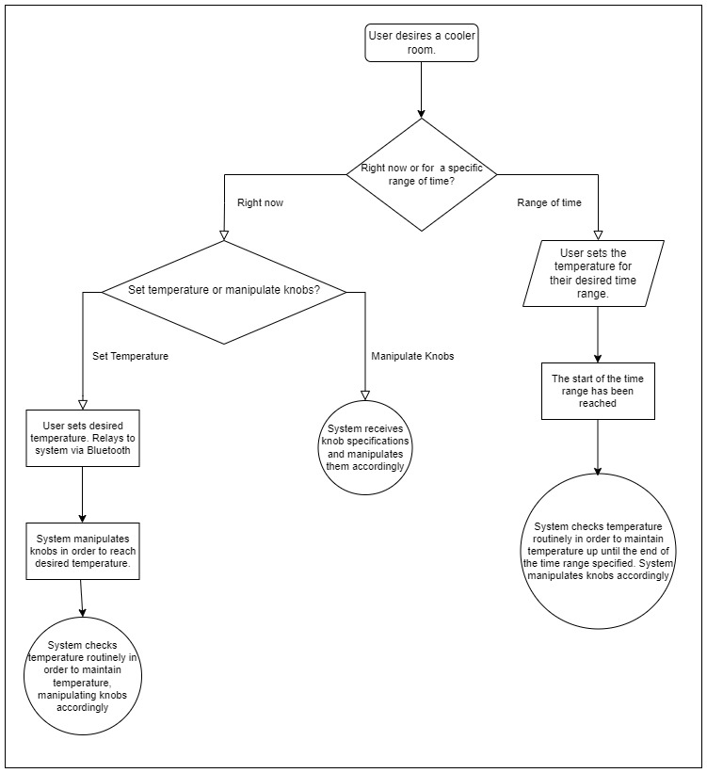

2.3 Subsystem Requirements

Power Unit  The system’s power unit must have a consistent supply voltage that can consistently power the entire system at standby and at full power. | Connect voltmeter to VCC pin, ensure that the voltage displayed is consistent and is within ±5% of the 5V VCC supply. Check output voltage from voltage regulator using voltmeter to make sure that ESP32, Display, and external sensors are all receiving 3.3V. Check output voltage to FS90R actuator, ensure it is at 4.8 V.  To test full power we shall run both actuation units at full speed, have the display run, as well as be actively transmitting data from sensor units to a mobile device, and ensure that all parts are fully powered. Repeat initial test to ensure stable voltage.
Sensor Unit  The system’s sensors will successfully measure humidity within ±0.5% of the room’s Real Humidity as well as the temperature of the room within ±0.25℃. Thus, the system should be able to calculate the heat index within ±0.2881℃. | Put the sensor unit in 4 different locations: In refrigerator, freezer, and near a humidifier, and out on a desk as a control. Acquire an accurate thermometer and hygrometer to verify temperature.  Output air from a humidifier should be close to 100% humidity, the sensor unit should read 95 ± 5% humidity. Moving the sensor unit from desk to humidifier should not significantly change temperature measurements  Put the sensor unit in the refrigerator with the accurate thermometer and hygrometer, close the refrigerator door for 20 minutes. The temperature and humidity readout from the sensor unit should be within 2F from the true value of the temperature measured by the thermometer, and ± 5% from the true humidity value of the hygrometer.
Knob Actuation  The system will manipulate the knobs of an Arctic King window unit to change its cooling settings according to the specifications of the user. | Connect Knob Actuator to the Air conditioning control knob.  Repeatedly turn the knobs from all the way off to all the way on, and repeat for 100 cycles. The knobs should be able to turn the window unit consistently and be reliable for a long time.
Display Unit  The system will visibly display the data received from the microcontroller, including, temperature, humidity, and heat index. | Ensure the temperature displayed by the display unit is accurate to the one displayed through the sensor system.
UI Unit  The system will allow the user to seamlessly input their desired settings for a room’s temperature.  The UI unit allows for instantaneous temperature adjustment  The UI Unit allows for the ability to plan temperature schedules like a smart-thermostat.  UI unit should also display the current temperature and plan. | Start with the AC Unit off. Turn the AC Unit on and turn the desired temperature higher than the temperature of the room. The AC Unit should then turn off.  Set the desired temperature very low, the AC Unit should then turn on at a very high setting to get the room to desired temperature.  Set a schedule that has the desired temperature fluctuate depending on the time of day. In the day time set it to temperature A and at night time set it to temperature B. At the transition point the AC should suddenly turn on or off to mark the transition point.  Compare displayed temperature on UI Unit and Display Unit, make sure they are identical.
Mobile Control Unit  The user application will be able to communicate with the Smart AC device via Bluetooth and/or Wi-Fi.  Changing settings on the app should also change the settings on the AC. If we toggle the units from F to C, the AC should reflect that and now display all temps in C. | The UI App should be able to communicate with the ESP32 and change settings via bluetooth. Ensure all settings changes are reflected accurately within the device.

2.4 Tolerance Analysis
Heat Index
When dealing with temperatures lower than 80 degrees Fahrenheit, the typical Rothfusz regression is replaced by the Steadman formula [1].
Heat Index = 0.047*H + 1.1*T - 10.3
In this representation of the formula, H stands for the relative humidity in percent and T is the temperature in degrees fahrenheit.
This, combined with the perceptible difference in temperature a human can feel is 2F, makes it such that our total margin of error for temperatures and ac operation is 2F[3].

3 Cost and Schedule

3.1 Cost Analysis

3.1.1 Labor
For labor costs, we will assume an hourly wage of $40/hr and a total of around 60 hours to complete. Therefore, ($40/hour) x 2.5 x 50 hours to complete = ​$5,000 per group member, so 3 members will bring the total cost to $15,000 in labor costs. The total cost of the products is $214.20. Therefore, the total cost would be $15,214.20.

3.1.2 Parts
Description | Manufacturer | Part #/Product ID | Quantity | Price | Link
5,000 BTU Arctic King Window Air Conditioner | Arctic King | WWK05CR01N | 1 | $164.00 | https://www.walmart.com/ip/Arctic-King-5-000-BTU-115V-Window-Air-Conditioner-with-Remote-WWK05CR01N/967172287
ESP32 Micro controlller | Espressif Systems | 3-01-1287 | 1 | $9.99 | https://www.amazon.com/HiLetgo-ESP-WROOM-32-Development-Microcontroller-Integrated/dp/B0718T232Z
FS09R Servo Motor | Feetech |  | 2 | $13.98 | https://www.amazon.com/DIYmalls-Feetech-Continuous-Rotation-Microbit/dp/B092VN3MTX
MCP9808 sensor | Microchip Technology | 1782 | 1 | 4.95 | https://www.adafruit.com/product/1782
HDC3020 IC | Texas Instruments |  | 1 | $1.65 | https://www.ti.com/product/HDC3020#order-quality
NHD-0108HZ-FSW-GBW | Newhaven Technologie | NHD-0108HZ-FSW-GBW-ND | 1 | $9.63 | https://www.digikey.com/en/products/detail/newhaven-display-intl/NHD-0108HZ-FSW-GBW/1701131?utm_adgroup=&utm_source=google&utm_medium=cpc&utm_campaign=PMax%20Shopping_Product_Medium%20ROAS%20Categories&utm_term=&utm_content=&utm_id=go_cmp-20223376311_adg-_ad-__dev-c_ext-_prd-1701131_sig-CjwKCAiA_tuuBhAUEiwAvxkgTteHWyoVTsgzh4mfxIwnHWTxBph9D2JuvQebfsR40nlmi3yXDQEV_xoCVAMQAvD_BwE&gad_source=1&gclid=CjwKCAiA_tuuBhAUEiwAvxkgTteHWyoVTsgzh4mfxIwnHWTxBph9D2JuvQebfsR40nlmi3yXDQEV_xoCVAMQAvD_BwE

3.2 Schedule
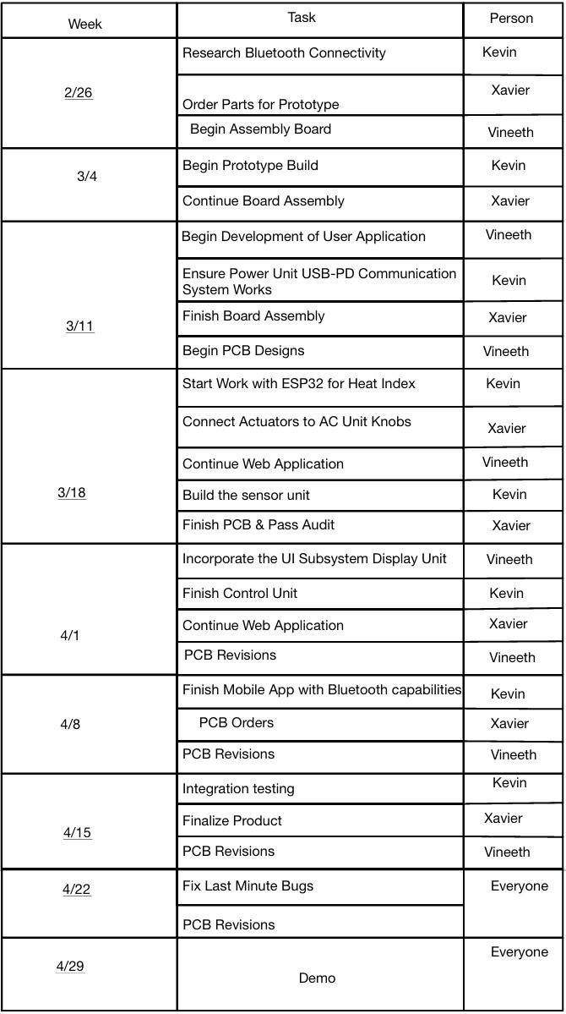

4 Ethics and Safety
While developing the Smart AC Unit, safety, and ethical considerations are very important factors to keep in mind while proceeding. Regarding safety, we plan to stick to the strict protocols and regulations and follow the correct procedures as we learned in our lab safety training. We plan on always having sufficient lab members present and carefully following all instructions and rules for safety. Moreover, our project shouldn’t require anything that would require additional training to complete. In terms of ethics, we plan to uphold all standards in the 7.8 IEEE Code of Ethics sections laid out to ensure a safe and healthy professional working environment that would allow for a respectful, comfortable, and supportive working environment for the members of this team and towards other groups. Moreover, according to the ACM Code of Ethics, we plan on complying with all general ethical principles, professional responsibilities, and professional leadership principles. One specific code that we hold dearly is 7.8 IEEE Code of Ethics Section II where we respect and support our colleagues and fellow group members. Moreover, section 2.9 of the ACM Code of Ethics is also very important, as to protect all future user’s information and ensure that there is no potential misuse of our product. We can avoid these breaches by ensuring a safe and helpful workplace and proper testing, monitoring, and patching to avoid potential safety concerns within our product.

References
[1] NOAA/ National Weather Service. “Heat index equation.” (2022), [Online]. Available: https://www.wpc.ncep.noaa.gov/html/heatindex_equation.shtml
[2] Kollman, R., & Betten, J. (2005). Powering electronics from the USB port. Available: https://www.ti.com/lit/ds/symlink/opa548.pdf

[3] Mazzai, A. (2023, August 3). Yes. you can feel one degree. Foresight. https://www.climateforesight.eu/interview/yes-you-can-feel-one-degree

