Standalone Steering Wheel for Solar Racing Vehicle

Team 3 - Anthony Rodriguez & Jonathan Mullen
Sponsor - Illini Solar Car
ECE 445 Project Proposal - Spring 2018
TA: Christopher Horn

1. Introduction

1.1 Objective
Solar vehicle racing is a university-sponsored, engineering-focused competition where participants design, build, and race a vehicle powered only by onboard solar arrays and energy stored from those arrays. Illini Solar Car (ISC) competes primarily in the American Solar Challenge (ASC), which alternates annually between a multi-day racetrack event and a week-long, 1800-mile endurance race on national highways, and World Solar Challenge (WSC), which is always a similar endurance race through the Australian Outback. All races occur with a drive team and a support team. The governing bodies of these competitions regularly update rules and requirements to promote innovative problem-solving skills, motivate students to push the limits of their knowledge and skills, and promote awareness and interest in renewable energy.

Each solar vehicle is a unique system that cannot be fully tested, and it is not feasible to simulate all of what the vehicle goes through during a competition. Safely and effectively racing a solar vehicle in any race requires the driver to have immediate access to not only detailed vehicle system information, but also the right information at the right time. Much like professional Formula Racing, solar vehicles are a barebones system, and we follow a similar control and communication design scheme where the steering wheel acts not only as the main input from the driver to the vehicle, but the main output of vehicle information to the driver. We also use a detachable steering wheel, which limits the number of signals that can pass to and from the driver.

Our first-generation vehicle is designed with a dashboard PCB that acts as the control center of the vehicle, and the steering wheel connects as a hardware slave to the dashboard. This design requires that the dashboard PCB be located near the steering wheel, which is causing placement conflicts between the dashboard PCB and the steering column in our new vehicle. After several races we discovered that the driver needs access to more real-time telemetry data to help troubleshoot vehicle systems while driving, rather than making unscheduled stops, which cost the team time and position in the race. In conjunction with these problems, we also realized that sometimes it is advantageous to change the control mapping during a particular segment of a race, but while attempting to do just this during a race, we ran into unforeseen problems that we had to pull over and fix.

Our solution to these problems is to build a standalone steering wheel as a completely independent system of the vehicle. To accomplish this, we will split the steering wheel and dashboard into two separate systems of the vehicle. The steering wheel will also support on-board LCD output of real-time system information in a way that can comprehensively display real-time telemetry to the driver, but also not overload the driver with too much information. In addition, we will also completely redesign control layout and add paddle controls on the steering wheel to give the driver finer control over regenerative braking. We will also use the modularity of our new steering system to our advantage and allow driver-specific control customization. To support this, we will completely rewrite our dashboard firmware and write steering wheel control code from scratch to interface with the vehicle over CANBUS. We will also design and implement a menu and graphical display system that allows the driver to pull telemetry data from CANBUS and perform remote maintenance (power cycling, changing settings, etc.) on vehicle PCBs.

1.2 Background
Although the vehicle does have a wireless telematics system that is actively monitored by a support team, in practice this turns out to be better suited for data logging and post-race analysis. Without actually being in the driver’s seat, the support team cannot fully understand the scope of a problem and can not be the one to decide if the vehicle can proceed safely. All intervehicular race communications occur via HAM radio, and troubleshooting via radio requires very heavy two-way communication and is not a viable option. With each vehicle being a unique system that we cannot fully test under race conditions, technical problems are inevitable, and it is ultimately the responsibility of the driver to keep the car moving safely while adhering to all applicable regulations. Any unscheduled stop means incurring time penalties during competition. Sometimes vehicle systems will partially fail while driving, or a bug will present itself, and the driver must work with the information at hand to decide if it is safe to continue racing, perform a maneuver, or if the team must stop to solve the problem.

Making the steering wheel an independent vehicle system will allow us to simplify the dashboard PCB and relocate it anywhere on the vehicle. This means that we will no longer have to disassemble the dashboard to access the main control board of the vehicle. Additionally, because the steering wheel will interface via CANBUS, we will be able to hook it up anywhere on the vehicle or test bench to perform testing and debugging. We expect that this will also greatly reduce maintenance time by making the PCBs much easier to access.

A steering wheel mounted LCD display would provide the driver with much more detailed telemetry data and put this information at their fingertips. This could be anything ranging from individual PCB statuses, current consumption by subsystem, battery balance information, etc. In addition, an LCD can give the driver much more control over vehicle systems, even allowing them to perform troubleshooting while still driving. This would include features like the ability to to power-cycle any PCB on the vehicle, or entering the vehicle into low-power charging mode or other one-time action type features. This would reduce maintenance times by allowing the driver to begin troubleshooting problems as soon as they pop up. Lastly, having access to vehicle system statuses during a race can help the driver better control the vehicle and maintain an appropriate safety margin during higher-risk maneuvers.

Control changes during a competition or during testing are desirable for many reasons. One example is that the American Solar Challenge competition is prefaced by an on-track qualifier event. On a track drivers don't need cruise control and, depending on the implementation, it may be distracting to drivers. Therefore these changes would be made between qualifications and the actual race. Secondly, there is a potential that the team may venture to make steering wheels custom to each driver with buttons placed conveniently based on their desires and hand-size. If the wheel is an independent system this can be developed without further changes.

1.3 High-level Requirements
- Steering wheel will be decoupled from dashboard PCB and both will be remade into separate control and communications systems.
- LCD display will be added directly to the steering wheel and will display detailed telemetry data from the vehicle and allow the driver to control any CANBUS connected PCB remotely.
- Steering wheel will feature paddle controls for acceleration/regenerative braking control

2. Design
The steering wheel uses a power board, control board, and a display board to function as specified. We use vehicle’s 12V low voltage (LV) line for input power to the steering wheel. We will also use a micro-USB port as an optional power source with a standard 5V power signal, but the board will not need to handle USB data. Input power will be stepped down to 5V and 3.3V via DC-DC convertors. All power inputs feature protection from over-voltage, reverse voltage, and over-current conditions. The control unit contains an ARM microcontroller to process communication and control to and from the vehicle using ISC’s custom CANBUS implementation. The CAN transceiver connects to the rest of the vehicle on a 12V CANBUS. This is converted to 5V on an isolated PCB, then interfaced to the MCU using a CAN transceiver. The display board will interface with both 7-segment and OLED displays using SPI communication to the control unit. Steering wheel inputs will consist mostly of simple buttons or toggle switches with the exception of the paddle inputs which will require an analog input - likely a linear position sensor or rotary potentiometer.

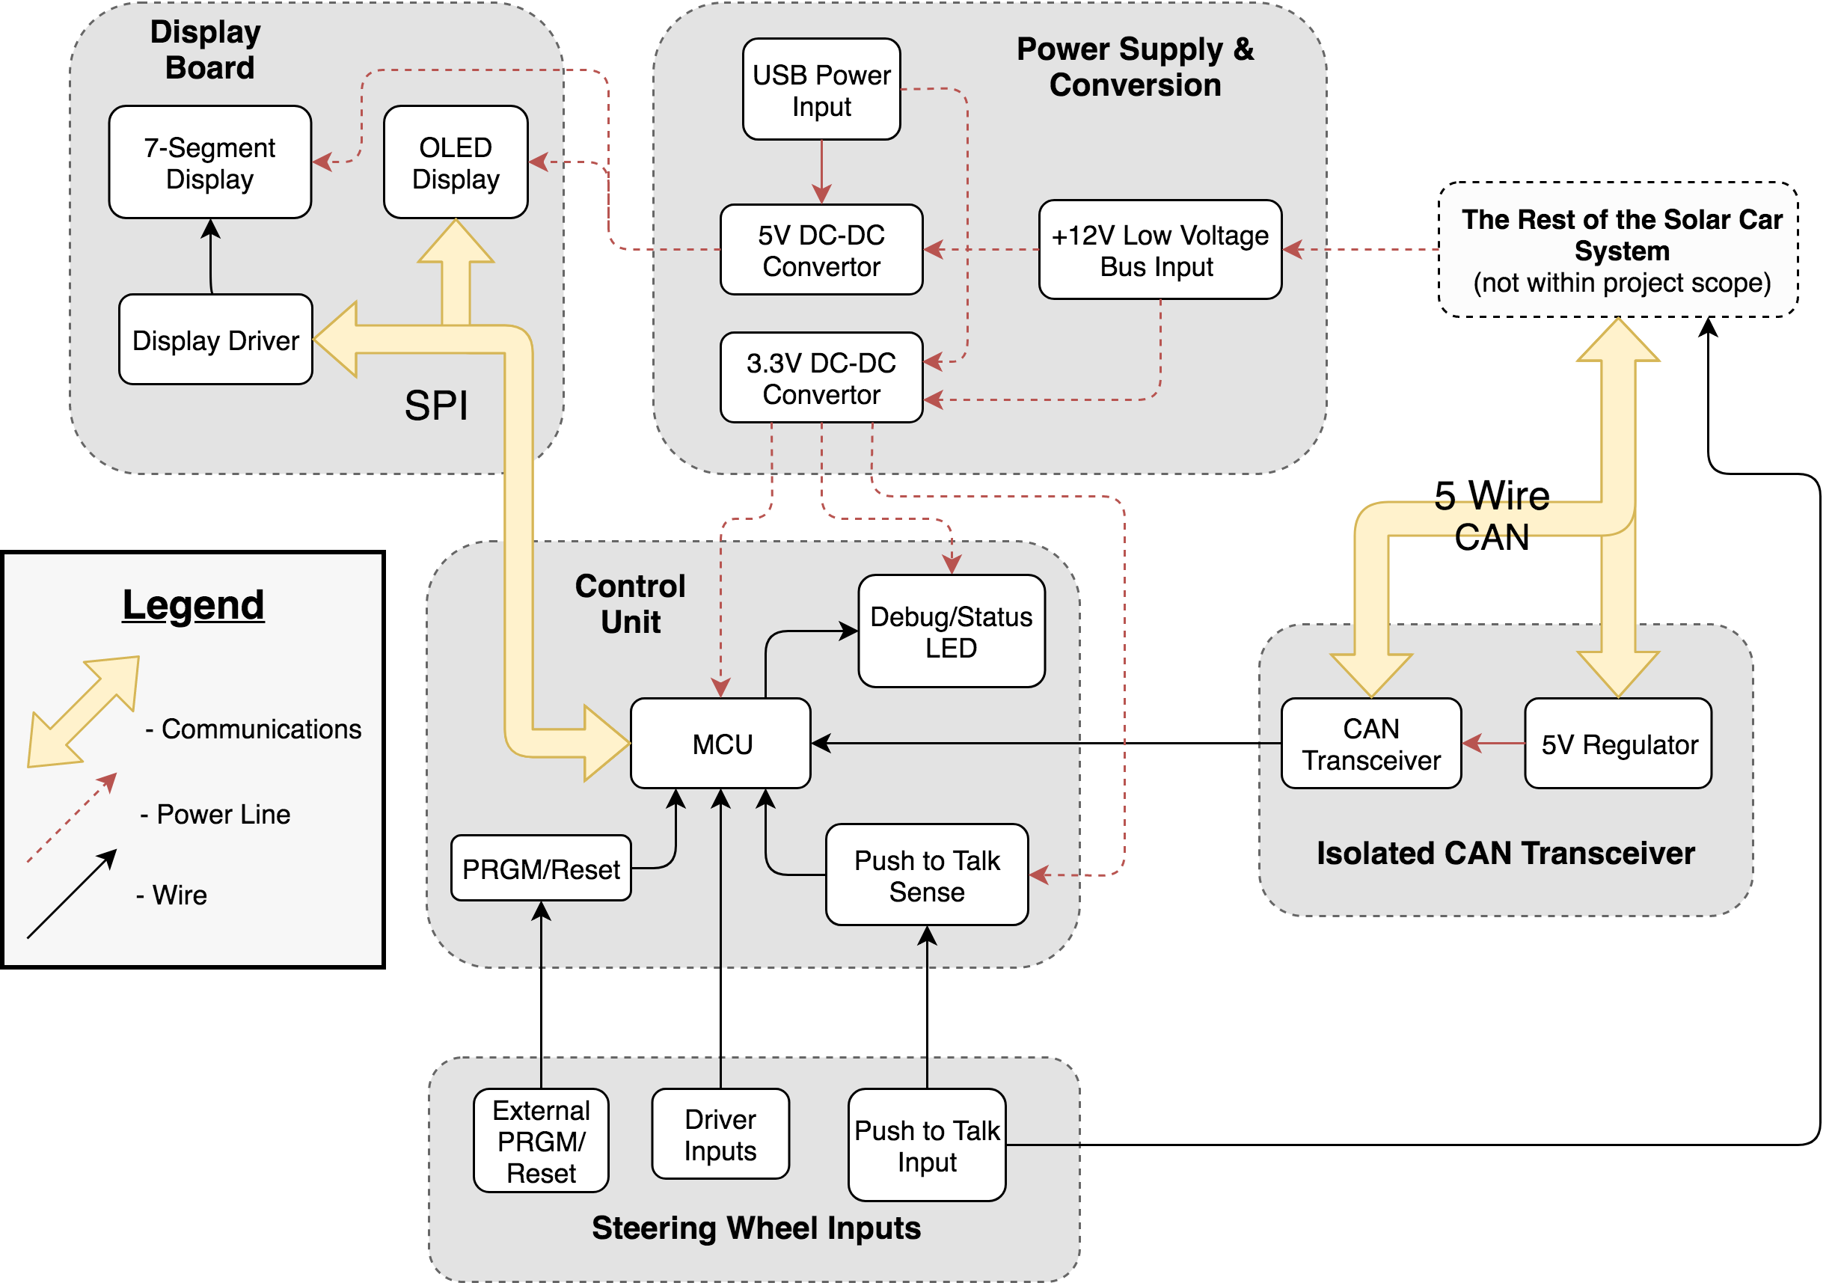
Figure 1 - Steering wheel flowchart

2.1 Power Supply and Conversion
This module receives power from external sources and supplies it to the rest of the steering wheel system at the appropriate, regulated voltage. When plugged into the vehicle LV bus, power will be drawn from there. Alternatively, micro-USB power can power the PCB when LV power is not available.

2.1.1 Low Voltage Bus Input
The LV power bus input provides primary input power to the steering wheel and runs at 12V nominal. When the board is powered from the LV bus the USB power input will not function.
Requirement 1: Must provide the steering wheel power supplies with overvoltage and overcurrent protection from the LV bus.
Requirement 2: Output to the 5V and 3.3V convertors must remain within their operating ranges for inputs between 9V to 18V from the bus.

2.1.2 USB Power Input
Micro-USB power input serves as an alternative power input for the board. We use this to power the board when bench testing or the LV supply is shut off. This port will only be used to power the board and not for any data transfer.
Requirement 1: Micro-USB port must be accessible from the exterior of the steering wheel.
Requirement 2: Micro-USB power automatically not be used when PCB is powered from LV bus.

2.1.3 5V DC-DC Convertor
The 5V DC-DC convertor powers the vehicle display board.
Requirement: This component must provide 0.5A and withstand 18V peak LV bus fluctuation.

2.1.4 3.3V DC-DC Convertor
The 3.3V DC-DC convertor powers the control unit..
Requirement: This component must provide 0.5A and withstand 18V peak LV bus fluctuation.

2.2 Control Unit
This module is the primary steering wheel PCB and contains the the microcontroller and most of the inputs from the driver to the system.

2.2.1 MCU
The microcontroller will be ARM based and must support CAN and I2C communication protocols.
Requirement 1: The MCU must be from the NXP LPC 15xx series per ISC standards
Requirement 2: The MCU must have enough GPIO pins to directly connect all inputs to the MCU without the need for any I/O expanders. This value will depend on the specific input methods determined

2.2.2 Debug/Status LEDs
The main board within this system must have LEDs on board for use in debugging and use as status indicators in normal operation. Status LEDs indicate various conditions such as CAN connection status, I2C bus status, and a heartbeat (successful completion of the function’s main loop).

Requirement 1: The control unit board must have local board heartbeat, CAN receive heartbeat, and CAN transmit heartbeat indicator LEDs per ISC standards.
Requirement 2: The control unit board shall have an LED display heartbeat indicator.

2.2.3 Push to Talk Sense
Per ASC regulation 11.4.A [1], solar vehicles drivers must carry out all communications with support vehicles without removing their hands from the steering wheel (i.e. hands-free or buttons on the steering wheel). We accomplish this by routing the push to talk (PTT) button for the mobile radio onto the steering wheel. While this functions completely independently of the solar vehicle system, being able to sense when the driver is activating PTT would allow the support team to detect radio problems sooner through transmitted telemetry data.

Requirement 1: Sense the status of the PTT button(s) without interfering with the operation of the PTT system

2.2.4 PRGM/Reset
PRGM/Reset are two separate buttons. PRGM boots the steering wheel PCB into program mode. Reset reboots the steering wheel PCB.
Requirement 1: The steering wheel must be programmable over CAN per ISC standards.

2.3 Display Board
The display board will use SPI to communicate with the MCU and display system information to the driver via a 7-segment display and an OLED screen.
Requirement: The display board must have a method to display the status of the turn signals with a green light of size equivalent to a 3/16” circle or larger [4]

2.3.1 Display Driver
This component will interface the seven segment display to the MCU using SPI

2.3.2 7-segment Display
The steering wheel will have three 7-segment display modules to display vehicle speed at all times
Requirement: Must be visible in bright sunlight.
Requirement: Must support at least four digits input from the MCU

2.3.3 OLED Display
OLED display will display detailed system information to the driver.
Requirement 1: Must be visible in bright sunlight
Requirement 2: Must not show burn-in damage when operated continuously for 8 hours.
Requirement 3: The OLED must be able to be read from driving position with three lines of text

2.4 Steering Wheel Inputs
Steering wheel inputs consist entirely of the control buttons on the steering wheel.

2.4.1 Driver Inputs
Driver inputs come from buttons and switches and must be of the appropriate type to control a particular function.
Requirements 1: Must support control of turn signals, cruise control, cruise set, cruise accelerate, horn, and regenerative braking
Requirements 2: Turn signal LED indicators must turn on in conjunction with turn signal switch actuation and be mounted on steering wheel
Requirements 3: Must provide method of interaction with the LED display for the driver to navigate menus, dismiss pop-ups, and otherwise easily and thoroughly interact with the vehicle
Requirement 4: The vehicle must exit cruise control upon brake input, accelerator input, and vehicle power down per ASC Regulation 8.8C [2]

2.4.2 External PRGM/Reset
External PRGM/Reset function identically to PRGM/Reset in the MCU block, but are activated externally on the steering wheel, allowing the steering wheel to be reflashed without opening it and also allowing the driver to reset the steering wheel at any time while driving.
Requirement 1: External PRGM must be actuated by a momentary switch.
Requirement 2: External Reset must be actuated by two separate buttons to reduce unintentional reboots.

2.4.3 Push to Talk Input
PTT input activates the driver’s radio and allows the driver to transmit a radio message without removing his or her hands from the steering wheel.
Requirement: This must function independently from the entire vehicle, even when the vehicle is off.

2.5 Isolated CAN Transceiver
The isolated CAN transceiver connects the steering wheel to the vehicle CANBUS system and allows the steering wheel to connect to the vehicle at any point in the CANBUS wiring.

2.5.1 CAN Transceiver IC
The CAN transceiver IC converts the vehicle’s CANBUS signals from 3.3V to 5V logic and isolates the vehicle CANBUS from digital noise.
Requirement: This IC must be able to withstand greater than +/- 24V spikes on the CAN_HIGH/CAN_LOW pins

2.5.2 5V Regulator
This component converts 12V CANBUS power into 5V power suitable for the CAN transceiver
Requirement: This component must be input limited to 0.5A

2.6 Risk Analysis

The driver input block is the most difficult and most likely to have problems. This is specifically in regards to the implementation of paddle controls for the acceleration & regenerative braking. Sourcing a sensor within cost, accuracy, and physical/mechanical constraints will be difficult. The sensor must provide sufficient accuracy and fidelity to allow the paddle to be used as an analog input for acceleration and regenerative braking. Additionally, the sensor must be able to be mounted in a robust way to the wheel and remain within budget.

3 Safety and Ethics

This project will need to mostly be concerned with IEEE Code of Ethics 7.8.1 regarding health, safety, and public welfare [3]. Solar Car racing has inherent dangers to the vehicle driver and others on and around the roadways where the vehicle travels. These experimental, student build vehicle can, and have, caused serious injury to drivers and can put drivers and the public at risk of serious injury or death. These risks are mitigated through engineering solutions on all aspects of the vehicle. It is the stated goal of this project to increase the safety of Illini Solar Car’s future vehicles by enabling the driver to better interact with and understand the behavior of the vehicle.

The task of creating a safe solar vehicle is aided by many external guidelines and regulations which will be adhered to in this project. The ASC and WSC regulations include requirements for the minimum information available to the driver, such as speed and battery data, and the USDOT Lighting Requirements (regulations that the State of Illinois requires vehicle to meet for registration) include regulations regarding pilot indicator lights. With these guidelines, experience from previous races, and other outside sources the steering wheel produced in this project should enhance safety of the vehicle however this relies on other vehicle systems as well which are outside the scope of this project.Considering the removability of the steering wheel other systems should be designed to function safely should the steering wheel be removed - this is also applicable in case of a failure. For this reason, the direct vehicle controls on the steering wheel (acceleration/regenerative braking) should be implemented in a way that both are disabled when the steering wheel has not transmitted data on the CAN bus for an unreasonably long amount of time (likely less than 3 seconds). Other actions that can be taken by the driver with the steering wheel are not safety critical or are one-off reducing hazards of a disconnect or failure. In any-case the driver would not have the ability to view vehicle info or control acceleration without the wheel and should safely pull off the road using the mechanical steering and brakes in case of a failure. This project will involve testing of the steering wheel to ensure desired behavior and reliability. Further testing in controlled environments will be needed to judge the safety of the full vehicle for public roads.

This project will also need to be clear regarding IEEE Code of Ethics 7.8.7 specifically “to properly credit the contributions of others” [3]. Solar car is a large project with many years of past development on electrical systems. We will use parts of the hardware or firmware that are standard among different PCBs across the vehicle, such as input power protection or the basics of CAN API, alongside our new designs. All reports and presentations for this project will clearly identify which portions of the project are pulled from ISC standards and past builds and original designs for this project.

References

[1] Communications, Formula Sun 2019 Regulations 11.4, 2018. Available:
http://americansolarchallenge.org/ASC/wp-content/uploads/2018/11/FSGP2019-Regs-External-Revision-A.pdf

[2] Cruise Control, 2020 Regulations Release A, American Solar Challenge. Available: http://americansolarchallenge.org/ASC/wp-content/uploads/2019/02/ASC2020-Regs-EXTERNAL-RELEASE-A.pdf

[3] IEEE Standards, IEEE Code of Ethics 7.8, 2019. Available:
https://www.ieee.org/about/corporate/governance/p7-8.html

[4] Standard No. 108; Lamps, Reflective Devices, and Associated Equipment; Electronic Code of Federal Regulations. Available: https://www.ecfr.gov/cgi-bin/text-idx?node=se49.6.571_1108

