PathTracker: A Smartphone Clip-on Instrument for HIV Detection
By
Yunxiao Diao, Qingxi Meng
Brain T. Cunningham

Final Report for ECE 445, Senior Design, Fall 2019
TA: Amr Martini

Abstract
This report explains the challenges, design details and alternatives for our project in the ECE 445 (Senior Design). Specifically, this report covers the design requirements, verifications and results for each of the subsystems. In addition, the report covers the costs, schedule and ethical considerations for our project. The report covers about conclusions and future work for our project in the end. Our project is to build a clip-on device that enables efficient HIV (Human Immunodeficiency Virus) sensing at the point of care. For our final product, we successfully build the device which allows the user to insert the testing sample into the device. Then, the device heats up the sample and captures a clear footage of the result through a smartphone. The requirements for all of the subsystems are met in the end. There are still some improvements that can be made for the future work.

Contents
1. Introduction.............................................................................................................................. 1
1.1 Objective............................................................................................................................. 1
1.2 Background........................................................................................................................ 1
1.3 High-level Requirements................................................................................................... 1
1.4 Block Diagram.................................................................................................................... 2
1.5 Visual Aids.......................................................................................................................... 3
2. Design....................................................................................................................................... 4
2.1 Power Module..................................................................................................................... 4
2.4 Cradle.................................................................................................................................. 9
3. Design Verification................................................................................................................ 10
3.1 Power Module................................................................................................................... 10
4.2 Labor................................................................................................................................. 14
4.3 Schedule........................................................................................................................... 15
5. Conclusion............................................................................................................................. 16
5.1 Accomplishments............................................................................................................ 16
5.2 Uncertainties.................................................................................................................... 16
5.3 Ethical considerations..................................................................................................... 16
5.4 Future work...................................................................................................................... 17
References................................................................................................................................. 18
Appendix A Requirement and Verification Table............................................................... 19

1. Introduction

1.1 Objective
HIV remains one of the most serious global health threats of our time. It is estimated that 1.8 million people were infected with HIV and 940,000 died of AIDS-related (Acquired Immunodeficiency Syndrome) causes in 2017 [1]. In their daily lives, HIV patients undergoing antiretroviral therapy need to perform frequent time-consuming blood tests to monitor their virus levels and the effectiveness of the treatment. To accomplish this, a device supporting quick point-of-care testing could prove helpful because of the potential to save patients considerable time.
We collaborate with Prof. Cunningham and a group of bioengineering students for an innovative solution: a smartphone clip-on device that enables efficient HIV sensing at the point of care. This device provides the required condition for HIV examination. Specifically, under proper illumination and temperature, an enzymatic amplification reaction occurs in a carefully prepared assay, which is a cartridge containing a patient's blood sample and some fluorescence materials. As the amplification reaction proceeds, the concentration of fluorescent product is increase exponentially in the cartridge. Finally, the rear-facing camera of the smartphone captures a video for quantitative estimates of the concentrations of HIV-1.

1.2 Background
Previously, Smith, Wallace and Bekker proposed a rapid HIV self‐testing device [2]. However, that device used the PCR (Polymerase chain reaction) reaction to test HIV which required the patients to change the temperature several times during one test. Also, the patients were required to manually use a phone or other device to capture the results. Thus, that device was inconvenient for patients to learn and use.
Our approach yields a small home monitoring tool so that patients could clip it on a smartphone to monitor HIV progression. We design a clip-on instrument that illuminates and heats a silicon-based test cartridge. The instrument also has a macro lens that facilitates the smartphone camera to capture video of the sample undergoing reaction. We use LAMP (Loop-Mediated Isothermal Amplification) instead of PCR, and with LAMP, the patients do not need to change the temperature during the reaction because it occurs at a constant temperature. The presence of the HIV virus can be clearly displayed in the phone’s footage as fluorescence dots and sent to a doctor for analysis.

1.3 High-level Requirements
- The device must enable the LAMP chemical reaction to occur in the assay containing HIV sample for 30 minutes.
- Clear footage of fluorescent foci of the HIV viruses must be captured through the smartphone’s camera with the average contrast between foci and background higher than 1.5. (Definition of contrast elaborated under the tolerance analysis section and reference [3])
The first requirement ensures the LAMP reaction to occur successfully, and the second requirement ensures to give the user an analyzable result by the format of video.

1.4 Block Diagram
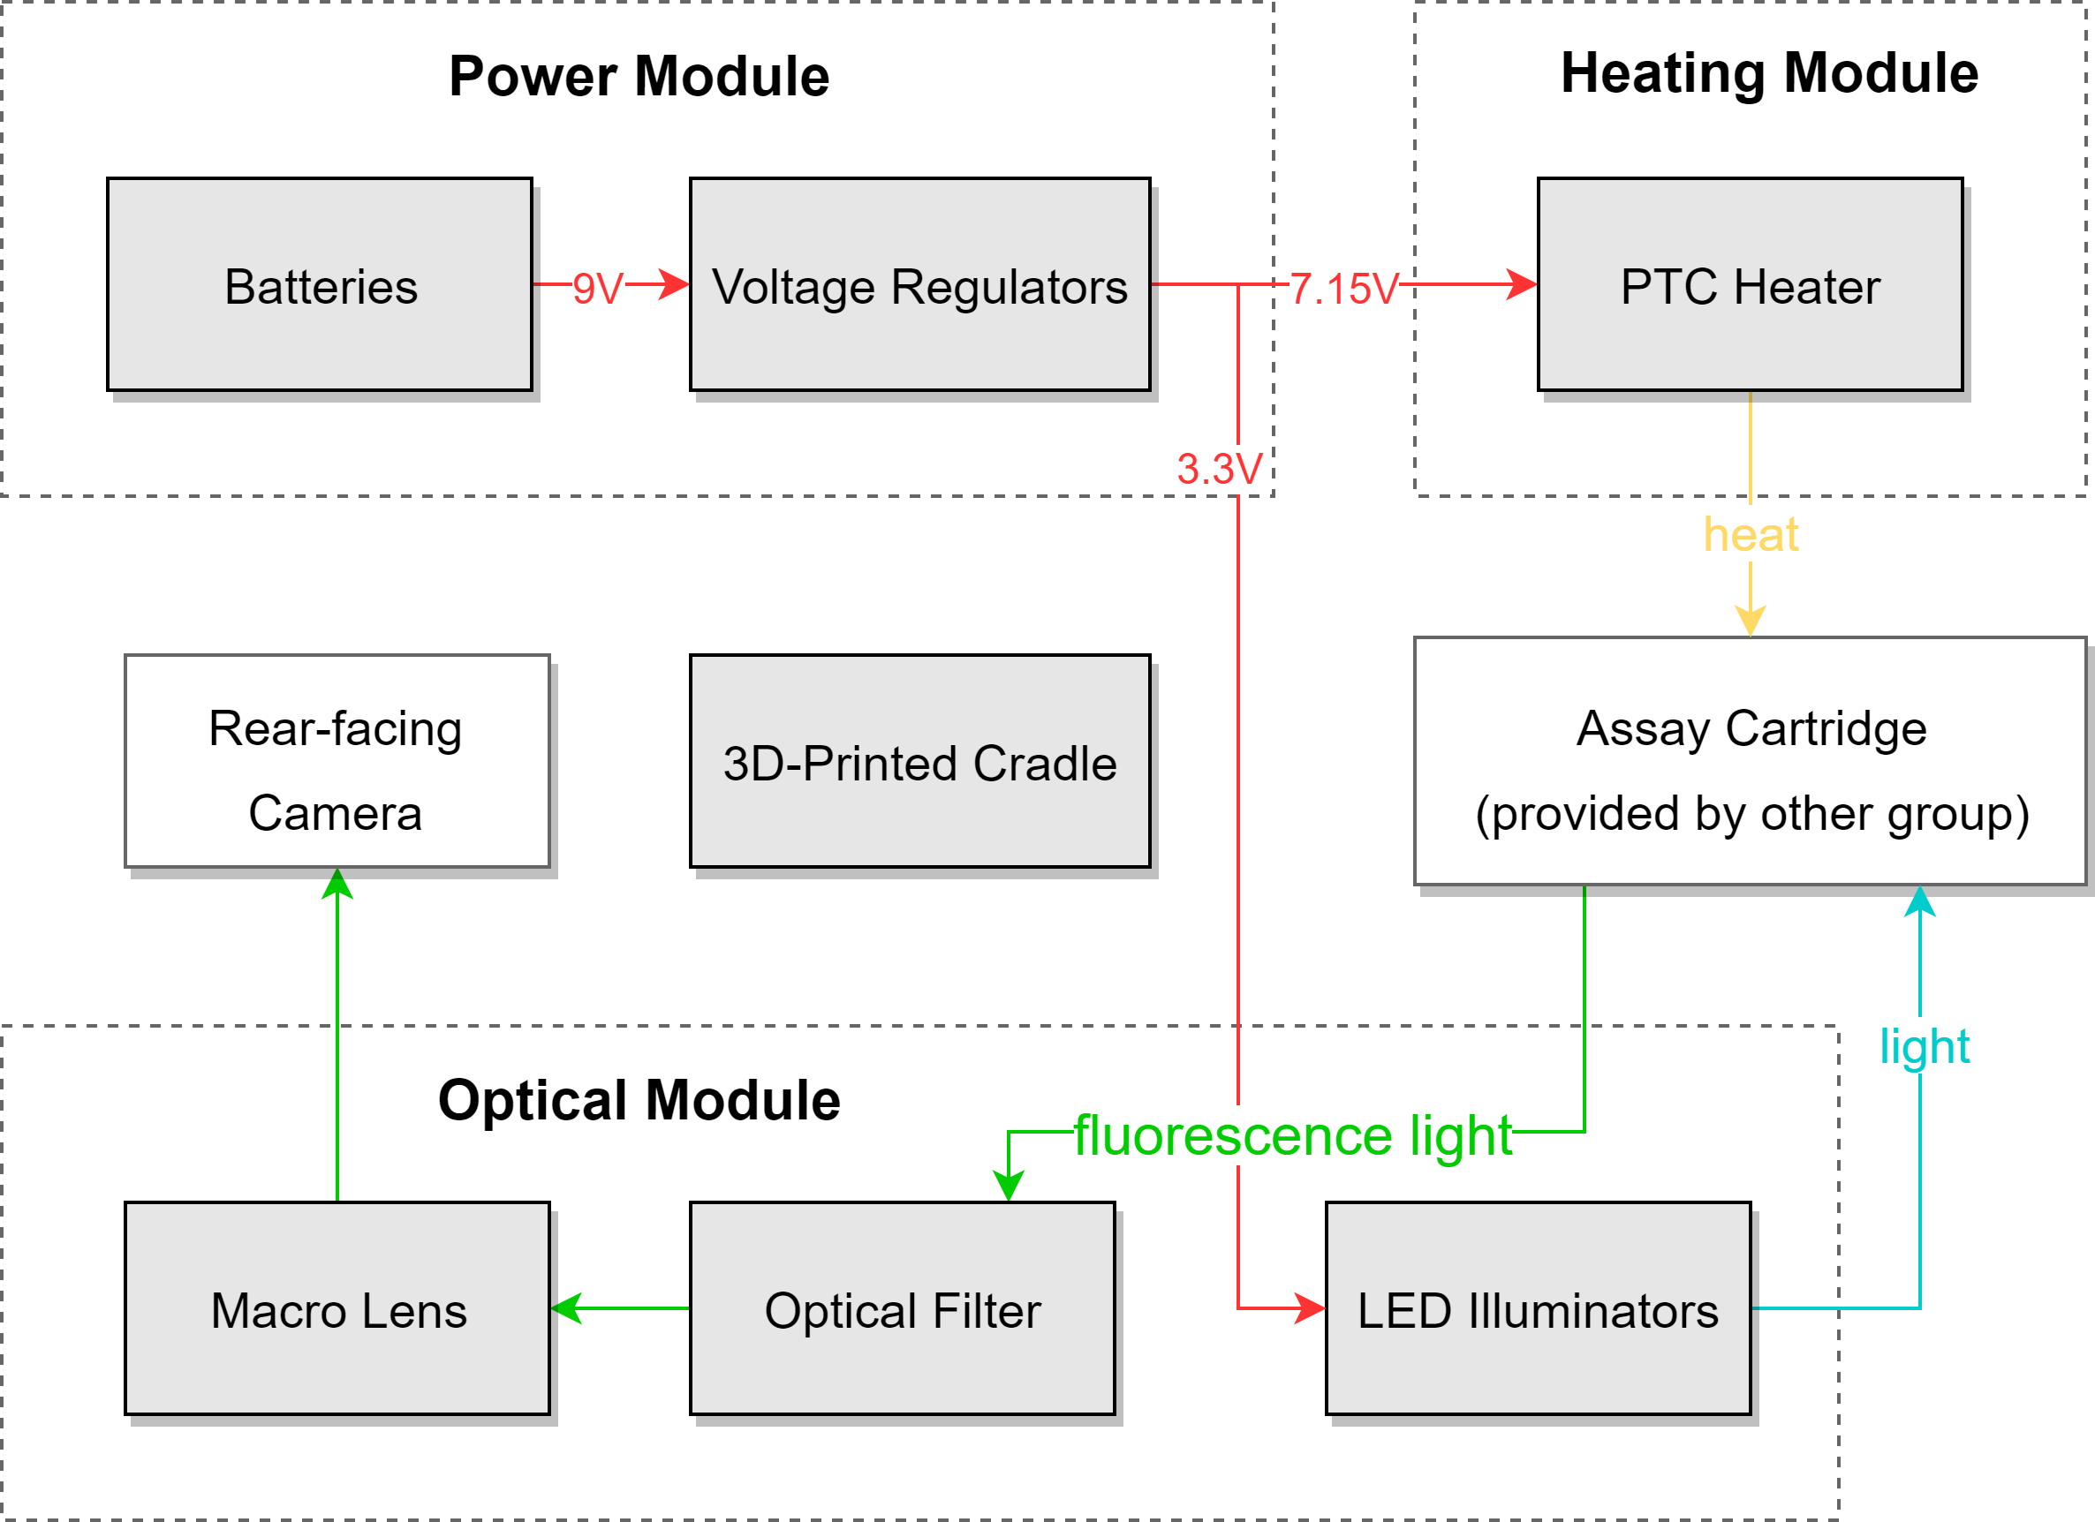
Figure 1: Block Diagram for our project
As Figure 1 shows, the design is divided into three modules: the power module, the heating module, the optical module, and an 3D-printed cradle. The power module provides power of different voltages for different electrical components in the other modules. The heating heats the assay cartridge to a certain temperature so that the reaction is triggered. The optical module lights the cartridge with light of certain wavelength so that the fluorescence is activated and the camera is able to capture the result. The cradle holds the three modules together and encapsulates so that the user won’t accidentally break any parts.

1.5 Visual Aids
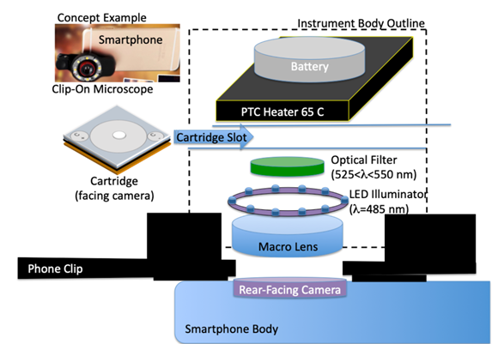
Figure 2: Visual Aid Diagram for our project [4]
Figure 2 gives a visual aid so that the spatial relationship between different parts are clearer. The instrument is comprised of a clip-on macro lens, LED illuminators, an optical filter, a PTC (positive temperature coefficient) heater and rechargeable batteries. The system fits over the rear-facing camera of a smartphone and has a slot to accept the assay cartridge after reagents are added.

2. Design

2.1 Power Module
The power module is comprised of the rechargeable battery and two voltage regulators. For the rechargeable battery, we choose two 9 V battery with 750 mAh. We choose two batteries because it can ensure that the LEDs and PTC heater have adequate power to last more than 30 minutes. For the PTC heater, we choose the linear regulator to provide the desired voltage. The alternative approach is to use a switching regulator. Since the PTC heater needs very accurate voltage input, the linear regulator with higher accuracy is desirable in this scenario. For the LEDs, we choose to use switching regulator because they do not require accurate voltage inputs. The linear regulator is not desirable because its efficiency in power is very low.
For the design of rechargeable batteries, we calculate the theoretical time that the components can last. Specifically, the time that a component could last is
$t=\frac{E}{P_{c}} (1)$
where E is the total energy of the battery, $P_{c}$ is the power of the component. Using Equation (1), we can know by calculations that the PTC heater could last for around 180 minutes and the LEDs could last for around 600 minutes. Theoretically, we could just use one battery to provide power for both PTC heater and LEDs. However, we choose to use two batteries for easier implementations. This design could definitely be improved by using only one battery.
For the design of the linear regulator, we choose the ISL80410 linear regulator [5] because it has ±1 accurate voltage reference. Although there are other linear regulators that consume less power, the accuracy of this linear regulator is the best among all. As shown in Figure 3, the output voltage of the linear regulator depends on the choice of two external resistors.
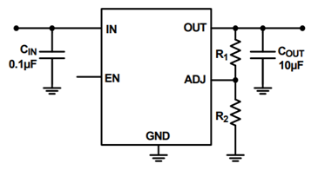
Figure 3: Linear Regulator Schematic

Specifically, the relationship between the output voltage and the resistors is
$V_{out}=1.233V×(\frac{R_{1}}{R_{2}}+1)$ (2)

where $V_{out}$ is the output voltage and $R_{1}$, $R_{2}$ are the external resistors.
Since the desired voltage for PTC heater is around 7.15 V, we can calculate the ratio to be around 4.8 from the Equation 2. We choose $R_{1}$ to be 2000 Ohm and $R_{2}$ to be 412 Ohm since these resistors are not too large to badly influence the efficiency.
For the design of the switching regulator, we choose the LMR23625 switching regulator [6] because it provides 2.5-A continuous current. Although there are other switching regulators that have even higher efficiency, they cannot provide adequate current for the LEDs. As shown in Figure 4, the output voltage of the switching regulator depends on the choice of external resistors, capacitors and inductors. The data sheet lists out the recommended resistors, capacitors and inductors to achieve a stable 3.3 V output. Specifically, we choose to use the components listed in Table 1.
Table 1: Switching Regulator Components Specifications
$C_{in}$ ($μF$) | $$C_{VCC }(μF)$$ | $$C_{boot} (μF)$$ | $$L (μH)$$ | $$C_{out} (μF)$$ | $$R_{FBT }(KΩ)$$ | $$R_{FBB} (KΩ)$$ | $$C_{FF} (pF)$$
10 | 2.2 | 0.47 | 2.2 | 47 | 51 | 22.1 | 33

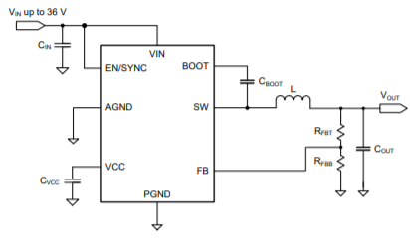
Figure 4: Switching Regulator Schematic

2.2 Heating Module
The heating module contains a PTC heater. The heater should heat up to 65 °C and remains in that temperature with a tolerance of 3 °C for at least 30 minutes. The alternative approach is to design a control loop using a thermal sensor. However, we choose to use PTC heater because it is simple to implement and verify. To determine the desired voltage, we measure the relationship between the PTC heater’s temperature and its voltage.

Table 2: Voltage vs Temperature for PTC Heater
Voltage (V) | Temperature(°C)
4.00 | $$50.0±0.5$$
5.00 | $$55.0±0.5$$
6.00 | $$60.5±0.5$$
7.00 | $$63.5±0.5$$
7.08 | $$64.5±0.4$$
7.15 | $$65.5±0.3$$
7.22 | $$65.7±0.2$$
7.25 | $$66.0±0.3$$
7.50 | $$66.8±0.2$$
8.00 | $$67.5±0.5$$
9.00 | $$69.5±0.5$$

Table 2 shows that the temperature of PTC heater increases as the voltage increases. As shown in Table 1, the optimal voltage is around 7.15 V since PTC heater reaches a temperature around 65 °C at that voltage. The potential issue may be that the voltage regulator could not provide a stable voltage. However, this problem is solved since we choose to use linear regulator with high accuracy.
2.3 Optical Module
The optical module is comprised of a clip-on macro lens set, an optical filter, and an LED ring. For the clip-on macro lens set, we choose a 15X macro lens for shortening the focus distance, and a 0.45X wide-angle lens for making sure the field of view is larger than 40*40 mm, which is the size of the cartridge.
For the optical filter, we firstly chose a bandpass filter with a diameter of 2 inches, which is the diameter of the macro lens, a center wavelength around 530 nm, which is the activation wavelength of the fluorescent dye we use in the LAMP reaction [7], and a FWHM (Full Width at Half Maximum) of at most 20 nm. However, we found that we could place the filter behind the macro lens, between the macro lens and the rear-facing camera of the smartphone, and in this way we can select a much smaller filter, with a diameter of around 0.5 inch, which is the diameter of the camera, and this reduces the cost greatly because the filter is the most precise and the most expensive part in our instrument. The final choice is a bandpass filter with a diameter of 0.5 inch, a center wavelength of 532 ± 2 nm and a FWHM of 10 ± 2 nm.
For the LED ring design, we started with the design of four sets of LEDs on each side of the macro lens, with each set having three LEDs. Later we discovered under this design, the light on different parts of the cartridge is not uniform, so we made a second design with the ring shape PCB as shown in Figure 5, holding the LEDs in a circle shape, which made them have equidistance to the center.
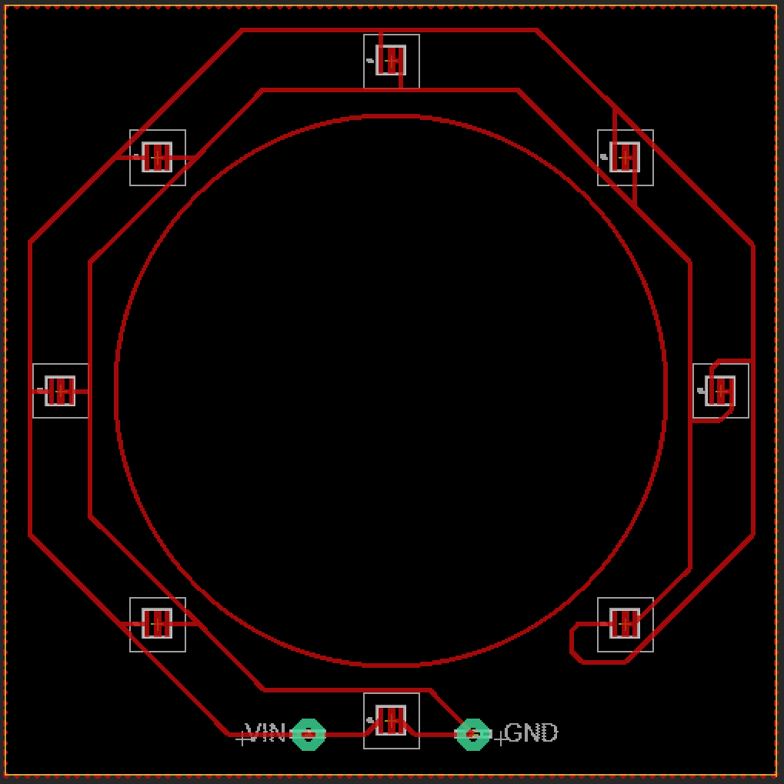
Figure 5: LED Ring Schematic
However, we found out that the high power LEDs we chose were too bright and the contrast was lower because of light saturation, so we switch to the third design, which is also the final design, and it uses seven normal power LEDs soldered together to make a ring.
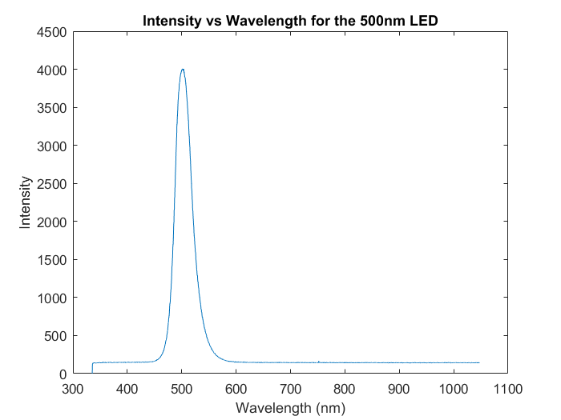
Figure 6: Spectrum of LED with Peak Wavelength at 500 nm
For the LEDs that make up of the ring, we firstly chose LEDs with peak wavelength of 500 nm, which is the activation wavelength of the fluorescent dye, but with the spectrum of the LED shown in Figure 6, we found that there was still a fair amount of intensity at a wavelength of 530 nm, which would make the light from LED and the light from fluorescence nondifferentiable. Therefore, we choose LEDs with peak wavelength of 470 nm, so that there’s still intensity at 500 nm but only a small amount of intensity at 530 nm.

2.4 Cradle
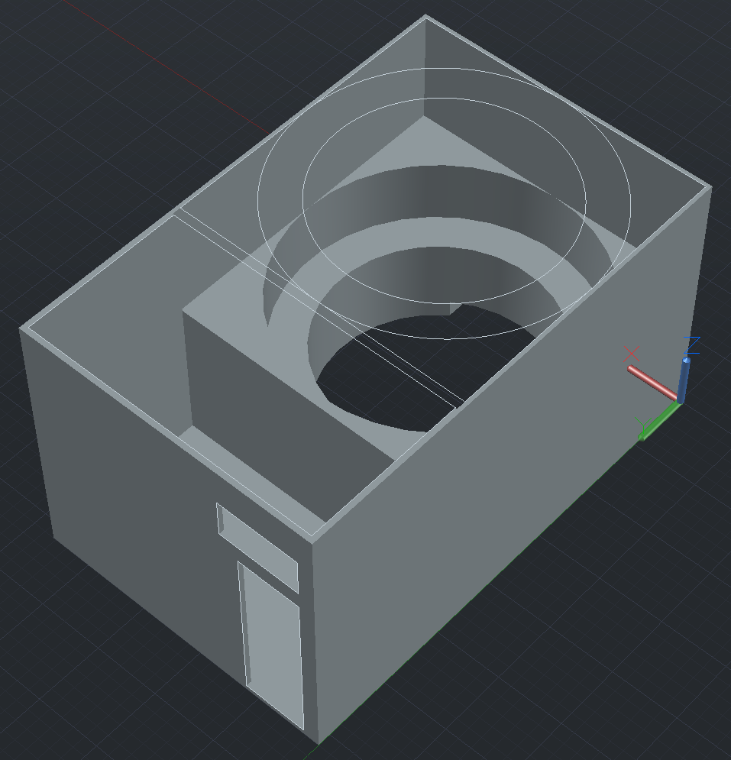
Figure 7: Top Part of the Cradle
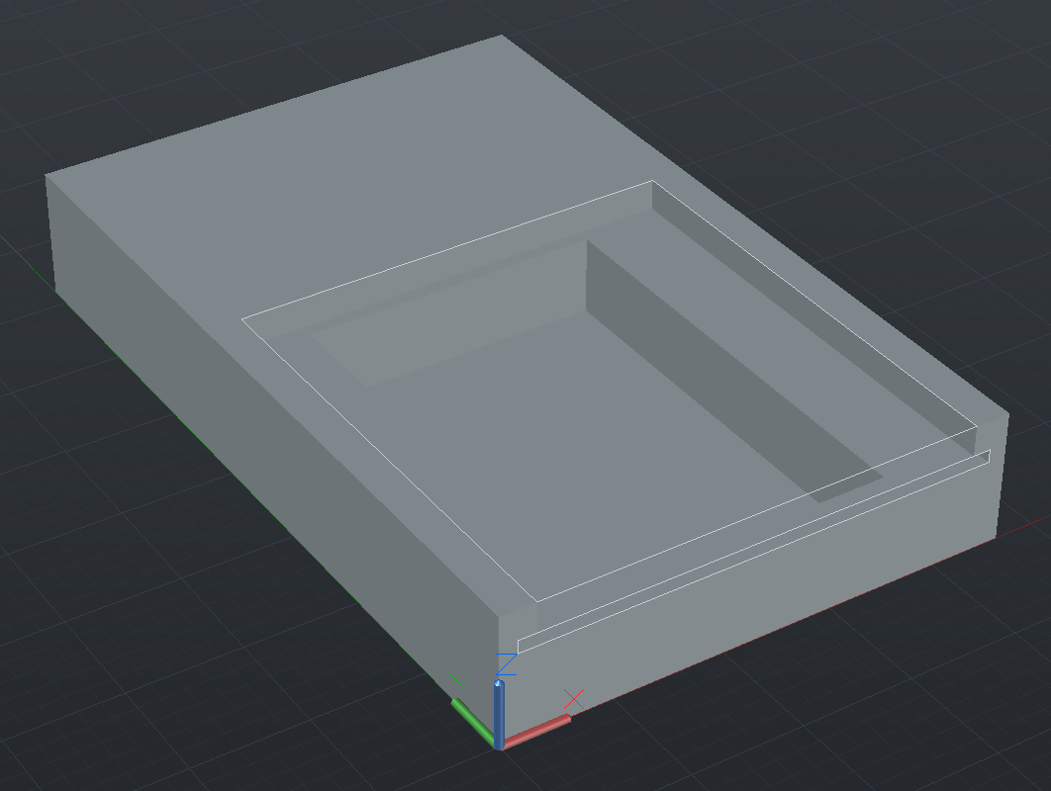
Figure 8: Bottom Part of the Cradle
The cradle is divided into the top part and the bottom part, so that we can assemble the other parts onto the cradle and then stick the two parts of the cradle together. The top part, which is shown in Figure 7, holds the clip-on macro lens set, the LED ring, the PCB (Printed Circuit Board), the switch and the batteries. The bottom part, which is shown in Figure 8, holds the PTC heater, and has a slot for taking the assay cartridge. It’s 3D-printed using dark color, non-fluorescent material to minimize the disturbance to the lighting.

3. Design Verification

3.1 Power Module
For the power module, we need to verify whether or not the batter and the regulators could provide correct voltages for the PTC heater and LEDs. For the linear regulator, we need to verify that its output voltage should be within 7.15 ± 0.03 V. Table 6 in Appendix provides details about the requirements and verification procedures for the linear regulator. Figure 9 shows the tested output voltage of the linear regulator following the verification procedure in Table 6 in the Appendix. The red lines in Figure 9 are at 7.12 V and 7.18 V respectively. As shown in Figure 9, the output voltage of linear regulator rises to around 7.15 V in less than 5 minutes, and then it stays within the range for about 40 minutes. Therefore, the requirement for linear regulator is met.

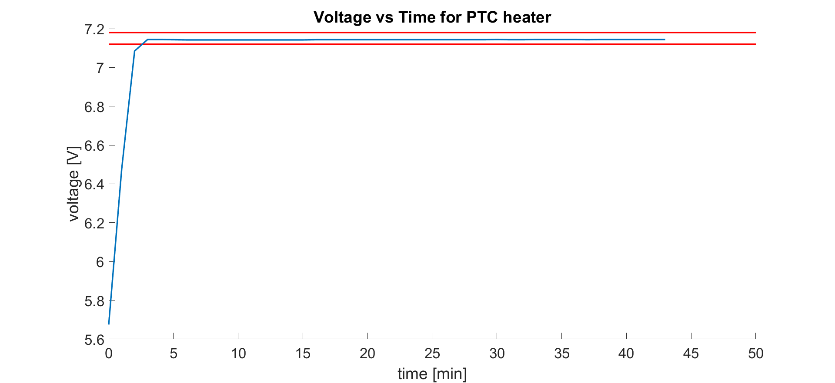
Figure 9: Voltage vs Time for PTC Heater

For the switching regulator, we need to verify that its output voltage should be within 3.3 ± 0.3 V. Table 6 in Appendix provides details about the requirements and verification procedures for the switching regulator. Figure 10 shows the tested output voltage of the switching regulator following the verification procedure in Table 6 in the Appendix. The red lines in Figure 10 are at 3.6 V and 3.0 V respectively. As shown in Figure 10, the output voltage of linear regulator rises to around 3.4 V in less than 5 minutes, and then it stays within the range for about 40 minutes. Therefore, the requirement for linear regulator is met. Compared with Figure 9, the curve in Figure 10 has more fluctuations because the switching regulator is noisier.
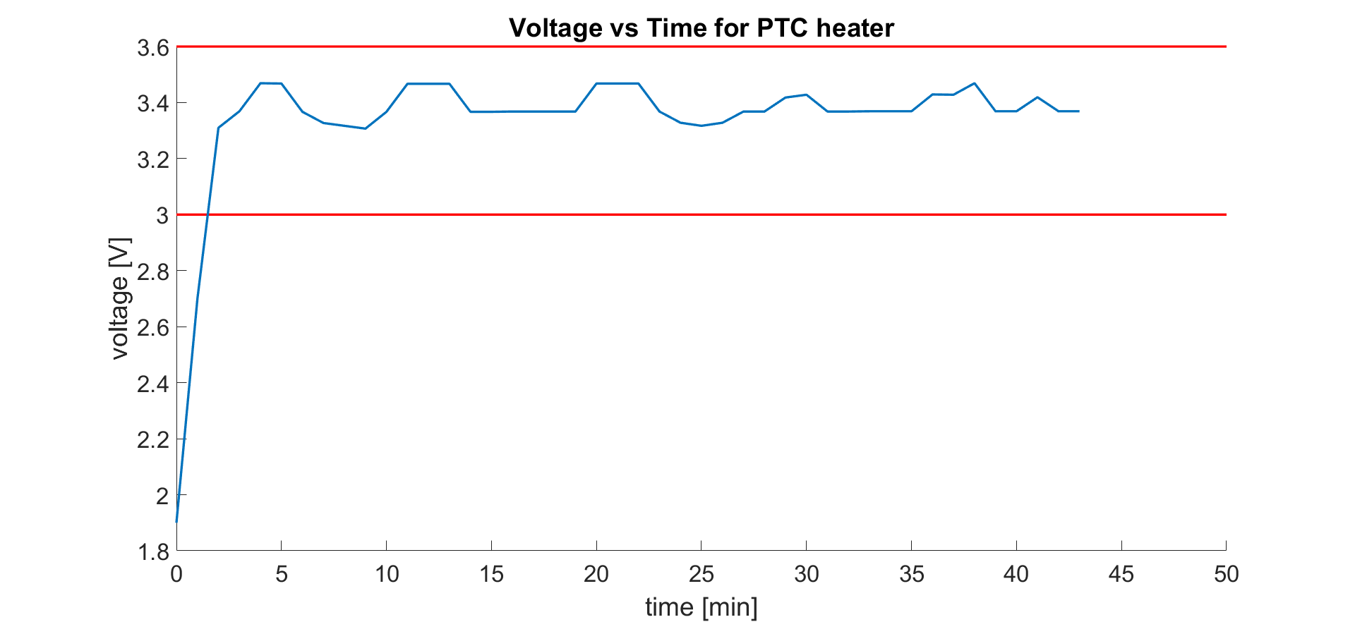
Figure 10: Voltage vs Time for LED

3.2 Heating Module
For the PTC heater, we need to verify that its temperature should remain at 65 ± 3 °C. Table 7 in Appendix provides details about the requirements and verification procedures for the PTC heater. Figure 11 shows the tested temperature of PTC heater following the verification procedure in Table 7 in the Appendix. The red lines in Figure 11 are at 66°C and 64 °C respectively. As shown in Figure 11, the temperature of PTC heater rises to around 65 °C in less than 8 minutes, and then it stays within the range for about 35 minutes. Therefore, the requirement for PTC heater is met. The result also shows that the PTC heater performs better than the requirement since it can remain at 65 ± 1 °C.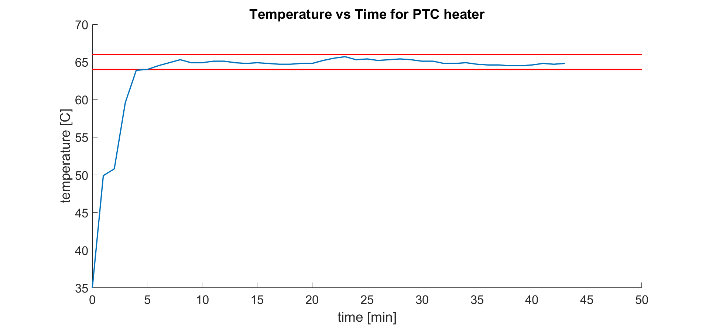
Figure 11: Temperature vs Time for PTC Heater
3.3 Optical Module
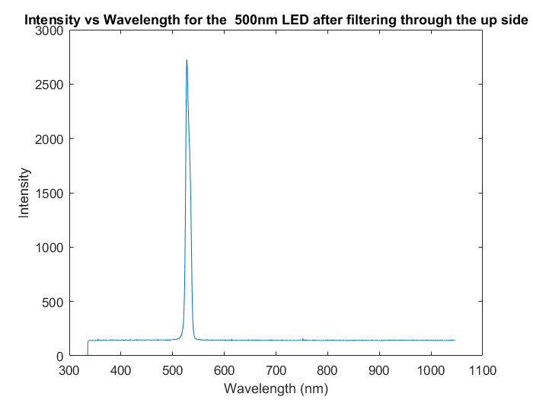
Figure 12: Filter Spectrum from the Upside
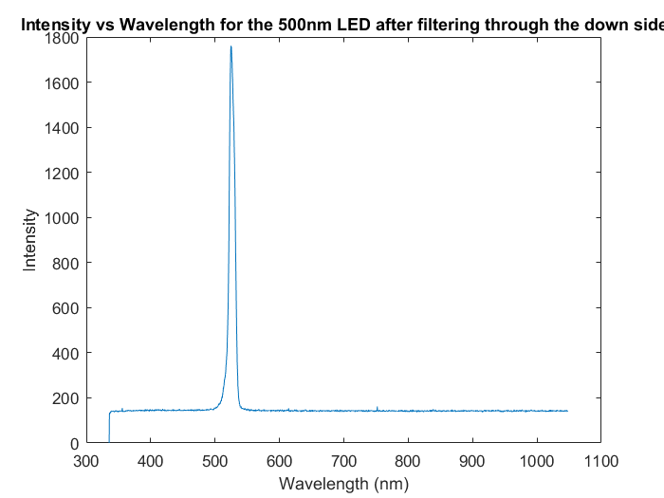
Figure 13: Filter Spectrum from the Downside
For the optical module, the first test is the wavelength of light passing through the optical filter. Figure 12 shows the spectrum of the light going through the filter from the upside, and Figure 13 shows the spectrum of the light going through the filter from the downside. In both figures, we can see the center wavelength is around 530 nm and the FWHM is around 10 nm.
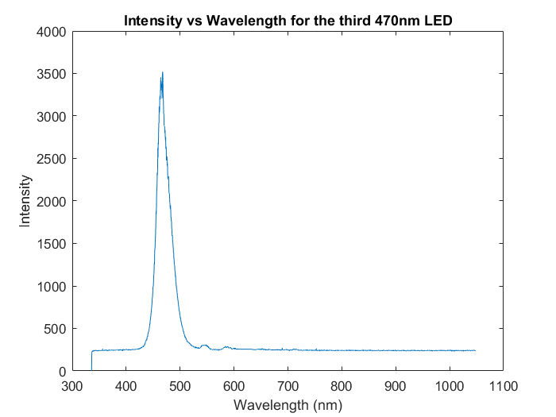
Figure 14: Spectrum for LED with Peak Wavelength at 470 nm
The second test is the wavelength of the LED. From Figure 14, we can see the peak wavelength of the LED is around 470 nm. However, the intensity at 530 nm is not zero, which gives some noise to the detection. It’s discussed more detailed in section 5.2 and 5.4.
For the verifications in Table 8 from the Appendix, the first verification is tested, with the focus distance of 20 mm or 0.79 inch. The second verification is not tested because of lack of time, but the tests of the passing spectrum of the filter and the spectrum of the LED should do similar work. The third verification is tested, with the field of view of 54*54 mm.
4. Costs and Schedule
4.1 Parts
Table 3: Parts Costs
Category | Brand | Quantity | Price (in dollars)
Macro lens set | AUKEY | 1 | 17.99
Battery | Blackube | 2 | 24.99
Filter | Thorlabs | 1 | 51.14
PTC heater | Uxcell | 1 | ~ 5.00
LED | Cree Inc. | 7 | 1.33
Voltage Regulator | Texas Instruments, Renesas / Intersil | 2 | 4.60
Resistor | Panasonic | 4 | 3.42
Capacitor | KEMET, AVX | 7 | 7.98
Inductor | Murata Electronics | 1 | 0.90
Switch | ECE Shop | 1 | ~ 0.50
PCB | PCBway | 1 | ~ 1.00
Cradle | Innovation Lab | 1 | ~ 3.00
Total |  |  | ~ 121.85

4.2 Labor
Table 4: Labor Costs
Name | Hourly rate  (in dollars) | Hours per week | Number of weeks | Total  (in dollars)
Yunxiao Diao | 10 | ~ 15 | 7 | 1050
Qingxi Meng | 10 | ~ 15 | 7 | 1050
Total |  |  |  | 2100

4.3 Schedule
Table 5: Schedule
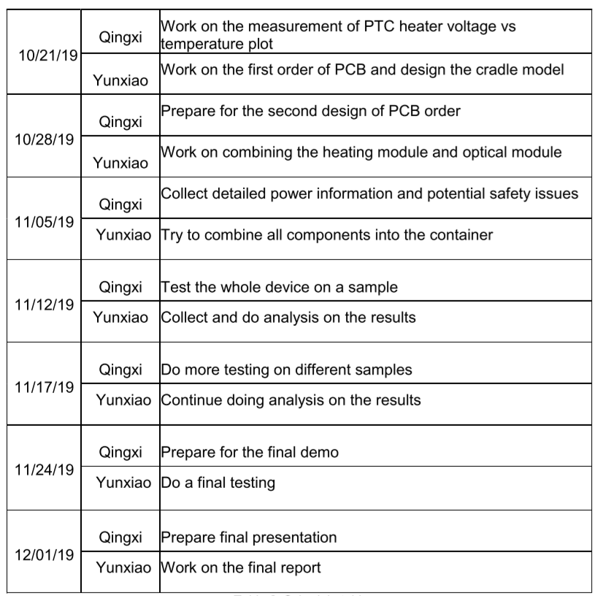

5. Conclusion

5.1 Accomplishments
Overall, we succeed in finishing the project by meeting most of the verifications. For the power module, both the linear and switching regulator meet the requirements by providing correct voltage within the tolerance. For the heating module, the PTC heater meet the temperature requirement within the tolerance. Also, the PTC heater meets the time requirement and lasts more than 30 minutes. For the optical module, the focus distance and the field of view requirements are met, and a clear footage is captured.
Our final product could heat up the testing sample and trigger the LAMP reaction for more than 30 minutes. Furthermore, our final product allows the user to capture a clear footage of the testing results.

5.2 Uncertainties
One of the unsatisfactory results is that we can still see undesirable lights from LED on the captured image. This is caused by the fact that the LED lights still pass partially through the optical filter. The intensity of the LED at 530 nm wavelength is around 5%, which is still too large. Since our optical filter has a center wavelength at 530 nm, the unfiltered lights from LED will greatly affect the quality of image.
Another unsatisfactory result is that the PTC heater rises to the desired temperature in around 8 minutes. Although the rising speed is not listed in our requirements, the long rising time is not desirable. Since the whole reaction only requires about 30 minutes, the rising time of PTC heater is more than a quarter of the reaction time.

5.3 Ethical considerations
We need to examine all aspects of IEEE Code of Ethics [8] that are relevant to our project. The IEEE Codes of Ethics #2 states that “to avoid real or perceived conflicts of interest whenever possible, and to disclose them to affected parties when they do exist”. Since we work closely with the patients’ health information related to HIV, we need to disclose that information and make them only available to the patients and related doctors. We need to make sure that we will not send those data to other interested parties who may utilize that private information for their own purposes. If the private information of patients is leaked to parties with interest of conflict, our plan is to inform the patients immediately and try our best to invalidate the leaked data. In addition, the IEEE Codes of Ethics #9 states that “to avoid injuring others, their property, reputation, or employment by false or malicious action”. In our case, we need to make sure that our product will not do harm or injury to the user. For example, the user may heat the PTC heater to the wrong temperature so that the heater may possibly burn the users. In order to prevent this, we will add some protections in the future that can cut off the power if the heater overheats. Another mitigation plan is to use LED indicator to warn the user once the heater exceeds the normal temperature.

5.4 Future work
There are some future improvements to be made for our project. First of all, we could use the thermal sensor to design a control loop to control PTC heater’s temperature more accurately. Now we just manually find the desired voltage for the PTC heater. However, the temperature of the PTC heater is subject to the environment changes. Using control looping could be more robust to the external changes.
Another improvement to be made is that we use one more filter to filter the LED lights. Now we could still see undesirable noise from LED lights in the captured image. A shortpass filter designed specifically for the LEDs could ensure that nearly no lights from LEDs could affect the captured image.
In addition, we need to change the voltage regulators in the future. Since the design for the cartridge is not fixed, we need to adapt our design accordingly in the future. Specifically, we need to change the resistors for the voltage regulator when a slightly different temperature is desired.

References

[1] HIV & AIDS, Pathfinder International. Available at: https://www.pathfinder.org/focus-areas/hivaids/?gclid=EAIaIQobChMIzNyE2YDR5AIVeSCtBh3ADwImEAAYASAAEgL-lvD_BwE.
[2] P. Smith, M. Wallace, L. -G. Bekker, Adolescents’ experience of a rapid HIV self-testing device in youth-friendly clinic settings in Cape Town South Africa: a cross-sectional community based usability study, Journal of the International AIDS Society, vol. 19, no. 1, p. 21111, 2016.
[3] Contrast (vision). Available at: https://en.wikipedia.org/wiki/Contrast_(vision). Accessed September 2019.
[4] W. Chen, H. Yu, F. Sun, A. Ornob, R. Brisbin, A. Ganguli, V. Vemuri, P. Strzebonski, G. Cui, K. J. Allen, S. A. Desai, W. Lin, D. M. Nash, D. L. Hirschberg, I. Brooks, R. Bashir, B. T. Cunningham, Mobile Platform for Multiplexed Detection and Differentiation of Disease-Specific Nucleic Acid Sequences, Using Microfluidic Loop-Mediated Isothermal Amplification and Smartphone Detection, Analytical Chemistry 2017 89 (21), 11219-11226.
[5] ISL80410, 40V, Low Quiescent Current, High Accuracy, 150mA Linear Regulator, Available at: https://www.mouser.com/datasheet/2/698/isl80410-1529524.pdf.
[6] LMR23625CFDDAR Texas Instruments: Mouser.” Mouser Electronics, 1.5A Switching Regulator, Available at: https://www.mouser.com/ProductDetail/Texas-Instruments/LMR23625CFDDAR?qs=sGAEpiMZZMsMIqGZiACxISRTt%2ByaBpL/FKNY69VNdcQbvjwNQk%2Bzqg==
[7] Biotium, Evagreen Dye, Available at: https://biotium.com/product/evagreen-dye-20x-in-water.
[8] Ieee.org, "IEEE Code of Ethics", 2016. [Online]. Available at: http://www.ieee.org/about/corporate/governance/p7-8.html. [Accessed: 29- Feb- 2016].

Appendix A Requirement and Verification Table
Table 6: Requirements and Verifications for Power Module
Requirements | Verifications
- Linear regulator circuit provides an output voltage of 7.15V ± 0.03V as required by the heater component. | - Assemble the circuit as shown in figure 3 with R₁/R₂ ≈ 4.85, connect 9V bench output to the V_{in}, and a voltmeter to V_{out}.  - Ensure that the output voltage remains 7.15V ± 0.03V for the time span of 30 minutes.
- Step-down switching regulator supplies an output of 3.3V ± 0.3V as required by LEDs. | - Assemble the circuit as shown in figure 4, connect 9V bench output to the Vin, and a voltmeter to the V_{out}.  - Ensure the output voltage is 3.3V ± 0.3V.

Table 7: Requirements and Verifications for Heating Module
Requirements | Verifications
- With the battery connected, the PTC heater remains in 65°C ± 3°C for at least 30 minutes. | - Connect the heater to a 7.15V bench output, wait 3 minutes for it to heat up.  - Measure the surface temperature of the PTC heater at 4 corners and the center using a thermometer for 30 minutes, ensure the temperature falls in the range of 65°C ± 3°C.

Table 8: Requirements and Verifications for Optical Module
Requirements | Verifications
- The focus distance of macro lens should be within 1 inch. | - Clip the micro lens on the rear-facing camera of the phone.  - Looking through the phone’s camera and see whether there is a clear image at 1 inch.
- The luminance contrast between the foci of fluorescence and background should be higher than 1.5. | - Use a 3D-printed fake cartridge with florescent Evagreen dye, which is the same dye we use for the LAMP reaction, inside of the cartridge.  - Power the LEDs with 3.3V bench output, clip the micro lens and the filter to the phone’s camera, and take several photos of the fake cartridge using phone’s camera.  - Use simple python program to extract the RGB data of the images, calculate the corresponding luminance and contrast, ensure that the average contrast between foci and background is above 1.5.
- The field of view should be bigger than 40*40 mm, which is the size of the cartridge, at the distance of 1 inch. | - Clip the micro lens on the rear-facing camera of the phone.  - Draw a square of 40*40 mm on paper, put the macro lens 1 inch from the paper, and see whether we can see the square through the phone’s camera.

