Off-grid Photovoltaic Generator (MDR)

Team 36 - Robert Parkinson, Jack Shea, Ruben Chairez
ECE 445 - Project Proposal - Fall 2018
TA: Zhen Qin

1 Introduction
1.1 Objective
With today's increase in technological dependence, humans require power for more purposes than ever before. Some of these purposes include home projects such as smart gardens, heated/cooled dog houses, etc. which are typically on homeowner’s property but away from the electrical grid. Current solutions such as fossil fuel generators, or extension cords have certain drawbacks including carbon footprint, control, & safety. In addition, many people are drifting away from the use of fossil fuels and are pursuing a greener solution. Figure_1 [1] shows how the use of renewable resources has grown over the years, which suggests that there are more potential users for our product as years pass.

Our project offers the ideal solution to these semi-remote home projects by delivering off-grid solar energy within 20 feet of a weatherproof location with wi-fi connection. It supplies enough energy to feed low power projects such as those mentioned previously & many more. It also gives customers the option to remotely monitor the capability & reliability of the solar system by offering real time information available on the web. This web interface also allows the user to switch loads on & off and to add preference on load priority in order that the system can optimize the power distribution.

1.3 High-Level Requirements
- The unit must provide 250Wh on average per day and last 2 days without any sun.
- The unit must transmit data to the user via Bluetooth and Wi-Fi depicting the performance of the solar panels, charge of the battery & draw from the loads.
- The user must be able to control the power being supplied to the outlets & add load preferences in order to optimize the power being delivered.

2 Design
2.1 Block Diagram
As shown in Figure 2.1, this system consists of six main sections. The Solar System/Battery section will consist of the photovoltaic array connected to battery through a charge controller. The power will be fed out of the battery through a DC to AC Inverter to the Relays/Outlets section. The Relay/Outlets section will consist of two solid state relays controlling two outlets based on output from the microprocessor to implement the control & power optimization. The Monitoring Circuit section will contain all necessary circuits for monitoring the current battery charge, solar panel output, and the power drawn from each load. It will then step down the readings to low enough levels for the microprocessor to handle. The Microprocessor will perform all the necessary calculations to make the readings real values then use the Bluetooth module to send the data to a raspberry pi which will host the web server. User input data from the web server will then be sent back to the microprocessor where it will be used to control the loads and optimize the power output. The Raspberry Pi and Web/UI sections will work together to act as a server storing and then displaying the measured values and take in the user input then transmit that to the microprocessor.
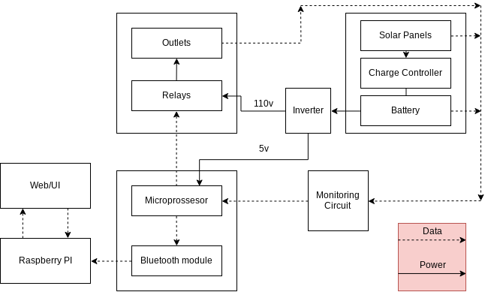
Figure 2.1: Block Diagram

2.2 Physical Design
The panels will have adjustable fold out legs to hold them up while still allowing for relocation and some portability. The main components will be housed in a weatherproof container to protect against rain and snow. Inside the container we will mount the battery, charge controller, and inverter. We will also build a housing for our circuit board that will be mounted to the side of the container to keep it safe from accidental movement. A rough sketch of the project can be seen in figure 2.2.1.

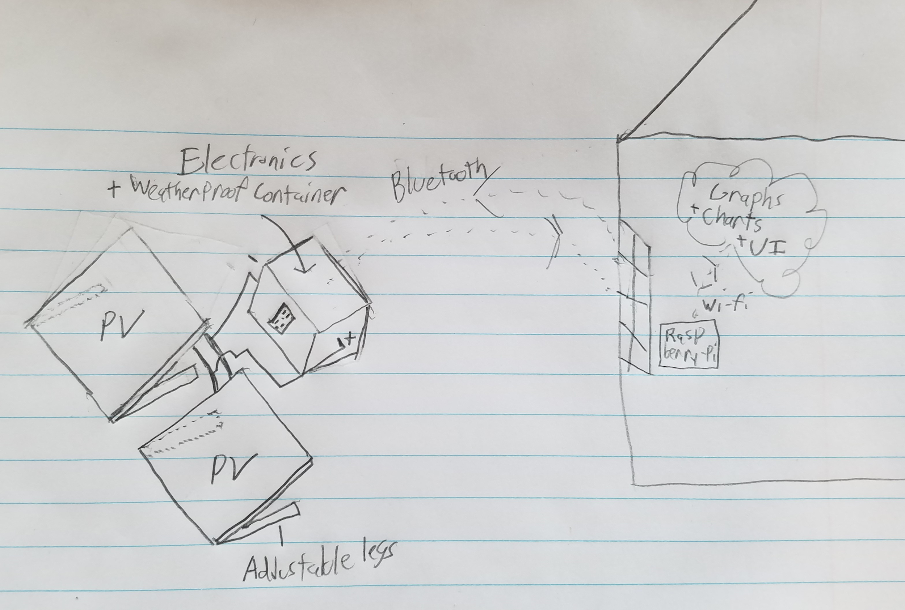
Figure 2.2.1: Physical Design Initial Sketch

2.3 Block Design: Functional Overview, Requirements, Supporting Material (A Few Examples)
2.3.1 Microprocessor/Bluetooth

This block will be entirely implemented on a group designed PCB which with house an ATmega328 microprocessor and a bluetooth module to communicate with other blocks. It will also contain the power circuit needed to take the 12v output from the battery to the 5.5v input needed to run the microprocessor and other components.

Requirements: Obtain all the signals coming from monitoring circuit and convert it to readable data that will be transferred to the raspberry pi and ultimately the user. This module must be able to transmit the data 20 feet (+- 1 foot) from the raspberry pi at the correct baud rate.

Verifications:
For correct distance:
- Run the code to start the bluetooth module and have it start transmitting data.
- Use a bluetooth signal meter app to test the signal strength of the bluetooth module at different distances and record data.
For correct baud rate:
- Start program to transmit data back to the Raspberry Pi.
- Check received data on the Raspberry Pi to make sure it is readable and the same data at the given baud rate

2.3.2 Battery

The battery required for this project will be a 100Ah 12V lead-acid deep-cycle battery.

Requirements:
- Must supply 7-17 volts
- Must supply 250Wh on average per day for 2 days.

Verifications:
- Measure voltage with multimeter at both full and drained charge.
- Hook up a known constant load to a fully charged battery and time how long before it dies.

When sizing our battery, we took the following into consideration:

- Actual Lead Acid Battery Capacity = 50% * rating
- Inverter Efficiency = 85%
- Required Capacity = 250Wh/day * 2 days = 500Wh

500Wh = Nameplate Capacity * .5 * .85
Nameplate Capacity = 1180Wh or 98 Ah at 12VDC

2.3.3 Solar Panels

The solar array will consist of 2 100W monocrystalline panels.

Requirements:
- Must supply 100W in direct sunlight.
- Must be self standing & adjustable for different angles.

Verifications:
- Take panel out on sunny day and measure current/voltage.
- Demonstrate that the panel self stands at angles from 30 - 80 degrees.

In order to size the solar array for our project, we took the following into consideration:

- The average hours of direct sunlight in Illinois is 3.14hrs.
- ^(https://www.turbinegenerator.org/solar/illinois/)
- The charge controller efficiency is 80%
- The panels on average should supply twice the daily load (2 * 250Wh = 500Wh)

500Wh = 3.14 * Power Rating * .8
Power Rating = 199W

2.3.7 Monitoring Circuit

The monitoring circuit will require 3 30 amp (AC/DC) current sensors. It also will require resistors, and capacitors for the current sensing circuits as well as a voltage divider circuits for safely monitoring the charge of the battery. The current sensors & their required circuitry will have direct connections or adapters on our PCB.

Requirements:
- Voltage Monitoring Circuit: Readings are within 0.5v of the actual value and are stepped down to within 0-5v so that the microprocessor can read the values.
- AC Current Sensors: Readings are within .2A of actual value.
- DC Current Sensors: Readings are within .5A of actual value

Verifications:
To test if the readings meet designated range:
- Use a multimeter to test the voltage and current of the different measurement locations and check the values with the computed values from the monitoring circuit.

For the voltage monitoring circuits, we needed to “step-down” the voltage from the solar panels & battery to 0-5V in order to protect the microprocessor. We used a simple voltage divider circuit with high value resistors to reduce power waste & a small capacitor to keep the readings steady. The circuit can be seen in figure 2.4.2. The max battery voltage is 17V which calls for R1/R2 = 12/5 and the max PV voltage is 23V which calls for R1/R2 = 18/5.

2.4 Schematics
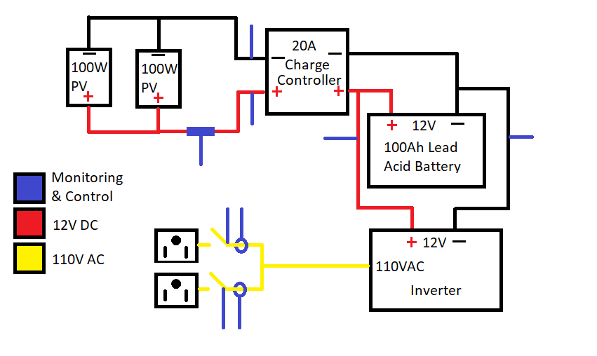
Figure 2.4.1: Solar Circuit Schematic

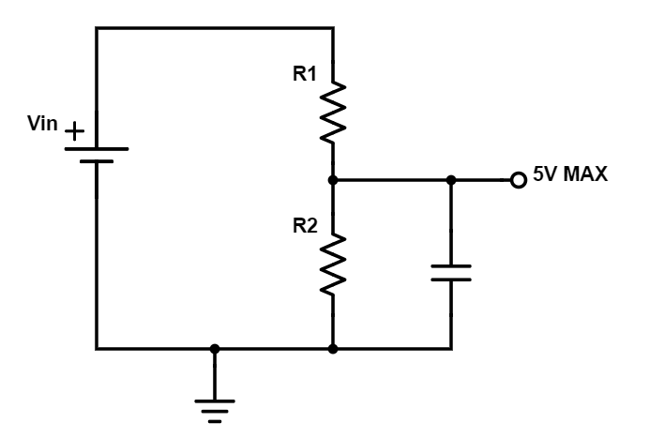
Figure 2.4.2: Voltage Monitoring Circuit
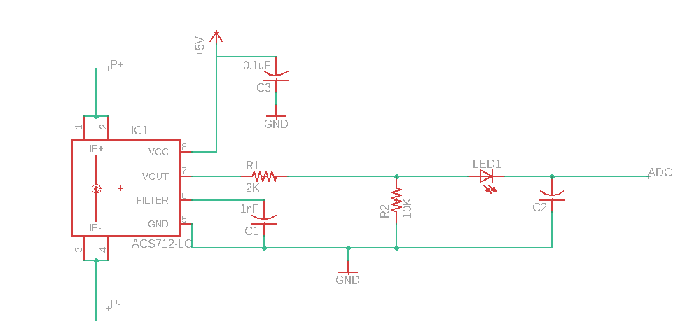
Figure 2.4.3: Current Sensor Circuit

4 Ethics and Safety

Because we are using a deep cycle lead-acid battery in our project, we will refer to IEEE 931-2007 “IEEE Recommended Practice for Installation and Maintenance of Lead-Acid Batteries for Photovoltaic (PV) Systems” when installing & working with the battery. In addition, we will include standard operating procedures for the battery in our final report. We will also add a fuse and insulated disconnect switch to the battery for safety.

The project is intended to be used outdoors so we will need to take special care to make sure the housing is element proof and can protect the internal components. We will accomplish this by making sure our housing is waterproof and only using components that are rated to withstand the wide range of temperatures they might be subjected too.

The overall project will follow the following IEEE Code of Ethics [2].

Code 1: All of our electrical components, minus the solar panels, will will be stored in a weather proof container that will have all the dangers of high power batteries insulated.

Code 2: This code does not apply since this project is for ECE 445 and we do not have any conflicts of interests.

Code 3: We provide quantitative claims with ranges due to the variability of our idea, but plan on building and testing all of our components before finalizing product claims.

Code 4: The project is not sponsored so we will not be accepting any bribery.

Code 5: The reason for pursuing our idea is for society to have the knowledge and access to renewable energy.

Code 6: Every member of our group has successfully completed the lab safety module and all offer experience in fields required to successfully implement this idea.

Code 7: This code is satisfied by the TA’s and professor’s comments and criticism while helping us properly complete our project.

Code 8: Our team consist of diverse members with different backgrounds and experience who offer a unique point of view for all aspect of our project.

Code 9: The safety of everyone is always a concern for our group and we plan on creating our idea properly and following all suggested guidelines.

Code 10: Our team is motivated to achieve our goals and understand that knowledge share and skills development is required by all of us to successfully build our idea.

References
[1] “Home.” CRYPTO News, www.stupen.com/markets-news/the-world-set-a-new-record-for-renewable-power-in-2017-but-emissions-are-still-rising/.

[2] “IEEE Code of Ethics”, ieee.org, 2017. [Online]. Available: http://www.ieee.org/about/corporate/governance/p7-8.html

[3] Solar Energy Industries Association, “Solar Industry Research Data.” (n.d.). [Online]. Available: from https://www.seia.org/solar-industry-research-data
[4] Standards.ieee.org. (2018). IEEE 937-2007 - IEEE Recommended Practice for Installation and Maintenance of Lead-Acid Batteries for Photovoltaic (PV) Systems. [online] Available at: https://standards.ieee.org/standard/937-2007.html [Accessed 2 Oct. 2018].

