Final Report for ECE 445, Senior Design, Spring 2018
TA: Kexin Hui
2 May 2018
Project No. 65
Edward Wang
Jerry Pitts

By

Bike Safety Sensor
Abstract
This report contains the details of our bike safety sensor’s design. It describes the different components and design decisions we used to create the final product. It will explain how we used the lidar sensors, ultrasonic sensors, servo motor, and vibration motors in detail. Software design is also explained in this report. The requirements and verifications are included in tables with tests to show the verifications.

Contents

1. Introduction 1
1.1 High Level Description 1
2 Design 2
2.1 Power Module 2
2.1.1 Voltage Regulator 2
2.1.2 Battery 3
2.2 Sensor Module 3
2.2.1 Lidar Sensor 3
2.2.2 Rotating Motor 4
2.2.3 Ultrasonic Sensor 5
2.3 Feedback Module 5
2.3.1 Vibrating Motors 5
2.4 Control Module 5
2.4.1 Microcontroller 5
4. Costs 7
4.1 Parts 7
4.2 Labor 7
5. Conclusion 8
5.1 Accomplishments 8
5.2 Uncertainties 8
5.3 Ethical considerations 8
5.4 Future work 8
References 9
Appendix A Requirement and Verification Table 10
Appendix B Circuit Diagram and Pictures 12

1. Introduction
The streets are a busy place, and it is impossible to be looking all around you at once. There could be a car approaching on your left while you are distracted by a flying newspaper. You could be so confident in your turns that you don’t notice the trash bin right beside you. There are many dangers that exist on the open road, some coming at you directly and some unable to be moved by the impact of your bike.
Our solution to this problem is a belt with haptic feedback that will detect objects behind and to the side of you to give you a better idea of where the dangers are. This belt will vibrate when a car pulls up beside you or if you’ve stopped by a garbage can without noticing. The vibrations get stronger the closer the object is to give you a better idea of how imminent the dangers are. You no longer need to look around aimlessly trying to find every roadblock as this belt will tell you where they are.
There are other options to solve this problem currently on the market, but they are very expensive. One example is a radar sensor that costs around three hundred dollars. The radar device also uses a display system to show when objects are detected, which we looked to improve on by using haptic feedback instead. Haptic feedback would allow the user to keep focusing on the road and use the sense of feeling to get feedback from the device. Our device would also be much cheaper, because one lidar device is much less expensive than the radar sensor. The rotating motor allows for one lidar to detect a range behind the bike.

High Level Description
The purpose of this device is to be able to detect approaching objects using the sensors and give feedback to the rider in the form of vibrations. The original requirements for the device are:
- Detect objects from 1 to 12 meters away and alert user based on distance
- Have range of 60 degrees in 1d when measuring objects within 1 m around the wearer and detect 3 lanes of traffic (3.7 m each) up to 12 m behind the wearer
- Cost less than current commercially available radar sensor ($300)
- Run for at least 4 hours on a single charge

Some of these requirements changed during the development of our project when we learned more about the sensors and microchip. The detection range changed to 7 meters because the range of the lidar changes in the daylight.

2 Design
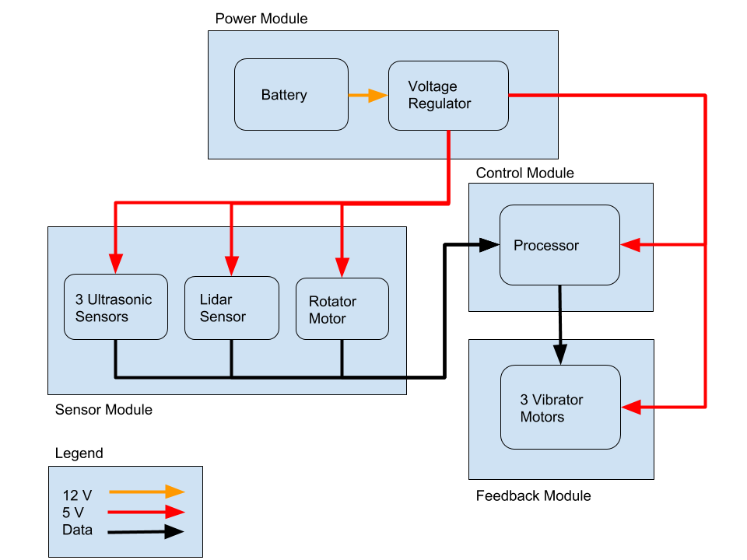
Figure 1 - Block Diagram

2.1 Power Module
The first thing we needed to do was provide power to the device. We also needed the power of the device to be small and compact, so the device could be portable. The obvious solution to this problem is to power the device using a battery. There are three ultrasonic sensors, one lidar sensor, one rotating motor, three vibrating motors, and one microprocessor that need power. The module consists of the battery and a voltage regulator.

2.1.1 Voltage Regulator
The voltage regulator needs to take the voltage from the battery and modulate it so that it can be used by the ultrasonic sensor, lidar sensor, rotating motor, microprocessor, and vibrating motor. The input voltage should be able to handle the operating ranges of the battery we choose and output a voltage that is within 5% of the required voltage of the other components.
The voltage regulator chosen for this is the L7806CV. This regulator operates between 7 to 35 V and produces an output voltage between 4.8 V to 5.2 V with an average of 5 V for its worst-case scenario [3].
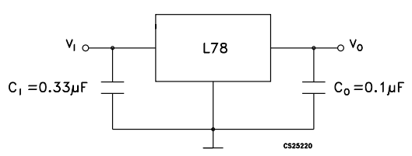
Figure 2 – Circuit diagram for voltage regulator

2.1.2 Battery
The battery of the device should be able to power the device for up to four hours. The reason we decided four hours was by taking the max current draw from the voltage regulator and dividing the mah of the battery by it. We initially decided to use a lithium ion battery as it would be the safest and easiest to obtain [4]. The battery output us through USB and it would be able to supply either 12 V for 6000 mah or 5 V for 12000 mah. Using the 12 V rating for 6000 mah, the battery should be able to supply four hours of power assuming the voltage regulator uses the max current draw (1.5 A).
The battery will be connected through a wire to the voltage regulator and exist as a free hanging object. The device can be stored in the wearer’s pocket or secured to the belt in a pocket or attachment.
Something we did not consider on the battery was that while the battery was capable of outputting 12 V, it only did so from a DC 5521 port. The way we connected our circuit to the battery was through a USB port on the battery. Something we didn’t consider when planning our design was that USB is only able to supply 5 V from its connection, and that requesting more power required a request on the data pins of the USB port. Due to this miscalculation, we are unable to draw 12 V from the battery pack without changing the cable on our device. In order to compensate for this oversight, we soldered the 5 V positive USB cable directly to the 5 V pin on the voltage regulator. This effectively made our voltage regulator useless as it had no input.

2.2 Sensor Module
The sensor module will be used to take information from the environment and feed it into the microcontroller. It will use lidar sensors and ultrasonic sensors to gather information about distances. It should be able to reasonably sense if there is an object behind the rider within 7 meters and become very accurate within 2 meters.

2.2.1 Lidar Sensor
The sensor that we initially chose is the Benewake TFMINI Micro LIDAR Module. This sensor is affordable and works under regular sunlight conditions of 70 klux up to 7 m and up a max range of 12 m. This sensor will be on a motor so that it can turn 60 degrees to detect things behind the wearer. We first test the lidar sensor using an Arduino and breadboard, then convert it to work with a microchip.

2.2.2 Rotating Motor
The sweeping motor will be attached to the lidar sensor and must rotate back and forth across a 60 degree range behind the belt. The motor needs to be able to send data containing the current angle the lidar is facing. The motor we will be using is the Parallax Standard Servo #900-00005. This motor will be constantly running and operates with an average current draw of 140 ± 50 mA.
We initially had a 140° range behind the rider, but after some testing we found that to be impractical. The reason we chose to rotate for 60 degrees was to get an area behind the belt that would span across three adjacent lanes of vehicles. The standard length for a highway is 3.7 meters [5], which also happens to be the widest type of road we would encounter. We then use this distance along with the assumed 7 m distance that the lidar sensor would be able to detect to find the angle that the motor would need to turn. We also assume that a car driving down an adjacent lane would fill the lane, so the sensor would not need to scan all the way into the second lane to detect the car. We ended up deciding halfway into the second lane would give us enough time to detect a car and rotate back in time.
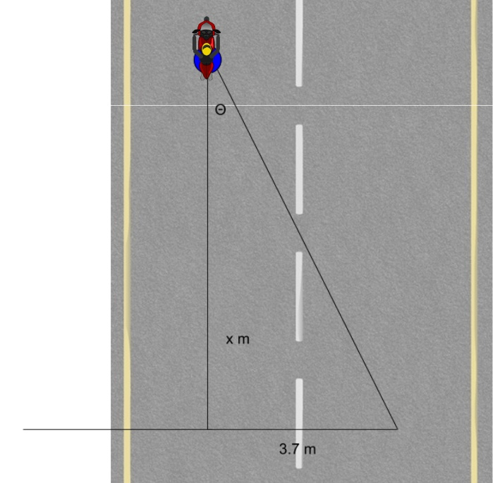
Figure 3 - Diagram to show how angle was determined based on sensing distance of lidar
Based on the diagram in Figure 3, we can calculate the angle θ that the motor is required to rotate based on how far the lidar sensor is able to detect.
$$\tan{θ}=\frac{3.7}{x}$$ | (1)
From Equation 1 and using a value of x = 12 m, which is the maximum distance that the lidar is rated for, we get an angle θ of 17.14°. However, the maximum distance of 12 m is only in an ideal situation. To be safe, we assumed that the rider would be using the device during standard daylight hours, so the range of x is reduced to 7 m. This gives us an angle of 27.86°, which we then rounded up to 30 for simplicity. The motor will have to scan both sides of the rider, so we account for this by rotating 30° on both sides.

2.2.3 Ultrasonic Sensor
The ultrasonic sensors that we will use are the HC-SR04 Ultrasonic Distance Sensor Modules. These sensors are cheap and accurate up to 4.5 meters [6]. There will be three of these sensors that will be on the left, right, and center of the back of the wearer. The purpose of these sensors is to give more accurate feedback at shorter ranges.
The sensors will be mounted on the back and sides of the rider to give a closer “bubble” around the rider that will set off the vibration motors if anything is within that space. We only chose the sides and back of the rider as the front of the bike will be in sight of the person riding the bike.

2.3 Feedback Module
The feedback module consists of a collection of three vibrating motors. The motors will be located at the left, right, and back side of the belt. The motors need to be able to vibrate at different intensities to signal how close an object is to the wearer. The motors will be supplied power from the battery and voltage regulator, and the control module should dictate when and how strong each of the motors will vibrate.

2.3.1 Vibrating Motors
The vibrating motors are connected through a transistor. The microchip gives a signal to the transistor and the duty cycle of the signal controls how powerful the vibration is.
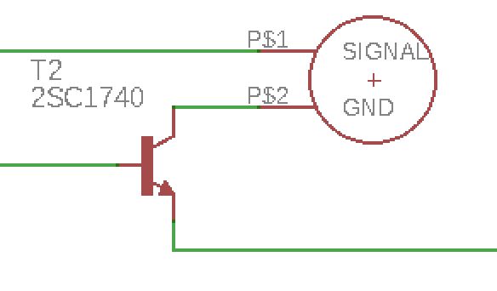
Figure 4 – Motor Circuit diagram

2.4 Control Module
The purpose of the control module is to process the inputs from the sensors and control the outputs to the vibration motor. This is done with a microprocessor chip.

2.4.1 Microcontroller
The control module consists of an atmega328 processor which is also the same chip used on arduinos. This chip could be programmed using the same code as the Arduino, and can output different voltages to any pin on the chip. This chip requires one 10 kilo ohm resistor, two 18 microfarad capacitors, and one 16 megahertz oscillator.
The lidar sensor must be connected to the scl and sda pins in order to use the i2c protocol. The chip needs 5 volts to operate. The program for the microchip has one main loop which controls the servo, lidar, ultrasonic sensors and vibrating motors. We ran into some problems while programming because it was difficult to make everything work off of one processor. The problem we ran into is that the program does not work properly when a delay is used. There is a delay when the ultrasonic sensors are used because the sensor sends a pulse then waits for the pulse to return. This becomes a problem because every sensor sends a pulse and waits so the delay time adds up. This problem can be resolved by using an interrupt pin so that the rest of the program can continue executing while the interrupt of the pulse can come at any time. Another problem we ran into was that the output pins to the vibration motors used a delay to create the correct duty cycle. This delay interfered with the other sensors. This can be fixed by using the analog output pins that can output a duty cycle by themselves.

4. Costs
One of the goals of this project was to keep the total cost of the components under $300. The reasoning was that there are devices on the market right now that are available for $300, so for our device to be an improvement we would need to lower that cost.

4.1 Parts
Table 1 - Parts Cost
Part | Manufacturer | Cost | Quantity | Total Cost
L7805CV | STMicroelectronics | $0.45 | 1 | $0.45
Ultrasonic Sensor | SparkFun Electronics | $3.95 | 3 | $11.85
Lidar Sensor | Benewake | $39.00 | 1 | $39.00
ATMEGA328P | Microchip | $2.28 | 1 | $2.28
Battery | TalentCell | $33.99 | 1 | $33.99
Vibrating Motor | Adafruit Industries LLC | $1.95 | 3 | $1.95
Rotating Motor | Parallax Inc. | $13.95 | 1 | $13.95
2N4401G | ON Semiconductor | $0.24 | 3 | $0.72
16 MHz crystal | SparkFun Electronics | $1.25 | 1 | $1.25
Total |  |  |  | $104.72

4.2 Labor
Table 2 - Labor Cost
Name | Hourly Rate | Hours | Total * 2.5
Jerry Pitts | $35 | 200 | $17500
Edward Wang | $35 | 200 | $17500
Total |  |  | $35000

5. Conclusion

5.1 Accomplishments
In this project, we learned much about what it takes to create an electronic device. It was very difficult and we had some pitfalls. It is important to plan ahead and choose the correct components that can work together. We also created a product that mostly did what it is supposed to do, and learned about lidar and other sensors.

5.2 Ethical considerations
Lithium ion batteries are known to malfunction when overcharged or at high temperatures [4]. Most of these issues can be avoided as the batteries usually come with overcharging protection. We must also consider how the battery is stored while the person is riding. The battery needs to be held on the person’s body and either carried in their pocket, a backpack, or on the bike itself. There could be a mount that would attach to the bike and allow for storage of the battery, lidar sensor, and control module.
Since we are using vibrating motors to alert the wearer where the dangers are coming from, the motors must be strong enough to alert the person but not enough to shock the person. Shock meaning both electrical shock and scaring the person that is wearing the device. We also cannot have a super strong motor that is constantly running while a person is right next to an object.
An important thing to note is that while this device will alert someone to the dangers around them they still need to be aware of their surroundings. A person cannot solely use this device to navigate around. This is not a replacement to paying attention to your surrounding but should be used as an assistance device.

5.3 Future work
Some future work on this project could include making it work better on the bike and giving it a better physical design. We could also add more features and make it more reliable. It could be useful to be able to tell which kind of object is coming up behind.

References

[1] D. Rainmaker, "Hands-On with Backtracker: Radar for your bike", DC Rainmaker, 2014. [Online]. Available: https://www.dcrainmaker.com/2014/07/hands-on-backtracker-radar.html. [Accessed: 30- Apr- 2018].
[2] "Wavetronix - Bicycle Detection", Wavetronix.com, 2018. [Online]. Available: https://www.wavetronix.com/en/case_studies/13-bicycle-detection. [Accessed: 30- Apr- 2018].
[3] “L7805CV”, mouser.com, 2018. [Online]. Available: https://www.mouser.com/productdetail/?qs=9NrABl3fj%2FqplZAHiYUxWg%3D%3D [Accessed: 1- May- 2018].
[4] "Lithium-ion Safety Concerns", Batteryuniversity.com, 2018. [Online]. Available: http://batteryuniversity.com/learn/archive/lithium_ion_safety_concerns. [Accessed: 2- May- 2018].
[5] "Mitigation Strategies For Design Exceptions - Safety | Federal Highway Administration", Safety.fhwa.dot.gov, 2018. [Online]. Available: https://safety.fhwa.dot.gov/geometric/pubs/mitigationstrategies/chapter3/3_lanewidth.cfm. [Accessed: 02- May- 2018].
[6] “Ultrasonic Ranging Module HC - SR04”, cdn.sparkfun.com, 2018. [Online]. Available: https://www.bananarobotics.com/shop/HC-SR04-Ultrasonic-Distance-Sensor?gclid=EAIaIQobChMI4eLL3J6V2QIVUJ7ACh0OUABFEAQYASABEgLNZvD_BwE [Accessed: 2- May- 2018].
[7] “From Arduino to a Microcontroller on a Breadboard”, arduino.cc, 2018. [Online].
Available:https://www.arduino.cc/en/Tutorial/ArduinoToBreadboard [Accessed: 22- Feb- 2018].

[8] “ATMEL 8-BIT MICROCONTROLLER WITH 4/8/16/32KBYTES IN-SYSTEM
PROGRAMMABLE FLASH”, mouser.com, 2018. [Online]. Available:
https://www.mouser.com/ds/2/268/atmel-8271-8-bit-avr-microcontroller-atmega48a-48p-1065900.pdf [Accessed: 22- Feb- 2018].

[9] “Ultrasonic Ranging Module HC - SR04”, cdn.sparkfun.com, 2018. [Online].
Available: https://www.bananarobotics.com/shop/HC-SR04-Ultrasonic-Distan
ce-Sensor?gclid=EAIaIQobChMI4eLL3J6V2QIVUJ7ACh0OUABFEAQYASABEgLN
ZvD_BwE [Accessed: 22- Feb- 2018].

[10] “L7805CV”, mouser.com, 2018. [Online]. Available: https://www.mouser.com/productdetail/?qs=9NrABl3fj%2FqplZAHiYUxWg%3D%3D [Accessed: 22- Feb- 2018].

Appendix A Requirement and Verification Table

Battery
Able to supply power for a minimum of 4 hours. | Voltage regulator supplies a max of 1 A at 5 V. The battery has 6000 mah at full charge operating at 12 V. This leads to a 6 hour operation time.

Voltage Regulator
Supplies 5 V ±5%. | Battery will apply unregulated 12 V while the regulator will convert that to 5 V with a min of 4.9 V and max of 5.1 V and have a max operating current of 1 A.

Lidar Sensor
Detects up to 3 lanes of traffic with an average of 7±5% m behind wearer. (Standard US interstate highway width is 3.7 m) | Mounted on a motor that will rotate back and forth between -30 and 30 degrees. Motor will only sweep halfway into adjacent lanes (because cars are wide). Calculations done assuming 7 m range for average sunlight conditions as stated by datasheet. (refer to calculations)

Ultrasonic Sensor
Detect objects from 0~1 meter away from the sensor. | Sensor is able to detect objects up to 4 meters away at max range, however there is a 2 cm blind spot in-front of the sensor.

Servo Motor
Have a range of motion between -30 to 30 degrees. | Motor holds any position between 0 and 180 degrees.

Microcontroller
Must be able to run at a voltage of 5.0V ± 5%. | Make a simple test program to light an LED using one of the input output pins, and test with the microchip powered from 4.75 to 5.25 Volts.
Must be able to turn vibration motors on and off. | Test the output of the microchip to make sure that it can control up to 5 Volts for the motor and measure using a voltmeter in the lab.
Must be able to take input values from the lidar sensor, ultrasonic sensors, and the servo motor. | Make a program to light up LEDs when signals are received from the sensors. Different LEDs will light up based on which sensors are detecting and what angle the servo motor is facing.

Vibration motors
Be able to buzz strong enough to alert the person wearing it. | Motor operates at 11000 rpm with a 5 V input.

Appendix B Circuit Diagram and Pictures

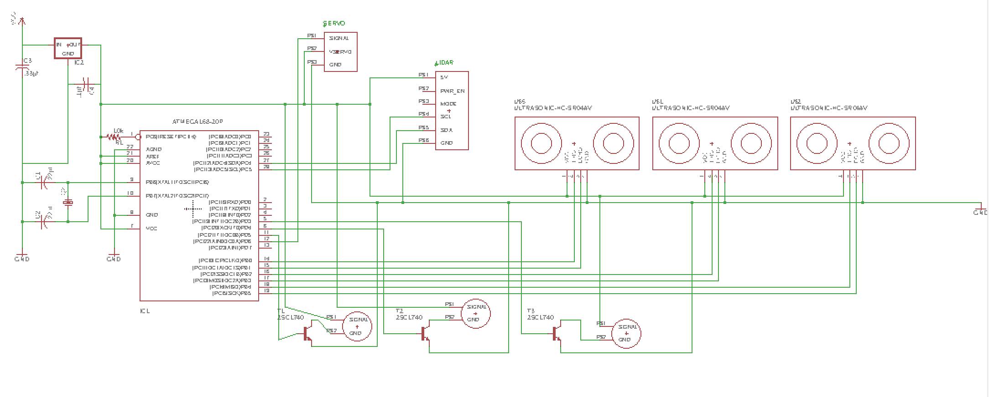
Figure 5 – Motor Circuit diagram

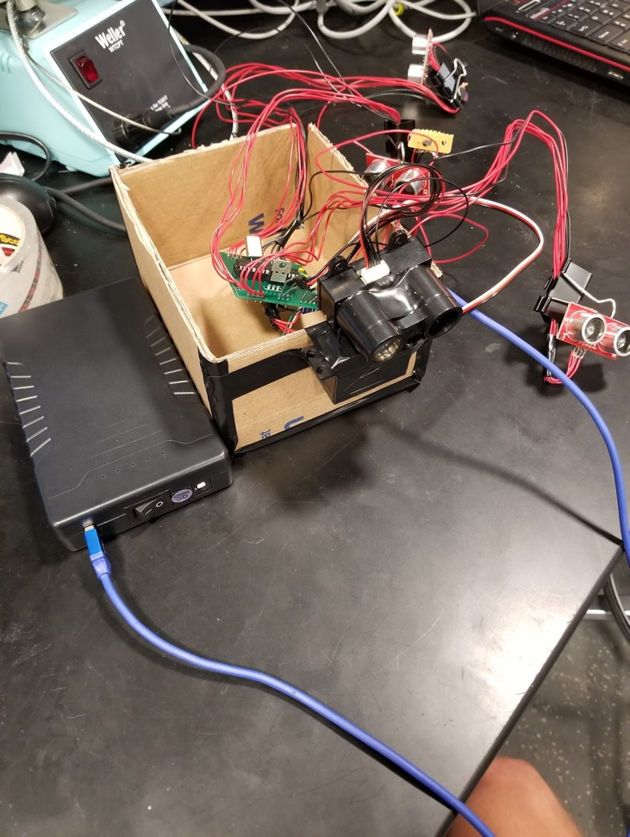

Figure 5 – Motor Circuit diagram

