Self-Adjusting Speakers
Samira Tungare, Edward Harper, Sarah Kolak
ECE 445 Project Proposal - Spring 2020
TA: Ruomu Hao

1. Introduction

1.1 Objective
Noise in a room is constantly changing. This typically means that the volume of music being played needs to be modified to fit the environmental noise. If many people are talking in a room then music being played may no longer be audible. On the other hand, if there is a lot of silence in a room then it is not necessary to have music blasting at a maximum volume. Currently, the only solution to this problem when using portable speakers is someone manually adjusting the volume.
Our goal is to create a speaker that will analyze the amount of ambient noise in a room and then automatically adjust the volume of the music. These speakers will have the same basic functionality as many portable bluetooth speakers with the addition of two modes that no longer require the user to adjust the volume. Mode 1 will increase the music volume when the ambient noise increases which would be applicable if someone is throwing a party. Mode 2 will decrease the volume when the ambient noise increases which is useful in a situation where people want to focus on conversation rather than music. Mode 3 will allow the speaker to behave in a normal operating mode with the user controlling the volume.

1.2 Background
Speed-sensitive volume control exists in many vehicles today. The purpose is to automatically adjust the speaker volume based on the speedometer. The volume will increase as the vehicle speeds up, in order to combat the extra outside noise. When the speed of the vehicle decreases, the volume will also decrease so that it is not too loud over minimal external noise. This technology exists in Hondas, Nissans, and more. Bose, Beats, Shure, JBL, and Sony have created noise cancelling headphones to analyze ambient sounds in order to eliminate them by using destructive interference.

1.3 High-Level Requirements
- The system will be able to communicate with a cell phone through Bluetooth so that the music can be sent through the phone to the speaker.
- The speakers will be able to operate with two self-adjusting modes where the volume is adjusted based on the ambient noise. The speakers will also be able to operate as standard speakers with the volume being controlled by the user.
- The self adjusting volume will take the average noise level over a 10 second period, cross matching the music being played and the noise the sensor receives in order to increase or decrease the volume on the speaker.

2. Design

2.1 Block Diagram
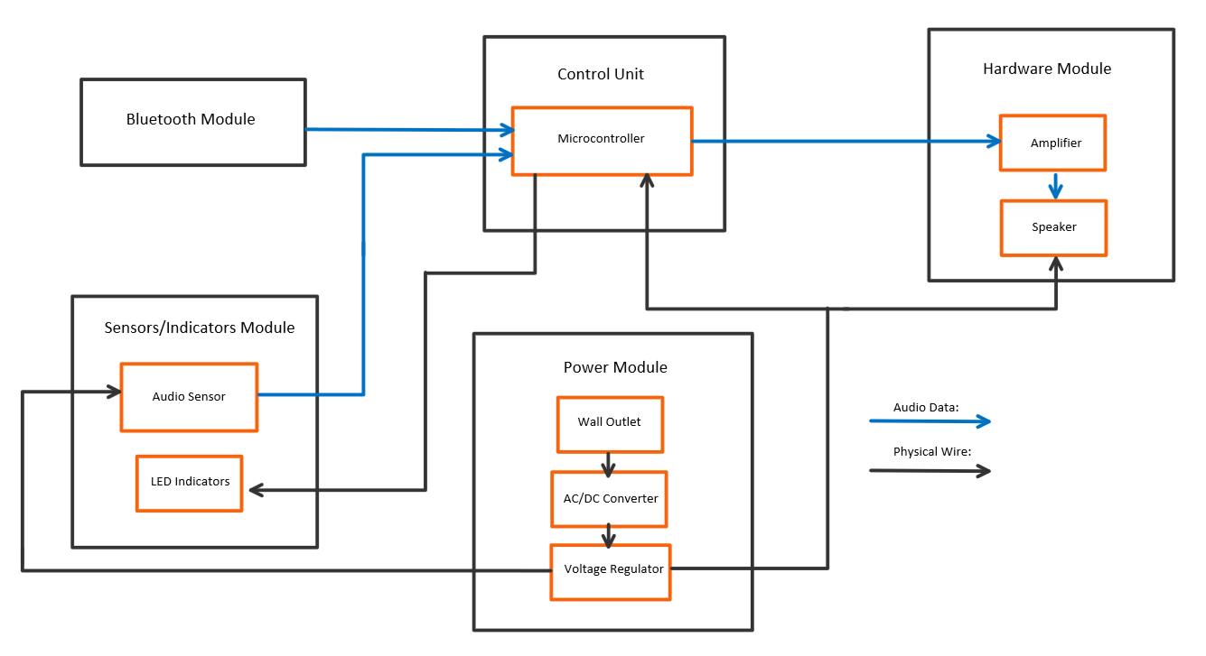
Figure 1: Block Diagram
2.2 Physical Design
An exact size isn’t specified right now but we want the speaker to be easily portable and small enough that it could fit in a backpack. The speakers will have a rectangular enclosure.

2.3 Functional Overview
2.3.1 Power Module
- Wall Outlet
A wall outlet will be the main source of power to the system. There will be a protection circuit implemented in case of a surge.

- AC/DC
The AC/DC converter will be used to convert the AC voltage from the wall outlet into a DC voltage.

- Voltage Regulator
The voltage regulator will be used to step down the DC voltage to a lower voltage that can be used to power various components.

2.3.2 Hardware
- Amplifier
The amplifier will be used to increase the magnitude of the signal that will be played by the speaker. This allows the signal to be audible by the users.

- Speaker Unit
The speaker unit will output the analog signal. There will be three modes available on the speaker for the user to choose. Mode 1 will adjust the music with the volume in the room. If the ambient noise increases, the volume will increase and if the ambient noise decreases, the volume will decrease. Mode 2 will have the opposite functionality of mode 1. As ambient noise increases, the volume of the music will decrease and as ambient noise decreases, the volume of the music will increase. Mode 3 will keep a constant volume no matter the volume of the ambient noise. In mode 3, there will be volume push buttons available for the user to manually change the volume.

2.3.3 Control Unit
- Microcontroller
The microcontroller will be used to handle the signal processing. It will receive input from the audio sensor as well as from the Bluetooth module. It will receive the music signal from the Bluetooth module and subtract its intensity from the total noise measured from the audio sensor. The microcontroller will also communicate with the amplifier to adjust the volume as necessary.

- DAC
A digital to analog converter will be used after the signal processing is complete so that the music can be output as an analog signal.

2.3.4 Sensors and Indicators
- Audio Sensors
Audio sensors will be attached to the speakers and will measure the incoming noise from the environment. This information will then be sent to the microcontroller to be processed.

- LEDs
The LEDs will be attached to the speaker and will indicate whether the volume of the speakers are increasing or decreasing. Two colors will be used so that one color will indicate an increase and the other will indicate a decrease.

2.3.5 Bluetooth Module
- Bluetooth
The Bluetooth module will allow a cell phone to communicate with the speakers so that the music data can be sent from the device to the speakers.

2.4 Block Requirements
2.4.1 Power Module
- Wall Outlet
  - 120VAC, 60Hz
  - Protection circuit incase of surges
- AC/DC
  - Input of 120VAC, 60 Hz
  - Output of 5V
- Voltage Regulator
  - TPS7A88
  - Input Voltage Range: 1.4V to 6.5V
  - Output Voltage Range: 0.8V to 5V ±5%
  - Output Current Range: 0A to 1A
  - Two Independent LDO channels
  - Able to power up all the respective components to their necessary voltage levels. This includes the microcontroller, audio sensor, and speaker.

2.4.2 Hardware
- Amplifier
  - LM741A
    - Max supply voltage ±22 V
    - Max differential input voltage ±30
    - Max input voltage ±15
- Speaker Unit
  - Power Switch
  - Power Jack
  - Volume control buttons
  - Speaker
    - Frequency range 80-15kHz
  - Bluetooth functionality

2.4.3 Control Unit
- Microcontroller
  - STM32F4
    - 1.8 V ≤VDD ≤3.6 V voltage range
    - Max current 240 mA
- DAC
  - AK4386
    - 24 bit
    - Max voltage = 4.6 V, current = 10 mA

2.4.4 Sensors and Indicators
- Audio Sensors
  - LMV324
  - 3.3V or 5V

- LEDs

2.4.5 Bluetooth Module
- Bluetooth receiver

2.5 Risk Requirements
The control module will have the highest amount of risk. In order for the volume control to work we will need to successfully analyze the changes in the noise in the room. One of our biggest challenges will be subtracting the noise from the music from the overall noise detected so that the room volume can be more accurately measured. The success of the signal processing will be crucial for success in this project.

3. Safety and Ethics
Our speaker will be a relatively safe product, with only a couple potential issues. We first need to ensure our components do not overheat, so as long as we keep our temperature inside the specified range then all of our parts will operate correctly. Although most of our processing will be done with digital signals so we do not foresee overheating being a major issue. Since our project deals with audio we have to keep the volume at a level that doesn’t harm anyone’s hearing. Therefore we will have to ensure that there is some sort of control in place to place bounds on the upper and lower limits of the volume.
One ethical issue that comes from many devices such as the Amazon Echo or Google Home is the fact that these devices could be monitoring someone’s private conversation. This could be a potential issue with a device like ours since we will be using an audio sensor to measure the noise. However, this is not something that our specific project will run into because we will not be analyzing the specific conversations rather just the overall noise intensity.

References
[1] Blom, Jim, “Bluetooth Basics” Sparkfun [Online] Available: <https://learn.sparkfun.com/tutorials/bluetooth-basics/all> [Accessed: 12 February 2020]

[2] Byron, J, “Sound Detector Hookup Guide” Sparkfun, 2014. [Online] Available: <https://learn.sparkfun.com/tutorials/sound-detector-hookup-guide/all> [Accessed: 10 February 2020]

[3] Electronics Tutorials, “Sound Transducers”, 2018. [Online] Available:<https://www.electronics-tutorials.ws/io/io_8.html> [Accessed: 11 February 2020]

[4] Harris, William, "How Noise-canceling Headphones Work", How Stuff Works, 2007. [Online] Available:<https://electronics.howstuffworks.com/gadgets/audio-music/noise-canceling-headphone.htm> [Accessed: 8 February 2020]

[5] Holt, Gordon, “Audio Basics: A is For Ampere”, Stereophile, 1991. [Online] Available:<https://www.stereophile.com/reference/62/index.html> [Accessed: 10 February 2020]

[6] Instructables Circuits, “DIY Pocket Sized Bluetooth Receiver” 2020. [Online] Available: <https://www.instructables.com/id/DIY-pocket-sized-bluetooth-receiver/> [Accessed: 7 February 2020]
[7] Khatri, Pankaj, “Voltage Regulator Circuits”, Circuit Digest, 2018. [Online] Available:<https://circuitdigest.com/electronic-circuits/voltage-regulators> [Accessed: 7 February]

[8] Moore, Robert “How Does Speed Sensitive Volume Control Work?” It Still Runs, 2020. [Online] Available :<https://itstillruns.com/speed-sensitive-volume-control-work-7646970.html> [Accessed: 4 February 2020]

[9] Morrison, Geoffrey “The Pros and Cons of Noise-Canceling Headphones” The New York Times, 7 May 2019. [Online] Available: <https://www.nytimes.com/2019/05/07/travel/the-pros-and-cons-of-noise-canceling-headphones.html> [Accessed: 4 February 2020]

