Automated Mask Enforcement
ECE 445 Final Report Spring 2021
Team 29: Teja Gupta, Faruk Toy, Kalpit Fulwariya
TA: Ali Kourani

Abstract
With the recent COVID-19 Pandemic, masks have become a part of the new normal. However, in the United States there is a growing anti-mask movement with many people attempting to enter public spaces without wearing a mask. While many places may have a monitor stationed at each entrance this can be expensive and places the monitor at an increased risk for COVID-19. We have created a system that obviates the need for such monitors using computer vision technology. The system we create will take in live video footage and lock or unlock a door based on whether people present at the building entrance are wearing a mask or not. This approach eliminates the need for a human to be present at each entrance. It is both cheaper and safer than having a human monitor.

Table of Contents
1. Introduction 1
1.1 Background 1
1.2 Problem and Solution 1
1.3 Visual Aid 2
1.4 High-level Requirements 3
1.5 Block Diagram 4
2. Design 6
2.1 Power Subsystem 6
2.1.1 AC/DC Converter 6
2.1.2 Voltage Regulator 6
2.2 Camera Subsystem 7
2.2.1 Acceleration Module 7
2.2.2 Camera 8
2.3 User Interaction Subsystem 8
2.3.1 Video Controller 8
2.3.2 Screen 9
2.4 Microcontroller/Controller 9
2.5 Lock Solenoid 9
3. Design Verification 10
3.1 Camera Subsystem 10
3.1.1 Acceleration Module 10
3.1.2 Camera 10
3.2 Power Subsystem 11
3.2.1 AC/DC Converter 12
3.2.2 Voltage Regulator 12
3.3 Lock Subsystem 12
4. Cost Analysis and Schedule 13
4.1 Cost Analysis 13
4.2 Labor Cost 14
5. Conclusion 15
5.1 Accomplishments 15
5.2 Uncertainties 15
5.3 Future Work 16
5.4 Ethical Considerations 17
References 19
Appendix A - Requirement and Verification Tables 21
Appendix B - Schedule 24
Appendix C - Pictures of Physical Design and Demo 27

1. Introduction

1.1 Background
With the coronavirus pandemic, the CDC has recommended the use of medical masks to slow the spread of the coronavirus [1]. There are a plethora of studies showing the effectiveness of masks in slowing the spread and the efficacy of masks in containing the spread of similar viruses [2]. However, despite these guidelines and studies, there is still an increasing number of people that refuse to wear masks in the United States. Groups such as The Free Face Society and Umask America are encouraging Americans to go without masks [3]. According to a Pew Research study, only 65% regularly wear masks when going outside to stores [4]. While most Americans are taking the necessary precautions, there is still a fairly large minority that refuse to follow the guidelines and laws that have been set. These individuals not only pose a risk to themselves but those around them as well. Roughly 74 million essential workers are at an increased risk of the coronavirus and 61% percent of that number are at a severe risk [5]. With the rise of a population that refuses to wear masks, there is a need for a system that prevents these people from entering buildings while not risking the lives of the essential workers.

1.2 Problem and Solution
With the current pandemic, masks have become part of the new normal. There are studies demonstrating reduced rates of infection in areas where mask mandates have been implemented [6] as well as the efficacy of masks at blocking droplets [7]. While most Americans are taking the necessary precautions, there is still a fairly large minority that refuse to follow the guidelines and laws that have been set. These individuals not only pose a risk to themselves but to those around them as well. Our goal is to create smart locks to keep such individuals out of buildings ensuring the safety of those inside. These systems will use cameras to track individual participants entering a building and detecting if they are wearing masks or not. If it detects approaching mask wearers, it will unlock the door, otherwise it will remain locked thereby preventing persons without a mask from entering. While many stores and buildings may have an employee stationed at the entrance to monitor mask-wearing of customers who enter the building, this practice poses a risk of infection to the monitor and imposes an additional salary cost. Additionally, for buildings where there are multiple entrances, such an arrangement is not practical.

1.3 Visual Aid
The illustration in Figure 1 illustrates the design of our solution. The Camera takes in video input, locks or unlocks the Lock and shows the corresponding visual message on the Display.
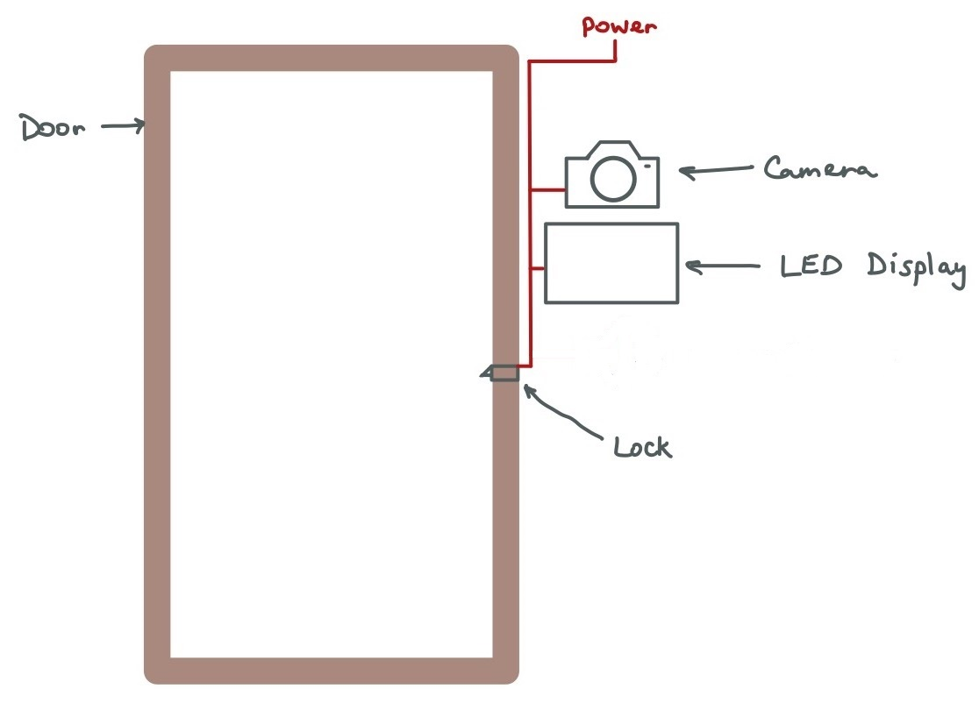
Figure 1. Physical Design

1.4 High-level Requirements
- Must be able to detect people not wearing/wearing masks with a test accuracy (# test samples classified correctly/ # test samples) >80% using computer vision.
- Recognize someone with or without a mask in under 2 seconds.
- Must be able to detect if multiple people are approaching the door and remain locked if one of them is not wearing a mask.

1.5 Block Diagram
The block diagram in Figure 2 demonstrates our original design. Our original design had 5 Subsystems: Power, Microcontroller, User Interaction, Camera and Lock. The Power Subsystem was responsible for providing the correct voltages to the remaining four subsystems using a 120 V AC supply. The Microcontroller Subsystem was responsible for coordinating the interactions between the other four subsystems. The User Interaction was responsible for playing a GIF telling the user to wear a mask based on input from the Microcontroller. The Camera Subsystem was responsible for taking video and detecting whether or not people were wearing a mask. The Lock Subsystem consisted of a single Lock Solenoid that would lock and unlock based on input from the Microcontroller. However, due to difficulties with both the Microcontroller and Video Controller we ended up modifying our design to that of Figure 3. We used the Acceleration Module to do the work of both of these components.
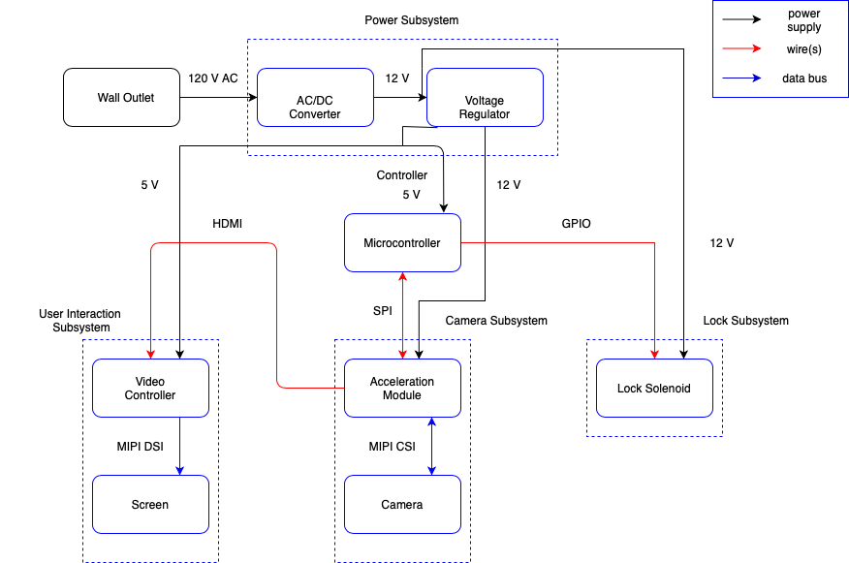
Figure 2. Original Block Diagram

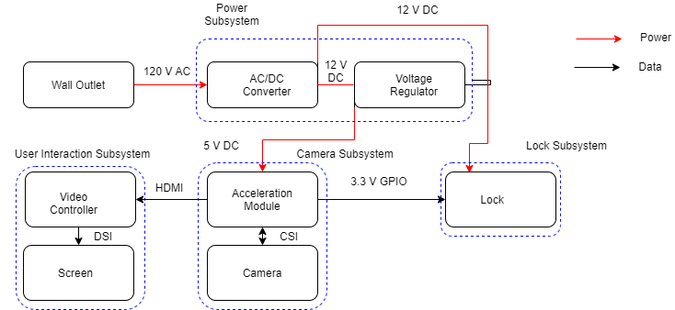
Figure 3. Final Block Diagram

2. Design
Pictures of our physical design can be seen in Appendix C, Figure 6.

2.1 Power Subsystem
The power subsystem is required to power all the other components in the system: Control, User Interaction, Camera and Lock. The power supply will take in a 120 V AC power supply from a wall outlet and use that to generate both a 5 V DC and 12 V DC power source for the systems. Power supplied is also another criteria. It is important to supply enough amperage to all subsystems and leave some space in order not to overload the unit and, eventually, burn it.

2.1.1 AC/DC Converter
This AC/DC Convertor plugs into a 120 V AC wall outlet and generates 12 V DC current as output. The converter will connect to the wall using a NEMA 1-15 wall plug and will give a 12 V output using a 2.1 mm x 5.0 mm plug. The plug is soldered onto the PCB. This unit supplies rated 2 A so that it will provide ample power to solenoid lock, camera subsystem, and user interaction subsystem.

2.1.2 Voltage Regulator
We used a RECOM DC/DC converter that takes in a 12 V DC input and output 5 V DC current in return. This allowed us to power the camera subsystem and we were originally using this to power the microcontroller subunit. Also, we use another voltage regulator which outputs 3.3 V DC to the user interaction subsystem. All voltage regulators have rated 600 mA. This satisfies the power consumption reported in the data sheets of each unit.

2.2 Camera Subsystem

2.2.1 Acceleration Module
This component runs the neural networks necessary for detecting whether or not someone is wearing a mask as well as relay this information back to the microcontroller. Our software will first use a ResNet-10 based architecture to detect each portion of the footage that possesses a face and draw a bounding box around it. We plan on using the OpenCV library in Python and taking advantage of some pretrained models for this task. Using these bounding boxes we will run a convolutional neural network on each of the faces and see if they are wearing a mask or not. We are currently considering taking advantage of pretrained models to complete this task. We are currently thinking of using MobileNetv2 and using transfer learning to retrain it to detect whether or not someone is wearing a mask. Will use the TensorFlow Lite framework for this portion of our software and take advantage of some of the hardware optimizations for this task. In our original design, if we detect faces that are all wearing masks we will signal to the microcontroller to unlock the door. We used a Google Coral mini-dev board for this and took advantage of the onboard Tensor Processing Unit (TPU) for our project. A TPU is an ASIC optimized for the inferencing stage of machine learning. To train our models we used a dataset of roughly 12,000 images of masked faces to train our model [8]. For the training phase we took 80% of our data as a training dataset and another 10% as a validation set. We trained the model on the training set and tune the parameters of our model using the validation set. After maximizing our performance on the validation set, we will then test if on the remaining 10% to determine our test accuracy. We trained our classifier for 10 epochs. Our overall training time was 105 minutes with each epoch taking 10 minutes and 35 seconds per epoch. We outline out accuracy and loss in Table 1 below. The loss function we used was binary cross entropy. Output of our module can be seen in Appendix C, Figure 7.

Table 1. Training Accuracies and Losses
Dataset | Accuracy | Loss
Training | 99.47% | 0.0204
Validation | 99.25% | 0.0230
Test | 99.00% | 0.0230

2.2.2 Camera
This is a camera that will be used to look at the surroundings and provide real time footage to the accelerator module. We connected to the mini dev board using the MIPI-CSI interface. The capture rate of our camera was limited by the acceleration module. We wouldn’t read in the next image until our neural network was finished processing the current image.

2.3 User Interaction Subsystem
This subsystem will play a small GIF showing how to wear a mask when the user is not wearing one.

2.3.1 Video Controller
This module is part of the Coral Dev Board Mini that handles the video storage on the dev board and video playback on the LCD Display via a Breakout Board that handles HDMI to MIPI DSI signal conversion. This component was obviated in the final design. We used the Coral to output to the screen directly.

2.3.2 Screen
A display that will take in input from the video controller and play the GIF. In our original design we used a MIPI-DSI display. Due to the video controller not working properly we used HDMI to connect directly to the Coral.

2.4 Microcontroller/Controller
This is the subsystem that coordinated the other subsystems taking in state signals from the camera subsystem through SPI and controlling the state of the lock solenoid in the lock subsystem through GPIO. Our final design obviates the need for this subsystem.

2.5 Lock Solenoid
This subsystem will use a 12 V signal to engage and disengage the locking mechanism. It will consist of a solenoid lock. We want this lock to be placed on a single-wing exterior door similar to the door in Figure 1. We will drive the lock solenoid with the microcontroller using a diode and a resistor as shown in Figure 4.
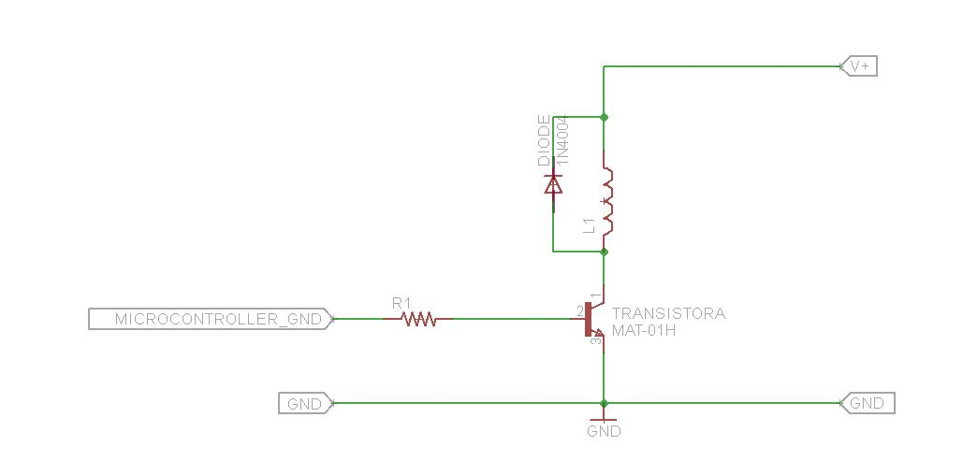
Figure 4. Lock Solenoid Diagram

3. Design Verification

3.1 Camera Subsystem
The verification of the camera subsystem involved ensuring that the Acceleration Module and the Coral Camera satisfied the requirements and verification table shown in Appendix A, Table 4.

3.1.1 Acceleration Module
The first verification for the acceleration module was to be able to classify multiple individuals in the same video frame. This was tested manually by having multiple persons in the Coral Camera frame and testing for classification by the model for each person. The model classified two persons consistently and three or more persons with few missed classifications. The second verification was for the model to have a testing accuracy greater than 80%. This was tested on a subset of the total dataset (10%) withheld during training. More information about the accuracy can be found in Table 1. The model performed on this previously unseen data with a testing accuracy of 99%. The final verification was for the model to classify a mask/no mask state in under 2 s. This was verified by modifying the code to calculate the time it takes to classify each frame and it took 680 ms per frame on average.

3.1.2 Camera
The Coral Camera had to have sufficient resolution and field of view (FOV) to detect persons approaching the door within 5 feet. This was verified by manually checking if a person can be clearly seen by camera displayed on the computer screen. This was verified by taking the required distance from the camera 5 feet and choosing the length of viewing plane 9 feet which can be seen in Figure 5.
ϴ = Field of View of Coral Camera
BF = Distance between the Coral Camera and the Person
DF = Length of Viewing Plane
AB = Distance between center and end of Viewing Plane
 | $$tan(\frac{ϴ}{2}) = \frac{AB}{BF}=\frac{4.5 ft}{5 ft}$$ | (1)
 | $$ϴ=2 * arctan(\frac{4.5}{5})$$ | (2)
 | $$ϴ=83.97°$$ | (3)

This measured FOV, ϴ, is met by the actual FOV of 84° of the Coral Camera.

Figure 5. Field of View verification for Coral Camera

3.2 Power Subsystem
The power subsystem consisted of the AC/DC Converter and Voltage Regulator. The requirements and verification table can be found in Appendix A, Table 6.

3.2.1 AC/DC Converter
The 120 V AC to 12 V DC Converter was required to have a $V_{out}= 12±0.5 V$at $2 A$. This was verified by attaching a $6 Ω$ resistor to the output and probing with an oscilloscope to measure the load.

3.2.2 Voltage Regulator
The 12V DC to 5V DC Converter was required to have a $V_{out}= 5±0.5 V$at $600 mA$. This was measured by attaching an oscilloscope and draw above 600 mA incoming to the camera and control subsystems and the output voltage and verified to be within requirements.

3.3 Lock Subsystem
The lock subsystem consists of the solenoid lock and it was required to be able to operate at 3.3 V. This requirement was verified with an oscilloscope to probe and check if the solenoid switches from locked to unlock state by a 3.3 V input signal. The requirements and verification table can be found in Appendix A, Table 5.

4. Cost Analysis and Schedule
The cost (taxes & shopping not included) for our original design is shown in Table 2. The labor cost is shown in table 3. The weekly schedule is shown in Appendix B.

4.1 Cost Analysis
Table 2. Project Cost
Part Name | Manufacturer | Cost | Quantity | Total Cost
Google Coral Dev Mini Board | Google | $99.99 | 1 | $99.99
USB A to USB C cable | Just Wireless | $6.99 | 2 | $13.98
32 GB microSD card | Sandisk | $13.99 | 1 | $13.99
CSI Camera | Google | $19.99 | 1 | $19.99
Solenoid Lock | FC MXBB | $9.99 | 1 | $9.99
USB Type-C to USB Cable | Amazon Basics | $10.49 | 1 | $10.49
12v DC Wall Adapter | Xinkaite | $11.99 | 1 | $11.99
12 V DC Power Barrel | Digi-Key | $0.92 | 2 | $1.84
Power Mosfet | Fairchield Semiconductors | $5.20 | 2 | $10.40
5 V Voltage Regulator | RECOM | $2.13 | 3 | $6.39
3.3 V Voltage Regulator | RECOM | $2.13 | 3 | $6.39
PCB Terminal Connector | TE Connectivity | $0.56 | 15 | $8.45
512-FQP30N06L Mosfet | Fairchield Semiconductors | $1.48 | 2 | $2.96

4.2 Labor Cost
Table 3. Labor Cost per employee
Employee | Hourly Rate | Hours Worked | Labor Factor | Labor Cost
Teja Gupta | $44.71 | 272 | 2.5 | $30,396
Kalpit Fulwariya | $44.71 | 272 | 2.5 | $30,396
Faruk Toy | $37.50 | 272 | 2.5 | $25,500

5. Conclusion

5.1 Accomplishments
Our team was able to create an effective prototype for a smart lock that enforces mask wearing. Depending on environmental conditions our system worked fairly well and performed with reasonable time and accuracy. Our system removes the need for a human monitor to be present and is much cheaper as well. We were also able to display an educational video demonstrating how to wear a mask despite the setbacks we faced. We were also able to address some of the privacy concerns we considered in our original design. Our system does not store individual frames so our users are not being recorded. Our system does not need a wireless connection to function properly. This reduces the security issues that we would have significantly.

5.2 Uncertainties
There were two major uncertainties we encountered when dealing with our project. The first was the glitches we encountered with our camera subsystem. When we were testing this subsystem by ourselves in a low lighting environment at eye level, the system seemed to function perfectly. However, in a lab setting where the lighting was higher and the camera was angled up towards the user, we encountered some difficulties. It struggled to detect some of the users present in the frame and would occasionally misclassify those it did detect. There are several possible issues why this might have occured. One possible reason was the resolution of the camera. The resolution of the camera was noticeably lower than that of the images which we used to train our model. This could have prevented our model from generalizing to images from the camera we used. Another point of uncertainty was the pretrained model we used to detect faces. This was essentially a black box so there was a lot of uncertainty with using this model. It is possible this model performed worse at certain angles or could not detect faces wearing a mask very well. The second major point of uncertainty we encountered was with the microcontroller. We were not able to get the microcontroller subsystem to work. We speculate that our microcontroller had a hardware defect that prevented it from being used. We are not entirely sure what the possible defect was and we are not entirely sure that it was in fact a hardware defect.

5.3 Future Work
There are several hardware and software developments we would need to make before this is a viable product. The first major development we would like to see is to use PyTorch instead of TensorFlow for our deep learning models. The reason we would like to make this decision is that object detection, our primary method for detecting faces, is much better done in PyTorch than TensorFlow. The TensorFlow object detection API is considerably underdeveloped in comparison to that of PyTorchs. With the current TensorFlow API we were not able to fully utilize all the hardware optimizations on the coral. We also feel that our project would fare much better had it been migrated to the Jetson Nano as opposed to the google coral. This is because PyTorch is guaranteed to run on the Jetson Nano. Although we might suffer slightly in terms of speed, the accuracy gain more than justifies the switch. We would also like to modify our system to work in the night time as well. We could do this by adding infrared cameras or night vision to our camera subsystem. We would also like to obviate the need for a microcontroller. During the process of building the system, we realized that the microcontroller was not necessary and that that workload could be done by the coral. We would also like to use a larger sized and higher resolution display for the User Interaction Subsystem as that improves visibility of the GIF or any other visual message of choice. We would also like to use DIP based ICs for the microcontroller, if required, for quick replacement in the case of mechanical failure.

5.4 Ethical Considerations
Electrical hazards pose a safety issue. Since our product will be powered by 120 V AC wall electricity, we must exercise caution. We will implement our product so that it will satisfy all the safety standards put in place by OSHA [9]. Our device might be installed outside of a building. Therefore, weather plays a big role in our safety considerations. If there is a heavy rain outside, water can leak into the product and cause short circuits. This would not only damage the product, but also it can possibly create a fire in the building. To combat this risk, we will be using a water proof casing around our product.
There is also the issue if people are not wearing a mask correctly. With the system we have in place we will not be able to detect people who are wearing masks incorrectly. For example, if people are not covering their nose, our system could potentially let them into the building, posing a risk to everyone that is inside. Another risk is if our system misidentifies people without a mask and lets them into a building. Both of these scenarios would be a violation of the IEEE code of ethics #9 “avoid injuring others [10]”. To prevent the first risk, there is a simulated dataset of people wearing masks incorrectly that we could potentially use. Since it is simulated, there is most likely a high rate of error when dealing with actual mask wearers. There is no easy way to prevent the second risk aside from doing everything to ensure our classifier has a low error rate on real-world samples.
A ethical issue that we may run into is unintentional racial discrimination. I have not done any analysis to show that our dataset is in any way racially diverse as a result it is possible our system may not work as well when detecting people of racial minorities. This might place us into conflict with IEEE code of ethics #7: “ to treat all persons fairly and with respect, and to not engage in discrimination based on characteristics such as race, religion, gender, disability, age, national origin, sexual orientation, gender identity, or gender expression [10]”. This same principle may also place into conflict with the people who may possess some sort of facial disfigurement or disability for the same reasons.

References
[1] “COVID-19: Considerations for Wearing Masks,” Centers for Disease Control and Prevention. [Online]. Available: https://www.cdc.gov/coronavirus/2019-ncov/prevent-getting-sick/cloth-face-cover-guidan ce.html. [Accessed: 13-Feb-2021].
[2] J. Howard, A. Huang, Z. Li, Z. Tufecki, Z. Vladimir, H.-M. van der Westhuizen, A. von Delft, A. Price, L. Fridman, L.-H. Tang, V. Tang, G. L. Watson, C. E. Bax, R. Shaikh, F. Questier, D. Hernandez, L. F. Chu, C. M. Ramirez, and A. W. Rimoin, “Face Masks Against COVID-19: An Evidence Review,” Apr. 2020.
[3] J. Guynn, “Trump's COVID-19 diagnosis is not slowing virulent anti-mask movement on Facebook,” USA Today, 03-Oct-2020. [Online]. Available: https://www.usatoday.com/story/tech/2020/10/02/facebook-anti-face-mask-groups-trump -covid-19/3597593001/. [Accessed: 11-Feb-2021].
[4] R. Igielnik, “Most Americans say they regularly wore a mask in stores in the past month; fewer see others doing it,” Pew Research Center, 27-Jul-2020. [Online]. Available: https://www.pewresearch.org/fact-tank/2020/06/23/most-americans-say-they-regularly-wore-a-mask-in-stores-in-the-past-month-fewer-see-others-doing-it/. [Accessed: 11-Feb-2021].
[5] S. Reinberg, “Nearly 74 Million Essential Workers at High Risk for COVID in U.S.,” U.S. News & World Report. [Online]. Available: https://www.usnews.com/news/health-news/articles/2020-11-09/nearly-74-million-essenti al-workers-at-high-risk-for-covid-in-us. [Accessed: 11-Feb-2021].
[6] H. Joo, G. F. Miller, G. Sunshine, M. Gakh, J. Pike, F. P. Havers, L. Kim, R. Weber, S. Dugmeoglu, C. Watson, and F. Coronado, “Decline in COVID-19 Hospitalization Growth Rates Associated with Statewide Mask Mandates — 10 States, March–October 2020,” MMWR. Morbidity and Mortality Weekly Report, vol. 70, no. 6, pp. 212–216, 2021.
[7] J. Howard, A. Huang, Z. Li, Z. Tufecki, Z. Vladimir, H.-M. van der Westhuizen, A. von Delft, A. Price, L. Fridman, L.-H. Tang, V. Tang, G. L. Watson, C. E. Bax, R. Shaikh, F. Questier, D. Hernandez, L. F. Chu, C. M. Ramirez, and A. W. Rimoin, “Face Masks Against COVID-19: An Evidence Review,” Apr. 2020.
[8] A. Jangra, “Face Mask ~12K Images Dataset,” Kaggle, 26-May-2020. [Online]. Available: https://www.kaggle.com/ashishjangra27/face-mask-12k-images-dataset. [Accessed: 05-Mar-2021].
[9] Acm.org. 2020. The Code Affirms An Obligation Of Computing Professionals To Use Their Skills For The Benefit Of Society.. [online] Available at: [Accessed 11-September-2020].
[10] Ieee.org. 2020. IEEE Code Of Ethics. [online] Available at: [Accessed 11-Feb-2021].

Appendix A - Requirement and Verification Tables
Table 4. Camera Subsystem

Requirement | Verification | Verification Status
Acceleration Module  - Be able to detect multiple people accurately.  - Have a classification accuracy of >80%.  - Recognize mask/no mask in under 2s. | Acceleration Module  - Test this manually with various people  - We will test this on a held out data set consisting of 10% of the total data we trained on.  - Modify the code to time each prediction of our acceleration module | - Y  - Y  - Y
Camera  - Must have sufficient resolution and angle to detect persons approaching the door. | Camera  - Manually check this on a laptop to see if persons with can be made out with the camera | - Y
Table 5. Lock Subsystem

Requirements | Verification | Verification Status
Lock  - Must be able to be switched on and off by a 1 bit 3.3 Volt Signal | Lock  - Verify using an oscilloscope to see if it is locked and unlocked by a 3.3 Volt Signal | - Y

Table 6. Power Subsystem

Requirements | Verification | Verification Status
120 V AC to 12 V DC Converter  - Vout= 12+/-0.5 Volts at 2 A | 120 V AC to 12 V DC  - Attach a 6 Ohm resistance to the output. Attach Oscilloscope to the load. Measure output voltage and current. | - Y
12 V to 5 V DC/DC Converter  - Vout=5+/-0.5 Volts at 600 mA | 12 V to 5 V DC/DC Converter  - Attach an oscilloscope and draw above 600mA incoming current to the camera and control subsystems and ensure the output voltage based on test pins is within 4.5V and 5.5V. | - Y

Appendix B - Schedule

Table 9. Work Schedule
Week | Teja | Kalpit | Faruk
3/1 | Design Document, Order Google Coral | Design Document | Design Document
3/8 | Order Google Coral and Camera. Figure out how to set it up and flash it. Will also need to learn TensorFlow Lite in this period. | Order Microcontroller, LCD Display and breakout board. Verify the MIPI DSI interface on the Display and HDMI compatibility. | Order power subsystem and lock subsystem elements (adapter, buck converter, solenoid lock etc.). Start designing the power subsystem PCB
3/15 | Start looking at different datasets that we can use to train our models. Maybe even create our own data using members of our group. Also start looking into pretrained models and similar projects that other people have done. | Finalize PCB layout for First Round of PCB orders. Verify signal transfer requirements between microcontroller and dev board. | Finalize the power subsystem PCB layout for First Round of PCB orders. Verify the parts we received works well.
3/22 | Begin the process of training our model and begin the model selection process | Finalize all verification for microcontroller and user interface subsystems | Solder received PCB and received parts to perform initial subsystem testing
3/29 | Continue the model selection process. Start looking into how to relay the information from the board to the microcontroller. See if the board can help with the user interaction subsystem. | Begin integrating microcontroller and user interface subsystems with the other subsystems and perform unit testing | Integrate power subsystem and lock system and test compatibility. Perform tests with compatibility with other subsystem such as microcontroller, camera subsystem and user interaction subsystem
4/5 | Investigate edge cases (hand covering mouth, etc.) in our model and tweak our model based on its response to these inputs. This set may require us to purchase additional PPE (face shields, different color masks, etc.) | Assist with testing subsystem integration and camera subsystem model training | Continue testing subsystem integration. Debug problems as they arise.
4/12 | Test a fully integrated system and fix any issues that may occur. | Test a fully integrated system and fix any issues that may occur. | Test a fully integrated system and fix any issues that may occur.
4/19 | Mock Demo | Mock Demo | Mock Demo
4/26 | Final Demo | Final Demo | Final Demo

Appendix C - Pictures of Physical Design and Demo
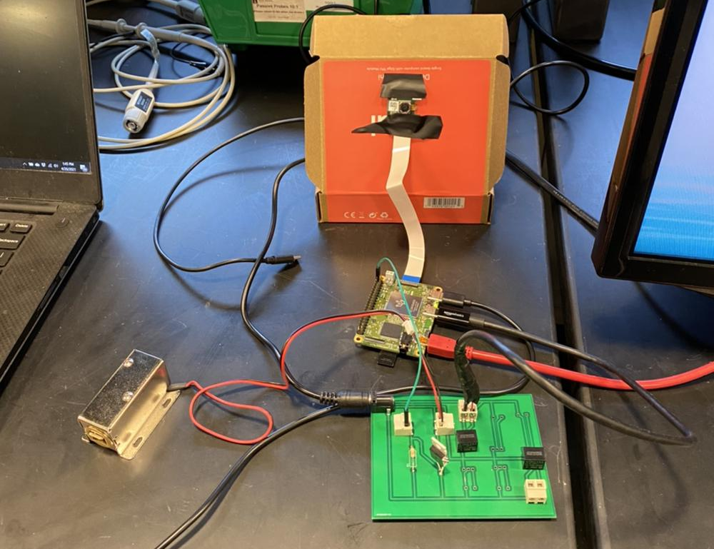
Figure 6. Final Design with PCB

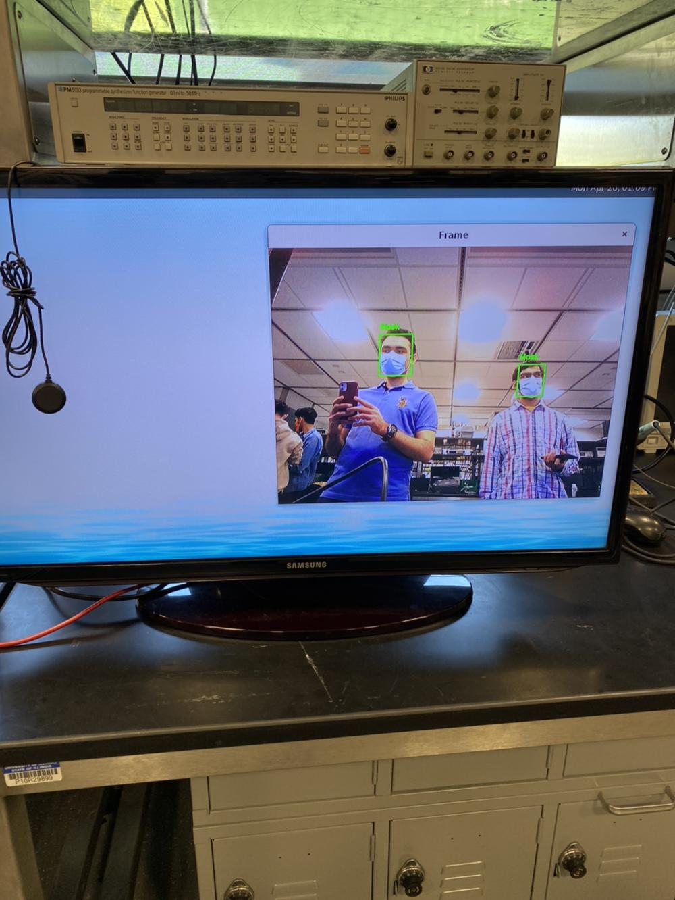
Figure 7. Sample output from acceleration module

