Working in Teams

Learning Objectives
At the end of this module students should be able to
- Identify, in order, the five stages of Tuckman’s Theory of Team Building.
- List two or more techniques for avoiding stagnation in the first three stages of Team Building.
- List two or more techniques for engaging a disengaged teammate.

Additionally, by the semester’s end, the students should be able to
- Provide a statement on the technical and economic benefits of diversity in a team.
- Reflect on personal challenges in teamwork and approaches to resolve.

When Is a Team Member also a Team Player?
What is your greatest weakness?
Do you work well in teams?
What motivates you?
Figure 1: Interview (modified) [source: cleanpng.com/ under Fair Use]
Are you a good teammate? Of course, you are! But why? What makes your teammates good teammates or poor teammates? You will soon generate a charter for your team. The charter should answer basic questions like, “Why does the team exist? What are the goals of the team? What do each of you promise to do as a member of this team?” This first exercise will help you take a meta-cognitive approach to team work rather than blindly hoping for the best. You will become a better teammate and encourage others to do the same. Understanding team function as a science will help you in future courses as well as your professional career.
This is your process for building the team charter. This document and a charter template will guide you.
- Read the section on Tuckman’s Stages of Team Formation (below).
- Read about Common Dysfunctions of Teams especially with respect to ECE 110 (below).
- Read about Expectations of the ECE 110 Course (below).
- As a team (in lab), meet and draft your charter using the template provided. You will surely have questions for the staff. Ask questions early and often.
- Sign and submit your charter to your TA electronically as instructed.

Tuckman’s Stages of Team Formation
In 1965, Bruce Wayne, no, wait, not Batman, Bruce Wayne Tuckman, an American Psychological researcher defined four (later expanded to five) stages in team development. Those neatly-rhyming stages are shown in Figure 1. Please read carefully through those descriptions.
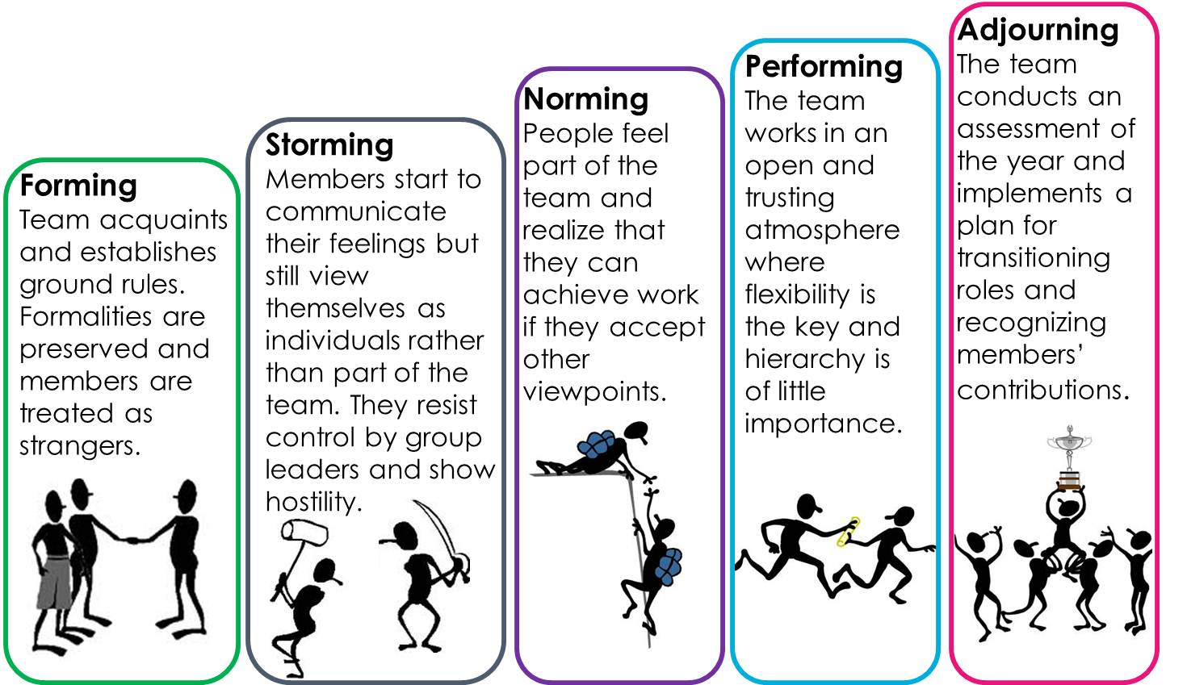
Figure 2: Tuckman’s Theory of Team Formation [source: https://culcbulanppa.wordpress.com/2014/07/07/dare-to-be-a-leader/ under Fair Use]
In course work assigned for teams, an instructor might mistakenly assume the forming, storming, and norming stages to be only a formality and expect students to quickly move to the performing stage. At the end of the project, students submit their work, reflect on the process, and receive a grade. This often sets the team up for failure.
Neglected by the instructor are a large portion of the forming stage and all the storming and norming phases. Admittedly, it is these neglected stages of team formation that may consume many working hours of the team or an individual member. To understand these stages and recognize the conditions that extend their duration is to also understand the process needed to shorten them. We can speed the process of reaching the performing stage. Let’s discuss these stages in just a bit more detail in the next section, Common Dysfunctions of Teams.
Explore More! Do you struggle with time management or find yourself putting off assignments and studying until the last minute? Have you convinced yourself that this works “just fine” for yourself? Dr. Tuckman also presented an interesting paper on college student procrastination that is well worth the read! He knows all your excuses and help you categorize them so that you can take your own meta-cognitive approach to understanding shortcomings of those excuses. Sorry, but despite what you keep telling yourself, he concludes that the “use” of typical procrastinator excuses is inversely proportional to grades. https://files.eric.ed.gov/fulltext/ED470567.pdf

Common Dysfunctions of Teams as Aligned with Tuckman’s Stages

Forming
Dysfunction often occurs at the very start of team formation. In the “Forming” stage, students come together for the first few meetings with a certain awkwardness. I hope I get a good team. Will I be liked? Who will be the leader? Will I be the dumbest person on this team? Will I get stuck carrying the load? If I take the lead, will I look pushy and dominant? These concerns and more will arise and cause hesitation and misgivings on the intent of all the team members. What can be done?
It is important for teams to get the formalities out of the way as soon as possible. Use an icebreaker. Have each team member prepare a 10, 20, or 30-second video that discusses who they are, what they like, why they are here. Play a game of Pictionary. Do something that increases comfort and allows you to talk without worry of judgement. Be willing to show vulnerabilities. Show your skills. Show your likes and dislikes. Let others know your personality. Openly discuss your personality traits. Provide the group with an opportunity to recognize where your role as team member may lie as soon as possible so that they can respect your strengths, challenges, and potential and thereby provide you the resources to be successful.

Storming
The second stage of team formation is rather scary, “Storming.” Whoa…why should there be a storm coming? Didn’t we just cover the introductions and gain each other’s respect? If only it was that easy. In forming, you laid the groundwork for expectations, but now everyone needs to start living up to them. But I have a Chemistry exam that night! Oh, I forgot about that meeting, I’ll just make it up with you later. I have all the answers, but no one wants to listen to me. Yes, it is a virtual firestorm! Feelings get hurt. Teammates are hesitant to call each other out. Some pick up the slack and others lose heart. Some believe they are purposely being left out of the team and meekly retreat. What is happening here?!
A large part of the issue is that channels of communication have not be pre-defined. This needs to be done during the timid-with-best-intents portion of team formation, the “Forming” stage. Don’t try setting down ground rules in the storming stage…that is much more difficult. Someone will feel that they are just being targeted. Why else would you make a rule only after identifying who would break it? No, these rules must be presented early. Do this in a quasi-legally-binding manner. Learn about team formation (you are doing just that now!) and do your best to define avenues for success by knowing what might be coming.
Think this through using a case study. Let’s assume a teammate has retreated. He has now missed two meetings in a row. Not answering emails, either. What do you do? Look to your charter and do exactly what you said you would do! BUT don’t assume the worst of that person. Start with empathy. You may find out that someone’s loved one has just passed away. They have been laid up with a broken leg. Or you may discover they became overwhelmed with their semester and didn’t know what to do about it! Become their advocate. Discuss the situation and find them help and resources. While your team will be better with them, they can also weather a hopefully-short absence of a teammate. In any case, recognize a responsibility to help yourself grow professionally while helping each classmate to grow professionally as well.

Norming
Through your activities and outreach, you are now coming to understand the strengths, weaknesses, and personalities of the team. The roles are becoming better defined and each student is finding where they can best contribute each week. Congratulations, you have entered the “Norming” phase. It will take work and you may find situations that revert (hopefully, only momentarily) to the storming phase, but the team will be simultaneously performing! Projects are completed, reports are written, and, most importantly, real LEARNING is happening. The TEAM is a real team and is creating value.

Performing
Performing happens on a plan. On a schedule. It uses collaboration tools. Ways to share. It doesn’t happen by accident. You need to think about what needs to happen, set deadlines, and then follow up on those deadlines. Everyone reports. Everyone asks questions. Delays will happen. Why did they happen? Does the team need to reallocate resources, including personnel, to keep the overall project on schedule? Is it acceptable for a team member to report that “only my part of the project got done?”
Performing also produces the best results only with the engagement of the full team. Why does teamwork produce better results? Diversity. Diversity in backgrounds. Diversity in experiences. Diversity in work. Diversity in play. A very diverse team may lead to a longer, tougher “Storming” phase as students become familiar with differences in personalities, expectations, and values across the team. Often, these can be misconstrued as each member tries to map the outward features to their own experiences. You ask yourself, “Is that teammate lazy? Maybe just shy. Maybe lacking confidence in her skillset. Maybe lacking confidence in his spoken English.” Don’t be afraid to ask questions while always being respectful. This is a great time to do a first peer review. From the results of that review, you can seek ways to improve skills or gain the confidence of your teammates. You will want that insight that their unique background brings. You will want that VALUE that turns a project into a solution that solves a real need. As a team, you can also revisit your Team Charter to improve its effectiveness.
Value added through diversity: Can an all-male team create a product used primarily by women? Can a team of engineers all born and raised in large cities build a project used primarily by rural farmers? For any product, intense market research is needed to produce a viable solution. Diversity in a team helps to lower instances and persistence of biased thinking. Can you image other ways diversity would bring value to a project? How might other forms of diversity benefit a team?
Finally, the pieces come together. There is a working prototype. Yes, there are pieces you wish you had the time and resources to make better. There are improvements that can be made. Maybe now you have enough experience that the entire approach could be scraped and replaced with a solution that is less-cost, faster to produce, more easily configured or expanded to address other needs. But it is a solution. It is your solution, and you should be proud of what you learned from the experience.

Adjourning
And now the report is written. The staff looks it over, asks questions, gives feedback, and, finally, a grade. Who earned that grade? The teammate who was the MVP? The teammate who showed the most growth/improvement? The teammate who was best for morale when things looked dim? If all team members became team players, they do, indeed, contribute each in their own valuable way. The team is better for having all of them. Congratulations! You are in the “Adjourning” stage. In our course, there is a final peer review. Will anyone be surprised at the results? Will you feel that the “team grade” is the appropriate grade for each team member? Was each team member a team player? Was the experience the kind of event that you would like to experience again?

Expectations of the Our Course
Now that you have plenty to consider in the stages and challenges of team formation, let’s try to develop this around the environment of the ECE 110 course. What happens each week? What kind of a schedule are we trying to keep? How can roles be different between students? What roles are universal across all students? Let’s try to break this down.
The course staff will work to assign 3 or 4 students to each team. You do not get to choose your teammates. That is rarely your choice in any work experience anyway. Working with a friend can be perk but can also lead to issues. What if your friend is not a team player, would you be willing to admit that in an assessment? What if she is the proverbial hitchhiker, present, but not a contributor? What if you and your friend work very well together? Will you do so at the cost of alienating the others? Perhaps not, but teams will be generated by your TAs all the same.
What do we expect the team to do? LEARN TOGETHER. Plain and simple. Learning has several aspects. We will not discuss all the facets of learning here, but it is worth mentioning a few. Learning happens when you devote time-on-task. If you don’t spend time reading, watching, and applying, then learning will not happen. You might remember some valuable information for a period, but it will soon be forgotten without pushing that learning curve through the different levels (see, for example, Bloom’s Taxonomy https://www.bloomstaxonomy.net/). In an intro course, many activities to gain a basic knowledge can be done more quickly and with more focus individually than in a team. Reading this document is one of them! However, to build deeper comprehension, to generalize, to analyze, to design, and to critique can often be accelerated and enhanced through group discussion…learning through both the failures and successes of the others…making realizations as you formulate the words to explain a concept to a teammate…imitating the approach seen by another…group work is a blessing in learning.
So, teamwork is great! Why shouldn’t everything be teamwork? Well, besides the prior example of focus during the acquisition of basic information, dependence on a team can also lead to false confidence. Everything makes sense when there are others around to talk you through it. However, you sit for an exam and can’t seem to get anything right! What happened? Even those tools that are “learned” while doing group work need to be exercised outside of the group setting. Say, in group, you found a new way to approach a certain problem? Then you will want to try it on a new problem yourself right away! You want this blend of individual plus teamwork to become a well-rounded master of the material.
Knowing this, let’s discuss the structure of the course. Each week, the students will find material to read, videos to watch, and activities to engage in (homework, prelab, etc.). Much of this should be attempted as an individual, but you have a team to reach out to as needed. The individual preparation provides yourself with the background to make team meetings more productive. In the meetings, everyone should be at the same point ready to tackle the group activities.
Consider your team as your peer resource for the course in general. If you find something is extremely difficult or otherwise taking much more time that it should, your teammates can serve as a resource in addition to our staff office hours. Reach out to them, build community, and learn while keeping frustration low!
Each week, there will procedures for everyone to complete (partly as individuals and partly as a team). Occasionally, mini projects will provide each student some freedom in choosing what they wish to learn from the course. Most of these projects are specifically helpful in building tools valuable towards a successful final project, building both technical skills as well as so-called soft skills. You may consider working together or sub-dividing the projects according to interest so that the team gains insight across a wider variety of tools and applications.
Your team will, at a minimum, formally meet at the time assigned to your lab section. In some weeks, you will meet with your team and, when possible (office hours?), a staff member can help you through the rough patches of team formation, to observe team behavior (for the process of contributing to peer review) and provide answers to questions you may have. In other weeks, the team will prepare a presentation (possibly both video and written materials) and then join the rest of the lab section and TAs for both instruction and assessment. Although these materials may be often prepared and presented as a team, every team member will be called upon to answer questions or explain concepts. The failure of one teammate is the failure of the team just as when a sports player fails to guard the opponent and the opponent scores.
The staff will work to be explicit regarding assessments that must be done by individuals without assistance from anyone else. All quizzes and the final exam clearly fall into this status as may a smaller number of activities throughout the semester. Most lab reports will be a group activity while students complete most of the hardware builds individually. The teams will use the charter along with assistance from the staff if needed, to facilitate best practices in team formation/performance.

Questions
- List two techniques you believe would help keep you and your teammates engaged in the weekly activities. They can be from this document or you can create your own. Explain why you believe they would help.
- List two ways to try to re-engage a student who is either absent or isn’t contributing as a teammate should to the team activities.

