# What are Transistors?

You are probably aware that the transistor is a critical element of today’s society. It is the backbone of every computer circuit. But did you know that there are many different types of transistors, each with a different physical mode of operation? For example, the first semiconductor transistor ever developed was a “point-contact” transistor. Today, bipolar junction transistor (BJTs) and metal-oxide-semiconductor field-effect transistors (MOSFETs) made up a majority of circuits. There are many other varieties, but these two popular varieties have been included in your electronics kit.

But what are they? Discussion of the physics of transistors will take more time and prerequisite knowledge of physics and chemistry. But what they *do* can be more simply described. Transistors act as either ***switches*** or ***amplifiers***. Let’s discuss switching first.

A mechanically-operated switch has two terminals (wires) and can be either open or closed (*open circuited* or *closed circuited*). Figure 1 below, shows a mechanical switch within a circuit. The switch represents the role the transistor might serve. It can be open (as in the figure) or closed (if the switch follows the arrow on the figure).

***Figure 1***: The use of a mechanical switch to control current flow.

Transistors are three-terminal devices that can control a switch located in a high-power circuit. The extra terminal provides a way to connect a low-power circuit that controls the state of the switch as OPEN or CLOSED. For example, in Figure 2, the voltage $V_{GS}$ need not supply any significant current (therefore nearly zero power is supplied) while it can close the transistor switch by choosing $V_{GS}>V_{HIGH}$ and the transistor switch can be opened such that not current can flow by choosing .

 

***Figure 2***: One example of a model for a transistor used as a switch (a) placed in the earlier circuit (b).

When a transistor is used as an amplifier, it amplifies either a low voltage or a low current and produces an output with higher power, the output having either a strong voltage or a strong current. A commercial amplifier can also be designed to provide both current and voltage amplification by using multiple transistors*.* In Figure 3, we provide an example of one such model. Here, the input voltage $V_{GS}$ is being amplified to a value of $K×V_{GS}$. We assume $K$ has a magnitude greater than 1 in which case $K×V_{GS}$ has a magnitude greater than .

***Figure 3***: One amplifier model for a transistor.

## Different Models for The Same Device?

We have shown two different models for the same transistor…and we aren’t even done yet! In a bit, we’ll introduce the transistor as a variable resistance. It may be confusing that the same transistor can have many different models, but this is true! A model only needs to represent the devices operation in the way it is being used in a particular application. For example, a nine-volt battery used in your smoke alarm might be accurately modeled as an ideal voltage source. But when you try to use it to power the engine starter of your car, it is far from ideal! In the same way, you will see many different models of the transistor throughout this semester, each sufficiently accurate for some set of applications!

## Bipolar Junction Transistor

In our kit, you will find several npn-type BJT transistors attached to a small ribbon of paper. They look like the device in Figure 4 (b). This device has three terminals: collector (C), base (B), and emitter (E).

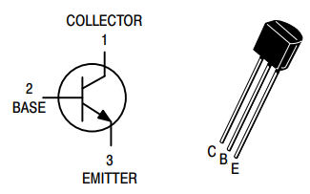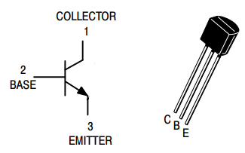

 

***Figure 4***: A BJT symbol (a) and physical device (b) with terminals labeled: C, B, and E. [Source: modified from <https://www.onsemi.com/pdf/datasheet/p2n2222a-d.pdf>]

When a voltage is applied through a series resistor to the base (B), a switching operation inside the transistor results in making a connection between the collector and emitter (the switch is closed). With the voltage at the base set low, the switch between collector and emitter is broken (the switch is opened). Let’s build a simple circuit where your finger can serve as the resistor that connects the base to the battery voltage. The switch between the collector and emitter can be caused to be closed by the presence of your finger or opened by the absence of your finger. The collector-to-emitter switch needs to be connected to its own circuit for this to work. Therefore, from your battery, insert a series circuit of an LED from your kit (any color will work) and a 330 Ohm (orange-orange-brown) resistor.

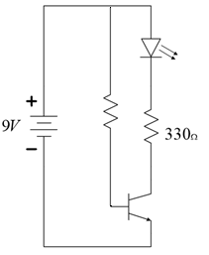

 

***Figure 5***: BJT transistor used as a switch. Complete your build by first placing the components in the orientation shown by (a), then by (b), and finally by (c).

Build the circuit of Figure 5 (a). Remember not to connect your battery, but rather make battery connections to the power and ground rails of your breadboard. Figure 5 (a) is not complete, but you need to make sure to build this circuit “loop” correctly or this experiment will fail! The C, B, and E terminals all need to be in a separate numbered “row” of your breadboard so that they are not shorted together. The row that the emitter is inserted into should be connected to the ground rail of your breadboard. The row of the connector should also be connected to one end of your resistor. When you are sure that your circuit represents Figure 5 (a), continue.

Next, use a second $330 Ω$ resistor to connect the base (B) to the power rail as in Figure 5 (b). At this point, connect your battery and the LED should illuminate. If it does not, quickly unplug your battery and check your connections again. You should be using the barrel connectors supplied in your kit as the primary means of connecting and disconnecting your battery. When you have an illuminated LED, continue.

**Disconnect your battery.** Figure 5 (c) asks that you remove the $330 Ω$ resistor from between the power and base nodes. Be sure to leave the resistor that connects to the LED or your will have a broken loop! Using *two wires*, plug one wire into the power rail and an unused numbered row on your breadboard. Connect the second wire between the base and an unused numbered row NEXT TO THE WIRE you just inserted. Be sure that these two wires DO NOT CONNECT TO THE SAME NODE or you will damage your transistor. Check that your circuit looks like Figure 5 (c) including the gap between the two wires. You may now reconnect your battery. Now, slightly lift each wire out and bend it back so that enough metal is exposed to make a good contact with your finger (see Figure 6). Use your finger to connect the two wires with your natural resistance. It may take some pressure to get a good electrical connection. You should see the LED illuminate with your finger present and turn off with the absence of your finger.

***Figure 6***: The two wires of Figure 5 (c) with wires exposed to make electrical connection with your finger. DO NOT CONNECT THESE TWO WIRES TOGETHER except by using your (high resistance) finger.

**Question 1**: Does the switching operation of the BJT transistor appear to be purely ON/OFF, or does it appear that there are some variations in the amount the switch can be “closed?” Explain what you see.

## Metal-Oxide-Semiconductor Field-Effect Transistor

The MOSFET (see Figure 7) can, of course, also be used as a switch. Because it has different physics (we will explain in lecture later this semester) than the BJT transistor, we will configure it just a little differently than the BJT. It also has a different set of names for its three terminals: gate (G), drain (D), and source (S). In the MOSFET, the gate is the control terminal and the switching action occurs between the drain and source terminals.

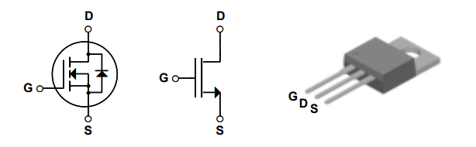

***Figure 7***: For the MOSFET, the datasheet symbol, the symbol used in ECE 110, and the physical appearance. [Source: <https://cdn.sparkfun.com/datasheets/Components/General/FQP30N06L.pdf>]

We will also take this opportunity to explore when a transistor operates in a region where it is not simply “closed.” In this third case, we will consider a model of the transistor where it behaves much like a variable resistor…that is, it is a resistor whose value can be electronically controlled. In Figure 8, we explore this model where the transistor between Drain and Source terminals has a soft region between OPEN and CLOSED. When the voltage $V_{GS}>V_{HIGH}$, then the resistance between Drain and Source (let’s call that $R_{DS}$) becomes very close to zero, $R_{DS}≈0 Ω$ and the switch is essentially closed and allowing current flow. When $V_{GS}<V_{LOW}$, the drain to source region becomes more like an open circuit with our model assuming a very large resistance, $R_{DS}≈∞ Ω$. In between, for values $V_{LOW}<V_{GS}<V_{HIGH}$, the resistor takes on varying values $R_{DS}∈\left(0,∞\right) Ω$ with smaller values as $V_{GS}$ increases towards .

***Figure 8***: A third transistor model where it acts like a variable resistor within a circuit.

Let’s explore to see how this works. **With the battery disconnected**, build the circuit of Figure 9. You can use a $10 kΩ$ potentiometer to control $V_{GS}$ (voltage divider rule). Note that we are now using the MOSFET and ***not*** the BJT from earlier!!

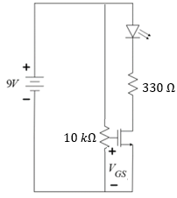

***Figure 9***: MOSFET with $V_{GS}$ set using a $10 kΩ$ potentiometer and the same LED + $330 Ω$ resistor now connected from battery to the drain.

Attach the battery. Starting with the $V_{GS}$ voltage set to 0.0 V (use your voltmeter to monitor), increase it slowly and watch the LED slowly illuminate. Stop when the LED no longer appears to be increasing in brightness. If your circuit is not behaving properly, disconnect the battery right away. Check your circuit connections and try again.

An important note here is that the “main circuit” is the 9-volt battery pushing current through the series LED and $330 Ω$ resistor. The Drain-to-Source connection acts like a switch (also in series with the LED/resistor) to throttle the current. The $10 kΩ$ potentiometer is just there to control $V_{GS}$ and will typically be replaced by some other voltage signal from your circuit.

**Question 2**: What is the voltage $V_{GS}$ applied to the gate where the LED no longer increases in brightness? Call this voltage, $V_{HIGH}$.

**Question 3**: What is the voltage $V_{GS}$ applied to the gate where the LED appears to shut off entirely? Call this voltage, $V_{LOW}$.

Over the range of control voltages $(V_{LOW}, V_{HIGH})$, the drain-to-source model of the transistor is clearly not well expressed by a simple switching action, CLOSED/OPEN. It would be better modeled by a variable resistance, $R_{DS}$, whose value travels from nearly infinite ($∞ Ω$) when the gate voltage is near $V_{LOW}$ to something much closer to zero ($0 Ω$) as the gate voltage approaches $V_{HIGH}$.

Do ***not*** disassemble your circuit. Continue on the next page!

## Finish and Submit:

***Question 4***: Build a summary of key points made in this lab regarding transistors. Be sure to address the following in addition to anything else that interested you.

* How many types of transistors are mentioned?
* How many transistor “models” are mentioned?
* What did you learn from the BJT experiment?
* What did you learn from the MOSFET experiment?
* What else might you like to know about transistors?
* **You will be asked to demo to your TA your Figure 9 circuit, highlighting when $V_{GS}$ reaches $V_{LOW}$ and $V_{HIGH}$.**
* **Submit your answers to the questions to GradeScope.**