Explore an Inverter through Falstad’s Simulator

Learning Objectives
- Explore the operation of a Schmitt-Trigger Inverter through the Falstad/circuit simulator.

Background
To invert the voltage, we will use a device called an inverter built in an integrated circuit (an IC). The inverter is based on “logic” voltages. That is, it operates on and outputs only voltages of one of two values. An inverter outputs a logical voltage signal that is the opposite of the logical voltage at its input. That is, if the input voltage is low (referenced to the supply battery’s negative post, 0 volts), the output-to-ground voltage is high (near the value of the battery’s voltage). If the input voltage is high, the output voltage is low. Thus, we say the output of the inverter “inverts” the voltage at its input.
For many students, the inverter may be a new concept. For practically all of our students, the Schmitt-trigger inverter is a new concept. This exercise is designed to help explore what is meant by the concept of an “inverter” and how the Schmitt-trigger is a special case that also includes a hysteresis (a kind of memory).
Study the datasheet of the Schmitt Trigger Inverter (CD40106). http://www.ti.com/lit/ds/symlink/cd40106b.pdf. A traditional inverter has an output that transitions from high [voltage near the supply value] to low [voltage near 0] as the input crosses a certain threshold from low to high. When the input drops across that same threshold value, the output transitions back to high. A Schmitt trigger has a hysteresis meaning that the threshold changes between two values, the choice of which depends on whether the output is currently high or currently low. The curious behavior of the Schmitt Trigger Inverter vs. a traditional inverter is highlighted in the following figure.

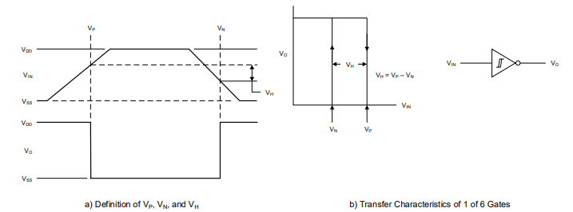
Figure 1: a) The input and output behavior vs. time. b) The hysteresis as a function of the output voltage vs. the input voltage. The arrows indicate how the threshold changes depending on the direction the output voltage is changing. [source: https://www.ti.com/lit/ds/symlink/cd40106b.pdf]
Now, continue with the simulation below.

Software Simulation
Simulate the following circuit using https://www.falstad.com/circuit.
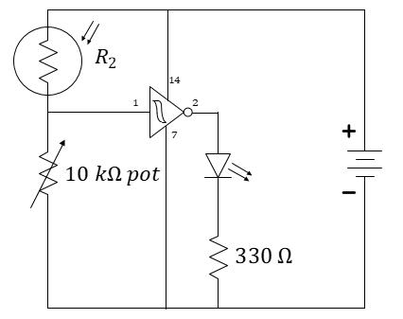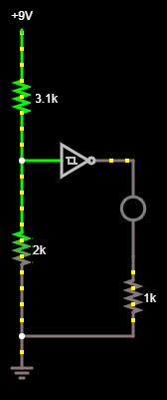
$1 kΩ$

Figure 2: A “cloud detector.” In the circuit schematic, the connection of the IC to the battery is included. In many schematics, it is assumed, but not explicitly shown.
In Figure 2, we show a cloud detector circuit where an LED illuminates when a photoresistor is shadowed. Falstad’s simulator does not provide us with a form of photoresistor, so we will simulate it with a variable resistor (specifically, a resistor controlled by a slider).
To build this circuit, start with a blank circuit (Circuits Blank Circuit). Use r to draw three resistors as shown. Use lower-case L, l, to draw the LED (the circle on the right). The Schmitt-trigger inverter is an active device meaning that it draws power not from its input, but from an external power supply. Find it under DrawActive Building BlocksAdd Schmitt Trigger (inverting). You will also need to adjust the parameters of the Schmitt Trigger so that it more-closely matches the version we are using. Right-click on the Schmitt-Trigger Inverter and enter the parameters given in Figure 3.
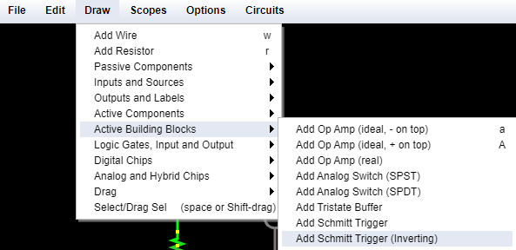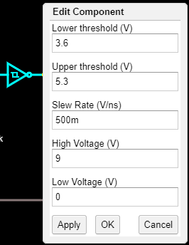
Figure 3: Adding the Schmitt Trigger Inverter and adjusting its parameters to match the CD40106.
You can then attach a power supply to your voltage divider by using g to add a ground (the negative side of a voltage source) to the lower-left resistor and then DrawInputs and SourcesAdd Voltage Source (1-terminal). A 1-terminal source will provide a fixed voltage at any node relative the ground node. Add this voltage source to the top-left resistor, completing the voltage divider. Add wire using w as needed to complete the circuit as shown in Figure 1.
Edit the 1-terminal voltage source to 9 volts. Also, set the values of the lower resistor (2 kOhm) and the lower-right (1 kOhm).
Now right-click the upper-left resistor and choose sliders… to add a slider control. Make the slider control have a range in resistance similar to your own photoresistor (which should have been done in a previous exercise).
You can now adjust the slider to imitate the darkening and lightening of the room.

- Starting from the highest slider value, find the slider value that turns the LED off. What is the voltage at the input to the inverter (relative to ground)?
- Repeat by starting from the lowest slider value and adjusting until the LED turns on. What is the voltage at the input of the inverter (relative to ground)?
- Find a datasheet for a traditional 74LS04 inverter and record the URL for that datasheet here. What is its maximum voltage rating? Would this work with a 9-volt battery?

