Human-Centered Design: Examining Assumptions
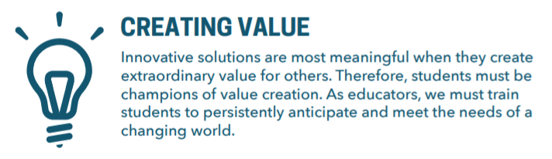
Source: https://orchard-prod.azurewebsites.net/media/Framework/KEEN_framework_new.pdf
When exploring design options, we are often blinded by our own experiences and expectations. A solution generated in this limited domain can often lack the broader value it might otherwise provide. In this exercise, we will explore assumptions as they relate to design, and how awareness and acknowledgement can help us remain unbiased in our approach.
You will be working through the Understand phase of the Siebel Center for Design’s design-thinking taxonomy. This exercise will help you develop the following mindsets*:
- Human-centeredness: characterized by a central focus on empathy for others and putting oneself in others’ shoes.
- Metacognitive: characterized by an awareness that is essential to be aware of where one is in the design thinking process in order to agilely respond to changing parameters of the problem.
*Lawrence, L., Shehab, S., Tissenbaum, M., Rui, T., & Hixon, T. (2020) Human-Centered Design Taxonomy: Case Study Application with Novice, Multidisciplinary Designers.

Part 1:
Documenting assumptions - Consider this hypothetical situation:
An (imaginary) tech giant company has teamed up with the University of Illinois to collaborate on the development of a new personal assistant “smart speaker” specifically for college students. The plan is for the university to ship one to every University of Illinois student, wherever they may be taking classes. You have been selected to be a part of this project team for your perspective as a student.
To start off the project, each member of the team has been asked to document their assumptions around the project space.
Important! All questions are repeated on the last page so that you can print and submit a smaller document to GradeScope.

- Based on your own experiences, write out your predictions for what you think the most significant challenges faced by you and your team throughout the course of this project will be. Don’t worry about being “right” for this part - it’s purely about understanding where each team member is coming from, and what your perceptions of the problem space are! Set a timer for 5 minutes and write out as many thoughts as you can before moving ahead in this document.
Part 2:
Considering other perspectives - Documenting our assumptions is an important part of acknowledging that each of us carries with us our own unique perspective. For this project, you’re a member of the project team as well as its target audience, which is both a blessing and a curse.
As a member of the target audience, you’re likely to be more in-tune to the needs and desires of that group, and thus your input will be extremely valuable to the project. However, it can be a curse in the sense that your perspective may or may not be representative of larger trends in the target audience, and it might be hard for you to see past the singular view of the world you’ve come to develop.
As a result, it’s extremely important for us to consider viewpoints other than our own when we’re designing something. Your predictions in part 1 might do a great job of considering challenges in designing a device for you or someone like you, but did you consider…
- Students who are worried about their privacy and security with personal assistant devices; how will you ensure these students feel safe and secure about their sensitive information?
- Students with accents that you might not hear on a daily basis; how will you ensure that the AI is culturally inclusive?
- Students with disabilities that make it difficult to speak or pronounce certain words; how will you ensure the AI is adaptive to each individual’s speaking ability?
Reflecting on assumptions - did you consider these perspectives when putting together your predictions in Part 1? It’s totally ok if you didn’t! The development of assumptions and biases is a natural part of being human - it’s normal to default to your own perspective when approaching a new problem. Pretending like personal bias doesn’t exist or that you can ignore it and it will go away can actually end up being really harmful to a project. Instead, learning to acknowledge and accept our biases can help us consider how our perception of the world is shaped by our experiences and to approach new challenges with an open mind. That being said…
- Take another look at the assumptions you wrote out in Part 1. Consider what personal beliefs you have that led you to respond in the way that you did. What are those beliefs? What experiences led to the development of those beliefs?
Part 3
Wrap-up - You may be starting to understand the importance of documenting and acknowledging our assumptions at the start of a project; it’s the first step in the deceptively difficult process of attempting to understand the perspectives of the people you’re designing for.
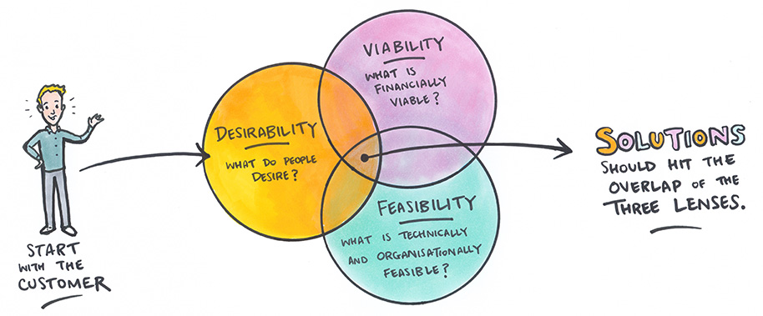
Gathering user perspectives can be hard work, but it’s always worth the effort. Putting in more time up-front on a project can save you lots of time down the road. Consider the following graphic:
Although it’s definitely true that all three of these circles are integral parts of effective solutions, desirability may be the most important. At the very least, it offers the most benefit for the investment of time early on; if an attempted solution fails, it’s much easier to pivot and try out a new idea if you already have a strong understanding of a real need you’re trying to fulfill. In contrast, if you spend time and energy developing the technical or business aspects of a solution without truly understanding the underlying unmet needs first, you may find yourself in the unfortunate situation of having wasted precious resources working on an idea no one actually wants.
Identifying those unmet needs is the all-important first step of any design, but it really is just that - the first step.

- Based on your own experiences, write out your predictions for what you think the most significant challenges faced by you and your team throughout the course of this project will be. Don’t worry about being “right” for this part - it’s purely about understanding where each team member is coming from, and what your perceptions of the problem space are! Set a timer for 5 minutes and write out as many thoughts as you can before moving ahead in this document.
- Take another look at the assumptions you wrote out in Question 1. Consider what personal beliefs you have that led you to respond in the way that you did. What are those beliefs? What experiences led to the development of those beliefs?

