Ultrasonic (US) Sensor

Prerequisites
- Experience with the oscilloscope.
- Prior construction and measurements of an oscillator.

Background
The ultrasonic (US) sensor can be used to sense the proximity of objects within a field-of-view. It is a sonar system that transmits a series of ultrasonic pulses, receives that pulse as it is scattered back to the device, and then generates a square wave (actually, a kind of Pulse-Width Modulated wave) whose duty cycle is related to the distance of the nearest object. The most cogent manual can be found at https://www.mpja.com/download/hc-sr04_ultrasonic_module_user_guidejohn.pdf. This project explores the HC-SR04.
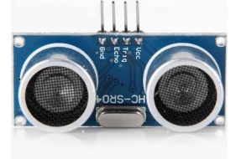
Figure 1: The HC-SR04 Ultrasonic Sensor.
As you can see from Figure 1, there are 2 devices similar to a loudspeaker/microphone that look strangely like eyes . One device sends an ultrasonic signal and the other receives it, so that is essentially what they are! The operation and design of this US sensor are proprietary so even the chips on the back have no designations to indicate their purpose. Lucky for us, the basic operation is summarized in the figure below that was found in the document mentioned above.
The two pins labeled $V_{cc}$ and Gnd indicate how to power the device. Be aware that the US sensor is has a maximum supply voltage of $5 V$. You will need to keep $V_{cc}≤5 V$ relative to the ground (Gnd) pin. If you have only your 9-volt battery and your Zener diode (a special diode you will find separate from the tape of signal diodes), you can still make this work!
You must provide a 5-volt source to the US sensor. You can complete the design project Zener DC-to-DC Converter before completing this exercise to make your solution mobile. You could use this “new” 5-volt source to power both your US sensor and a Schmitt-trigger oscillator.
There are also two other pins Trig and Echo. To emit an ultrasonic pulse, a trigger signal is used. The trigger signal must be provided by a square pulse that transitions from 0 to $V_{cc}$ (again, 5 volts) for a prescribed length of time. See Figure 2. You must provide this pulse periodically to the trigger pin to make the US sensor continually scan the field of view for objects.
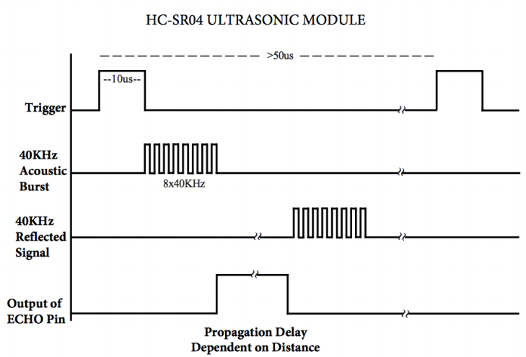
Figure 2: Timing Diagram: The Trigger is provided by the user to initiate the detection sequence that generates the ECHO signal.
This trigger signal causes the device to transmit an ultrasonic pulse that consists of eight short bursts of a signal at $40 kHz$ (the figure only shows the enabling of the $40 kHz$ burst so the pulses are square without the actual sinusoidal variation). Ultrasonic frequencies are those that exceed $20 kHz$, the nominal range of human hearing. Once triggered and the eight-cycle pulse is sent, The Echo pin voltage is set to $V_{cc}$ by the proprietary chip. The Echo pin transitions back to $0 V$ when the first reflection containing an image of the eight ultrasonic bursts returns. This means that the width of the pulse available at the ECHO pin is related to the distance to the nearest object in the field-of-view.
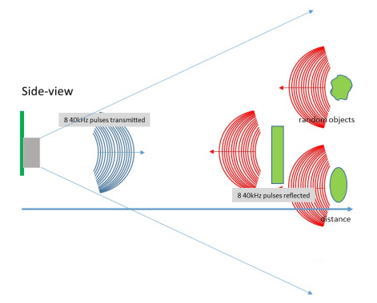
Figure 4: Visual interpretation of the ultrasonic wave propagation.
As Einstein pointed out distance and time are integrally related in the sense that when we are measuring distance we always have to send out a signal of some kind – in our case sound - and wait [insert time word] for its return. But the speed of sound at $343.2 m/s$ weighs in at only $0.000001\%$ the speed of light so the distance can be computed from the time it takes the transmitted signal to reach the receiver using the non-relativistic formula speed*time=distance.
The technical specifications of the HC-SR04 are summarized below. These specifications with the visual interpretation provided by Figure 2 allow us to answer many questions.
HC-SR04 Specifications:
- Working Voltage: DC 5V
- Working Current: 15 mA
- Working Frequency: 40 Hz
- Max Range: 4 m
- Min Range: 2 cm
- Measuring Angle: 15 degree
- Trigger Input Signal: 10 µs TTL pulse
- Echo Output Signal Input TTL lever signal and the range in proportion
- Dimension 45 * 20 * 15 mm
We see that the US sensor is intended to have a maximum range of 4 meters.
- After triggering the US pulse with the “falling” edge of a square-wave signal, how many $ms$ will it take for the ultrasonic signal to travel to an object $4 m$ away and then return to the US sensor?
We can also interpret that the Trigger signal is recommended to be a short pulse (0 to 5 volts) of length $10 μs$ and that this pulse occurs on a “working frequency” of $40 Hz$ cycle (40 pulses/sec).
- In $ms$, what is the period of a $40 Hz$ trigger signal?
- If the “on” part of the pulse is only $10 μs$ in length, how long in $ms$ is the “off” part of the trigger signal? Does this make sense when considering your answer to the first question? HINT: To avoid ambiguity, you would not want to send another trigger until even the furthest reflections have had a time to return to the device. You wouldn’t want to send a new pulse even while reflections of the previous pulse are still arriving!
- Compare this answer to your answer to the first question. How does the length of the “off” part of the trigger signal relate to the maximum distance?
- If we were to use a trigger signal that has a 50% duty cycle, what frequency should we consider using to still maintain a maximum distance of $4 m$?

Procedure
Insert the sensor into your breadboard. The four pins are well labeled on the board. We will also need the 5-volt source from Module 2917: Zener DC-to-DC Converter.
- Connect $5 V$ to the $V_{cc}$ pin and the negative side of your supply to the Gnd pin.
Continue with this setup:
- Build a Schmitt-trigger oscillator using a $10 kΩ$ resistor and a $10 μF$ capacitor like in your earlier lab. Because the Trig pin should also be limited to a maximum of 5 volts, be sure to power the Schmitt-trigger using your 5-volt supply and not directly from the 9-volt battery.
- Attach the square-wave output to the Trig pin and observe it on one channel of your M2k’s oscilloscope.
- Monitor the Echo pin on the second channel of the oscilloscope.
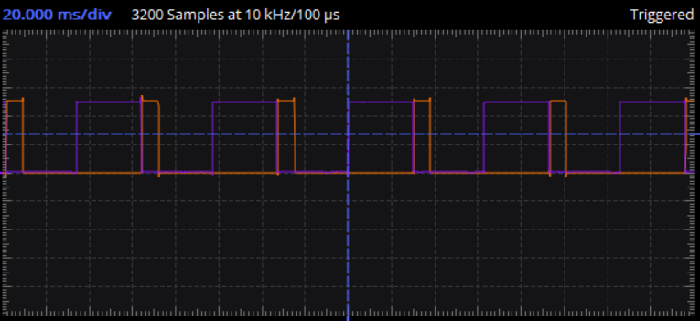
Figure 5: Example of the trigger (blue) and echo (orange) signals.
- Keeping the HC-SR04 in a fixed location looking off the edge of the table, move a large book to and from the sensor slowly.
- What are the minimum and maximum echo pulse widths that you observed? What distances do these widths correspond to?
Think about it… What would happen if you used the Echo pin to drive the MOSFET gate of your motor-drive circuit? What would happen if you simultaneously drive the opposite motor-drive with the “inverse” of the Echo signal? Hmmm…might be fun to see!
- Record a video of your working US sensor showing, simultaneously, the movement of an object and the changing of the echo signal on the oscilloscope.

Learning Objectives
- Evaluate limitations on an electronic trigger as determined by the physics of sound travel. (Analyzing, Connections)
- Observe and record electronic responses to physical stimuli. (Understanding)
- Model an electronic response (echo signal) as a function of object distance. (Applying, Analyzing)

Ultrasonic Sensor Characterization

- After triggering the US pulse with the “falling” edge of a square-wave signal, how many $ms$ will it take for the ultrasonic signal to travel to an object $4 m$ away and then return to the US sensor?
- In $ms$, what is the period of a $40 Hz$ trigger signal?
- If the “on” part of the pulse is only $10 μs$ in length, how long in $ms$ is the “off” part of the trigger signal? Does this make sense when considering your answer to the first question? HINT: To avoid ambiguity, you would not want to send another trigger until even the furthest reflections have had a time to return to the device. You wouldn’t want to send a new pulse even while reflections of the previous pulse are still arriving!
- Compare this answer to your answer to the first question. How does the length of the “off” part of the trigger signal relate to the maximum distance?
- If we were to use a trigger signal that has a 50% duty cycle, what frequency should we consider using to still maintain a maximum distance of $4 m$?
- What are the minimum and maximum echo pulse widths that you observed? What distances do these widths correspond to?
- Record a video of your working US sensor showing, simultaneously, the movement of an object and the changing of the echo signal on the oscilloscope.

