Zener DC-to-DC Converter

Procedure
Some devices (for example, the ultrasonic sensor in your kit) are designed to work with a maximum voltage supply below the 9-volts that you have in your kit. This exercise will allow you to complete a design for a 9-volt-to-5-volt dc converter. The end result will be something that behaves much like a 5-volt battery although with a higher effective resistance than the original battery.
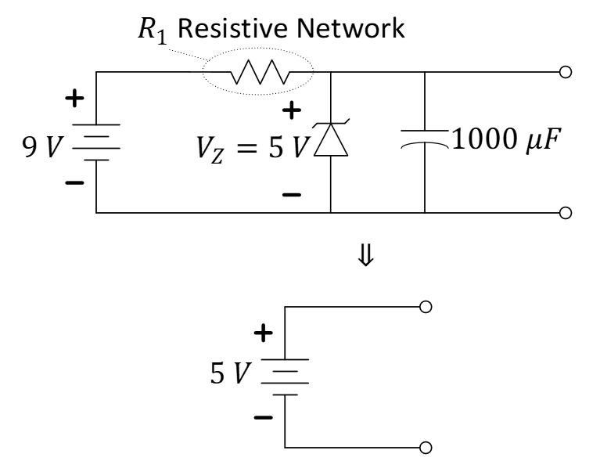
Figure 1: A 9VDC-to-5VDC Zener-regulator circuit (top schematic).
The Zener diode (https://en.wikipedia.org/wiki/Zener_diode) is a special diode that allows current to flow in either direction once a turn-on voltage has been reached in that polarity. While the forward-bias turn-on voltage is typical of the semiconductor material, the reverse-bias turn-on voltage (also called a “breakdown” voltage although it does not imply damage) can be designed to take on different turn-on voltage for different projects. The IV characteristic of a Zener diode is demonstrated in Figure 2.
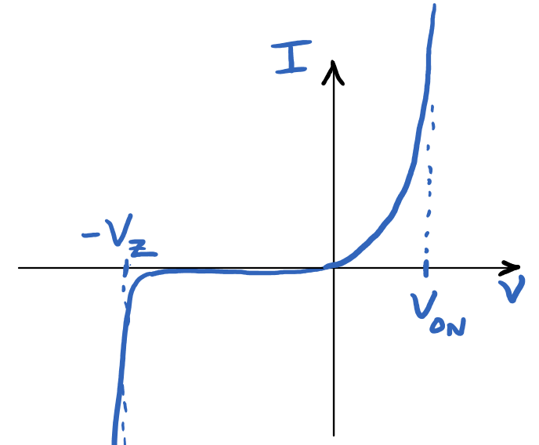
Figure 2: Current-voltage characteristic of a Zener diode with a breakdown voltage labeled “$V_{Z}$”.
The special diode in your kit (it will be separate with thicker wires than the “signal” diodes that you may have already used) is a Zener diode with a reverse-bias turn-on voltage near 5 volts. For our analysis purposes, you can imagine the Zener diode in Figure 1 to be a regular diode oriented in the downward direction with a (sharp) turn-on voltage of $V_{Z}≈5 V$.
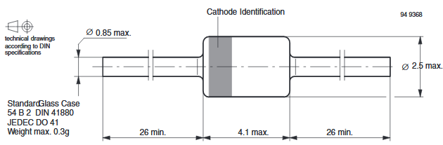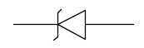
Figure 3: Select details from the Zener datasheet to aid with orientation in your circuit.
Before you build, as a design engineer, you will need to perform some analysis to verify both safety and function. Consider these facts and answer the following questions.
- We want to use this new 5-volt supply to operate both the ultrasonic (US) sensor which draws about 15 mA as well as a Schmitt-trigger oscillator which draws up to 35 mA. Using Kirchhoff’s Voltage Law on the loop below, what is a good value to represent the resistive load, $R_{load}$, to represent both the current draw of the oscillator and the current draw of the US sensor? $R_{load}=___________________?$ Explain.
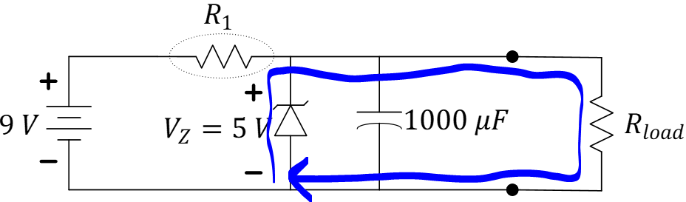
- You know that a charged capacitor draws no current. Determine the range of values appropriate for $R_{1}$ to provide $50 mA$ to the load. Hint: You need to use Kirchhoff’s Current Law to find the range of $R_{1}$ that guarantees $I_{Z}≥0 mA$ while the Zener diode operates at the breakdown voltage, $V_{Z}=5 V$. Show your work.
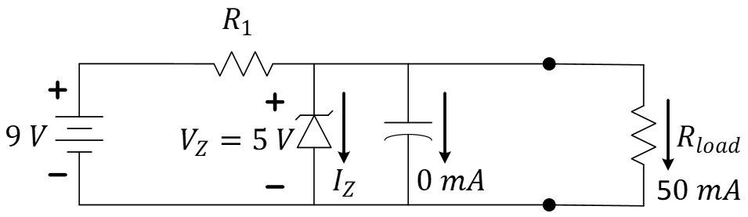
- Now, we must consider an engineering tradeoff. Choosing $R_{1}$ small will provide a 5-volt source with a smaller effective resistance and, therefore, capable of providing more current to the load if using this for other applications. However, a small $R_{1}$ will also mean more power dissipated by $R_{1}$ even when the load is drawing little current or disconnected entirely! Consider the resistor values in your kit and design a resistive network for $R_{1}$ that meets these goals:
- The effective resistance of your network, $R_{1}$, is near the largest value in the range, but does not exceed the range so that $50 mA$ may be drawn by the load.
- Each resistor used in the resistive network for $R_{1}$ dissipates less than $0.2 W$ (our resistors are rated for $0.25 W$, so we are being a little conservative here).
- The resistors come from the limited values available in your kit, the contents of which may be found at https://ece.illinois.edu/academics/ugrad/lab-kits/ece110.
Explain your reasoning as you show your work.

- Sketch the schematic of Figure 1 explicitly showing your resistor network for $R_{1}$.
- How would you redesign your resistive network if you needed it to be capable of delivering more current, say $100 mA$, to the load? Explain.
You may now build the circuit according to your design.
- Use your 9-volt battery and the M2k’s voltmeter or oscilloscope to validate your design. Submit a video demonstrating the 9-volt input and 5-volt output with two different resistive loads, $1 kΩ and 0.5 kΩ$.

Learning Objectives
- Ability to map a circuit design onto the breadboard in a functional and clean manner.
- Demonstrate the ability to use the M2k to monitor voltage.
- Design by considering both safety and function of a device.
- Ability to troubleshoot problems that occur during a build.

