Voltage-Divider-Based Cloud Detector

# Learning Objectives

* Explore the operation of a Schmitt-Trigger Inverter through its datasheet.
* Use two leads of a potentiometer as a variable resistor.
* Properly apply power to the Schmitt-trigger DIP-packaged IC.
* Use values from the photoresistor datasheet to properly design a voltage divider.
* Use a sensor-based voltage divider in a cloud-detector circuit.

# Background

Imagine you are in charge of designing a circuit that triggers power reduction in a solar-powered vehicle when the sunlight is blocked by clouds. We’ll call this circuit a cloud detector. A simple circuit component that responds to sunlight is the photoresistor. A photoresistor’s resistance is high when shaded, but sunlight will result in an excitation of electrons within the window of the device causing its resistance to decrease significantly.

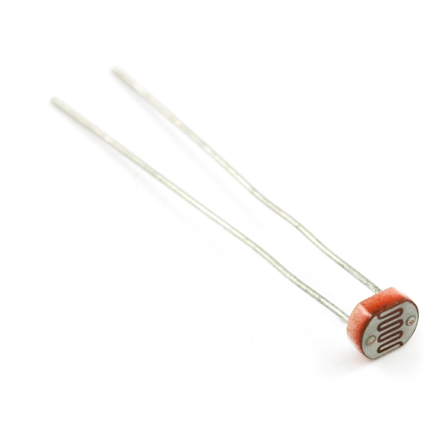 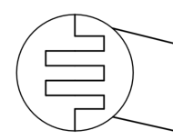 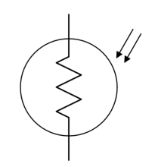

(a) (b) (c)

**Figure 1**: The photoresistor (a), a physical representation (b) and its traditional circuit symbol (c), where the twin arrows represent light rays impinging on the device.

To learn more about an electronics device, engineers consult the datasheet. The datasheet contains a wealth of knowledge about the physical layout of a component, ranges in its descriptive parameters, typical uses and/or its limitations. Like any resource, it is best to consume this knowledge in small doses. Do not worry that much a datasheet may be difficult to understand at first glance. It is merely important that you can find the data that you most-urgently require and understand. Open the datasheet for the photoresistor (<https://cdn.sparkfun.com/datasheets/Sensors/LightImaging/SEN-09088.pdf>) and answer the following questions.

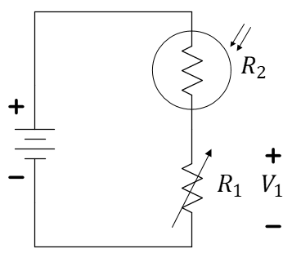

A resistor with variable resistance…generally changed by turning a knob or a screw.

***Important:*** All questions are repeated at the end of this document so that you can fill it out there, print, and submit less paper via GradeScope.

## Individual Exercise

## (You can discuss with your teammates if you need help, but please try to read the datasheet. You must construct your own Cloud Detector when you get to Figure 5!)

1. Based on the datasheet of the photoresistor, what *approximate* resistance might you expect to see for a darkened sensor (0 Lux)?
2. Based on the datasheet of the photoresistor, what approximate resistance might you expect to see for a sensor in a dimly lit room (10 Lux)?
3. Based on the datasheet of the photoresistor, what approximate resistance might you expect to see for a sensor in a very bright setting (100 Lux)?

Potentiometer: 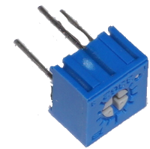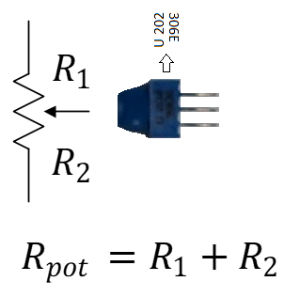

Suppose the photoresistor is used in the following voltage-divider circuit. Assume the battery voltage is $9 V$.

1. What output $V_{1}$ might you expect under the following conditions (please complete the table at the end of this document)?
2. Now, place a photoresistor into your breadboard and use your voltmeter to measure the resistance with a) your finger placed to block all light, b) a dim location, and c) a bright location. Record all three measurements including the units.



**Figure 2**: Consider this voltage divider circuit when completed the table below. $V_{1}$ is the voltage across $R_{1}$.

Note that we have already used resistors as a current-limiting device (for the car motors). This is a second common usage of resistors, a voltage divider to control a desired voltage level. There are two other uses that may be discussed this semester: resistors for power dissipation (like the rear defroster of an automobile) and resistors for pull-up or pull-down uses.

**Let’s assume $R_{1}=10 kΩ$.** From Table 1, it should be evident that $V_{1}$ is closer to $9 V$ when the voltage-divider is well-lit and closer to $0 V$ when shadowed. We would like to create the “invert” of this voltage reference creating a signal that goes “high” when shadowed so that this new voltage can trigger the cloud indicator (an LED) to illuminate.

To invert the voltage, we will use a device called an inverter built in an integrated circuit (an IC). Study the datasheet of the Schmitt Trigger Inverter (CD40106). <http://www.ti.com/lit/ds/symlink/cd40106b.pdf>.

The circuit contained in each IC is goes through a rigorous design process and tested under a wide range of conditions. Most ICs follow a few sets of universal standards, making it possible to wire them together and implement more complicated design. In general, there are three aspects of ICs that we are concerned with:

1. Chip orientation (pin numbering)
2. Circuit functionality and Schematic
3. Operation envelops and output characteristics.

The first of these points comes deals with a very common set of industry standards while the second two points differ from chip to chip. Let us begin with chip orientation and pin numbering. Below is an illustration of an IC in a dual in-line package (DIP) as seen from an oblique angle and from directly above.

pin #1



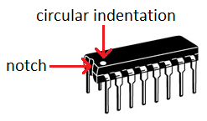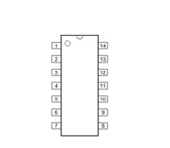

Potentiometer used as a variable resistor…

**Use the center lead plus *one* of the outer leads to create a variable resistor.** Insert the unused lead into an unused row of the breadboard, but **do not cut it off**! Tune your value of $R_{1}$ using this “screwdriver”:

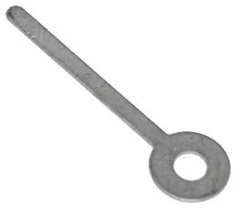

The potentiometer should have three values on it. The numbers 103 mean 10 plus another 3 zeros… $10 kΩ$…between the two outside leads.

**Figure 3**: Two views of an IC “DIP” package showing the counter-clockwise pin numbering system*.*

Usually IC DIP chips have a semi-circle or notch on one side of chip body. Pin numbers always start counter-clock-wise from the notch, wrapping around the chip body and back up the other side. In some cases, a chip may have a small circular indent in one corner of the chip rather than (or, in addition to) a notch. In this case, the indent resides right next to pin 1 and the numbering proceeds in the same fashion.

In most case the chips will have to be powered to work properly. Most chips are powered by a $5 V$ or $3 V$ source, however some amplifiers will do better at $+12 V$ and $-12 V$. In most cases, the positive terminal of the power source (often called $V_{dd}$) will be wired to the highest numbered pin, $N$, and the negative terminal (often called the “ground” and indicated by ) of the power source is connected to the lower left pin, numbered $N/2$.

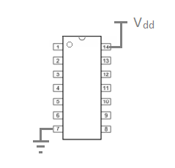

**Figure 4**: Typical “power and ground” configuration of a DIP package.

Although most chips found in the ECE 110 lab are powered in this way, not every IC follows this convention. Countless chips have been DAMAGED due to incorrect powering. Every IC (and virtually all circuit elements) come with a datasheet. The datasheet is a resource that attempts to list all important information on the internal circuit of an IC as well as its operational envelope. It is very important to check the datasheet for each IC for the correct pins and appropriate voltage level before using that IC. The datasheet generally contains all the information necessary for implementing a device in a circuit and gives the user an idea of what limitations the device might have in terms of voltage, current or temperature tolerances. These characteristics vary from chip to chip so it is very important to learn to read and understand the information listed on a datasheet if you ever wish to use an unknown device.

**Build** the circuit shown in Figure 5 where $R_{2}$ is the photoresistor and the $10 kΩ$ resistor is formed using the center lead and one outer lead of the potentiometer (see the breakout box on previous page). The small numbers on the circuit schematic are the pin numbers of the IC and correspond to the connections shown on the physical diagram.

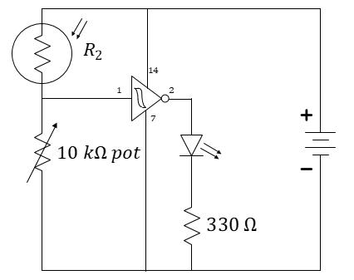 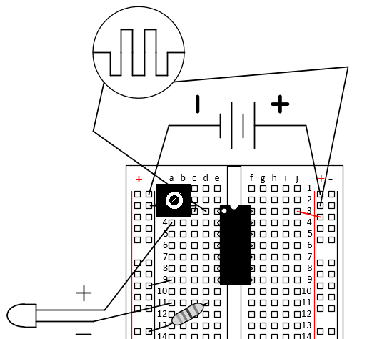



Schmitt Trigger Invertor with used pins labelled for clarity.

**Remember**: The power rails (aka power bus) are connected vertically. Each set of five holes a-e or f-j are connected for each row, but a-e is not connected to f-j. In this way, the IC straddles the board without shorting the left pins to the right pins.

$1 kΩ$

blue LED

**Figure 5**: The cloud detector. In the circuit schematic, the connection of the IC to the battery is included. In many schematics, it is assumed, but not explicitly shown.

## Team Exercise (meet as a team at the center bench to complete this exercise)

Think about this: Is this still a voltage divider when the inverter is present?

Be aware that we cannot generally just cascade interesting circuits together and expect their operation to be unaffected. When adding the inverter to the voltage-divider circuit, we might anticipate that the operation of the voltage divider would be significantly affected because we have added something in parallel to the $10 kΩ$ potentiometer. The Schmitt Trigger draws very little current into its input and it will have relatively small effect. We would say that the input resistance (actually, “impedance”) of the invertor is quite large and that is why it will not affect the operation of our voltage divider.

1. In just a few sentences, explain how your voltage-divider ***would*** be affected if the input to the Schmitt Trigger were much smaller, say, only .

Have each teammate adjust the potentiometer () to improve their circuit performance for the specific lighting conditions in your room.

1. Without making any further adjustments, use your cloud detector in both bright and dim light (you can use your hand to block the light). Think about this…will your detector need to be tuned to operate well in other locations?
2. Choose one of the circuits and record the voltage $V_{1}$ in low, medium, and bright light. Compare it to your predictions and discuss.

## Individual Submission

1. Based on the datasheet of the photoresistor, what *approximate* resistance might you expect to see for a darkened sensor (0 Lux)?
2. Based on the datasheet of the photoresistor, what approximate resistance might you expect to see for a sensor in a dimly lit room (10 Lux)?
3. Based on the datasheet of the photoresistor, what approximate resistance might you expect to see for a sensor in a very bright setting (100 Lux)?
4. What output $V_{1}$ might you expect under the following conditions (please complete the table while explaining your math)?

|  |  |  |  |  |
| --- | --- | --- | --- | --- |
| Lux | Approximate $R_{2} [kΩ]$ | $$R_{1} [kΩ]$$ | $$V_{1} [V]$$ | Comments: |
| 10 |  | 1 |  |  |
| 100 |  | 1 |  |  |
| 10 |  | 10 |  |  |
| 100 |  | 10 |  |  |
| 10 |  | 50 |  |  |
| 100 |  | 50 |  |  |

**Table 1:** The photoresistor-based voltage divider predicted responses.

1. Now, place a photoresistor into your breadboard and use your voltmeter to measure the resistance with a) your finger placed to block all light, b) a dim location, and c) a bright location. Record all three measurements including the units.

## Team Submission

1. In just a few sentences, explain how your voltage-divider would be affected if the input to the Schmitt Trigger were much smaller, say, only .

Have each teammate adjust the potentiometer () to improve their circuit performance for the specific lighting conditions in your room.

1. Without making any further adjustments, use your cloud detector in both bright and dim light (you can use your hand to block the light). Think about this…will your detector need to be tuned to operate well in other locations?
2. Choose one of the circuits and record the voltage in low, medium, and bright light. Compare it to your predictions and discuss.