Human-Centered Design: Storytelling in Engineering

Prerequisites
- A project worth telling! In this document, consider your current project, the Light-Seeking (and shadow-seeking) Car.

Hardware Needed
- None.

Learning Objectives
- Apply the 6 stages of Freytag’s pyramid for storytelling to a current lab project.
- Outline ideas for a video tailored to a specific audience.

Outline
“Storytelling” is a word that may call to mind folktales, fairy tales, and fables; you might think it’s something a performer does on a stage or around a campfire. In reality, storytelling refers to anytime you use fact and narrative to communicate something to your audience. Yes, it’s the stand-up comic telling jokes about a wild experience on the bus, but it’s also the product engineer presenting a new idea and trying to convince the CTO that it’s worth exploring. A “Storyteller” is an actor in a theatre production performing a Shakespeare play, but it’s also the researcher putting together a proposal to get funding for a new project.
You could be the most brilliant engineer in the world, but unless you can convey details of your work and the value it creates, it will be hard to make a difference. To turn your thoughts and ideas into reality, you will need to get buy-in from someone with the power to make a decision (your boss, an investor, a client, etc.); even the best ideas don’t sell themselves - effective communication is critical to getting them implemented.

Reflection
- Reflect for a moment on what you hope to be doing after you graduate (it’s OK if you only have a general idea or aren’t completely sure yet - just choose something you could see yourself doing!) - What is it? Can you think of a specific situation where your storytelling skills might end up being more important than your technical skills in that position? (2-3 sentences)

The Art and Arc of Storytelling in Engineering
Let’s explore how to apply storytelling skills in the video you will create in this week’s lab. Our goal will be to create a compelling story that is more engaging than a simple demonstration. For the purpose of this exercise, you will be creating the video for incoming students to ECE 110 regarding your car. This pre-lab will help you plan out but not yet produce that video. Your goal is to design a video that
- conveys your expertise at a level the intended audience will understand,
- follows a narrative arc with a set-up and a resolution, and
- shows off the interesting aspects of the project.
The first step in preparing a story is to consider your target audience. A story that isn’t tailored to your audience runs the risk of being incomprehensible (or worse, boring); ensuring your story is constructed in a way that makes sense and is actually interesting to your audience can go a long way in improving how your story is received. Some questions to consider are:
- Why is the audience there?
- What prior knowledge does the audience have?
- What does your audience know about you (if anything)?
- What is the audience hoping to get out of this story?
- What are you hoping the audience gets out of your story?
- For the audience of your video (next semester’s cohort of ECE 110 students), what are some considerations you should make? How will you adapt your story to be appropriate for this audience? (2-3 sentences)
Next, we’ll move on to how to create a compelling narrative arc. To do this, we’ll use a common framework for dramatic structure, known as “Freytag’s Pyramid:”
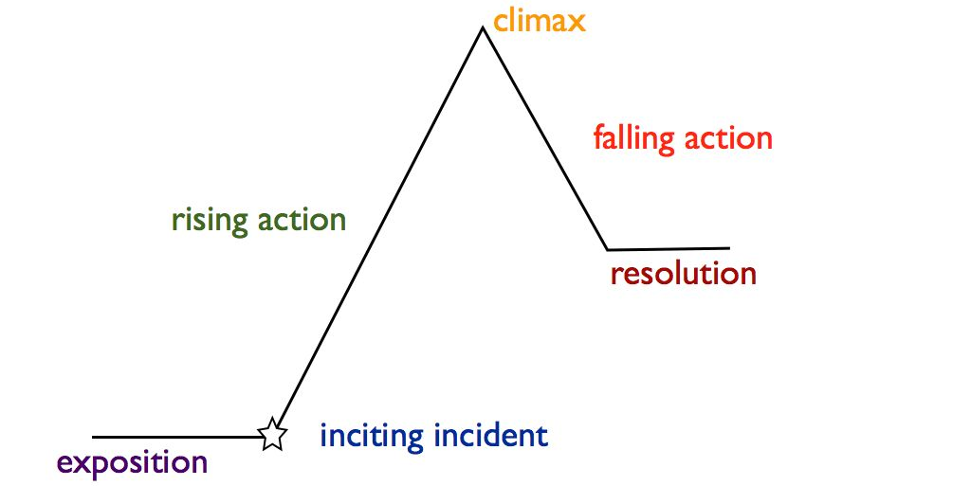
Figure 1: Freytag’s pyramid for storytelling.
Freytag’s Pyramid is not the only framework for dramatic structure, but it’s useful for describing the general trajectory that most stories tend to follow. In this chart, the position on the y-axis can be thought of as the relative level of “conflict” or “tension” within the story. Stories that follow the arc of the pyramid start at some point with low tension, introduce some sort of problem or issue (the “inciting incident”), ramp up the tension, and finally resolve the tension in an interesting or exciting way (the “climax”).
To apply this structure to your video, we can start with the climax and work backwards. The “climax” is the most significant or memorable moment in a story. In a work of fiction, it might be the moment where the protagonist and antagonist face off in a dramatic showdown, or when the band of heroes finally reaches the destination they’ve been searching for throughout the whole story.
Another way to think about the climax: if you have some sort of important lesson or piece of information you want your audience to walk away remembering, save it for the peak of the story rather than giving it away right at the beginning. Use the set-up to your story to build intrigue and tension and then resolve that tension through the revealing of the climax.

- Let’s start by thinking about what that important lesson is - if you could ensure your audience leaves your video understanding one thing from the lab you’re working on, what would it be? (1-2 sentences)
Once we’ve identified where we want to go with our story, it makes it easier to see where we need to begin. The “inciting incident” is the moment that introduces the central conflict of the story. Again, thinking about the world of fiction, this could be the moment that the antagonist steals some sort of sacred artifact, disrupting the balance of the world, or the moment that an adventuring party makes the decision to embark on their epic quest.
For this context, where the purpose of our video is primarily to inform, the “inciting incident” will be the introduction of the problem or mystery that the information in the climax will be used to solve. Another way to think about the “conflict” of your story is to consider what engineering task or goal is made easier or possible to achieve through the information in the climax. What does the information you’re imparting enable someone to accomplish that we couldn’t before? Which aspect of the solution did you personally find most intriguing?
In this exercise, we want you to sell your story. Don’t be afraid to exaggerate the problem or the novelty of the solution!
- Let’s define the central conflict for our story - what is the engineering problem that we can solve using the information or concept(s) from the climax? (2-3 sentences)
And just like that, we already have the key components of an interesting and engaging story! The last thing to do before lab is begin thinking about how you might map out the video you’re going to record.
- Use the space below to write a few bullet points to outline the critical elements of your video.

Storytelling in Engineering
- Reflect for a moment on what you hope to be doing after you graduate (it’s OK if you only have a general idea or aren’t completely sure yet - just choose something you could see yourself doing!) - what is it? Can you think of a specific situation where your storytelling skills might end up being more important than your technical skills in that position? (2-3 sentences)
- For the audience of our video (next semester’s cohort of ECE 110 students), what are some considerations you should make? How will you adapt your story to be appropriate for this audience? (2-3 sentences)
- Let’s start by thinking about what that important lesson is - if you could ensure your audience leaves your video understanding one thing from the lab you’re working on, what would it be? (1-2 sentences)
- Let’s define the central conflict for our story - what is the engineering problem that we can solve using the information or concept(s) from the climax? (2-3 sentences)
- Use the space below to write a few bullet points to outline the critical elements of your video.
...
[INCITING INCIDENT]:
...
[CLIMAX]:

