Lissajous: The Oscilloscope’s XY Mode

Module Outline

In this module you will use the oscilloscope in what is called the XY mode. In lecture, we will often trace out the transfer characteristics of many different devices (called I-V curves). Previously, you used the oscilloscope to plot voltage vs. time. The oscilloscope can also plot voltage vs. voltage. But, if we measure the voltage across a resistor, Ohm’s Law tells us that we will have a voltage value that is proportional to the current. Therefore, XY mode using voltage across a known resistor to measure current is a way to display IV characteristics in the lab.
For this experiment, you will need to cooperate with the neighboring bench as you will need a second function generator.
A fun way to experiment with the XY mode is by generating Lissajous figures. To do so, we’ll the sine-wave output of one function generator to channel 1 of the oscilloscope and the sine-wave output of another function generator to channel 2 of the oscilloscope. By letting channel 1 drive the horizontal and channel 2 the vertical, a shape will be traced out on the scope’s display.
In this mode the variations in x and y are time-varying. For example: consider the two equations $x\left(t\right)=sin⁡(t)$ and $y=\cos\left(t\right).$ We could find the shape that is drawn out by reducing the two equations to a single equation $x^{2}\left(t\right)+ y^{2}\left(t\right)=1$ which is the equation of a circle. The set of equations, where the variables, in this case x and y, are written in terms of another variable, in this case t, are called parametric equations. Often it is not simple to find an equation for the shape of the resulting curve so let us look at a graphical approach.
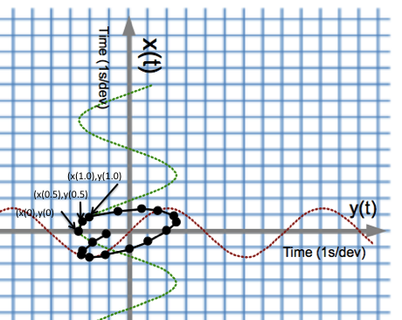
Figure 1: A demonstration of what happens when two “time-domain” sinusoids are plotted in XY mode.
See Figure 1. By plotting $x(t)$ along the vertical axis and $y(t)$ along the horizontal axis the resulting curve can be drawn by plotting $(x\left(0\right),y\left(0\right))$, $(x\left(0.5\right),y\left(0.5\right))$, $(x\left(1\right),y\left(1\right))$, … using $x(t)$, and $y(t)$ and a ruler and pencil. The frequencies of the sine waveforms depicted in the graph are not simple multiples of each other so it will take many cycles to repeat the curve. Only the time interval $t=0 to 8 s$ has been plotted.
Wikipedia and YouTube have a wealth of information about these curves. It is about the most fun you can have with an oscilloscope (unless it secretly plays Tetris as did some older scopes). Laser light and drone shows often use complex parametric equations to draw interesting figures with light.
To understand why certain signals produce the corresponding Lissajous curves, consider the following set of parametric equations and the shape of the resulting figure.
Example 1: identical sine waves
$$x\left(t\right)=sin⁡(2000πt)$$
$$y\left(t\right)=sin⁡(2000πt)$$
The plot of $x(t)$ and $y(t)$ on the x-y plane can be found by eliminating the variable $t$. Since $x\left(t\right)=y\left(t\right)=sin⁡(2000πt)$ the equation describing the figure is $x=y \text{for }\left|x\right|≤1\text{ and }\left|y\right|≤1$. If the frequencies were not the same it would be considerably more difficult to find a closed form solution.
Example 2: sine waves with the same frequency but out of phase by $\frac{π}{2}rad$ ($90°)$
$$x\left(t\right)=sin⁡(2000πt)$$
$$y\left(t\right)=sin⁡(2000πt+π/2)$$

The resulting figure in this case can be found by eliminating $t$ but using the trig identity $\sin\left(α+β\right)=\sin\left(α\right)\cos\left(β\right)+\cos\left(α\right)sin⁡(β)$.
Step 1: Rewrite $y\left(t\right)=sin⁡(2000πt+π/2)$ as $y\left(t\right)=\sin\left(2000πt\right)\cos\left(\frac{π}{2}\right)+\cos\left(2000πt\right)\sin\left(\frac{π}{2}\right)$. Since $\cos\left(\frac{π}{2}\right)=0$ then $y\left(t\right)=cos(2000πt)$. The variable t is eliminated by squaring both equations and adding to get $x^{2}+y^{2}=1$.
Example 3 – sine waves with the same frequency with a phase difference that varies with time
$$x\left(t\right)=sin⁡(2000πt)$$
$$y\left(t\right)=sin⁡(2000πt+ϕ(t))$$
- Use the same identity on $y(t)$. What does it tell you about the shape produced in XY mode?

Oscilloscope Procedure
Using the output from two function generators, generate Lissajous figures.

- Connect the output of your function generator to channel 1 of the oscilloscope. Have the function generator output a sine wave with a peak-to-peak amplitude of $2 V$, a frequency of $1 kHz$, and a $0 V$ offset. If this is your first time using the function generator (user guide), don’t worry. Just press the button showing the sine waveform, then press the button for Freq, Ampl, and Offset, using the wheel (alternately, the arrow buttons) to set the values from above. Please see your TA if you need assistance.
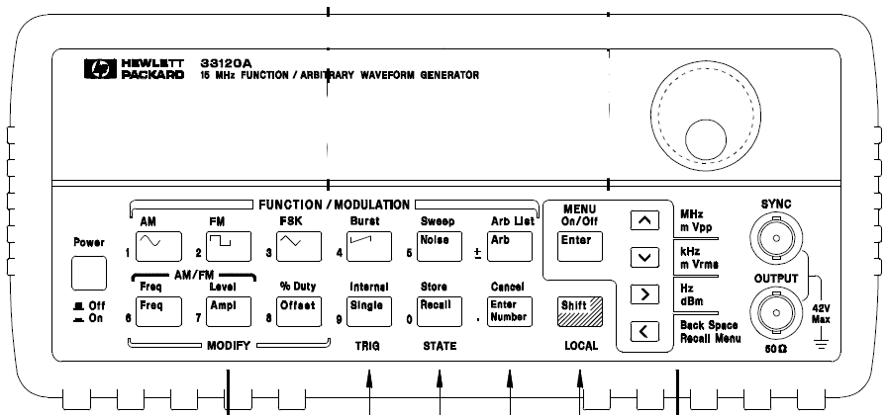
Output
SYNC (don’t use)
Figure 2: The function generator. Please don’t accidentally use the SYNC!
- Connect the output of your neighbor’s function generator to channel 2. Have the function generator output a sine wave with a peak-to-peak amplitude of $2 V$, a frequency of $1 kHz$, and a $0 V$ offset. The banana plugs can be “stacked” allowing you to go from BNC to BNC connector. They can be stacked further to even allow your neighboring bench to view the same signals on their oscilloscope. Please see your TA if you need assistance.
- At this point you should see two time-domain sine waves on the display of the oscilloscope. Push the [Horiz] button on the oscilloscope in the set of buttons controlling the horizontal sweep and put the display in XY mode by selecting Time Mode followed by “XY”. You can also find these instructions on page 69 of the Keysight oscilloscope user guide. The oscilloscope is now displaying the same information except now one of the sine waves is driving the x-axis deviations and the other the y-axis.
- A fun application of Lissajous curves can be seen in laser light shows. Pink Floyd was especially famous for this. You may want to find a recording of “Dark side of the Moon” by Pink Floyd and listen while doing module.

- Describe the figure you see. Since the outputs of both signal generators are sine waves of identical amplitudes and frequency, is the resulting figure what you expected? Explain.
- When using two independent signal generators with the amplitude and frequencies set identically, the relative phases are not the same and will drift slowly with time. Is your figure time-varying? Describe how the figure is changing.
- Change the frequency of one of the function generators to $2 kHz$. Sketch the result.

The following chart shows you some of the possible curves you can draw by varying the frequency and phase of the sinusoidal functions. Unfortunately, the phase of the signal generator outputs is fixed, though it often drifts slowly with time. Play with all sorts of different frequency combinations and see how many you can create.

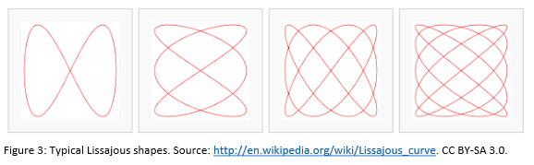
- Generate one of these shapes (tell us which one) and describe your function generator settings (for both instruments) that produced it.

This is only the beginning. More fun things to try…
- Because the important parameter is the proportional values of the frequencies of the two signals you can watch the figure being drawn. Reduce the frequencies of the signals to $10 Hz$ and $20 Hz$. You should see a dot tracing out the figure you got in question 4.
- There are more functions that you can try. With a press of a button, the signal generator can provide a sine wave, a square wave, a triangle wave, a sawtooth wave, a cardiac signal, a signal that sweeps frequencies, and many, many more. Play around with them to see what patterns you can generate.
- Generate some interesting combinations. Give the parameters of the two function generators used to get one of them.

