Electret Microphone
In electronics, biasing' usually refers to a fixed DC voltage or current applied to a terminal of an electronic component such as a diode, transistor, or vacuum tube in a circuit in which AC signals are also present, to establish proper operating conditions for the component. -Wikipedia
https://en.wikipedia.org/wiki/Biasing

Laboratory Outline
An electret microphone with proper biasing produces a response from ordinary sounds often measured only in millivolts. These voltages will need to be amplified for typical sound applications like detection (did someone clap?), equalization (pump up the bass!), or even transmission over short distances (tiny signal + tiny noises = significant noise interference). The electret microphone’s output voltage should be amplified right after the microphone to both preserve the best integrity, that is the lowest-noise version of the signal and allow for further electronics operations at voltage levels typical of other basic electronic devices like diodes and transistors.
The microphone in Figure 1 is like the one in your electronics kit. It has two leads (wires, see arrows) which exit the microphone’s capsule (the “can”). Close examination of the can in the photo shows the negative lead has metallic connections (circled) to the can of the mic capsule…therefore, you should be careful not to let other component leads touch the can or you would short those nodes.
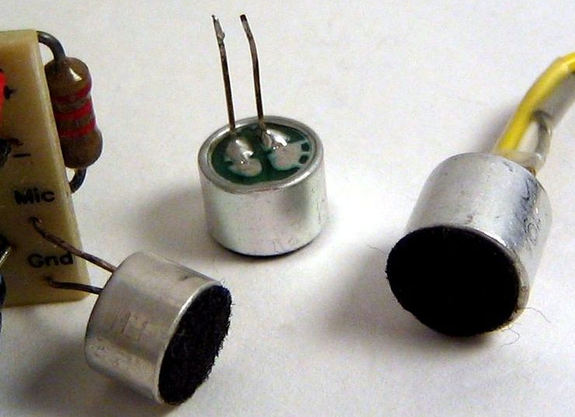
-
+
Figure 1: A photo and a model of the inner operation of the electret microphone capsule. Photo credit: https://upload.wikimedia.org/wikipedia/commons/5/57/Electret_condenser_microphone_capsules.jpg

Prerequisites
- Breadboarding experience.
- Use of an oscilloscope.
- Thevenin-equivalent circuit theory.

Parts Needed
- (1) electret microphone capsule,
- (1) battery or voltage source, preferably near 9 volts,
- A device (smartphone?) with a loudspeaker to play a 1 kHz tone,
- Other components:
  - (1) $0.1 μF or 1 μF$ ceramic capacitor (choose the largest ceramic/yellow capacitor from your kit),
  - (2) $2.2 kΩ$ resistor,
  - (1) $1 kΩ$ resistor,
  - (1) $10 kΩ$ resistor

Learning Objectives
- To gain practical experience in circuit building and use of a microphone.
- To improve oscilloscope skills.
- To apply Thevenin modelling to a microphone circuit.

Resources
Datasheet: https://media.digikey.com/pdf/Data%20Sheets/Soberton%20PDFs/EM-9745P-46.pdf
Electret microphones: https://mynewmicrophone.com/the-complete-guide-to-electret-condenser-microphones/
AC coupling capacitor: http://www.learningaboutelectronics.com/Articles/What-is-a-coupling-capacitor
From these resources, we can discover quite a bit about the microphone sensor we will be using.
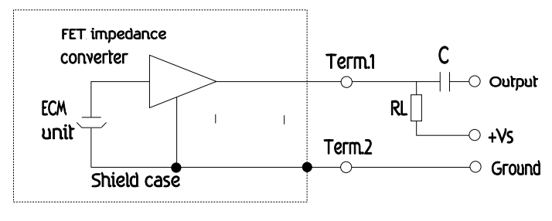
Figure 2: Schematic of the microphone and typical use configuration.
Figure 2 shows the typical way to configure the microphone for use. The physical content of the microphone capsule is shown inside the dotted box. External to the capsule, a resistor provides bias to the internal “FET impedance converter” of the capsule while an AC-coupling capacitor removes the DC component before sending a zero-mean microphone signal to the next component of your design. By “zero-mean” we mean that the signal will vary above and below the ground reference evenly such that its average voltage is zero.
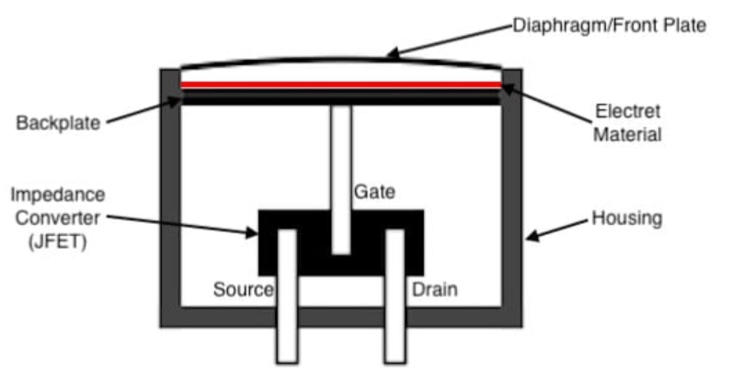
Figure 3: A physical diagram of the electret microphone capsule (canister). Click for Source.
The physical diagram of Figure 3 provides some insight into the simplicity and construction of the microphone capsule. The “magic” (if there is any magic) is in the electret material used. If interested in the history of locking electrical dipoles into a material for the purpose of building simple, long-lasting microphones, you can read more about at https://mynewmicrophone.com/the-complete-guide-to-electret-condenser-microphones/.
Next, let’s turn that microphone capsule on its side and blend it with the necessary biasing resistor and the AC coupling capacitor (see Figure 4, top left).
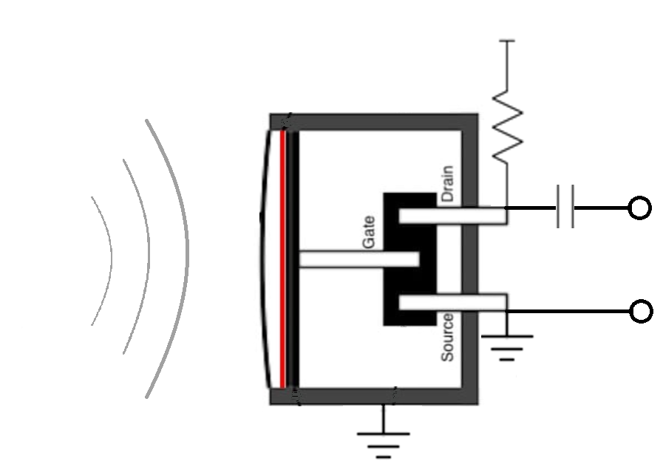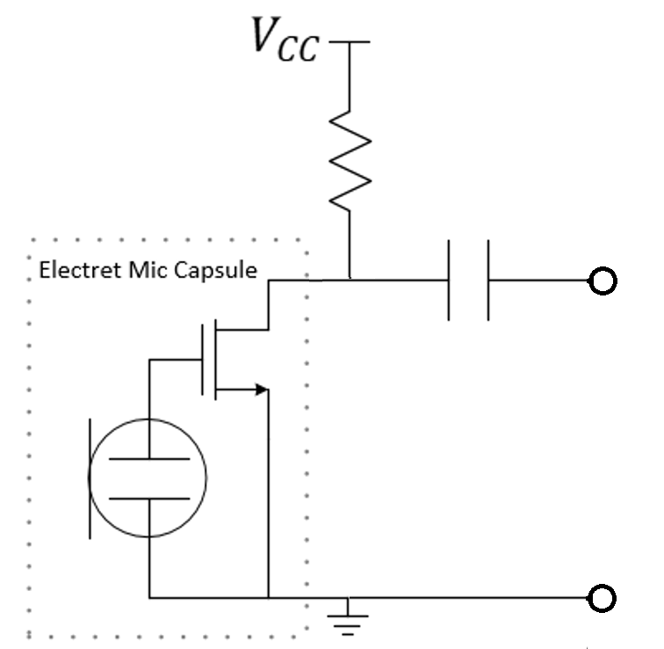
Lumped-Circuit Model
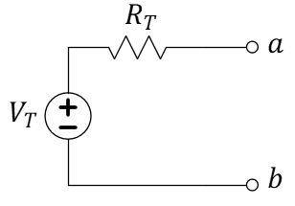
Thevenin Model
Figure 4: A mixed-physical diagram, full-circuit schematic, and Thevenin-equivalent model of the microphone circuit you will build and test.
Replacing the microphone capsule with our own circuit models for the electret diaphragm (a type of capacitor) and a transistor (we imagine that our nMOS transistor is a reasonable approximation appropriate at the ECE 110 level), we get the “lumped-circuit model” schematic of the top-right figure in Figure 4. Remember that the FET is inside the microphone capsule…you will only need to add the biasing resistor and a capacitor to complete a basic microphone sensor circuit. Finally, for purposes of predicting how the microphone circuit will interact with another circuit, we will explore the Thevenin-equivalent model of this microphone circuit (see bottom of Figure 4).

Build
Figure 5: Your circuit build.
Use a $2.2 kΩ$ resistor to connect the non-ground pin (the drain of the FET internal to the microphone capsule) to the power rail of your breadboard. Connect the ground pin to the negative power rail. Do not attach your power supply to the rails yet.
For the AC coupling capacitor, use the largest value ceramic/yellow capacitor from your electronics kit. This should be either $0.1 μF$ or $1 μF$ depending on when your kit was assembled. Either ceramic capacitor should work fine, but you should not use an electrolytic capacitor (blue capacitor) for this. Record your values here:
- $R=____________ kΩ (measured value)≈2.2 kΩ;C=__________________ μF (nominal value)$
Attach channel 1 of your oscilloscope between the open end of the capacitor and the ground rail of your breadboard (between nodes a and b of Figure 5. Be sure that the oscilloscope is started in the default mode. Then, adjust the vertical axis of channel 1 to be about 500 mV per division (but adjust as you see fit).
Connect the battery to the power rails to energize the microphone capsule. Can you detect the sound of a clap on the oscilloscope as a sudden disruption in the voltage signal? You can try whistling (a nearly-sinusoidal acoustic wave) or playing a $1 kHz$ tone from your cell phone if your hands get tired. If you cannot find the voltage signal, after some trial and error plus adjustment of your oscilloscope, then you should disconnect your battery, return your oscilloscope to the default mode, and seek TA assistance.
Once you can reliably see your acoustic signal transformed into a voltage waveform visible on the oscilloscope, you may continue to the next step.

Measure
Recall from Figure 4 that we might model the microphone as a Thevenin-equivalent circuit (now repeated in Figure 6). We know from our theory that the voltage observed on the oscilloscope is both the “open-circuit” voltage and the Thevenin voltage for the equivalent circuit. The Thevenin voltage $V_{T}$ is that time-varying signal you just saw! To find the resistance, $R_{T}$, we need to strictly control $V_{T}$ and attach a couple of loads to terminals a and b and observe how the Thevenin circuit behaves.
Figure 6: Thevenin-equivalent model of the microphone circuit.
Before we start our measurements, select three resistors, $1 kΩ$, $2.2 kΩ$, and $10 kΩ$.

- Use an Ohmmeter to record the actual resistance of each here.
$$R_{1kΩ}=_________________Ω$$

$$R_{2.2kΩ}=_________________Ω$$

$$R_{10kΩ}=_________________Ω$$
To control $V_{T}$, play a $1 kHz$ tone into the microphone being careful not to allow the distance or orientation of the loudspeaker and microphone to change through this series of measurements. To do so, set your phone down with the loudspeaker very close to the microphone and don’t move it.
Use the meas feature of the oscilloscope to obtain the peak-to-peak amplitude of the open-circuit voltage. Adjust the vertical axis as needed. Record the measured value now. You might choose to instead measure the peak-to-peak voltage of the waveform using manual cursors, rather than relying on the meas function of the oscilloscope, which may capture spurious voltage spikes and overestimate the peak-to-peak voltage. Press the [Run/Stop] button to capture a static version of the waveform. To activate cursors, press the [Cursors] button. Set the cursor mode to manual by using the touch screen and altering the corresponding Mode to manual, which can be found in the bottom left corner. Press the cursor knob down to select which cursor you wish to use; for this measurement, you will select the horizontal cursors.
- Once you position these cursors to adequately capture the minimum and maximum of the waveform, read the ΔY value to record the peak-to-peak voltage of the waveform.
$V_{T}=________________volts$, peak-to-peak

- (continued) Being careful not to disturb your arrangement, attach a $1 kΩ$ resistor between terminals a and b and record the peak-to-peak voltage again.
$V_{1kΩ}=_________________volts$, peak-to-peak

- (continued) Being careful not to disturb your arrangement, attach a $2.2 kΩ$ resistor between terminals a and b and record the peak-to-peak voltage again.
$V_{2.2kΩ}=_________________volts$, peak-to-peak

- (continued) Being careful not to disturb your arrangement, attach a $10 kΩ$ resistor between terminals a and b and record the peak-to-peak voltage again.
$V_{10kΩ}=_________________volts$, peak-to-peak
IMPORTANT: If you disturb the loudspeaker/microphone arrangement, $V_{T}$ will change and you will want to start over!

Model
Since we are loading the microphone circuit with a resistor, and we are modelling the microphone as a Thevenin equivalent circuit with Thevenin voltage equal to the microphone’s “open-circuit voltage,” you can use the voltage-divider rule to determine three estimates of the Thevenin resistance, $R_{T}$. Specifically, find the three estimates of $R_{T}$ based on the single measurement of $V_{T}$ and the three measurements of the voltages across the three resistors.
- For the $1 kΩ$ load, use the voltage divider rule to estimate $R_{T}$ from your measured values of $V_{T}$, $V_{1kΩ}$, and $R_{1kΩ}$. Repeat for the $2.2 kΩ$ load and the $10 kΩ$ load as well. Show your work!

$$R_{T}=_________________kΩ,using 1kΩ$$

$$R_{T}=_________________kΩ,using 2.2kΩ$$

$$R_{T}=_________________kΩ,using 10kΩ$$

- Comment on the voltage levels you are seeing from your microphone circuit. Are they large enough to drive, say, a diode-based half-wave rectifier (reference the lectures with diode applications)? Explain.
- Your three estimates are likely very different. When doing circuit design, your microphone circuit will be attached to another circuit probably built by one of your lab partners. Which estimate of $R_{T}$ might be most accurate and why?
Extra (consider for your final report):
You can produce an IV characteristic from this data. Plot the peak-to-peak voltage on the x-axis and the peak-to-peak current (calculated using Ohm’s law) on the y-axis. This will give you four data points, including ($V_{T},0$). At the other three data points, you have an estimate of $R_{T}$…meaning you also have an estimate of the slope at that data point! You could draw these three tangent lines onto your graph. This plot would help you better understand Thevenin modeling. A key points to note is that even though the circuit does not have a perfectly linear IV characteristic, collecting data near the expected operating point can still help you predict its behavior when connected in a complete circuit.

