Oscilloscope Intro: Getting Started with KeySight
Name: From Experiment 4 SP19: Voltage-Divider-Based Motor Speed

Laboratory Outline
An oscilloscope is a powerful device for gaining insight into an electronic circuit. While voltmeters and ammeters are great for DC circuits in steady state (no time variation), circuits with voltages that change (examples could involve microphones, switches, or oscillators) can be better examined by an engineer with a tool that shows voltage as a function of time. This is the oscilloscope. An oscilloscope can, at first glance, be overwhelming. In this first look, we focus on what the oscilloscope can do at a high level and present only three basic control knobs. Further exploration of the oscilloscope is left for a later exercise.

Learning Objectives
- Gain a basic understanding of Keysight’s benchtop oscilloscope with a focus on horizontal and vertical scales.
- Obtain a voltage trace using a single triggering action.

Introduction
To analyze voltages that vary with time, we must use a measurement device that can capture a time history of those voltages. This device is called an oscilloscope.

Oscilloscope
The oscilloscope (often called an “o-scope” or “scope” for short) is a measurement device that can capture a time history of a signal. At first glance, it appears to be a very complex piece of hardware. As you learn to use it, however, you will learn that most common adjustments use only a few of the controls present on the front panel of the device.
We will focus on these three control knobs:
- Horizontal scale (this will zoom in or out on the voltage axis)
- Vertical scale (this will zoom in or out on the time axis)
- Trigger level (this will adjust the voltage level that says “it’s time to grab some data!”)
See Figure 1. The horizontal control changes the scale of the time axis allowing you to see more and less time range of the waveform as needed. The vertical control changes the scale of the voltage axis allowing you to shrink the display’s height of the waveform so that it fits within the screen or expand it to better fill the screen and make a more-accurate voltage measurement. A third menu consists of the triggering controls. The description of the trigger is less intuitive than scale so we will spend much more time investigating its key role. For now, just remember that the oscilloscope’s trigger aids in displaying voltage waveforms in a human-readable format.
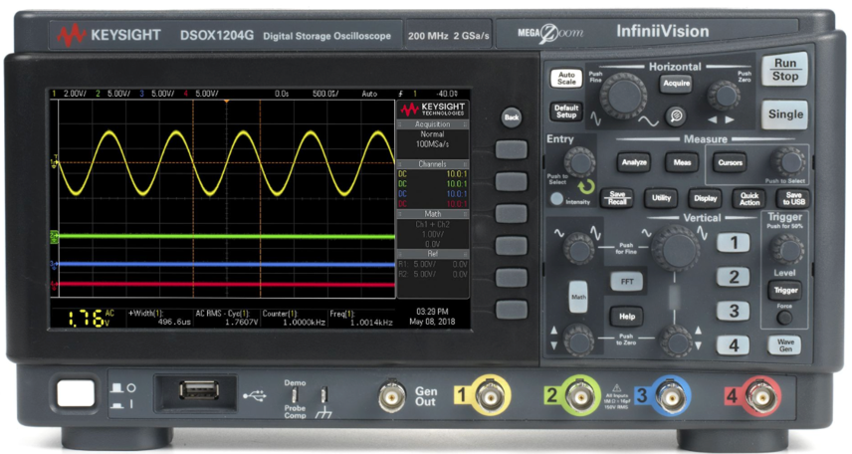
Vertical
Trigger
Horizontal

Figure 1: A photo of the KEYSIGHT oscilloscope.
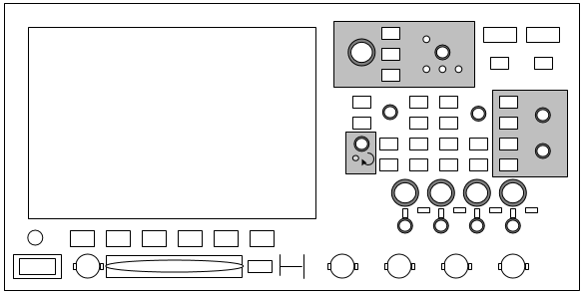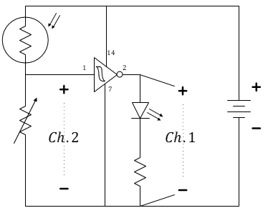
(a) | (b) | (c)

Figure 2: A physical model of the KEYSIGHT oscilloscope (a) and a common schematic symbols for a channel (b). In ECE110, often only voltage polarity (and no symbol) will be used as shown for two channels (c).

The best way to learn is just to do. Let’s use the oscilloscope to measure your battery’s voltage. This is overkill for such a sophisticated instrument, but this will be a valuable learning experience in your first usage. Due to the oscilloscope’s triggering mechanism, you will be able to observe the exact moment the battery is connected to the power rails of your breadboard and you will also be able to observe some small amount of time needed for that voltage to fully appear across the rails.
On the oscilloscope, press the Default setup to start in a known configuration. See Figure 3.
Default

Figure 3: Always start by pressing the Default Setup on the oscilloscope.

Prepare a coaxial BNC-to-banana cable for connection to Channel 1 of the oscilloscope. See Figure 4. Find two alligator clips, preferably with black and red insulating “boots.” Pinch each alligator clip to insert a wire. Make sure each alligator clip is holding onto bare metal and not the insulation of the wire. Slide them onto the black and red banana ends of the coaxial cable.
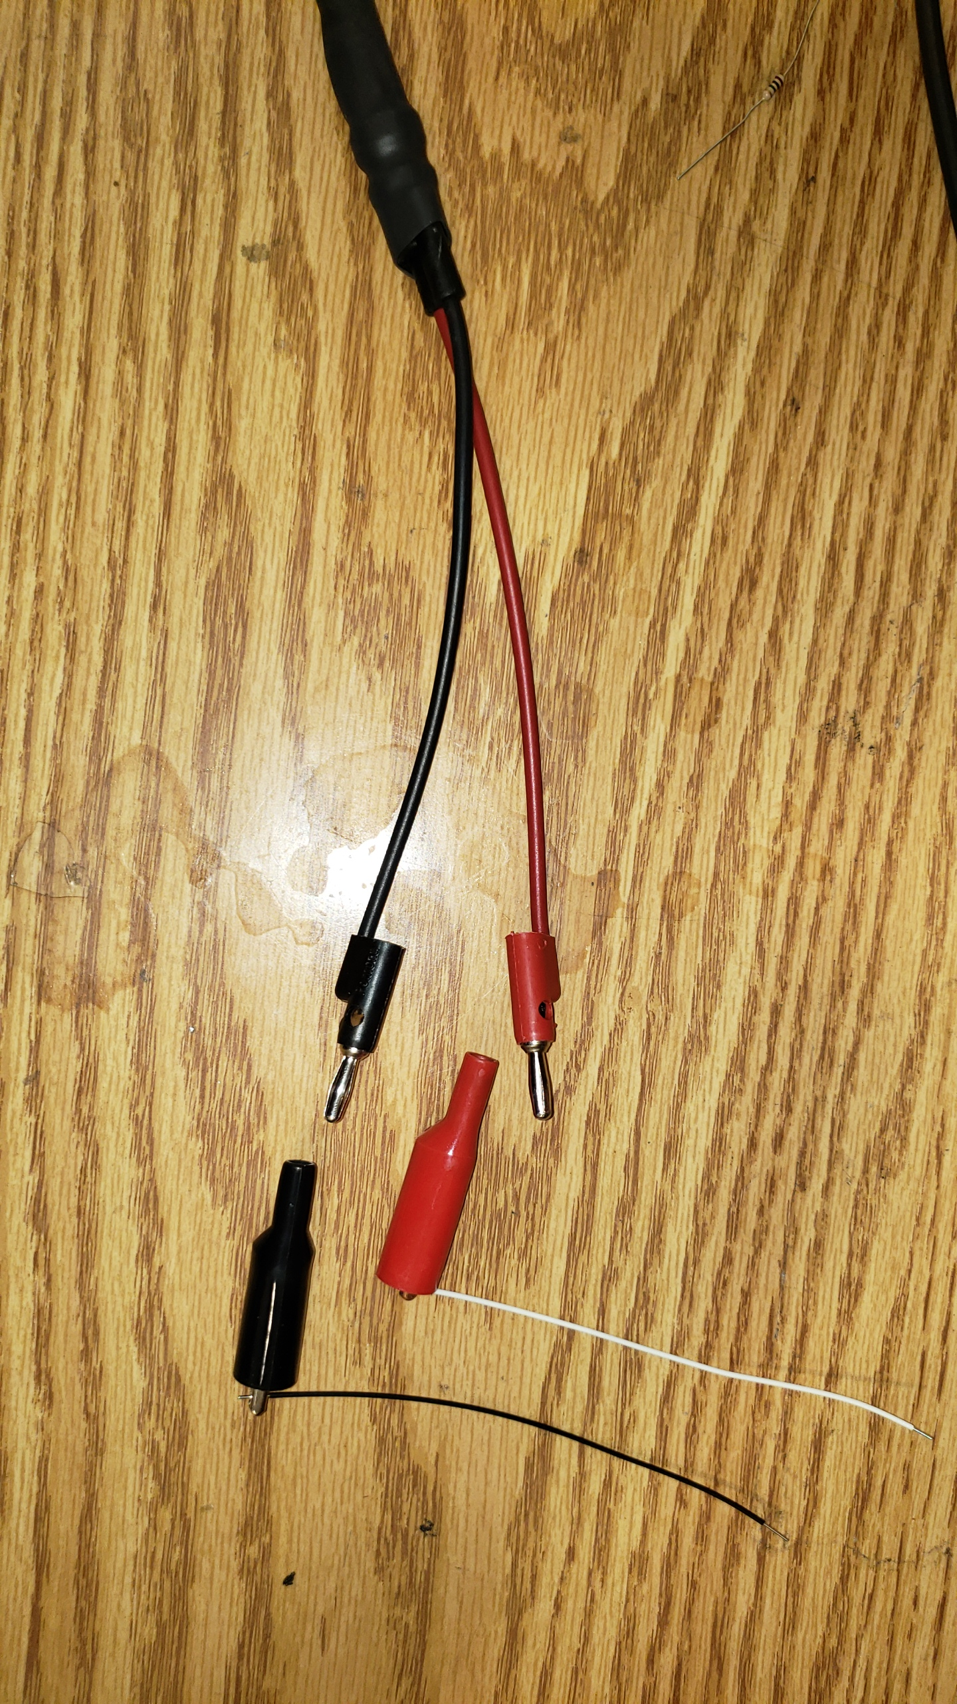
Figure 4: Preparing to attach alligator clips with wires to the coaxial cable.
The BNC style connector must be aligned with the “knobs” on the Channel 1 connector and then pressed in and turned ¼ turn clockwise until it locks on.
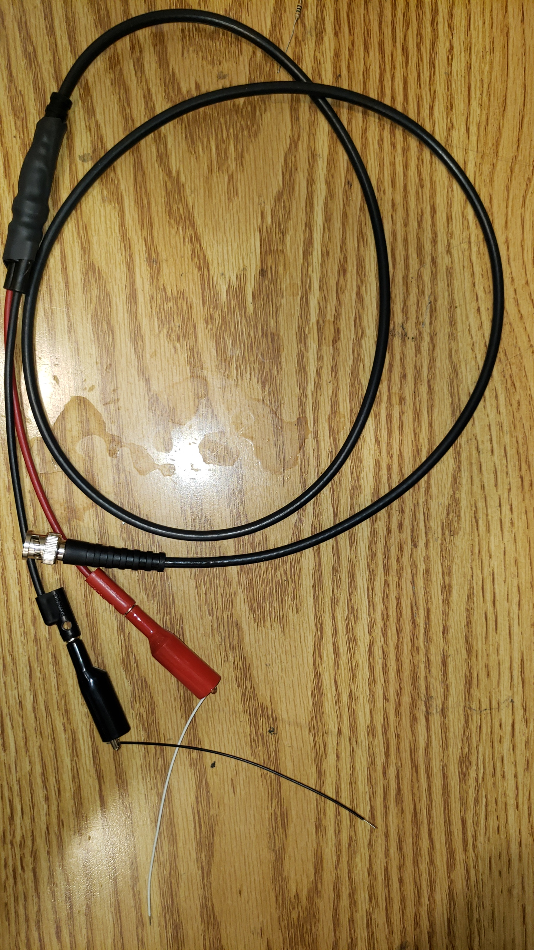
Figure 5: A coaxial cable with attachments (a) and the BNC connector (b).
Figure 6: Aligning and securing the BNC connection with a clockwise twist.
With the battery not connected and the breadboard empty, attach the red probe of the scope to the positive power rail and the black probe to the negative power rail. We will use the scope to record data around the instant you plug in your battery.
Turn the “Trigger” knob clockwise until the horizontal trigger line on the oscilloscope is near $2 V$.
The simplest way to trigger the oscilloscope is to press the Single button in the upper right of the oscilloscope’s front panel. The screen should go blank as the oscilloscope is waiting for an event to tell it something interesting has occurred. For the oscilloscope in default mode, triggering means for the oscilloscope to wait for a voltage that rises above a set threshold. Press the Single button now. The scope should be waiting for a trigger event.
Attach your battery to the power rails (so that it will be in parallel with Channel 1 of the scope). As the power rail voltages suddenly go to a 9-volt difference (or whatever the true open-circuit voltage of your battery is), the trigger of your scope will see it rise past the 2-volt threshold that you set earlier. It will display data before and after the trigger event and the left side of your display should show a time when the rails were both at the same potential (due to the large 1-MOhm resistance of the scope’s Channel 1) and, the right half of the screen will display the voltage for the time after you plugged in the battery.
The scope is no longer collecting data because you requested a single sweep. If you now adjust your horizontal (time) axis, you can zoom in and see that the center of your screen corresponds to the time at which the voltage between the power rails swept past the 2-volt threshold.

Questions
Figure 7: Plot the signal that you see on your oscilloscope when zoomed in on the time axis. Please include time and voltage labels.

- Hand-sketch the plot you obtained on the oscilloscope as requested in Figure 7.
- In your own words, what does the trigger of an oscilloscope do?

Quick Reference to Using the Oscilloscope
- Always start from a known configuration by pressing the Default button.
- Attach a coaxial cable to each channel of the oscilloscope that you will use.
- Adjust the vertical (voltage) scale in volts/division to match the voltage level that you expect to see. Do this for each channel.
- Adjust the horizontal (time) scale in s/div to match the time scale changes that you expect to observe in your signal.
- Use the alligator clips with wires at the end of the coaxial cable to make differential voltage measurements on your circuit.
Comment: Many novice experimentalists neglect to note the scales of their oscilloscope and are fooled into thinking a mis-wired circuit provides the data they want. As an engineer-in-training, refuse to be fooled and always know what to expect from your circuit and always check that the parameters of your instrument are preset to match.
Note: The oscilloscope is much like a voltmeter in that it measures voltage. An ideal voltmeter has infinite resistance such that it doesn’t affect the voltage of the circuit being measured. The Keysight scope has a default resistance of 1 MOhm which is large (compared to most resistances used in our course), but not infinite!

