The Oscilloscope’s Trigger

Laboratory Outline
The Oscilloscope’s most important feature is its trigger. Unfortunately, it is also often overlooked by students who are in a hurry to see something/anything and write down a value. When asked what the scope is displaying and how that data was chosen for display, they will have little clue. The knowledge of what an oscilloscope does is in the trigger. We will learn in greater detail how the oscilloscope achieves its function to produce a quasi-static display of periodic and near-periodic signals.

Learning Objectives
- Adjust an oscilloscope’s horizontal axis, vertical axis, and trigger to purposely explore a signal with known parameters.
Think about it…
Signals that are “nearly” periodic occur around us every day. The buzz of the honeybee, vibrations of a car engine, and sunlight hitting a solar panel day-by-day all contain measurable signals that show repetition. What periodic signals can you think of? How might those signals be measured electronically? What engineering solution might come from having that kind of information?

Introduction
To analyze voltages that vary with time, we must use a measurement device that can capture a time history of those voltages. This device is called an oscilloscope which you have probably already used without full appreciation for the “magic under the hood.”

Oscilloscope
The oscilloscope (often called an “o-scope” or “scope” for short) is a measurement device that can capture a time history of a signal. At first glance, it appears to be a very complex piece of hardware. As you learn to use it, however, you will learn that most common adjustments use only a few of the controls present on the front panel of the device. The horizontal control changes the scale of the time axis allowing you to see more and less time range of the waveform as needed. The vertical control changes the scale of the voltage axis allowing you to shrink the display’s height of the waveform so that it fits within the screen or expand it to better fill the screen and make a more-accurate voltage measurement. A third menu consists of the triggering controls. The description of the trigger is less intuitive than scale so we will spend much more time investigating its key role. For now, just remember that the oscilloscope’s trigger aids in displaying voltage waveforms in a human-readable format.
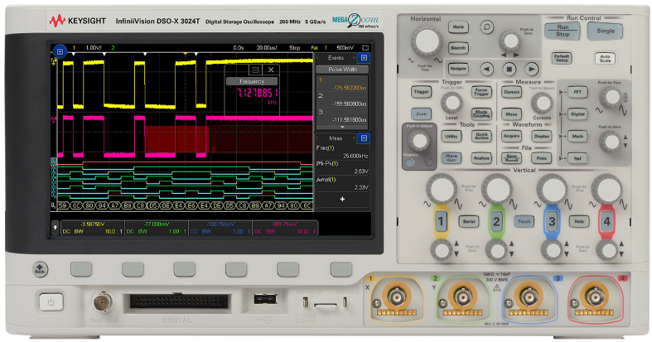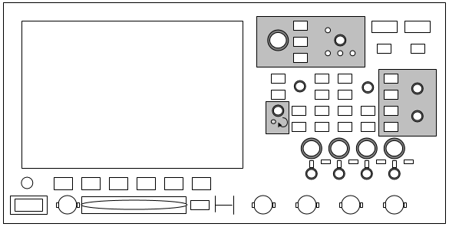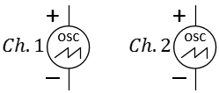
(a) | (b) | (c)

Figure 2: A photo of the KEYSIGHT oscilloscope, our physical model of it, and common schematic symbols for two channels. In ECE110, often only a label (and no symbol) will be used.
On the oscilloscope, press the Default setup, then attach Channel 1 and Channel 2 of the scope to the circuit locations shown in the schematic below. Always press Default before using the scope to clear any strange modes the previous user set.
The simplest way to trigger the oscilloscope is to press the Single button in the upper right of the oscilloscope’s front panel. The screen should go blank for just a moment as the oscilloscope is waiting for an event to tell it something interesting has occurred. For the oscilloscope in default mode, triggering means for the oscilloscope to wait for a voltage that rises above a set threshold.
Think about it…
If your Single mode plot doesn’t match your expectations, consider changing your time scale to 200 ms per division and trying again. Why does this matter?
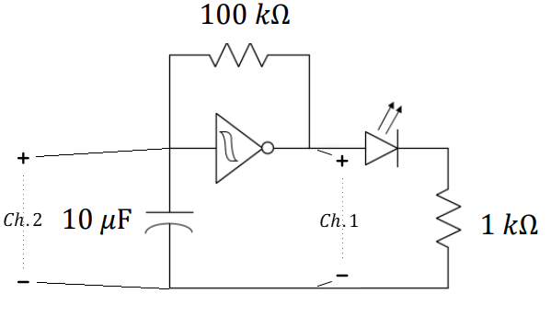
Figure 3: Use the oscilloscope to view the time-varying input and output of your oscillator, Channel 1 is the output.
Turn the “Trigger” knob clockwise until the horizontal trigger line on the oscilloscope is near $2 V$.
An Analogy …
As you consider the oscilloscope’s trigger, imagine a photographer wishing to set up a camera to automatically photograph the phases of the moon by photographing it as it rises over the horizon in the East. Since the time of the moonrise will vary each day, snapping a photo every 24 hours will do no good. The photographer might rely on light from the moon to trigger the camera to snap the photo. Similar to the oscilloscope, the photographer’s system is waiting for a value to rise above a certain threshold before capturing data. The series of captured photographs will repeatedly show the moon at the same location above the horizon.
- Use the oscilloscope as shown in Figure 3 to measure the input and output of the (Schmitt trigger) inverter by using the Single run mode. Sketch in Figure 4 the waveform you see on the oscilloscope. Verify that the oscilloscope’s $2$-volt trigger is the value the plotted voltage reaches in the center of the screen.
Figure 4: Plot the oscillator’s input and output. Please include time and voltage labels, units, and ticks.

Oscilloscope Triggering

Without Triggering
Suppose we input a periodic signal into Channel 1 of the oscilloscope. Without triggering, each plotted frame (a short time-sweep of the voltage) will begin at arbitrary point in the waveform and, with each sweep, the signal will jump around on the time axis so fast that the plot will just look like garbage. The explanation is simple. Refer to the figure below. For the first frame, the computer inside the oscilloscope will collect a waveform (frame) starting at an arbitrary point in time. A second frame is also collected starting at a later, but at a point in time unrelated to the period of the periodic signal. The second frame will be an arbitrarily-time-shifted version of the first. It is this arbitrary time shift between consecutive frames that causes the waveform to appear on the oscilloscope placed at random time intervals. If only the oscilloscope had some way of estimating the period of the waveform, it might be able to produce a stable display of one or more periods. So we note that many “basic” period waveforms (like sinusoids, square waves, and triangular waveforms) do something specific only once or twice each cycle…like transitioning across a certain voltage value.
(a)
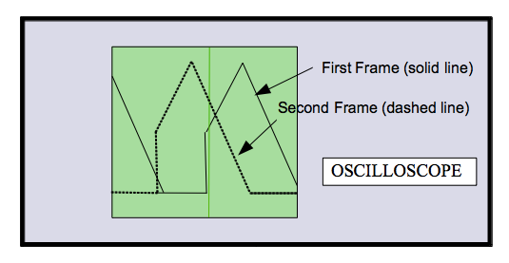
(b)

Figure 5: Two frames of an un-triggered periodic signal shown in time (a) and plotted simultaneously (b).

Continuous Triggering (Run)
Continuous triggering allows the user to specify how the oscilloscope draws and redraws a signal on the screen. Our oscilloscopes are digital scopes. A digital scope reads the analog signal (analog: continuous in time and continuous in amplitude) applied to each channel and converts it into a series of binary numbers sampled in time that represents the original signal. These numbers are stored in memory continuously with new numbers always replacing the old. Continuous triggering is used to tell the oscilloscope how to display the signals in a manner that underscores the periodic nature of the waveform.
The oscilloscope does not actually estimate the waveform’s period (although it could). It does something clever with a “trigger”. The trigger is a voltage threshold that we choose. We specify a particular voltage level and the oscilloscope starts to sketch a new frame when the voltage waveform again crosses that threshold.

(a)
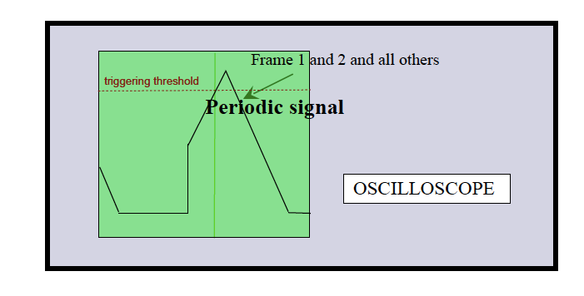
(b)
Figure 6: Two frames of a triggered periodic signal shown in time (a) and plotted simultaneously (b).
Since the signal is periodic, each frame will be nearly identical (even if several periods are missed between frames!). Therefore, the oscilloscope display overlays similar frames and the image it shows will be steady. With a steady display, the parameters of the waveform (amplitude, frequency, offset, etc.) will be easy to measure.

- Explain how the oscilloscope’s trigger causes multiple time captures of a periodic signal to look like a static image. Put a simple example of a periodic signal in the figure below to help illustrate your explanation.
Figure 7: Illustration of the oscilloscope’s trigger operation.

